CHAPTER 7

EVALUATION

7.1 Evaluation Strategy
The purpose of this chapter is to determine whether the proposed sequential specialist SLM ensemble satisfies Objectives 3, 4, and 5 defined in Section 1.2. Every claim made by the proposed architecture is mapped to a corresponding experiment: that category-specialised adapters detect their assigned attack class effectively, that the sequential OR-gate composition yields a stronger system-level detector, that the system can report which attack category triggered a detection, and that the design remains lightweight at runtime.
The evaluation is organised into three levels. Component-level evaluation assesses each specialist LoRA adapter independently on the held-out test split of its own category dataset, isolating the contribution of QLoRA fine-tuning [16], [21] against the identical un-finetuned Gemma3-1B-it backbone [12] evaluated zero-shot under the same protocol. System-level evaluation executes all three adapters as the deployed pipeline over a single combined test set; because the system flags a prompt if any adapter fires, false positive rates compound under the OR-gate and must be measured empirically rather than inferred from component results. This level also measures cross-category generalisation and category-attribution accuracy. Deployability evaluation quantifies GPU memory, per-prompt latency, and adapter-swapping overhead, reflecting the serving model in which multiple LoRA adapters share one frozen backbone [22]. In addition, an ablation fine-tunes a single control adapter on the union of all three category datasets under an identical training protocol, testing whether the decomposition provides a measurable benefit over a single classifier of equivalent capacity.
Metric choices follow established practice in the prompt injection detection literature: the False Positive Rate and False Negative Rate are treated as first-class metrics [3], [10], [20], threshold-independent metrics (AUROC [1] and the true positive rate at fixed low false positive rates [20]) characterise the full operating range, and bootstrap confidence intervals with paired significance tests ground all comparisons statistically. Comparative context is provided by the zero-shot backbone within the controlled setting, and indicatively by published figures for representative detection approaches [1], [3], [7], [8], [20], [31].
The evaluation protocol itself was verified before any result was accepted. An earlier protocol constructed model inputs from formatted training records that embed the gold label, leaking the target into the evaluation prompt. The corrected protocol truncates each record immediately before the answer turn, evaluates every adapter under the exact instruction template used during its fine-tuning, and parses outputs fail-closed (any unparseable output is treated as an injection verdict). All results in this chapter were produced under the corrected protocol.

7.2 Experimental Setup
The backbone for all detectors is Gemma3-1B-it [12], loaded in 4-bit NF4 quantisation with double quantisation and float16 compute via BitsAndBytes, following QLoRA [21]. Each specialist adapter was fine-tuned with Unsloth-accelerated supervised fine-tuning (TRL SFTTrainer) using the configuration in Table 7.1; only low-rank adapter parameters are trained while the backbone remains frozen [16]. Training was performed on Kaggle NVIDIA T4/P100 GPUs. All experiments use a fixed random seed (42).
Parameter | Value | Parameter | Value
LoRA rank r / alpha | 16 / 16 | Epochs | 2
LoRA dropout | 0.0 | Learning rate | 2e-4 (cosine)
Target modules | q,k,v,o, gate, up, down proj. | Batch size | 4 (x2 grad. accum.)
Quantisation | 4-bit NF4, fp16 compute [21] | Optimiser | AdamW 8-bit
Trainable parameters | 13,045,760 per adapter (~1.3%) | Packing / max length | yes / 512
Table 7.1: Fine-tuning configuration (identical for all specialist adapters).
Evaluation ran on dual NVIDIA T4 GPUs (Kaggle) with the backbone loaded once in 4-bit and all adapters attached to it, activated by runtime swapping [22]. Classification is generation-based: the model receives the evaluation prompt and produces a one-word verdict (INJECTION or BENIGN) under greedy decoding (maximum 6 new tokens); the first-token log-odds between the INJECTION and BENIGN token sets are recorded from the same forward pass as a continuous injection score. Evaluation prompts are byte-identical to the fine-tuning inputs with the gold answer removed, as described in Section 7.1.

7.3 Datasets
Three task-specific datasets were constructed by filtering and standardising seven public Hugging Face corpora of prompt injection attacks, jailbreak prompts, and benign instructions (Abdennebi shieldlm-prompt-injection and synthetic-prompt-injections, centrepourlasecuriteia jailbreak-dataset, neuralchemy Prompt-injection-dataset and prompt-injection-Threat-Matrix, watchdogsrox Mirror-Prompt-Injection-Dataset, and tatsu-lab alpaca for benign samples). Injection samples were grouped by attack category, benign samples were pooled at a 3:1 benign-to-injection ratio, exact-text duplicates were removed, and every sample was rendered into the Gemma chat template with the category's instruction sentence. Each dataset was split 80/10/10 (train/validation/test) with label stratification. Table 7.2 summarises the held-out test splits.
Detector (dataset) | Test rows | Benign | Injection
SLM-A: Role & instruction violation | 6,744 | 5,057 | 1,687
SLM-B: Privilege escalation | 8,356 | 6,267 | 2,089
SLM-C: Obfuscation & evasion | 8,000 | 6,000 | 2,000
Combined system-level test set (after dedup.) | 21,492 | 15,751 | 5,741
Table 7.2: Held-out test splits and the combined system-level test set.
For system-level evaluation the three test splits were concatenated and deduplicated on the raw user prompt (1,608 duplicates removed, predominantly benign samples shared across the three datasets), matching deployment semantics in which a single incoming prompt is examined once by the pipeline. Each injection sample retains its true category label, enabling the cross-category and attribution analyses in Section 7.5.

7.4 Performance Metrics
Detection is a binary classification task (injection = positive class). From the confusion matrix (TP, FP, TN, FN) the evaluation reports accuracy, injection-class Precision TP/(TP+FP), Recall TP/(TP+FN), their harmonic mean F1, the False Positive Rate FP/(FP+TN), and the False Negative Rate FN/(FN+TP). FPR and FNR are treated as first-class metrics: a guardrail that blocks legitimate prompts is unusable in production regardless of headline accuracy [20], and a missed injection is the costliest failure of a security control [3], [10]. Accuracy is reported but not relied upon for comparison, as it is inflated by the 3:1 class ratio.
Because fixed-threshold metrics describe a single operating point, a continuous injection score (first-token log-odds between the INJECTION and BENIGN token sets) additionally yields the Area Under the ROC Curve [1], the Precision-Recall AUC appropriate under class imbalance, and the true positive rate at fixed false positive rates of 0.1%, 1%, and 5%, following the low-FPR evaluation regime argued for by PromptShield [20]. All headline metrics are reported with 95% bootstrap confidence intervals (2,000 resamples), and paired comparisons between detectors use McNemar's exact test on identical samples.

7.5 Results

7.5.1 Component-Level Results
Table 7.3 reports each specialist adapter on its own test split against the zero-shot backbone on the same data. Fine-tuning is decisive: F1 rises from 0.33-0.52 to approximately 0.95 for every category, and AUROC from 0.73 to at least 0.995. All three adapters converge to nearly identical performance (F1 0.946-0.948, FPR 2.9-3.6%, FNR 0.5-2.1%). Every adapter-versus-baseline McNemar comparison is significant (p < 10^-300).
Detector | Acc. | Prec. | Recall | F1 | FPR | FNR | AUROC
SLM-A (fine-tuned) | 0.973 | 0.918 | 0.979 | 0.948 | 0.029 | 0.021 | 0.995
SLM-B (fine-tuned) | 0.972 | 0.908 | 0.987 | 0.946 | 0.033 | 0.013 | 0.998
SLM-C (fine-tuned) | 0.971 | 0.901 | 0.995 | 0.946 | 0.036 | 0.006 | 0.999
Baseline on SLM-A data | 0.778 | 0.583 | 0.362 | 0.447 | 0.085 | 0.638 | -
Baseline on SLM-B data | 0.755 | 0.615 | 0.230 | 0.335 | 0.053 | 0.770 | -
Baseline on SLM-C data | 0.734 | 0.537 | 0.501 | 0.518 | 0.173 | 0.500 | -
Table 7.3: Component-level results on each detector's own test split (baseline = zero-shot gemma-3-1b-it). 95% CIs for the fine-tuned adapters are within ±0.008 of every reported value.
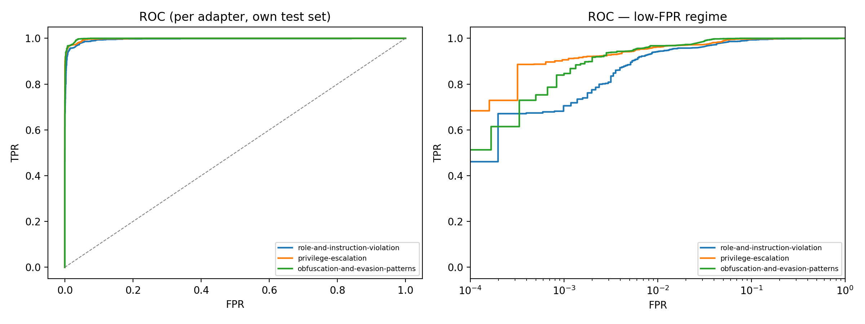
Figure 7.1: Per-adapter ROC curves; the right panel shows the low-FPR regime (logarithmic axis) [20].

7.5.2 System-Level Results
Table 7.4 reports the sequential OR-gate pipeline on the combined test set. The system detects 99.25% of injections (FNR 0.75% [0.54%, 0.97%]) at an FPR of 8.39% [7.99%, 8.82%] - the compounding predicted analytically (9.63% under independence) is confirmed, with the empirical value slightly lower because the adapters' false positives are positively correlated: of 1,322 benign false positives, 187 were flagged by two or more adapters. Against the zero-shot baseline on the same combined set (F1 0.442, FNR 63.8%), the system's improvement is significant (McNemar p ~ 0, discordant counts 4,873 vs 984).
System (combined set) | Acc. | Prec. | Recall | F1 | FPR | FNR
Sequential OR-gate ensemble | 0.936 | 0.812 | 0.993 | 0.893 | 0.084 | 0.007
Zero-shot baseline | 0.756 | 0.566 | 0.362 | 0.442 | 0.101 | 0.638
Merged single adapter (ablation) | [PENDING] | - | - | - | - | -
Table 7.4: System-level results on the combined test set (n = 21,492). The merged-adapter ablation row will be completed when its fine-tuning run finishes.
Cross-category generalisation (Figure 7.2) shows that specialisation is partial. The obfuscation adapter is a genuine specialist (99.5% own-category recall, 21.9-25.1% cross-category), whereas the role adapter behaves as a generalist, recalling 97.0% of privilege-escalation and 77.6% of obfuscation attacks. This redundancy benefits detection - system recall exceeds any single adapter - but it degrades first-fire category attribution, which reaches only 62.8%. An ordering sweep over all six adapter sequences shows first-fire attribution is bounded between 48.8% and 63.5% regardless of order, because the leakage is bidirectional. Attributing instead by the arg-max of the three adapters' injection scores raises attribution accuracy to 77.5% at negligible additional cost, since benign traffic already traverses all three stages; this refinement is adopted as the recommended attribution mechanism.
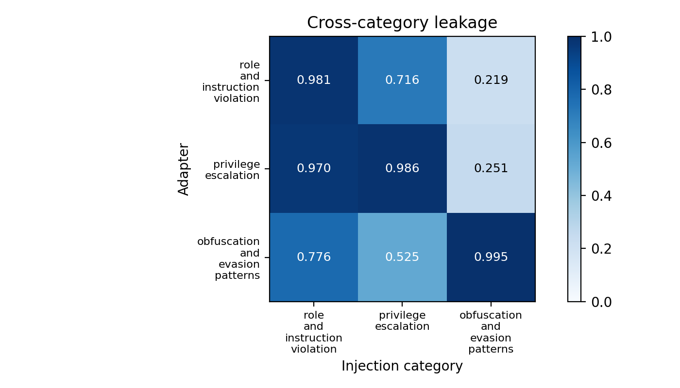
Figure 7.2: Cross-category leakage - recall of each specialist adapter on every category's injection test set.
The continuous scores enable calibrated operating points (Figure 7.3): at a threshold set for 1% FPR, the max-score fusion of the three adapters retains 95.6% recall (AUROC 0.996 [0.9955, 0.9967]), and each individual adapter retains 94.1-96.1% recall. The system can therefore be deployed in a high-security mode (OR-gate verdicts: 99.25% recall at 8.4% FPR) or a precision mode (calibrated scores: 95.6% recall at 1% FPR), selected per application. A majority-vote (2-of-3) fusion was also tested and rejected: it reduces FPR to 1.2% but collapses recall to 66.6%.
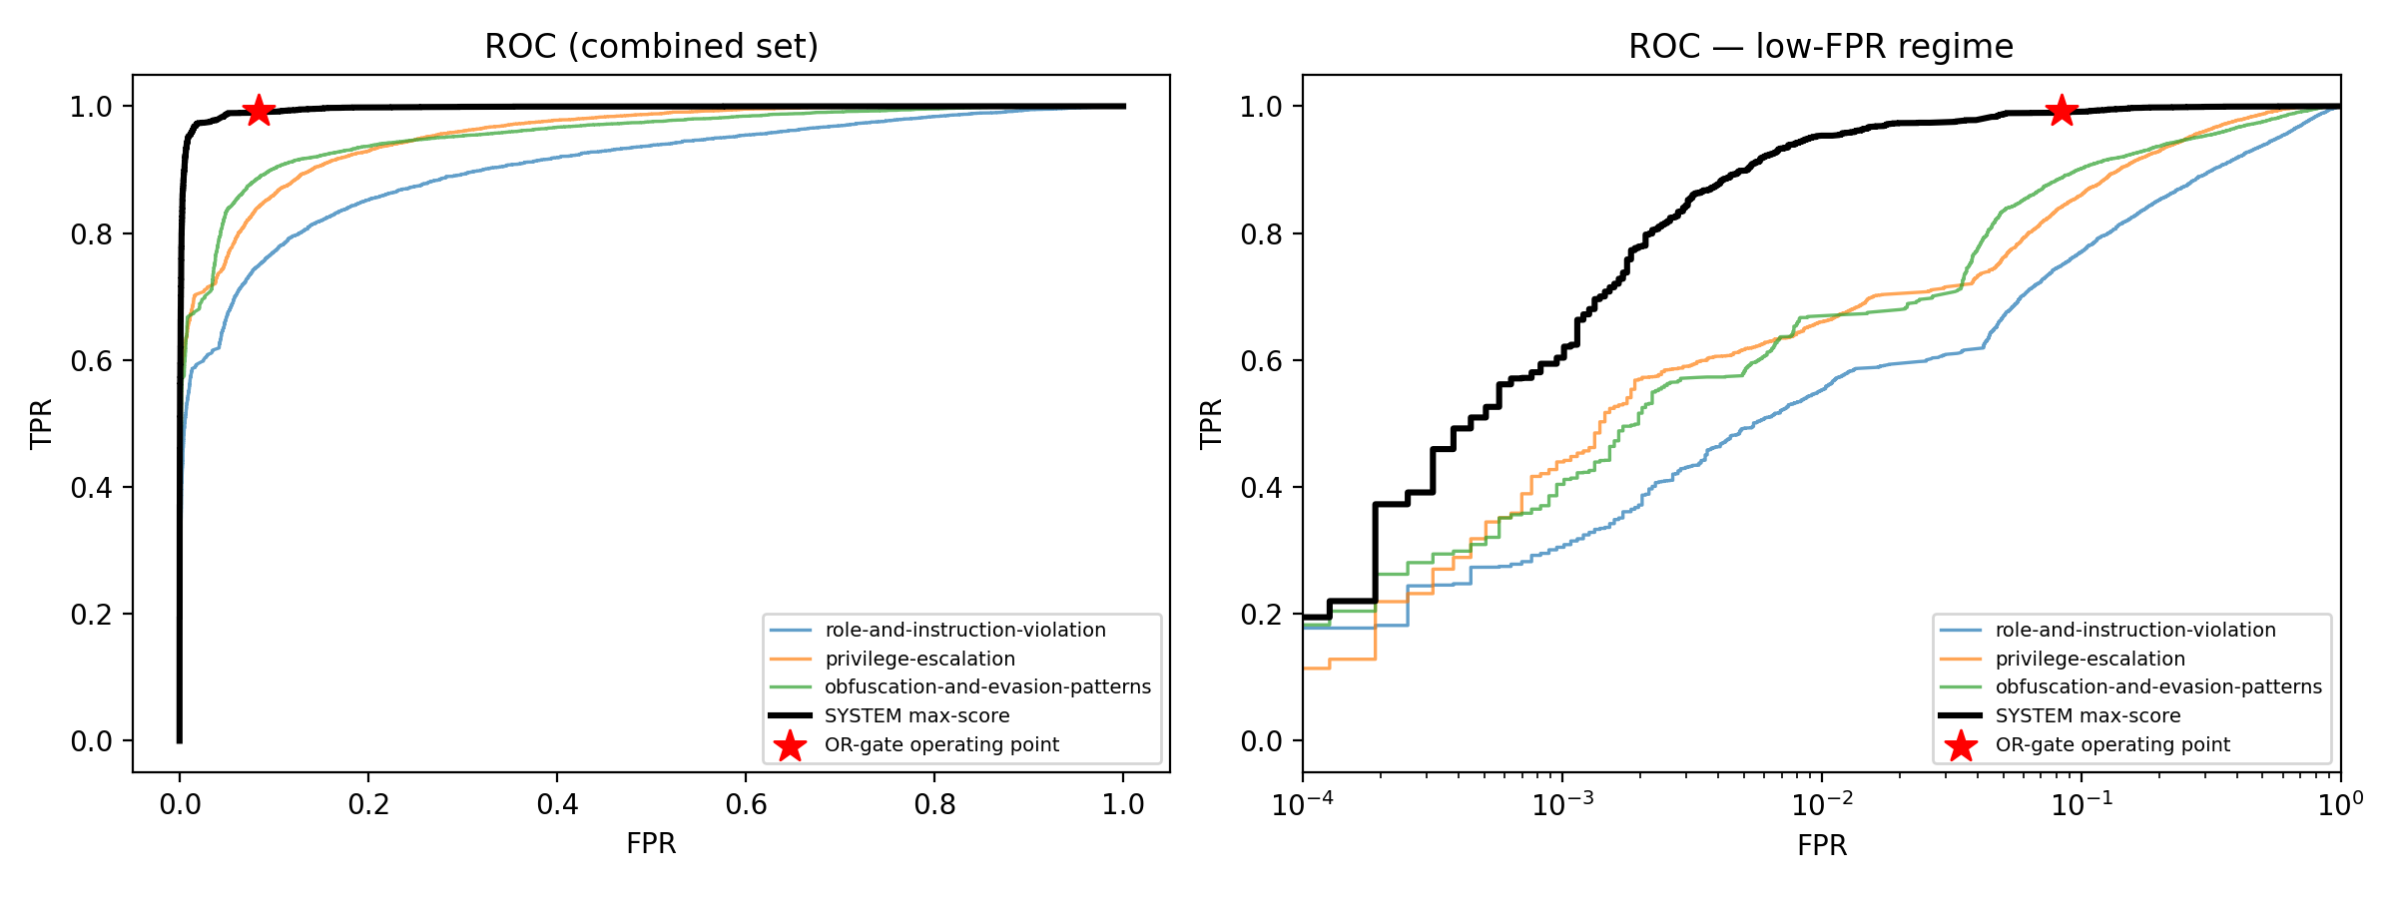
Figure 7.3: System-level ROC on the combined test set; the star marks the OR-gate operating point.

7.5.3 Deployability Results
Table 7.5 summarises the efficiency measurements (dual T4, 4-bit backbone). The complete system - backbone plus all three adapters - occupies 1.04 GB of VRAM at rest and peaked at 4.95 GB during batched inference, within the capacity of a 6 GB consumer GPU. Warm adapter swapping costs ~13 ms, negligible against per-prompt inference, supporting the S-LoRA-style multi-adapter serving design [22]. Score-based single-pass classification is 2.6x faster than generation (167 ms vs 435 ms per prompt at batch 1), giving an estimated benign-path pipeline latency of 530 ms versus 1,335 ms; since benign prompts always traverse all three stages (mean 2.93 adapters invoked, versus 1.63 for injections), score-based inference is the recommended deployment mode. This multi-pass cost is the principal efficiency trade-off of the decomposed design relative to single-pass unified defences [31].
Measurement | Value
VRAM: backbone only / + 3 adapters / peak inference | 0.90 GB / 1.04 GB / 4.95 GB
Adapter storage (each) / trainable parameters | 87.2 MB / 13.0 M (~1.3%)
Warm adapter-swap overhead | 13.1 - 13.8 ms
Batch-1 latency per stage: generation / scoring | 435 ms / 167 ms
Estimated benign-path latency: generation / scoring | 1,335 ms / 530 ms
Peak throughput (scoring) | 14.5 prompts/s (batch 4)
Table 7.5: Deployability measurements (2x NVIDIA T4, 4-bit NF4 backbone).

7.5.4 Ablation: Decomposition versus a Single Generalist Adapter
[PENDING - to be completed when the merged-adapter fine-tuning run finishes.] A single control adapter is being fine-tuned on the union of all three category datasets under the configuration of Table 7.1. Its metrics on the combined test set will complete Table 7.4, and a McNemar paired test against the ensemble will determine whether the observed difference is statistically significant. Given the partial generalisation already evident in Figure 7.2, this experiment determines whether the decomposition's benefit lies in raw detection performance or in the capabilities a single binary classifier cannot provide: category attribution (Section 7.5.2) and modular extensibility, whereby a new attack category requires training one 87 MB adapter without retraining existing detectors [22].
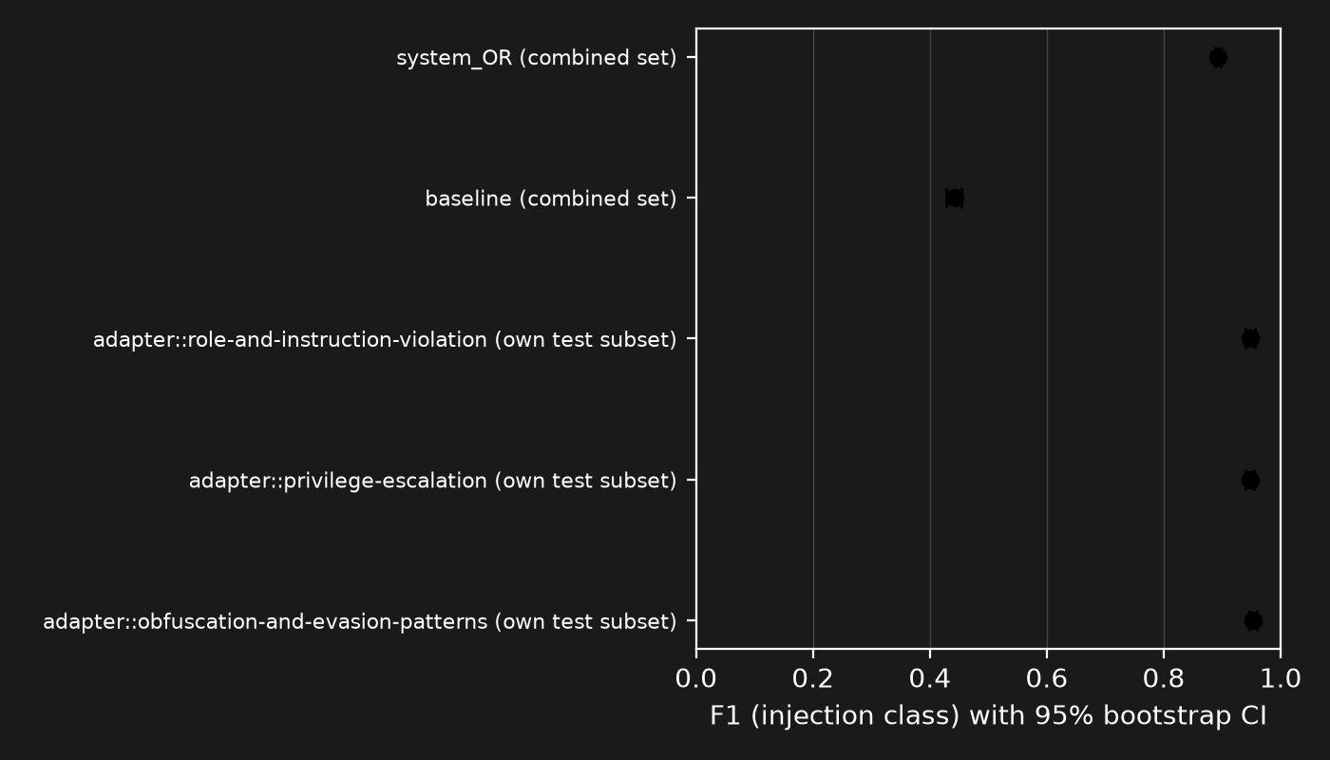
Figure 7.4: F1 of all detectors with 95% bootstrap confidence intervals.

