This user manual provides the guidance for the use of the CIDE application, currently available on this url:

<https://pproo.azo.hr/cide/app/>

**User role types and rights**

There are currently three target users groups (roles) defined within the CIDE application:

**1. ROLE_CIDE_COORDINATOR**

Inspection Coordinator: Providing the possibility to create the Coordinated Inspections and to read the inspection records filled by the Specific Inspectors. Coordinator can delete an inspection that has no saved records yet.

This role provides the Coordinated inspector with the possibility to:

* create a new coordinated inspection
* create a new specific inspection
* delete a coordinated and/or specific inspection that has no saved records

**2. ROLE_CIDE_INSPECTOR**

Specific inspector group: This role offers Specific Inspector with the possibility to: Collect defined type of information for the specific inspections created by the Inspection Coordinator, particularly:

* provide the Score for defined criteria and Note, where relevant
* provide the information about the Open issues
* report: uploading the report (PDF)

**3.ROLE_CIDE_ADMIN**

System administrator: Representing the role with full administration control on top of the system.

This role provides the Administrator with the possibility to:

* create a new coordinated inspection
* create a new specific inspection
* delete a coordinated and/or specific inspection that has no saved records

This Manual is still a draft version, providing the information for the further testing and operational deployment phase. Based on the outcomes and feedback received, documentation will be updated.

**Login**

In order to access the application functionality, users have to authorize via Login page, entering their credentials (login and password). The credentials will be provided by the administrator.

Login page url: <http://pproo.azo.hr/cide/app/#/login>

*Snap 1: Login page:* 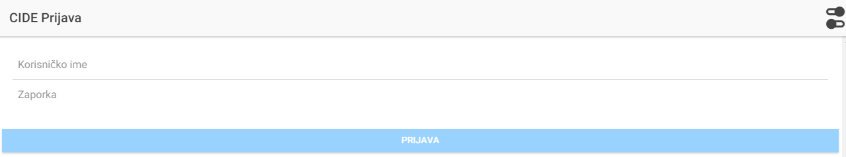

Default version of the app is available in Croatian language. There is also possibility to switch into the English version of the application, using the switch button (highligthed in yellow in the next image)

*Snap 2: EN Login page:* 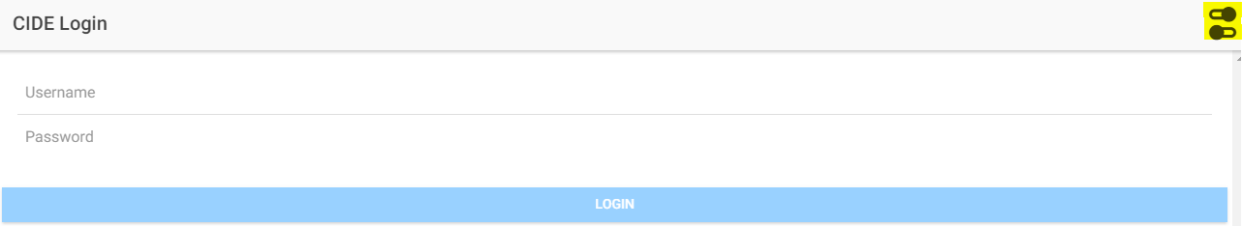

After a successful authorization, user will access the Home page, providing the information relevant to his role.

*Snap 3: Home page:* 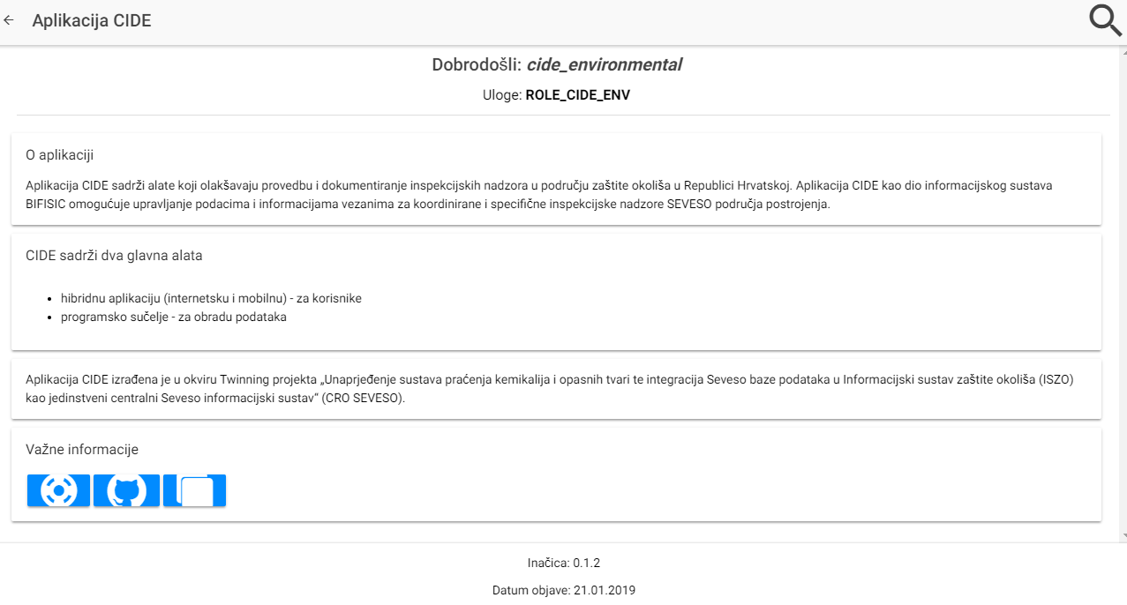

**Establishment search**

After selecting the magnifier icon,magnifier icon user can access the page with the establishments.

*Snap 4: Establishments page screeenshot:* 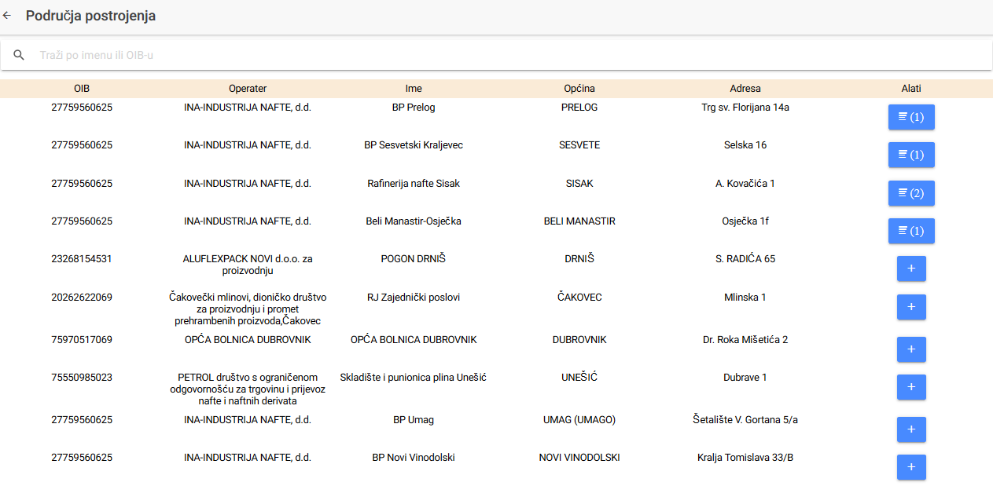

Establishments can be searched and filtered by the Name or by OIB. Establishments summary provides an information about the ID, OIB, Name of the establishment, Municipality, Address and access to the tools for specific inspections.

**Coordinated inspection creation**

Coordination inspection can be created by the user role Inspection coordinator. After authorization, the role is visible via Home page with relevant role "ROLE_CIDE_COORDINATOR".

*Snap 5:Coordinator home page:* 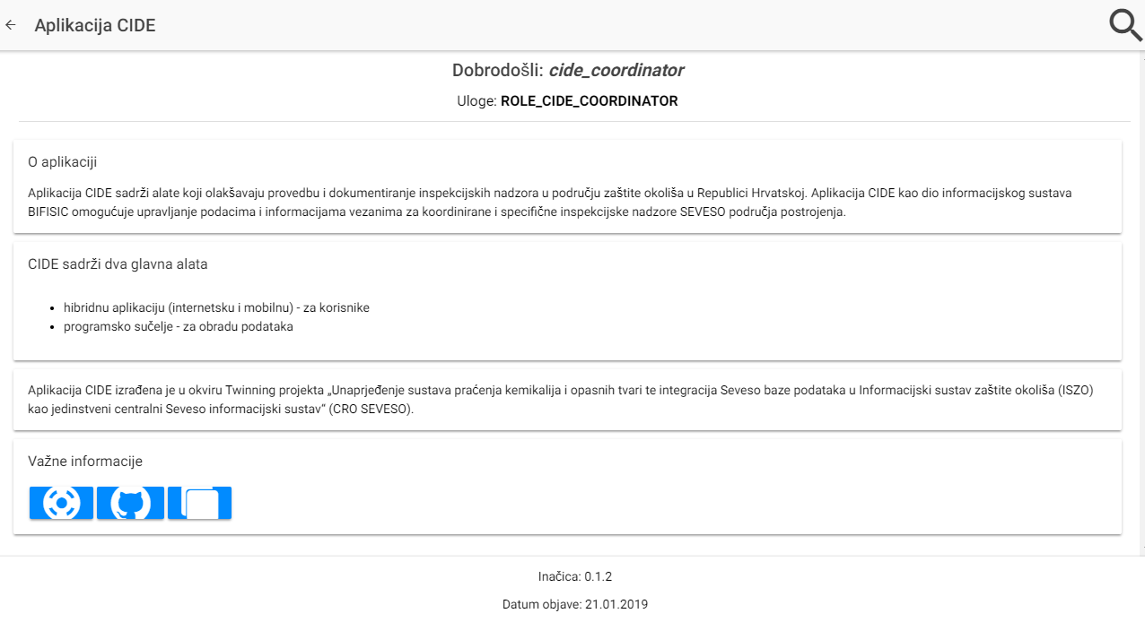

After entering into the Establishments section, coordinator can create the new Coordinated Inspection via selecting the "+" signcreating new coordinated inspection, Inspection coordinator can create new Coordinated Inspection.

*Snap 6: Creating new Coordinated Inspection:* 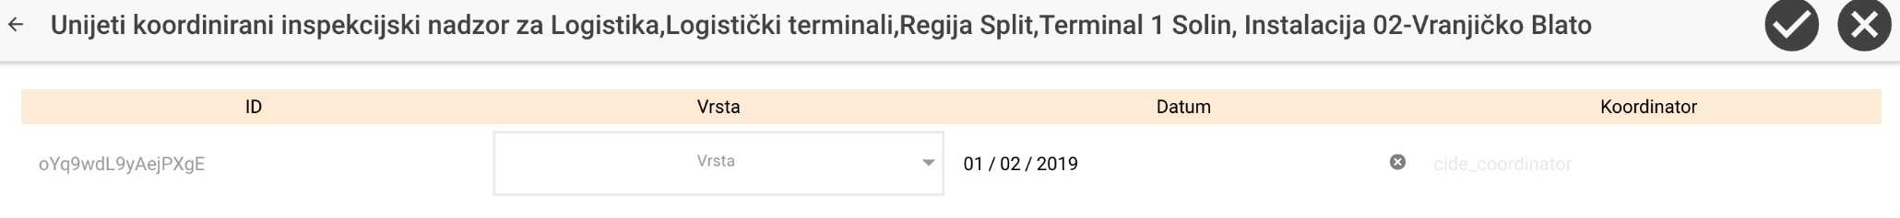

**Specific inspection creation**

After creating the new Coordinated Inspection, Coordinated Inspector can create the new Specific inspection.

*Snap 7: Creating new Specific inspection:* 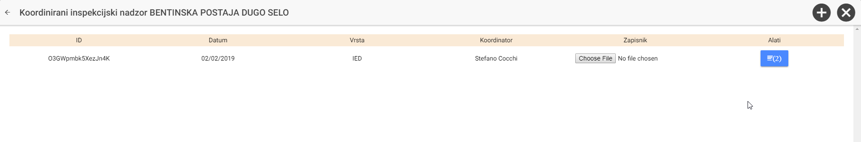

In the form for the new specific inspection, Inspection Coordinator selects type of inspection (there are 13 different types of specific inspection under the coordinated inspections) and automatically the relevant organisation responsible for the particular Specific inspection is assigned.

*Snap 8: Specific inspection details:* 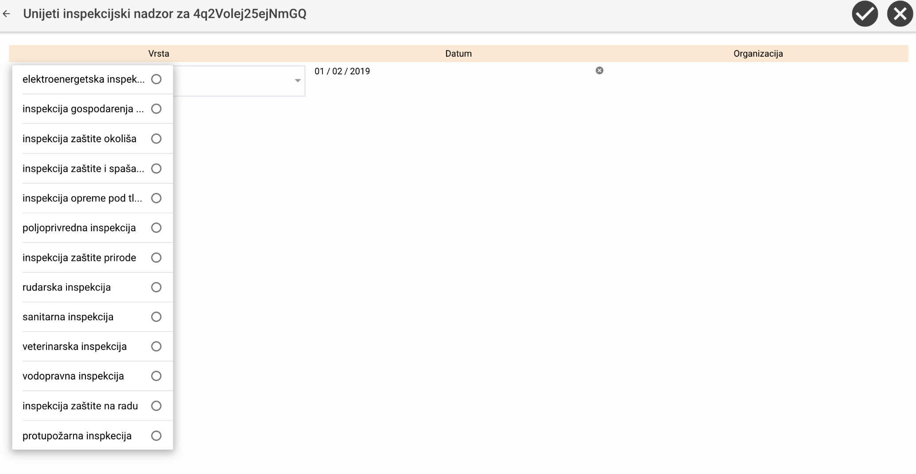

After filling up the information for the Specific inspection, summary table already contains the information about the first specific inspection for the particular Coordinated inspection.

Based on the type of the specific inspection selection appropriate organisation will be assigned based on the "[List of specific inspections and the corresponding institutions](https://github.com/HRSEVESOSK/cide-ionic-app/wiki/03-List-of-specific-inspections-and-the-corresponding-institutions)".

*Snap 9: Example of first Specific inspection under the Coordinated inspection:* 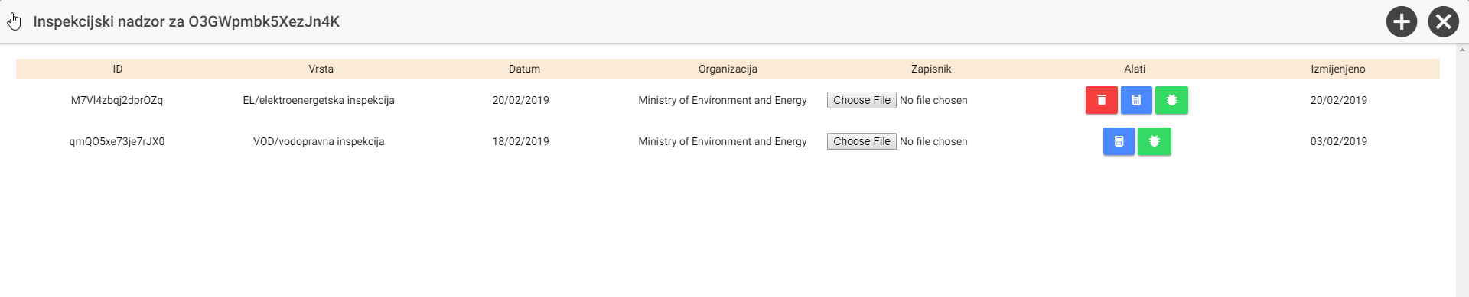

**Inspection report upload/download**

Specific inspection final report can be uploaded by the Specific inspector for particular Specific inspection. Upload function is available under the particular Specific inspection record in the collumn "Report".

*Snap 10: Specific inspection report upload:* 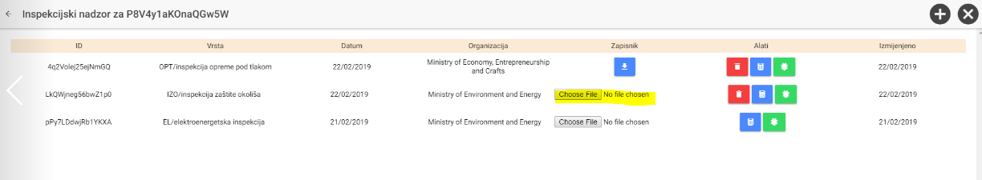

In order to access already uploaded Specific inspection report, user can click download button and save report on local drive.

*Snap 11: Specific inspection report download screeenshot:* 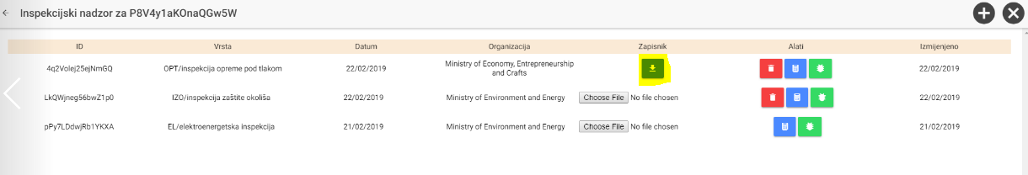

**Filling score for a specific inspection**

In connection to the specific inspections, inspectors shall first select from the tools button with link to the Criteria and score sestionhttps://github.com/HRSEVESOSK/cide-ionic-app/raw/master/user_manual/20181023_16.PNG. Consequently can select particular criterion from the available codelist values. Where relevant, for each elementary criterion inspector can insert/update the note.

*Snap 12: Specific inspection score for criteria and note download:* 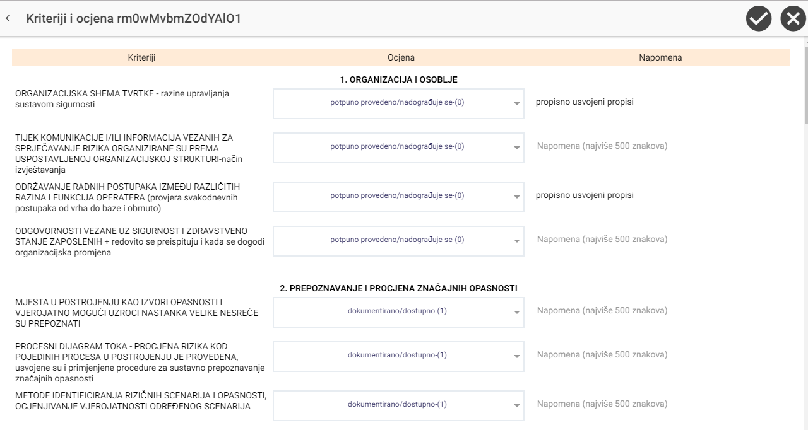

**Adding open issues for a specific inspection**

In order to document specific issues related to the inspections, user can document these issues via separtate section, which can be launched by the green issue buttonhttps://github.com/HRSEVESOSK/cide-ionic-app/raw/master/user_manual/20181023_17.PNG.

Inspector can create and update issues related to the inspection via set of attributes:

* issue description
* accomplished according to the measures/prescriptions on the inspection minutes (Yes/No)
* deadline (date)
* administrative measure (decision) – accomplished (Yes/No)
* information to court/misdemeanor warrant (text field-2000 characters)

*Snap 13: Open issue section screeenshot:* 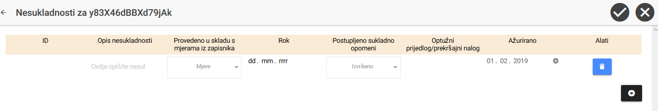

**Deleting Specific inspection**

If needed, specific inspection can be deleted. This can be done by the delete icon under the particular specific inspection only by the Admin or Coordinator.

*Snap 14: How to delete the specific inspection:* 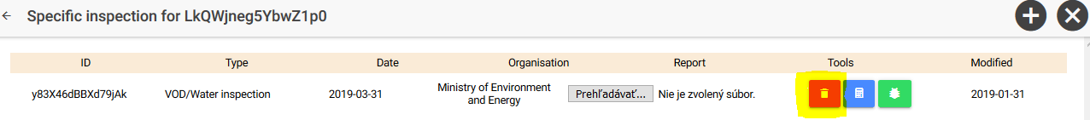Note: Specific inspection can be deleted only till information about the score and issue is inserted.

Online version available on:

<https://github.com/HRSEVESOSK/cide-ionic-app/wiki/02-User-manual>