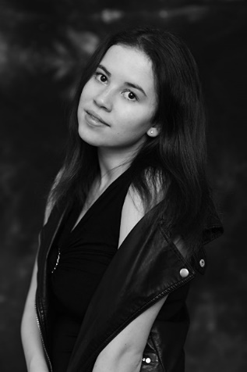

**Wendy Anne Daloz**

**Wendy-Anne is currently in rehearsals for the Island of wonder and Despair, produced by Johny Fiolett Ragnar and directed by Irene Maffei**

**Location:** Greater London **Eye Colour**: Brown

Photo: Constance Victoria

**Height**: 5'4" (164cm) **Hair Colour:** Dark Brown

**Weight**: 9st.6lbs (60 kg) **Hair Length:** Long

**Playing Age**: 16 - 22 years **Voice Quality**: Clear

**Appearance**: Eastern European, Scandinavian, White **Voice Character**: Natural

**Credits:**

**Experience as an actress:**

**Film :**

2022, Film, Alex/Jody, THE ISLAND OF WONDER AND DESPAIR, dir Irene Maffei

2021, Film, Gemma, GEMMA’s Tale, dir Alan Cosgrove

2020, Film, Magda, THE ROSE IN THE FLAME, Baltas Erelis Ltd, dir Tom Delmar

**Musical:**

2014, Musical, Voice Ensemble, SEUSSICAL, YATS Strasbourg, dir Victor Benedetti

2013, Musical, Pepper, ANNIE, YATS Strasbourg, dir Victor Benedetti

**Short Film:**

2020, Short Film, Lokesh, STAR WARS SEQUEL, Loud Hearts, dir Sidney Lee Berthier

2020, Short Film, Woman, UNTITLED MARK OWEN, Belloq Productions, dir Mark Owen

2019, Short Film, Angie Lemaire, ANGIE LEMAIRE, Loud Hearts, dir Sidney Lee Bethier

**Voiceover:**

2018, Voice Over, Homeless Woman (voice), UNSKIN, Crimson Black, dir Elcid Asaei

2013, Voice Over, Bully/Voiceover, BEAT BULLYING/ HALTE AU HARCÈLEMENT, Council of Europe, Council of Europe

**Web Series:**

2013, Web Series, June Stone-Déziel, KAIDAN, Syred Picture, dir Maykel Stone

**Stage:**

2015 Lady Macbeth, European School of Strasbourg, dir Steve Penton

2014: Beth,Wizard of Oz, Young Actors Theater Strasbourg, dir Victor Benedetti

2014, Musical, Voice Ensemble, Seussical, YATS Strasbourg, dir Victor Benedetti

2013, Musical, Pepper, Annie, YATS Strasbourg, dir Victor Benedetti

2007, The Magic Paintbrush, European School of Oxford, dir Suzy Bess

**Video:**

2020, 5 Videos, Actor, dir.Chris Stone

2020, Video, Actor, dir Mark Owen

2019, Video, Actor, dir Luke Baxter

2018, Video, Model,  dir ALORD WALKER PRODUCTION, Alord Walker, Alord Walker

2018, Video, Model, WHARTON FILMS PRODUCTION,  dir Charlie Wharton

2018, Video, Model dir Vincent James, Cityimagine music Video

**Accents & Dialects**: *(* = native)*

American-Standard, French, RP*, Heightened RP, Italian, Spanish

**Music and Dance:**

Contemporary Dance

**Skills:**

|  |  |
| --- | --- |
| **Accents & Dialects**: *(* = native)* | American-California, American-Standard, French, Heightened RP, Italian, London, RP*, Spanish |
| **Languages**: *(* = Native/Fluent)* | English*, French*, German, Spanish  2018-2020 : British Council (French Language Assistant), help students in French and in English |
| **Music & Dance**: *(* = highly skilled)* | Contemporary Dance |
| **Performance**: | Master@Arms Unarmed Combat for Stage & Screen, Meisner Technique, Poetry Reading, Presenting, Public Debating, Public Speaking, Role Play, Story Telling, TV Presenting, Voice Acting, Voice Over |
| **Sports**: *(* = highly skilled)* | Badminton, Baseball, Basketball, Canoe, Cycling*, Football, Gymnastics, Hockey (field), Rhythmic Gymnastics, Swimming* (golden and silver medal), Yoga, Contemporary Dance, Cross Country*, Rounders |

# Training:

2020, The Impulse Company

2019, Andy Johnson Acting Coach

2018, Royal Academy of Dramatic Arts: A taste of RADA Workshops, Elements of Rada, Combat for screen and Stage

2018, University of Strasbourg: Bachelor in Languages, Literature and Civilizations

2018, Training in Combat for Screen and Stage, Dan Syles and Strike Company

2018, British Academy of Dramatic Combat: Combat Lab

2016, National Youth Theater London:

Audition technique (February 2016),

Shakespeare performance (October 2016),

Acting for Screen (February 2018).