Исследование параметров системы при коэффициенте вариации, равном 0,2 и различных коэффициентах корреляции.

D[0] = { 2 2  -3 1  1 –21.5016909518  }  D[1] = { 2 2  1 1  10 10.5016909518  }  lambda = 4.8464139925846155  correlation = 0.001975003449502683  variation = 2.0000000000052731 | D[0] = { 2 2  -3 1  1 -11.9463008  }  D[1] = { 2 2  1 1  2 8.9463008  }  lambda = 5.57852032  correlation = 0.049845864490385111  variation = 2.0000000092413557 | D[0] = { 2 2  -3 1  1 -11  }  D[1] = { 2 2  1 1  1 9  }  lambda = 6  correlation = 0.062500000000000028  variation = 2
D[0] = { 3 3  -13 1 2  4 -10 1  1 1 -33.783314247  }  D[1] = { 3 3  5 1 4  1 3 1  1 1 29.783314247  }  lambda = 20.022582837355557  сorrelation = 0.1120244482173183  variation = 2.0000000000112292 | D[0] = { 4 4  -35 1 2 3  4 -38 5 6  3 4 -28 5  6 7 8 -145.64146915  }  D[1] = { 4 4  12 3 5 9  10 5 7 1  7 1 5 3  4 8 2 110.64146915  }  lambda = 44.51521576823216  correlation = 0.1141737024153182  variation = 2.0000000000032871 | D[0] = { 3 3  -15 3 2  4 -33 9  1 8 -62.1085590316  }  D[1] = { 3 3  5 1 4  10 3 7  1 1 51.1085590316  }  lambda = 31.777440158542422  correlation = 0.11582590491479801  variation = 2.0000000000010716

D[0] = { 2 2  -12 1  1 -44.73644135334  }  D[1] = { 2 2  10 1  1 42.73644135334  } | lambda = 27.368220676669999  сorrelation = 0.19892438270220283  variation = 2.0000000000004752

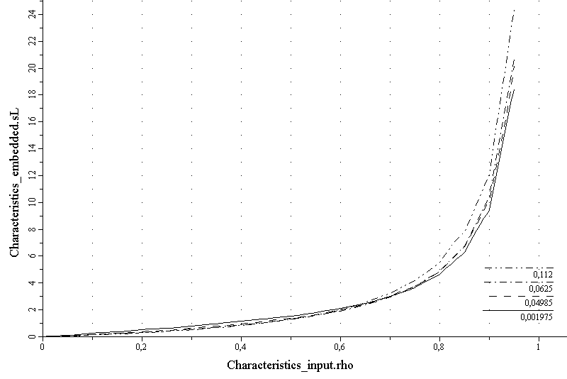

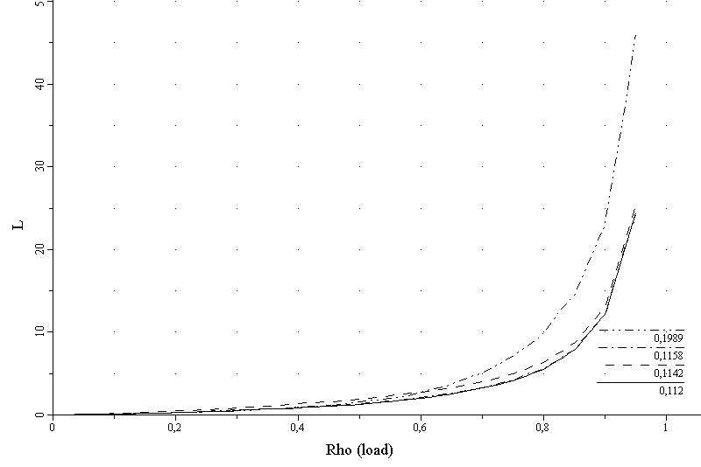

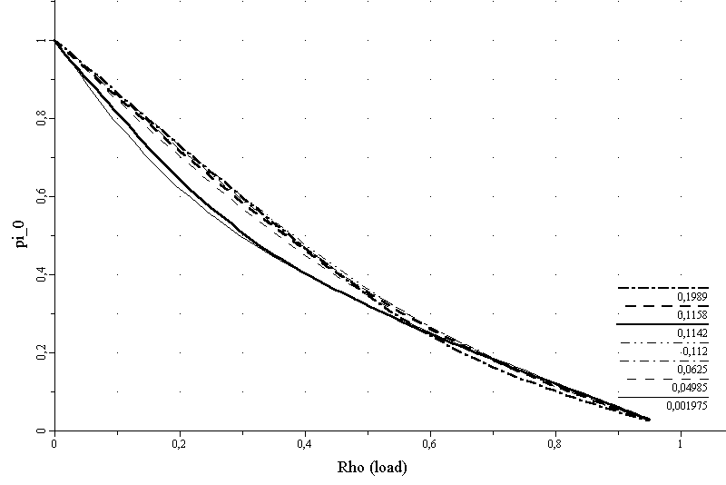
Исследование параметров системы при коэффициенте вариации, равном 0,4 и различных коэффициентах корреляции.

D[0] = { 2 2  -3 1  1 -45.0771448437  }  D[1] = { 2 2  1 1  10 34.0771448437  }  lambda = 8.4734068990307687  correlation = 0.067263896477957927  variation = 4.0000000000002514 | D[0] = { 2 2  -3 1  1 -24.869610868  }  D[1] = { 2 2  1 1  2 21.869610868  }  lambda = 10.747844347199999  correlation = 0.1012256792016247  variation = 4.0000000001265725 | D[0] = { 2 2  -3 1  1 -23.3578167  }  D[1] = { 2 2  1 1  1 21.3578167  }  lambda = 12.17890835  correlation = 0.1105226574367776  variation = 4.0000000013811308
D[0] = { 3 3  -15 3 2  4 -33 9  1 8 -128.5694403  }  D[1] = { 3 3  5 1 4  10 3 7  1 1 117.5694403  }  lambda = 62.490423168939387  correlation = 0.18387690060115847  variation = 4.0000000010870265 | D[0] = { 3 3  -13 1 2  4 -10 1  1 1 -71.7539399527  }  D[1] = { 3 3  5 1 4  1 3 1  1 1 67.7539399527  }  lambda = 39.429791531380005  correlation = 0.18544572954538513  variation = 4.0000000000000115 | D[0] = { 4 4  -35 1 2 3  4 -38 5 6  3 4 -28 5  6 7 8 -311.674334329  }  D[1] = { 4 4  12 3 5 9  10 5 7 1  7 1 5 3  4 8 2 276.674334329  }  lambda = 79.729579717537604  correlation = 0.20834950635011887  variation = 4.0000000000005675

D[0] = { 2 2  -12 1  1 -94.4112056  }  D[1] = { 2 2  10 1  1 92.4112056  } | lambda = 52.205602800000001  correlation = 0.30581895957557803  variation = 4.0000000023170381

