**Recommendation System for Residential Area**

**Introduction where you discuss the business problem and who would be interested in this project.**

Nowadays we can check for sites that are available for sale/lease ,on the internet. But these sites don't tell the user whether it is actually worth the price when comes to the area its located in .Apart from the specifications of the property we buy we also consider its vicinity to various venues .The idea of mine tends to take this burden of manually looking for different venues ,out of human hands. The idea is evaluate whether a given location is suited for the client according to his/her requirements. The recommendation system considers only surrounding public places.

* **Data where you describe the data that will be used to solve the problem and the source of the data.**

Foursquare location data acts as a backbone to this project as we rate the Cities/location on the basis of their vicinity to various venues, for example :stores and shops where we tend go on daily basis should be close(<1.5km),whereas hospitals ,hotels ,educational institutes shall be given range values (4-10km)according to their importance .The location data will be refined and converted as inputs to a ML model which will label the site as recommended /not-recommended.

* **Methodology section which represents the main component of the report where you discuss and describe any exploratory data analysis that you did, any inferential statistical testing that you performed, if any, and what machine learnings were used and why.**

To recommend a residential location we must ensure the location is lively enough to make the life of its resident convenient . Acknowledging the fact different age groups have different needs. We do the following :-

1. Take the desired location that needs to checked.
2. Use the Foursquare API to gather information of various venues in close proximity to the location.
3. Looking at the html maps generated and the numbers of venues ,the required person can give his inference. Even the client can make up the observation by just looking at the maps.
4. Use graph to compare various categories by their count.

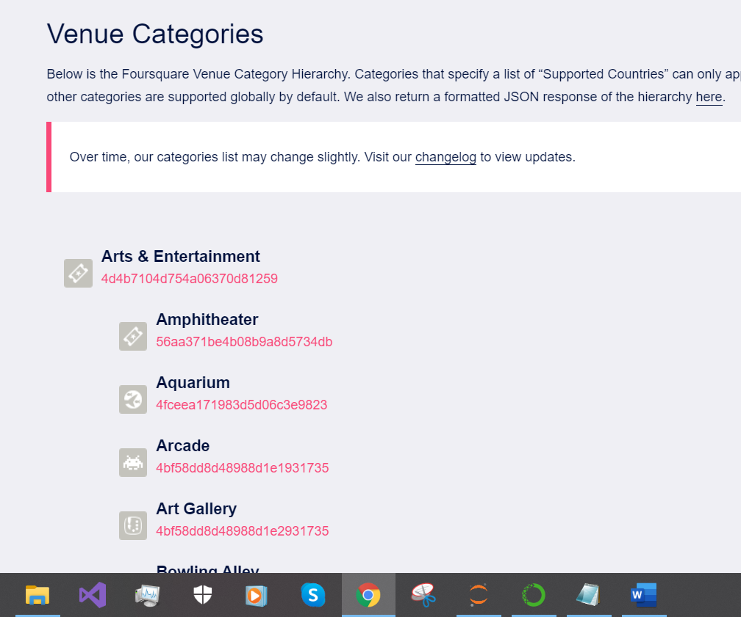

In order maintain the time constraint ML techniques were not deployed ,since gathering actual data was my priority and I wanted to avoid the use of dummy data .The idea of giving the customer the required data and our inference on it , is apt as the client can make decision by looking at actual data.

* **Results section where you discuss the results.**

In this case bar graph was used as it a simple and easy to understand way to visualize data .We found the venues belonging to two categories –“Entertainment”, ”Medical” .As these are the main things required by residents .No one would prefer a location that is away from these venues.

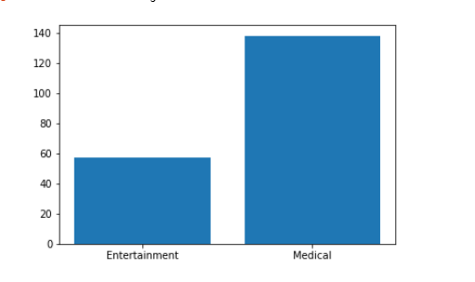

Sector 35,Chandigarh ,India

Our results showed it to be close to various venues within 5km/~3miles.We recommend it as ideal place to live for every age group. Since I have visited this area many times I can personally confirm the inference based on just data.

* **Discussion section where you discuss any observations you noted and any recommendations you can make based on the results.**

Sector 35,Chandigarh ,India

Our results showed it to be close to various venues within 5km/~3miles.We recommend it as ideal place to live for every age group. Since I have visited this area many times I can personally confirm the inference based on just data.

Entertainment venues:-

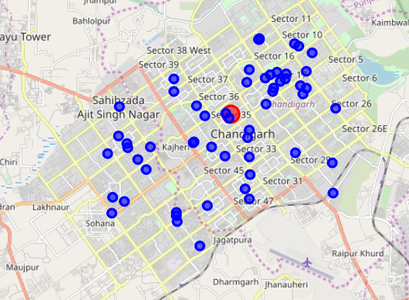

Medical venues(Clinics, hospitals etc):-

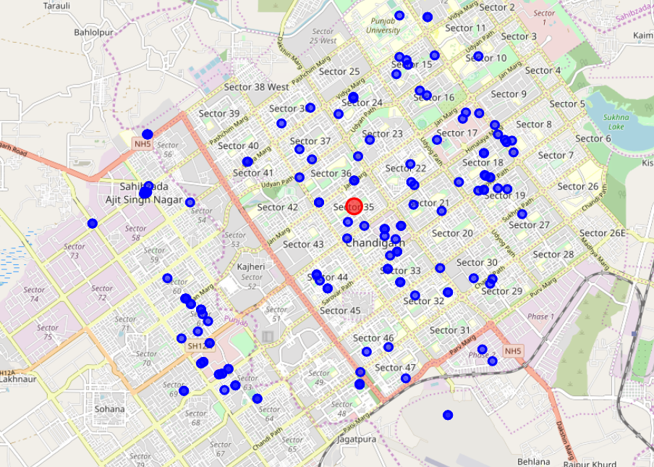

* **Conclusion section where you conclude the report.**

The initial phase of the project has shown the challenges on programming level ,that are needed to be addressed to fully automate the process of recommendation .I have identified various areas where ML and NLP techniques can be used to make itself updating system .With more time devoted to this project ,it can become a fully automated residential recommendation system .