|  |  |
| --- | --- |
|  | Government SchemesWFS-s------------------------Group 22020 |

# Class Diagram

Two servlet controllers were used instead of one controller as used in conventional MVC architecture. Two controllers were created to control each side of the data flow i.e. Citizen side and Employee side. Standard layered architecture is focused upon.

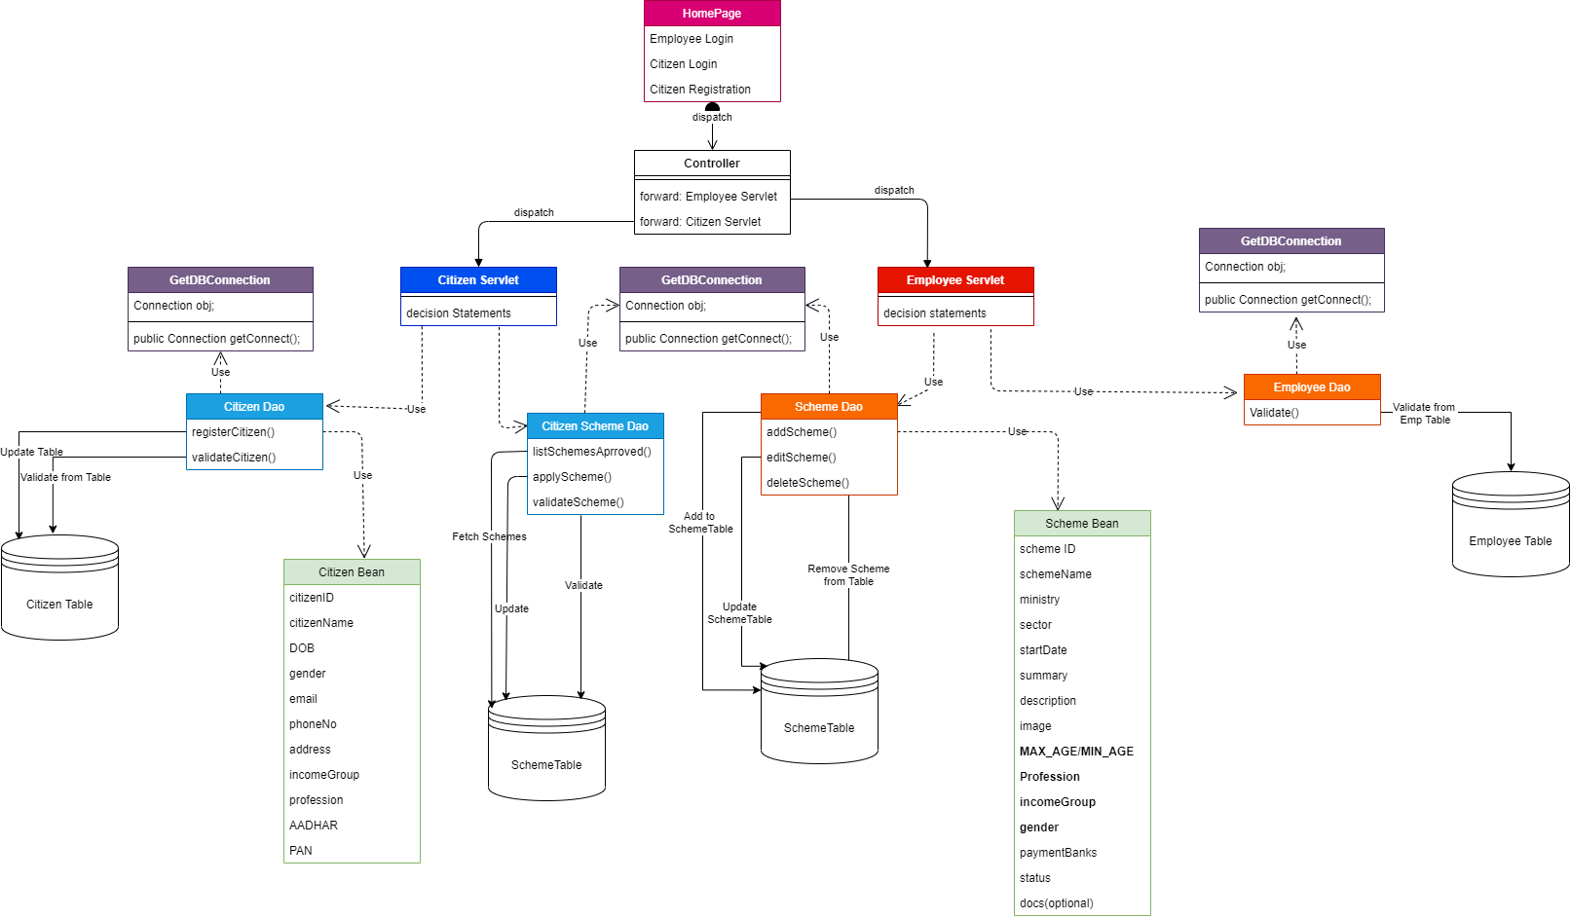

# Data Flow Diagram

Data Flow Diagram (DFD) is a methodology of graphical structural analysis and information systems design, which describes the sources external in respect to the system, recipients of data, logical functions, data flows and data stores that are accessed.

* Employee side DFD shows how data is transferred between the employee user and the system. Employee user can login via credentials which are authenticated from the Employee database and if they are correct employee login into the system. Functions that can be performed by the employee are like add scheme, edit scheme and delete scheme in which data is provided by the employee user and operations are performed on the scheme database and response is reverted back to the employee.

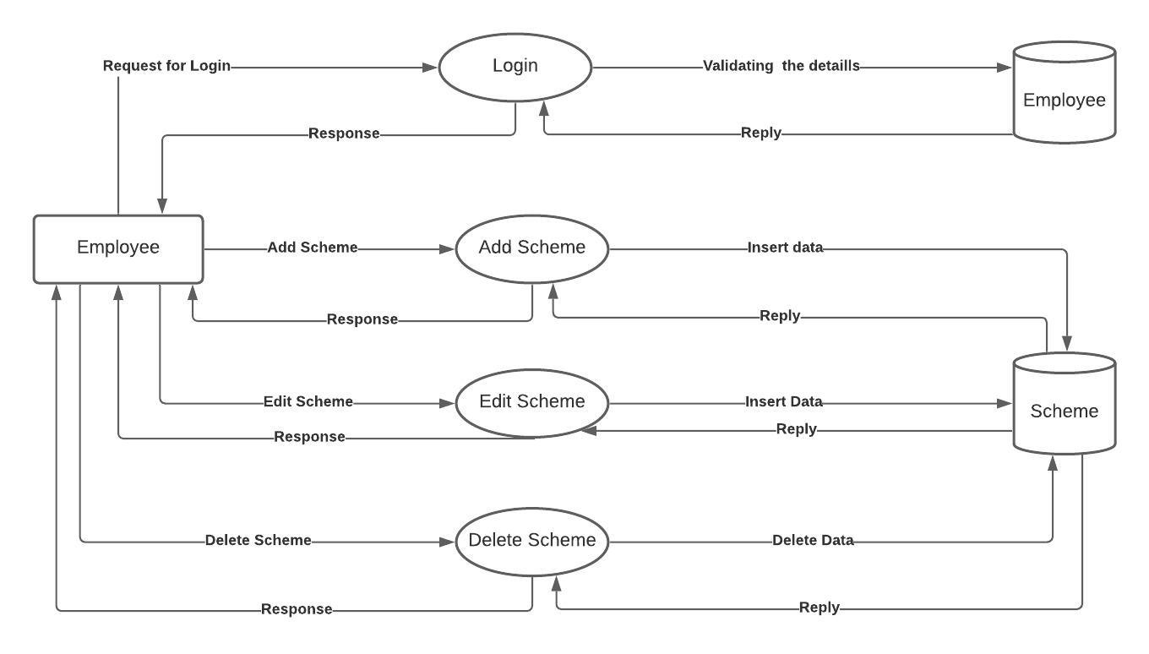

* Citizen side DFD shows how data is transferred between the citizen user and the system. For the first time citizen has to register to the portal and provide his/her details. He/she then can login into the system via that credentials. Citizen can now browse through all the schemes available and apply for any of those for which he/she is eligible. After applying that application goes for verification if it is approved citizen user can view that scheme under his/her approved scheme (that will be fetched from the Scheme Database).

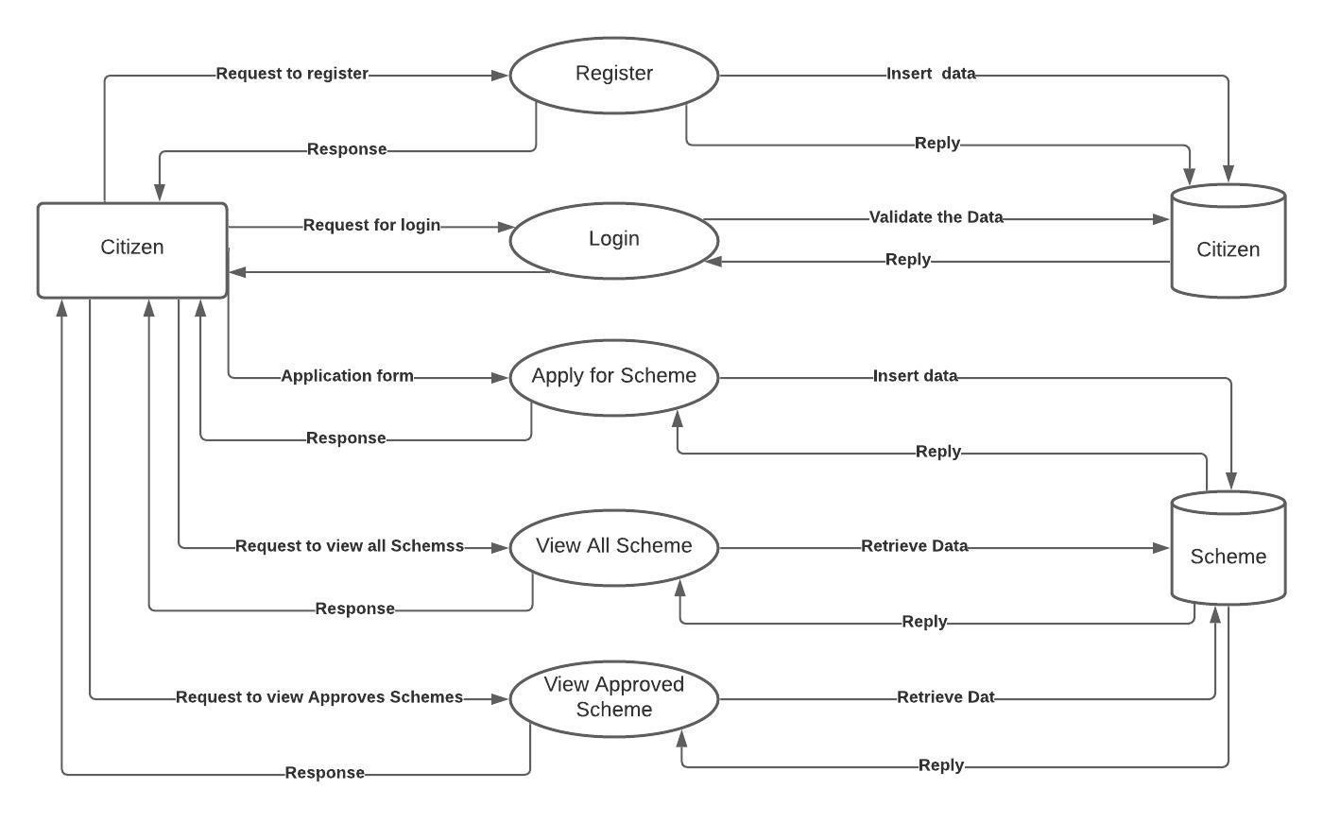

# Project Scope

This web based system, Nagrikyojana , provides information about all the available government schemes. Citizens can view details and apply to various schemes depending on the eligibility criteria specified. It provides a lucid interface that the users can easily browse.

Once a citizen views all schemes, they can apply for multiple schemes. After submission the scheme goes for approval which is based on the eligibility criteria. If all validation succeeds the scheme is either approved or rejected for the particular citizen. Once approved the payment is directly credited to the citizen’s bank account.

The above mentioned process includes several data requirements that are collected from the user. The system stores all the data in a database. The citizen must fill every data field that is required before initiating the final submission. A citizen can only make one entry for a particular scheme. Multiple submissions for a single scheme is not accepted.

The website aims to provide a single platform for citizens to ease their experience of knowing about different schemes provided by the government. It not only makes the application process smooth and seamless but also helps users in possessing a clear knowledge about the available schemes.

# Project Methodology & Approach

Instead of regular approach, agile approach was used while building the project. Primary focus was given to basic functionality and not to build more than what is necessary. Although the team was divided to work on separate aspects of the project, flexibility of switching in between the teams was kept as everyone was kept updated about the whole progress of the project through regular two-day meetings.

# Assumptions

The following are the assumptions made while developing the web based system:

Citizen ID will be given to citizen after login which is used every time later.

Schemes are considered under single category and have not been differentiated according to central government schemes or state government schemes . The list of all available schemes is reflected on one page and the required details can be viewed from there.

After a successful citizen validation and scheme approval , the citizen is redirected to a page for acknowledgement which also symbolizes that the payment is under process.Due to lack of resources, currently the functionality of transferring funds to the citizen’s bank account has not been implemented i.e. no payment gateway has been used. This functionality is included in the future scope of the project when the required resources would be available.

The validation of documents is done by checking if the document is uploaded or not. The authenticity of the documents uploaded by the citizen, for example – aadhar card/residential address proof , is based on the assumption that the citizen will adhere to the rules and guidelines provided by the government and would not act otherwise.

# Testing Use cases

# Lessons Learned

The major thing that we learned through this process was team work . It helped us to improve our collaboration skills . It is important to act with integrity . Team work includes several people relying on each other for producing a final product hence credibility is a major factor .

Communication is the key. Reaching the perfect conclusion would not be possible without proper communication.

Resolving conflicts is also a part of collaboration . In a team of 10 members , not every member agrees to every point suggested by other members . But discussing by holding meetings and taking into account the concerns and challenges leads to effective conflict resolution .

# References