TASK 1:

Testbench:
`timescale 1ns/1ps

module testbench;

reg pclk;
reg presetn;

reg transfer;
reg read;
reg write;

reg [8:0] apb_write_paddr;
reg [7:0] apb_write_data;
reg [8:0] apb_read_paddr;

wire pslverr;
reg [3:0] test_case;
wire [7:0] apb_read_data_out;

top dut (
.pclk(pclk),
.presetn(presetn),
.transfer(transfer),
.read(read),
.write(write),
.apb_write_paddr(apb_write_paddr),
.apb_write_data(apb_write_data),
.apb_read_paddr(apb_read_paddr),
.pslverr(pslverr),
.apb_read_data_out(apb_read_data_out)
);

initial begin
pclk = 1'b0;

forever #5 pclk = ~pclk;
end

integer pass_count;
integer fail_count;

task reset_dut;
begin

presetn = 1'b0;

transfer = 1'b0;
read = 1'b0;
write = 1'b0;

apb_write_paddr = 9'h000;
apb_write_data = 8'h00;
apb_read_paddr = 9'h000;

#20;

presetn = 1'b1;

@(posedge pclk);
#1;

end
endtask

task apb_write_transaction;

input [8:0] address;
input [7:0] data;

begin

@(negedge pclk);

transfer = 1'b1;
write = 1'b1;
read = 1'b0;

apb_write_paddr = address;
apb_write_data = data;

// IDLE -> SETUP
@(posedge pclk);
#1;

// SETUP -> ENABLE
@(posedge pclk);
#1;

// Wait until transfer completes
while ((dut.master_inst.state == 2'b10) &&
(dut.master_inst.pready == 1'b0)) begin
@(posedge pclk);
#1;
end

@(negedge pclk);

transfer = 1'b0;
write = 1'b0;

end
endtask

task apb_read_transaction;

input [8:0] address;
output [7:0] data;

begin

@(negedge pclk);

transfer = 1'b1;
write = 1'b0;
read = 1'b1;

apb_read_paddr = address;

// IDLE -> SETUP
@(posedge pclk);
#1;

// SETUP -> ENABLE
@(posedge pclk);
#1;

// Wait until transfer completes
while ((dut.master_inst.state == 2'b10) &&
(dut.master_inst.pready == 1'b0)) begin
@(posedge pclk);
#1;
end

data = apb_read_data_out;

@(negedge pclk);

transfer = 1'b0;
read = 1'b0;

end
endtask

task TC1_basic_write;

begin

$display("");
$display("TC1 - BASIC WRITE OPERATION");

reset_dut;

apb_write_transaction(9'h005, 8'hAA);

#2;

if (dut.slave1_inst.memory[8'h05] === 8'hAA) begin

$display("TC1 PASS");
$display("Address = 9'h005");
$display("Data = 8'hAA");
$display("Slave 1 = SELECTED");
$display("Memory[5] = %h", dut.slave1_inst.memory[8'h05]);

pass_count = pass_count + 1;

end
else begin

$display("TC1 FAIL");
$display("Expected memory[5] = AA");
$display("Actual memory[5] = %h",
dut.slave1_inst.memory[8'h05]);

fail_count = fail_count + 1;

end

end
endtask

task TC2_basic_read;

reg [7:0] read_data;

begin

$display("");
$display("TC2 - BASIC READ OPERATION");

reset_dut;

// First write AA to address 005
apb_write_transaction(9'h005, 8'hAA);

// Now read address 005
apb_read_transaction(9'h005, read_data);

#2;

if (read_data === 8'hAA) begin

$display("TC2 PASS");
$display("Address = 9'h005");
$display("Expected = 8'hAA");
$display("Read Data = 8'h%h", read_data);

pass_count = pass_count + 1;

end
else begin

$display("TC2 FAIL");
$display("Expected = 8'hAA");
$display("Actual = 8'h%h", read_data);

fail_count = fail_count + 1;

end

end
endtask

task TC3_address_decoding;

begin

$display("");
$display("TC3 - ADDRESS DECODING / SLAVE SELECTION");

reset_dut;

@(negedge pclk);

transfer = 1'b1;
write = 1'b1;
read = 1'b0;

apb_write_paddr = 9'h005;
apb_write_data = 8'hA5;

@(posedge pclk);
#1;

if ((dut.master_inst.psel1 === 1'b1) &&
(dut.master_inst.psel2 === 1'b0)) begin

$display("Slave 1 selection PASS");
$display("Address 9'h005 -> PSEL1 = 1, PSEL2 = 0");

end
else begin

$display("Slave 1 selection FAIL");
fail_count = fail_count + 1;

end

// Finish transfer
@(posedge pclk);
#1;

@(negedge pclk);

transfer = 1'b0;
write = 1'b0;

@(negedge pclk);

transfer = 1'b1;
write = 1'b1;
read = 1'b0;

apb_write_paddr = 9'h085;
apb_write_data = 8'h5A;

@(posedge pclk);
#1;

if ((dut.master_inst.psel1 === 1'b0) &&
(dut.master_inst.psel2 === 1'b1)) begin

$display("Slave 2 selection PASS");
$display("Address 9'h085 -> PSEL1 = 0, PSEL2 = 1");

end
else begin

$display("Slave 2 selection FAIL");
fail_count = fail_count + 1;

end

@(posedge pclk);
#1;

@(negedge pclk);

transfer = 1'b0;
write = 1'b0;

#2;

if ((dut.slave1_inst.memory[8'h05] === 8'hA5) &&
(dut.slave2_inst.memory[8'h85] === 8'h5A)) begin

$display("TC3 PASS");
$display("Slave 1 memory[05] = %h",
dut.slave1_inst.memory[8'h05]);
$display("Slave 2 memory[85] = %h",
dut.slave2_inst.memory[8'h85]);

pass_count = pass_count + 1;

end
else begin

$display("TC3 FAIL");

fail_count = fail_count + 1;

end

end
endtask

task TC4_write_wait_state;

begin

$display("");
$display("TC4 - WRITE WITH WAIT STATES");

reset_dut;

@(negedge pclk);

transfer = 1'b1;
write = 1'b1;
read = 1'b0;

apb_write_paddr = 9'h010;
apb_write_data = 8'hBB;

// IDLE -> SETUP
@(posedge pclk);
#1;

// SETUP -> ENABLE
@(posedge pclk);
#1;

// Force ready LOW to simulate slave wait states
force dut.pready = 1'b0;

$display("Simulating wait state...");

repeat (3) begin

@(posedge pclk);
#1;

if (dut.master_inst.state !== 2'b10) begin

$display("TC4 FAIL: Master left ENABLE during wait");

fail_count = fail_count + 1;

release dut.pready;
disable TC4_write_wait_state;

end

end

$display("Master remained in ENABLE during wait.");

// Release ready
release dut.pready;

@(posedge pclk);
#1;

@(posedge pclk);
#1;

@(negedge pclk);

transfer = 1'b0;
write = 1'b0;

#2;

if (dut.slave1_inst.memory[8'h10] === 8'hBB) begin

$display("TC4 PASS");
$display("Address = 9'h010");
$display("Data = 8'hBB");
$display("Wait states successfully handled.");

pass_count = pass_count + 1;

end
else begin

$display("TC4 FAIL");
$display("Expected memory[10] = BB");
$display("Actual memory[10] = %h",
dut.slave1_inst.memory[8'h10]);

fail_count = fail_count + 1;

end

end
endtask

task TC5_read_wait_state;

reg [7:0] read_data;

begin

$display("");
$display("TC5 - READ WITH WAIT STATES");

reset_dut;

// Put known data into address 010
apb_write_transaction(9'h010, 8'hBB);

@(negedge pclk);

transfer = 1'b1;
write = 1'b0;
read = 1'b1;

apb_read_paddr = 9'h010;

// IDLE -> SETUP
@(posedge pclk);
#1;

// SETUP -> ENABLE
@(posedge pclk);
#1;

// Simulate wait states
force dut.pready = 1'b0;

$display("Simulating read wait state...");

repeat (3) begin

@(posedge pclk);
#1;

if (dut.master_inst.state !== 2'b10) begin

$display("TC5 FAIL: Master left ENABLE during wait");

fail_count = fail_count + 1;

release dut.pready;
disable TC5_read_wait_state;

end

end

$display("Master remained in ENABLE during wait.");

release dut.pready;

@(posedge pclk);
#1;

@(posedge pclk);
#1;

read_data = apb_read_data_out;

@(negedge pclk);

transfer = 1'b0;
read = 1'b0;

#2;

if (read_data === 8'hBB) begin

$display("TC5 PASS");
$display("Address = 9'h010");
$display("Read Data = 8'hBB");

pass_count = pass_count + 1;

end
else begin

$display("TC5 FAIL");
$display("Expected = 8'hBB");
$display("Actual = 8'h%h", read_data);

fail_count = fail_count + 1;

end

end
endtask

task TC6_error_handling;

begin

$display("");
$display("TC6 - ERROR HANDLING / PSLVERR");

reset_dut;

apb_write_transaction(9'h1FF, 8'hFF);

#2;

if (pslverr === 1'b1) begin

$display("TC6 PASS");
$display("PSLVERR correctly asserted.");
$display("Invalid address = 9'h1FF");

pass_count = pass_count + 1;

end
else begin

$display("TC6 FAIL");
$display("Expected PSLVERR = 1");
$display("Actual PSLVERR = %b", pslverr);
$display("");
$display("REASON:");
$display("9'h1FF is decoded to Slave 2.");
$display("Slave 2 receives paddr[7:0] = 8'hFF.");
$display("The slave considers 8'hFF valid.");

fail_count = fail_count + 1;

end

end
endtask

task TC7_burst_transfers;

begin

$display("");
$display("TC7 - BURST / BACK-TO-BACK TRANSFERS");

reset_dut;

// Keep transfer asserted between transactions
transfer = 1'b1;

@(negedge pclk);

write = 1'b1;
read = 1'b0;

apb_write_paddr = 9'h001;
apb_write_data = 8'h11;

@(posedge pclk);
#1;

@(posedge pclk);
#1;

@(negedge pclk);

apb_write_paddr = 9'h002;
apb_write_data = 8'h22;

@(posedge pclk);
#1;

@(posedge pclk);
#1;

@(negedge pclk);

apb_write_paddr = 9'h003;
apb_write_data = 8'h33;

@(posedge pclk);
#1;

@(posedge pclk);
#1;

@(negedge pclk);

write = 1'b0;
read = 1'b1;

apb_read_paddr = 9'h001;

@(posedge pclk);
#1;

@(posedge pclk);
#1;

if (apb_read_data_out !== 8'h11)
$display("TC7 READ 001 FAIL");
else
$display("TC7 READ 001 PASS");

@(negedge pclk);

apb_read_paddr = 9'h002;

@(posedge pclk);
#1;

@(posedge pclk);
#1;

if (apb_read_data_out !== 8'h22)
$display("TC7 READ 002 FAIL");
else
$display("TC7 READ 002 PASS");

@(negedge pclk);

apb_read_paddr = 9'h003;

@(posedge pclk);
#1;

@(posedge pclk);
#1;

if (apb_read_data_out !== 8'h33)
$display("TC7 READ 003 FAIL");
else
$display("TC7 READ 003 PASS");

@(negedge pclk);

transfer = 1'b0;
read = 1'b0;
write = 1'b0;

#2;

if ((dut.slave1_inst.memory[8'h01] === 8'h11) &&
(dut.slave1_inst.memory[8'h02] === 8'h22) &&
(dut.slave1_inst.memory[8'h03] === 8'h33)) begin

$display("TC7 PASS");
$display("Back-to-back transfers completed correctly.");

pass_count = pass_count + 1;

end
else begin

$display("TC7 FAIL");

fail_count = fail_count + 1;

end

end
endtask

task TC8_out_of_range;

begin

$display("");
$display("TC8 - OUT OF RANGE ADDRESS");

reset_dut;

apb_write_transaction(9'h1FF, 8'hFF);

#2;

if (pslverr === 1'b1) begin

$display("TC8 PASS");
$display("PSLVERR asserted for invalid address.");

pass_count = pass_count + 1;

end
else begin

$display("TC8 FAIL");
$display("Expected PSLVERR = 1");
$display("Actual PSLVERR = %b", pslverr);
$display("");
$display("Current RTL maps 9'h1FF to Slave 2");
$display("with local address 8'hFF.");

fail_count = fail_count + 1;

end

end
endtask

task TC9_reset_behavior;

begin

$display("");
$display("TC9 - RESET BEHAVIOR");

// Assert reset
presetn = 1'b0;

transfer = 1'b0;
read = 1'b0;
write = 1'b0;

#20;

#1;

if ((dut.master_inst.state === 2'b00) &&
(dut.master_inst.psel1 === 1'b0) &&
(dut.master_inst.psel2 === 1'b0) &&
(dut.master_inst.penable === 1'b0)) begin

$display("TC9 PASS");
$display("Master returned to IDLE.");
$display("PSEL1 = 0");
$display("PSEL2 = 0");
$display("PENABLE = 0");

pass_count = pass_count + 1;

end
else begin

$display("TC9 FAIL");
$display("Reset did not return signals to default.");

fail_count = fail_count + 1;

end

// Release reset
presetn = 1'b1;

@(posedge pclk);
#1;

end
endtask

task TC10_randomized;

integer i;

reg random_write;
reg [8:0] random_address;
reg [7:0] random_data;
reg [7:0] random_read_data;

begin

$display("");
$display("TC10 - RANDOMIZED TRANSACTIONS");

reset_dut;

for (i = 0; i < 20; i = i + 1) begin

random_write = $random;
random_address = $urandom_range(0, 8'hFF);
random_data = $urandom_range(0, 8'hFF);

if (random_write) begin

apb_write_transaction(
random_address,
random_data
);

$display(
"Random TX %0d: WRITE Addr=%h Data=%h",
i + 1,
random_address,
random_data
);

end

else begin

apb_read_transaction(
random_address,
random_read_data
);

$display(
"Random TX %0d: READ Addr=%h Data=%h",
i + 1,
random_address,
random_read_data
);

end

end

$display("20 randomized transactions completed.");

// If simulation survived all 20 transactions,
// consider the randomized stress test successful.
$display("TC10 PASS");

pass_count = pass_count + 1;

end
endtask

initial begin

// Initialize counters
pass_count = 0;
fail_count = 0;

// Initialize test-case marker
test_case = 0;

// Initial values
pclk = 1'b0;
presetn = 1'b0;

transfer = 1'b0;
read = 1'b0;
write = 1'b0;

apb_write_paddr = 9'h000;
apb_write_data = 8'h00;
apb_read_paddr = 9'h000;

// Allow initialization
#10;

// TC1

test_case = 1;
TC1_basic_write;

// TC2

test_case = 2;
TC2_basic_read;

// TC3

test_case = 3;
TC3_address_decoding;

// TC4

test_case = 4;
TC4_write_wait_state;

// TC5

test_case = 5;
TC5_read_wait_state;

// TC6
test_case = 6;
TC6_error_handling;

// TC7

test_case = 7;
TC7_burst_transfers;

// TC8

test_case = 8;
TC8_out_of_range;

// TC9

test_case = 9;
TC9_reset_behavior;

// TC10

test_case = 10;
TC10_randomized;

// FINAL RESULTS

#20;

$display("");
$display("====================================");
$display(" APB TEST RESULTS");
$display("====================================");
$display("TOTAL PASSED = %0d", pass_count);
$display("TOTAL FAILED = %0d", fail_count);

if (fail_count == 0)
$display("ALL TEST CASES PASSED");
else
$display("SOME TEST CASES FAILED - CHECK RTL");

$finish;

end

Endmodule
TC1 – Basic Write Operation
Tests whether the master can successfully write 8'hAA to address 9'h005 and the data is stored correctly in Slave 1 memory.

TC2 – Basic Read Operation
Tests whether the master can read previously stored data (8'hAA) from address 9'h005 and receive the correct value.

TC3 – Address Decoding / Slave Selection
Tests whether the master correctly selects Slave 1 for lower addresses and Slave 2 for higher addresses using the address MSB.

TC4 – Write with Wait States
Tests whether the master remains in the ENABLE state when the slave is not ready and completes the write only after PREADY is asserted.

TC5 – Read with Wait States
Tests whether the master waits for PREADY during a read operation and correctly captures the requested data after the wait states.

TC6 – Error Handling (PSLVERR)
Tests the system's response to an invalid address and checks whether the slave correctly asserts PSLVERR.

TC7 – Burst / Back-to-Back Transfers
Tests multiple consecutive write and read transactions to verify that transfers can be performed back-to-back without incorrect APB control signals.

TC8 – Out-of-Range Address
Tests the behavior of the system when an address outside the intended valid range is accessed and checks for an error response.

TC9 – Reset Behavior
Tests whether asserting the active-low reset returns the master and APB control signals to their default states, including IDLE, PSEL = 0, and PENABLE = 0.

TC10 – Randomized Transactions
Performs 20 randomly generated read and write transactions with different addresses and data to stress-test the APB system and check its stability.
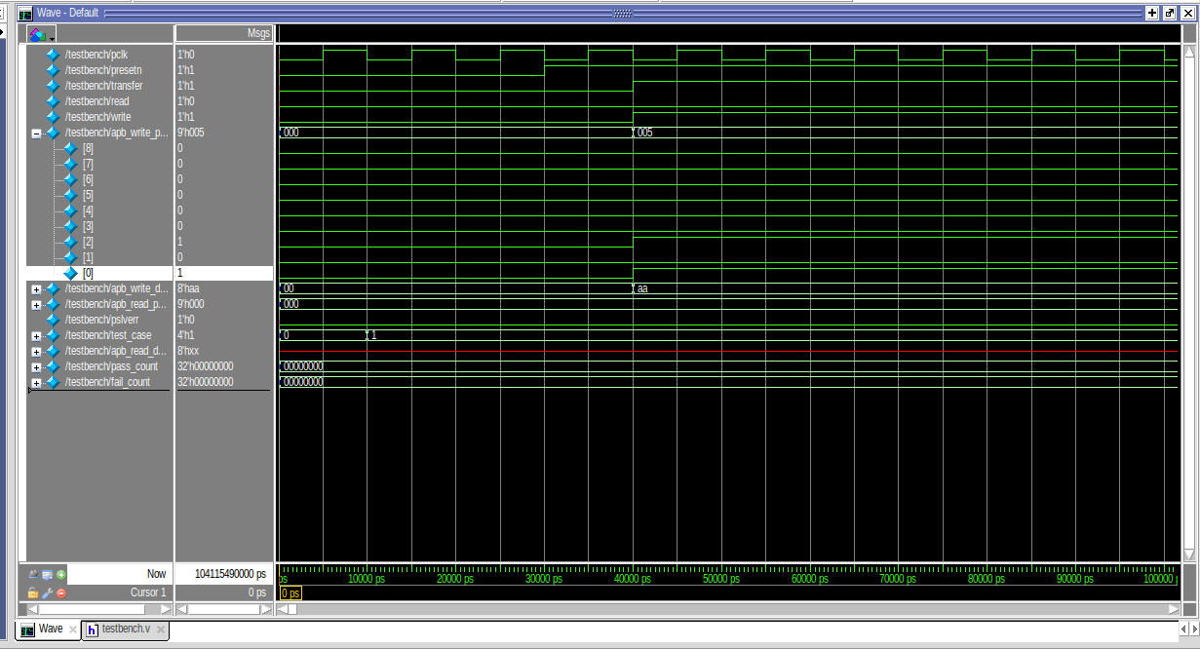

TASK 2:
Master:

module master(
input clk,
input rst,
input start,
input ready,

input [1:0] addr_in,
input rw_in,
input [7:0] data_in,

output reg valid,
output reg [1:0] addr,
output reg rw,
output reg [7:0] datain
);

parameter IDLE = 2'b00,
SEND = 2'b01,
WAIT = 2'b10;

reg [1:0] state,next_state;

always @(posedge clk or posedge rst)
begin
if(rst)
state <= IDLE;
else
state <= next_state;
end

always @(*)
begin
case(state)

IDLE:
if(start)
next_state = SEND;
else
next_state = IDLE;

SEND:
next_state = WAIT;

WAIT:
if(ready)
next_state = IDLE;
else
next_state = WAIT;

default:
next_state = IDLE;

endcase
end

always @(*)
begin

valid = 0;

case(state)

IDLE:
begin
valid = 0;
end

SEND:
begin
valid = 1;
addr = addr_in;
rw = rw_in;
datain = data_in;
end

WAIT:
begin
valid = 1;
addr = addr_in;
rw = rw_in;
datain = data_in;
end

endcase

end

endmodule

Slave:

module slave(

input clk,
input rst,

input valid,
input rw,

input [1:0] addr,
input [7:0] datain,

output reg ready,
output reg [7:0] dataout

);

parameter IDLE = 2'b00,
ACCESS = 2'b01,
DONE = 2'b10;

reg [1:0] state,next_state;

reg [7:0] mem [3:0];

always @(posedge clk or posedge rst)
begin
if(rst)
state <= IDLE;
else
state <= next_state;
end

always @(*)
begin

case(state)

IDLE:
if(valid)
next_state = ACCESS;
else
next_state = IDLE;

ACCESS:
next_state = DONE;

DONE:
if(valid)
next_state = DONE;
else
next_state = IDLE;

default:
next_state = IDLE;

endcase

end

always @(posedge clk)
begin

if(state==ACCESS)
begin

if(rw)
mem[addr] <= datain;
else
dataout <= mem[addr];

end

end

always @(*)
begin

ready = 0;

case(state)

IDLE:
ready = 0;

ACCESS:
ready = 0;

DONE:
ready = 1;

endcase

end

endmodule

Top:

module top(

input clk,
input rst,
input start,

input [1:0] addr,
input rw,
input [7:0] datain,

output [7:0] dataout,
output valid,
output ready

);

wire valid_wire;
wire ready_wire;

wire [1:0] addr_wire;
wire rw_wire;
wire [7:0] data_wire;

master M1(

.clk(clk),
.rst(rst),
.start(start),
.ready(ready_wire),

.addr_in(addr),
.rw_in(rw),
.data_in(datain),

.valid(valid_wire),
.addr(addr_wire),
.rw(rw_wire),
.datain(data_wire)

);

slave S1(

.clk(clk),
.rst(rst),

.valid(valid_wire),
.rw(rw_wire),

.addr(addr_wire),
.datain(data_wire),

.ready(ready_wire),
.dataout(dataout)

);

assign valid = valid_wire;
assign ready = ready_wire;

Endmodule
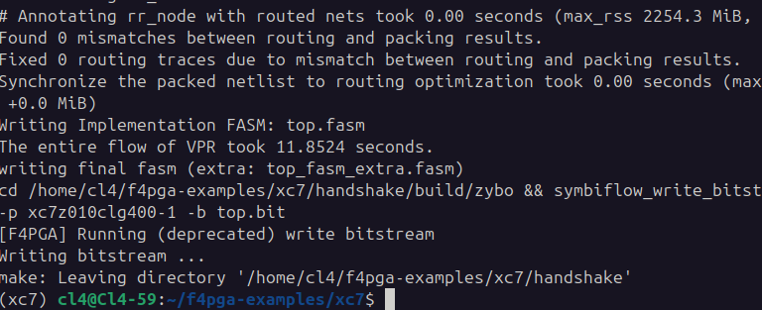
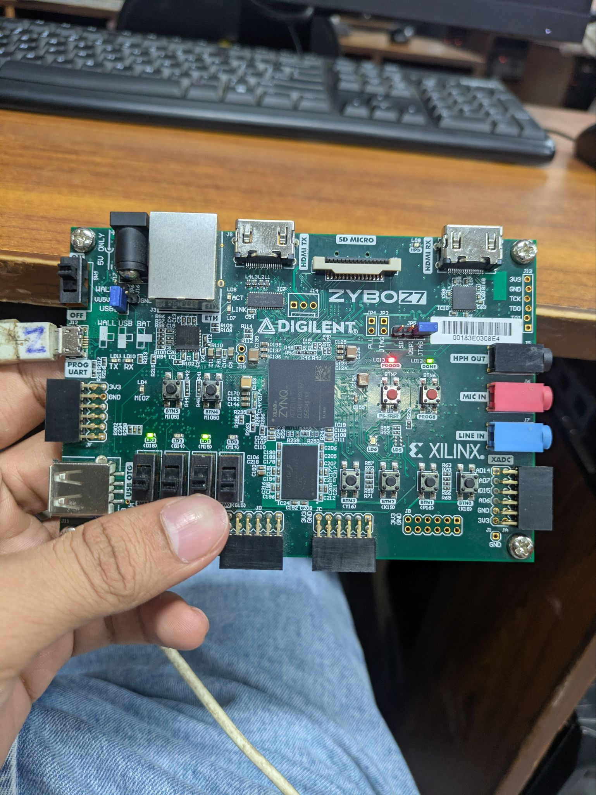

TASK 3: Handshaking protocol

Slave
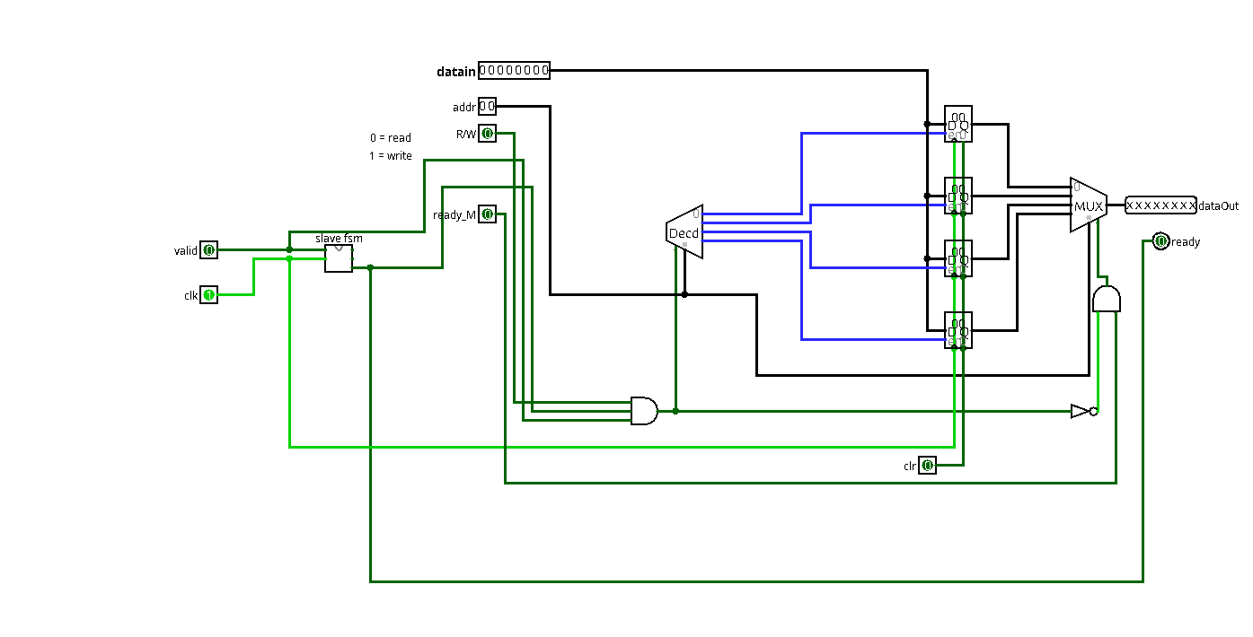
FSM of Slave
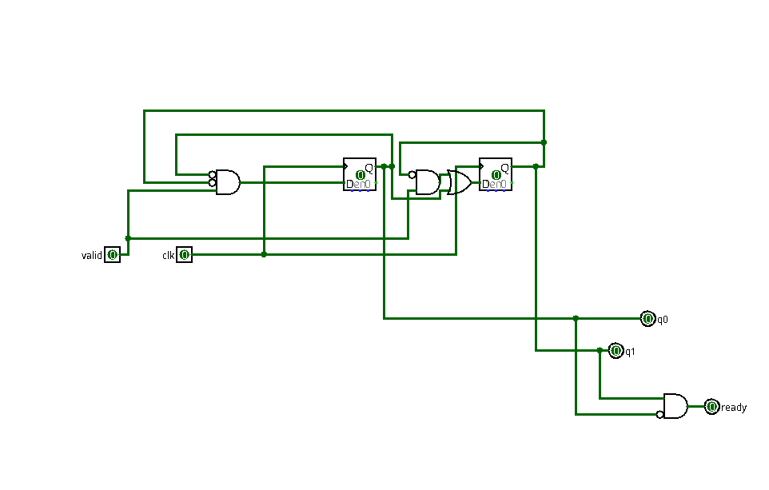

FSM of Master
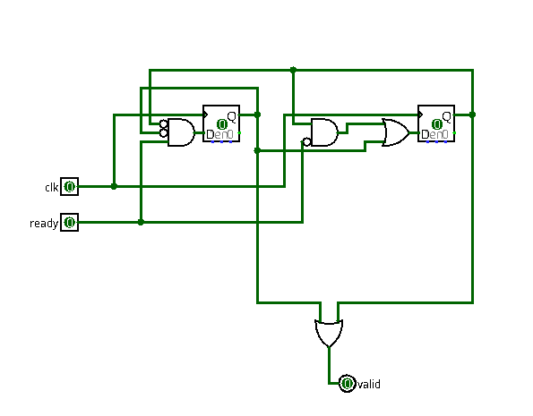
Master Slave handshaking protocol

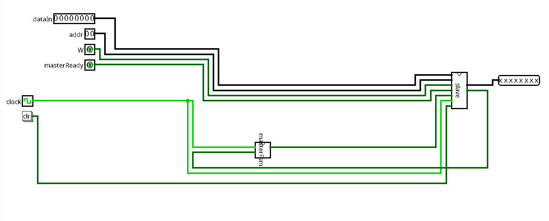

Master FSM

State | Name | valid | What happens?
00 | IDLE | 0 | Wait for a start command. Nothing is sent.
01 | SEND | 1 | Put addr, R/W, and datain on the bus. Start the transaction.
10 | WAIT | 1 | Keep the signals stable and wait until the slave asserts ready.

Slave FSM

State | Name | ready | What happens?
00 | IDLE | 0 | Wait for the master to assert valid.
01 | ACCESS | 0 | Perform the requested read or write operation.
10 | DONE | 1 | Assert ready to indicate the transaction is complete.

