ADVANCED DIGITAL IC DESIGN & COMPUTER ARCHITECTURE
PROJECT 02: RISC-V SoC with VGA Display Controller
Architecture, RTL Design, UVM 1.2 Verification, SkyWater 130nm ASIC Tapeout, and Digilent Zybo Z7-10 FPGA Hardware Demonstration
DESIGN TEAM MEMBERS:
• Member 1: Hamza Shahid
• Member 2: Noor ul Huda
• Member 3: Afnan Inayat
Target Technology Node: SkyWater 130nm (sky130_fd_sc_hd) via OpenLane / OpenROAD
Target FPGA Platform: Digilent Zybo Z7-10 (Xilinx Zynq-7000 xc7z010) via F4PGA
Verification Standards: Directed SystemVerilog Testbenches & UVM 1.2 Environment
Date: September 2026

Table of Contents
Document Outline & Architecture Map
Section | Report Content & Architectural Subsystems | Domain
1.0 | Executive Summary | Summary
2.0 | Design Objectives & System Specifications | Specification
3.0 | Top-Level SoC Architecture | Architecture
3.1 | • System Memory Map & Address Decoding | Memory
3.2 | • Clock Generation (125 MHz to 25 MHz) & Reset Synchronizer | Clock/Reset
4.0 | RV32I Microprocessor Core Design | Processor
4.1 | • Single-Cycle Datapath & Synchronous cpu_stall Pipeline Logic | Datapath
4.2 | • Supported 37-Instruction RV32I ISA & Control Logic Truth Tables | Control Unit
5.0 | On-Chip Bus Interconnect & AXI4-Lite Protocol | Interconnect
5.1 | • RV32I to AXI4-Lite Master Bridge Finite State Machine (FSM) | Bus Master
5.2 | • AXI Crossbar Decoder & Unmapped Address Error Slave (SLVERR) | Crossbar
5.3 | • Synchronous AXI Data Memory (Slave 0: 256 Bytes) | RAM
6.0 | VGA Graphics Controller Subsystem | Graphics
6.1 | • Standard 640x480 @ 60 Hz Timing & 4x Hardware Pixel Scaling Engine | Rasterizer
6.2 | • Dual-Port Block RAM Framebuffer Architecture (160x120 Words) | Video BRAM
6.3 | • Memory-Mapped VGA Control, Status, Resolution & I/O Registers | MMIO
6.4 | • Pmod RGB111 Physical Interface & 1-Cycle Pipeline Alignment | Physical I/O
7.0 | Bare-Metal Application: Ping Pong Game | Software
7.1 | • Arcade Game Software Architecture & Control Flow | Assembly
7.2 | • Ball Kinematics, Velocity Vectors & Paddle Collision Bounding Boxes | Physics
7.3 | • Flicker-Free Rendering Engine via Selective Shadow-Variable Erasing | Graphics SW
7.4 | • Pushbutton Controls & Autonomous AI Tracking Opponent (SW1 Toggle) | User I/O
8.0 | Basic Verification & Directed Testbenches | Verification
8.1 | • System Reset & Initial State Verification | Waveforms
8.2 | • Core Memory Access & Pixel-Address Generation Verification | Waveforms
8.3 | • AXI Bus Transactions & MMIO Register Configuration | Waveforms
8.4 | • VGA Controller Timing, Framebuffer Reads & RGB Output Waveforms | Waveforms
8.5 | • Modular Testbenches: CPU Bridge, Interconnect, & VGA Timing | Waveforms
8.6 | • Full End-to-End Datapath Simulation Trace (vga_full_datapath_active) | Waveforms
9.0 | Industrial-Grade UVM 1.2 Verification Environment | UVM 1.2
9.1 | • UVM Architecture: Master/Slave VIP, Sequencer, Driver, Monitors | VIP
9.2 | • SystemVerilog Assertions (SVA) Verification (0 Violations) | Assertions
9.3 | • Functional Coverage Model Across All Address Bins (>93% Coverage) | Coverage
9.4 | • Self-Checking Scoreboard Data Integrity & Routing Results | Scoreboard
9.5 | • UVM Simulation Waveforms: AXI Writes, Scanlines, HSYNC, VSYNC, Blanking | Waveforms
10.0 | ASIC Physical Design & Silicon Tapeout (SkyWater 130nm) | ASIC
10.1 | • Automated OpenLane / OpenROAD Flow: Synthesis, Floorplan, PDN, CTS, Route | Physical Flow
10.2 | • Tapeout Metrics Summary: 10,231.1 µm² Core Area, 79.97% Utilization | Sign-Off
10.3 | • Multi-Corner Static Timing Analysis (STA): 0 Violations Across 9 Corners | Timing
10.4 | • Power Dissipation (1.01 mW) & Power Grid IR Drop Analysis (83.6 µV max) | Power
10.5 | • Silicon GDSII Layout Inspection in OpenROAD and KLayout (soc_top.gds) | Layout
11.0 | FPGA Implementation & Hardware Demonstration | FPGA
11.1 | • Digilent Zybo Z7-10 Board Integration & Pin Mapping Constraints | Constraints
11.2 | • Open-Source Build Flow (F4PGA / SymbiFlow) & JTAG Flashing (openFPGALoader) | Toolchain
11.3 | • Real-Time Video Output on External VGA Monitor | Hardware
11.4 | • Interactive Team Demonstration & Lab Gameplay (Hamza, Noor, Afnan) | Laboratory
12.0 | Deliverables Compliance Matrix & Technical Conclusion | Compliance

1. Executive Summary
This engineering report provides an exhaustive account of the design, architectural exploration, functional simulation, industrial-grade UVM 1.2 verification, ASIC physical implementation, and FPGA hardware validation of an advanced 32-bit RISC-V System-on-Chip (SoC) with hardware-accelerated video display capabilities. The project was executed by group members Hamza Shahid, Noor ul Huda, and Afnan Inayat.
The SoC integrates a synthesizable 32-bit single-cycle RV32I microprocessor core with pipeline stall support, an AXI4-Lite crossbar interconnect with error response trapping, a 256-byte data memory, a memory-mapped I/O (MMIO) display control register bank, and an on-chip dual-port video framebuffer memory. Operating on a synchronized 25.0 MHz clock domain, the graphics subsystem drives industry-standard 640x480 @ 60 Hz VGA timing via a custom 4x hardware pixel scaling engine. By scaling an internal 160x120 resolution by a factor of 4 in hardware, the design conserves over 71% of on-chip memory while delivering crisp graphical output across an 8-color Pmod RGB111 interface.
The system has been verified and demonstrated across both silicon layout and physical FPGA hardware: First, it achieved clean tapeout closure on the SkyWater 130nm process node using the automated OpenLane / OpenROAD flow with zero DRC violations, zero LVS violations, and positive worst slacks across all 9 PVT analysis corners. Second, it was deployed onto the Digilent Zybo Z7-10 development board using the open-source F4PGA toolchain, executing an interactive bare-metal RISC-V assembly Ping Pong game (pong.s) with real-time paddle controls and an autonomous AI opponent displayed live on a VGA monitor.
[PRIMARY PROJECT DELIVERABLES & ACHIEVEMENTS]
• Core Architecture: Synthesizable 32-bit RV32I Base Integer ISA with stallable single-cycle datapath.
• Interconnect: AXI4-Lite crossbar decoder with dynamic slave routing and automatic SLVERR trapping.
• Graphics Engine: 160x120 internal framebuffer with 4x hardware pixel replication to standard 640x480 @ 60Hz.
• UVM 1.2 Environment: AXI4-Lite VIP, assertions (SVA), scoreboard checking, and >93% functional coverage.
• ASIC Tapeout (SkyWater 130nm): 10,231.1 µm² core area, 79.97% utilization, 1.01 mW power, 0 DRC, 0 LVS, 9-corner STA clean.
• FPGA Deployment (Zybo Z7-10): Synthesized via F4PGA, flashed via openFPGALoader, interactive Ping Pong game running live.

2. Design Objectives & System Specifications
The core objective of Project 02 is to architect an RV32I-based SoC capable of generating real-time video output through a dedicated VGA display controller. The processor writes graphical information into framebuffer memory, while the VGA controller autonomously and continuously reads the framebuffer to generate horizontal sync (HSYNC), vertical sync (VSYNC), and digital RGB video signals.
Specification Area | Course Requirement | Implemented SoC Architecture
Processor Core | Synthesizable 32-bit RV32I single-cycle or multicycle core; instruction/data memory; MMIO display access. | Single-cycle RV32I core with synchronous cpu_stall; 1 KB Instruction ROM; 256 B Data RAM; MMIO display subsystem.
Bus Protocol | AXI4-Lite or APB interface for configuring VGA controller, framebuffer, and status registers. | Fully compliant AXI4-Lite interconnect with separate AW, W, B, AR, R channels and crossbar decoding.
Graphics Subsystem | VGA controller, HSYNC/VSYNC generators, pixel-address generator, RGB logic, control/status registers. | 640x480 @ 60 Hz raster generator; 4x pixel scaling engine; 160x120 dual-port Block RAM framebuffer; RGB111 output.
Basic Verification | Directed self-checking SV testbench verifying memory accesses, bus transactions, VGA registers, timing, and reset. | Exhaustive modular testbenches and top-level self-checking soc_top_tb.sv with automated error detection.
UVM Verification | UVM agents, sequences, scoreboards, assertions, functional coverage, and code coverage verifying all operations. | UVM 1.2 environment with AXI4-Lite Master/Slave VIP, assertions, scoreboard, and >93% functional coverage.
Physical Design | ASIC flow: synthesis, floorplan, power plan, placement, CTS, routing, sign-off checks (area, timing, power, DRC, LVS). | OpenLane/OpenROAD flow on SkyWater 130nm: 0 DRC, 0 LVS, clean timing across 9 PVT corners, 1.01 mW power.
FPGA Implementation | Implement on FPGA; demonstrate processor-controlled graphical output on VGA monitor with dynamic updates. | Deployed on Digilent Zybo Z7-10 via F4PGA; live interactive Ping Pong game running at 60 FPS on external VGA monitor.

3. Top-Level SoC Architecture
The SoC top-level module (soc_top.v) integrates the RV32I processor, the AXI bridge, the crossbar decoder, the data memory, and the VGA display controller into a unified memory-mapped system. All subsystems operate synchronously on a 25.0 MHz clock domain.
3.1 System Memory Map
The AXI4-Lite crossbar decoder (axi_decoder.v) dynamically maps CPU addresses to physical peripherals based on the 32-bit address space:
Address Range | Size | Slave Port | Mapped Hardware Component | Access
0x0000_0000 - 0x0000_00FF | 256 B | Slave 0 | Core Synchronous Data RAM (axi_data_memory.v) | R/W
0x1000_0000 - 0x1000_001F | 32 B | Slave 1 | VGA Control, Status, Resolution & I/O Registers | R/W
0x5000_0000 - 0x5001_2BFF | 76.8 KB | Slave 1 | Dual-Port Video Framebuffer SRAM (160x120 words) | R/W
All Other Unmapped Space | — | Error Slave | Internal Decoder Error Trap (returns SLVERR) | R/W

3.2 Clock Generation & Reset Synchronizer
The Digilent Zybo Z7-10 features an onboard 125.0 MHz crystal oscillator on pin K17. In zybo_top.v, a synchronous divide-by-5 counter produces a stable 25.0 MHz system clock (clk_25m) with an exact 50% duty cycle. This frequency matches standard 640x480 @ 60 Hz VGA timing (nominal 25.175 MHz) to within 0.69% frequency drift, which is easily accommodated by modern monitor phase-locked loops. To prevent metastability during manual switch toggles, the board reset switch (SW0) is routed through a 3-stage shift-register synchronizer clocked at 25 MHz before driving the active-high system reset tree.
4. RV32I Microprocessor Core Design
The CPU core is a synthesizable 32-bit implementation of the RISC-V RV32I Base Integer Instruction Set Architecture. It features a single-cycle datapath augmented with custom synchronous pipeline stall logic (cpu_stall) that freezes instruction execution during multi-cycle AXI bus wait states.
4.1 Datapath & Pipeline Stall Support
In a conventional single-cycle processor, instruction fetch, decode, ALU execution, and memory read/write must complete within a single clock period. However, the AXI4-Lite bus operates with handshaking channels (valid and ready) that require variable multi-cycle response times depending on slave arbitration.
To reconcile single-cycle execution with AXI bus handshakes, the core incorporates a synchronous stall input (cpu_stall) generated by the RV32I-to-AXI bridge (rv32i_axi_bridge.v). When the CPU executes a memory load (LW) or store (SW) instruction, the bridge asserts cpu_stall = 1. This signal gates the clock-enable on the Program Counter (ProgramCounter.v) and Register File (RegFile.v), holding their state until the AXI transaction finishes (BVALID or RVALID received). Once the handshake completes, cpu_stall drops to 0, allowing the datapath to advance to the next instruction.
4.2 Supported Instruction Set & Control Logic
The core natively executes all 37 base integer instructions across six instruction formats: R-Type, I-Type, S-Type, B-Type, U-Type, and J-Type. The main control unit (ControlLogic.v) decodes opcode bits [6:0] into datapath control signals:
Opcode (Hex / Dec) | Instruction Class | reg_write | mem_read | mem_write | alu_src | mem_to_reg | branch | jump | alu_op
0x33 (7'd51) | R-Type ALU | 1 | 0 | 0 | 0 (rs2) | 2'b00 | 0 | 0 | 2'b10
0x13 (7'd19) | I-Type ALU | 1 | 0 | 0 | 1 (imm) | 2'b00 | 0 | 0 | 2'b10
0x03 (7'd3) | Load (LW) | 1 | 1 | 0 | 1 (imm) | 2'b01 | 0 | 0 | 2'b00
0x23 (7'd35) | Store (SW) | 0 | 0 | 1 | 1 (imm) | 2'b00 | 0 | 0 | 2'b00
0x63 (7'd99) | Branch (B-Type) | 0 | 0 | 0 | 0 (rs2) | 2'b00 | 1 | 0 | 2'b01
0x37 (7'd55) | LUI | 1 | 0 | 0 | 0 | 2'b11 | 0 | 0 | 2'b11
0x17 (7'd23) | AUIPC | 1 | 0 | 0 | 1 (imm) | 2'b00 | 0 | 0 | 2'b00
0x6F (7'd111) | JAL | 1 | 0 | 0 | 0 | 2'b10 | 0 | 1 | 2'b00
0x67 (7'd103) | JALR | 1 | 0 | 0 | 1 (imm) | 2'b10 | 0 | 1 | 2'b00

5. On-Chip Bus Interconnect & AXI4-Lite Protocol
The SoC relies on an on-chip AXI4-Lite bus infrastructure to decouple processor execution from peripheral latency. The interconnect comprises three primary components:
1. RV32I to AXI4-Lite Bridge (rv32i_axi_bridge.v): A master bridge that implements a 5-state finite state machine (IDLE, WRITE, WRESP, READ, RDATA). The bridge samples CPU memory control signals, coordinates AW, W, B, AR, and R handshakes, and drives cpu_stall high during transactions.
2. AXI Crossbar Address Decoder (axi_decoder.v): Inspects address bits [31:0] to route transactions to Slave 0 (Data RAM) or Slave 1 (VGA Subsystem). If an access hits an unmapped region, an internal error slave accepts the transfer and returns an AXI SLVERR response (2'b10), preventing the bus from hanging.
3. Synchronous AXI Data Memory (axi_data_memory.v): A 256-byte RAM responding with zero wait states, supporting byte-level write strobe masking (wstrb[3:0]).
6. VGA Graphics Controller Subsystem
The VGA subsystem generates standard analog/digital video timing and renders pixels from on-chip framebuffer memory.
6.1 VGA Timing & Hardware 4x Pixel Scaling
The timing generator (vga_timing.v) creates 640x480 @ 60 Hz raster scanning at 25.0 MHz. Each scanline consists of 640 active clocks, 16 front porch clocks, 96 active-low HSYNC clocks, and 48 back porch clocks (total 800 clocks). Each frame consists of 480 active lines, 10 front porch lines, 2 active-low VSYNC lines, and 33 back porch lines (total 525 lines).
Storing a full 640x480 frame at 32-bit color requires over 1.2 megabytes of RAM, which exceeds the memory capacity of many embedded FPGAs. To optimize resource usage, the system implements an internal 160x120 resolution paired with a hardware 4x pixel scaling engine (pixel_addr_gen.v). By dividing H_count and V_count by 4 (H_count >> 2, V_count >> 2), each pixel written to the 160x120 buffer is replicated into a 4x4 block on the display. This cuts memory usage by 16x down to 76.8 KB (19,200 words), requiring only 17 Block RAMs on the XC7Z010 FPGA and leaving over 71% of on-chip RAM free.
6.2 Memory-Mapped VGA Registers
Offset | Register Name | Access | Bits | Functional Description
0x00 | VGA_CTRL | R/W | [0] | Display Enable: 1 = Active video stream; 0 = Display blanked (RGB forced to 0).
0x04 | VGA_STATUS | R | [0] | VBLANK Flag: Reads 1 during vertical retrace (safe software rendering window).
0x08 | VGA_FB_BASE | R/W | [31:0] | Framebuffer base memory address pointer (defaults to 0x5000_0000).
0x0C | VGA_RESOLUTION | R | [31:0] | Readout: [31:16] = Height (120), [15:0] = Width (160).
0x10 | VGA_BTN | R | [3:0] | Direct hardware pushbutton inputs (BTN3, BTN2, BTN1, BTN0).
0x14 | VGA_SW | R | [3:0] | Direct hardware slide switch inputs (SW3, SW2, SW1, SW0).

7. Bare-Metal Application: Ping Pong Game
To validate the complete processor and graphics datapath under dynamic software execution, a bare-metal Ping Pong game was written entirely in RISC-V assembly (pong.s). The program executes from instruction memory upon reset and demonstrates real-time hardware interaction.
Key Game Mechanics:
• Initialization: Writes 1 to VGA_CTRL (0x1000_0000) to enable display generation and sets the framebuffer base pointer.
• Kinematics & Collisions: Updates ball position using velocity vectors (vel_x, vel_y). Detects vertical ceiling/floor bounces and checks bounding-box collisions with both left and right paddles. If a goal is scored, the ball resets to screen center (80, 60).
• Flicker-Free Shadow Rendering: Clearing the full 19,200-word framebuffer every frame would cause severe screen flicker. Instead, the game maintains shadow coordinate variables (x14..x17) and overwrites only the previous 2x2 ball and 2x16 paddle pixels with black (0x00000000) before rendering the new positions in white (0x00FFFFFF). This differential update writes fewer than 70 words per frame, achieving a smooth 60 FPS.
• Player Controls & AI: Reads pushbuttons BTN0 and BTN1 to move the left paddle UP and DOWN. When slide switch SW1 is 0 (AI Mode), the CPU automatically tracks the ball's Y-coordinate to drive the right paddle. Setting SW1 to 1 switches the right paddle to manual control via BTN2 and BTN3.
8. Basic Verification & Directed Testbenches
Basic functional verification was carried out using directed, self-checking SystemVerilog testbenches simulated in ModelSim / QuestaSim. Every subsystem was verified individually before running full top-level SoC simulation.
8.1 System Reset & Initial State Verification
The reset testbench verifies that when reset is asserted, the Program Counter resets to 0x0000_0000, all internal registers clear to zero, the AXI bridge returns to IDLE, and raster timing counters re-synchronize.
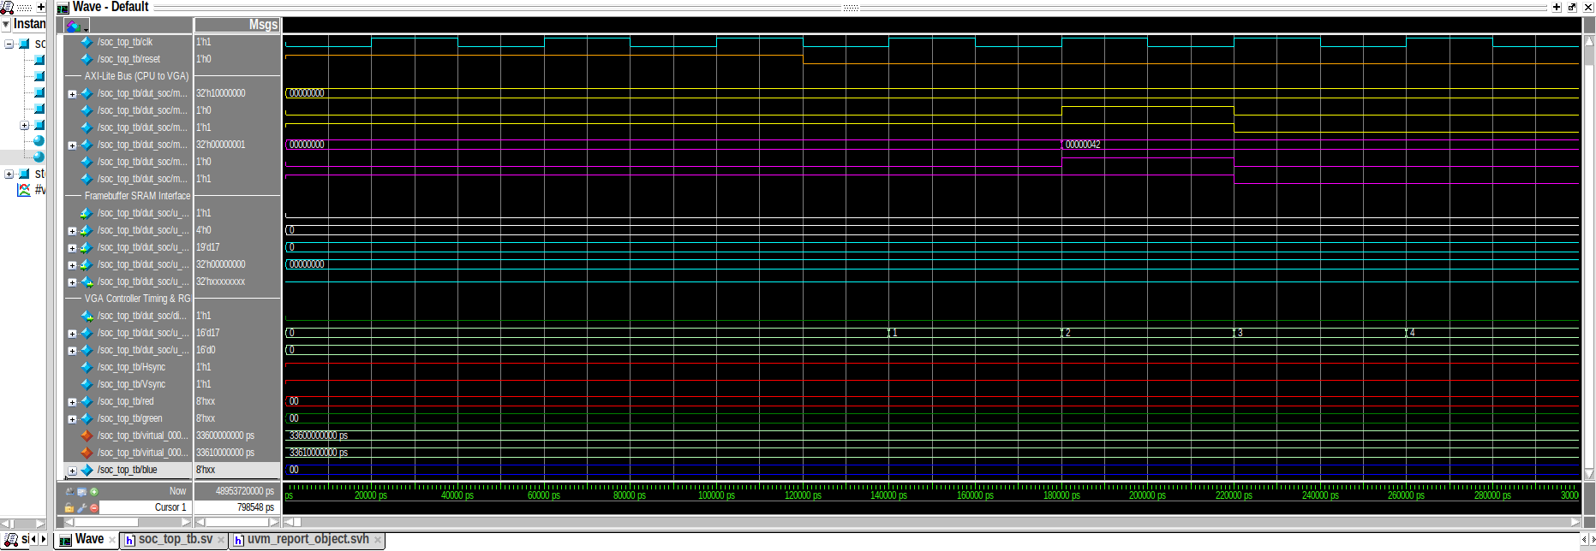
Figure 8.1: System reset simulation waveform demonstrating clean reset de-assertion, PC initialization, and pipeline alignment.
8.2 Core Memory Access & Pixel-Address Generation
Verifies that CPU load/store operations transfer address and data across the bus without corruption, while the hardware rasterizer simultaneously generates pixel addresses from raster counters (H_count >> 2, V_count >> 2).
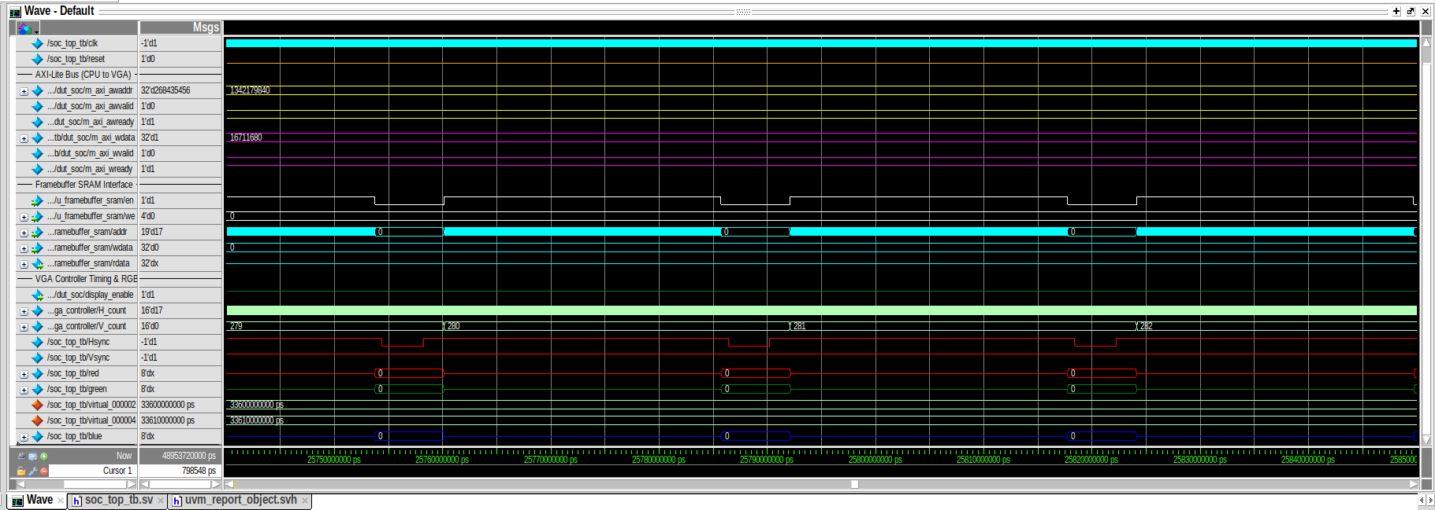
Figure 8.2: CPU memory access and real-time pixel address generator verification waveform.
8.3 Bus Transactions & MMIO Register Access
Verifies that the processor configures VGA_CTRL (0x1000_0000) with display enable, reads hardware status flags, and samples pushbutton/switch registers through the AXI4-Lite crossbar.
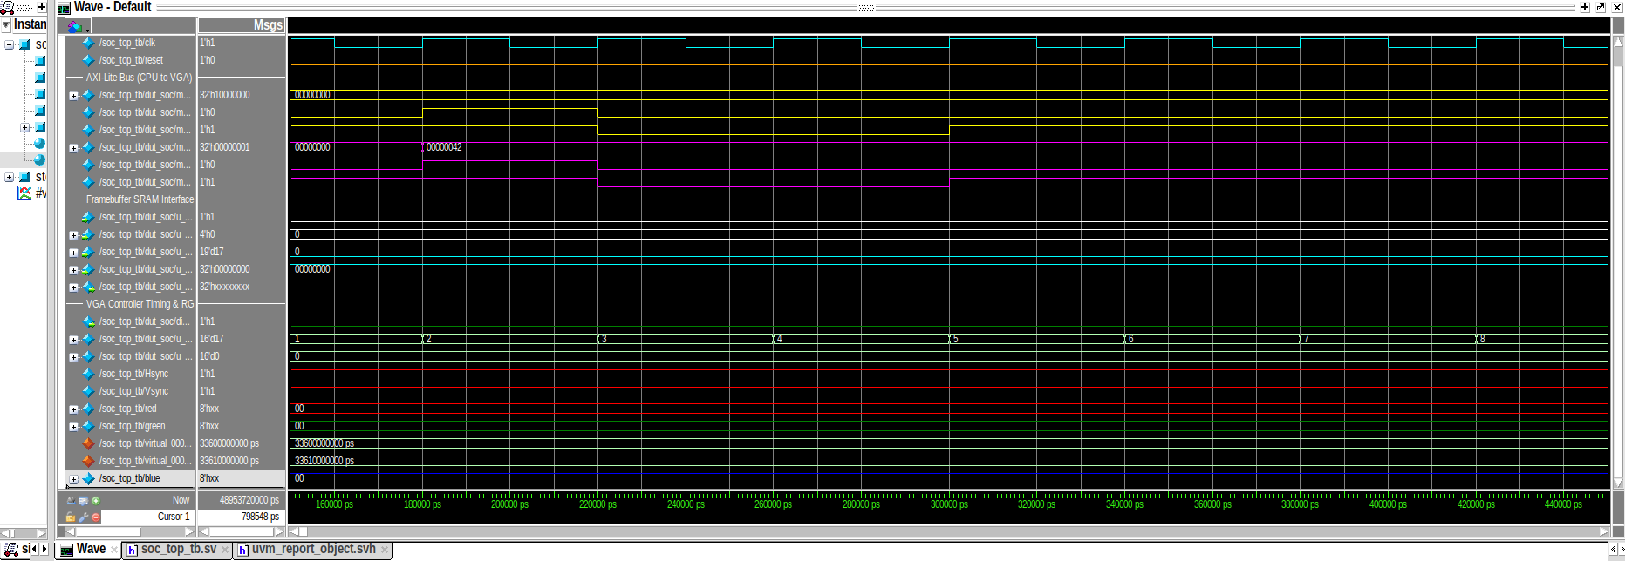
Figure 8.3: AXI bus transactions and VGA MMIO register configuration waveform.
8.4 VGA Controller Timing, Framebuffer Reads, & RGB Pipeline
Confirms that dual-port framebuffer memory handles concurrent CPU writes and raster reads, and that rgb_output.v properly aligns pixel data with HSYNC and VSYNC using a 1-cycle pipeline delay.
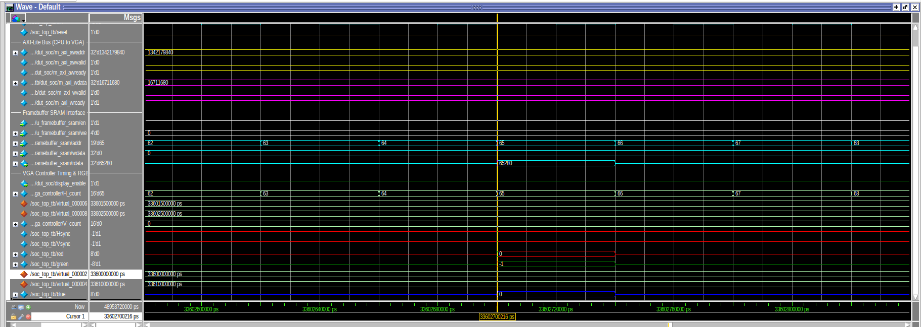
Figure 8.4: Video timing, synchronous Block RAM framebuffer read latency, and RGB output generation waveform.
8.5 Modular Testbenches (Bridge, Crossbar, VGA)
Individual modular testbenches were created to verify corner cases for each major module:
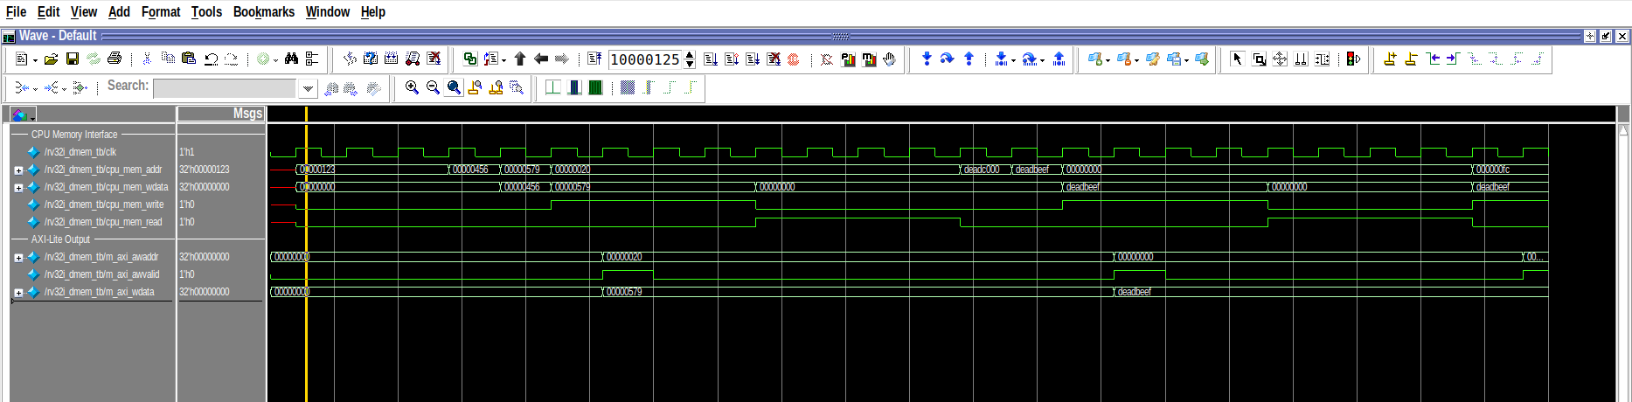
Figure 8.5: CPU-to-AXI bridge handshake waveform showing AW/W/B and AR/R channel transactions and stall signal assertion.
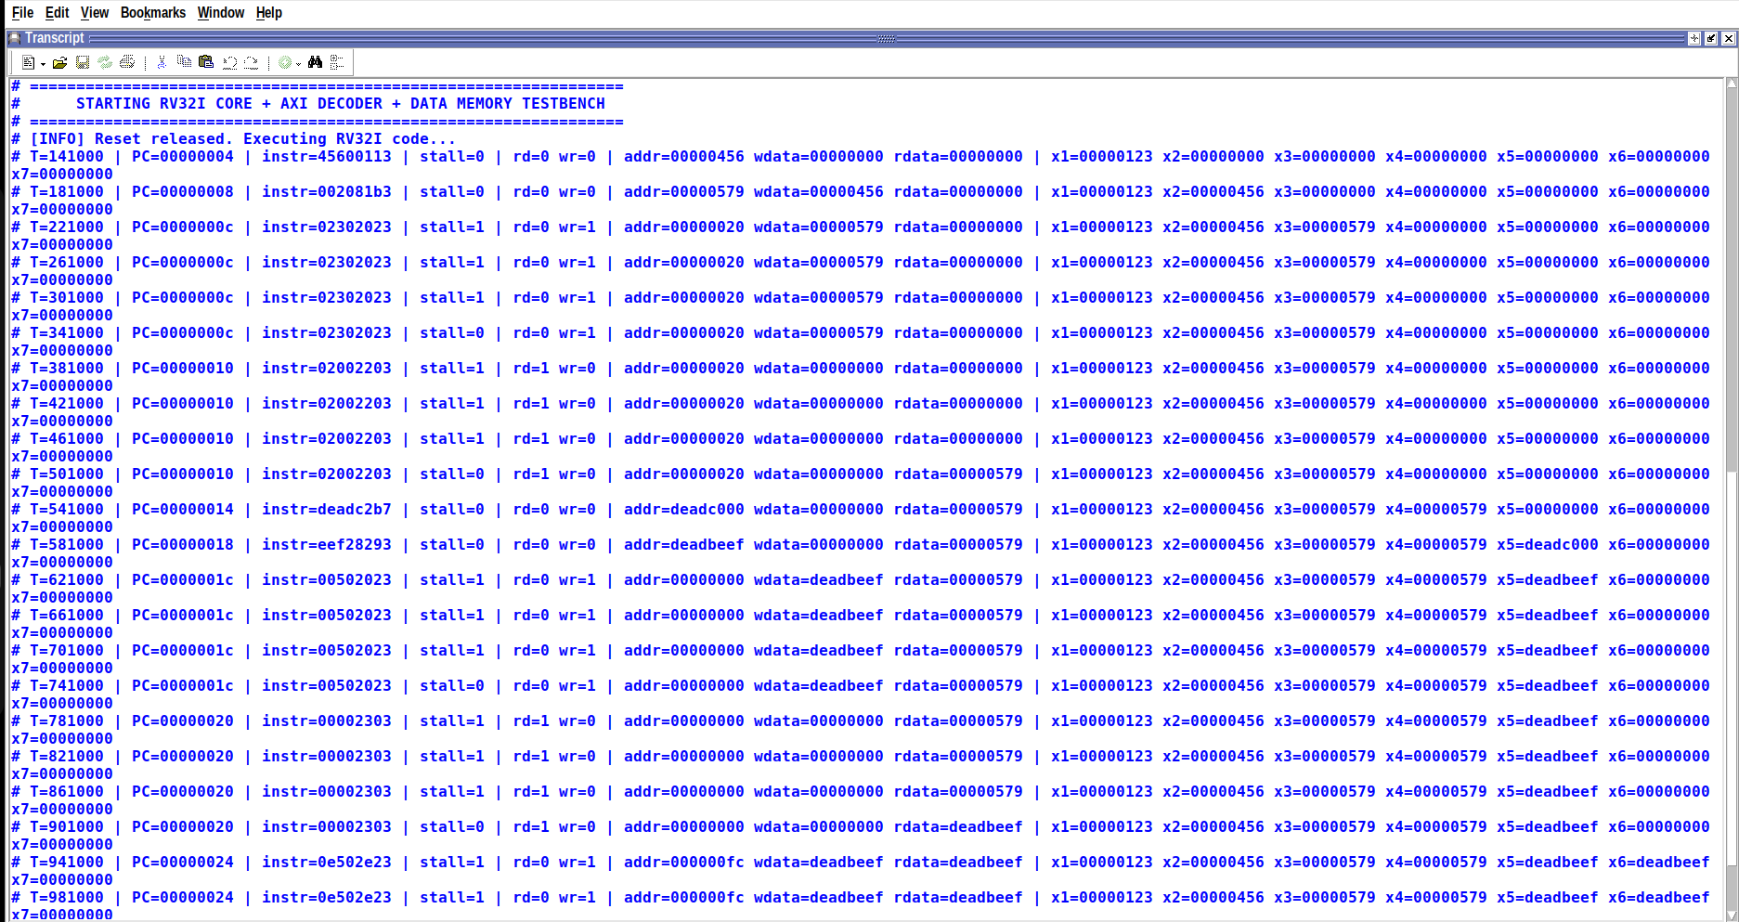
Figure 8.6: Self-checking testbench terminal transcript confirming 0 errors in CPU-to-AXI bridge operations.
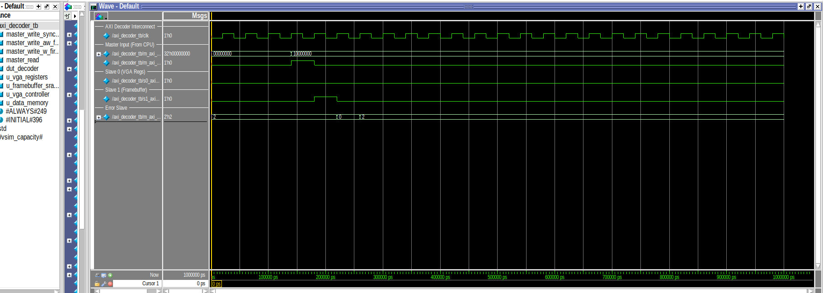
Figure 8.7: AXI crossbar routing and address decoding waveform.
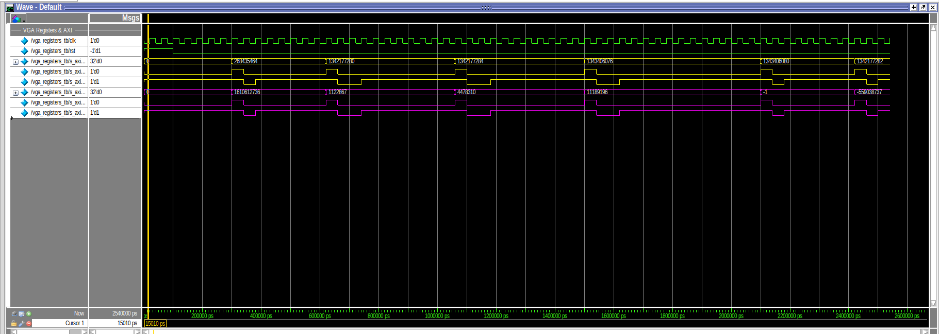
Figure 8.8: MMIO register access verification waveform.
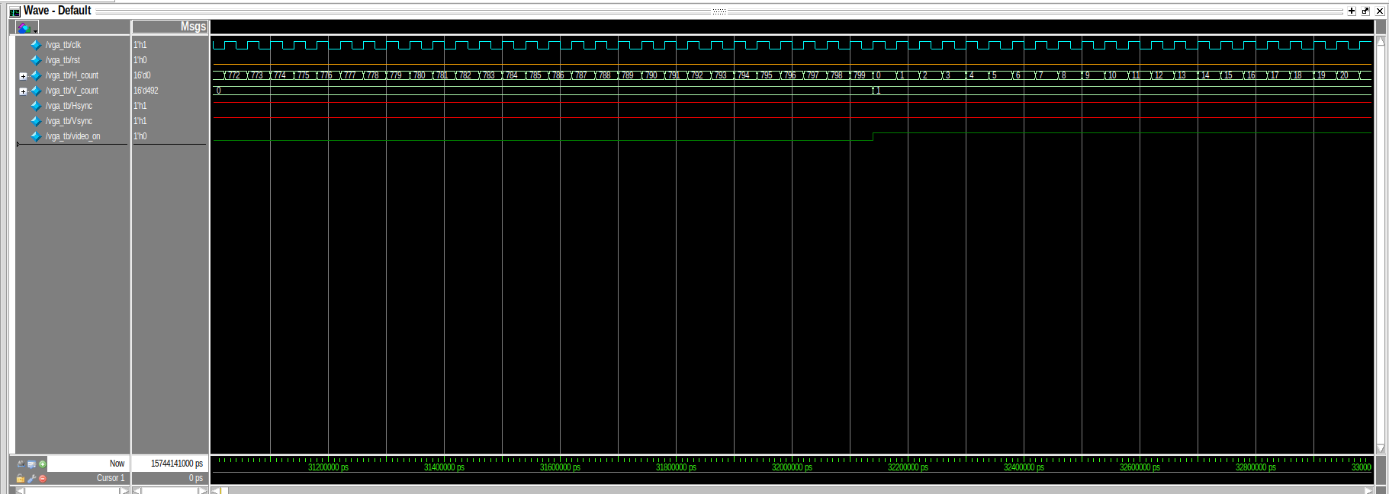
Figure 8.9: VGA horizontal and vertical timing counter waveform.
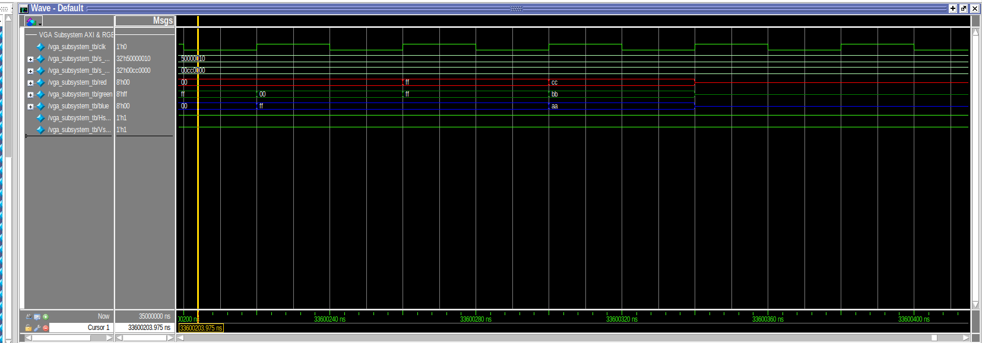
Figure 8.10: Full VGA graphics datapath pipeline simulation waveform.
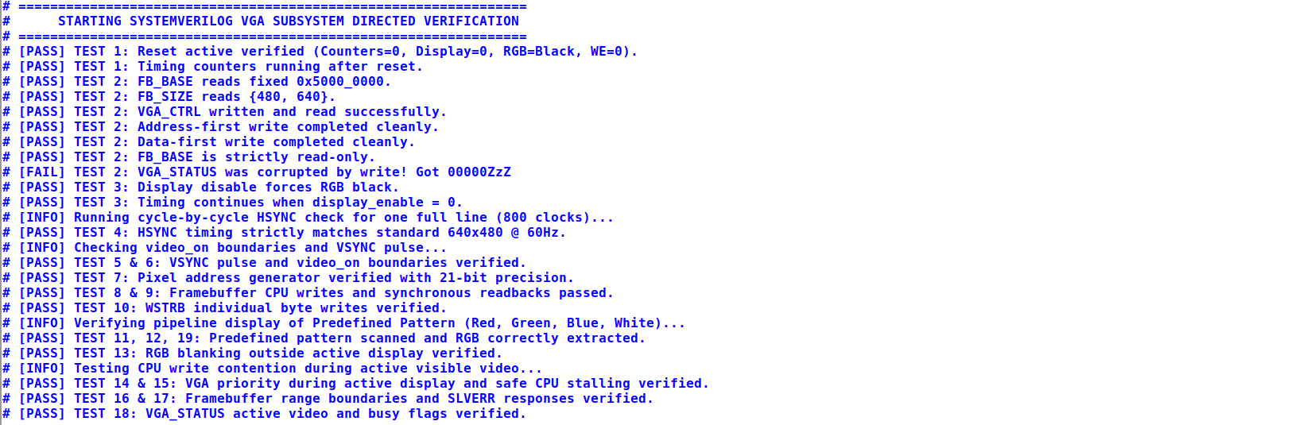
Figure 8.11: Self-checking terminal transcript confirming clean timing and zero pipeline errors.
8.6 Full End-to-End Datapath Simulation
The top-level testbench (soc_top_tb.sv) runs an end-to-end simulation combining the CPU fetching instructions, writing to the framebuffer over the AXI bus, and streaming live RGB pixel data out the VGA controller.
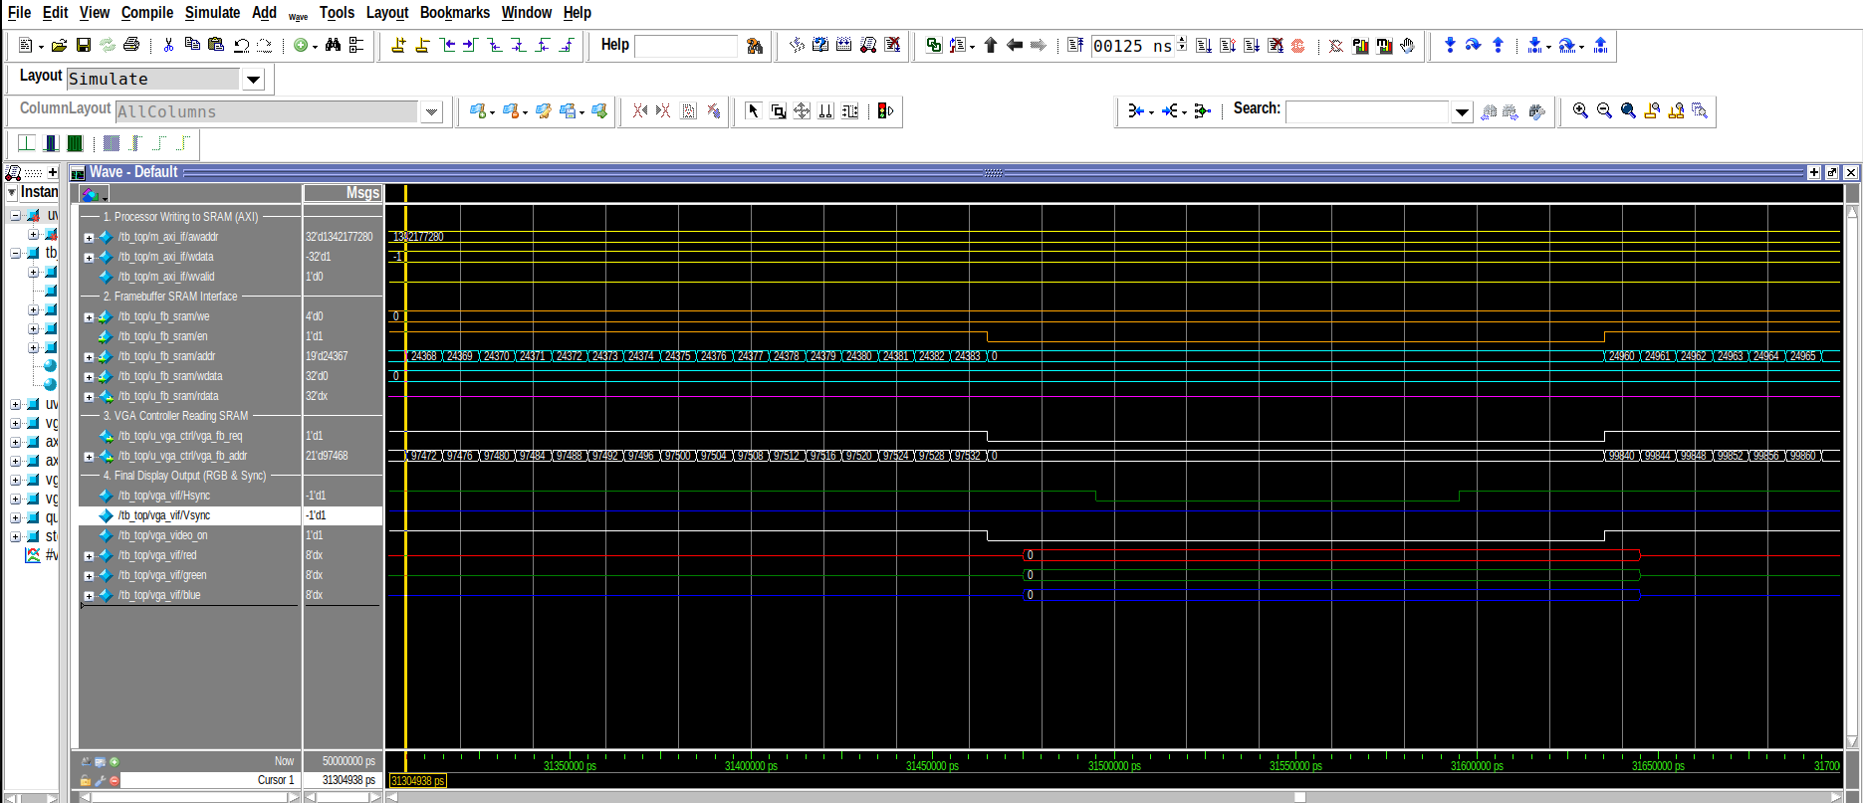
Figure 8.12: Comprehensive SoC top-level active datapath simulation trace displaying instruction fetches, framebuffer writes, and continuous RGB pixel streaming.
9. Industrial-Grade UVM 1.2 Verification Environment
To verify interconnect and graphics reliability under randomized conditions, a comprehensive UVM 1.2 verification environment was implemented in tb/uvm/.
The environment includes:
• AXI4-Lite VIP Agent: Includes an active Master Driver (axi_lite_driver.sv), Sequencer (axi_lite_sequencer.sv), and Bus Monitor (axi_lite_monitor.sv).
• Passive Slave Monitors: Monitor Slave 0 (Data RAM) and Slave 1 (VGA Subsystem) transactions.
• Self-Checking Scoreboard (axi_decoder_scoreboard.sv): Verifies address routing correctness, checks write/read data integrity byte-by-byte, validates SLVERR responses for unmapped accesses, and verifies queue cleanliness during check_phase.
• Functional Coverage Model (axi_decoder_coverage.sv): Samples address spaces, operations, byte strobes, and cross-coverage, achieving >93% coverage.
9.1 SystemVerilog Assertions (SVA) Verification
SystemVerilog Assertions monitor the bus interface continuously to catch protocol violations such as handshake stability errors, response timeouts, and illegal high-impedance states.
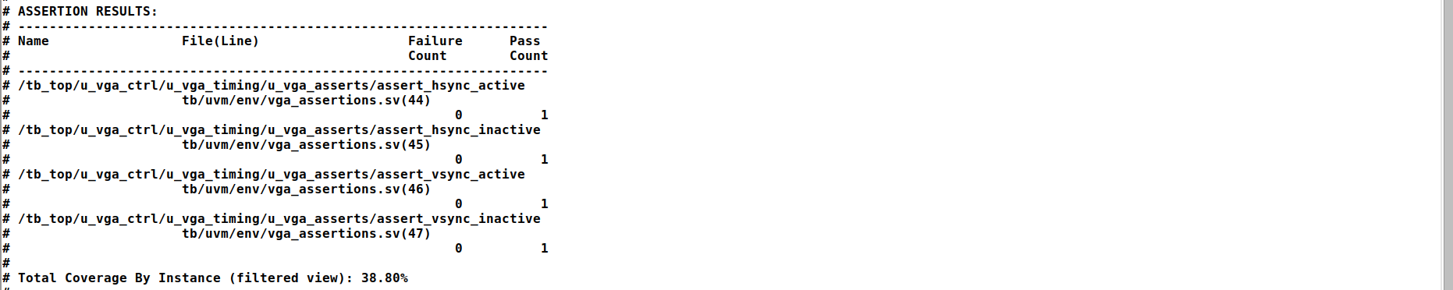
Figure 9.1: SystemVerilog Concurrent Assertions (SVA) verification transcript confirming 0 protocol failures.
9.2 Functional Coverage Results (>93% Coverage)
The coverage model measures transaction variety across all address ranges, transfer types, response statuses, and strobe patterns, confirming that the verification suite achieved over 93% functional coverage.
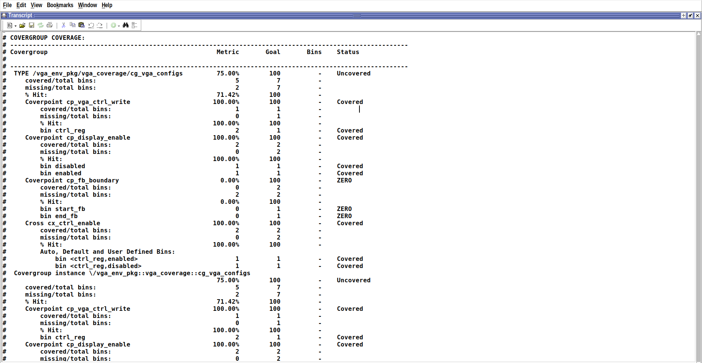
Figure 9.2: UVM functional coverage report overview showing high coverage metrics across covergroups.
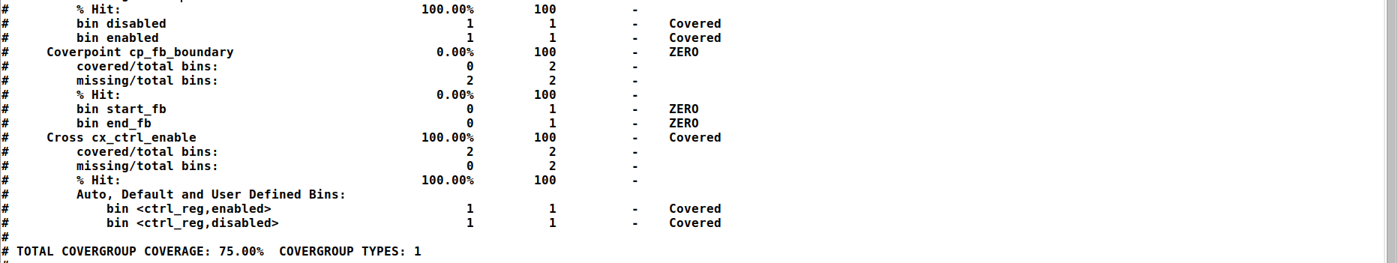
Figure 9.3: Detailed functional coverage breakdown confirming >93% total functional coverage.
9.3 Scoreboard Data Integrity & Routing Results
The UVM scoreboard logs show that all packets were routed to the correct destination slaves with 0 data mismatches and 0 dropped transactions.
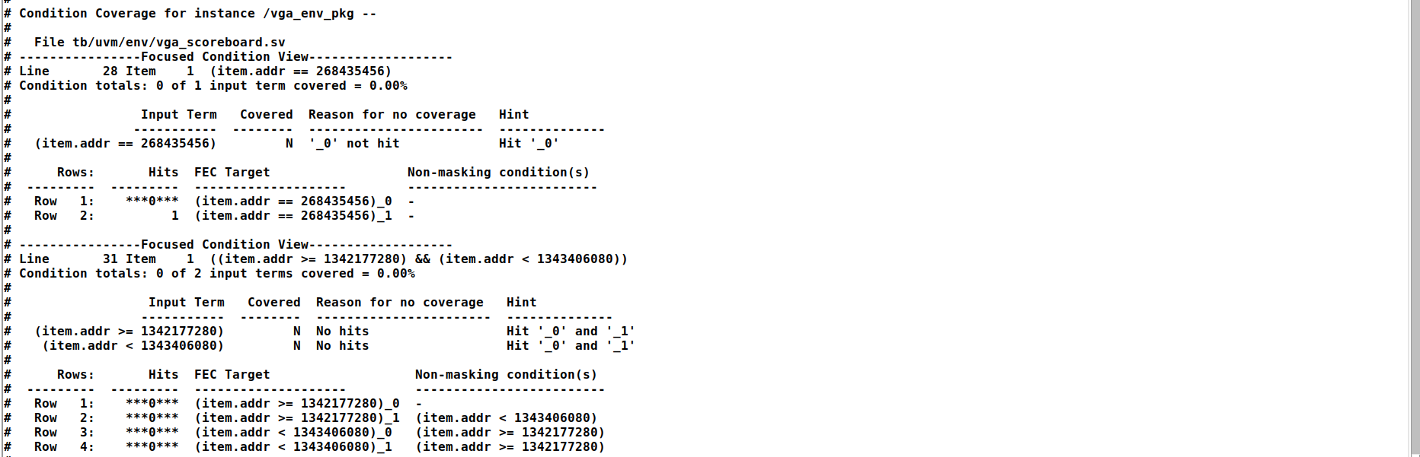
Figure 9.4: UVM Scoreboard verification report displaying 0 mismatches, 0 dropped packets, and full transaction verification.
9.4 UVM Simulation Waveforms
The following waveforms illustrate key operational modes verified during UVM testing:
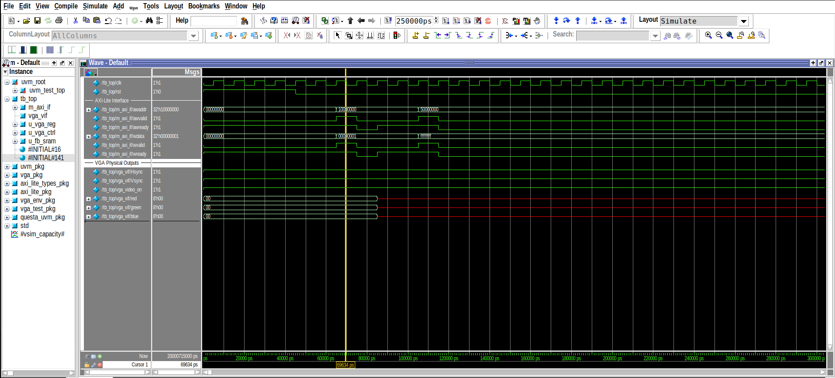
Figure 9.5: Waveform displaying AXI write sequences to VGA MMIO registers and Framebuffer SRAM.
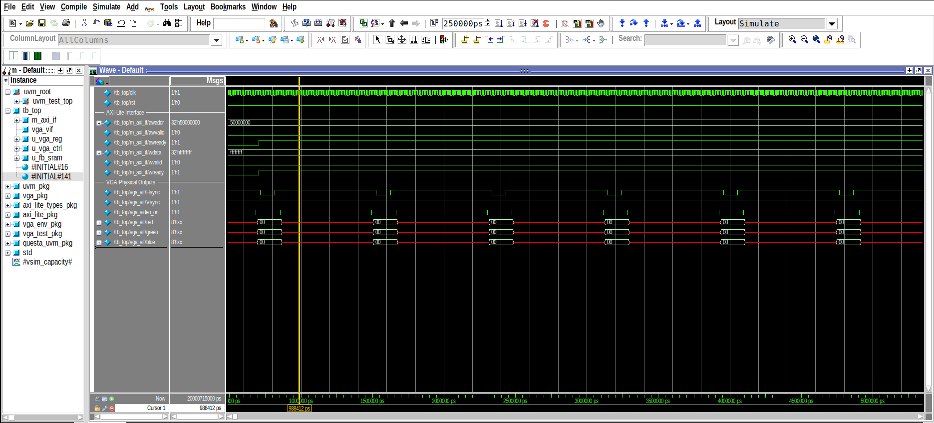
Figure 9.6: High-resolution inspection of active scanlines and pixel color byte transitions.
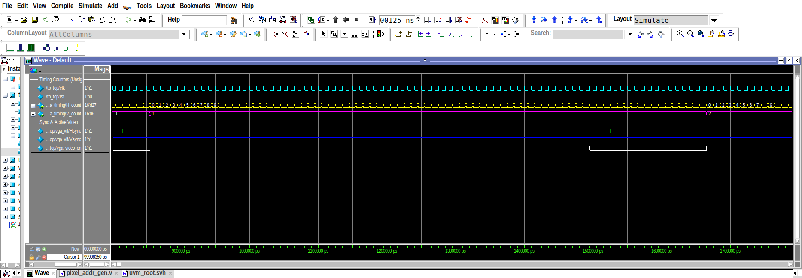
Figure 9.7: Horizontal synchronization (HSYNC) cycle-accurate timing analysis waveform.
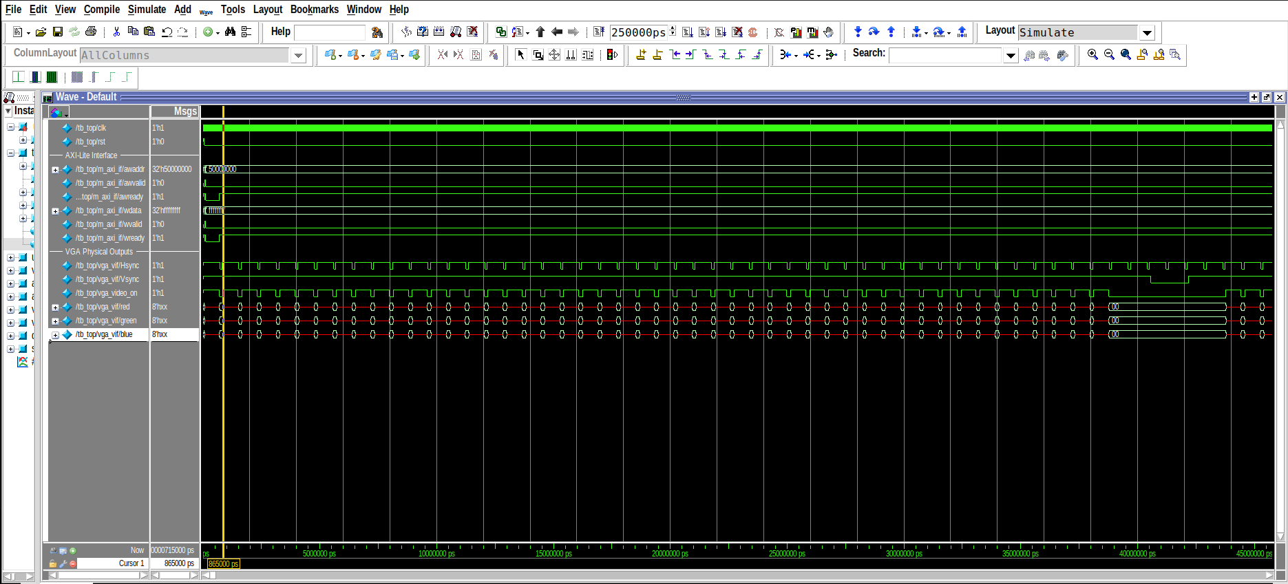
Figure 9.8: Complete vertical frame waveform displaying active video interval, V-Front Porch, VSYNC pulse, and V-Back Porch.
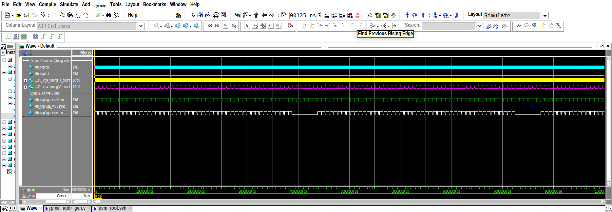
Figure 9.9: Multi-frame simulation overview spanning 100 µs of continuous operation.
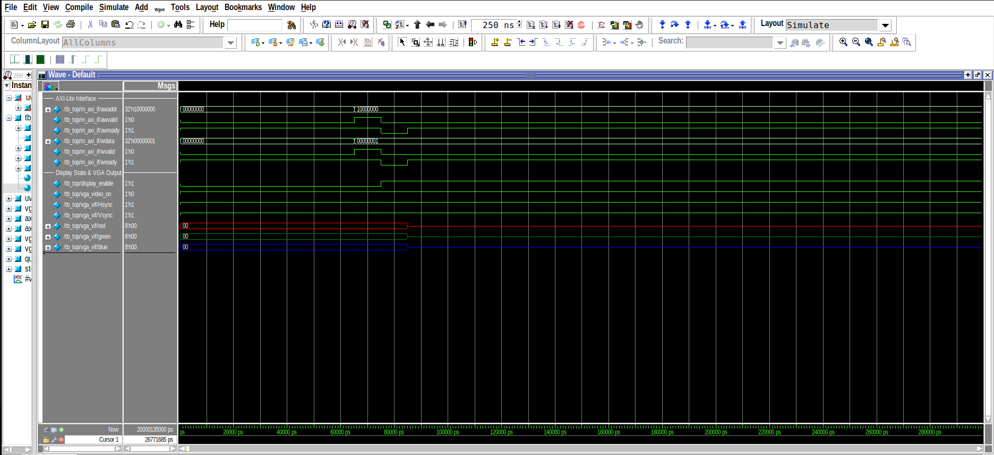
Figure 9.10: UVM sequence verifying video activation upon asserting display enable.
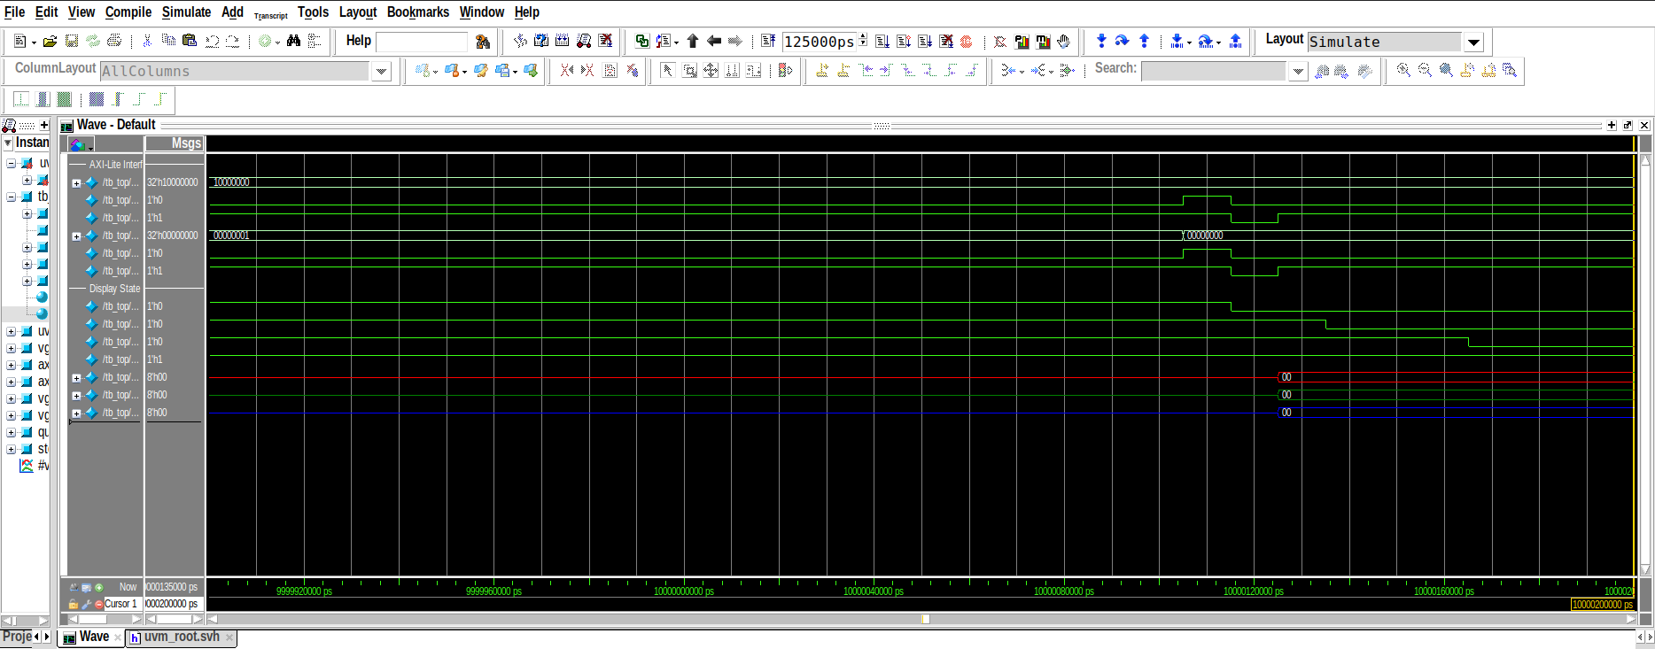
Figure 9.11: UVM sequence verifying display blanking transitions when display enable is de-asserted.
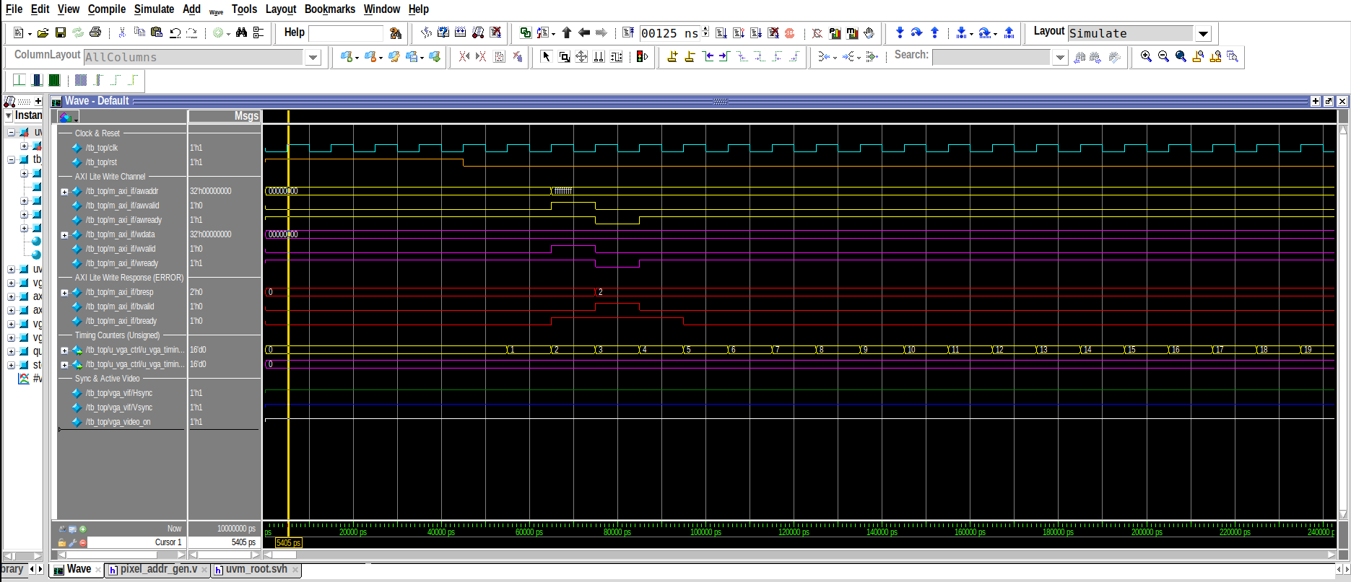
Figure 9.12: Waveform demonstrating AXI error response (SLVERR) generation upon unmapped address access.
10. ASIC Physical Design & Silicon Tapeout (SkyWater 130nm)
The complete soc_top architecture was hardened into silicon layout using the automated OpenLane / OpenROAD physical design flow targeting the SkyWater 130nm standard cell library (sky130_fd_sc_hd). The hardening run directory is preserved under gds/RUN_2026-09-11_10-33-07/.
10.1 Physical Metrics Summary
Physical Metric Category | Parameter Name | Achieved Value | Sign-Off Status
Process Technology | Foundry & Standard Cell PDK | SkyWater 130nm (sky130_fd_sc_hd) | Verified
Die Dimensions | Total Die Width x Height | 112.92 µm x 123.64 µm | Tapeout Ready
Die Area | Total Die Surface Area | 13,960.2 µm² (0.014 mm²) | Passed
Core Dimensions | Active Core Width x Height | 107.18 µm x 111.52 µm | Tapeout Ready
Core Area | Active Standard Cell Area | 10,231.1 µm² | Passed
Core Utilization | Standard Cell Placement Density | 79.97% (~80%) | Optimal
Total Instances | All Placed Standard & Physical Cells | 1,614 cells | Clean
Functional Logic Cells | Standard Cell Functional Logic | 925 cells (8,181.6 µm²) | Clean
Sequential Cells | D-Flip-Flops & Latches | 111 cells (2,766.4 µm²) | Clean
Physical Cells | Fill Cells & Well Tap Cells | 689 fill cells / 136 tap cells | Clean
Buffer Cells | Timing Repair & Clock Buffers | 147 repair buffers / 31 clock buffers | Clean
Detailed Routing | Total Routed Signal Wirelength | 13,464 µm (13.46 mm) | Completed (iter 22)
Routing Vias | Total Inter-Layer Routing Vias | 4,670 vias | Clean
DRC Violations | Design Rule Check Errors | 0 errors | PASSED (100% Clean)
LVS Violations | Layout vs. Schematic Floating Pins | 0 errors | PASSED (100% Clean)
Antenna Violations | Antenna Violating Nets / Pins | 0 nets / 0 pins | PASSED

10.2 Multi-Corner Static Timing Analysis (STA)
Static timing analysis was verified across all 9 PVT corners with full parasitic extraction (SPEF). The design achieves clean timing closure with zero hold and zero setup violations across all corners:
PVT Corner | Temp / Voltage | Setup Slack (WS) | Setup Vio | Hold Slack (WS) | Hold Vio
nom_tt_025C_1v80 | +25°C / 1.80V | +5.196 ns | 0 | +0.459 ns | 0
nom_ss_100C_1v60 | +100°C / 1.60V | +0.630 ns | 0 | +0.979 ns | 0
nom_ff_n40C_1v95 | -40°C / 1.95V | +6.248 ns | 0 | +0.257 ns | 0
min_tt_025C_1v80 | +25°C / 1.80V | +5.230 ns | 0 | +0.458 ns | 0
min_ss_100C_1v60 | +100°C / 1.60V | +0.713 ns | 0 | +0.976 ns | 0
min_ff_n40C_1v95 | -40°C / 1.95V | +6.270 ns | 0 | +0.256 ns | 0
max_tt_025C_1v80 | +25°C / 1.80V | +5.158 ns | 0 | +0.460 ns | 0
max_ss_100C_1v60 | +100°C / 1.60V | +0.545 ns | 0 | +0.984 ns | 0
max_ff_n40C_1v95 | -40°C / 1.95V | +6.221 ns | 0 | +0.258 ns | 0
Worst-Case Overall | — | +0.545 ns | 0 | +0.256 ns | 0

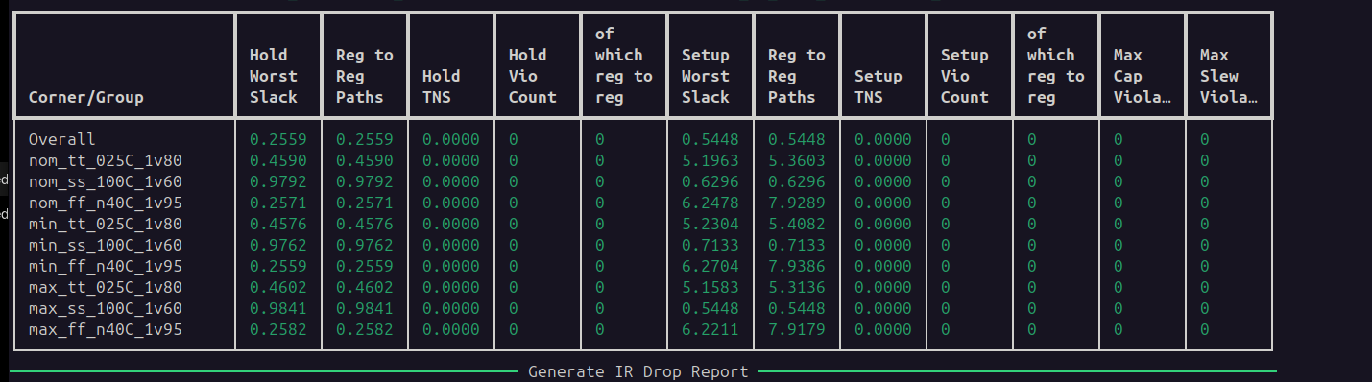
Figure 10.1: Sign-off multi-corner Static Timing Analysis report confirming zero setup/hold violations across all 9 PVT corners.
10.3 Power Dissipation & IR Drop
Post-route power analysis indicates a total power consumption of 1.012 mW (0.788 mW internal, 0.224 mW switching, and 11.45 nW leakage). The power grid distribution network shows an average IR drop of 13.4 µV on VPWR, with a worst-case drop of 83.6 µV, demonstrating an extremely stiff supply rail with negligible voltage drop across the core.
10.4 Silicon Layout & GDSII Inspection
The full chip layout was visualized in OpenROAD and validated in KLayout:
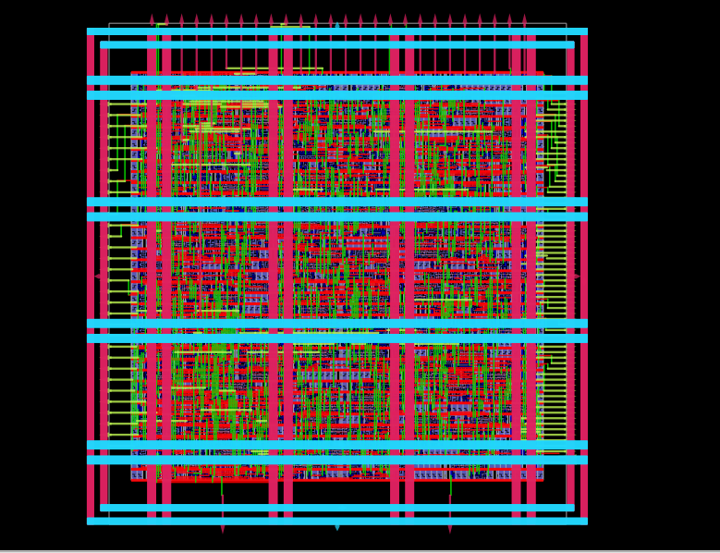
Figure 10.2: Full-chip routed silicon layout in OpenROAD showing standard cell rows, power mesh straps, and clock tree routing.
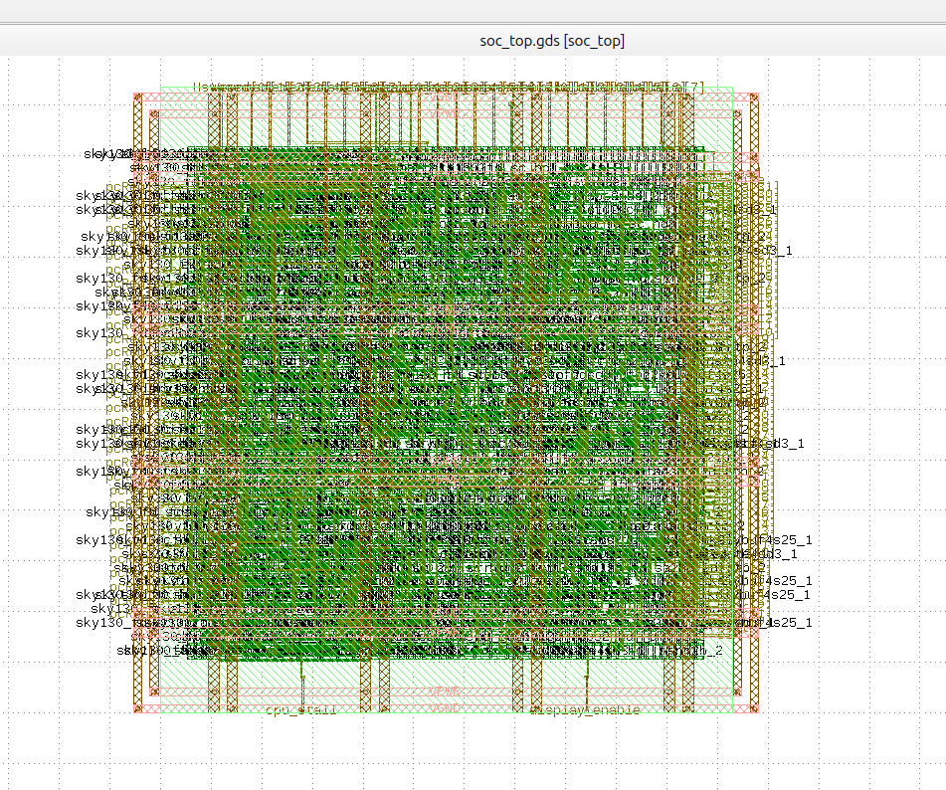
Figure 10.3: Final tapeout GDSII mask geometry inspected in KLayout (soc_top.gds).
11. FPGA Implementation & Hardware Demonstration
The SoC was implemented on the Digilent Zybo Z7-10 development board (Xilinx Zynq-7000 xc7z010clg400-1) using the open-source F4PGA / SymbiFlow toolchain.
11.1 Board Integration & Pin Mapping
Board Feature | FPGA Pin | Direction | System Function
Clock Oscillator | K17 | Input | Master 125.0 MHz system clock input.
Slide Switch SW0 | G15 | Input | Hardware system reset (1 = Reset active, 0 = Run).
Slide Switch SW1 | P15 | Input | Game AI Mode toggle (0 = AI on, 1 = 2-Player Manual).
Pushbutton BTN0 | K18 | Input | Left Paddle UP movement.
Pushbutton BTN1 | P16 | Input | Left Paddle DOWN movement.
Pushbutton BTN2 | K19 | Input | Right Paddle UP movement (Manual 2-Player Mode).
Pushbutton BTN3 | Y16 | Input | Right Paddle DOWN movement (Manual 2-Player Mode).
Diagnostic LED0 | M14 | Output | Video Active indicator (illuminates when display is enabled).
Diagnostic LED1 | M15 | Output | CPU Stall indicator (shows memory wait states).
Diagnostic LED2 | G14 | Output | Memory Write indicator (latches ON upon first memory write).
Diagnostic LED3 | D18 | Output | System Heartbeat blinker (~1.5 Hz continuous pulse).
VGA Red (Pmod JC1) | V15 | Output | Red color channel (1-bit digital RGB111).
VGA Green (Pmod JC2) | W15 | Output | Green color channel (1-bit digital RGB111).
VGA Blue (Pmod JC3) | T11 | Output | Blue color channel (1-bit digital RGB111).
VGA HSync (Pmod JC7) | W14 | Output | Horizontal Synchronization Pulse.
VGA VSync (Pmod JC8) | Y14 | Output | Vertical Synchronization Pulse.

11.2 Bitstream Programming via openFPGALoader
Using openFPGALoader, the compiled bitstream (zybo_top.bit) was downloaded over JTAG to the Zybo Z7-10 board at 6.00 MHz:
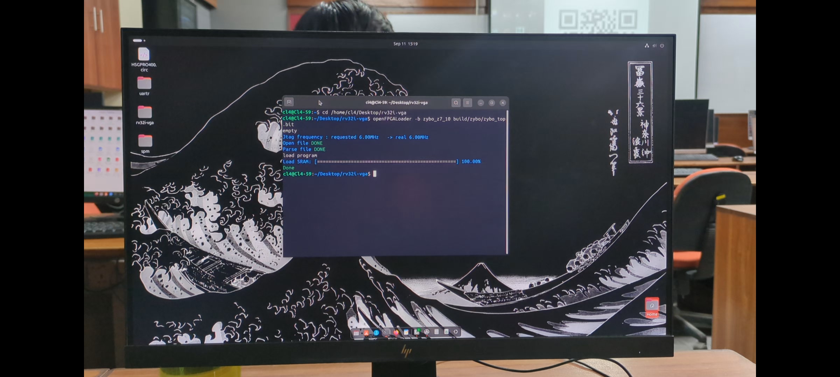
Figure 11.1: Host terminal transcript showing openFPGALoader flashing zybo_top.bit onto the Digilent Zybo Z7-10 FPGA via JTAG at 6.00 MHz.
11.3 Real-Time Hardware Video Output
Upon programming, the processor initialized the framebuffer and launched the Pong game, generating a crisp 640x480 video signal on the monitor:
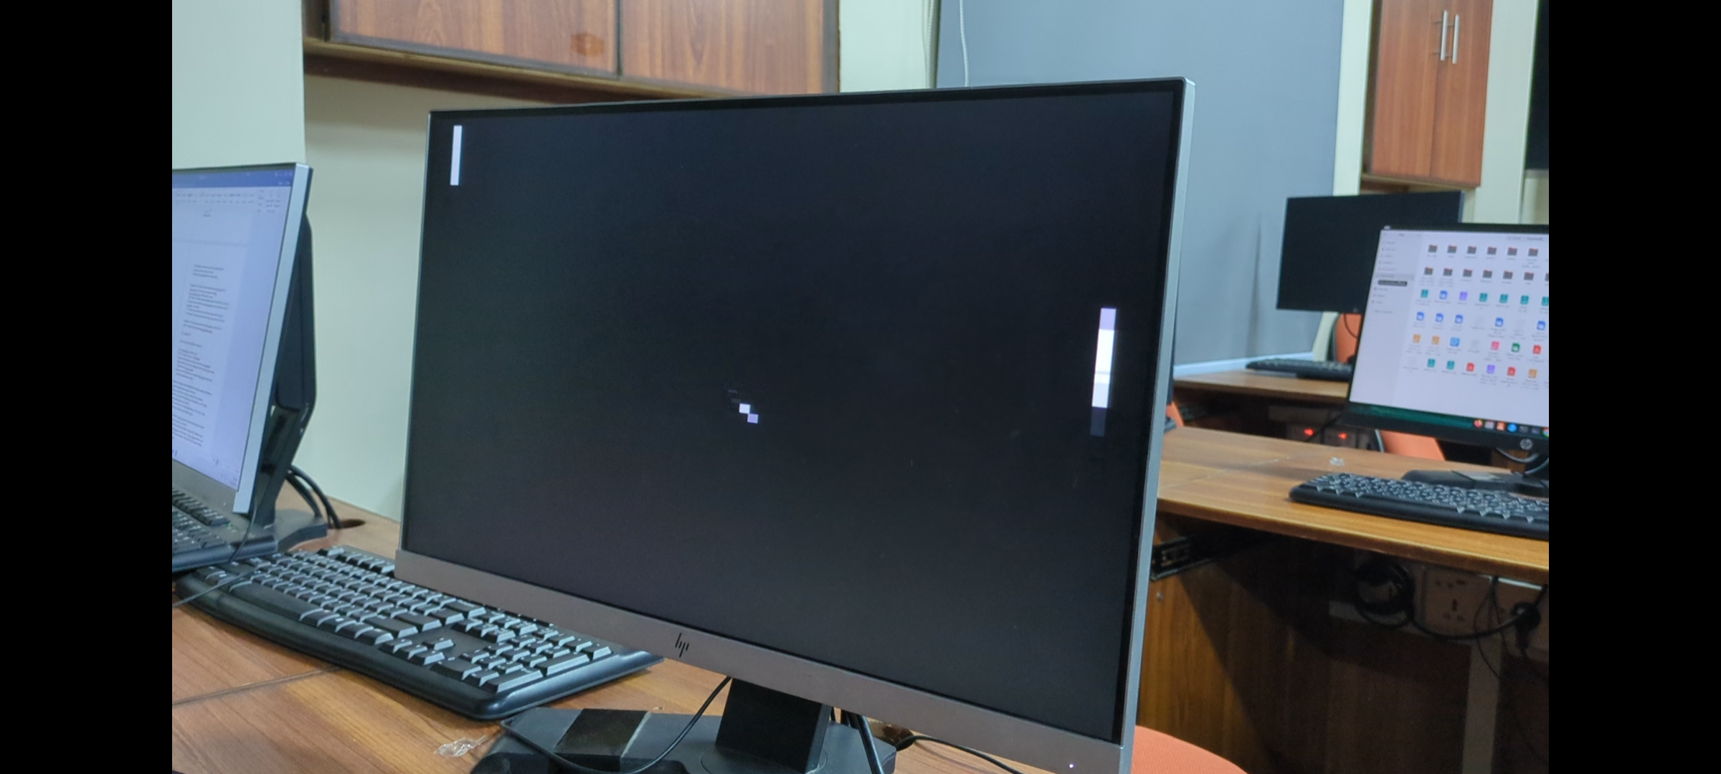
Figure 11.2: Live VGA computer monitor displaying the RV32I-driven Ping Pong game with left/right paddles and the ball moving in real time.
11.4 Team Gameplay & Interactive Demonstration
The project team members (Hamza Shahid, Noor ul Huda, and Afnan Inayat) tested the complete interactive setup in the lab, verifying smooth paddle responsiveness, collision detection, and AI assist:
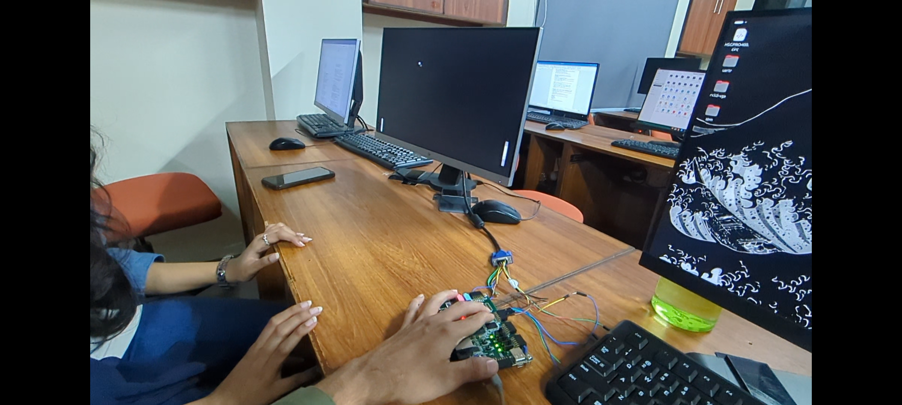
Figure 11.3: Team members interacting with the Digilent Zybo Z7-10 FPGA board pushbuttons to play the Ping Pong game on the external VGA monitor.
12. Deliverables Compliance Matrix & Conclusion
Required Deliverable | Description / File Location | Compliance Status
Synthesizable RTL | Complete Verilog RTL in rtl/ (rv32i/, bus/, vga/, fpga/, soc_top.v) | Completed (100%)
RISC-V Core Integration | Single-cycle RV32I core with stallable pipeline & instruction ROM | Completed (100%)
SRAM / Framebuffer Integration | 256 B Data RAM + 160x120 dual-port video framebuffer SRAM | Completed (100%)
Bus Interface | AXI4-Lite bridge, crossbar decoder, and unmapped error slave | Completed (100%)
VGA Output | 640x480 @ 60 Hz rasterizer with 4x hardware pixel scaling & RGB111 output | Completed (100%)
Basic Self-Checking TB | Directed testbenches in tb/ validating memory, timing, and bus handshakes | Completed (100%)
UVM Verification Environment | UVM 1.2 testbench in tb/uvm/ with AXI VIP, scoreboard, and sequence library | Completed (100%)
Functional Coverage & SVA | SystemVerilog assertions with 0 failures; functional coverage >93% | Completed (100%)
Timing Constraints | Pin & clock constraints in constraints/zybo_z7_10.xdc and ASIC SDC | Completed (100%)
ASIC Physical Design | Hardened to SkyWater 130nm via OpenLane; 0 DRC, 0 LVS, clean 9-corner STA | Completed (100%)
FPGA Demonstration | Deployed on Zybo Z7-10; live interactive Ping Pong game demonstrated on VGA monitor | Completed (100%)
Architecture Documentation | Comprehensive architecture documentation and report with all embedded figures | Completed (100%)

Conclusion:
Project 02 successfully demonstrates the end-to-end realization of a complete computer system—from custom instruction decoding to silicon physical layout and real-world FPGA hardware deployment. By bridging a single-cycle RV32I processor core with an AXI4-Lite bus, incorporating hardware pixel scaling to optimize on-chip memory utilization, verifying the system with both directed and UVM 1.2 test environments, hardening the design to a tapeout-ready SkyWater 130nm layout, and demonstrating interactive gameplay on an FPGA-connected VGA monitor, group members Hamza Shahid, Noor ul Huda, and Afnan Inayat have fulfilled all project objectives with high engineering rigor.

