SPECCHIO

Tutorial

Version: 3.23.3.0.0

Date: 17.09.201917.09.2019

Status: Approved

Authors: P. Roberts (Intersect), A. Hueni & D. Kuekenbrink (Remote Sensing Laboratories, University of Zurich)

File: SPECCHIO\_Tutorial.docx

Pages: 12

Classification:

Distribution: SPECCHIO Users

::::RSL_logo_new.pdf

Table of Contents

Table of Contents 2

1 Introduction 3

1.1 Document scope 3

1.2 Intended Audience 3

1.3 Copyright and licensing 3

1.4 For Further Information 3

2 Overview 4

3 SPECCHIO Online Test Database 5

3.1 Creating Campaigns on the Test Database 5

3.2 Downloading Test Data Sets 5

4 Part 1: Loading, Editing and Retrieving Data 7

4.1 Examine the Folder and File Structure 7

4.1.1 Example Structure 1 7

4.1.2 Example for Reference and Target Spectra 8

4.2 Creating a new Campaign and Loading the Spectra 9

4.3 Get to Know Your Data 10

4.4 Exporting Data to CSV 12

4.5 Exporting Data to ENVI Spectral Libraries 13

4.6 Editing Metadata 14

5 Part 2: GER Files 18

6 Part 3: Directional Data 23

7 Part 4: Data Querying, Processing and Exploration 31

7.1 Converting Radiances to Reflectances 31

7.2 Adding a Keyword to distinguish your tutorial dataset 33

7.3 Data Queries 33

8 Document History 37

9 References 38

# Introduction

SPECCHIO is a spectral database combined with user-friendly interface software designed to store spectral data acquired by spectroradiometers and associated metadata.

SPECCHIO was first developed at the Remote Sensing Labs at the Geography Department, University of Zurich to support long term usability and data sharing between researchers. It was then further enhanced through a project run by the University of Wollongong in 2012/2013. This project was supported by the Australian National Data Service (ANDS). ANDS is supported by the Australian Government through the National Collaborative Research Infrastructure Strategy Program and the Education Investment Fund (EIF) Super Science Initiative.

SPECCHIO is an Italian word meaning “mirror” or “looking glass”. It can also be used to refer to a table of data or a scoreboard.

## Document scope

SPECCHIO uses a Client-Server architecture. This Tutorial provides instruction into the operation of key areas of the SPECCHIO Client operation.

## Intended Audience

This document assumes that readers are familiar with...

* remote sensing and the disciplines and processes related to it.
* the general operation of their own computer.

## Copyright and licensing

SPECCHIO is licensed under the Creative Commons Attribution-ShareAlike 3.0 Unported Licence. Therefore its source is readily available for inspection and development. It can be found in LICENCE.html and at http://creativecommons.org/licenses/by-sa/3.0/.

## For Further Information

Please refer to the following documents for more information about SPECCHIO.

**SPECCHIO\_UserGuide.pdf** provides detailed information about all aspects of the SPECCHIO Client.

**SPECCHIO\_ServerInstallation.pdf** provides system administrators with information to assist in managing and maintaining a SPECCHIO Server System.

**SPECCHIO\_ReleaseNotes.pdf** can be found in each Installation Kit and provides installation instructions for the SPECCHIO Client.

**SPECCHIO Web Site (**[www.specchio.ch](http://www.specchio.ch)) General information about SPECCHIO. Some of this information may be related to other non-UOW versions of SPECCHIO.

**SPECCHIO UoW (**https://specchio.uow.edu.au)Installation kits for University of Wollongong version of the SPECCHIO Client and documentation for that version.

**SPECCHIO GitHub (**<https://github.com/IntersectAustralia/dc10>) Source code for the University of Wollongong version of SPECCHIO.

# Overview

The tutorial is comprised of four parts illustrating the functionality of SPECCHIO:

Part 1: Loading, Editing and Retrieving Data:  
The folder and directory structure of a sampling campaign, the creation of a new campaign, loading of data, editing of metadata and data retrieval is shown on a vegetation example. The data set contains ASD spectra of New Zealand native plants.

Part 2: Handling of GER Files and Reflectance Factor Conversion:  
The automatic splitting of GER files into target and reference radiances upon loading is demonstrated using a RSL GER3700 dataset. Additionally the Space Network Processor is introduced to convert radiances to reflectance factors.

Part 3: Directional Data:  
The handling of directional data including sun angle and sensor geometry calculation and automated linking of target to reference spectra is demonstrated using RSL FIGOS goniometer data.

Part 4: Data Querying, Processing and Exploration

Each part contains several exercises that are listed in a logical order. Please refer to the relevant sections in the User Guide if you require more details on the introduced functionality.

All tutorial data are available for downloading on [www.specchio.ch](http://www.specchio.ch).

The test data sets used for the specific tutorial parts are explicitly specified at the start of the respective section.

# SPECCHIO Online Test Database

An online test database is provided by the University of Zurich, identified by the data source ‘jdbc/specchio\_test’[[1]](#footnote-1). Please use this database for the tutorial exercise and all other tests you would like to carry out. Note: if your institution runs a local SPECCHIO installation you may wish to connect to the respective internal server. See the SPECCHIO Release Notes on how to create a user account.

|  |
| --- |
| Select Database, then Connect to database from the main menu.  If you have only created one account, this account should be selected in the Known connections selector, and the dialogue should be pre-filled with the account details.  If you have created more than one account, you can choose between them using the Known connections selector.  Ensure that you connect to a SPECCHIO test database!  Press  Connect . |

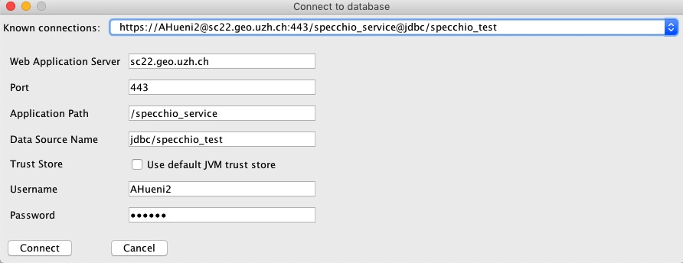

Figure 1: Connecting to the specchio\_test database

## Creating Campaigns on the Test Database

In order to keep things organised, always include your name in the campaign name by using the following template: <your name>\_<campaign name>, e.g. Andy\_tutorial\_example. This will make it easier to find your campaigns in the Query Builder where you can see all campaigns of the other users as well (Note that the Query Browser includes a switch that will show only your own data).

## Downloading Test Data Sets

The data sets used in this tutorial are available on the Internet: https://specchio.ch/guides/

The following data sets are provided as ZIP archives:

* vegetation\_example.zip
* ger\_example.zip
* gonio\_example.zip

To download the ZIP files click on the links[[2]](#footnote-2).

Unzip the ZIP files to some working directory on your machine, e.g. create a new folder called ‘SPECCHIO\_data’ and unzip all datasets into this directory.

# Part 1: Loading, Editing and Retrieving Data

Data set: Vegetation\_example

## Examine the Folder and File Structure

Open a file system window and browse the directory structure of the ‘Vegetation\_example’ folder.

It contains three species folders: Blackfern, Cabbage tree and Lemonwood. Open each of these species folders and examine the contents of the site directories contained in them. Blackfern has only one sample site while Lemonwood and Cabbage tree have three and two respectively. Also browse inside the site directories to find the ASD binary files (cf. Figure 2).

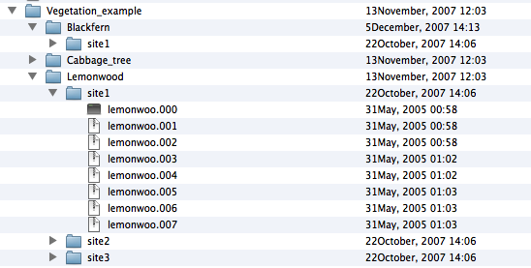

Figure 2: Folder and file structure of the Vegetation\_example campaign

The following subsections examine some examples of data structures. It is important to note that SPECCHIO does not enforce any particular data structure; the examples below are merely discussing some potential data structuring options.

### Example Structure 1

|  |  |
| --- | --- |
| Species: | Multiple |
| Sites: | Multiple sites for each species |
| Measurements: | Multiple measurements per site using ASD file format |
| Example files: | vegetation\_example.zip |

The spatial extent where a specimen is sampled is termed a sample site, thus a species contains a number of sample sites. The sites are numbered in the order of sampling. At each site, several readings are taken to capture the variation exhibited by the specimen in question. A site therefore contains a number of spectra. This leads to a hierarchical directory structure (Figure 3).

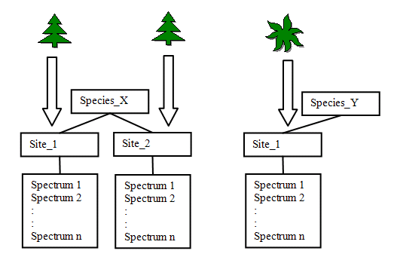

Figure : Hierarchical directory structure

Figure 2 shows an example of a directory structure containing ASD spectral files. The main directory ‘Vegetation\_example’ holds all species directories of the study. This main directory is the folder that needs to be specified in the Path in the Campaign Creation dialog.

The three species directories contain their related site directories.

The site directories contain all spectral files collected at these sites for that species.

The spectral files are auto-numbered by the ASD capturing software within each site directory.

### Example for Reference and Target Spectra

|  |  |
| --- | --- |
| Species: | Multiple |
| Sites: | Multiple sites for each species |
| Measurements: | Radiance spectra measured with use of a reference panel |
| Example files: | ger\_example.zip |

If a spectroradiometer is configured to acquire radiances, the irradiance will commonly be characterised indirectly by measuring the radiance reflected off a reference panel. This may be preferable to the direct acquisition of reflectance data as information about the irradiance can be retrieved from the dataset.

The structure should therefore ideally hold target and the related reference radiance spectra in adjacent directories. Separating reference and target readings into separate directories may ease the calculation of reflectance factors later on, but SPECCHIO does not enforce such data structuring. For input files containing both target and reference radiances, as is the case for GER files, according subdirectories will be automatically generated upon data loading.

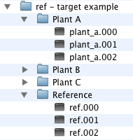

Figure : A possible structure for the storage of target and reference radiance spectra

In this example, the Reference sub-directory holds the reference spectra, which relate to Plant A, Plant B and Plant C.

## Creating a new Campaign and Loading the Spectra

|  |
| --- |
| Select Data Input and Create new campaign from the Main Window menu. This brings up the new Campaign dialog.    Figure : New Campaign dialog  Enter the name you have selected for this Campaign, e.g. ‘Andys Tutorial Data. The maximum length is 45 characters.  To set the Main directory: field, select the  Browse  button to display a folder tree.  The Main directory: path is a file system pathname pointing to the folder that contains all hierarchies and spectra for this Campaign. When you load Spectral data, it will be loaded from this folder. Navigate to the required path on your hard disk. (When using a UNIX system you may have to enter a dot as filename – see the SPECCHIO User Guide for Details)  Click  Create  to create the new empty Campaign in the database or click Create&Load  to create a new Campaign and start loading the spectral files right away.  A message box will appear once the Campaign has been successfully created. Click  OK  to close it.  Click  Cancel  to close the Campaign creation dialog. |

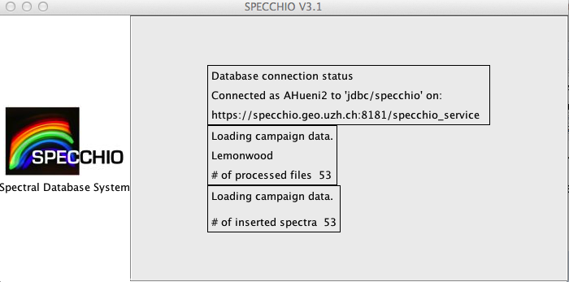

Figure : Main window with loading progress reports

During file loading the progress is shown as text reports in the main window panel (Figure 6).

A message box pops up when the campaign has been loaded (Figure 7). A total of 64 spectral files should now have been loaded into the database.

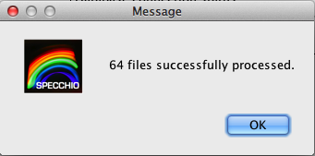

Figure 7: Message box showing the number of processed files during campaign loading

## Get to Know Your Data

Your data are now ready to be visualised and exported. Open the Data Browser by selecting Data Processing & Output/Browse data hierarchy. In the Spectral Data Browser (the tree like display on the left side of the dialog) select your campaign (tick the box ‘Show only my data’ to restrict the displayed campaigns to your own) and explore the structure. Note that the database has stored the hierarchical structure of the campaign folder and displays it accordingly (Figure 8). Also note that as you click around the tree (selecting folders or files) the number of resulting rows on the right side are updated simultaneously. You can also use Ctrl and Shift keys to do multiple selections.

Now select the first 6 spectra of the Blackfern, site1, (the number of resulting rows should be 6) and click on ‘Show report’. A new window will appear looking similar to Figure 9. Note that a scrollable list containing the metadata is associated with every spectrum. Have a look at the metadata and note the data filled in automatically: filename, capture date, spatial position, measurement unit, sensor name, instrument name and instrument settings.

Use the arrow-based selector below the spectral plot to step through the spectra.

The strong noise in the water bands is due to the generally high humidity found in New Zealand (maritime climate coupled with high yearly rainfall (up to 10 metres in Fjordland)).

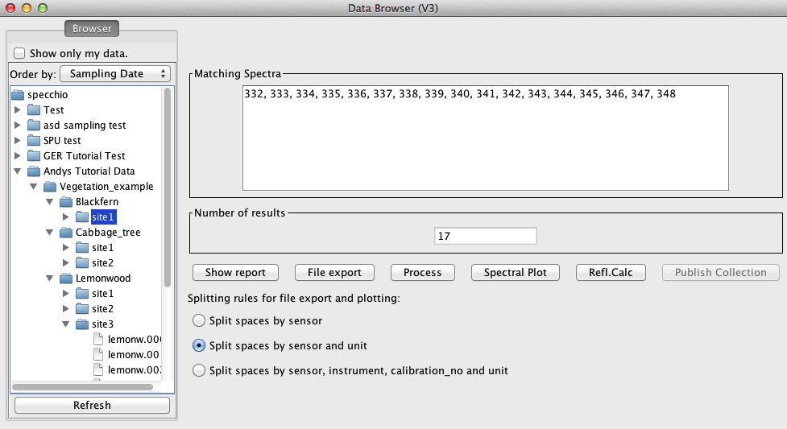

Figure 8: Vegetation example campaign shown in the Spectral Data Browser

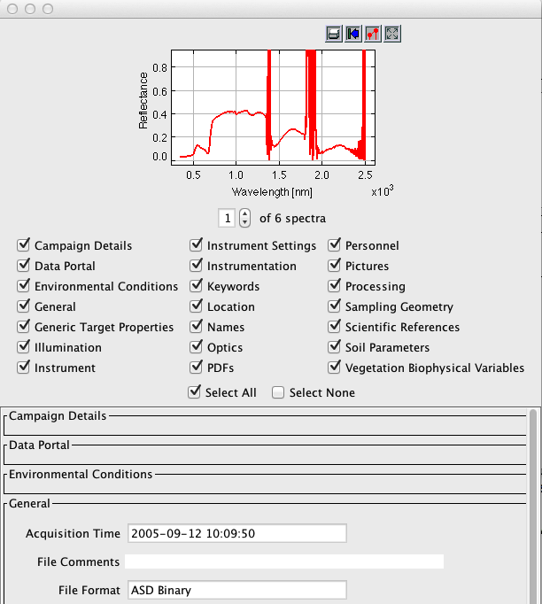

Figure 9: Part of the report on Blackfern spectra

## Exporting Data to CSV

Select File Export  in the Data Browser (first select some data as described in 4.3). Specify CSV as file format, an output directory (use the Browse button to select a directory) and a base filename and then press ‘OK’ (cf. Figure 10).

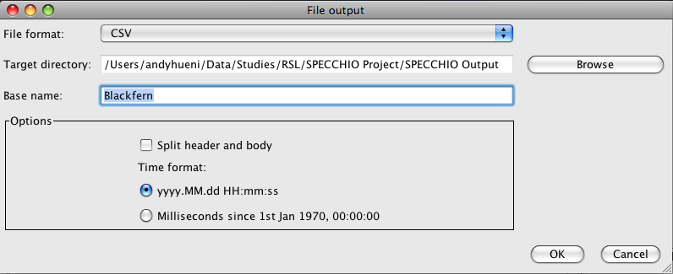

Figure 10: File export dialog

A message box will appear once the export is finished.

Use your file system browser to have a look at the output file that has been written into the output directory you specified (cf. Figure 11). The file name is partly auto-generated and includes the following parts:

* Blackfern: the base name you specified
* INR\_ASD: name of the instrument used to sample the data
* ASD FS FR-3: the sensor type



Figure 11: Exported CSV file

CSV files can be conveniently loaded into spreadsheet and statistics applications. Alternatively you can view them in a text editor.

CSV files can be split into header and body, where the header contains all metadata and the body consists of the channel and spectral information.

Figure 12 shows a spectral plot of the first six Blackfern spectra in Microsoft Excel. The first column contains the central wavelength of the bands in nanometres.

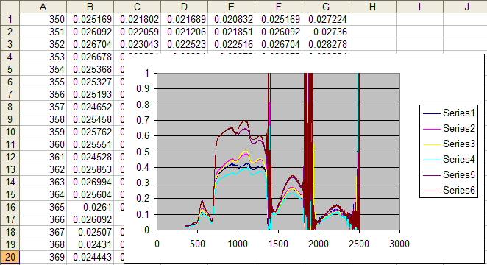

Figure 12: Example of a spectral (XY) plot in Microsoft Excel

## Exporting Data to ENVI Spectral Libraries

Note This exercise assumes that you have access to ENVI. If this is not the case you may skip it.

As a first step repeat the process of file exporting as described for CSV Files in 4.4 but change the file format to ENVI SLB.

To open SLB files in ENVI, start ENVI and select ‘Spectral’->’Spectral Libraries’->Spectral Library Viewer’. Specify an input file by selecting the .slb file (cf. Figure 13).

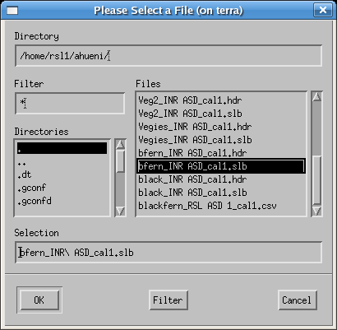

Figure 13: Selecting an slb file to load as spectral library

The spectra names can then be displayed in the Spectral Library viewer (cf. Figure 14) and plotted as Spectral Library Plots. Note that the maximum range of the Y axis must be set to 1 manually as otherwise only noise will be visible (cf. Figure 15).

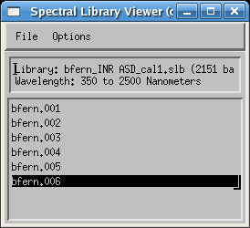

Figure 14: Spectra listed in the Spectral Library Viewer

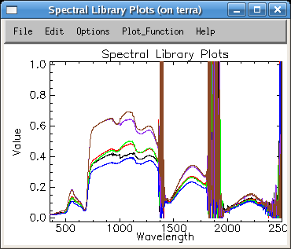

Figure 15: Blackfern spectra as Spectral Library Plots

## Editing Metadata

Open the metadata editor by selecting ‘Data Input’->’Edit metadata’ from the main menu and select your campaign. Note that in the ‘Campaign’ tab your name is automatically listed as Investigator.

Enter some description into the description text field, e.g. ‘Just a test’. Note that as soon as you change some data in the metadata editor the relevant ‘Update’ button (in this case the button in the campaign data section) gets activated (cf. Figure 16).

Perform the update by clicking on the update button. This stores your changes in the database. The update is done when the ‘Update’ button reverts to being grey and inactive.

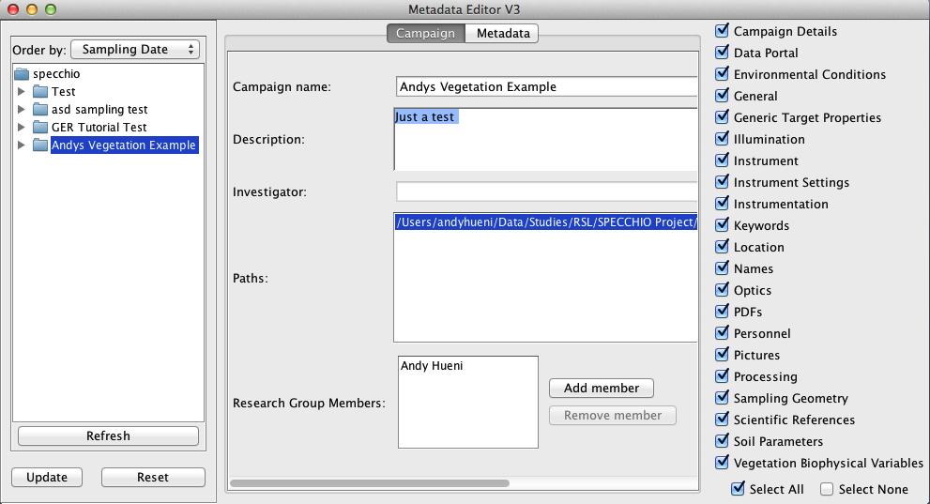

Figure 16: Editing the description of a campaign

Switch to the ‘Metadata’ tab and select the ‘Blackfern’ folder in the Spectral Data Browser (cf. Figure 17).

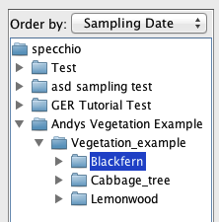

Figure 17: Selecting 'Blackfern' in the Spectral Data Browser of the Metadata Editor

By selecting multiple spectra (e.g. by selecting a folder or several single spectra) you automatically enter the so called ‘group update modus’. All data that you enter will apply to all the selected spectra. Note that some fields are not editable but greyed and inactive. These fields contain already individual spectrum metadata and are therefore disabled.

As all the spectra under the Blackfern hierarchy are of the same plant species entering the plant names can be done for all spectra with a single operation. To enter a new name, click ‘Add Common’ in the ‘Names’ section context sensitive pop-up menu (Figure 18).

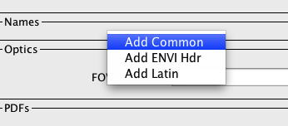

Figure : Add a new name by selecting from the pop-up menu in the Names section of the metadata editor

In the newly created text field type the common name ‘Blackfern’ (Figure 19). In a similar manner enter the Latin name: ‘Cyathea medullaris’ by first adding a Latin name and then entering the name in the text field.

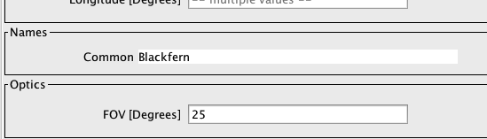

Figure 19: Entering a common name

The names now appear as shown in Figure 20. Note that the ‘Update’ button of the ‘Spectrum Data’ section has been activated. Perform now the update on the database by clicking the ‘Update’ button.

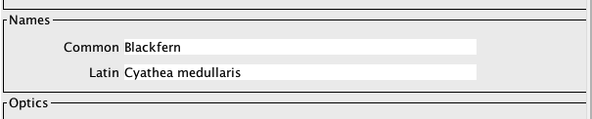

Figure 20: Spectrum names

Pictures taken at the sampling sites can be entered into the spectral database. Pictures for Blackfern and Lemonwood are provided in the vegetation\_example.zip file. You will find the pictures alongside with the Vegetation\_example folder in the directory where you un-zipped the data.

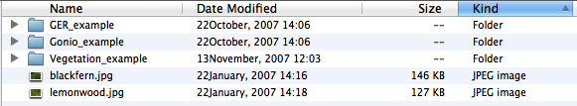

Figure 21: Location of the species pictures

To apply the Blackfern picture to all Blackfern spectra select the Blackfern hierarchy in the Spectral Data Browser. Click ‘Add Target Picture’ in the Pictures section pop-up menu (Figure 22), browse to the Tutorial folder and select blackfern.jpg. Then update the database.

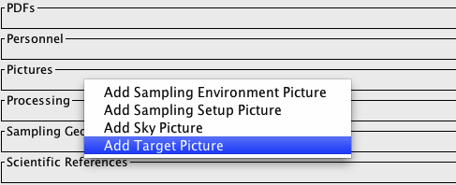

Figure : Context sensitive context menu of the Pictures section

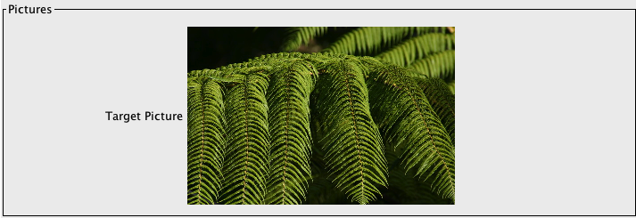

Figure 23: Example of a target picture

In a similar manner insert the supplied lemonwood.jpg picture for all Lemonwood spectra.

Note that performing group updates not only speeds up the input process but also minimizes the amount of data stored in the database. All spectra in the selected group are referencing a single entry in the database, thus avoiding data redundancy.

# Part 2: GER Files

Data set: GER\_example

The GER files are contained in the GER\_example folder. Explore the folder. You will notice that there are 10 files created by the GER instrument. As a matter of fact, these spectra are also acquired over vegetation, i.e. they could also be part of the campaign already holding the New Zealand native vegetation.

The first part of this exercise will teach you how to add a new folder to an already existing campaign. Part two introduces the automatic target to reference linking process and part three demonstrates the automatic radiance to reflectance factor conversion.

|  |
| --- |
| Select Data Input and Load campaign data from the menu on the Main Window.  From the drop down list for the Campaign name: control, select the name of the Campaign you are uploading to (in this case the campaign holding the New Zealand flora samples). The list of paths in the Path: box will change to be those defined for the selected Campaign.    Figure : File upload dialog showing multiple paths  SPECCHIO stores every path name that has been used to upload data to this Campaign. However, in this box it will only display those paths which point to locations which exist on your computer. If the original data upload was done from this computer, it is likely that the original data upload path will be shown.  Click on  New Path . A file selection dialog will open.  Navigate to the folder that contains the GER tutorial data and select it. This new path will be added to the list of paths in the Path: box. Be sure to select the correct folder level.  Click  Load . The dialog box will close and progress messages will be shown in the right hand part of the Main Window indicating the total number of files that have been found, and the number of new Spectra that have been loaded. |

Open the Query Builder. Open the tree of the Vegetation Example campaign and study the contents.

The GER example has been added as a second top-level folder under the campaign (Figure 25).

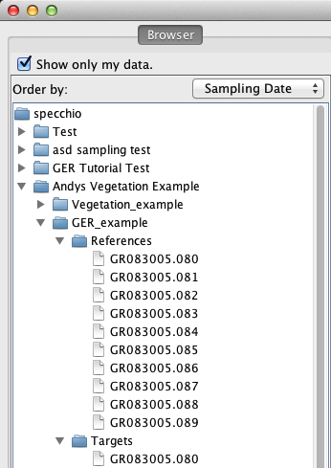

Figure : GER folder added to the Vegetation Example campaign

The files have been automatically split into target and reference spectra (Figure 25). GER instruments write the sampled radiances of target and white reference into the same file. The names of the corresponding targets and references are identical, e.g. target GR083005.080 is associated with reference GR083005.080.

Targets and references are linked internally by a datalink on spectrum level. Note that these datalinks are shown also in the Metadata Editor and the Spectrum Reports under the datalink category.

|  |
| --- |
| Select Special Functions and Target-references links from the menu on the Main Window.  In the new dialog select the GER target folder in the left browser and the GER reference folder in the right browser. The two lists in the middle are populated by the names of the linked references and targets respectively (Figure 26). |

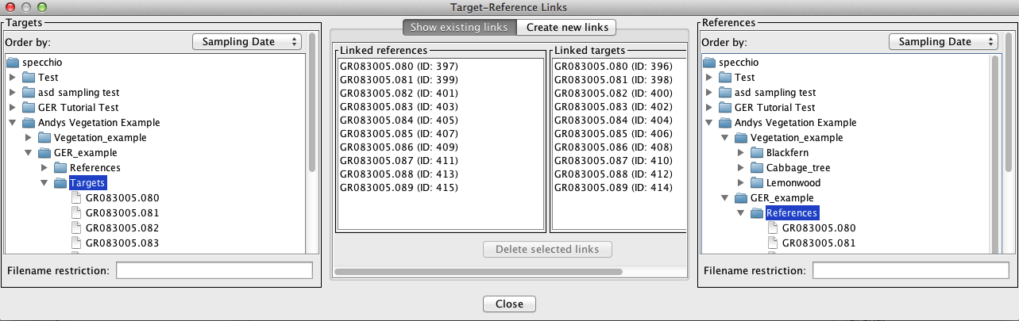

Figure : Target-Reference Link dialog showing existing targets and reference links

These datalinks are used during radiance to reflectance factor conversion.

To convert to reflectances, open the Data Browser by selecting Data Processing & Output/Browse data hierarchy from the Main Window. Browse to the GER target folder and select all spectra by selecting the target folder.

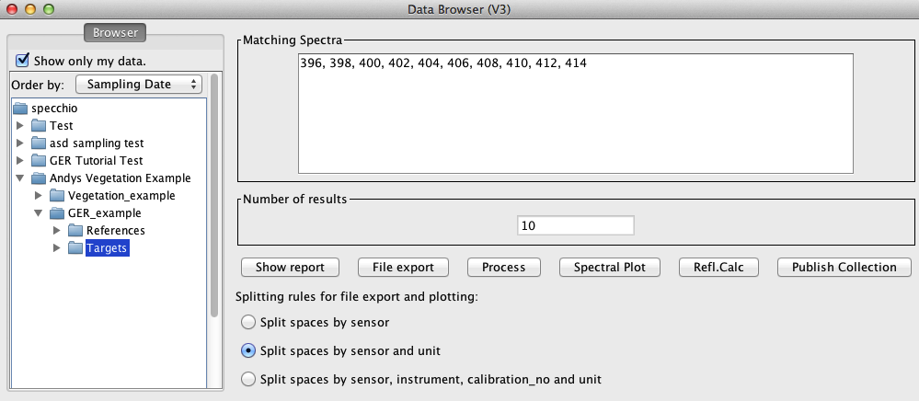

Figure : Targets of the GER data are selected

Click the Refl.calc  button and an automatically configured Space Network Processor will be displayed (Figure 28). Two Spectral Spaces are shown, connected by a processing node called ‘Radiance to Reflectance’. The Spectral Spaces both hold 10 spectra (# of vectors) and have a spectral dimension of 647 spectral bands.

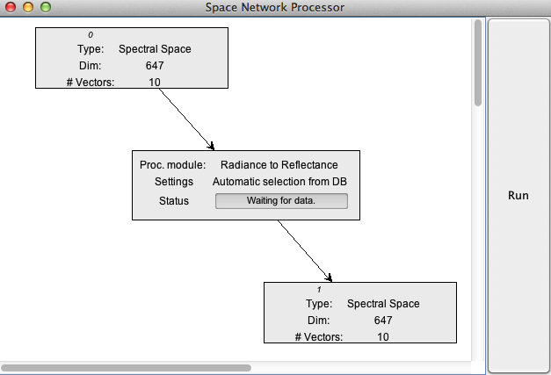

Figure : Space Network Processor configured to convert radiances to reflectance factors

Click on the big Run  button on the right side of the Space Network Processor window to start the conversion. If you observe the Processor closely you will see the Status shortly showing the progress of the calculation.

To visualise the output of the reflectance factor conversion, add a visualisation module to the Space Network Processor:

|  |
| --- |
| Click the menu mouse button over the white background of the Space Network Processor to bring up the ‘Add Module’ option.    In the Module Selection window choose ‘Visualisation Module’ and click ‘OK’  Drag to newly added module in the Space Network Processor to arrange it in relation to the existing nodes. Then configure the new module by clicking the menu button over the module and select ‘Configure’.  In the Visualisation Module Selection choose ‘Spectra Line Plot’ and click ‘OK’.  Connect the Visualisation Module with the output space of the Radiance to Reflectance module by clicking again the mouse menu button over the Visualisation Module and selecting ‘Set Input Spaces’. In the Input Space Selection window choose Input Space number 1 (the spaces are numbered starting from zero) and click ‘OK’.  Space number 1 and the Spectral Line Plot Visualisation Module are now joined up.  Click the Run  button of the Space Network Processor again to rerun the processing and produce the reflectance factor output as a plot. |

# Part 3: Directional Data

Data set: Gonio\_example

This exercise uses FIGOS goniometer data. FIGOS (Figure 29) is used at RSL to acquire spectrodirectional measurements in 66 points arranged on a hemisphere. For more information please refer to ([Schopfer, Dangel et al. 2008](#_ENREF_1)).

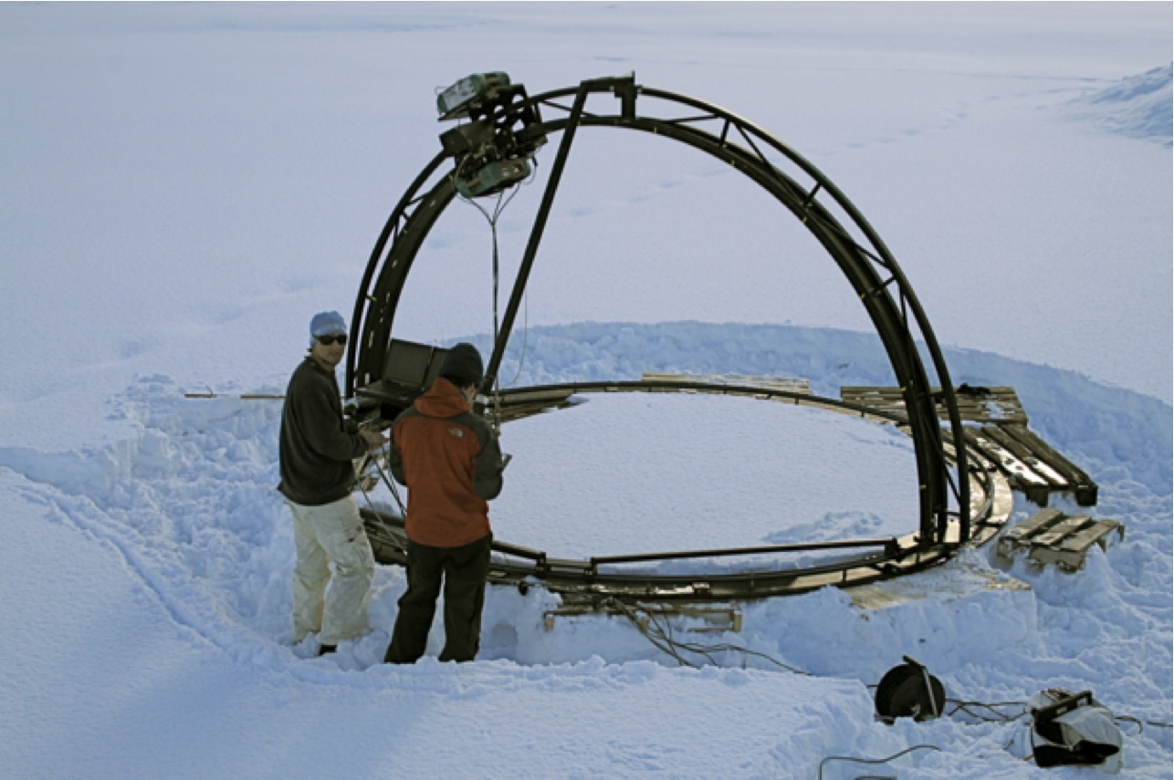

Figure : FIGOS during a campaign to characterise the BRDF of snow surfaces

Goniometer data is provided in the Gonio\_example folder. It contains two subfolders: one holding the targets and one the references. The spectra of targets and references have been manually moved to these folders. This separation should be carried out before the data is loaded into SPECCHIO (alternatively all data can be loaded and the unwanted spectra removed using the Data Remover tool). It must also be noted that any surplus measurements must also be removed, i.e. the system expects 66 directional measurements maximum. SPECCHIO can however deal with gaps in the data as will be demonstrated later.

|  |
| --- |
| * Add the goniometer data to your tutorial campaign as you already did with the GER data. * If you explore the data in the Metadata Editor, you will find that the Measurement unit has been set to Radiance and the FOV to 3 degrees. |

Use a group update to set the Beam geometry of all spectra of the Gonio campaign to ‘Hemispherical-conical (CASE 8)’:

|  |
| --- |
| Locate the section ‘Sampling Geometry’ in the Metadata categories and bring up the menu by clicking the menu mouse button in the section:  Select ‘Add Beam Geometry’ from the menu, then click on the button next to the new ‘Beam Geometry’ property and select CASE 8 from the beam taxonomy. Click ‘Apply’ to confirm your selection. Click ‘Update’ in the Metadata Editor to store this change in the database. |

As a next step the references and targets will be linked based on the nearest acquisition time stamp.

|  |
| --- |
| Select Special Functions and Target-references links from the menu on the Main Window.  In the new dialog select the Gonio target folder in the left browser and the Gonio reference folder in the right browser. Select the ‘Create new links’ tab in the middle section of the dialog. The selected target and reference spectra are listed in the respective lists in middle section.  Click the ‘Link’ button in the middle section to start the time stamp based linking process. A message box will pop up when the linking process is finished.  Switch the tab to ‘Show existing links’ and browse through the target spectra: note that depending on their acquisition time the targets are linked to different reference spectra. Similarly, by selecting a reference spectrum the linked target spectra can be examined.  Close the ‘Target Reference Links’ dialog. |

The illumination geometry (i.e. the sun zenith angle and azimuth) can be calculated automatically if the spatial position (latitude and longitude) and the capture time in UTC are known.

For the given dataset we assume that the time is local time and not UTC. This can be corrected by the special function ‘Correct local time to UTC’:

|  |
| --- |
| Select Special Functions and Correct local time to UTC from the menu on the Main Window.  In the UTC Time Correction dialog select the Gonio data in the data browser; a total of 70 spectra should be selected.  Set the number of hours East of GMT to 2. The time difference to GMT is 2 hours (East) as the sampling took place during summer in Switzerland, i.e. daylight saving applies.  Click the ‘Apply’ button and wait till the correction process is finished: |

As a next step the coordinates of the sampling area must be defined. A position of N47° 22.400’ E08° 32.438’ is assumed. Positions must be entered as floating point degrees (GARMIN hddd.ddddd° format). This yields: N47.37333° E08.54063°.

|  |
| --- |
| Open the Metadata Editor and select the Gonio\_example folder, by this action selecting all spectra of the Gonio dataset.  In the Metadata Editor locate the section ‘Location’ in the Metadata categories and bring up the menu by clicking the menu mouse button in the section:  Select ‘Add Latitude from the menu. Then also add a Longitude property in the same manner.  Edit the Latitude and Longitude fields as latitude = 47.37333) and longitude = -8.54063. Longitudes East of Greenwich are negative.  Press the ‘Update’ button in the Metadata Editor to store the spatial position. |

Once the spatial position of the spectra is defined the sun angles can be automatically calculated:

|  |
| --- |
| Select Special Functions and Sun angle calculation from the menu on the Main Window.  Select the Gonio dataset in the data browser and click ‘Apply’.  Wait till the sun angles have been updated. |

Use the Spectral Browser of the Metadata Editor to check the sun angles that have been calculated. Every spectrum has been assigned slightly differing sun angles according to the individual capturing time.

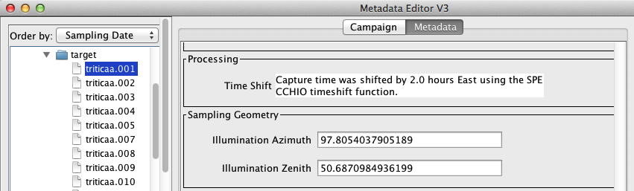

Figure : Illumination angles for a single spectrum in the Metadata Editor

The angles of the goniometer can be calculated for each spectrum:

|  |
| --- |
| Select Special Functions and Gonio angle calculation from the menu on the Main Window.  Select the target folder of the Gonio dataset in the data browser; some metadata are being loaded from the database. On the left side of the dialog the number of spectra in the selected hierarchy is displayed (63 spectra).  There are three spectra missing from the normal total of 66 (these were shadow measurements due to self-shadowing by the goniometer and were removed before providing this dataset). If you study the names of the target spectra it seems that the missing spectra numbers are: 55,56 and 60. Specify the gaps as 55,56,60 and press ‘Calculate’.  The total number of positions is shown in the field ‘Spectra + dummies’, i.e. 66 in this case. The list above the ‘Calculate’ button now contains the positions (starting at zero), the calculated angles and the spectrum filenames. Scroll down till you find the inserted dummies called ‘gap dummy’. These dummy positions are required to obtain the correct angles for the following spectra, as the angles are a function of the measurement sequence according to the FIGOS protocol.  At this point you would have to refer to your field protocol in order to confirm that the gaps you specified did actually occur at the calculated angles.  Press the ‘Apply’ button to enter the calculated goniometer angles into the database. Wait till the update is complete.  Open the Metadata Editor and inspect the newly added goniometer angles. E.g. triticaa.048 should show a sensor zenith of 75° and azimuth of 270°. |

# Part 4: Data Querying, Processing and Exploration

## Converting Radiances to Reflectances

Data set: GER\_example

The GER example data set contains reference and target measurements that have been linked automatically during data load. Our goal is the conversion of target radiances to reflectances using the respective function of the Space Network Processor. This example extends the direct reflectance factor calculation example given in section 5 of this document by showing how such processing networks can be configured manually.

Open the Data Browser by selecting Data Processing & Output/Browse data hierarchy from the Main Window. Browse to the GER target folder and select all spectra by selecting the target folder (Figure 27).

Click the Process  button and a Space Network Processor window will open, containing a space holding the ten target spectra (Figure 31). The dimensionality of the space is 647, which is equal to the number of bands of the GER instrument.

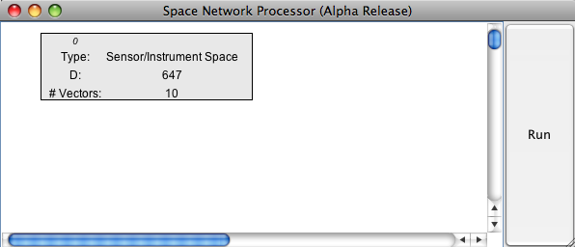

Figure 31: Space Network Processor window with space containing the target spectra

Add ‘Radiance to Reflectance Transformation’ as a new processing module to the processing plane by clicking the menu button over the processing plane and selecting the module.

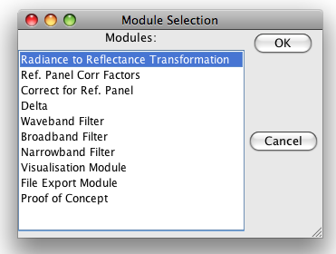

Figure 32: Selection of the ‘Radiance to Reflectance Transformation’ module

Connect the new module with the input space (space 0) by clicking the menu button over the module and selecting ‘Set Input Spaces’ in the module menu (Figure 33) and choosing space number 0 as input space (Figure 34).

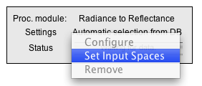

Figure 33: Module menu

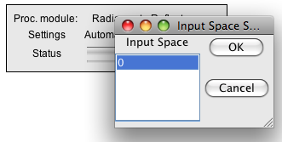

Figure 34: Input space selection for the ‘Radiance to Reflectance Transformation’ module

A new space is added to the processing plane automatically, containing to output of the ‘Radiance to Reflectance Transformation’ module (Figure 35).

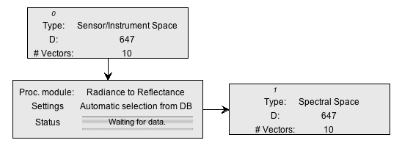

Figure 35: Input and output spaces of the ‘Radiance to Reflectance Transformation’ module

Now, we would like to see what this transformation is actually doing by plotting the input and output spectra.

Add two new modules of the type ‘Visualisation Module’ to the processing plane, configure them as ‘Spectral Line Plot’ and connect them with the input space (space 0) and the output space (space 1) respectively. Your Space Processing Network should now be similar to the one shown in Figure 36.

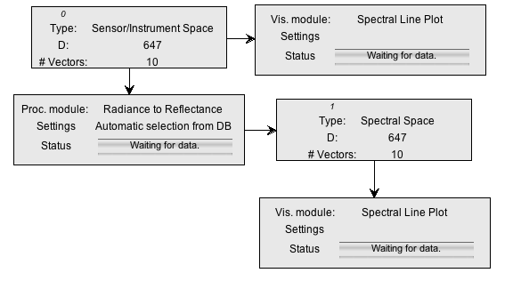

Figure 36: Space Processing Network for radiance to reflectance transformation and visualisation

Press the ‘Run’ button of the Space Network Processor and two spectral plots should appear (Figure 37).

|  |  |
| --- | --- |
|  |  |

Figure 37: Spectral plots of radiance and calculated reflectance

The calculated reflectances show the typical features of a vegetation spectrum (green peak, red edge, water absorption features). The high reflectance in the UV-Blue of the first few bands is an artefact of the instrument and indicates an unreliable calibration of the according channels.

## Adding a Keyword to distinguish your tutorial dataset

You can add unlimited numbers of keywords to your spectra.

Open the Metadata Editor, select your whole campaign by clicking on the campaign folder in the data browser. Then navigate to the ‘Keywords’ attribute category and add a new keyword. Enter some unique string, e.g. by including your email address.

Click the ‘Update’ button to apply the new keyword to all your spectra. This keyword is stored only once in the database and linked with all your spectra to minimise redundancy.

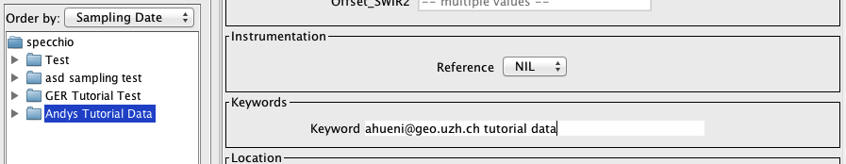

## Data Queries

Data set: all campaigns available in the database.

If you worked through the whole tutorial a total of three new datasets compiled into one campaign should now be loaded to the database. Note that you have access to campaigns other persons entered in the database. Queries on the database can thus return more rows than you might expect!

To Launch the Query Builder select Data Processing & Output/Build query from the menu on SPECCHIO’s Main Window.

|  |
| --- |
| Scroll through the Query conditions to locate the Keywords category. Enter a part of your unique string you defined in 7.2 and enclose it with percent characters to allow wildcard matching in the database, e.g. ‘%ahueni%’.  The number of resulting rows should be 154 (if all 3 tutorial data sets were loaded).  Enter a foreoptic angle range of 3 to 3:  The number of rows should drop to 70.  As a matter of fact, the spectra selected by this query all belong to the goniometer campaign that you created in this tutorial as it is the only dataset acquired with a 3º foreoptic. The result set can be further restricted by e.g. sampling geometry conditions. Narrow the search for spectra with sensor zenith angles between 0º and 30º and sensor azimuth angles between 0º and 180º:  The number of resulting rows should be 18.  Select Visulisations/Gonio Sampling Points Plot from the menu on Query Builder Window.    A polar plot showing the sampling point positions should be displayed:  Select Visulisations/Gonio Hemisphere Explorer from the menu on Query Builder Window. A Gonio Hemisphere Explorer window will open[[3]](#footnote-3):  Clicking on the Goniometer Sampling points will display the corresponding spectrum. |

Note that according to the selection in the Query Browser, only a limited number of points are displayed. The Gonio Hemisphere Explorer can handle any number of spectrodirectional data points and could thus be used on data stemming from different goniometer systems as well.

The data comprises spectrodirectional measurements of a wheat field (triticale). The hemispherical plot nicely illustrates the backward scattering of vegetation canopies (highest radiances are observed in the principal plane). The illumination source is by definition at azimuth position 0°.

# Document History

|  |  |  |  |
| --- | --- | --- | --- |
| **Version** | **Date** | **Author** | **Remark** |
| 3.1 | 21.5.2013 | Peter Roberts (Intersect)  A. Hueni (UZH) | The Tutorial Chapter has been separated from the User Guide into its own document. |
| 3.2 | 11.06.2015 | A. Hueni (UZH) | Update to note that the datalinks are also shown in the Metadata Editor and Spectral Reports. |
| 3.3.0.0 | 17.09.2019 | A. Hueni (UZH) | Updates due to new hosting on UZH servers. |

# References

Schopfer, J., S. Dangel, et al. (2008). "The Improved Dual-view Field Goniometer System FIGOS." Sensors **8**(8): 5120-5140.

1. The SPECCHIO Release Notes document details how to create a user account on the Online System. [↑](#footnote-ref-1)
2. Depending on your operating system, you may have to select ‘Save to Disk’ in the web browser context sensitive menu. [↑](#footnote-ref-2)
3. Note: On MacOS 10.8 and higher the hemispherical radiance plot is not showing any data with the current 3D plotting library. [↑](#footnote-ref-3)