SPECCHIO VM Upgrade Guide

Table of Contents

Upgrade Scenarios 1

In-place Upgrade 1

Virtual Machine Image Upgrade 2

Database Export 2

Transferring the dumps 3

Importing the dump 5

Apply Schema Changes 7

# Upgrade Scenarios

There are two possible scenarios when upgrading SPECCHIO.

1. Updating the SPECCHIO client and server inside the virtual machine.
2. Replacing the virtual machine image with a newer version of it.

# In-place Upgrade

Most of the times you simply want to get your hands on a new SPECCHIO release. For this you need to start the “SPECCHIO Update Tool” and confirm the dialog. The script will then download the most recent SPECCHIO client and webapp release.

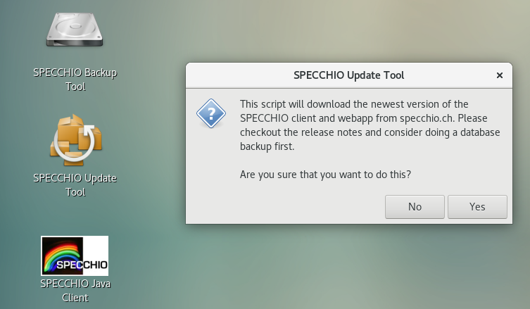

# Virtual Machine Image Upgrade

To upgrade the virtual machine image you want download the newest version from the website. Then start the new virtual machine as well as the old one side by side.

By default the only persistent thing inside the virtual machine is the database. The database can be exported through the built in SPECCHIO backup tool. This export (also called dump) can then be transferred to the new virtual machine and imported using the same tool.

You might also consider to create a snapshot of your current virtual machine (just in case). Checkout the [virtualbox manual](https://www.virtualbox.org/manual/ch01.html" \l "snapshots) on how to do this.

## Database Export

Simply click on the desktop link called “SPECCHIO Backup Tool”. You will then be asked whether you would like to do backup or restore an existing dump. Select “Backup”:

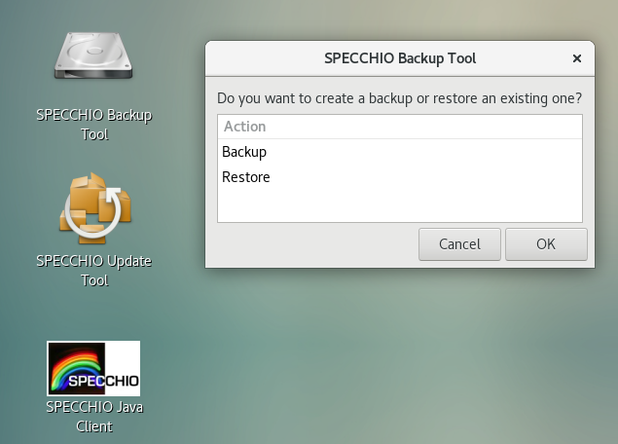

Confirm once more that you want to create a backup. Also ensure that your virtual machine has enough space to store the database export:

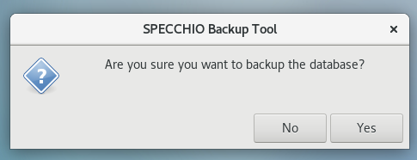

Dependent on the size of your database you will see a progress bar. After the export has finished you should see a confirmation that the backup was successful:

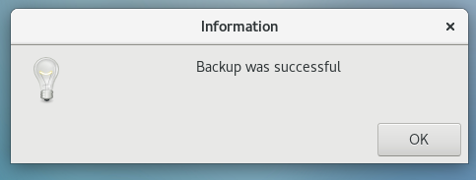

## Transferring the dump

To transfer your backup to the new virtual machine image we recommend that you create a shared folder and copy the database dump to your host system. Then create a second shared folder inside the new virtual machine and restore the dump from there.

Open the shared folders menu (“Devices” → “Shared Folders” → “Shared Folders Settings...”). Then click on the folder with the green plus symbol on it:

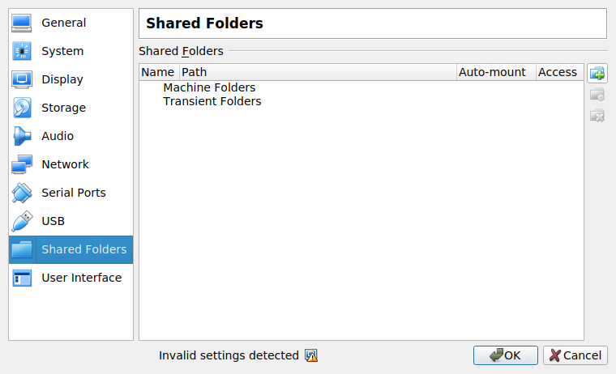

Create a new directory on your system and select it as “Folder Path”. Name the shared folder “specchio_update” and ensure the the “Auto-mount” feature is selected.

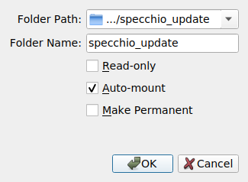

You then want to restart the virtual machine. Once you’re logged in again you should see a new symbol on your desktop called “sf_specchio_update”. Open up a terminal and copy your backup with rsync to the shared folder. (*sudo rsync -P Desktop/SPECCHIO_*.sql.gz /media/sf_specchio_update)*

### 

Create the shared folder on the new virtual machine, reboot and run rsync again. This time with the arguments reversed. (*sudo rsync -P /media/sf_specchio_update/SPECCHIO_*.sql.gz ~/Desktop/).*

## Importing the dump

To import the database backup you want open the SPECCHIO backup tool but this time choose the “Restore” action.

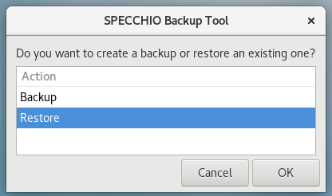

You will then be asked to specify the dump from which you want to restore:

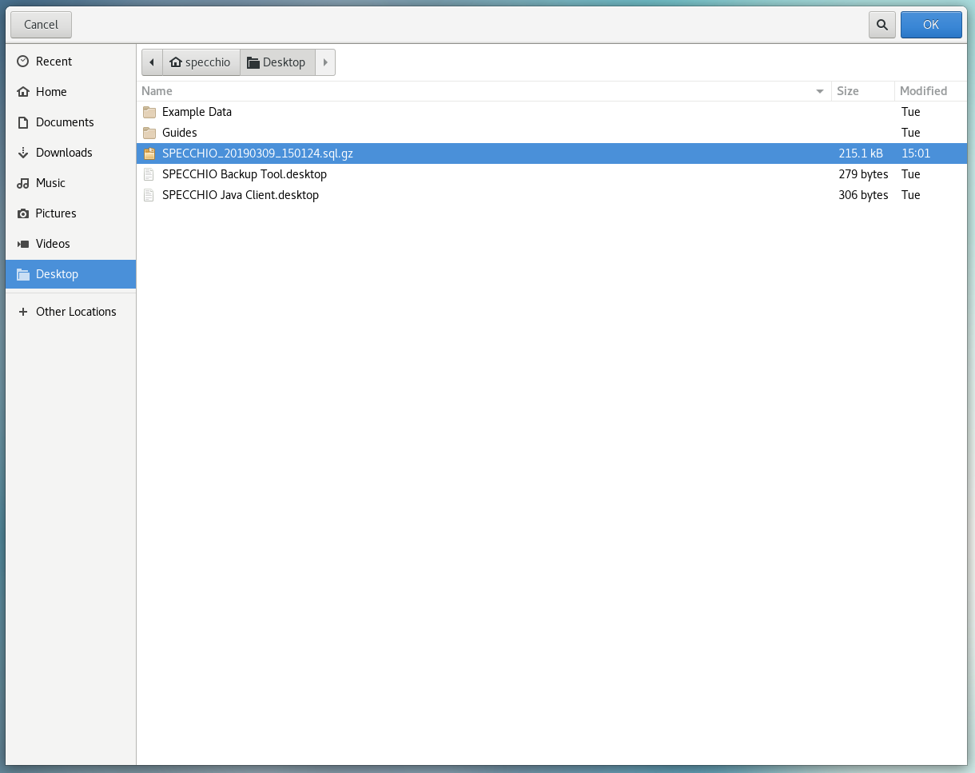

***Restoring a database will delete the current database and will also reset all users and passwords to the version of the dump. If you are ok with this, confirm the warning dialog:***

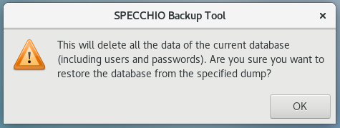

Once again dependent on the size of the dump you will see a progressbar or not. Once the import finished you should see the following info box:

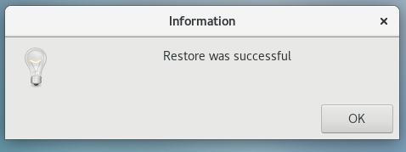

Congratulations you’ve successfully transferred all your data to the new virtual machine.

# Apply Schema Changes

Independent of the scenario you chose, their might be pending schema changes that need to be applied. To verify this, checkout the SPECCHIO_ReleaseNotes.pdf inside the Guide folder.

If there are schema migrations simply start the SPECCHIO client select “Upgrade database” from the “Database” context menu.

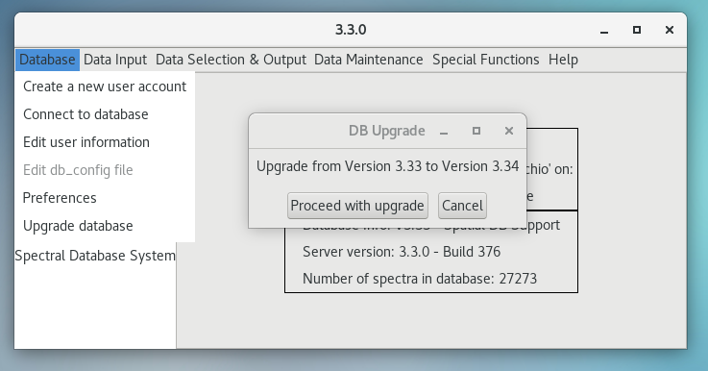

You’re now ready to use the new features. Have fun!