

IS418

Agent-based Modeling and Simulation

AY2017-18T2

Final Report

**Group 2**

Members:

Aaron Poh Weixin | Tan Kah Sheng (Zack) | Tang Shing Hei

**1 Abstract**

Shared space, as a road design methodology, aims to remove the reliance on signage and traffic controls and replace it with designs like roundabout. However, researches have shown that this shared approach might lead to an increase in accident rates. In this report, we will discuss if having a lower vehicular speed limit in shared space designs will translate to lower number of accidents on the road.

**2 Introduction**

According to Edquist & Corben (2012), “shared space” is an approach to road design that erases the separation between pedestrians and traveling vehicles. The idea is to remove the reliance on signage and traffic controls and replace the road with a shared space that both the vehicles and pedestrians can travel on. For example, this can include a conversion of signal-controlled intersection to a roundabout.

In theory, this force both the pedestrians and the vehicles to negotiate their right of way through eye contact and social protocols, while encouraging a more cautious and diligent behavior on the road. The concept rest on the belief that road users are more cautious and therefore safer for the road users. As there is less time spent on waiting for traffic lights, the design is also more efficient for road users, as compared to conventional traffic light road design.

**2.1 Problem Domain**

The shared space design approach is not new and some cities have already implemented them. Some cities that were not successful with the implementation reflected higher stress to both pedestrians and drivers (Holmes, 2015). Some cities such as Makkinga and Kaden experienced a significant increase in accident rates (Edquist & Corben, 2012).

This shows that the shared space design could potentially be more dangerous for the users involved. As such, our team wants to find out what would improve the safety and efficiency of traffic flow in a shared space design.

**2.2 Why ABMS**

Since the implementation could be dangerous, a simulation could be done instead to understand what is critical to the success of a shared space design. This would be helpful for town planners to find the cause and effect of different variables in a shared space design.

The simulation involves two main agents - pedestrians and vehicles. As each agent would perceive and react to the environment differently and also interact with each other differently, an agent-based simulation with a bottom-up approach would be suitable to understand how different factors will affect the involved users.

**3 Literature Review**

In a quantitative study by MVA Consultancy on the shared spaces in the United Kingdom (UK), they found that pedestrians are more likely to use the whole space (including the carriageway), the more ‘shared’ a site is. ‘Shared’ levels are defined using a weighted detailed questionnaire on various design features (e.g. presence of kerbs and road markings). The paper explains that the removal of demarcation between footway and carriageway (such as the removal of kerbs) are deemed more “shared” and  actually encourage pedestrians to use the carriageway. Conversely, the paper also found that high traffic flow discouraged pedestrians from using the carriageway.

Moody and Melia shared a contrasting view from MVA Consultancy with their research conducted by video tracking in Elwick Square, a city ranked second in “sharedness” according to MVA Consultancy. While Moody and Melia agreed that reducing the speed and volume of traffic does benefit pedestrians such as reduced stress levels, they disagreed that removing demarcation encourages pedestrians to move more freely. Their video evidence showed 56% of all crossings made by pedestrians were made around the perimeter of the shared space, away from the main shared area of the space.

Lord Holmes of Richmond MBE provided a different perspective by doing online surveys. He found that majority of respondents had negative experiences with shared spaces. Pedestrians find it dangerous and difficult to cross the roads with vehicles rarely giving way. Drivers were confused and unsure of what the norm or protocols were. Thus, increasing stress level from both pedestrians and the drivers.

The research by MVA Consultancy also provided more insight into the type and severity of the encounters. They categorized the encounters into six different levels, based on whether there is any contact in the encounter, and time to react for either parties.

The above literature reviews provide extensive insight into the subject, using varied approaches in analysing the issue. MVA Consultancy mainly used regression, while Moody and Melia used video tracking and Holmes used Surveys. Our project therefore seek to add new insight to the subject by approaching the issue using an agent-based model to simulate how agents might behave in a shared space environment without the need to implement a new potentially dangerous shared space. Some of these findings may also be integrated into the model to better replicate reality.

**4 Hypotheses**

Our null hypotheses for this model is set as: a low speed within shared spaces leads to low accident rate.

**5 Description of Model**

**Setup**

There are two breeds in our model - Pedestrians and Cars. Our map is based on a roundabout used a in a typical shared space design. The surrounding black patches around the intersection represents buildings that are out of bound for both cars and pedestrian, whereas the white patches represent the shared space. The green patches at the three corners of the road illustrate the pedestrians spawning points, on the other hand, the blue corner patches represent the cars spawning points. Whenever a pedestrian or car is randomly spawned, they have a destination *goal-patch*to represent the guided movement that each road user has when using the shared space. These patch characteristics are captured under the spawn color global variables.

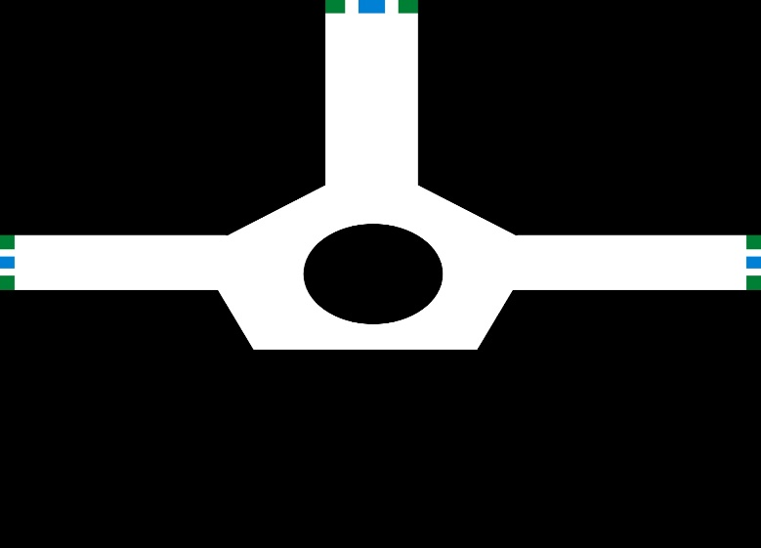

*Shared Space Design*

**Go**

Each tick spawns both agents exponentially random with a predetermined mean value. As mentioned in our literature review, pedestrians have a tendency to stay near to the side and cars slightly away from the side. Therefore, after moving, the cars will reassess their position to stay slightly away from the buildings, depending on their relative individual cautiousness.

The pedestrians will assess their surroundings at each tick for any nearby cars. If the cars are within the stop zone, they will stop to give way to the passing cars. If the cars are within their danger zone, they will take a step back to give way to the passing cars. If there are no cars within their stop zone or danger zone, they will make a move towards their destination. The pedestrians will stay close to the side based on their individual cautiousness.

The three measurements - Accident rate, stress level, and time taken to reach destination is taken at the end of each tick.

**Pedestrians Movement**

The pedestrians will first check if they have reached their goal. If yes, they will die after contributing to the time taken to reach destination for the pedestrians.

Next, the pedestrians will determine the patch they want to go to (can-see-patch). This patch is determined by the patch closest to their destination, within their visibility range. Their visibility range is bounded in a natural human field of view of 114 degree (Howard and Rogers, 1995). If their view is obstructed, they will look around implemented by adding on to this natural view repeatedly until they see a viable patch to walk to. The visible patch to move to determines their heading. After determining their heading, the pedestrians will move towards that patch based on their walking speed. If the pedestrian is too far away from the side of the road (determined by their individual cautiousness), they will adjust by moving closer to the side.

**Cars Movement**

The cars will first check if they have reached their goal. If yes, they will die after contributing to the time taken to reach destination for the cars.

Similar to pedestrians, the cars will determine the patch they want to go to first in the same way pedestrians determine their visible patch (can-see-patch). However, after determining their heading, they will check for any turtles within their heading and speed. If there are pedestrians in front, they will slow down to let the pedestrians pass. If there are other cars in front moving at a slower speed than them, they will slow down to match that speed.

During movement, cars also constantly try to avoid accidents by checking for other agents within their ‘jam-break-zone’ and ‘warning-zone’. The jam-break-zone is defined as an in-cone area with radius 114 and distance (⅓ size of length of car * cautiousness). If there are agents within this zone, they appear red and add 2 to stress level. They will then attempt to avoid the car by turning clockwise by 5 degrees and moving forward by 1m or 2 patches.

If there are no agents in the jam break zone, the car will then check for agents within the warning zone with the same radius as the jam break zone but with 3 times the distance i.e (size of length of car * cautiousness). If there are agents within this zone, they appear orange and add 1 to stress level. They will then attempt to stay away from the car at a speed 2 times slower than their current speed.

**Stay Away from Car**

Each car will first determine the heading towards the nearest wall (wall-heading) and the nearest car (car-heading) within their warning / jam break zone. By determining the headings, we can then determine if the opposing car is on the right (clockwise) or left (anti-clockwise) of the wall. Should it be the former, the own car will decide to turn clockwise 5 degrees from its current heading and anti-clockwise otherwise. If the cars are in a jam break situation, the cars will turn at 30 degrees instead.

**Measurements**

*Stress Level*

Our team modelled the stress level based on the severity of encounter mentioned in the literature review. Each time the cars or pedestrians need to stop to let others pass, the stress level will increase by one. Each time the cars need to jam brake, or when the pedestrians need to step back to allow cars to pass, the stress level will increase by two. The average stress level will be taken for pedestrians and cars separately.

*Accident Rate*

Any contact between a car and a pedestrian is considered an accident. Contact is determined if the agents are within a distance of 0.2. It is important to note that an accident is not necessarily fatal.

*Time Taken to Destination*

Each car and pedestrian will time themselves (in ticks) from spawn till reaching destination. This measurement is updated only if the agent reaches its destination. The average will be taken for pedestrians and cars separately.

**6 Description of Parameters**

For driver’s parameter variables, we have included car size, average driver cautiousness, average driver visibility range. The latter two variables are multiplied by a deviation level of 0.15 to calculate the standard deviation when initiating each agent’s attributes.

For the rest of the parameters, we followed the definition *1 Patch length = 0.5 metres* and *tick = 0.5 seconds* as the reference point. These values are based on a junction in Elwick.

*Size*

We first determined the size of our model to be 160 x 160 patches wide (approx. 80 x 80m) which is reasonable, as it’s similar to the Elwick Square, a famous shared space in the UK. We also defined the size of a car to be about 9 patches long and 4 patches wide (approx. 4.5 x 2m), similar to a standard Toyota Salon. Lastly, we defined a person to be size 2.

*Speed*

We then determined the speed of the agents to be approximately 8.9m/s and 1.3m/s according to research. Following our above definitions, this works out to be 8.9 patch/tick and 1.3 patch/tick respectively.

*Visibility*

Humans can perceive depth up to an angle of 114 degrees. For range, people can actually see quite a distance, and faintly make out a car approximately 3 kilometres away. This would not make sense in Netlogo as we also need to model vision obstruction and line of sight which is not a trivial task. To correct for this gap, we estimated visibility range based on our experiences at road crossings. We found that in general, people have a ‘temporary goal location’ to walk towards approximately 10 metres away. We tested this estimate using sensitivity analysis and it turned out to be a reasonable estimate.

*Accident avoidance*

|  |  |  |
| --- | --- | --- |
| **Action** | **Details** | **Rationale** |
| Car slow dramatically and swerve | ⅓ Length of car * Cautiousness | Length of Car  Values estimated from own driving experiences & our consideration that this is a low-speed driving environment  (8.9 m/s = 32 km/hr)  Sensitivity Analysis also done to ensure that the model runs smoothly at those values  Cautiousness  (default = 1)  >1 : Drivers more cautious and react earlier  <1 : Drivers less cautious and react later |
| Car slow and turn away | ⅓ Length of car * Cautiousness |
| Pedestrian stop | Length of car * Cautiousness |
| Pedestrian step back | ⅓ Length of car * Cautiousness |

*Footfall / Throughput rate*

Our research revealed that, based on the size of the junction (similar to Elwick) (Moody & Melia, 2016), the vehicle flow rate is approximately 790 per hour. This worked out to be approximately 1 car entering the area every 4.5 seconds on average. According to Kaparias et al (2015), the ratio of pedestrians and cars at any given instance is approximately about one. However, the pedestrians move much slower than the cars. Thus, the spawn rate of pedestrians must be slower to match the ratio of the cars. The team then run an experiment to find that spawning the pedestrians at an average of 1 pedestrian every 30 seconds, using the random-exponential function, mirrors the ratio mentioned.

**7 Description of results  
  
Vehicle Speed Variation**

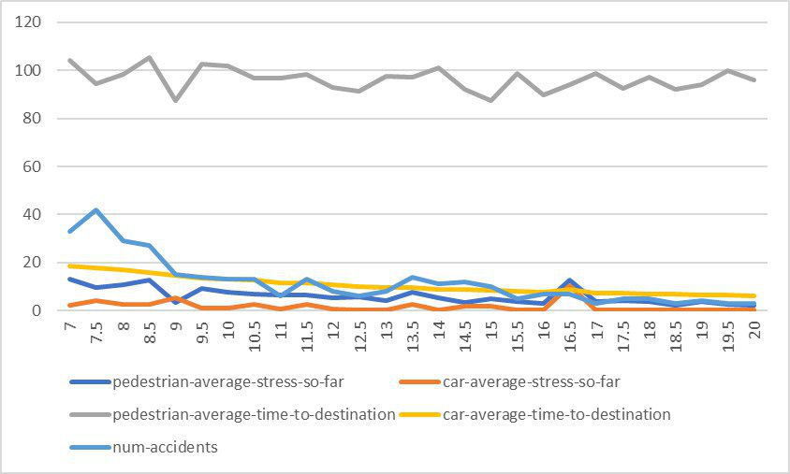

|  |  |
| --- | --- |
| **https://lh4.googleusercontent.com/qqZ_bL2XRiiM69mgp5bJR4xhyk9fXXbv9AINu8sGoHarTXM8gX0IMofs3aL87yoe_0fpYW0zSUVGSLdC1Yv6pAfvwODSAU8dIKdhWG-cywUbeECOsAij_d074Y_oT-_fWsjDbLto** | **https://lh5.googleusercontent.com/djvFnmhj-OSRKDUhHDivnqOBn55012Ud0WK1W8tEssrdnLtW7Qeox-ivsxE6Mwy9u9wyw7CiH_AQe1qCu6SrUdbewn8Cy4OH3y-e5867JwGo-mrInONjiTW4HWpWdWIW8B6_pi8E** |

To relate back to the hypothesis, we sought to find out the the most suitable speed within shared spaces that can lead to lower accident from occurring. Using BehaviorSpace Experiment, we plotted a range of vehicle speed limit in intervals of 0.5 ticks/sec against key measures like pedestrian and car average stress as well as their time to destination. This is done using 7200 runs (which is equivalent to an hour in real-life scenario, since 1 tick is equal to 0.5 seconds).

From the left diagram above where we first started from a range from 7 to 20 patches/tick, it can be seen that as the vehicle speed limit increases, the number of accidents also decreases. However, as the decrease in number of accidents seem marginal after a certain speed, we conducted a simple test of significance to investigate at which speed limit resulted in a significant reduction in the number of accidents as compared to the previous speed limit. Looking at the t-statics on the right image, we find that a speed limit of 9 is optimal in significantly reducing the number of accidents.

The above results seem counter-intuitive as it implies that a faster speed limit results in lower number of accidents. Our group speculated that this could be because at higher speeds, the car would be able to exit the model quicker and hence have less chances of encountering other agents, lowering the probability of accidents happening.

**Singapore vs Elwick**

Having modeled after Elwick, our team is interested if such a design approach can be applied in Singapore’s context. According to LTA (2015), there are about 300,400 vehicles of traffic flow in a 12 hours period across Singapore. Spread across about 25 residential areas (SingStat, 2017), that worked out to be about slightly less than 1 car entering the area every 4 seconds on average. Also according to LTA (2015), the cars travel at an average of 28.9 km/h in arterial roads. Assuming the pedestrian spawn rate stays the same, our team ran the experiment and compared the results as shown below.

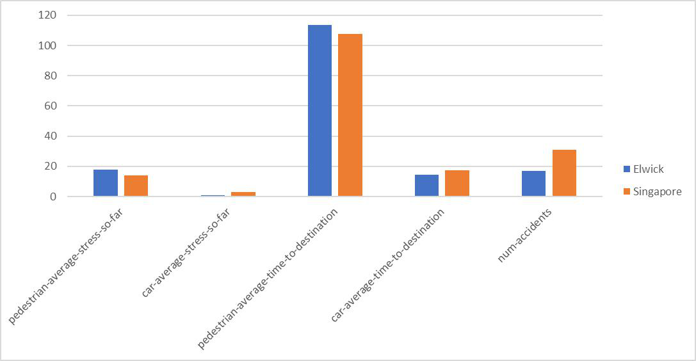

It is no surprise that the cars in Singapore takes slightly longer time to reach their destination due to the lower average speed. The slower car speed may also be a cause of the slightly lower pedestrian stress level.

It is interesting that despite the slower speed, the number of accidents in Singapore is actually higher. This could be due to the slower car speed causing more cars to be in the area at a given instance. This therefore leads to increased congestion in the area and could be the reason for the higher accident rate in the Singapore setting.

**8 Verification / validation of model**

Our model attempts to emulate reality as closely as possible by closely referencing the parameters of a real shared space in the UK, Elwick Square. Sensitivity analysis was also done to ensure our parameters allowed the model ran smoothly. In addition, we were careful to conduct statistical analysis of our results to ensure that our results were statistically significant. The above steps enabled us to ensure robustness of our model.

However, it must be noted that our current model has its limitations in modelling vision obstruction and agents’ continuous movement in one tick. Pedestrians might have different visibility range and cautiousness of pedestrians is dependent on a variety of factors, such as age or past accident history. Furthermore, detection of collision is limited by twice per second.

**9 Conclusion**

Shared space is a design approach that relies on the potential that road users will be more cautious and hence move at a slower speed. Our team sets out to verify the extent of truth in that assumption. Our team then build a model based on an existing city that had implemented the shared space design - Elwick. We then ran several experiments to find that the optimal vehicle speed limit. Our findings reveal that the optimal vehicle speed limit is 9 patch/tick, which is 32.4 km/h. From our results in the variation of speed, we also noticed a significant improvement in performance when the speed increased from 4 patches/tick to 6 patches/tick. This shows that a slower vehicle speed may not always result in lower stress level and accident rate. As we prioritize accident rate as a more important measurement, our team picked 9 patches/tick to be an optimum speed with relatively good performance in other measurements.

The comparison between Singapore and Elwick settings showed that even with a lower traffic flow, slower cars may worsen the congestion in the area and cause more accidents.

Having said that, we should keep in mind that the model is imperfect. There remain many areas for improvement such as more frequent collision detection, better model of human behavior, and better driving agility to reflect reality more accurately can be improved. In addition, our current model only attempts to find the optimal speed limit by minimising accident rate. Future models could improve on this analysis by taking into consideration the increased stress on pedestrians when vehicle speeds past a shared space.

In conclusion, in an implementation of a shared space design, it is important to have a smooth flow of vehicle traffic. This can be done by increasing the vehicle speed or simply implementing the design in an area with less traffic.

**10 References**

Binocular Vision and Stereopsis. (n.d.). Retrieved from <https://books.google.com.sg/books?id=I8vqITdETe0C&lpg=PA32&ots=JhaI-4InNv&pg=PA32&redir_esc=y#v=onepage&q&f=false>

Edquist, J., & Corben, B. (2012, March). Potential application of Shared Space principles in urban road design: effects on safety and amenity . Retrieved from <http://acrs.org.au/files/roadsafetytrust/1339632202.pdf>

Holmes, L. (2015, July). Accidents by Design: The Holmes Report on “shared space” in the United Kingdom. Retrieved from <https://www.theihe.org/wp-content/uploads/2013/08/Holmes-Report-on-Shared-Space-.pdf>

Kaparias, Bell, M., Biagioli, T., Belleza, L., & Mount, B. (2015). Behavioural analysis of interactions between pedestrians and vehicles in street designs with elements of shared

space. Transportation Research Part F, 115-127.

Land Transport Authority. (2015). [Brochure]. Author. Retrieved from https://www.lta.gov.sg/content/dam/ltaweb/corp/PublicationsResearch/files/FactsandFigures/Statistics in Brief 2015 FINAL.pdf

Moody, S. and Melia, S. (2014) Shared space: Research, policy and problems. Proceedings of the Institution of Civil Engineers - Transport, 167 (6). pp. 384-392. ISSN 0965-092X Available from: <http://eprints.uwe.ac.uk/17937>

MVA Consultancy. (2010, October). Designing the Future Shared Space: Operational Assessment. Retrieved from <https://nacto.org/docs/usdg/shared_space_operational_assessment_shore.pdf>

SingStat. (2017). Map of Planning Areas/Subzones in Singapore. Retrieved from <https://www.singstat.gov.sg/docs/default-source/default-document-library/publications/publications_and_papers/population_and_population_structure/population2017-map1.pdf>

**11 Appendixes**

The following are the list of parameters used in the model.

*Pedestrian Variables*

|  |  |  |  |  |  |
| --- | --- | --- | --- | --- | --- |
| visibility-range | walking-speed | goal-patch | cautiousness | stress | time-to-destination |

*Car Variables*

|  |  |  |  |  |  |
| --- | --- | --- | --- | --- | --- |
| visibility-range | actual-speed | goal-patch | cautiousness | stress | time-to-destination |
| turtles-in-zone | warning? | cars-spawn-mean | pedestrians-spawn-mean |  |  |

*Global Variables*

|  |  |  |  |
| --- | --- | --- | --- |
| **Stress Level** | **Spawn Color** | **Total time to**  **destination** | **Others** |
| pedestrian-total-stress | pedestrian-spawn-pcolor | car-total-time-to-destination | road-width |
| pedestrian-total-stress-so-far | pedestrian-destination-pcolor | pedestrian-total-time-to-destination | num-accidents |
| pedestrian-current-average-stress | car-spawn-pcolor | car-average-time-to-destination | total-cars-spawned |
| pedestrian-average-stress-so-far | car-destination-pcolor | pedestrian-average-time-to-destination | total-pedestrian-spawned |
| car-total-stress |  |  | ticks-to-spawn |
| car-total-stress-so-far |  |  | accumulated-pedestrian-to-car-ratio |
| car-current-average-stress |  |  | average-pedestrian-to-car-ratio |
| car-average-stress-so-far |  |  |  |