PRACTICAL NO 1

Practical: Install Hadoop on Ubuntu (Basic)
Prerequisites: An Ubuntu server VM with a user having sudo privileges

#Check existing users on ubuntu
cut -d: -f1 /etc/passwd
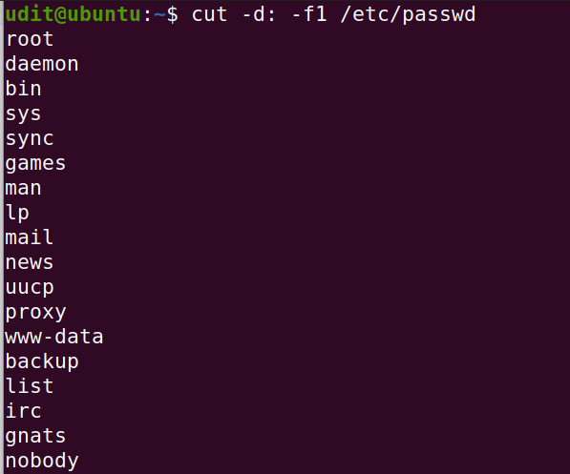
# remove hadoop user
sudo deluser hduser
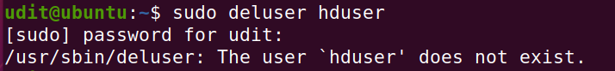
# ps aux | grep
sudo killall -TERM -u hduser1
## remove hadoop group
sudo deluser --group hadoop
# check presence of hadoop
# go to location /usr/local/
# if you see a hadoop folder then hadoop installation was attempted and needs to be removed before fresh installation

# remove hadoop
sudo rm -r -f /usr/local/hadoop/

Step 1 — Installing Java

o get started, we’ll update our package list:
sudo apt update
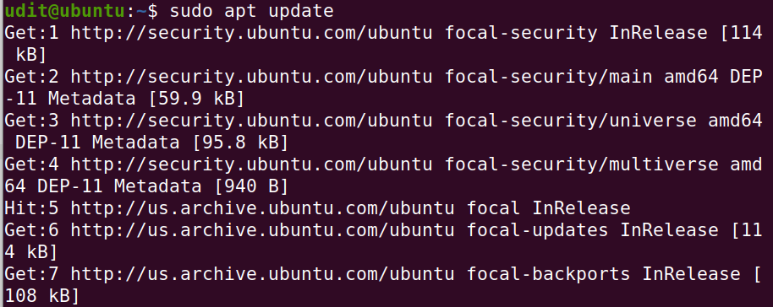

Next, we’ll install OpenJDK, the default Java Development Kit on Ubuntu 18.04:
sudo apt install default-jdk
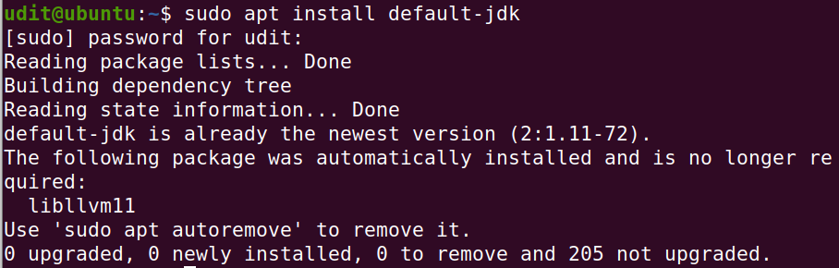

#check folder for java installation at location -
java path- /usr/lib/jvm/java-11-openjdk-amd64
# JDK should be present so just chk
java -version
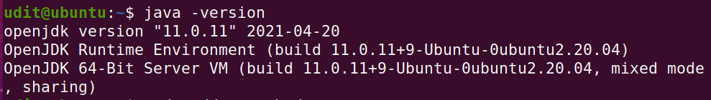
This output verifies that OpenJDK has been successfully installed.

==================================================================

#Add newuser to new usergroup
#group-hadoop, #user - hduser
sudo addgroup Hadoop
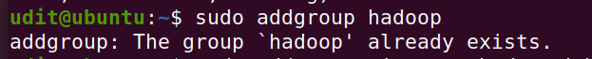
sudo adduser --ingroup hadoop hduser
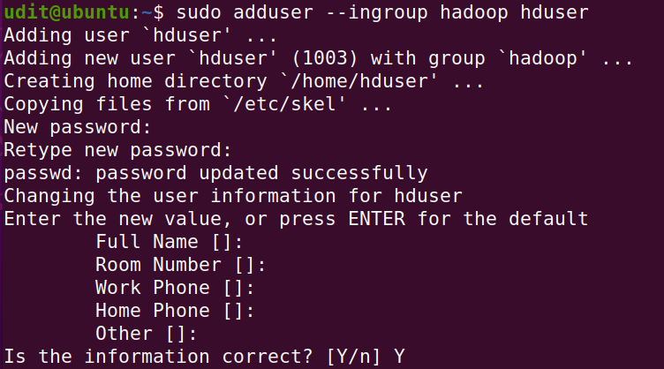
#add new user to listed groups
sudo usermod -aG sudo hduser
#change to new user
su hduser
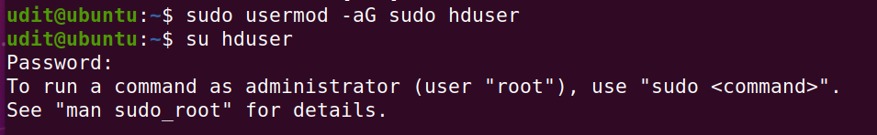
#The prompt shoud look like this - hduser@ubuntu:/
==================================================================
#Create a ssh keygen for the user.
ssh-keygen -t rsa -P '' -f ~/.ssh/id_rsa
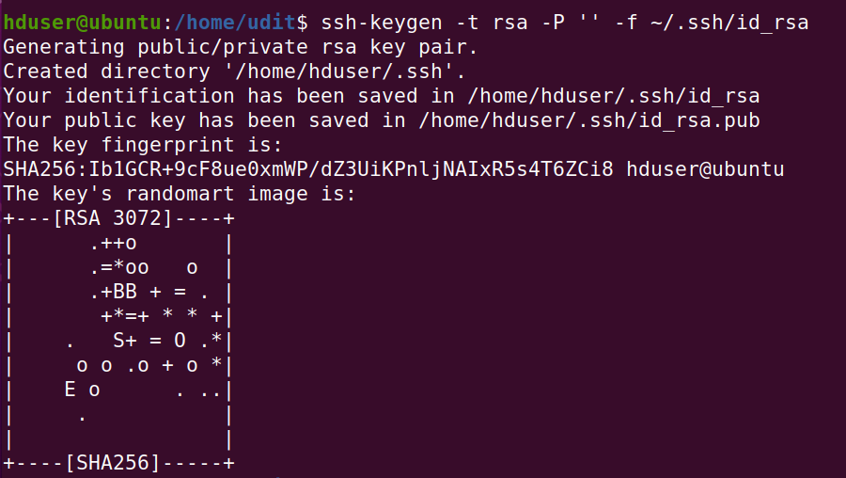
cat ~/.ssh/id_rsa.pub >> ~/.ssh/authorized_keys
chmod 0600 ~/.ssh/authorized_keys

# Disable IPv6.
sudo nano /etc/sysctl.conf
#add the following lines to the end of the file
net.ipv6.conf.all.disable_ipv6 = 1
net.ipv6.conf.default.disable_ipv6 = 1
net.ipv6.conf.lo.disable_ipv6 = 1
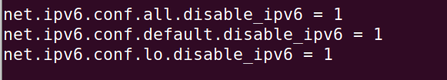

Step 2 — Downloading & Installing Hadoop
==================================================================
#Extract Hadoop and move to group hadoop
cd /usr/local

sudo tar xvf /home/udit/Downloads/hadoop-3.2.3.tar.gz

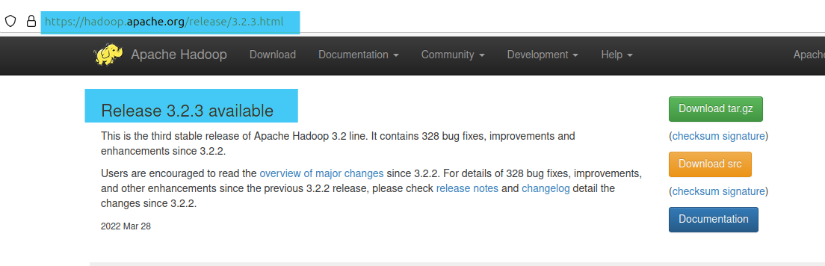



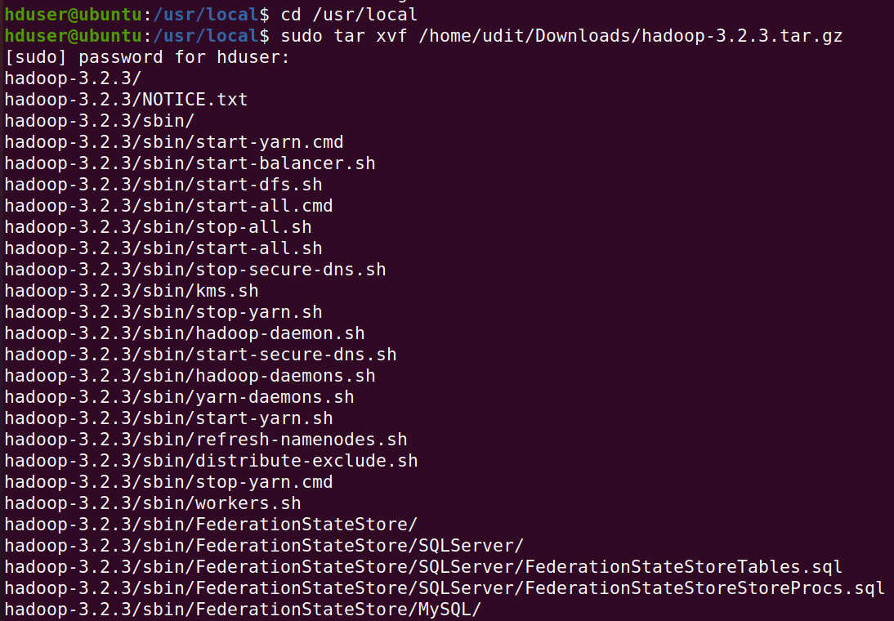
sudo mv hadoop-3.2.3 hadoop
sudo chown -R hduser: hadoop Hadoop

#Now open $HOME/.bashrc
sudo nano $HOME/.bashrc
#add the following lines
export JAVA_HOME=/usr/lib/jvm/java-11-openjdk-amd64
export HADOOP_HOME=/usr/local/hadoop
export PATH=$PATH:$HADOOP_HOME/bin
export HADOOP_HDFS_HOME=$HADOOP_HOME
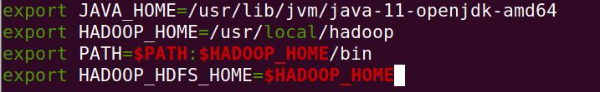
#Save file - Ctrl + s
#Close file - Ctrl + x

#Run the following command to make changes through the .bashrc file.
source ~/.bashrc
#Check version of java and hadoop
Command: java -version
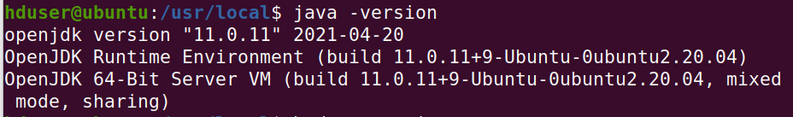

Command: hadoop version
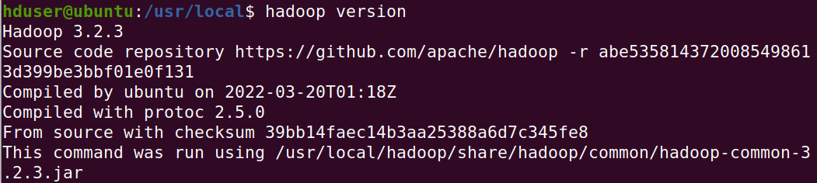
===========================================================================
#Create a tmp folder in /app/hadoop/tmp and change the owner to hduser.
cd /usr/local
sudo mkdir -p /app/hadoop/tmp
sudo chown hduser:hadoop /app/hadoop/tmp/
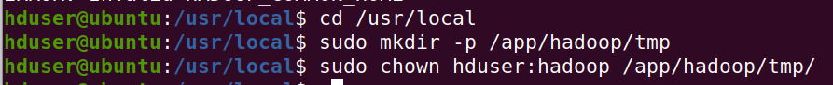

Step 3 — Configuring Hadoop
# Hadoop requires that you set the path to Java, either as an environment variable or in the Hadoop configuration file.hadoop-env.sh
cd /usr/local/hadoop/etc/hadoop/
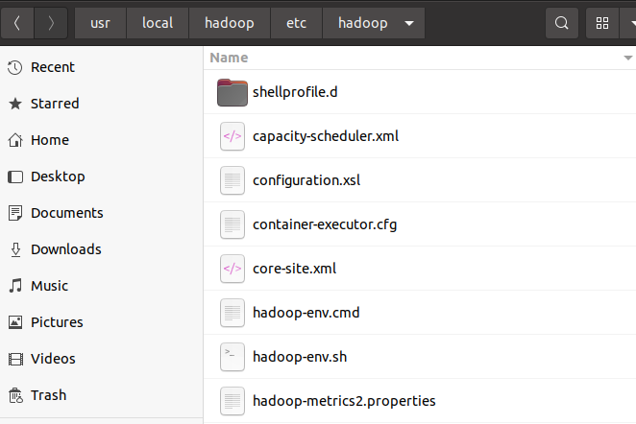
#To Configure Hadoop’s Java Home, begin by opening hadoop-env.sh
sudo nano hadoop-env.sh
#Add the following line at the end of .sh file
export JAVA_HOME=/usr/lib/jvm/java-11-openjdk-amd64
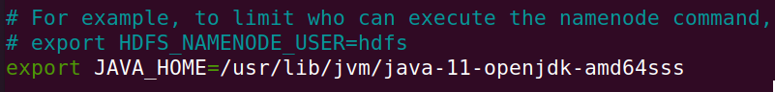
# save & close

#Make the changes in core-site.xml file
cd /usr/local/hadoop/etc/hadoop
sudo nano core-site.xml
#Add the following lines
<property>
<name>hadoop.tmp.dir</name>
<value>/app/hadoop/tmp</value>
<description>A base for other temporarary directories</description>
</property>

<property>
<name>fs.default.name</name>
<value>hdfs://localhost:54310</value>
<description>The name of the default file system.</description>
</property>
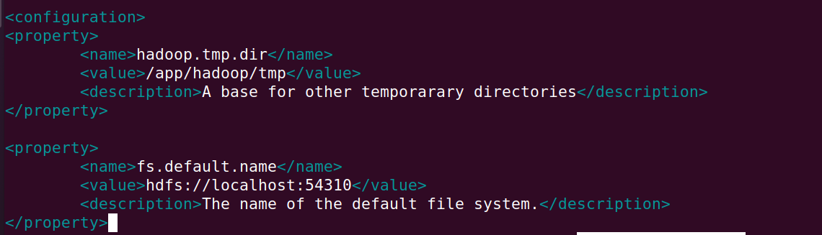
# save & Close
===========================================================================
#Make the changes in mapred-site.xml
sudo nano mapred-site.xml
#Add the following lines
<property>
<name>mapred.job.tracker</name>
<value>localhost:54311</value>
<description>The host and port that the MapReduce job tracker runs
at. If "local", then jobs are run in-process as a single map
and reduce task.
</description>
</property>
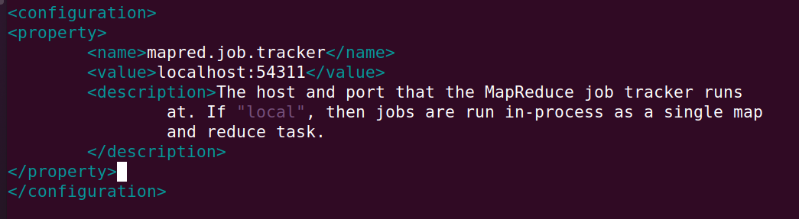
# save & Close
===========================================================================
#Make the changes in hdfs-site.xml
===========================================================================
sudo nano hdfs-site.xml
#Add the following lines
<property>
<name>dfs.namenode.name.dir</name>
<value>/app/hadoop/tmp/dfsdata/namenode</value>
</property>

<property>
<name>dfs.datanode.data.dir</name>
<value>/app/hadoop/tmp/dfsdata/datanode</value>
</property>

<property>
<name>dfs.replication</name>
<value>1</value>
<description>Default block replication.
The actual number of replications can be specified when the file is created. The default is used if replication is not specified in create time.
</description>

</property>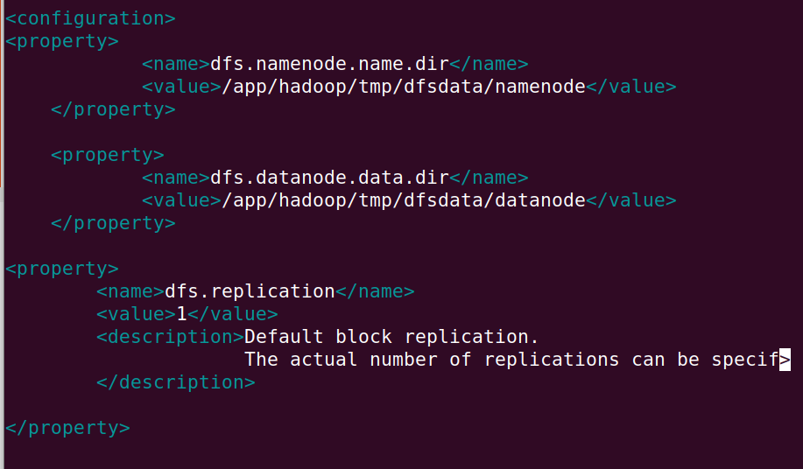
# save & Close
===========================================================================
#format namenode
hadoop namenode –format
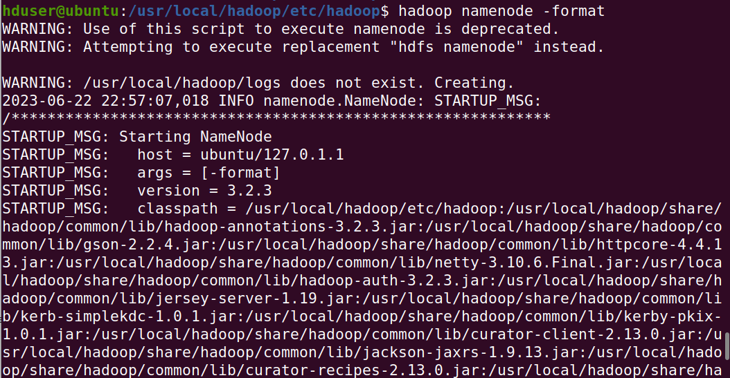

hdfs datanode –format
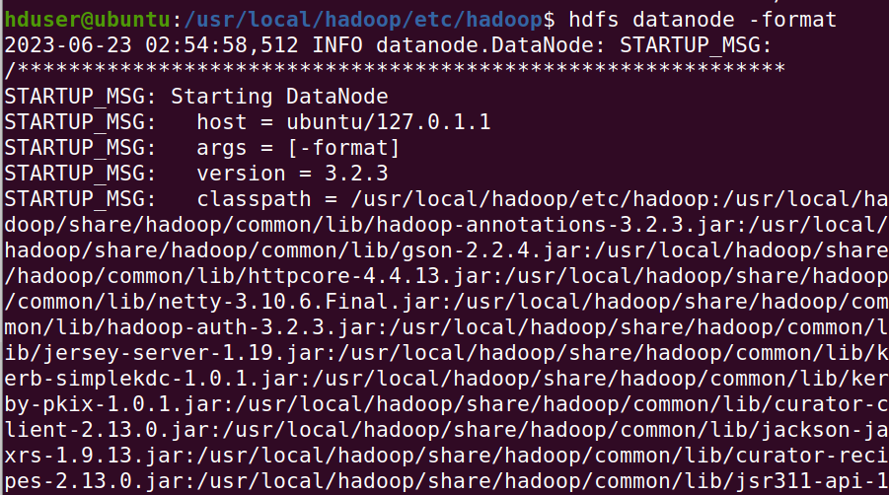

# Step 4 - Running Hadoop
# To start hadoop, we need to start localhost
ssh localhost
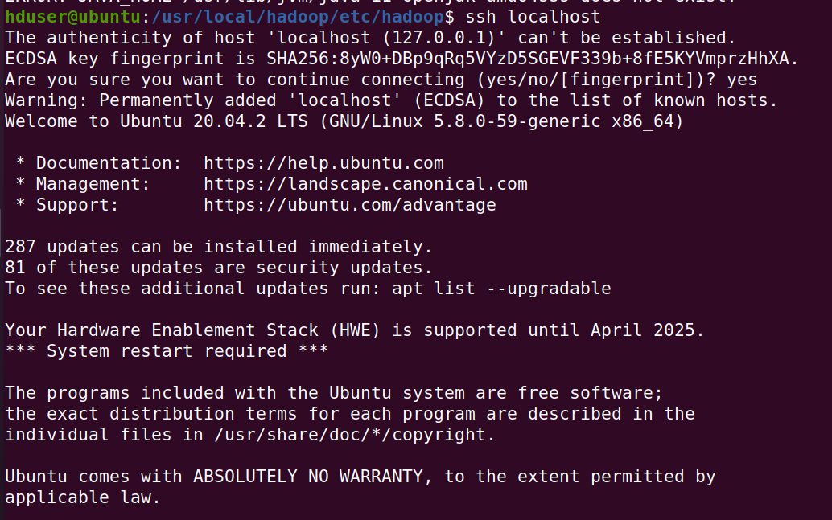
# If connection is refused, it will result in error - run only if error & then run previous command
sudo apt-get install shh
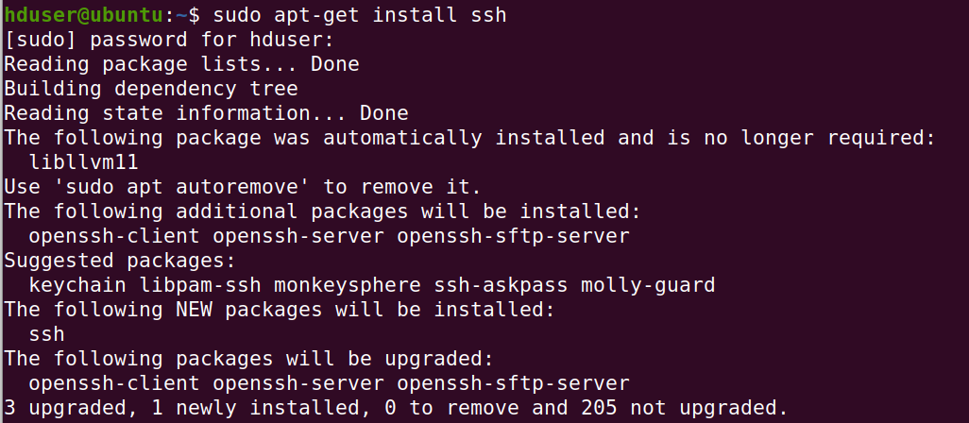
# Start all the hadoop services
/usr/local/hadoop/sbin/start-all.sh
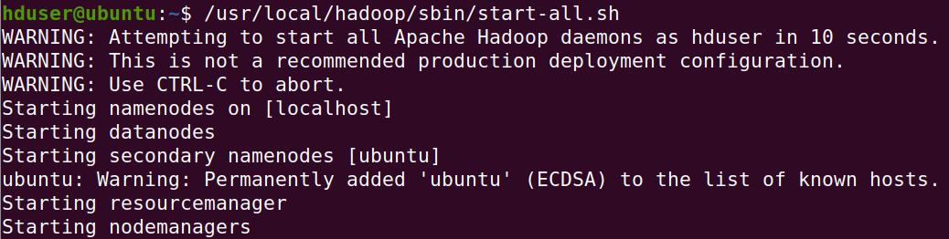
# Check if that all hadoop services are running (6 services should appear)
jps
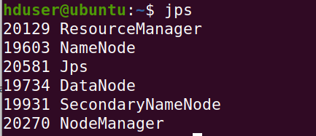
#Access localhost:9870 to get nanmenode status, open browser and type
http://localhost:9870
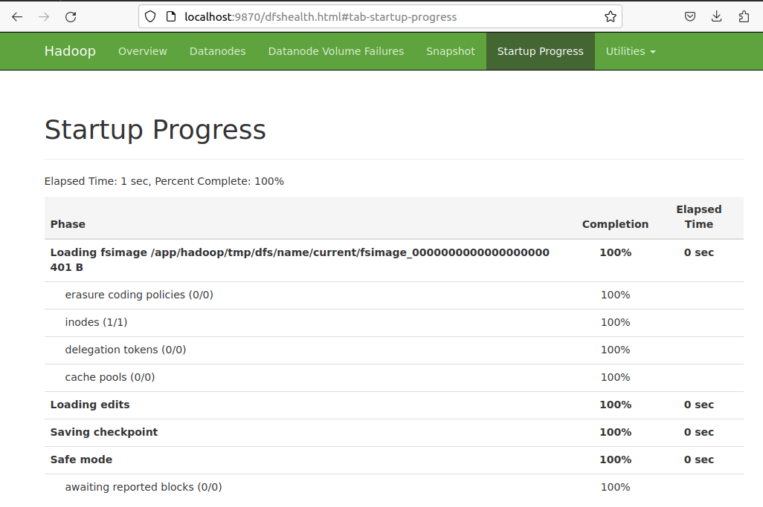

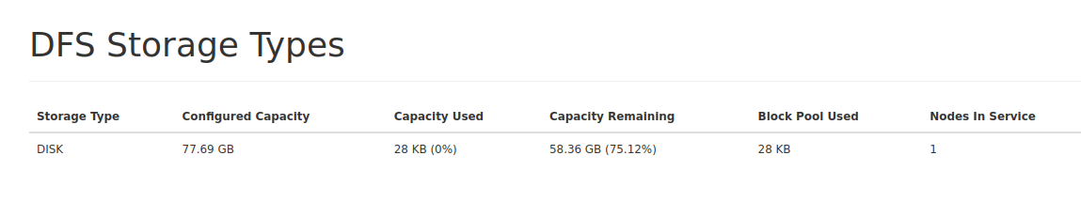

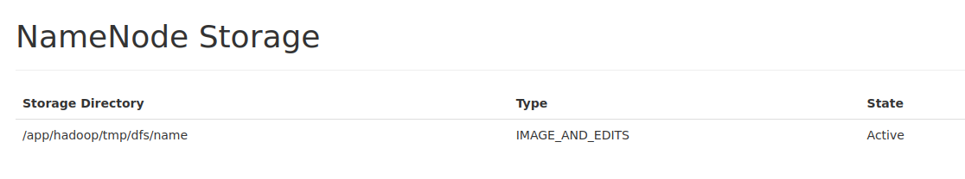

#Stop all the hadoop services.
/usr/local/hadoop/sbin/stop-all.sh
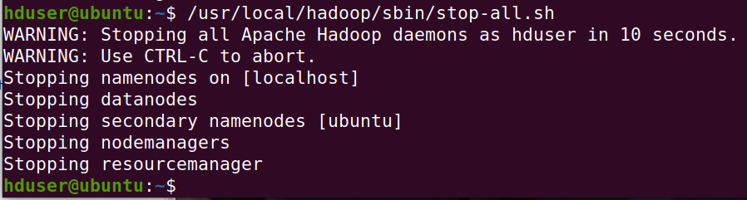

Conclusion: Install, configure and Run Hadoop and HDFS is successfully demonstrated.

PRACTICAL NO 2

Aim: Implement Word count / Frequency programs using MAPREDUCE

Code:
# Prac no 2 Implement Wordcount using MAPREDUCE
===========================================
#login to hadoop user if not already logged in
su hduser

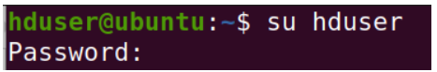

#start hadoop services
ssh localhost
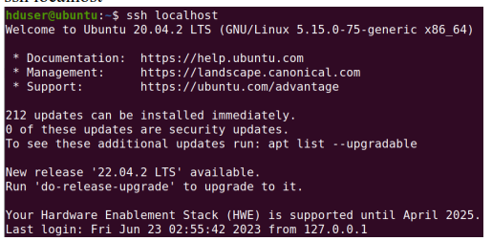

/usr/local/hadoop/sbin/start-all.sh
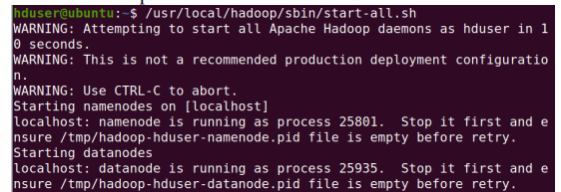
jps

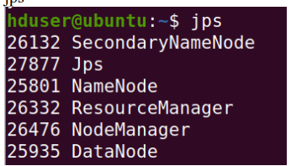

#start localhost - on browser
http://localhost:9870

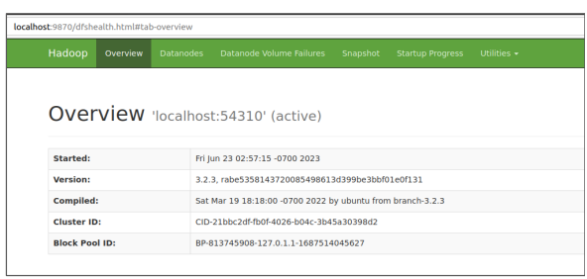

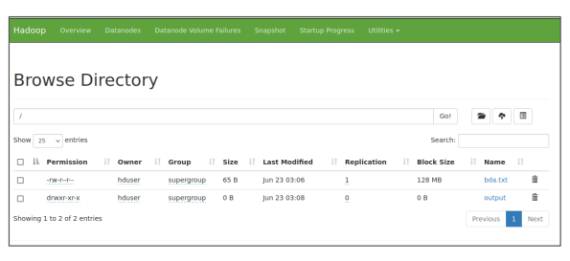

# 2. Create a text file with some words at local file system
# (Necessary to include same and repeated words)
sudo nano bda.txt
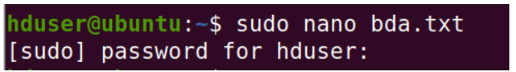

sudo chown hduser:hadoop /home/hduser/bda.txt
# 3. Move bda.txt file to HDFS
hdfs dfs -put /home/hduser/bda.txt /
# 4. Running MapReduce for wordcount file bda.txt
hadoop jar /usr/local/hadoop/share/hadoop/mapreduce/hadoop-mapreduce-examples-3.2.3.jar wordcount /bda.txt /output
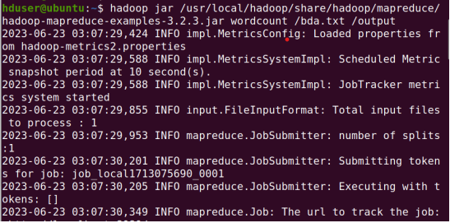

# 5 Check output at default output location
hdfs dfs -head /output/part-r-00000

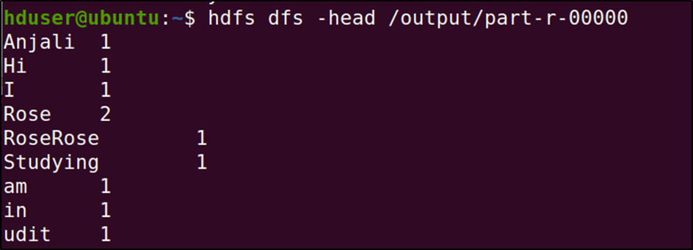
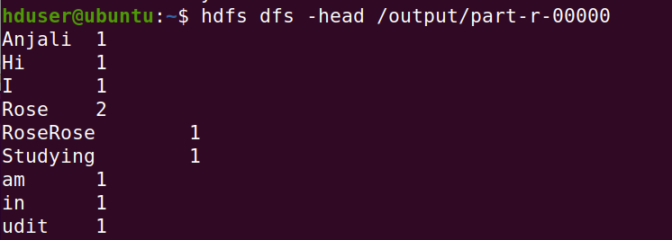

#6. To get output in a .txt file in HDFS
hdfs dfs -mv /output/part-r-00000 /output/opt.txt
# 7. To check the file system in HDFS
hdfs dfs -ls /
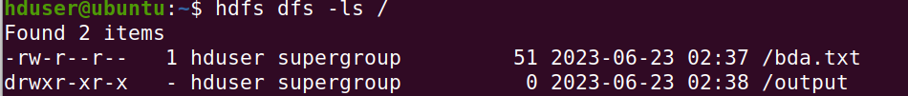

Conclusion: Implement Word count / Frequency programs using MAPREDUCE
is successfully demonstrated.

PRACTICAL NO 3

Aim: Implement an application that stores big data in MongoDB and manipulate it using R / Python

Code:
# Step 1: # Install mongodb by executing the installation file "mongodb-windows-x86_64-4.4.6-signed"
# Click next, next and finish the installation

# Step2: Launch MongoDB
# Navigate to the following location: "C:\Program Files\MongoDB\Server\4.4\bin"

#Start mongo daemon -
mongod

#Start mongo service -
mongo

# Creating Collections and Documents
A MongoDB database is a physical container for collections of documents. Each database gets its own set of files on the file system. These files are managed by the MongoDB server, which can handle several databases.
In MongoDB, a collection is a group of documents. Collections are somewhat analogous to tables in a traditional RDBMS, but without imposing a rigid schema. In theory, each document in a collection can have a completely different structure or set of fields.

# Show list of db
show dbs

# Show current db
db

# create/switch to a db - use dbname
use udit

# display existing collections
show collections;

# create collection - db.collectionname
db.subjects

#insert into collection
db.subjects.insert({"name":"bda"})
db.subjects.insert({"name":"mn"})
db.subjects.insert({"name":"ip"})
db.subjects.insert({"name":"msa"})
show collections;

# Display all records in collection
db.subjects.find();

# Display specific record in colleciton
db.subjects.find({"name": "bda"});

# Using MongoDB with Python and PyMongo
# Install python 3.7.4
# Launch IDLE 3.7

# Installing PyMongo
# MongoDB provides an official Python driver called PyMongo.
python -m pip install pymongo

# start a Python interactive session and run the following import:
import pymongo

#Working With Databases, Collections
# Program 1: Creating a Database
from pymongo import MongoClient //import MongoClient from pymongo.
myclient = MongoClient() //create a client object to communicate with running MongoDB instance
myclient //test client

#to provide a custom host and port when you need to provide a host and port that differ from MongoDB’s default
myclient = MongoClient(host="localhost", port=27017)

# chk db list
print(myclient.list_database_names())

#define which database you want to use
db = myclient["udit"]

# Progam 2: Creating a Collection
import pymongo
myclient = MongoClient(host="localhost", port=27017)
db = myclient.mlib
col=db.subjects1 /// create collection
dict = {"name":"ds", "sem":"1"} /// create dictionary
x=col.insert_one(dict) /// insert into collection
print(client1.list_database_names())

Output:

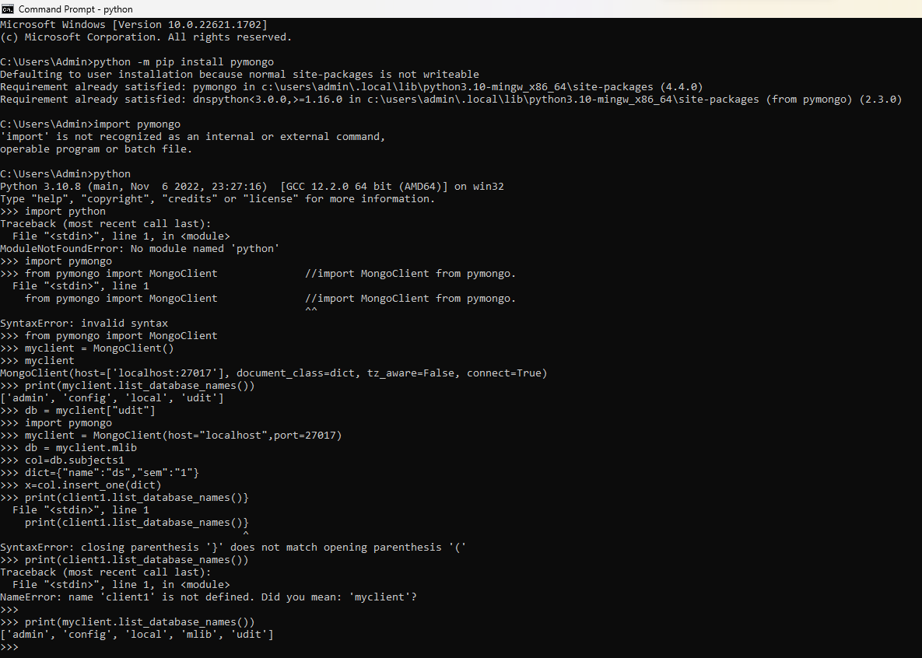

Conclusion: Implement an application that stores big data in MongoDB and manipulate it using R / Python is successfully demonstrated.

PRACTICAL NO 4

Aim: Install, Configure and Run pig

Code:

# Prac 5 Implement PIG
# 1. Start Hadoop and check it using jps command
jps
# 2. Go to /usr/local
cd /usr/local
# 3. extract the pig tar file
sudo tar xzvf /home/udit/Downloads/pig-0.17.0-src.tar.gz
sudo mv pig-0.17.0-src/ pig
# 4. Add the Pig environment variables in bashrc and
check the pig version to verify the installation.
sudo nano ~/.bashrc
# Add the following lines
export PIG_HOME=/usr/local/pig
export PATH=$PATH:$PIG_HOME/bin
export PIG_CLASSPATH=$HADOOP_HOME/conf
# Execute the changes
source ~/.bashrc
# 5. Create a database file.
sudo nano products.txt
#Enter some text like (without spaces)
1,Hardik,Navi Mumbai,123
2,Om,Thane,456
3,Saumitra,Thane,789
#save & exit
# 6. Run the pig in Local mode (pig can access data present only in local file system, eg the product file) Start pig using following command:
pig -x local
product = LOAD 'products.txt' USING PigStorage(',');
dump product;
quit
# 7. Running in HDFS mode (pig can access data on HDFS)
First we need to move products.txt to HDFS
hdfs dfs -put /usr/local/products.txt /
# 8. Start pig using pig command
pig
product = LOAD 'hdfs://localhost:54310/products.txt' USING PigStorage(',');
dump product;
quit;

Output:

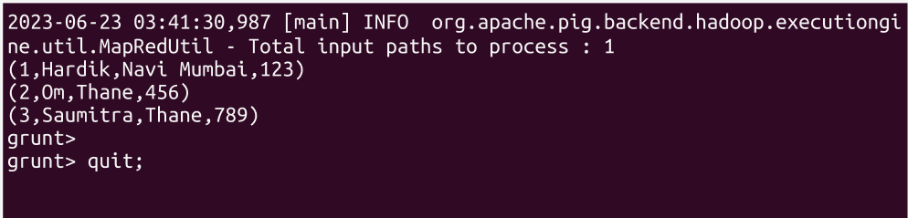

Conclusion: Install, Configure and Run pig is successfully demonstrated.

PRACTICAL NO 5

Aim: Install, Configure and Run Hive

Code:

#Configure and implement Hive
sudo rm -r -f /usr/local/hive
# 1. Start Hadoop and check it using jps command
jps
# 2. Go to /usr/local & extract the hive tar file from downloads
cd /usr/local
sudo tar xvzf /home/udit/Downloads/apache-hive-3.1.2-bin.tar.gz
sudo mv apache-hive-3.1.2-bin/ hive
sudo chmod 777 hive
# 3. Add the HIVE_HOME path in the bashrc file.
cd /home/hduser
sudo nano ~/.bashrc
#add following lines
export HIVE_HOME=/usr/local/hive
export PATH=$PATH:$HIVE_HOME/bin
source ~/.bashrc
# 4. Change the directory to /usr/local/hive/bin
and add the following lines in hive-config.sh
cd /usr/local/hive/bin
sudo nano hive-config.sh
export HADOOP_HOME=/usr/local/hadoop
# 5. Hive is installed now, but
we need to first create some directories in HDFS for Hive to store its data
hdfs dfs -mkdir /tmp
hdfs dfs -chmod g+w /tmp
hdfs dfs -mkdir -p /user/hive/warehouse
hdfs dfs -chmod g+w /user/hive/warehouse
sudo chmod 777 /usr/local/hive/
# 6. Now we need to initialize the derby database.
cd /usr/local/hive/
cd /$HIVE_HOME/bin

$HIVE_HOME/bin/schematool -initSchema -dbType derby
# 7. There is compatibility error between Hadoop and Hive guava versions.
To fix the NoSuchMethodError, Locate the guava jar file in the Hive lib directory
Remove the guava jar file from /hive/lib

sudo rm lib/guava-19.0.jar

# Copy the guava jar from hadoop lib to hive lib directory
sudo cp $HADOOP_HOME/share/hadoop/common/lib/guava-27.0-jre.jar /usr/local/hive/lib/

# Once copied, Use the schematool command once again to initiate the Derby database.
cd /$HIVE_HOME/bin
schematool -initSchema -dbType derby
$HIVE_HOME/bin/schematool -initSchema -dbType derby

# 8. Start the Hive command-line interface using the ‘hive’ command
hive
show database
# 9. Create a database and a table in a hive
create database company;
show databases;
create table employees (id int, name string, country string, department string, salary int) row format delimited fields terminated by ' ';
# 10. Load the data into a table from a file
sudo nano employees.txt
# Enter few rows without spaces
nikhil faculty udit 45000
subodh industry l&t 80000
load data local inpath "/home/hduser/employees.txt" into table employees;
# 11. Display the loaded data
select * from employees
# 12. Exit hive using ‘exit;’ command;
exit

Output:
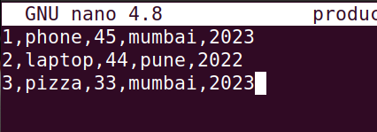

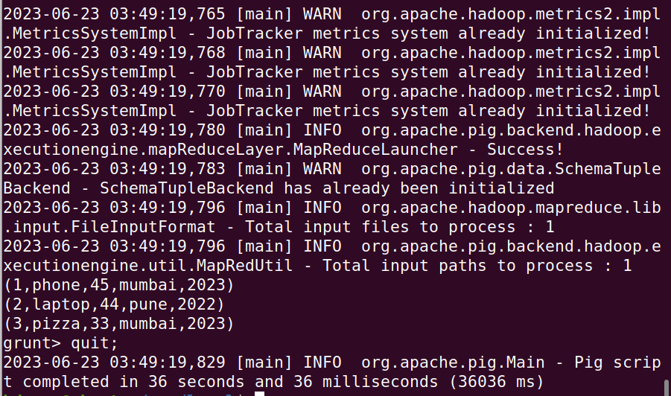

Conclusion: Install, Configure and Run Hive is successfully demonstrated.

PRACTICAL NO 6

Aim: Implement Decision tree classification

Code:
# section 6a Decision Trees
#######################################################
install.packages("rpart.plot") # install package rpart.plot
library("rpart")
library("rpart.plot")
# Read the data
setwd('C:/Users/Admin/Desktop/Anjali BDA Prac')
getwd()
banktrain <- read.table("bank-sample.csv",header=TRUE,sep=",")
View(banktrain)
summary(banktrain)
## drop a few columns to simplify the tree
drops<-c("age", "balance", "day", "campaign", "pdays", "previous", "month")
banktrain <- banktrain [,!(names(banktrain) %in% drops)]
summary(banktrain)
# Make a simple decision tree by only keeping the categorical variables
fit <- rpart(subscribed ~ job + marital + education + default + housing + loan + contact + poutcome,
method="class",
data=banktrain,
control=rpart.control(minsplit=1),
parms=list(split='information'))
summary(fit)
# Plot the tree
rpart.plot(fit, type=4, extra=2, clip.right.labs=FALSE, varlen=0, faclen=3)
##########################################
# section 7.1.2 The General Algorithm
##########################################
# include a numeric variable "duration" into the model
fit <- rpart(subscribed ~ job + marital + education + default + housing + loan + contact + duration + poutcome,
method="class",
data=banktrain,
control=rpart.control(minsplit=1),
parms=list(split='information'))
summary(fit)
# Plot the tree
rpart.plot(fit, type=4, extra=2, clip.right.labs=FALSE, varlen=0, faclen=3)
# Predict
newdata <- data.frame(job="retired",
marital="married",
education="secondary",
default="no",
housing="yes",
loan="no",
contact = "cellular",
duration = 598,
poutcome="unknown")
newdata
predict(fit,newdata=newdata,type=c("class"))

Output:

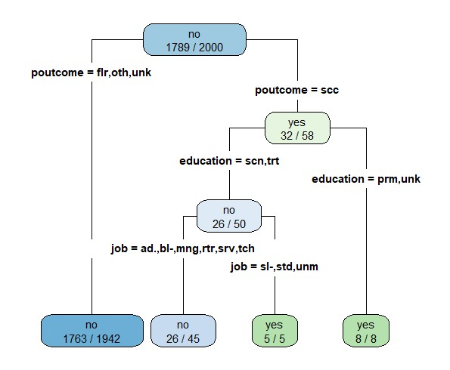

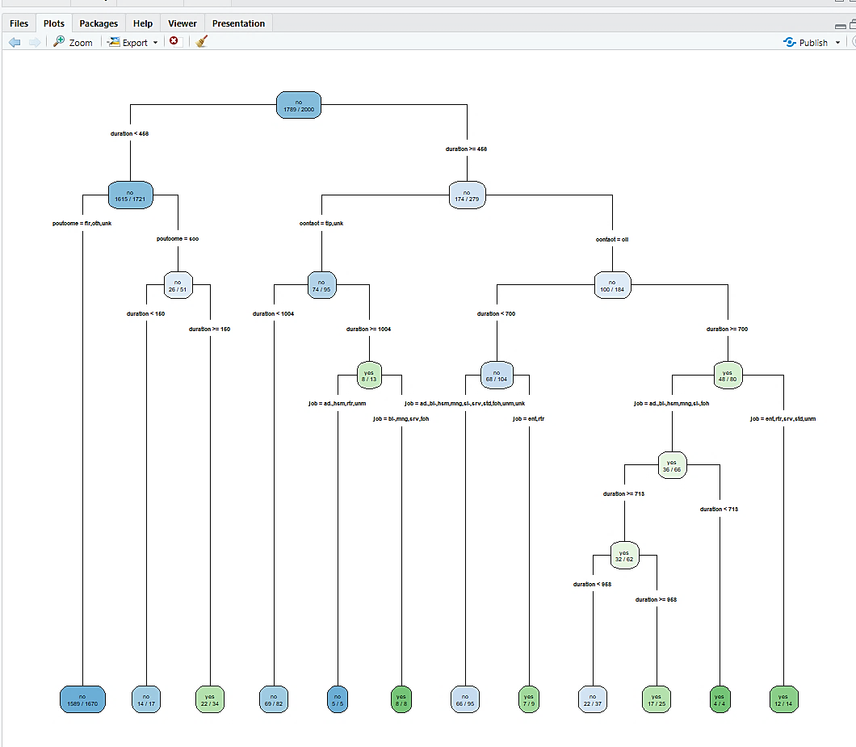

Prediction:
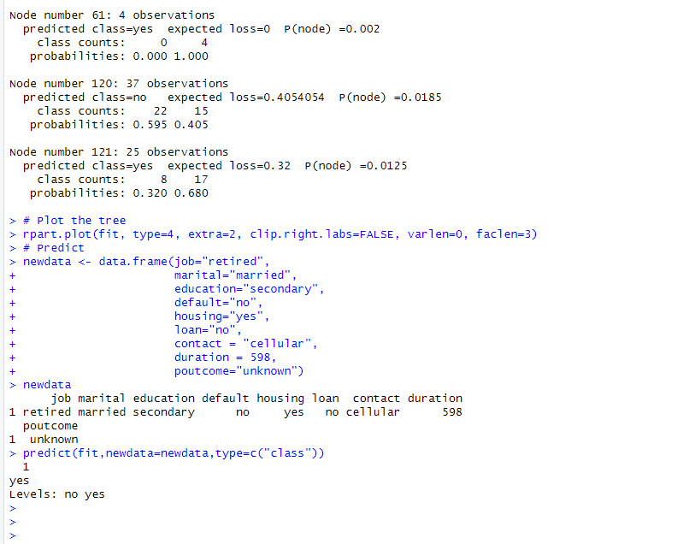

Conclusion: Implement Decision tree classification is successfully demonstrated.

PRACTICAL NO 7

Aim: Implement SVM classification techniques

Code:
###############################################################
##7 SVM.R####
################################################################
set.seed(10111)
x = matrix(rnorm(40), 20, 2)
y = rep(c(-1, 1), c(10, 10))
x[y == 1,] = x[y == 1,] + 1
eplot(x, col = y + 3, pch = 19)
library(e1071)
dat = data.frame(x, y = as.factor(y))
svmfit = svm(y ~ ., data = dat, kernel = "linear", cost = 10, scale = FALSE)
print(svmfit)
plot(svmfit, dat)

Output:

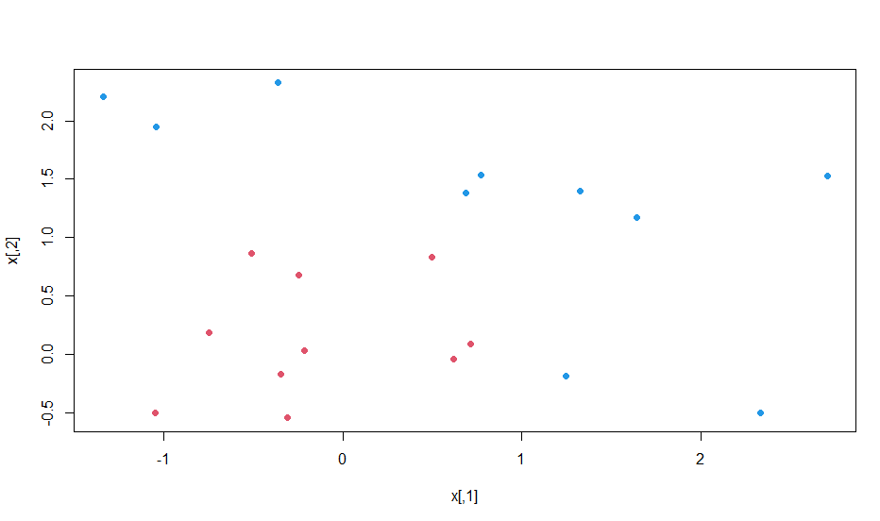
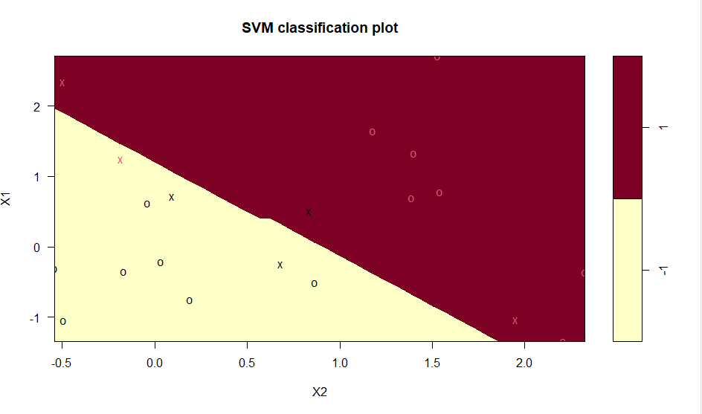
Prediction:

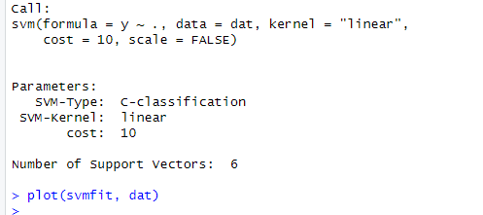

Conclusion: Implement SVM classification techniques is successfully demonstrated.

PRACTICAL NO 8

Aim: Implement Logistic Regression Model
Code:
###############################################################
# This code covers the code presented in
# Section 8 Logistic Regression
##############################################################
churn_input = as.data.frame( read.csv("C:/Users/Admin/Desktop/BDA Prac/9A/churn.csv") )
head(churn_input)
sum(churn_input$Churned)
Churn_logistic1 <- glm (Churned~Age + Married + Cust_years + Churned_contacts,
data=churn_input, family=binomial(link="logit"))
summary(Churn_logistic1)
Churn_logistic2 <- glm (Churned~Age + Married + Churned_contacts,
data=churn_input, family=binomial(link="logit"))
summary(Churn_logistic2)
Churn_logistic3 <- glm (Churned~Age + Churned_contacts,
data=churn_input, family=binomial(link="logit"))
summary(Churn_logistic3)
# Deviance and the Log Likelihood Ratio Test
# Using the residual deviances from Churn_logistics2 and Churn_logistic3
# determine the signficance of the computed test statistic
summary(Churn_logistic2)
pchisq(.9 , 1, lower=FALSE)
# Receiver Operating Characteristic (ROC) Curve
install.packages("ROCR") #install, if necessary
library(ROCR)
pred = predict(Churn_logistic3, type="response")
predObj = prediction(pred, churn_input$Churned )
rocObj = performance(predObj, measure="tpr", x.measure="fpr")
aucObj = performance(predObj, measure="auc")
plot(rocObj, main = paste("Area under the curve:", round(aucObj@y.values[[1]] ,4)))

Output:
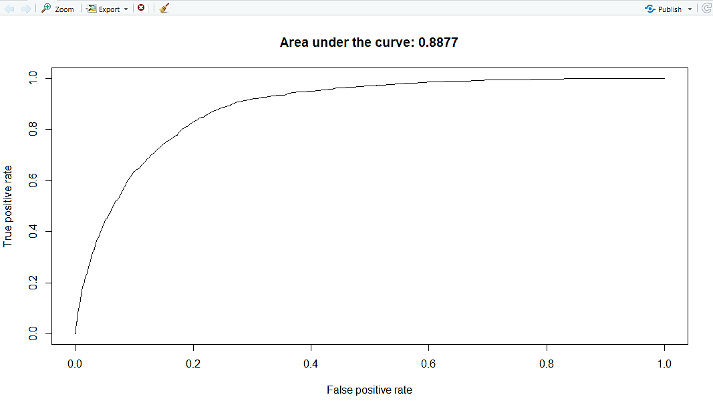

Prediction:
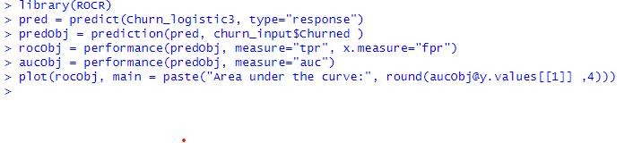
Conclusion: Implement Logistic Regression Model is successfully demonstrated.

PRACTICAL NO 9

Aim: Implement Linear Regression Model
Code:
# This code covers the code presented in
# Section 9b Linear Regression
########################################

income_input = as.data.frame( read.csv('C:/Users/Admin/Desktop/ BDA Prac/9A/income.csv') )
income_input[1:10,]
summary(income_input)
library(lattice)
splom(~income_input[c(2:5)], groups=NULL, data=income_input,
axis.line.tck = 0,
axis.text.alpha = 0)
# can use pairs() as used in earlier pracs
results <- lm(Income~Age + Education + Gender, income_input)
summary(results)
results2 <- lm(Income ~ Age + Education, income_input)
summary(results2)
# compute confidence intevals for the model parameters
confint(results2, level = .95)
# compute a confidence interval on the expected income of a person
Age <- 41
Education <- 12
new_pt <- data.frame(Age, Education)
conf_int_pt <- predict(results2, new_pt, level=.95, interval="confidence")
conf_int_pt
# compute a prediction interval on the income of the same person
pred_int_pt <- predict(results2, new_pt, level=.95, interval="prediction")
pred_int_pt

Output:
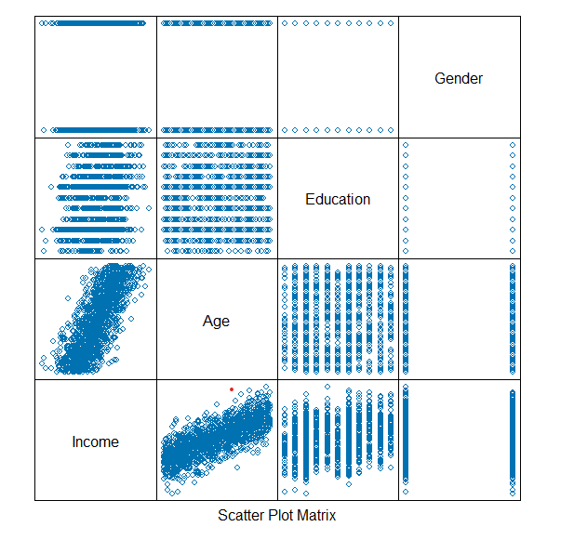

Prediction:
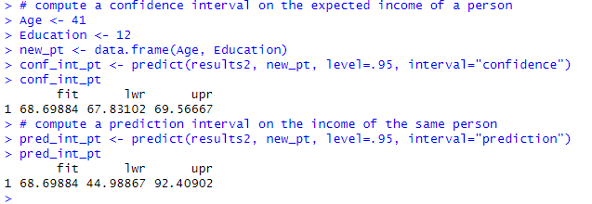

Conclusion: Implement Linear Regression Model is successfully demonstrated.

PRACTICAL NO 10

Aim: Implement classification using Naive Bayes Theorem & Evaluate the performance of classifier
Code:
install.packages('e1071')
#Installing package into ‘C:/Users/NGT/Documents/R/win-library/3.6’ (as ‘lib’ is unspecified)
library(e1071)
data=read.csv("C:/Users/Admin/Desktop/Anjali BDA Prac/10/diabetes.csv")
View(data)
head(data)
nbsmodel=naiveBayes(Outcome ~.,data=data)
nbsmodel
nbspred=predict(nbsmodel,data)
nbspred
tt=table(nbspred,data$Outcome)
tt
acc_test=sum(diag(tt)/sum(tt))
acc_test
Output:
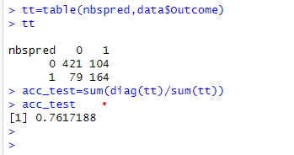

Conclusion: Implement classification using Naive Bayes Theorem & Evaluate the performance of classifier is successfully demonstrated.

PRACTICAL NO 11

Aim: Implement Clustering algorithms for unsupervised classification & plot the cluster data using R visualizations.
Code:
# 11. Open & Read Iris data set
iris
View(iris)
newiris = iris
newiris
summary(newiris)
View(newiris)
newiris$Species = NULL
View(newiris)
#2.Apply kmeans to newiris, and
# store the clustering result in kc.
# The cluster number is set to 3.
kc = kmeans(newiris,3)
kc
table(iris$Species, kc$cluster)
# 4. Plot the clusters and their centres
plot(newiris[c("Sepal.Length", "Sepal.Width")], col=kc$cluster)
# Mark Cluster centers
points(kc$centers[,c("Sepal.Length", "Sepal.Width")], col=1:3, pch=6, cex=2)

Output:

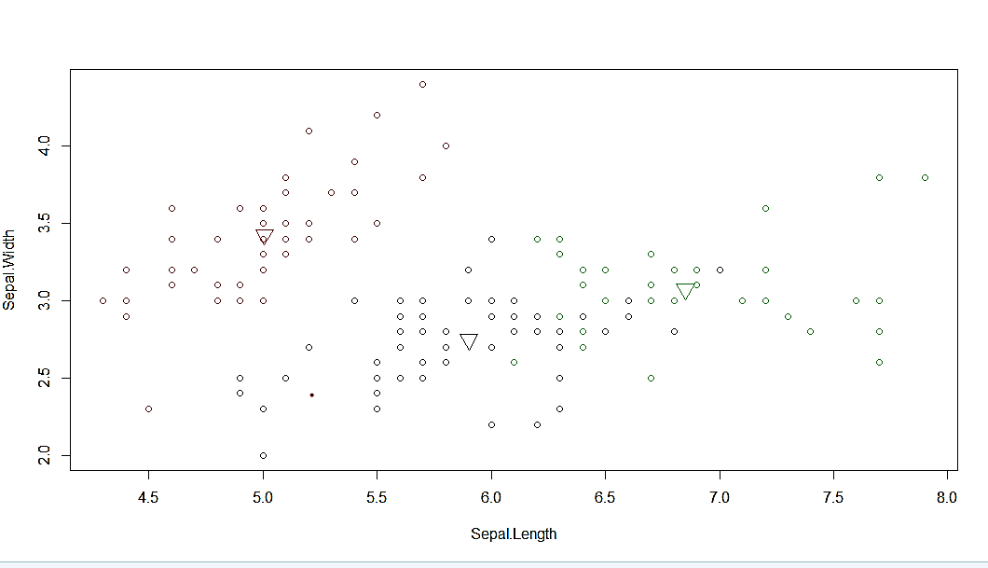

Prediction:

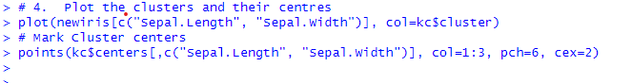

Conclusion: Implement Clustering algorithms for unsupervised classification & plot the cluster data using R visualizations is successfully demonstrated.

