PRACTICAL 01
Aim: Create a console based ASP.Net Core application
Step 1:
- Download asp.net core from https://dotnet.microsoft.com/en-us/download
- Install the downloaded file
- To verify installation, open command prompt and enter ‘dotnet’.
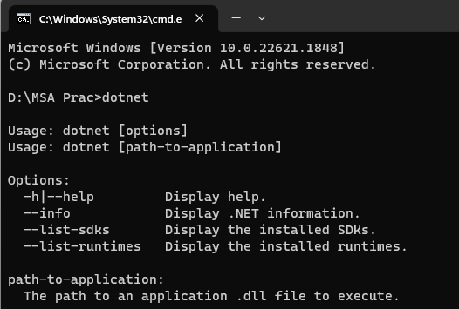
- To check version, type ‘dotnet –version’ and click Enter
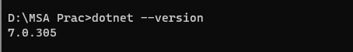

Step 2:
- Create a directory where you want to store all the files
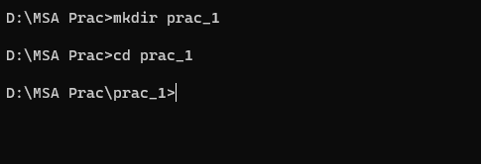
- Create a new dotnet console using ‘dotnet new console’
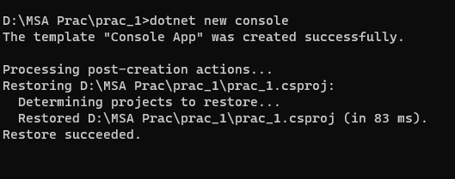
- To restore dotnet, enter ‘dotnet restore’
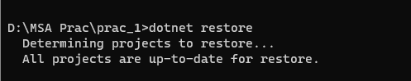

Step 3:
- Open the file location. You will find the following files.
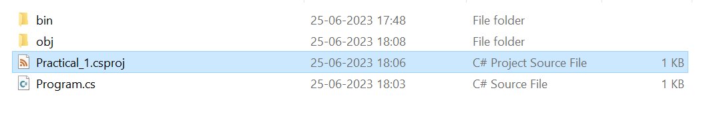
- Open Practical_1.csproj. The following code will available there by default.
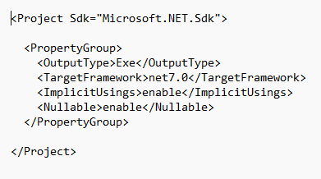
- Open Program.cs. The following code will available there by default.

- Run the program using ‘dotnet run’
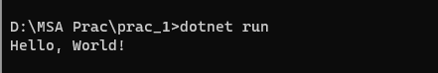

Step 4:
- Install the following packages using ‘dotnet add package package_name -v version_number’
- Microsoft.AspNetCore.Mvc
- Microsoft.AspNetCore.Server.Kestrel
- Microsoft.Extensions.Logging
- Microsoft.Extensions.Logging.Console
- Microsoft.Extensions.Logging.Debug
- Microsoft.Extensions.Configuration.CommandLine
- The installed packages will be reflected automatically in the helloworld.csproj file.
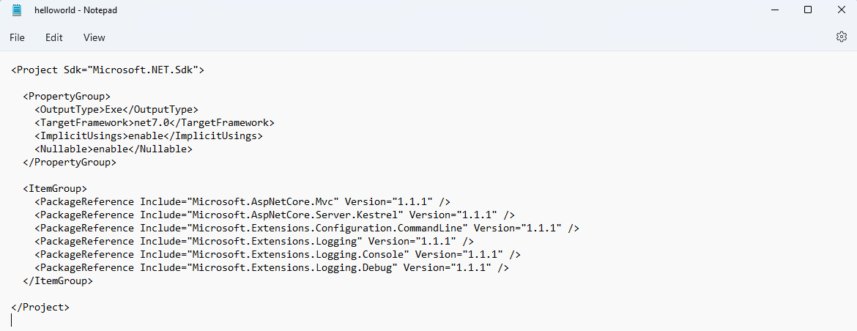
- Use ‘dotnet restore’ to restore

Step 5:
- Open Program.cs and enter the following code.
using System;
using Microsoft.AspNetCore.Builder;
using Microsoft.AspNetCore.Hosting;
using Microsoft.Extensions.Logging;
using Microsoft.Extensions.Configuration;
using Microsoft.AspNetCore.Http;

namespace helloworld
{
internal class Program
{
static void Main(string[] args)
{
var config=new ConfigurationBuilder()
.AddCommandLine(args)
.Build();
var host=new WebHostBuilder()
.UseKestrel()
.UseStartup<Startup>()
.UseUrls("http://localhost:5200/")
.UseConfiguration(config)
.Build();
host.Run();
}
}
public class Startup
{
public Startup(IHostingEnvironment env) {}
public void Configure(IApplicationBuilder app, IHostingEnvironment env, ILoggerFactory loggerFactory)
{
app.Run(async (context) => {await context.Response.WriteAsync("Hello, world!");});
}
}
}

OUTPUT
- Use ‘dotnet restore’ to restore
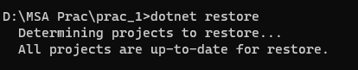
- Use ‘dotnet run’ to run
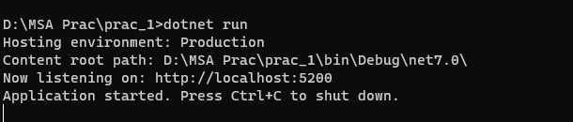
- Copy the URL and open it in any browser
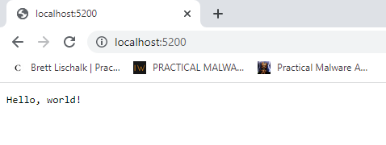

PRACTICAL 02

Aim: Working with Docker
Step 1: Install WSL command
- Open PowerShell or Windows Command Prompt in administrator mode.
- Enter the ‘wsl’ command. WSL stands for Windows Subsystem for Linux.
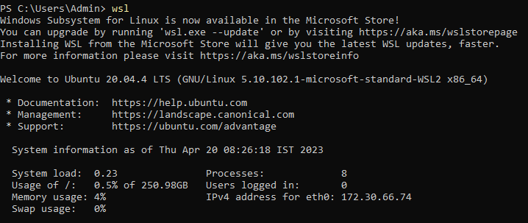

- To see a list of available Linux distributions available for download through the online store, enter: ‘wsl -l -o’.
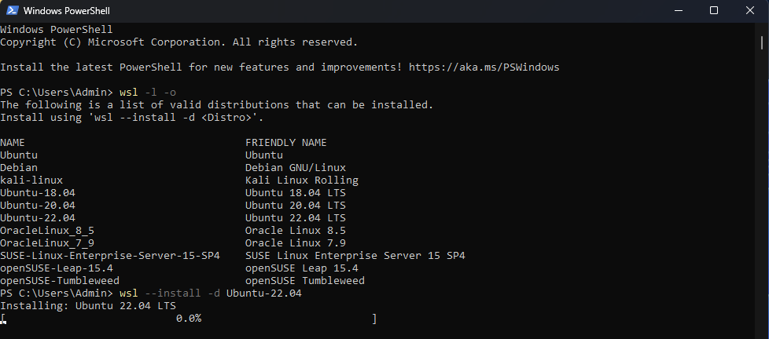

- To install Linux distributions use the command: ‘wsl --install -d <Distribution Name>’.
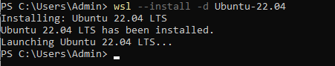
- After successful installation of the Linux distribution, the following window will appear. Set username and password for the Windows Subsystem for Linux.
Note: The password will not be visible when you enter it.
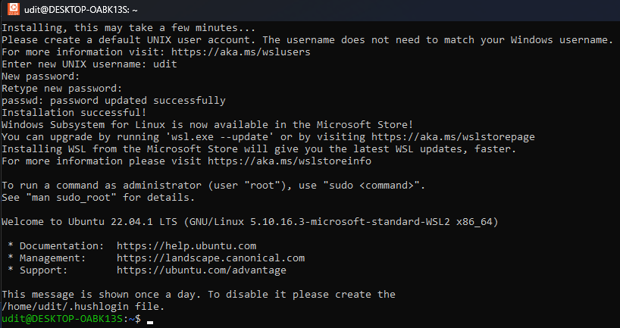
Step 2: Install Docker Desktop
- Download Docker Desktop using the following link: https://www.docker.com/products/docker-desktop/
- Install Docker Desktop
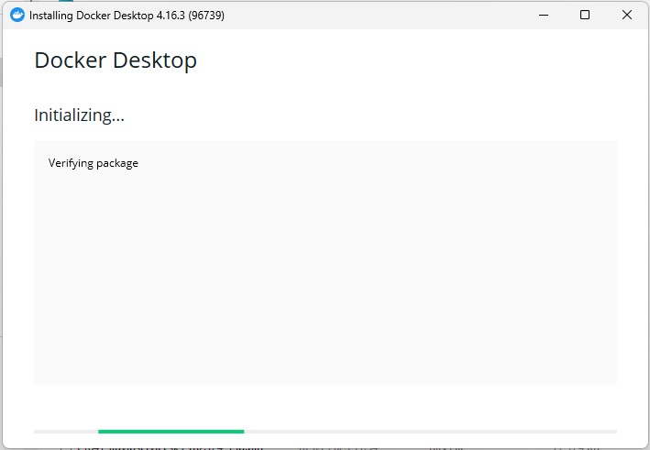
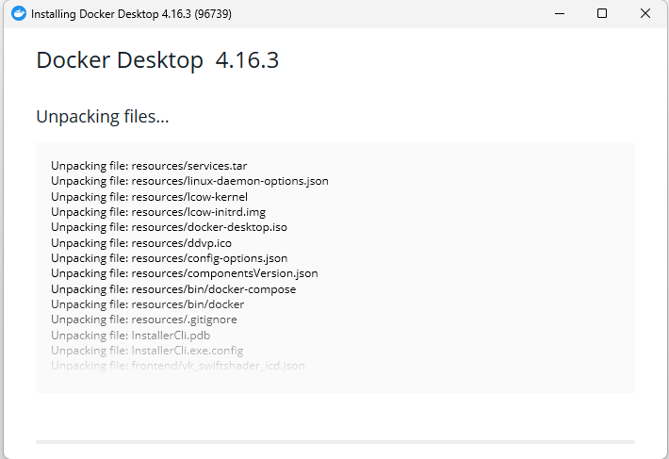

- Select the following checkboxes when prompted
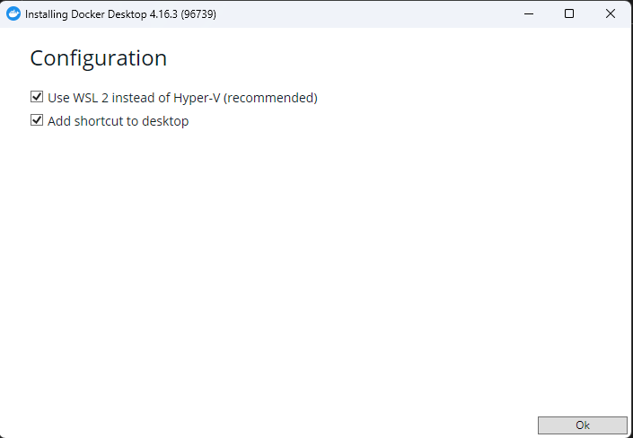
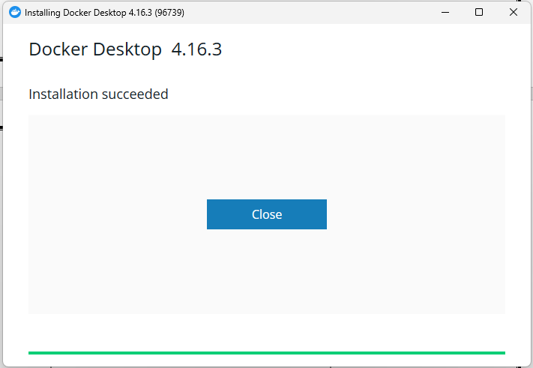
- After installation, run Docker Desktop. Accept the terms and conditions.
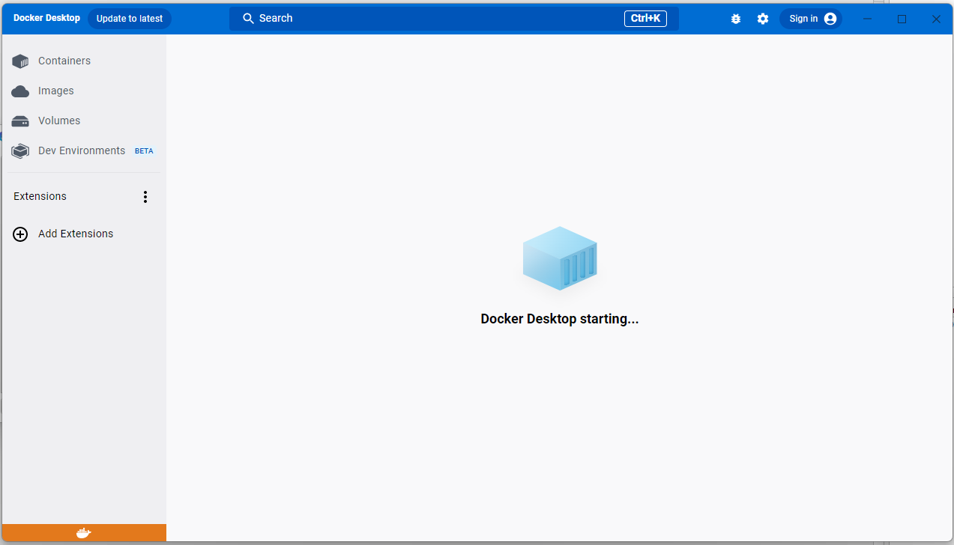

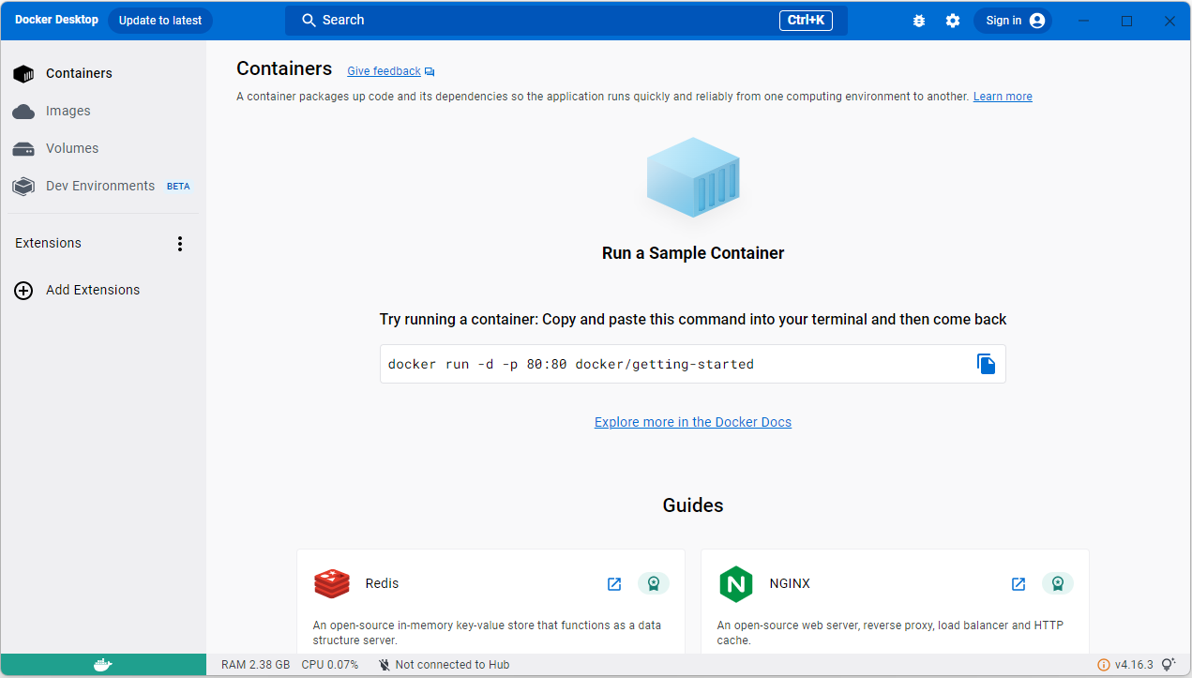

- Go to command prompt, to check docker installation enter: ‘docker’
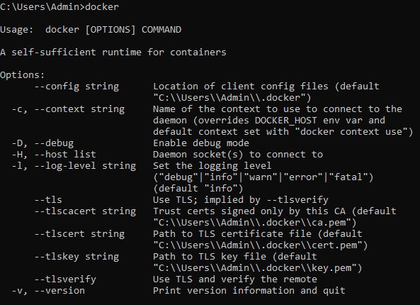

- To check version of Docker, enter the following command: ‘docker --version’
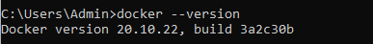

Step 3: Publishing an existing image into Docker container
- To publish an existing docker ‘hello world’ image into a docker container, use:
‘docker run -p 8080:8080 dotnetcoreservices/hello-world’
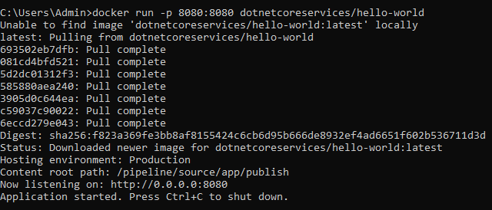
- Copy the URL from the above output and paste it in any browser. Change the IP address in the URL to ‘127.0.0.1’.
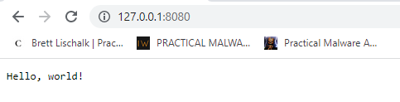

- Also if you go to Docker Desktop Images, you will see that the hello-world image has been published in the container.
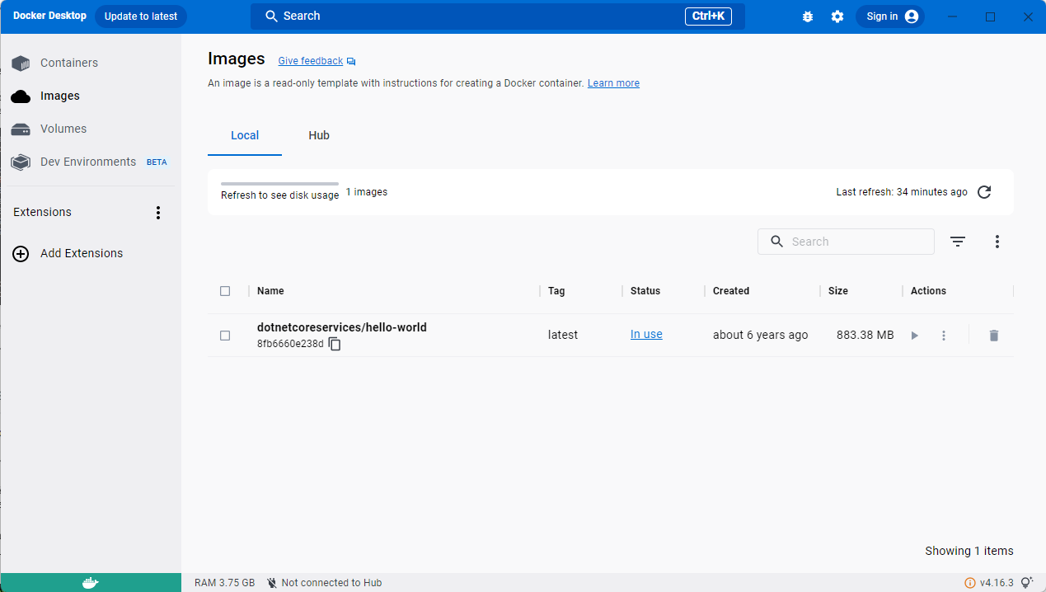

- To run the image in the command prompt enter: ‘curl http://localhost:8080/will/it/blend?’.curl or ClientURL is a command line tool that enables data exchange between a device and a server through a terminal.
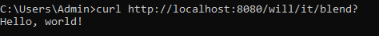
- To list all containers, use: ‘docker ps’.
- To delete or kill a Docker container, use ‘docker kill <Container ID>’.
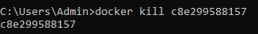

- Verify deletion using ‘docker ps’.

PRACTICAL 03
Aim: Usage of Docker - Docker Hub
- Pull an existing image from docker and push it to docker repository and run it.
Step 1:
- Go to Docker Hub using the following URL: https://hub.docker.com/
- Create an account on Docker Hub and sign in.
- Go to Repositories Click on Create repository.
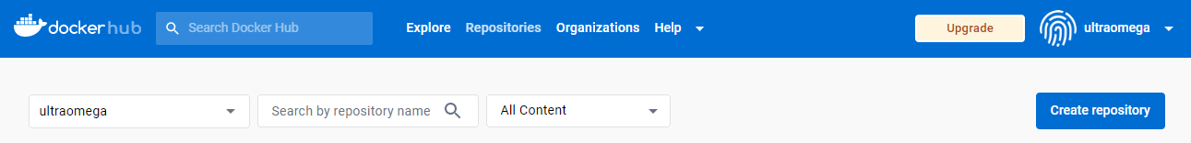
- Set the name of the repository as ‘repo1’ and add some description about the repository. Set the visibility as Private.
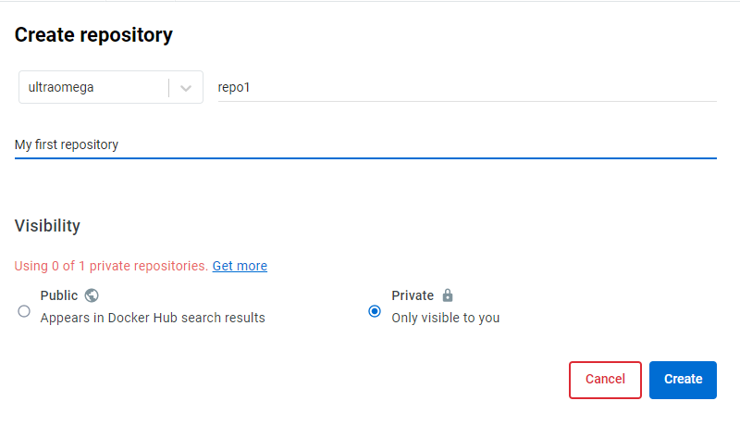
- Click Create.

Step 2:
- Go to Docker Playground using the following link: https://labs.play-with-docker.com/

- Click on Start
- Create on add new instance
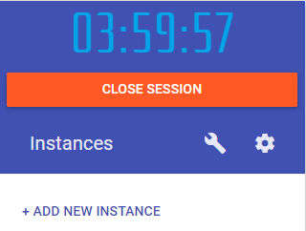
- The following command prompt will open.
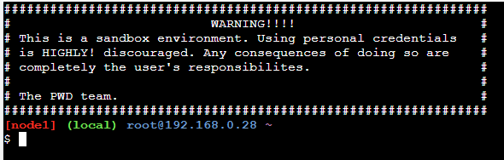
- To check version of Docker, enter the following command: ‘docker --version’
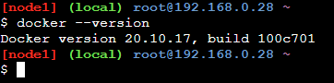

Step 3:
- To pull an existing docker ‘hello world’ image, use: ‘docker pull hello-world’
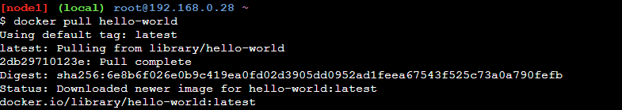
- To check the images available in docker use: ‘docker images’
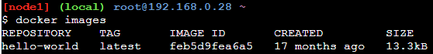
- To log into your Docker Hub use: ‘docker login’. Enter username and password.
Note: The password will not be visible when you enter it in the password section.
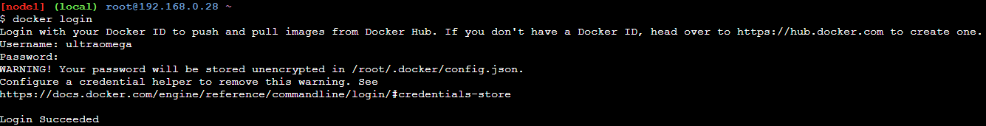
- Create a tag in the repository created in Step 1. To do this use: ‘docker tag <image id> <username>/<repository_name>:tag_name’. In our case the repository name is ‘repo1’ and tag name is ‘firsttag’
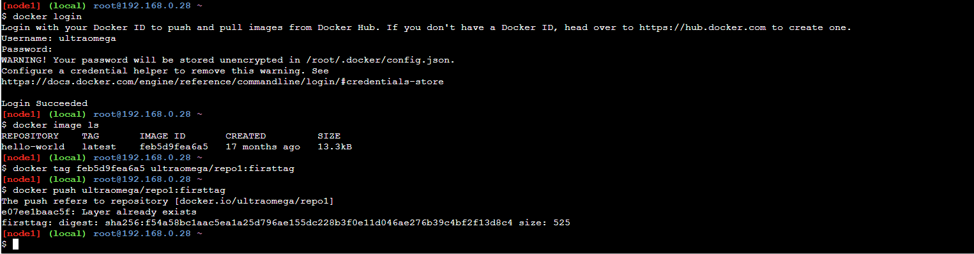
- To push the hello world image to your repository use: ‘docker push <username>/<repository_name>:tag_name’
- Now go to Docker Hub. Under Respositories, select your repository Go to Tags You will see the ‘firsttag’ tag has been created.
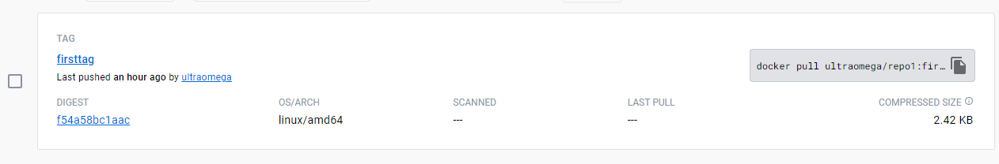
- Build your own image and then push it to the docker repository and run it.
- Go back to Docker Hub.
- To build a new image, use the following commands:
cat > Dockerfile << EOF
FROM busybox
cmd echo “Hello World! This is my first docker image”
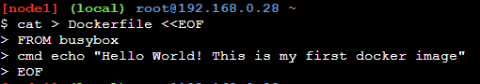
- To build this image to a new repository, use: ‘docker build -t <username>/<repository_name> .’
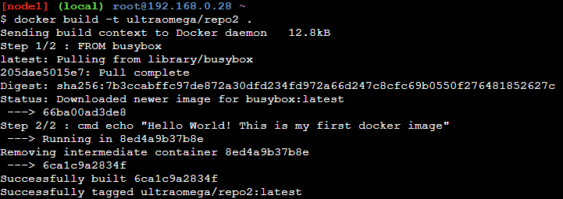
- Push this image to Docker hub repository
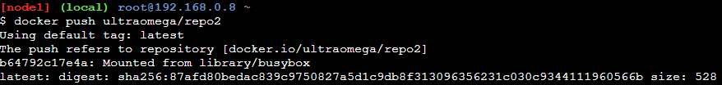
- Check the output on docker hub
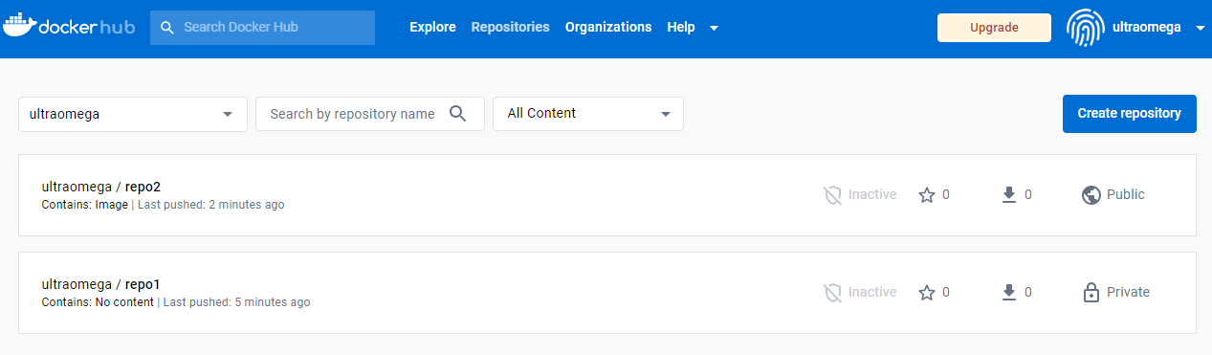
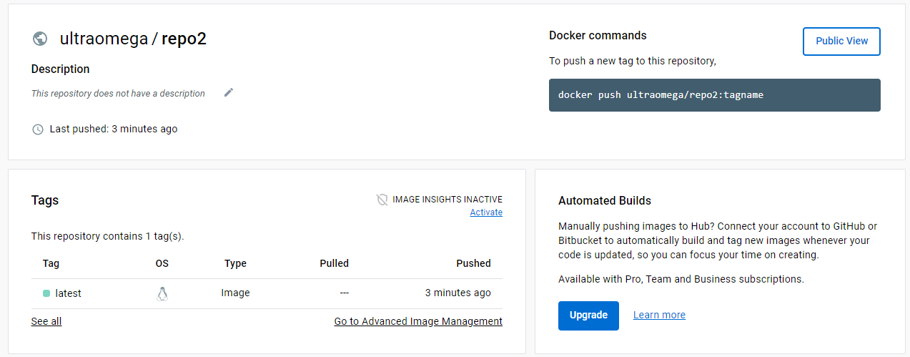
- Use ‘docker run <username>/<repository_name>’ to run the image.
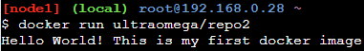

PRACTICAL 04
Aim: Creating a MVC based ASP .NET application
Step 1:
- Go to command prompt and navigate to the folder to where you want to store application files. Enter the following command: ‘dotnet new mvc --auth none’.
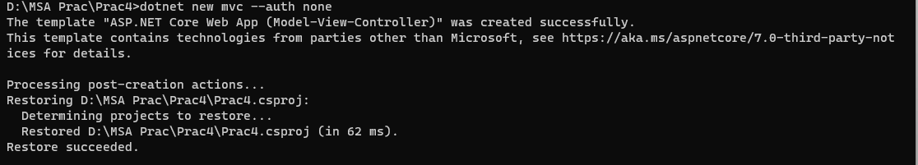
- The following files will be created in the specified location.
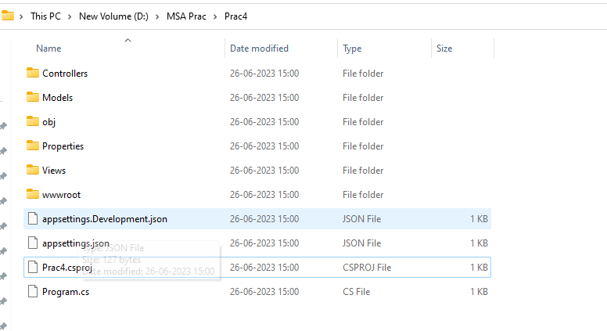
Step 2:
- Go to Notepad. Create a new file and enter the following code.
namespace Practical_4.Models
{
public class StockQuote
{
public string Symbol{get; set;}= default!;
public int Price{get; set;}= default!;
}
}

- Save the file as ‘StockQuote.cs’ in the Models folder of the project.

Step 3:
- Go to Views folder Open Home folder Open Index.cshtml file and replace the existing code with the following:
@{
ViewData["Title"] = "Home Page";
}

<html>
<head>
<title>Hello World</title>
</head>
<body>
<h1>Hello World</h1>
<div>
<h2>StockQuote</h2>
<div>
Symbol: @Model.Symbol<br/>
Price: $@Model.Price<br/>
</div>
</div>
</body>
</html>

Step 4:
- Go to Controllers folder Open HomeController.cs file and replace the existing code with the following:
using System;
using System.Collections.Generic;
using System.Diagnostics;
using System.Linq;
using System.Threading.Tasks;
using Microsoft.AspNetCore.Mvc;
using Microsoft.Extensions.Logging;
using Practical_4.Models;

namespace Practical_4.Controllers;

public class HomeController : Controller
{
public async Task <IActionResult>Index()
{
var model= new StockQuote{ Symbol="Nike", Price=3200};
await Task.Delay(0);
return View(model);
}
}

Step 5:
- Go back to the command prompt. Restore and run the application using ‘dotnet restore’ and ‘dotnet run’ respectively.
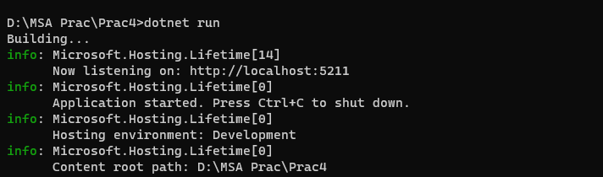

- Open the above URL in any browser.
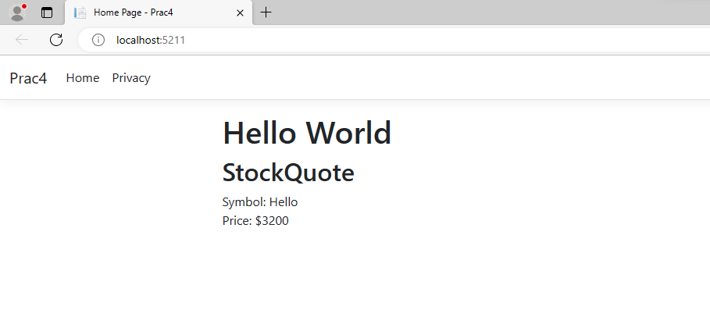

PRACTICAL 05
Aim: Running a Asp.net Core Console Application in Docker Container
Step 1:
- Go to command prompt and navigate to the folder to where you want to store application files. Enter the following command: ‘dotnet new console -o App -n DotNet.Docker’.
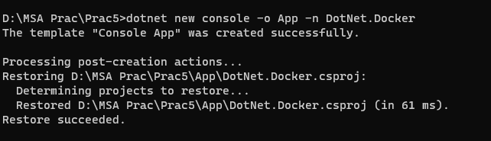

- The following files will be created in the specified location.
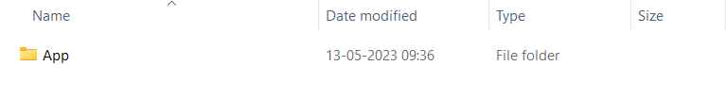
- Go back to command prompt and run the application using ‘dotnet run’.
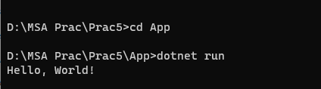
Step 2:
- Go to project folder Open App folder Open Program.cs. Replace the existing code with the following code:
var counter = 0;
var max = args.Length is not 0 ? Convert.ToInt32(args[0]) : -1;
while (max is -1 || counter < max)
{
Console.WriteLine($"Counter: {++counter}");
await Task.Delay(TimeSpan.FromMilliseconds(1_000));
}

- The above given code counts numbers every second.

- Save the file and run the application in command prompt using ‘dotnet run’. This app runs indefinitely so use cancel command Ctrl+C to stop it.
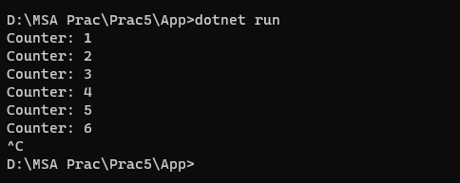

- If you pass a number on the command line to the app, it will only count up to that amount and then exit. For example: ‘dotnet run -- 3’
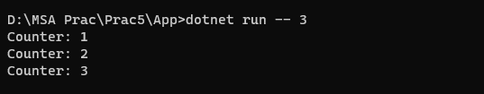
Step 3:
- Before adding the .NET app to the Docker image, first it must be published. To publish the app, run the following command: ‘dotnet publish -c Release’
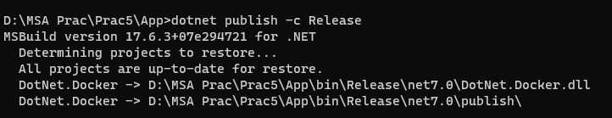

- This command compiles your app to the publish folder. The path to the publish folder from the working folder will be ".\App\bin\Release\net7.0\publish\".
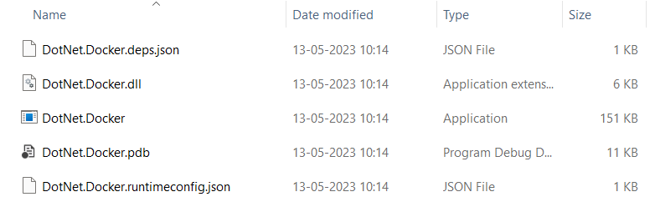

Step 4:
- Open Notepad Create a Dockerfile using the following code:

FROM mcr.microsoft.com/dotnet/sdk:7.0 AS build-env
WORKDIR /App

# Copy everything
COPY . ./
# Restore as distinct layers
RUN dotnet restore
# Build and publish a release
RUN dotnet publish -c Release -o out

# Build runtime image
FROM mcr.microsoft.com/dotnet/aspnet:7.0
WORKDIR /App
COPY --from=build-env /App/out .
ENTRYPOINT ["dotnet", "DotNet.Docker.dll"]

- This file should be saved in the same directory where the .csproj file is saved i.e., in the App folder. Note: Dockerfile is a text file that doesn't have any extension. While saving the file, use double inverted quotes - “Dockerfile” - and it will be saved as a file as shown below.
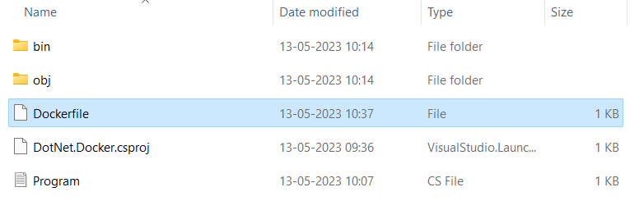

Step 5:
- Open Docker Desktop Go to Images.
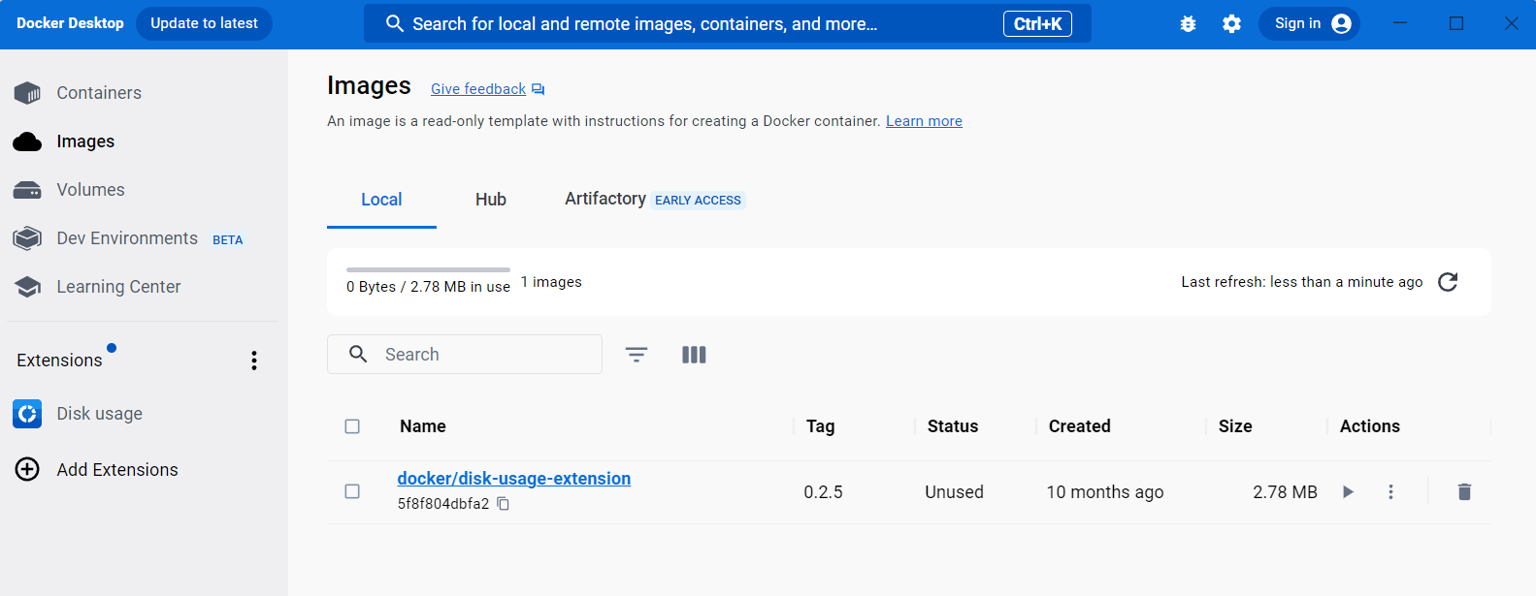
- Go back to the command prompt. Create a local repository named ‘counter-image’ and build the image using the following command: ‘docker build -t counter-image -f Dockerfile .’
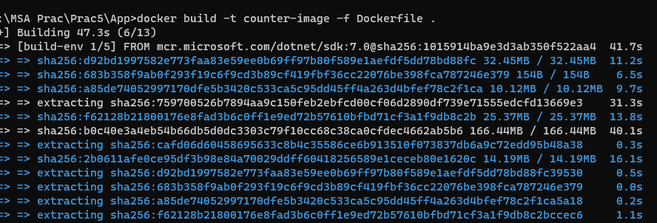
- Run ‘docker images’ to see a list of images installed.
- Also, if you check Images in Docker Desktop you will see the newly created image.
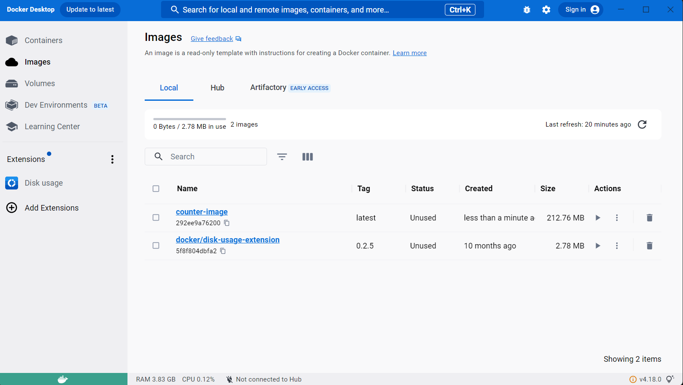
Step 6:
- Create a container named ‘core-counter’ using the following command: ‘docker create --name core-counter counter-image’
- To see a list of all containers, use the ‘docker ps -a’ command.
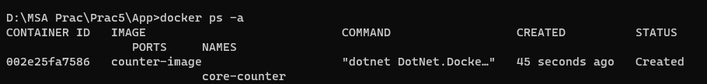
Step 7:
- Start the ‘core-counter’ container using following command: ‘docker start core-counter’.
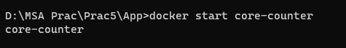
- Check the output in Docker Desktop Containers core-counter Logs.
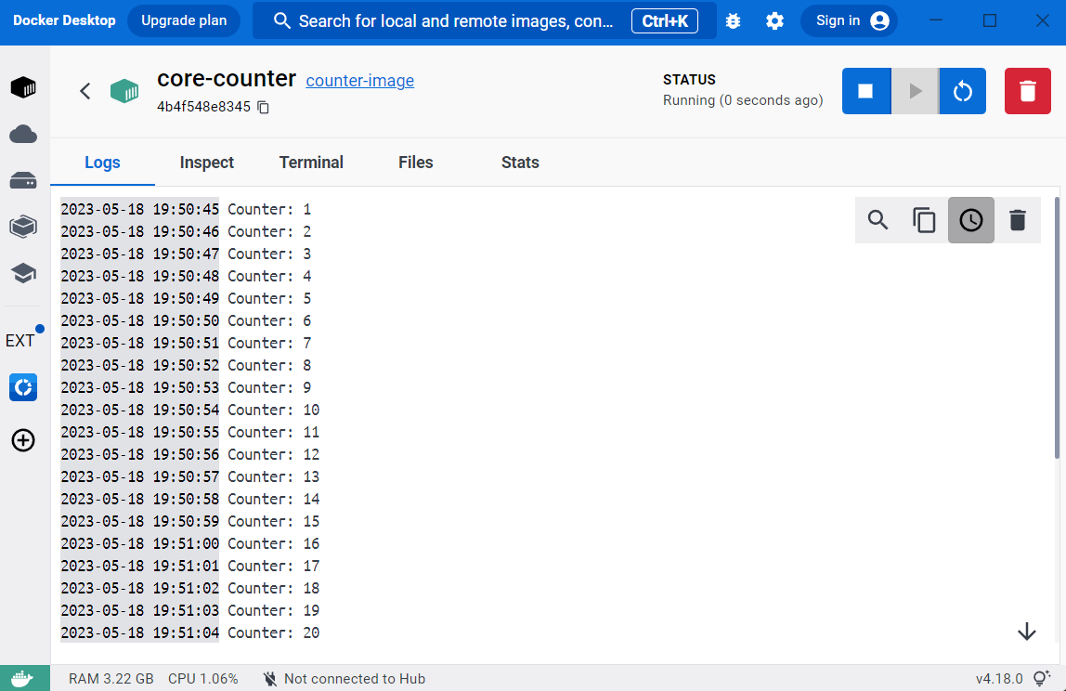
- To stop the code, enter ‘docker stop core-counter’ in the command prompt.
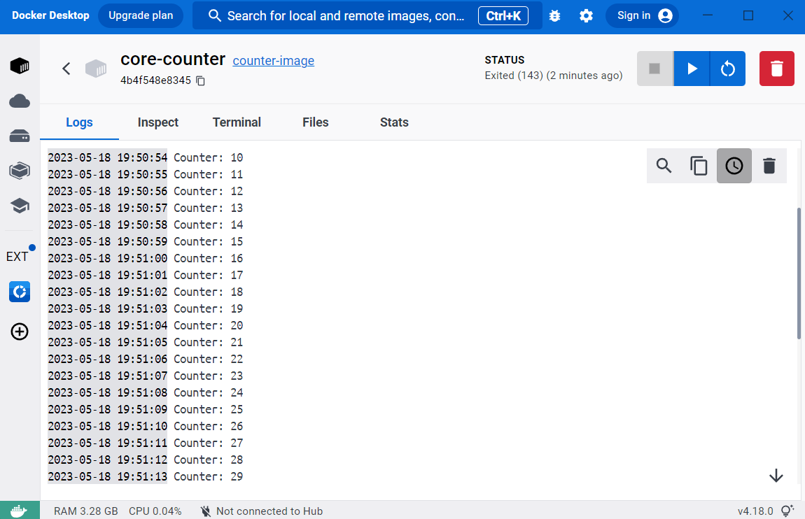

PRACTICAL 06
Aim: Building ASP.Net core REST API

Step 1:
- Go to command prompt and navigate to the folder to where you want to store application files. Enter the following command: ‘dotnet new webapi -o Glossary’.
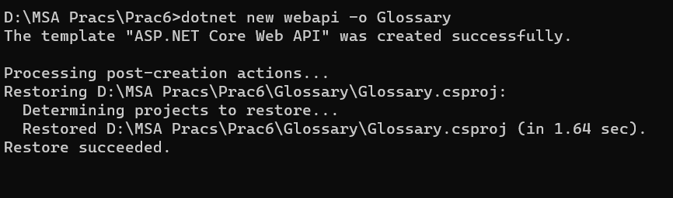

- The following files will be created in the specified location.
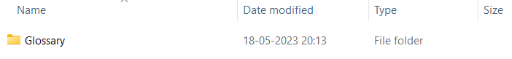

- Go back to command prompt and run the application using ‘dotnet run’.
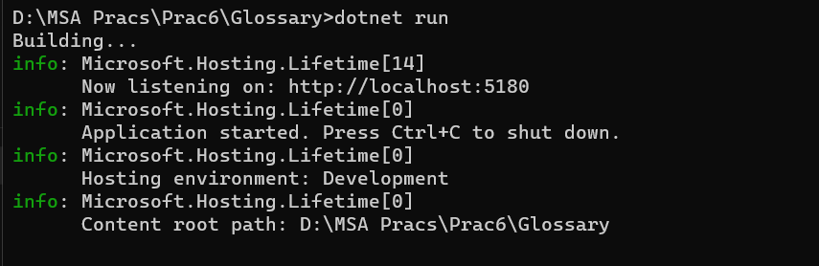

- Note down the URL as shown above and open one more command prompt window. Enter the following command: ‘curl –-insecure http://localhost:5180/WeatherForecast’ 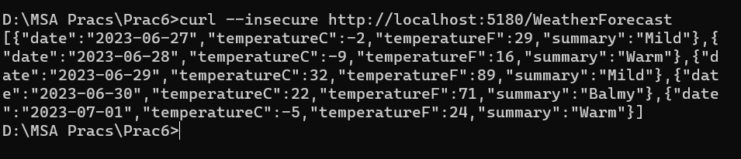

- Delete the WeatherForecast.cs from the Glossary folder and also delete WeatherForecastController.cs from the Controllers folder.
Step 2:
- Create a class file named “GlossaryItem.cs” in the Glossary folder with the following code:
namespace Glossary
{
public class GlossaryItem
{
public string Term {get; set;}= default!;
public string Definition {get; set;}= default!;
}
}

- Create a class file named “GlossaryController.cs” in the Controllers folder with the following code:
using System;
using System.Collections.Generic;
using Microsoft.AspNetCore.Mvc;
using System.IO;

namespace Glossary.Controllers;

[ApiController]
[Route("api/[controller]")]

public class GlossaryController :ControllerBase
{
private static List<GlossaryItem> Glossary =new List<GlossaryItem>
{
new GlossaryItem
{
Term="HTML",
Definition="Hypertext Markup Language"
},
new GlossaryItem
{
Term="MVC",
Definition="Model View Controller"
},
new GlossaryItem
{
Term="OpenID",
Definition="An open standard for authentication"
}
};

[HttpGet]
public ActionResult<List<GlossaryItem>>Get()
{
return Ok(Glossary);
}

[HttpGet]
[Route("{term}")]
public ActionResult<GlossaryItem>Get(string term)
{
var glossaryItem=Glossary.Find(item =>
item.Term.Equals(term, StringComparison.InvariantCultureIgnoreCase));
if (glossaryItem == null)
{
return NotFound();
}
else
{
return Ok(glossaryItem);
}
}

[HttpPost]
public ActionResult Post(GlossaryItem glossaryItem)
{
var existingGlossaryItem=Glossary.Find(item =>
item.Term.Equals(glossaryItem.Term, StringComparison.InvariantCultureIgnoreCase));
if (existingGlossaryItem != null)
{
return Conflict("Cannot create term because it already exists");
}
else
{
Glossary.Add(glossaryItem);
var resourceUrl=Path.Combine(Request.Path.ToString(),Uri.EscapeDataString(glossaryItem.Term));
return Created(resourceUrl, glossaryItem);
}
}
[HttpPut]
public ActionResult Put(GlossaryItem glossaryItem)
{
var existingGlossaryItem=Glossary.Find(item =>
item.Term.Equals(glossaryItem.Term, StringComparison.InvariantCultureIgnoreCase));
if (existingGlossaryItem == null)
{
return BadRequest("Cannot update a non existing term");
}
else
{
existingGlossaryItem.Definition=glossaryItem.Definition;
return Ok();
}
}

[HttpDelete]
[Route("{term}")]
public ActionResult Delete(string term)
{
var glossaryItem=Glossary.Find(item =>
item.Term.Equals(term, StringComparison.InvariantCultureIgnoreCase));
if (glossaryItem == null)
{
return NotFound();
}
else
{
Glossary.Remove(glossaryItem);
return NoContent();
}
}
}
Step 3:
- Run the application in command prompt using ‘dotnet run’. Note down the URL. Open one more command prompt window. Enter the following commands:
- Getting the list of Items
curl --insecure http://localhost:5180/api/glossary
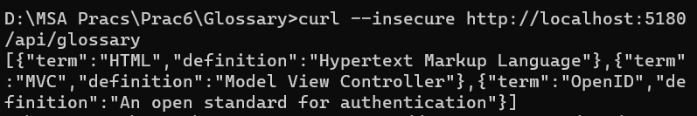

- Getting single Item
curl http://localhost:5180/api/glossary/MVC
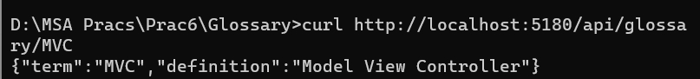
curl http://localhost:5180/api/glossary/HTML
curl http://localhost:5180/api/glossary/OpenID
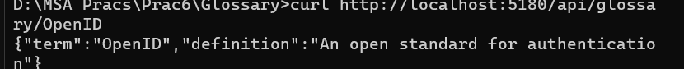

- Creating an Item
curl --insecure -X POST -d "{\"term\": \"MFA\", \"definition\":\"An authentication process.\"}" -H "Content-Type: application/json" http://localhost:5180/api/glossary
Check the output using:
curl --insecure http://localhost:5180/api/glossary/MFA
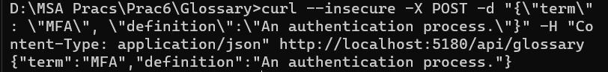
- Updating an Item
curl --insecure -X PUT -d "{\"term\": \"MVC\", \"definition\":\"Modified record of Model View Controller.\"}" -H "Content-Type: application/json" http://localhost:5180/api/glossary
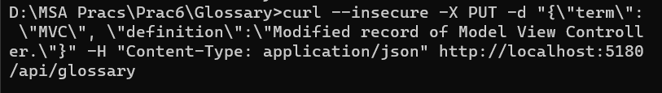
Check the output using:
curl --insecure http://localhost:5180/api/glossary/MVC
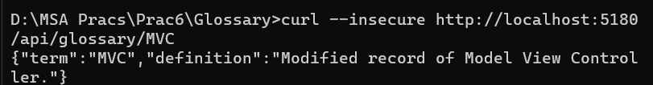

- Deleting an Item
curl –-insecure --request DELETE --url http://localhost:5180/api/glossary/OpenID
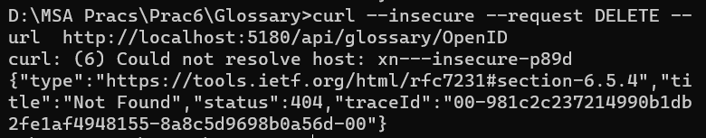
Check the output using:
curl --insecure http://localhost:5180/api/glossary
OR
curl --insecure http://localhost:5180/api/glossary/OpenID
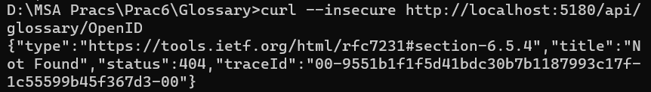
PRACTICAL NO 07
Aim: Working with Team Service
Source Code:
Step 1:
- Open command prompt and create a web API project:
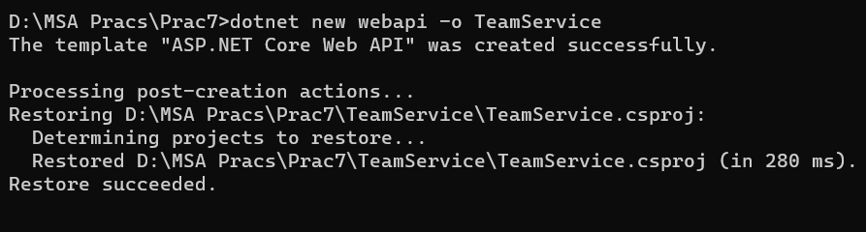
- Remove existing weatherforecast files both Teamservice and controllers folder.
Step 2: Add new files as follows:
- Create a folder named Models in the TeamService folder.
- Create Member.cs in Models folder and write the following code:
using System;
namespace TeamService.Models
{
public class Member
{
public Guid ID { get; set; }= default!;
public string FirstName { get; set; }= default!;
public string LastName { get; set; }= default!;
public Member() { }
public Member(Guid id) : this()
{
this.ID = id;
}
public Member(string firstName, string lastName, Guid id) : this(id)
{
this.FirstName = firstName;
this.LastName = lastName;
}
public override string ToString()
{
return this.LastName;
}
}
}

- Create a class file named “Team.cs” in the Models folder with the following code:
using System;
using System.Collections.Generic;
namespace TeamService.Models
{
public class Team
{
public string Name { get; set; }= default!;
public Guid ID { get; set; }= default!;
public ICollection<Member> Members { get; set; }= default!;
public Team()
{
this.Members = new List<Member>();
}
public Team(string name) : this()
{
this.Name = name;
}
public Team(string name, Guid id) : this(name)
{
this.ID = id;
}
public override string ToString()
{
return this.Name;
}
}
}

- Create a class file named “MembersController.cs” in the Controllers folder with the following code:
using System;
using Microsoft.AspNetCore.Hosting;
using Microsoft.AspNetCore.Builder;
using Microsoft.AspNetCore.Mvc;
using System.Collections.Generic;
using System.Linq;
using TeamService.Models;
using System.Threading.Tasks;
using TeamService.Persistence;

namespace TeamService
{
[Route("/teams/{teamId}/[controller]")]
public class MembersController : Controller
{
ITeamRepository repository;

public MembersController(ITeamRepository repo)
{
repository = repo;
}

[HttpGet]
public virtual IActionResult GetMembers(Guid teamID)
{
Team team = repository.Get(teamID);

if(team == null) {
return this.NotFound();
} else {
return this.Ok(team.Members);
}
}

[HttpGet]
[Route("/teams/{teamId}/[controller]/{memberId}")]
public virtual IActionResult GetMember(Guid teamID, Guid memberId)
{
Team team = repository.Get(teamID);

if(team == null) {
return this.NotFound();
} else {
var q = team.Members.Where(m => m.ID == memberId);

if(q.Count() < 1) {
return this.NotFound();
} else {
return this.Ok(q.First());
}
}
}

[HttpPut]
[Route("/teams/{teamId}/[controller]/{memberId}")]
public virtual IActionResult UpdateMember([FromBody]Member updatedMember, Guid teamID, Guid memberId)
{
Team team = repository.Get(teamID);

if(team == null) {
return this.NotFound();
} else {
var q = team.Members.Where(m => m.ID == memberId);

if(q.Count() < 1) {
return this.NotFound();
} else {
team.Members.Remove(q.First());
team.Members.Add(updatedMember);
return this.Ok();
}
}
}

[HttpPost]
public virtual IActionResult CreateMember([FromBody]Member newMember, Guid teamID)
{
Team team = repository.Get(teamID);

if(team == null) {
return this.NotFound();
} else {
team.Members.Add(newMember);
var teamMember = new {TeamID = team.ID, MemberID = newMember.ID};
return this.Created($"/teams/{teamMember.TeamID}/[controller]/{teamMember.MemberID}", teamMember);
}
}

[HttpGet]
[Route("/members/{memberId}/team")]
public IActionResult GetTeamForMember(Guid memberId)
{
var teamId = GetTeamIdForMember(memberId);
if (teamId != Guid.Empty) {
return this.Ok(new {
TeamID = teamId
});
} else {
return this.NotFound();
}
}

private Guid GetTeamIdForMember(Guid memberId)
{
foreach (var team in repository.List()) {
var member = team.Members.FirstOrDefault( m => m.ID == memberId);
if (member != null) {
return team.ID;
}
}
return Guid.Empty;
}
}
}
- Create a class file named “TeamsController.cs” in the Controllers folder with the following code:
using System;
using Microsoft.AspNetCore.Hosting;
using Microsoft.AspNetCore.Builder;
using Microsoft.AspNetCore.Mvc;
using System.Collections.Generic;
using System.Linq;
using TeamService.Models;
using System.Threading.Tasks;
using TeamService.Persistence;

namespace TeamService
{
[Route("[controller]")]
public class TeamsController : Controller
{
ITeamRepository repository;

public TeamsController(ITeamRepository repo)
{
repository = repo;
}

[HttpGet]
public virtual IActionResult GetAllTeams()
{
return this.Ok(repository.List());
}

[HttpGet("{id}")]
public IActionResult GetTeam(Guid id)
{
Team team = repository.Get(id);

if (team != null) // I HATE NULLS, MUST FIXERATE THIS.
{
return this.Ok(team);
} else {
return this.NotFound();
}
}

[HttpPost]
public virtual IActionResult CreateTeam([FromBody]Team newTeam)
{
repository.Add(newTeam);

//TODO: add test that asserts result is a 201 pointing to URL of the created team.
//TODO: teams need IDs
//TODO: return created at route to point to team details
return this.Created($"/teams/{newTeam.ID}", newTeam);
}

[HttpPut("{id}")]
public virtual IActionResult UpdateTeam([FromBody]Team team, Guid id)
{
team.ID = id;

if(repository.Update(team) == null) {
return this.NotFound();
} else {
return this.Ok(team);
}
}

[HttpDelete("{id}")]
public virtual IActionResult DeleteTeam(Guid id)
{
Team team = repository.Delete(id);

if (team == null) {
return this.NotFound();
} else {
return this.Ok(team.ID);
}
}
}
}

Step 3: Create a folder named Persistence in the teamservice folder and create the following files
- Create a class file named “ITeamRepository.cs” in the Persistence folder with the following:
using System;
using System.Collections.Generic;
using TeamService.Models;

namespace TeamService.Persistence
{
public interface ITeamRepository {
IEnumerable<Team> List();
Team Get(Guid id);
Team Add(Team team);
Team Update(Team team);
Team Delete(Guid id);
}
}

- Create a class file named “MemoryTeamRepository.cs” in the Persistence folder with the following code:
using System;
using System.Collections.Generic;
using System.Linq;
using TeamService;
using TeamService.Models;

namespace TeamService.Persistence
{
public class MemoryTeamRepository : ITeamRepository {
protected static ICollection<Team> teams;

public MemoryTeamRepository() {
if(teams == null) {
teams = new List<Team>();
}
}

public MemoryTeamRepository(ICollection<Team> teams) {
MemoryTeamRepository.teams = teams;
}

public IEnumerable<Team> List() {
return teams;
}

public Team Get(Guid id) {
return teams.FirstOrDefault(t => t.ID == id);
}

public Team Update(Team t)
{
Team team = this.Delete(t.ID);

if(team != null) {
team = this.Add(t);
}

return team;
}

public Team Add(Team team)
{
teams.Add(team);
return team;
}

public Team Delete(Guid id) {
var q = teams.Where(t => t.ID == id);
Team team = null;

if (q.Count() > 0) {
team = q.First();
teams.Remove(team);
}

return team;
}
}
}

Step 4: Create a class file named “Startup.cs” in the TeamService folder with the following code:
using System;
using System.Collections.Generic;
using System.Linq;
using System.Threading.Tasks;
using Microsoft.AspNetCore.Builder;
using Microsoft.AspNetCore.Hosting;
using Microsoft.AspNetCore.HttpsPolicy;
using Microsoft.AspNetCore.Mvc;
using Microsoft.Extensions.Configuration;
using Microsoft.Extensions.DependencyInjection;
using Microsoft.Extensions.Hosting;
using Microsoft.Extensions.Logging;
using TeamService.Persistence;
namespace TeamService
{
public class Startup
{
public Startup(IConfiguration configuration)
{
Configuration = configuration;
}

public IConfiguration Configuration { get; }

// This method gets called by the runtime. Use this method to add services to the container.
public void ConfigureServices(IServiceCollection services)
{
services.AddControllers();
services.AddScoped<ITeamRepository, MemoryTeamRepository>();
}

// This method gets called by the runtime. Use this method to configure the HTTP request pipeline.
public void Configure(IApplicationBuilder app, IWebHostEnvironment env)
{
if (env.IsDevelopment())
{
app.UseDeveloperExceptionPage();
}

app.UseHttpsRedirection();

app.UseRouting();

app.UseAuthorization();

app.UseEndpoints(endpoints =>
{
endpoints.MapControllers();
});
}
}
}
Step 5: Replace the code in ‘TeamService.csproj’ file with the following code:
<Project Sdk="Microsoft.NET.Sdk.Web">
<PropertyGroup>
<TargetFramework>net7.0</TargetFramework>
</PropertyGroup>
<ItemGroup>
<PackageReference
Include="Swashbuckle.AspNetCore" Version="5.6.3"/>
</ItemGroup>
</Project>
Step 6: Replace the code in ‘Program.cs’ file with the following code:
using System;
using System.Collections.Generic;
using System.Linq;
using System.Threading.Tasks;
using Microsoft.AspNetCore.Hosting;
using Microsoft.Extensions.Configuration;
using Microsoft.Extensions.Hosting;
using Microsoft.Extensions.Logging;

namespace TeamService
{
public class Program
{
public static void Main(string[] args)
{
CreateHostBuilder(args).Build().Run();
}

public static IHostBuilder CreateHostBuilder(string[] args) =>
Host.CreateDefaultBuilder(args)
.ConfigureWebHostDefaults(webBuilder =>
{
webBuilder.UseStartup<Startup>();
});
}
}

OUTPUT:
- Working with Team API of TeamService
- Run the application in command prompt using ‘dotnet run’. Note down the URL. Open one more command prompt window. Enter the following commands:
- To get all teams
curl --insecure https://localhost:5001/teams

- To create new team
curl --insecure -H "Content-Type:application/json" -X POST -d "{\"id\":\"e52baa63-d511-417e-9e54-7aab04286281\", \"name\":\"KC\"}" https://localhost:5001/teams
curl --insecure -H "Content-Type:application/json" -X POST -d "{\"id\":\"e12baa63-d511-417e-9e54-7aab04286281\", \"name\":\"MSC Part1\"}" https://localhost:5001/teams
- To get all teams
curl --insecure https://localhost:5001/teams

- To get single team with team-id as parameter
curl --insecure https://localhost:5001/teams/e52baa63-d511-417e-9e54-7aab04286281

- To update team details (change name of first team from “KC” to “KC IT DEPT”)
curl --insecure -H "Content-Type:application/json" -X PUT -d "{\"id\":\"e52baa63-d511-417e-9e54-7aab04286281\", \"name\":\"KC IT DEPT\"}" https://localhost:5001/teams/e52baa63-d511-417e-9e54-7aab04286281

- To delete team
curl --insecure -H "Content-Type:application/json" -X DELETE https://localhost:5001/teams/e52baa63-d511-417e-9e54-7aab04286281

- With get all teams now it shows only one team (first one is deleted). Check using:
curl --insecure https://localhost:5001/teams

- Working with Member API of TeamService
- Run the application in command prompt using ‘dotnet run’. Note down the URL. Open one more command prompt window. Enter the following commands:
- To create team (to add member team must exist)
curl --insecure -H "Content-Type:application/json" -X POST -d "{\"id\":\"e52baa63-d511-417e-9e54-7aab04286281\", \"name\":\"KC\"}" https://localhost:5001/teams

- To add new member to above team
curl --insecure -H “Content-Type:application/json” –X POST –d “{\"id\":\"63e7acf8-8fae-42ce-9349-3c8593ac8292\", \"firstName\":\"Joel\", \"lastName\":\"Dmello\"}” https://localhost:5001/teams/e52baa63-d511-417e-9e54-7aab04286281/members

- To confirm in Teams: (now it shows newly added member in team)
curl --insecure https://localhost:5001/teams/e52baa63-d511-417e-9e54-7aab04286281

- To get individual member details:
curl --insecure https://localhost:5001/teams/e52baa63-d511-417e-9e54-7aab04286281/members/63e7acf8-8fae-42ce-9349-3c8593ac8292

- To check all members:
curl --insecure https://localhost:5001/teams/e52baa63-d511-417e-9e54-7aab04286281/members

- To change details of member: changing first name
curl --insecure -H "Content-Type:application/json" -X DELETE https://localhost:5001/teams/e52baa63-d511-417e-9e54-7aab04286281

Check output using:
curl --insecure https://localhost:5001/teams/e52baa63-d511-417e-9e54-7aab04286281/members

PRACTICAL NO 08
Aim: Working with Location Service
Source Code:
Step 1:
- Create a folder named Prac 8 and move your TeamService folder of practical no 7 in this.
- Open command prompt and create a web API project:
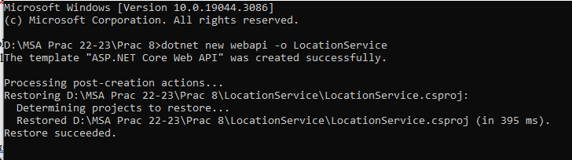

- Remove existing weatherforecast files both LocationService and controllers folder.
Step 2: Add new files as follows:
- Create a folder named Models in the TeamService folder.
- Create LocationRecord.cs in Models folder and write the following code:
using System;
using System.Collections.Generic;

namespace LocationService.Models
{

public class LocationRecord
{
public Guid ID { get; set; } = default!;
public float Latitude { get; set; } = default!;
public float Longitude { get; set; } = default!;
public float Altitude { get; set; }= default!;
public long Timestamp { get; set; }= default!;
public Guid MemberID { get; set; } = default!;
}

public class LocationRecordComparer : Comparer<LocationRecord>
{
public override int Compare(LocationRecord x, LocationRecord y)
{
return x.Timestamp.CompareTo(y.Timestamp);
}
}

}
- Create a class file named “ILocationRecordRepository.cs” in the Models folder with the following code:
using System;
using System.Collections.Generic;

namespace LocationService.Models
{

public interface ILocationRecordRepository
{
LocationRecord Add(LocationRecord locationRecord);
LocationRecord Update(LocationRecord locationRecord);
LocationRecord Get(Guid memberId, Guid recordId);
LocationRecord Delete(Guid memberId, Guid recordId);

LocationRecord GetLatestForMember(Guid memberId);

ICollection<LocationRecord> AllForMember(Guid memberId);
}
}

- Create a class file named “LocationRecordController.cs” in the Controllers folder with the following code:
using System;
using Microsoft.AspNetCore.Mvc;
using LocationService.Models;

namespace LocationService.Controllers
{

[Route("locations/{memberId}")]
public class LocationRecordController : Controller
{

private ILocationRecordRepository locationRepository;

public LocationRecordController(ILocationRecordRepository repository)
{
this.locationRepository = repository;
}

[HttpPost]
public IActionResult AddLocation(Guid memberId, [FromBody] LocationRecord locationRecord)
{
locationRepository.Add(locationRecord);
return this.Created($"/locations/{memberId}/{locationRecord.ID}", locationRecord);
}

[HttpGet]
public IActionResult GetLocationsForMember(Guid memberId)
{
return this.Ok(locationRepository.AllForMember(memberId));
}

[HttpGet("latest")]
public IActionResult GetLatestForMember(Guid memberId)
{
return this.Ok(locationRepository.GetLatestForMember(memberId));
}
}
}

Step 3: Create a folder named Persistence in the teamservice folder and create the following files
- Create a class file named “InMemoryLocationRecordRepository.cs” in the Persistence folder with the following:
using System;
using System.Collections.Generic;
using LocationService.Models;
using System.Linq;

namespace LocationService.Persistence
{

public class InMemoryLocationRecordRepository : ILocationRecordRepository
{
private static Dictionary<Guid, SortedList<long, LocationRecord>> locationRecords;

public InMemoryLocationRecordRepository()
{
if (locationRecords == null)
{
locationRecords = new Dictionary<Guid, SortedList<long, LocationRecord>>();
}
}

public LocationRecord Add(LocationRecord locationRecord)
{
var memberRecords = getMemberRecords(locationRecord.MemberID);

memberRecords.Add(locationRecord.Timestamp, locationRecord);
return locationRecord;
}

public ICollection<LocationRecord> AllForMember(Guid memberId)
{
var memberRecords = getMemberRecords(memberId);
return memberRecords.Values.Where(l => l.MemberID == memberId).ToList();
}

public LocationRecord Delete(Guid memberId, Guid recordId)
{
var memberRecords = getMemberRecords(memberId);
LocationRecord lr = memberRecords.Values.Where(l => l.ID == recordId).FirstOrDefault();

if (lr != null)
{
memberRecords.Remove(lr.Timestamp);
}

return lr;
}

public LocationRecord Get(Guid memberId, Guid recordId)
{
var memberRecords = getMemberRecords(memberId);

LocationRecord lr = memberRecords.Values.Where(l => l.ID == recordId).FirstOrDefault();
return lr;
}

public LocationRecord Update(LocationRecord locationRecord)
{
return Delete(locationRecord.MemberID, locationRecord.ID);
}

public LocationRecord GetLatestForMember(Guid memberId)
{
var memberRecords = getMemberRecords(memberId);

LocationRecord lr = memberRecords.Values.LastOrDefault();
return lr;
}

private SortedList<long, LocationRecord> getMemberRecords(Guid memberId)
{
if (!locationRecords.ContainsKey(memberId))
{
locationRecords.Add(memberId, new SortedList<long, LocationRecord>());
}

var list = locationRecords[memberId];
return list;
}
}
}
Step 4: Create a class file named “Startup.cs” in the TeamService folder with the following code:
using System;
using System.Collections.Generic;
using System.Linq;
using System.Threading.Tasks;
using Microsoft.AspNetCore.Builder;
using Microsoft.AspNetCore.Hosting;
using Microsoft.AspNetCore.HttpsPolicy;
using Microsoft.AspNetCore.Mvc;
using Microsoft.Extensions.Configuration;
using Microsoft.Extensions.DependencyInjection;
using Microsoft.Extensions.Hosting;
using Microsoft.Extensions.Logging;
using Microsoft.OpenApi.Models;
using LocationService.Persistence;
using LocationService.Models;

namespace LocationService
{
public class Startup
{
public Startup(IConfiguration configuration)
{
Configuration = configuration;
}

public IConfiguration Configuration { get; }

// This method gets called by the runtime. Use this method to add services to the container.
public void ConfigureServices(IServiceCollection services)
{

services.AddControllers();
services.AddScoped<ILocationRecordRepository, InMemoryLocationRecordRepository>();
services.AddSwaggerGen(c =>
{
c.SwaggerDoc("v1", new OpenApiInfo { Title = "LocationService", Version = "v1" });
});
}

// This method gets called by the runtime. Use this method to configure the HTTP request pipeline.
public void Configure(IApplicationBuilder app, IWebHostEnvironment env)
{
if (env.IsDevelopment())
{
app.UseDeveloperExceptionPage();
app.UseSwagger();
app.UseSwaggerUI(c => c.SwaggerEndpoint("/swagger/v1/swagger.json", "LocationService v1"));
}

app.UseHttpsRedirection();

app.UseRouting();

app.UseAuthorization();

app.UseEndpoints(endpoints =>
{
endpoints.MapControllers();
});
}
}
}
Step 5: Replace the code in ‘TeamService.csproj’ file with the following code:
<Project Sdk="Microsoft.NET.Sdk.Web">
<PropertyGroup>
<TargetFramework>net7.0</TargetFramework>
<Nullable>enable</Nullable>
<ImplicitUsings>enable</ImplicitUsings>
</PropertyGroup>
<ItemGroup>
<PackageReference Include="Microsoft.AspNetCore.OpenApi" Version="7.0.8" />
<PackageReference Include="Swashbuckle.AspNetCore" Version="6.5.0" />
</ItemGroup>
</Project>

Step 6: Replace the code in ‘Program.cs’ file with the following code:
using System;
using System.Collections.Generic;
using System.Linq;
using System.Threading.Tasks;
using Microsoft.AspNetCore.Hosting;
using Microsoft.Extensions.Configuration;
using Microsoft.Extensions.Hosting;
using Microsoft.Extensions.Logging;

namespace LocationService
{
public class Program
{
public static void Main(string[] args)
{
CreateHostBuilder(args).Build().Run();
}

public static IHostBuilder CreateHostBuilder(string[] args) =>
Host.CreateDefaultBuilder(args)
.ConfigureWebHostDefaults(webBuilder =>
{
webBuilder.UseStartup<Startup>();
});
}
}

OUTPUT:
- We require three command prompt to run this practical
- Command Prompt 1:
Go to LocationService Project and run the project: dotnet run –server.urls http://*:5001
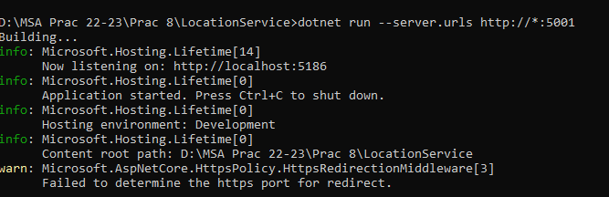
- Command Prompt 2:
Go to TeamService Project and run the project: dotnet run
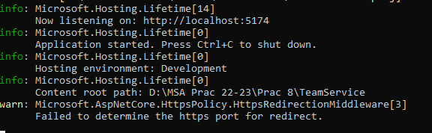
Rest of the command is to executed on command prompt 3:
- Command to Add new team.
(Note that the port number is given of the TeamService Project)
curl -H "Content-Type:application/json" -X POST -d "{\"id\":\"e52baa63-d511-417e-9e54-7aab04286281\", \"name\":\"UDIT\"}" http://localhost:5174/teams
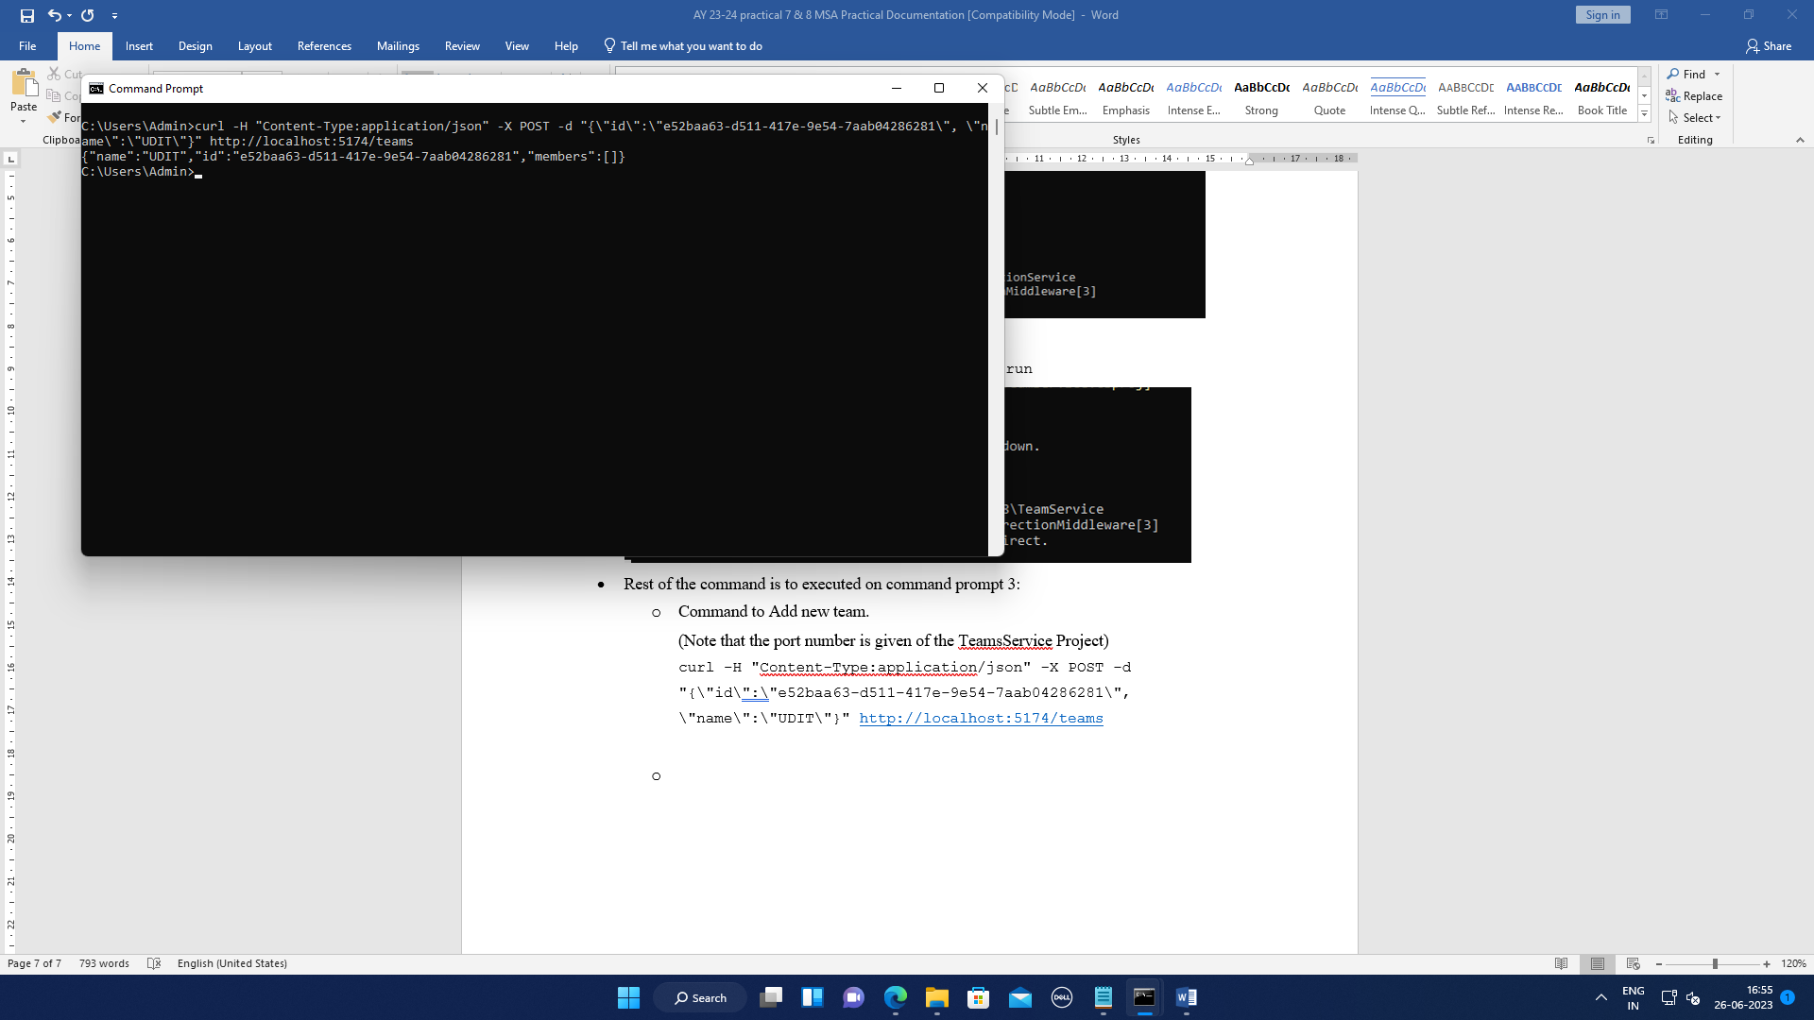
- Command to add new member to team
(Note that the port number is given of the TeamService Project)
curl -H "Content-Type:application/json" -X POST -d "{\"id\":\"63e7acf8-8fae-42ce-9349-3c8593ac8292\", \"firstName\":\"Shraddha\", \"lastName\":\"Kadam\"}" http://localhost:5174/teams/e52baa63-d511-417e-9e54-7aab04286281/members
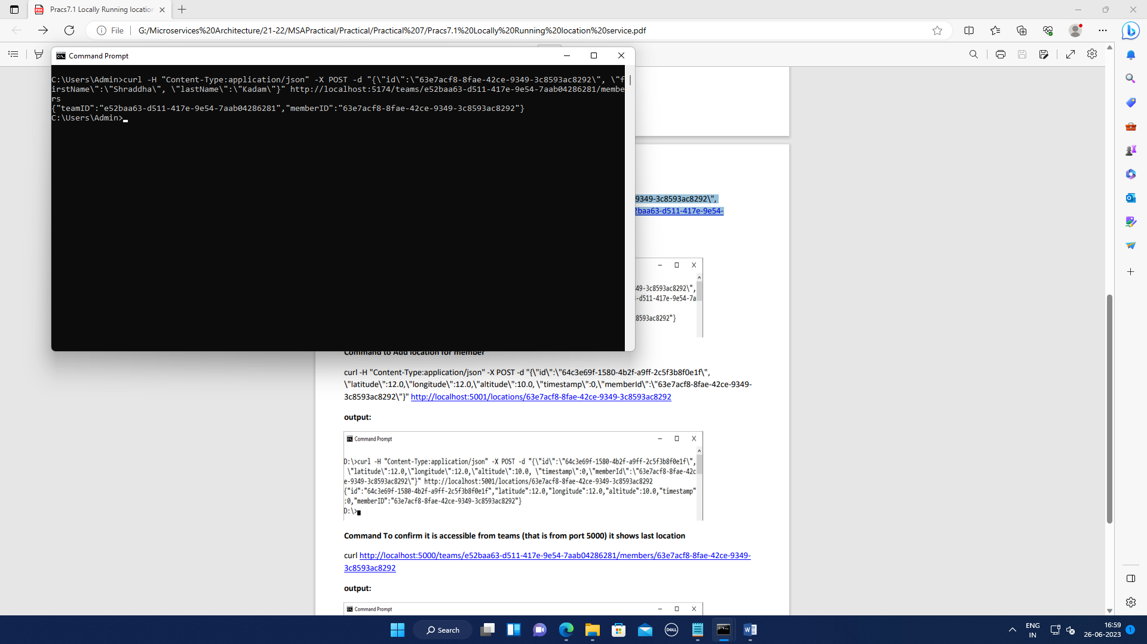
- Command to Add location for member
(Note that the port number is given of the LocationService Project)
curl -H "Content-Type:application/json" -X POST -d "{\"id\":\"64c3e69f-1580-4b2f-a9ff-2c5f3b8f0e1f\", \"latitude\":12.0,\"longitude\":12.0,\"altitude\":10.0, \"timestamp\":0,\"memberId\":\"63e7acf8-8fae-42ce-9349-3c8593ac8292\"}" http://localhost:5186/locations/63e7acf8-8fae-42ce-9349-3c8593ac8292
