## The Simulating Substances App GUI

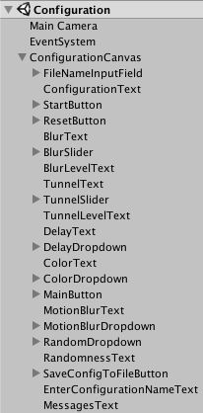Unity uses the metaphor „Scene“ in order to refer to a file which contains the objects of your game. They can be used to create a main menu, individual levels, and anything else. Think of each unique Scene file as a unique level. In each Scene, you will place your environments, obstacles, and decorations, essentially designing and building your game in pieces.

The Hierarchy Window in Unity is a hierarchical text representation of every object in the scene. The hierarchy reveals the structure of how objects are attached to one another and can became very complex.

Below we explain the four Simulating Substances application scenes ordered by growing complexity. Each scene has a corresponding C sharp script responsible of its control following the Model-View-Controller Pattern.

For a better understanding of the GUI it’s necessary to explain before how is data preserved between scenes.

## Communication between scenes

A scene is an independent entity with its own lifecycle. That means, that when a new scene is loaded (f.e. a new level in a game) all objects from the previous scene are destroyed.

In order to preserve data Unity provides the PlayerPrefs class, wich stores and accesses player preferences between game sessions. This class uses a simple Key/Value system to save the data to a file:

PlayerPrefs.SetInt("Player Score", 10);

var score = [PlayerPrefs.GetInt](https://docs.unity3d.com/ScriptReference/PlayerPrefs.GetInt.html)("Player Score")

We employ this class to preserve the configuration values of the image effects selected by the user. So the user can switch between scenes or even shut down the application without losing the configuration.

## Simulating Substances scene

This is the scene where all happens. The Vuforia Plugin provides de Augmented Reality functionality and the different Unity Image Filters create the desired effects as blur or tunnel view.

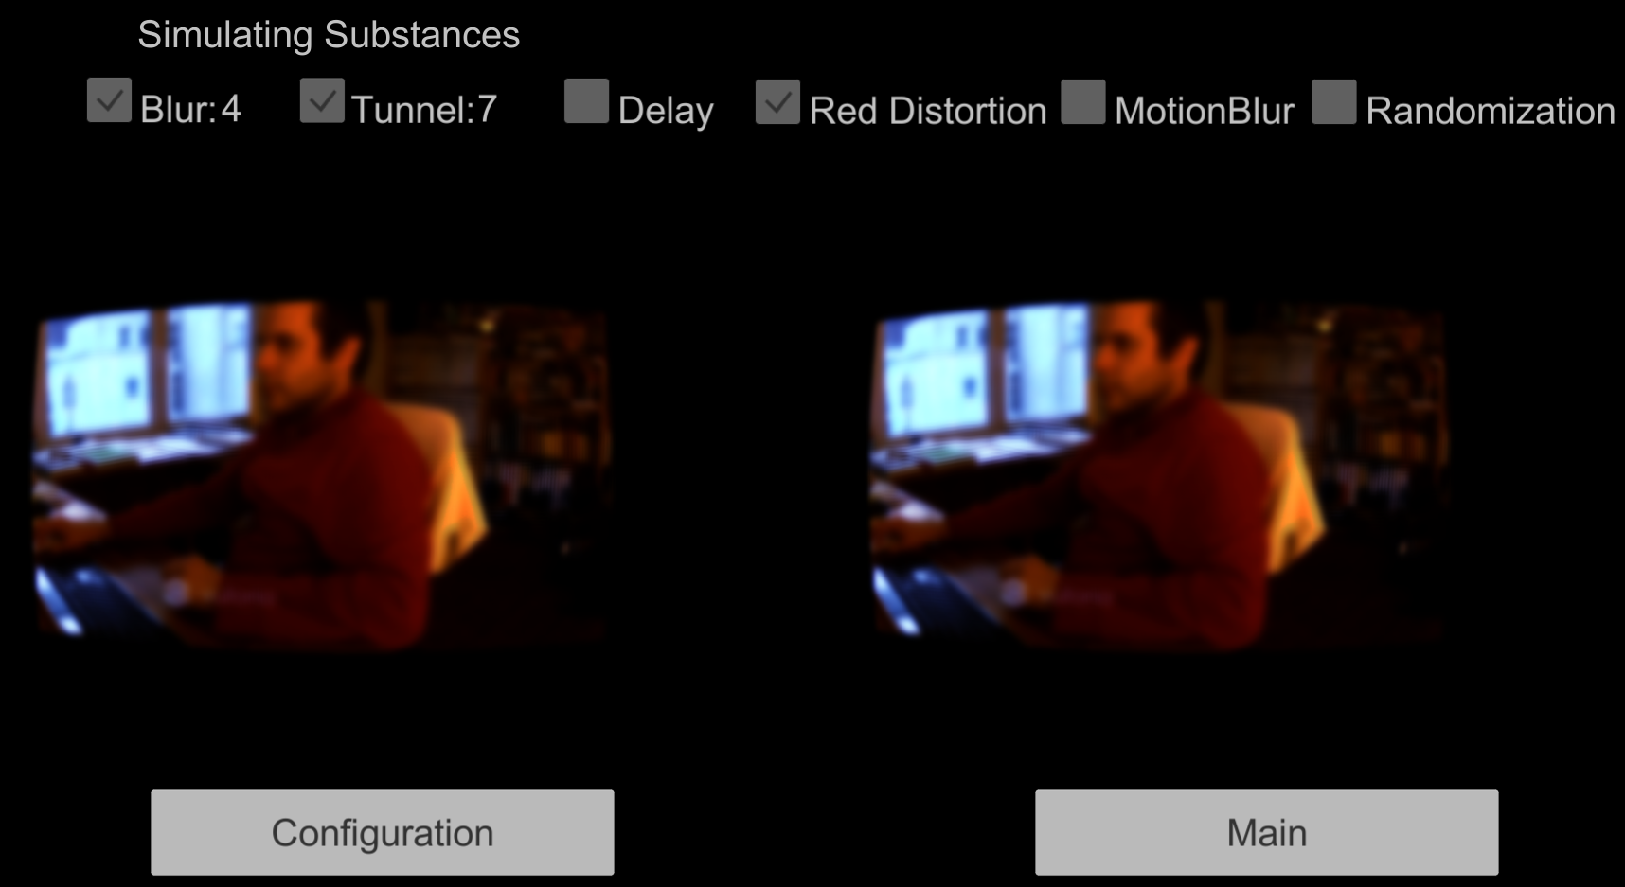

Main scene

This simple scene is the app start point.

Configuration scene

Here you can configure the image effects strength. The configuration is saved automatically when you play start. The scene shows always the last configuration used.

Here is the true augmented reality. You can see the chosen configuration values above the camera and navigate back to the main or configuration scenes.

The navigation between scenes