Consent form for the publication in eprints.hsr.ch

⭘ Term Project

⭘ Bachelor Thesis

Term Project Title: Virtual Buzz

Team: Roberto Cuervo-Alvarez & Konrad Höpli

Advisor: Prof. Oliver Augenstein

We agree with the publication of our term project, as there is no arrangement of confidentiality signed.

Within 14 days after the grade’s announcement we have the possibility of elevating an objection and retire the publication consent. In this case only the abstract will be published.

Rapperswil,

Names Signature

Roberto Cuervo Alvarez 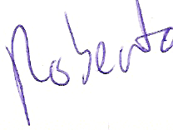

Konrad Höpli ____________________________