SCOPE : A Transformer-Based System for Predicting Influencer Popularity via Comment Sentiment and Topic Analysis
Jeonghun Kim Seok Kee Lee Mi-Hwa Song
Division of Computer Engineering Division of Computer Engineering Division of Computer Engineering
Hansung University, Seoul, Korea Hansung University, Seoul, Korea Hansung University, Seoul, Korea
bandlagom0927@hansung.ac.kr seelee@hansung.ac.kr mhsong@hansung.ac.kr

Abstract

With the rapid growth of social media platforms, the volume of comments on influencer content has significantly increased. However, it is highly challenging for influencers to individually review, remember, and statistically analyze all comments. This study aims to address this challenge by leveraging Opinion Mining techniques to analyze comments on influencer content, which has become a critical marketing channel on social media. The objective is to predict fluctuations in influencer popularity based on the sentiment and audience interest expressed in these comments. To achieve this, comments on influencer content, including that of YouTubers, were analyzed using a Transformer-based model to classify the sentiments and categorize audience interests in the content's subject. By conducting this analysis, the study measures subscriber loyalty and implements a system to predict future changes in influencer popularity.

- Introduction
As the number of comments on influencer content continues to grow, influencers have solidified their position as key figures in driving public attention, brand awareness, and revenue growth. Particularly on video platforms like YouTube, influencer marketing has become a dominant force, leading companies to allocate more resources toward collaboration with influencers than traditional advertising channels.
Services such as NoxInfluencer[1] analyze data from influencer channels to provide statistical insights; however, this study aims to offer a more detailed analysis through the application of Opinion Mining techniques. By analyzing consumer reactions in the form of comments on influencer content, we seek to gain a deeper understanding of the emotions and interests reflected in these responses.
This research leverages a Transformer-based model to analyze comments, classifying both the sentiment expressed and the level of audience interest in the content's subject. Through this analysis, we measure subscriber loyalty and develop a system to predict future changes in influencer popularity. Given that influencer success can fluctuate dramatically due to various external factors, the need for predictive indicators is paramount. The platform selected for this study is YouTube, where consumer sentiment and empathy can be extracted from comments. By linking this data to subscriber loyalty, the study aims to forecast influencer performance and future trends in popularity.

- Method
2-1. SCOPE : Sentiment and Comment Opinion Prediction Engine
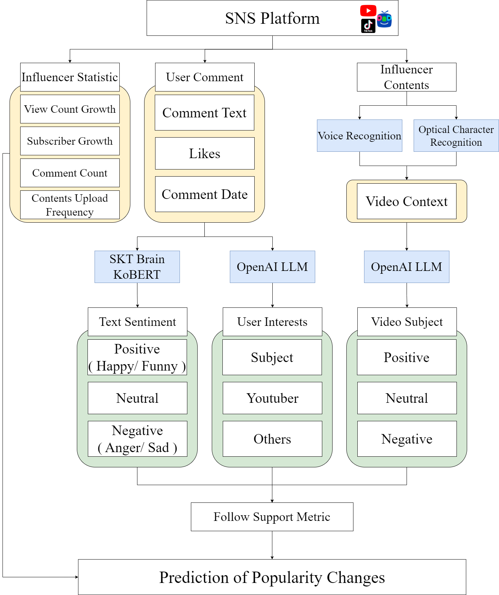
Figure 1. SCOPE Overview
This study aims to predict fluctuations in influencer popularity by analyzing three primary inputs: influencer statistics, user comments, and influencer content. These inputs serve as the foundational elements for determining the relationship between Follow Support and influencer popularity, and each dataset undergoes specialized analysis. This data analysis and prediction process was described through Figure 1.
First, influencer statistics are used to generate derived features. These features include metrics such as upload frequency, based on content posting dates, subscriber growth rates, and variations in content viewership. These derived features explain the growth patterns of influencers and provide valuable indicators for predicting future trends.
Second, user comments are analyzed using Transformer-based models such as KoBERT and GPT-3.5 Turbo for sentiment analysis and topic interest classification. This approach generates Opinion Mining results, offering detailed insights into the emotional reactions of users and their interest in specific content topics. Such analysis allows for a more structured understanding of user engagement.
Third, influencer content is processed using Google OCR and Speech-to-Text API to extract text, which is then summarized and categorized using the GPT-3.5 Turbo model. By extracting key information from the content and linking it with user reactions, this analysis evaluates the impact of the content on subscriber loyalty.
Finally, combining the Opinion Mining results and content analysis, we derive a subscriber loyalty metric for each comment and implement a system that predicts future changes in influencer popularity. This predictive model offers valuable indicators that can inform influencer marketing strategies.

2-2. Data set & Preprocessing
In order to analyze comments to evaluate emotions and interests and classify the analysis results based on the date of writing, it was necessary to collect comments from users first. Influencer content and comment data were gathered from the YouTube platform for this research. Channels that exhibited high user engagement were chosen for data collection. To obtain the latest content and relevant information from the selected influencers, the YouTube API v3 was utilized.
YouTube API v3 provides official access to real-time YouTube video and channel statistics. Using this API, data from July 1 to July 30 was collected. The dataset included 12 feature items related to channel data, as well as comment data. Specifically, a total of 33 videos and 219,150 comments were collected over a 30-day period. Details of the specific attributes for channel data are provided in Table 1. This dataset serves as the foundation for the analysis conducted in this study. 30 days.

Table 1. Youtuber Channel Data
Feature | Type
Comment Count | Integer
Dislike Count | Integer
Like Count | Integer
Published At | Date
Subscriber Count | Integer
Tags | String
View Count | Integer

The nature of the YouTube platform results in numerous comments containing grammatically incorrect sentences. To effectively process this unstructured data, comments were preprocessed using morphological analysis via the KoNLPy library[2]. KoNLPy is optimized for Korean natural language processing and offers various morphological analyzers that help capture the meanings of comments more accurately. This preprocessing allows AI models to better understand the comments, thereby improving the accuracy of sentiment analysis and interest evaluation.

Additionally, the need to extract and summarize video data arose for users to assess their interest in the subject presented by influencers. To address this, auditory information was converted to text using Google Speech to Text technology, while visual information within the videos was textualized using Google OCR technology.
The Google Speech to Text API utilizes state-of-the-art voice recognition technology to convert speech into text with high accuracy, effectively capturing dialogue and utterances within influencer content, which enhances the reliability of the analysis. Furthermore, Google OCR quickly and accurately extracts text from images and videos, allowing for effective recognition of subtitles or graphic text, which aids in the precise analysis of the subjects within influencer content. For these reasons, Google Speech to Text and Google OCR APIs were selected as tools for textualization.

Now describe the dataset we used for model evaluation and fine tuning. To evaluate the performance of topic interest classification with the Transformer-based GPT-3.5 Turbo model, the research employed the "Video Content Highlight Editing and Description (Summary) Dataset" from AI HUB. This dataset features labeled categories for YouTube videos and comprises 33,437 sentences organized into eight distinct groups: Other, Pets, Styling, Sports, Travel, Food, Daily Life, and Automobiles.
Specifically, this research added two new classification categories, Criticism and Social Issues, to the existing "Other" category. This addition aimed to enable a more nuanced assessment of topic classification performance. For the topic classification performance test, 20% of the data from each category was evenly sampled to be used as the test dataset. This approach allowed us to validate the topic classification performance of the GPT-3.5 Turbo model effectively. Details of the specific DataSet for Subject Classification are provided in Table 2.

Table 2. Subject Label Classification DataSet
Youtube Category | Count | Presence
Etc. | 8866 | 26.5%
Criticism | 1384 | 4.1%
Social Issue | 3478 | 10.4%
Animal | 2240 | 6.6%
Beauty | 2509 | 7.5%
Sports | 3658 | 10.9%
Travel | 2720 | 8.1%
Food | 2506 | 7.4%
Daily | 3976 | 11.8%
Car | 2100 | 6.2%
Total | 33437 | 100%

To perform sentiment analysis using the KoBERT model and topic classification using the GPT-3.5 Turbo model, sentiment data was collected from SNS and online comments through crawling. The data was obtained from AI Hub's "Single-instance Dataset Containing Korean Emotion Information." This dataset consists of a total of 38,594 sentences labeled with seven emotions: joy, sadness, surprise, anger, fear, disgust, and neutrality, particularly including the emotions of anger, sadness, neutrality, and happiness.

Additionally, data on emotions of anger, Funny, and sadness were collected from the "Emotion Dialogue Corpus Dataset." This dataset contains a total of 51,630 sentences labeled with six emotions: anger, joy, anxiety, embarrassment, sadness, and hurt. Details of the specific DataSet for Sentiment Analysis are provided in Table 3. To avoid data bias, the anger and sadness sentiment data, which were common across both datasets, were randomly split in half and merged. The constructed learning data will be utilized to enhance the accuracy of sentiment analysis using the KoBERT model and topic classification using the GPT-3.5 Turbo model.
Table 3. Sentiment Analysis DataSet
Sentiment | Sentence Count | Presence
Happiness | 6037 | 19.1%
Funny | 6126 | 19.4%
Sadness | 7195 | 22.8%
Anger | 7412 | 23.5%
Neutral | 4830 | 15.2%
Total | 31600 | 100%

2-3. Transformer model-based summarization and classification
The YouTube videos were textualized using Google Speech to Text and OCR technology. Subsequently, this text was summarized using the GPT-3.5 Turbo model. As noted by Gue et al. (2024)[3], GPT-3.5 Turbo demonstrated significant time savings and high accuracy in information extraction tasks. Notably, the model achieved a 100% matching rate in extracting simple information, which justified its selection for summarization tasks.
The subjects of influencer content were classified into three sentiment categories: Positive, Neutral, and Negative. The GPT-3.5 Turbo model excels in natural language processing (NLP) tasks, having been trained on large volumes of text data, which enables it to understand various contexts effectively. This capability allows for accurate identification of meanings and emotions within the given text, facilitating classification into sentiment categories such as Positive, Neutral, and Negative. Summarization and subject classification were performed through prompt engineering.
In addition, topic interest evaluation was conducted using the GPT-3.5 Turbo model. Comments were classified based on their relevance to the video subject, identifying whether they were directly related to the video's content, the YouTuber, or other topics. In cases where the classification did not align with the primary subject of the video, a validation process was implemented to ensure accurate categorization. This process helped to distinguish comments related to the influencer or broader content categories, such as the YouTuber's personal brand, other unrelated subjects, or promotional content. The ability to precisely categorize these comments allowed for a deeper analysis of audience engagement and interests, further refining the study's evaluation of influencer popularity trends.

For the sentiment analysis of comments, a multi-emotion analysis model was implemented by fine-tuning the SKT Brain KoBERT model[4]. Comments were classified into five emotional categories: Happiness, Sadness, Humor, Anger, and Neutral. This fine-grained classification provided deeper insights into the emotional responses evoked by the content, helping to measure the emotional impact of influencer videos. Following classification, the emotions were integrated into three features: Positive (Happiness, Humor), Neutral (Neutral), and Negative (Anger, Sadness). Although the Transformer-based BERT model developed by Google is known for its excellent performance, it has limitations in training on Korean datasets since it primarily trained on English data. Therefore, the KoBERT model, which is capable of training on Korean data, was chosen for this study. The model parameters were set as shown in the following table 4, which outlines the specific configurations used for the fine-tuning process, ensuring the accuracy and relevance of the emotion classifications for Korean-language comments.

Table 4. Model Parameter
Hyperparameter | Values
Max_len | 64
Batch_size | 64
Num_epochs | 5
Learing_rate | 5e-5

2-4. Follow Support(FS) Metric
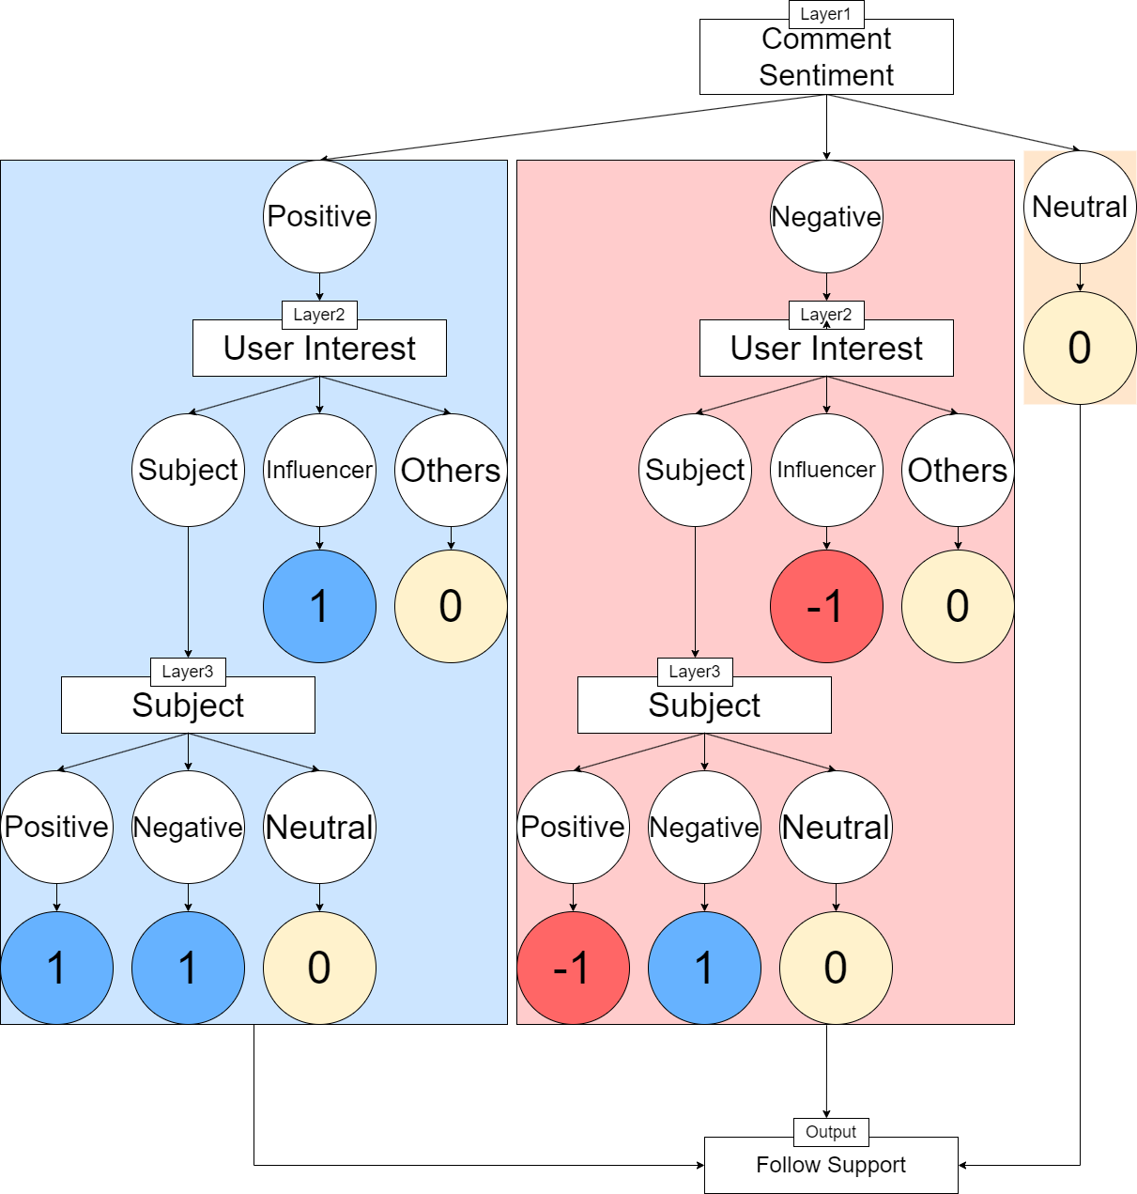
Figure 2. Follow Support Metric Layer
Based on Emotion and Interests obtained by analyzing the subject and comments of the video obtained through image analysis, a layer for Follow Support Metric was constructed. If express the Layer condition in Figure 2 in a formula

FS = f( Comment Sentiment, User Interest, Subject )

the parameter of the function f must satisfy the form. Comment Sentiment C is based on the results of categorizing the sentiment into Positive, Neutral, and Negative based on five emotions: Happiness, Funny, Sadness, Anger, and Neutral.
C∈{Positive, Neutral, Negative}
User Interest U analyzes comments and uses the content of the comment and the Content Summary to gain interest and categorize where that interest is directed into three categories: topics, YouTubers, and other.
U∈{Subject, Youtuber, Others}
Subject S uses the Subject Category label and Content Summary to categorize the topic into three categories: positive, negative, and neutral.
S∈{Positive, Neutral, Negative}
C, U, and S undergo a classification process as they pass through each layer. For instance, negative comments directed at the YouTuber as a direct criticism are distinguished from negative comments expressing interest in critical video content. In such cases, scores of -1 and 1 are assigned based on emotion and the subject of interest. If the subject of interest corresponds to the topic, the results of the topic classification are utilized to derive subscriber loyalty.
Neutral comments primarily consist of information such as the order in which the comment was posted and are often unrelated to the video's subject or fail to express clear emotions. Such comments are assigned a score of 0 to minimize their impact on the overall results. By aggregating all scores and applying a rescaling process, the values are normalized to a range between 0 and 100, which quantifies subscriber loyalty and serves as an indicator for predicting fluctuations in influencer popularity.

2-5. Evaluation
The performance of topic classification was evaluated using the GPT-3.5 Turbo model. By merging the datasets "Korean Emotion Information Dataset" and "Emotion Dialogue Corpus," topics were classified into three categories: Positive, Neutral, and Negative. The results of this classification process yielded the following performance metrics, Table 5.

Table 5. gpt3.5-turbo Subject Classification Performance
Category | Accuracy | Recall | F1 Score | Presence
Positive | 0.89 | 0.84 | 0.88 | 38.4%
Neutral | 0.86 | 0.75 | 0.73 | 15.2%
Negative | 0.84 | 0.70 | 0.76 | 46.1%

The performance of the Gpt3.5-turbo model for classifying topic interest (mentions) is presented as follows. Based on the 'Video Content Highlights Summary Data,' the subjects mentioned in the comments were classified into three categories: Subject, Influencer, and Others, yielding the following results. Table 6 presents the performance metrics for each category.

Table 6. gpt3.5-turbo User Interest Classification Performance
Category | Accuracy | Recall | F1 Score | Presence
Subject | 0.84 | 0.84 | 0.82 | 45%
Influencer | 0.83 | 0.71 | 0.75 | 35%
Others | 0.81 | 0.52 | 0.51 | 20%

The performance of sentiment analysis using the KoBERT model is presented here. By training on a dataset that combines the 'Korean Emotion Information Single-use Dataset' and the 'Sentiment Dialogue Corpus,' the model achieved the following performance across five distinct emotions, as shown in Table 7.

Table 7. KoBERT model Sentiment Analysis Performance
Category | Accuracy | Recall | F1 Score | Presence
Happiness | 0.65 | 0.66 | 0.37 | 19.1%
Funny | 0.67 | 0.75 | 0.43 | 19.3%
Sadness | 0.70 | 0.83 | 0.51 | 22.7%
Anger | 0.69 | 0.82 | 0.50 | 23.4%
Neutral | 0.61 | 0.74 | 0.33 | 15.2%
2.6 Prototype Implementation
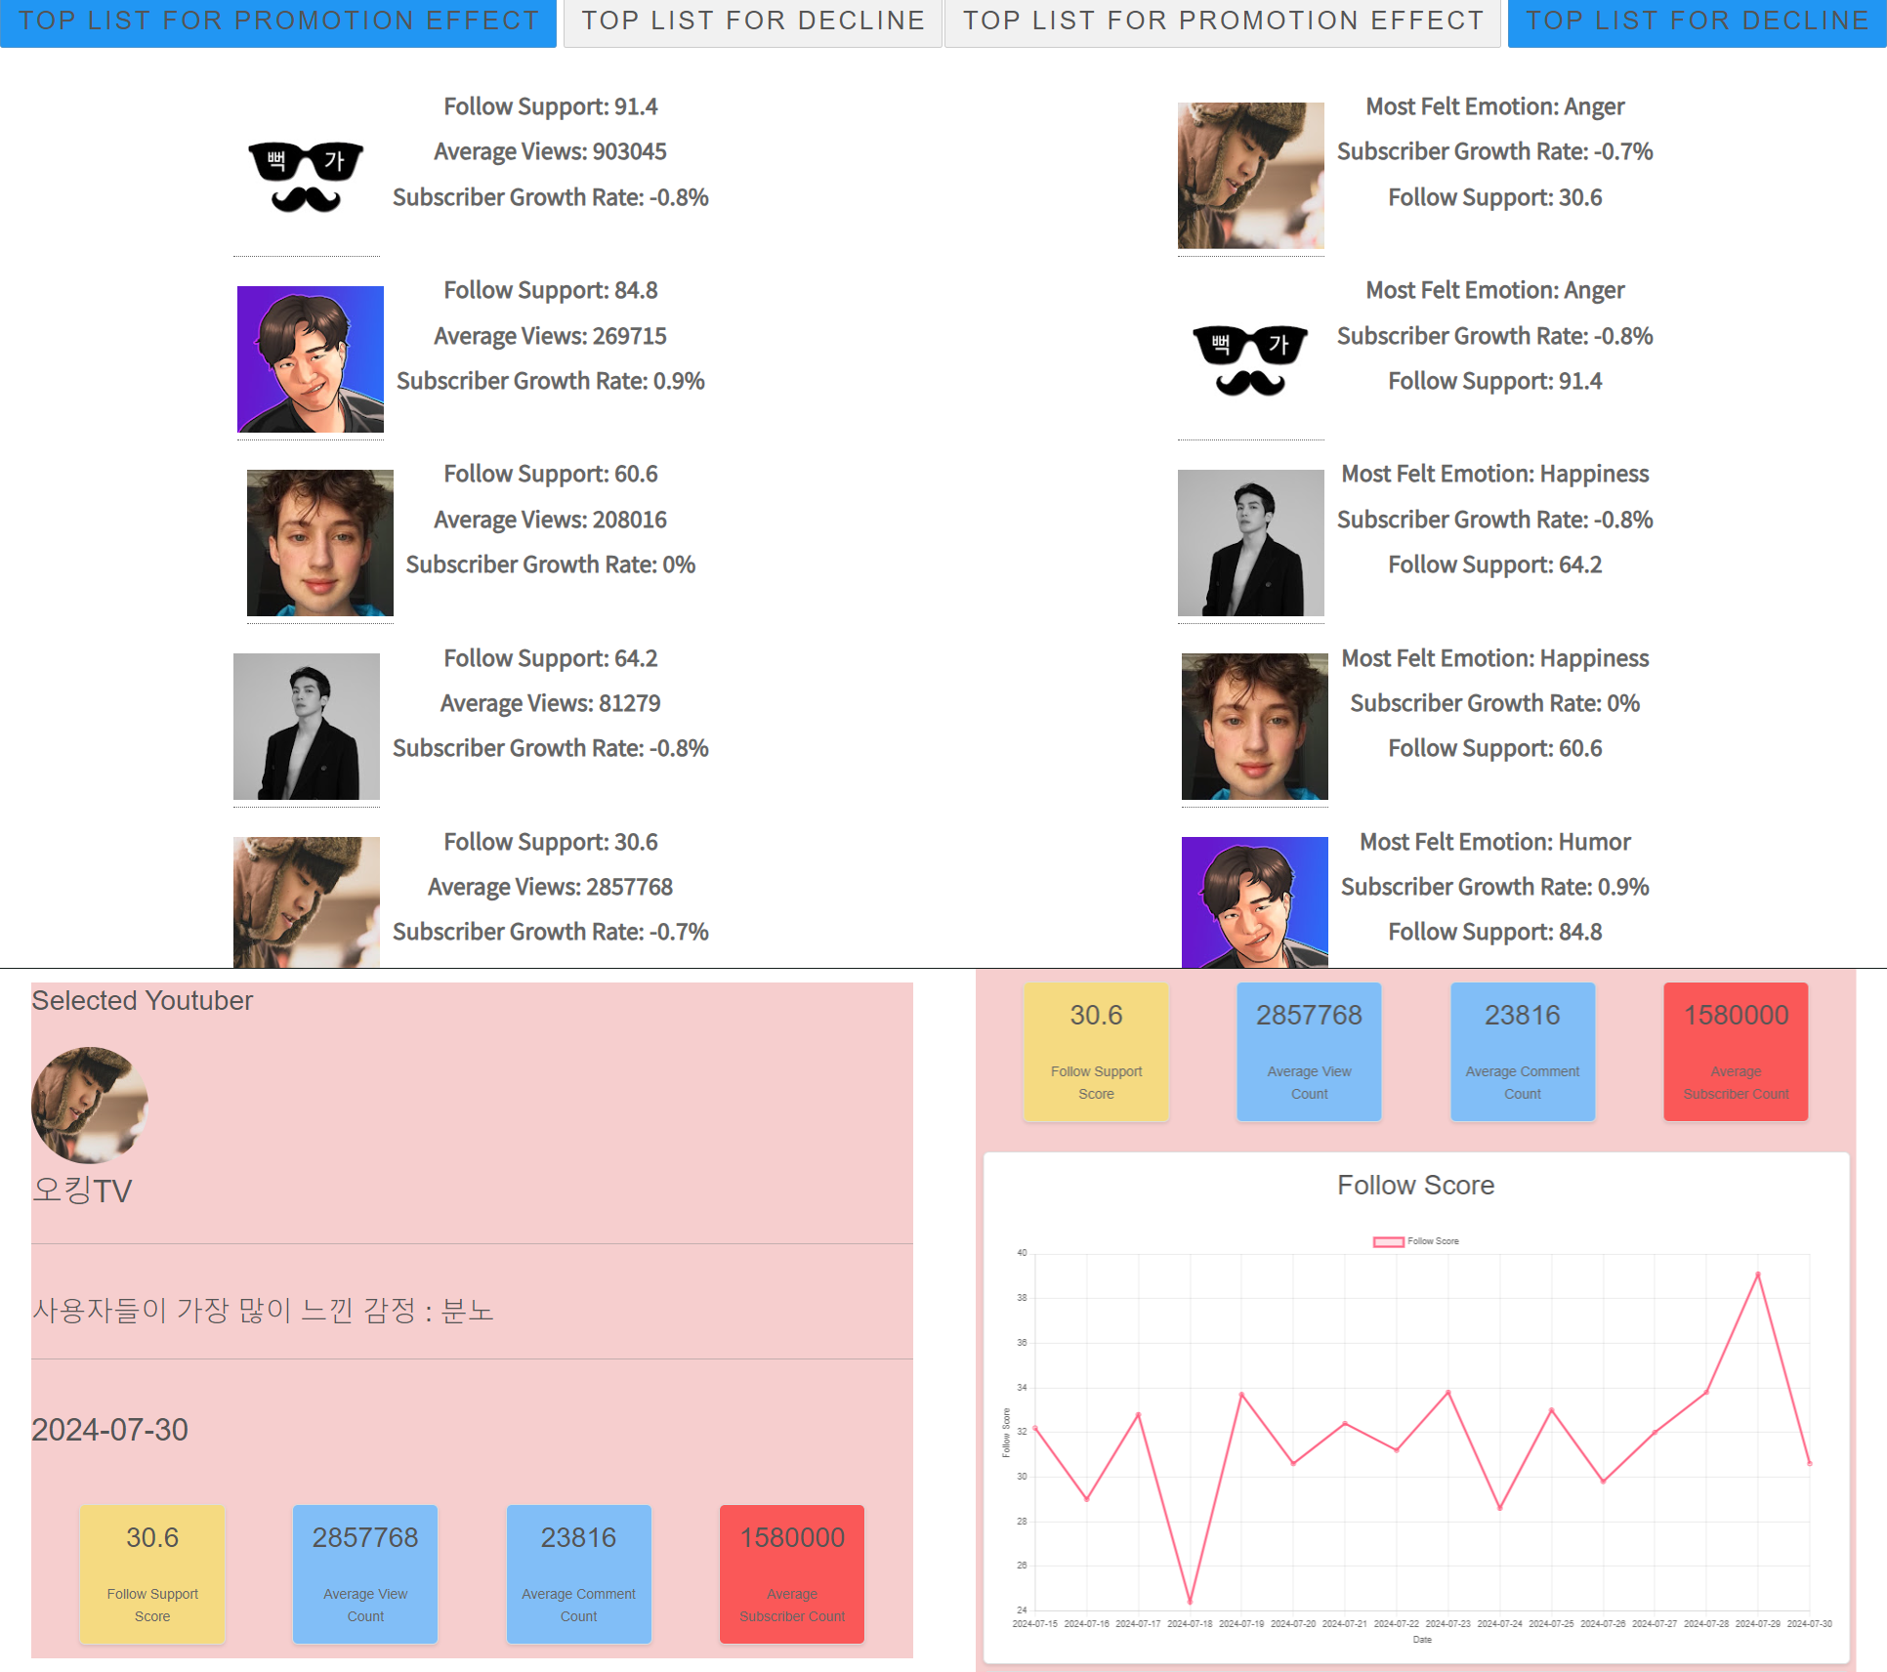
Figure 3. SCOPE Prototype Web UI
The data, including the FollowSupport indicators and influencer statistics, was organized into a MySQL database and deployed as a web service using Python Django. Figure 3 illustrates this prototype web service, which leverages the derived features and FollowSupport indicators to generate rankings based on promotional effectiveness and decline trends.This facilitated predictions of both rising and declining popularity. Additionally, a detailed page for each influencer was created, allowing users to visualize the fluctuations in their popularity over time. This implementation method enhances the applicability of the research findings.

3. Conclusions
The results of sentiment analysis and topic interest classification have been utilized to derive a Follow Support metric, which serves as a basis for ranking the potential fluctuations in influencer popularity. While the current methodology allows for ranking based on these metrics, there is a primary goal to enhance the derivation of Follow Support by incorporating user features such as location, gender, age, and interests. This expansion of user data features aims to develop a model capable of predicting fluctuations in popularity as continuous values.
During the research, one of the selected YouTubers experienced a statistically significant decline in popularity, and leveraging this data is expected to improve the accuracy of predicting influencer popularity changes. Initially, video content was summarized using text extraction; however, future efforts will focus on sentiment analysis of facial recognition and voice recognition data to derive a more sophisticated measure of subscriber loyalty. This approach is anticipated to enhance the accuracy of sentiment analysis and contribute to a deeper understanding of the relationship between influencers and their subscribers.

References

[1] Sung, S., & Kim, K. (2020). The impact of influencer engagement on startup brand attitude and purchase intention: Focusing on influencer characteristics. Korean Journal of Entrepreneurship, 15(2), 52-75.
https://www.kci.go.kr/kciportal/ci/sereArticleSearch/ciSereArtiView.kci?sereArticleSearchBean.artiId=ART002604172
[2] Park, E. L., & Cho, S. (2014). KoNLPy: Korean natural language processing in Python. Seoul National University, Industrial Engineering Department.
https://scienceon.kisti.re.kr/commons/util/koNLPy
[3] Gue, C. C. Y., Abdul Rahim, N. D., Rojas-Carabali, W., Agrawal, R., RK, P., Abisheganaden, J., & Yip, W. F. (2024). Evaluating the OpenAI's GPT-3.5 Turbo's performance in extracting information from scientific articles on diabetic retinopathy. Systematic Reviews, 13, 135. https://doi.org/10.1186/s13643-024-02523-2
[4] Jacob Devlin, Ming-Wei Chang, Kenton Lee, Kristina Toutanova, BERT: Pre-training of Deep Bidirectional Transformers for Language Understanding, NAACL, 4171-4186, 2019. https://aclanthology.org/N19-1423.pdf

