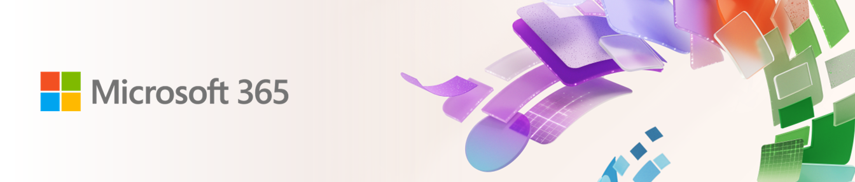
{customer_name} | Proposal for {target_sku}

​Hi [Partner Name],​

As your Microsoft contact, I am writing to share with you a proactive proposal you can send for a customer opportunity.

Customer name | {customer_name}
Target SKU | {target_sku}
Seats | {seats}

The customer will get:
{solution_overview}

Please find the customized proactive proposal you can send to the customer for {seats} seats!

Download proactive proposal flyer and e-mail

Also, please find below details on:
- Incremental cost for the customer
- Potential profitability for you

SKU for renewal | {starting_sku}
# Seats due for renewal | {seats}
Current investment | {expiring_arr}
Upgrade solution | {target_sku}
# Proposed seats for upgrade | {proposed_seat}
Cost of the solution per user | {after_promo_price}
Incremental cost per user | {difference}
Total incremental annual investment for {seats} seats | {incremental_cost}
Incentive from the current SKU for {seats} Seats | {current_incentive}
Potential incentive for upgraded seats | {new_incentive}
Incremental incentive for {seats} Seats | {difference}

I am also sharing additional BOM you can use in your discussions with the customer: {link}.

Let me know if you want to connect to discuss this in detail.

PS: If you want to explore some of the options yourself, you can upload the details of your customer here: {url}.

Hope this helps!

Please Note: This material is provided on an automated, as-is and non-binding basis and may contain errors or inaccuracies. Any disclosure, distribution, or reliance on this material is solely at your discretion and responsibility and must be strictly limited to parties who are duly authorized and legally entitled to receive it. Nothing herein shall be construed as creating any binding obligation, representation, or commitment on the part of Microsoft.
​
If you prefer I not forward you these types of communications, just let me know. To learn how to manage your contact preferences for other parts of Microsoft, please read our Privacy Statement.

Regards,​
[NAME]​
[SIGNATURE]

Microsoft Corporation
One Microsoft Way
Redmond, WA 98052

