
EVERGREEN PACIFIC HOLDINGS GROUP | Options for renewal upsell

​Hi [Partner Name],​

As your Microsoft contact, I am writing to share with you potential upsell options for an upcoming renewal.

We have an upcoming renewal opportunity with EVERGREEN PACIFIC HOLDINGS GROUP. Their renewal is scheduled for October 11, 2026 with 441 seats of Business Premium expiring with an ARR of $149,940.

This is a great moment for us to position AI and Security upsell.

I am sharing the options below with details on:
- Value proposition of different options
- Incremental cost for customers
- Incremental incentive for you

Business Premium + Copilot Business | View Proposal Flyer
Business Premium + Copilot Business + Purview Suite | View Proposal Flyer
Business Premium + Defender Suite | View Proposal Flyer
Business Premium + Purview Suite | View Proposal Flyer
Business Premium + Purview Suite + Defender Suite | View Proposal Flyer

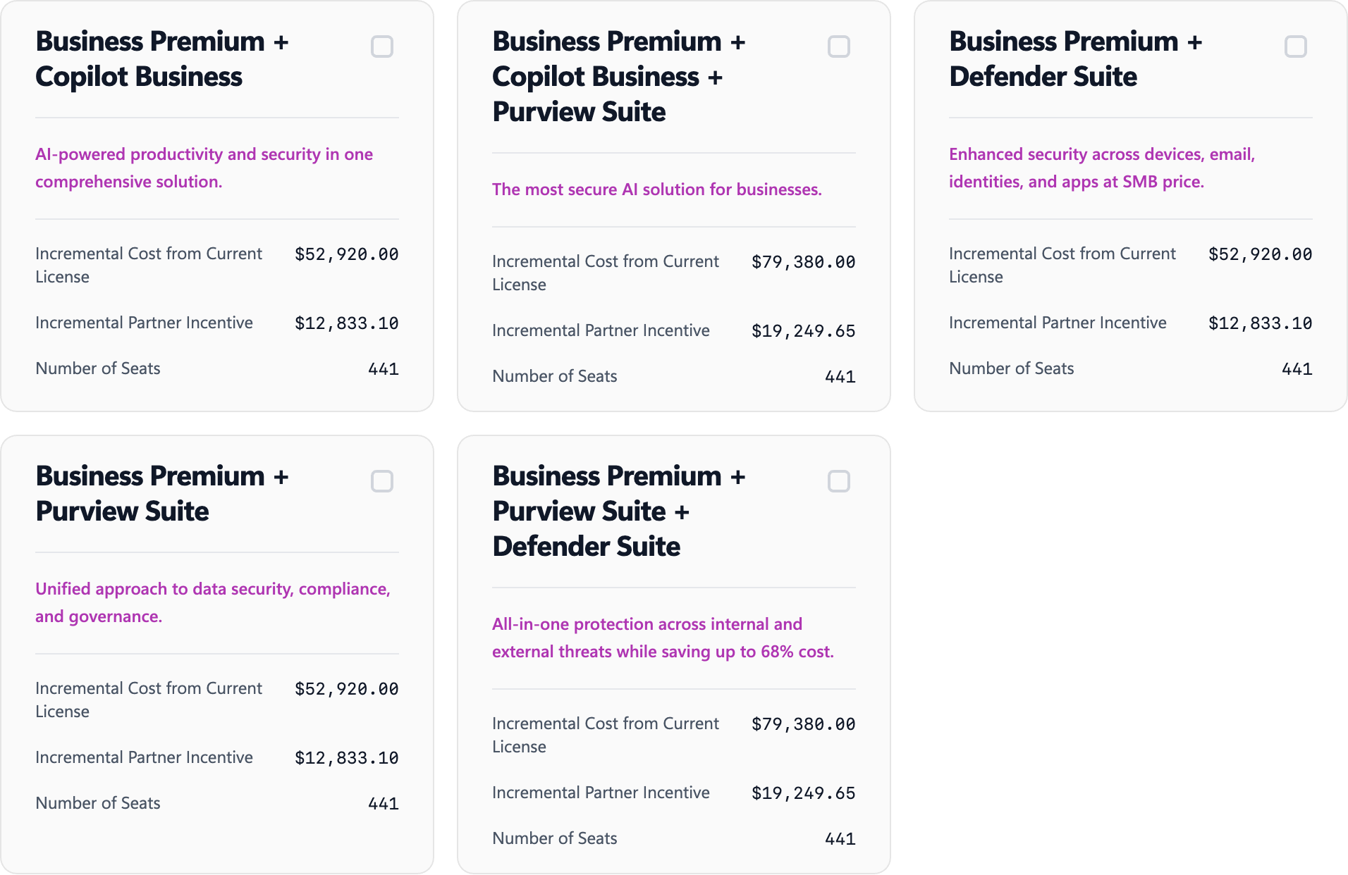

Let me know if you want to connect to discuss this in detail.

PS: If you want to explore some of these options yourself, you can upload the details of your customer here: https://agentb.cloud-programs.com/resellers.

Hope this helps!
​
If you prefer I not forward you these types of communications, just let me know. To learn how to manage your contact preferences for other parts of Microsoft, please read our Privacy Statement.

Regards,​
[NAME]​
[SIGNATURE]

Microsoft Corporation
One Microsoft Way
Redmond, WA 98052

