An Integrated Omnidirectional Mobile Inspection and Repair Robot for Fine Measurement of Road Cracks
Shuyi He^{a,b},Zhenqin Huang^{a,b}, Kang Gao^{a,b,c*}
ª Key Laboratory of Concrete and Prestressed Concrete Structures of the Ministry of Education, School of Civil Engineering, Southeast University, Nanjing 211189, China
^{b} National and Local Joint Engineering Research Center for Intelligent Construction and Maintenance, Southeast University, Nanjing 211189, China
^{c} State Key Laboratory of Safety, Durability and Healthy Operation of Long Span Bridges
Abstract:

Introduction
道路裂缝是路面早期病害的重要表现。传统人工巡检和人工灌缝修复存在效率低、主观性强、修复一致性差、对交通环境依赖高等问题。随着移动机器人、视觉分割和边缘计算发展，构建自动化道路裂缝巡检与局部修复系统具有工程价值。
传统检测的缺陷：
检测与修复分离：许多研究只做裂缝检测或分割，缺少从视觉结果到修复执行轨迹的闭环。
移动平台对准能力不足：差速或阿克曼底盘难以横移，面对细长裂缝、路边裂缝、局部修复点时，对准效率低。
修复控制较粗糙：传统方法多采用恒定喷嘴速度或简单按裂缝宽度调速，难以保证材料填充平整性，容易欠填或溢出。

System Architecture of the IOMIR system

Overall workflow
As illustrated in Fig. 1, the proposed integrated omnidirectional mobile inspection and repair (IOMIR) robot combines crack detection, cooperative positioning, fine-scale measurement, and localized repair within a unified framework. The overall workflow is organized into three main stages: preliminary crack inspection, cooperative robot positioning, and fine inspection with repair execution. This integrated architecture enables visual information to be converted into executable repair tasks through the coordinated operation of the perception, locomotion, and repair modules.
During the preliminary inspection stage, the robot moves along the pavement surface while the wide-field camera continuously captures road images. The acquired images are processed by the crack segmentation network to identify potential crack regions and determine their approximate locations. Based on the detected crack positions and the robot kinematic model, the omnidirectional mobile platform adjusts its longitudinal and lateral positions, as well as its orientation, to align the target crack with the working area of the repair module. The omnidirectional motion capability allows the robot to perform positioning adjustments without unnecessary turning maneuvers.
Once the target crack is located within the effective working area, the robot proceeds to the fine inspection and repair stage. Close-range images are acquired and processed to refine the initial crack segmentation results, providing more detailed geometric information for subsequent repair planning. The refined crack mask is then used to extract the crack centerline and generate a corresponding repair trajectory. Finally, the repair module coordinates nozzle movement and material dispensing to perform localized crack filling along the planned path. The ground station provides task visualization and supervisory control throughout the operation.
Through the coordination of large-range chassis positioning and small-range nozzle manipulation, the proposed workflow establishes a connection between visual crack inspection and physical repair execution, providing a systematic approach to automated pavement crack maintenance.
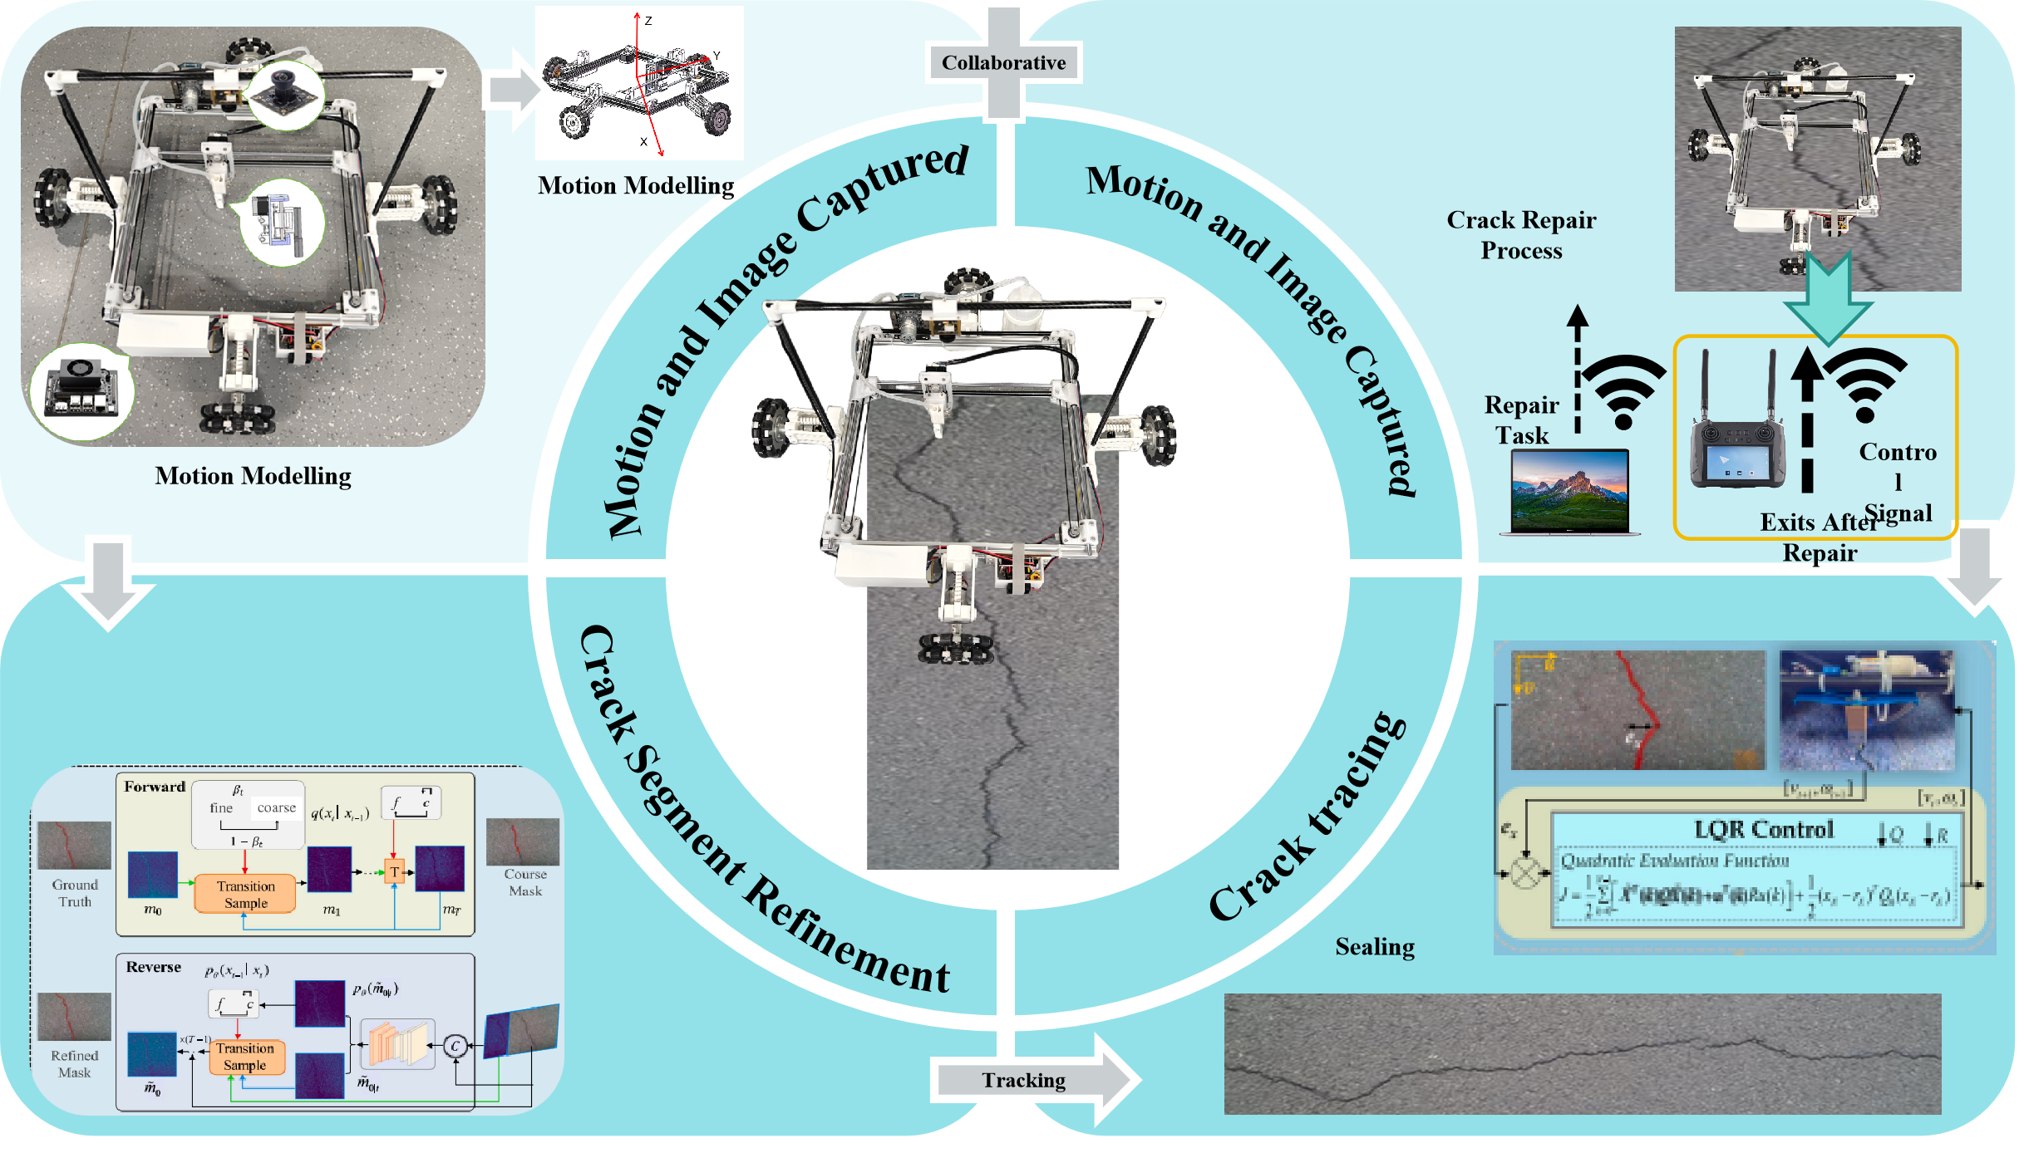
Fig. 1Workflow of the IOMIR robot.

Hardware System Configuration
The IOMIR robot adopts a modular design to facilitate the integration and coordinated operation of its inspection and repair functions. As shown in Fig. 2, the robotic system consists of five main functional modules: the motion module, vision module, repair module, control module, and ground station. The main body of the robot is constructed using an open-frame chassis, with the vision and repair components arranged to support pavement inspection and localized crack filling. The side and front views in Fig. 2 illustrate the spatial arrangement of the major mechanical components.
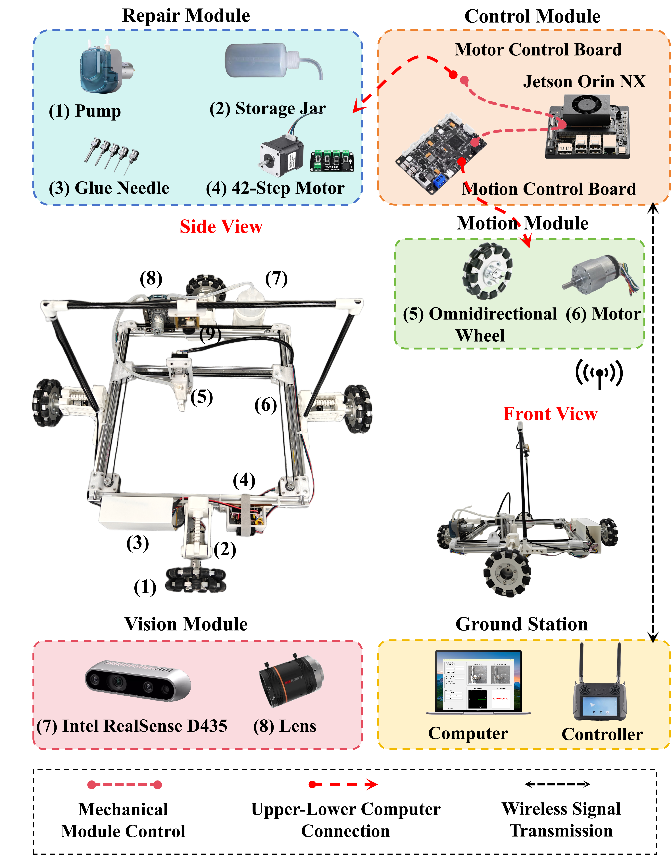
Fig. 2Components of the IOIR system.
The motion module consists of four independently driven omnidirectional wheels and their corresponding DC geared motors. Unlike conventional differential-drive platforms, the omnidirectional configuration enables longitudinal movement, lateral translation, and rotational adjustment, providing greater flexibility for aligning the robot with irregular crack geometries. This mobility is particularly important when the repair nozzle must be positioned over a specific crack region without repeatedly changing the orientation of the entire platform.
The vision module integrates an Intel RealSense D435 camera and an industrial imaging unit equipped with an optical lens. These components support pavement image acquisition at different observation scales. The wide-field imaging unit provides visual information for preliminary crack identification and target localization, while the close-range imaging unit is intended to capture detailed crack features for refined segmentation and geometric measurement. The acquired visual information provides the basis for subsequent coordinate transformation and repair trajectory generation.
The repair module comprises a peristaltic pump, a material storage jar, a dispensing needle, and a stepper-motor-driven positioning mechanism. The material storage jar supplies repair material to the dispensing system, while the peristaltic pump controls material delivery through the connecting tube and dispensing needle. The positioning mechanism enables local adjustment of the nozzle along the X-, Y-, and Z-axes, allowing the repair module to follow the planned crack trajectory within its working area. This configuration separates large-range robot movement from fine-scale nozzle positioning, improving the flexibility of localized repair operations.
Table 1. Main hardware components and specifications of the IOMIR robot.
No. | Component | Description | Specifications
1 | Peristaltic pump | Delivers repair material | BP600-DNUN40B, Rated voltage: 12 V, Flow rate: 500 mL/min, Power: 10 W
2 | Storage jar | Stores repair material | Capacity: 500 mL
3 | Glue needle | Extrudes repair material | Diameter: 1 mm, Length: 10 mm
4 | Stepper motor | Drives dispensing mechanism | MS42C, Step angle: 1.8°, Rated current: 1.68 A, Holding torque: 3.6 kgf·cm, Max. speed: ≤3000 RPM
5 | Stepper motor control board | Controls dispensing motion | ESP32-S3-WROOM-1U-N4R2, Dual-core Xtensa LX7 processor, Max. clock frequency: 240 MHz, SRAM: 512 KB, PSRAM: 2 MB, Flash: 4 MB
6 | Jetson Orin NX | Core processing unit | NVIDIA Jetson Orin NX 16GB SUPER, Max. GPU frequency: 1173 MHz, Memory: 16 GB LPDDR5, Memory bandwidth: 102.4 GB/s, AI performance: 157 TOPS
7 | Motion control board | Controls locomotion motors | STM32F103RCT6, ARM Cortex-M3 processor, Flash: 256 KB, SRAM: 48 KB, 51 GPIOs, Operating voltage: 2.0–3.6 V
8 | Omnidirectional wheel | Enables omnidirectional locomotion | Diameter: 127 mm
9 | DC geared motor | Drives locomotion system | GA36Y-3530-12100-EN, Rated voltage: 12 V, Reduction ratio: 100:1, No-load speed: 100 RPM, Rated-load speed: 72 RPM, Rated torque: 7.3 kgf·cm, Power: 5 W
10 | Industrial camera | Image acquisition | HIKROBOT MV-CU120-10GM, Resolution: 4024 × 3036, Sensor: CMOS, Pixel size: 1.85 μm × 1.85 μm
11 | Prime lens | Optical focusing | HIKROBOT 12 MP low-distortion lens, Focal length: 8 mm, Max. aperture: f/1.8
12 | Computer | System monitoring and task management | Laptop/PC
13 | Remote controller | Manual operation and remote monitoring | 5.5-inch 1080P touch display, Android 9.0, RAM: 2 GB, Storage: 16 GB, Max. communication distance: 15 km, Battery: 10200 mAh
To coordinate the individual subsystems, a hierarchical control architecture is employed. The NVIDIA Jetson Orin NX serves as the high-level computing unit responsible for image processing, crack perception, task planning, and command generation. It communicates with the motion control board and motor control board, which execute the low-level commands for chassis locomotion and repair-module actuation, respectively. The ground station consists of a computer and a wireless controller, providing an interface for task monitoring, command transmission, and manual intervention when required.
The modular hardware configuration enables the motion, vision, and repair functions to operate within a coordinated robotic platform. The main hardware components and their specifications are summarized in Table 1, while the overall specifications of the IOMIR robot are presented in Table 2.
Table 2 Summary of the main specifications of the IOIR robot.
Description | Specifications
Over dimensions | 5
Total weight | 5kg
Nominal speed | 10
Payload capacity | 5kg
Power supply | 12V

Robot Kinematic Models
Fig. shows the bottom view of the crack-filling robot. The robot is equipped with four independently driving omnidirectional wheels, and therefore, it can move in any direction with free rotation. Fig. 8(b) illustrates the driving mechanism for the filling nozzle, denoted as $N_{z}$. Two frames are used in robot modeling: a global frame $N(x,y)$ and a body frame $B(x_{b},y_{b})$. The robot footprint is assumed to be square, with its center $O$ equidistant from four wheels, denoted by $W_{i}$, $i=1,…,4$. The distance between $O$ and $W_{i}$ is denoted as $R_{d}$. The nozzle is driven by two step motors (denoted as $W_{5}$ and $W_{6}$) with two timing belts and moves along the $x_{b}$- and $y_{b}$-axis in $B$.
The robot pose is captured by $q_{r}=[x_{r} y_{r} θ]^{T}$ in $N$, where $(x_{r},y_{r})$ and $θ$ are the position of robot center $O$ and the robot orientation, respectively. The position of $N_{z}$ in $B$ is denoted as $q_{n}=[x_{n} y_{n}]^{T}$. We denote the angular velocity for $W_{i}$ as $ω_{i}$, $i=1,…,6$, and define $ω_{r}=[ω_{1} ω_{2} ω_{3} ω_{4}]^{T}$ and $ω_{n}=[ω_{5} ω_{6}]^{T}$. Assuming no wheel slip and no deformation of the timing belts, the kinematic models for robot motion in $N$ and nozzle relative motion in $B$ are obtained as
$$ω_{r}=A_{r}{\overset{˙}{q}}_{r}, ω_{n}=A_{n}{\overset{˙}{q}}_{n}.$$
Where
$$\begin{aligned}A_{r}=\frac{\sqrt{2}}{R_{w}}\left[\begin{matrix}−s_{θ_{1}} & c_{θ_{1}} & R_{d} \\ −s_{θ_{2}} & c_{θ_{2}} & R_{d} \\ −s_{θ_{3}} & c_{θ_{3}} & R_{d} \\ −s_{θ_{4}} & c_{θ_{4}} & R_{d}\end{matrix}\right], A_{n}=\frac{1}{R_{g}}\left[\begin{matrix}1 & −1 \\ 1 & 1\end{matrix}\right].\#(2)\end{aligned}$$
$R_{g}$ is the radius of the driving pulley for $W_{5}$ and $W_{6}$, and $R_{w}$ is the radius of the robot wheel. In (2), we use notations $s_{θ}=sin⁡θ$ and $c_{θ}=cos⁡θ$ for $θ$ and other angles. Angles $θ_{1}=θ+π/4$ and $θ_{i+1}=θ_{i}+π/2$, $i=1,2,3$.
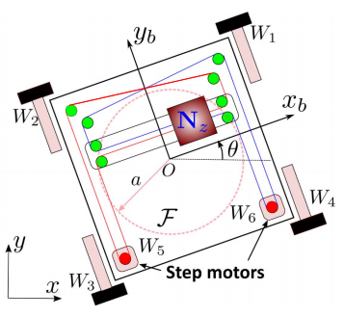
Fig. 3Schematic of the filling nozzle driving mechanism and robotic kinematic configuration.

Methodology for integrated inspection and repair

SegFormer-B0 Encoder and MLP Decoder
$I∈ℝ^{3×H×W}$$i$本研究采用 SegFormer-B0 作为路面裂缝语义分割的基础模型。其编码器为四阶段 Mix Vision Transformer（MiT-B0），使用重叠式 patch embedding 和空间缩减注意力提取多尺度特征。MiT-B0 的四个阶段参数分别为：通道数 [32, 64, 160, 256]，attention heads [1, 2, 5, 8]，Transformer blocks [2, 2, 2, 2]，sr_ratio [8, 4, 2, 1]。各阶段的 MLP ratio 均为 4，qkv_bias 开启，drop path rate 为 0.1。对于 400 × 400 输入，四个阶段实际输出尺寸为 100 × 100 × 32、50 × 50 × 64、25 × 25 × 160 和 13 × 13 × 256，其中最后一个空间尺寸由 3 × 3、stride=2、padding=1 的重叠式 patch embedding 产生。
$$F_{i}={MiT}_{i}(F_{i−1}), F_{i}∈ℝ^{C_{i}×H_{i}×W_{i}}, i=1,2,3,4.$$
第 i 个阶段的输出记为 F_i ∈ R^(C_i × H_i × W_i)，其中 (C_i, H_i, W_i) 依次为 (32,100,100)、(64,50,50)、(160,25,25) 和 (256,13,13)。四个阶段分别保留不同空间分辨率和语义层次，使网络同时利用长裂缝的区域上下文与细裂缝的局部纹理。
$$E_{i}={MLP}_{i}(Flatten(F_{i})), E_{i}∈ℝ^{(H_{i}W_{i})×C}.$$
$E_{i}$对于每个阶段，PaddleSeg 实现首先将二维特征展平为 token 序列，再通过线性层投影到统一的 256 维嵌入空间： E_i = MLP_i(Flatten(F_i)) ∈ R^((H_iW_i) × 256)。随后将 token 重排为空间特征，并通过双线性插值将第 2 至第 4 阶段上采样到第一阶段的 100 × 100 空间尺寸： F̂_i = Up_{100×100}(Reshape(E_i))。
$${\tilde{F}}_{i}=Reshape(E_{i}), {\hat{F}}_{i}={Up}_{H_{1},W_{1}}({\tilde{F}}_{i}).$$
$1×1$四个尺度的特征按照 [F̂_4, F̂_3, F̂_2, F̂_1] 在通道维拼接，得到 1024 通道特征；随后使用 1 × 1 ConvBNReLU（1024 → 256）进行融合。融合结果经过 Dropout2D(p=0.1)，再由 1 × 1 分类卷积（256 → 2）产生背景/裂缝 logits，最后通过双线性插值恢复到输入图像的 H × W 尺寸： Z = Conv_{1×1}(Dropout(ConvBNReLU(Concat(F̂_4,F̂_3,F̂_2,F̂_1))))，P = Softmax(Up_{H×W}(Z))。
$$F_{fuse}={Conv}_{1×1}\left(Concat[{\hat{F}}_{1},{\hat{F}}_{2},{\hat{F}}_{3},{\hat{F}}_{4}]\right),$$
$$Z={Conv}_{1×1}\left(Dropout(F_{fuse})\right),qquadP=Softmax\left({Up}_{H,W}(Z)\right).$$
$P$该结构具有较低的解码开销，适合部署到搭载 RTX5060 训练、并在机器人端执行视觉巡检和局部修复的系统中。需要注意的是，13 × 13 的深层特征和 400 × 400 裁剪会压缩极细裂缝的空间信息，因此后续实验必须区分信息是在输入缩放、编码器特征提取、MLP 融合还是最终预测恢复阶段损失。UAFM 和 PPContextModule 仅作为受控消融模块，用于验证两个具体位置的结构假设。

Controlled decoder ablations

UAFM_SpAtten 接在基线的多尺度融合卷积之后、Dropout2D 和分类卷积之前。基线融合特征记为 C ∈ R^(B×256×100×100)，第一阶段细节特征记为 C1 ∈ R^(B×256×100×100)，UAFM 的输入为 (C1, C)，输出仍为 R^(B×256×100×100)，随后进入 Dropout2D 和 1 × 1 分类卷积。SegFormer-B0 的参数量为 3.715M，加入 UAFM 后为 4.897M，增加约 1.182M；RTX5060 上验证 batch 耗时由 0.0175 s 增至 0.0215 s。其设计目标是改善高低层特征融合、细裂缝端点和边界恢复，但当前 Crack500 验证结果未达到筛选门槛。

PPContextModule 同样位于融合特征瓶颈，但其输入仅为 C ∈ R^(B×256×100×100)。按照当前 PaddleSeg 代码，模块参数为 PPContextModule(256, 64, 256, (1,3,6))，即以 64 通道中间表示和三个上下文尺度提取多尺度上下文，输出与 C 同形状的上下文残差；模型计算 C' = C + PPContextModule(C)，再执行 Dropout2D、1 × 1 分类卷积和最终双线性上采样。加入该模块后参数量为 3.914M，增加约 0.199M，验证 batch 耗时为 0.0183 s。其设计目标是提高长裂缝连续性以及阴影和低对比度区域的识别，但当前结果表现为 Recall 增加而 Precision、IoU 和边界 F1 下降。
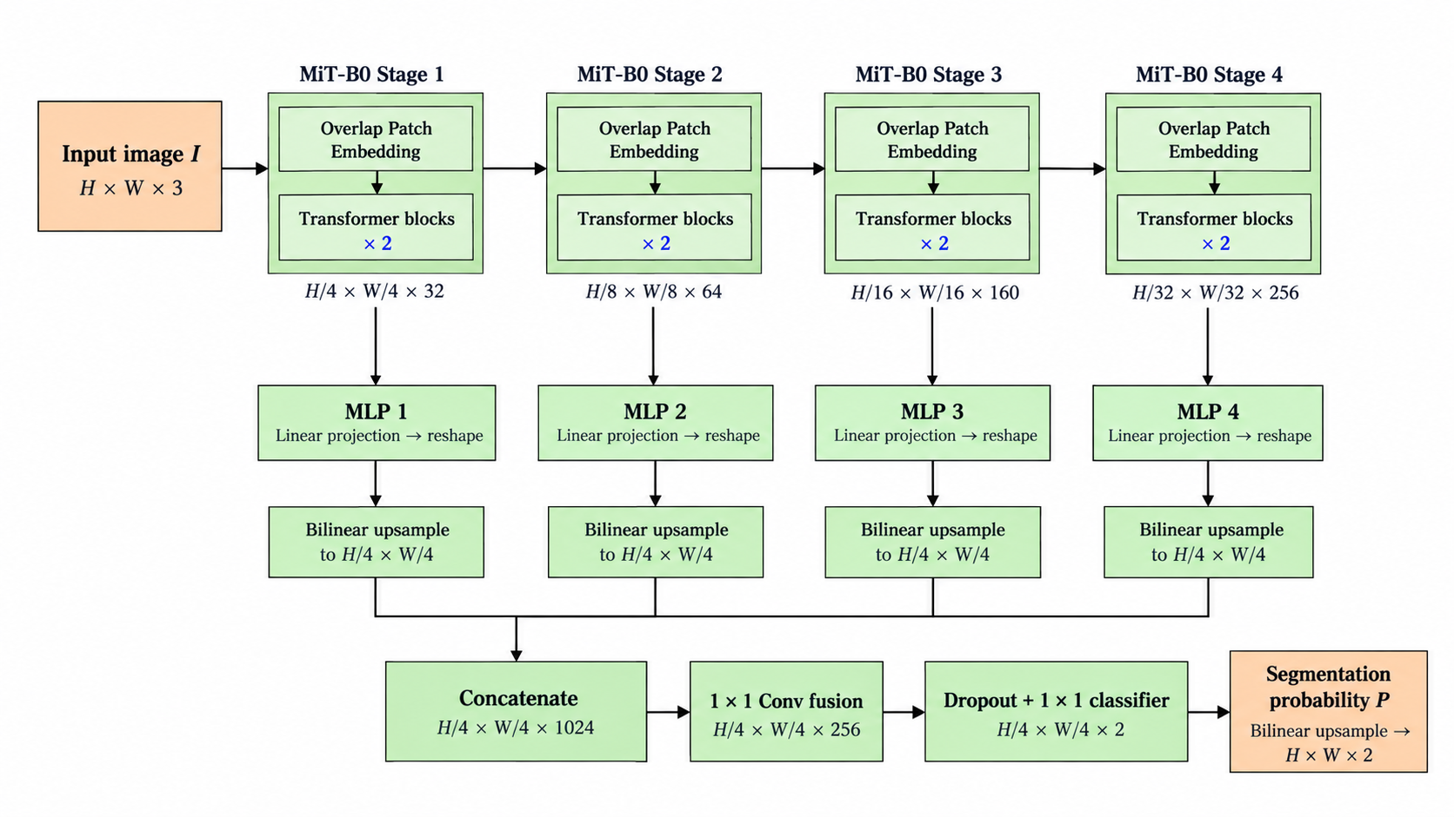
Fig. 4 SegFormer-B0 architecture
$β_{1}=0.9$$β_{2}=0.999$$6×{10}^{−5}$所有实验均基于 PaddleSeg-2.10.0 官方实现，在 RTX5060 GPU、FP32 精度下运行。随机种子为 42，batch size 为 4，总训练预算为 18,000 iterations。优化器采用 AdamW，β1=0.9、β2=0.999、weight decay=0.01，初始学习率 η0=6×10^−5。训练阶段使用 ResizeStepScaling（0.75–1.25，step=0.25）、400 × 400 RandomPaddingCrop、随机水平翻转、亮度/对比度/饱和度扰动和归一化；验证阶段只使用归一化。
$$η_{t}=η_{0}{\left(1−\frac{t}{T}\right)}^{p},$$
$η_{0}=6×{10}^{−5}$$T=18000$$p=1$$t$学习率按照 polynomial decay 下降至 0： η_t = η_0 (1 − t/T)^p，η_0=6×10^−5，T=18,000，p=1，t 为当前 iteration。
$$ℒ_{CE}=−\frac{1}{N}\sum_{p=1}^{N}{ }\sum_{c=1}^{2}{ }y_{p,c}log⁡{\overset{ˆ}{y}}_{p,c},$$
$N$$y_{p,c}$${\overset{ˆ}{y}}_{p,c}$$×$训练损失采用二分类交叉熵： L_CE = −(1/N) Σ_p Σ_{c=0}^{1} t_{p,c} log(p̂_{p,c})，其中 t_{p,c} 为像素 p 的 one-hot 真实标签，p̂_{p,c} 为模型预测概率，N 为参与计算的像素数。这里使用 t 和 p̂ 区分真实标签与预测概率，避免变量混用。
每次训练同时保存普通模型和 EMA 模型 checkpoint。模型选择只使用验证集 mIoU： k* = argmax_{k∈{ordinary, EMA}} mIoU_val(k)。选中的 checkpoint 被复制到冻结目录并计算 SHA-256。测试集只在 checkpoint 冻结后访问一次，不能用 test 指标反向选择模型。
$$k^{∗}=arg⁡\max_{k∈\{ordinary,EMA\}} {mIoU}_{val}(k).$$
$k^{∗}$该流程保证所有模型使用相同的数据清单、标签编码、数据增强、训练预算和评价脚本，也使验证集消融结果与最终测试集公开模型对照保持独立。
Fig. 5

Datasets
本研究同时考虑公开 Crack500 数据集和课题组自建裂缝数据集。公开数据用于与已有分割模型进行可复现比较，自建数据用于检验模型对本机器人视觉系统、相机安装方式和真实路面纹理的适应性。所有图像—标签对在训练前进行配对检查、尺寸检查、标签值检查和 SHA-256 审计；训练、验证和测试文件清单固定后不再修改。

Crack500 dataset
Crack500 的 1,896、348 和 1,124 分别是官方 train、validation 和 test 清单中的裁剪图像—标签对数量，而不是 1,896、348 和 1,124 个独立原始采集 frame。每个 crop 应保留其 source_frame_id 和 crop_index；同一原始 frame 产生的相邻 crop 不能分别进入训练集和验证/测试集，否则会产生相邻裁剪泄漏。当前结果使用官方 crop 清单，已完成配对关系、文件存在性、标签值和 SHA-256 审计；source-frame-disjoint 复核还必须按照 source_frame_id 重新汇总，并检查 S_train∩S_val=∅、S_train∩S_test=∅、S_val∩S_test=∅。在该复核完成前，本文只能将这组结果称为 official crop-split results，不能称为 source-frame-disjoint results。

Source-frame audit protocol. 先从文件名或原始元数据恢复 source_frame_id，再按 source_frame_id 分组统计 crop 数量、裂缝像素比例和尺寸。审计表应同时列出 crop 数、source frame 数、每个 source frame 的 crop 数分布、跨 split 重叠数和重复哈希数。该表应放在 Crack500 数据集描述之后，并与最终 test 结果一起保存为可复核的清单附件。

Evaluation metrics and statistical protocol

本文同时记录两种统计口径。参考论文报告类别平均 Precision、Recall 和 F1，并使用 2 像素容差衡量边界匹配；本研究的主结果则由全验证集混淆矩阵聚合得到前景裂缝 IoU、Precision、Recall、F1 和 mIoU，边界 F1 也由全数据集边界匹配计数计算。两种口径不能直接混合比较。

对裂缝前景类别，IoU_crack = TP/(TP+FP+FN)，Precision = TP/(TP+FP)，Recall = TP/(TP+FN)，F1 = 2·Precision·Recall/(Precision+Recall)，mIoU = (IoU_bg + IoU_crack)/2。参考论文的类别平均指标应写为 mP=(P_bg+P_crack)/2、mR=(R_bg+R_crack)/2 和 mF1=(F1_bg+F1_crack)/2。

边界 F1 的计算先对二值掩膜 G 和 P 使用 3 × 3 腐蚀： B_G=G−Erode_3×3(G)，B_P=P−Erode_3×3(P)。若预测边界像素与真实边界像素的欧氏距离不超过 2 像素，则视为匹配，再由聚合后的边界 Precision 和 Recall 计算 Boundary F1。
Crack500 包含细长裂缝、交叉裂缝、宽裂缝、阴影干扰和纹理复杂的路面区域，适合检验 SegFormer-B0 对裂缝连续性、边界定位和低对比度目标的处理能力。为了与公开模型保持可比性，本研究的所有 Crack500 模型使用相同清单、400×400 训练裁剪、相同归一化和相同 checkpoint 选择规则。

Training setup and experimental results
为评价模型是否适合部署到机器人巡检系统，在同一 RTX5060 环境下测量参数量、FLOPs 和验证 batch 的推理时间。SegFormer-B0 包含约 3.715M 参数，FLOPs 约为 4.135G，验证 batch 推理耗时约 0.0175 s。UAFM 将参数量增加到约 4.897M，FLOPs 增至约 15.943G，batch 耗时约 0.0215 s；PPContextModule 约 3.914M 参数、5.626G FLOPs、0.0183 s；OCRNet-HRNet-W18 约 12.110M 参数、32.396G FLOPs、0.0619 s；PP-LiteSeg-STDC1 约 8.039M 参数、3.568G FLOPs、0.0184 s。该比较说明 UAFM 虽然只增加一个融合模块，但其当前实现的计算开销明显高于基线；PPContext 的开销增量较小，但验证指标未提升。

Fig. 6 Omputational efficiency on RTX5060
Model | Parameters | FLOPs | Validation batch time
SegFormer-B0 | 3.715M | 4.135G | 0.0175 s
SegFormer-B0 + UAFM | 4.897M | 15.943G | 0.0215 s
SegFormer-B0+PPContext | 3.914M | 5.626G | 0.0183 s
OCRNet-HRNet-W18 | 12.110M | 32.396G | 0.0619 s
PP-LiteSeg-STDC1 | 8.039M | 3.568G | 0.0184 s
实验结果表明，SegFormer-B0 在当前 Crack500 official crop-split 协议下取得验证 mIoU 0.8280、裂缝 IoU 0.6782、Precision 0.8283、Recall 0.7891、F1 0.8082 和边界 F1 0.5894，因此保留为当前控制模型。UAFM 的验证结果为 mIoU 0.8263、裂缝 IoU 0.6752、Precision 0.8202、Recall 0.7924、F1 0.8059；其裂缝 IoU 和 F1 没有达到预设增益门槛，且 mIoU 下降，因此不能写成性能提升。PPContextModule 的验证结果为 mIoU 0.8249、裂缝 IoU 0.6728、Precision 0.8109、Recall 0.7979、F1 0.8044 和边界 F1 0.5776。该模块虽然提高 Recall，但同时降低 Precision、裂缝 IoU、F1 和边界 F1，说明在当前设置下扩大候选响应带来了更多阴影和纹理误检。两个模块均保留为受控消融负结果，不启动联合模型，也不根据这些失败模型访问 test 集。

Table 4. Controlled ablation results on the Crack500 validation set.
Model | mIoU | Crack IoU | Precision | Recall | F1 | Boundary F1 | Decision
SegFormer-B0 | 0.8280 | 0.6782 | 0.8283 | 0.7891 | 0.8082 | 0.5894 | Control
SegFormer-B0 + UAFM | 0.8263 | 0.6752 | 0.8202 | 0.7924 | 0.8059 | 未计算 | Fail
SegFormer-B0 + PPContext | 0.8249 | 0.6728 | 0.8109 | 0.7979 | 0.8044 | 0.5776 | Fail
PP-LiteSeg-STDC1 | 0.8205 | 0.6641 | 0.8250 | 0.7730 | 0.7982 | 0.5643 | Reference

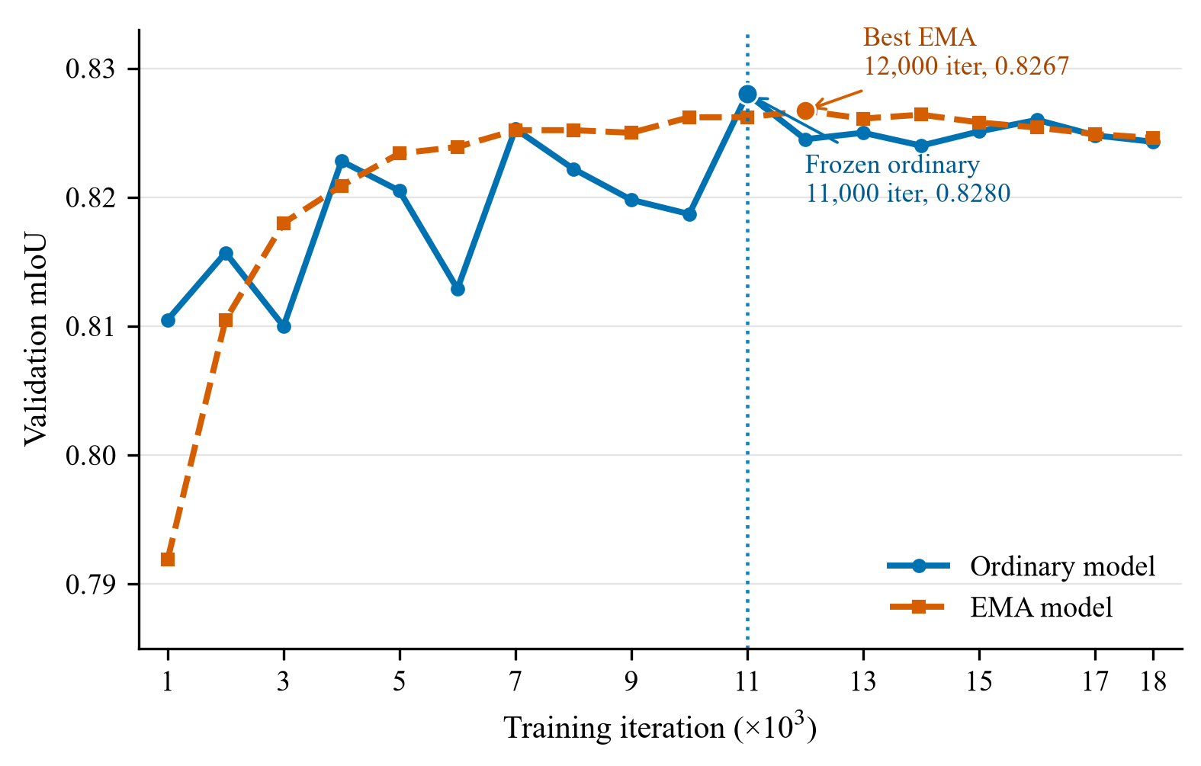
Fig. 7
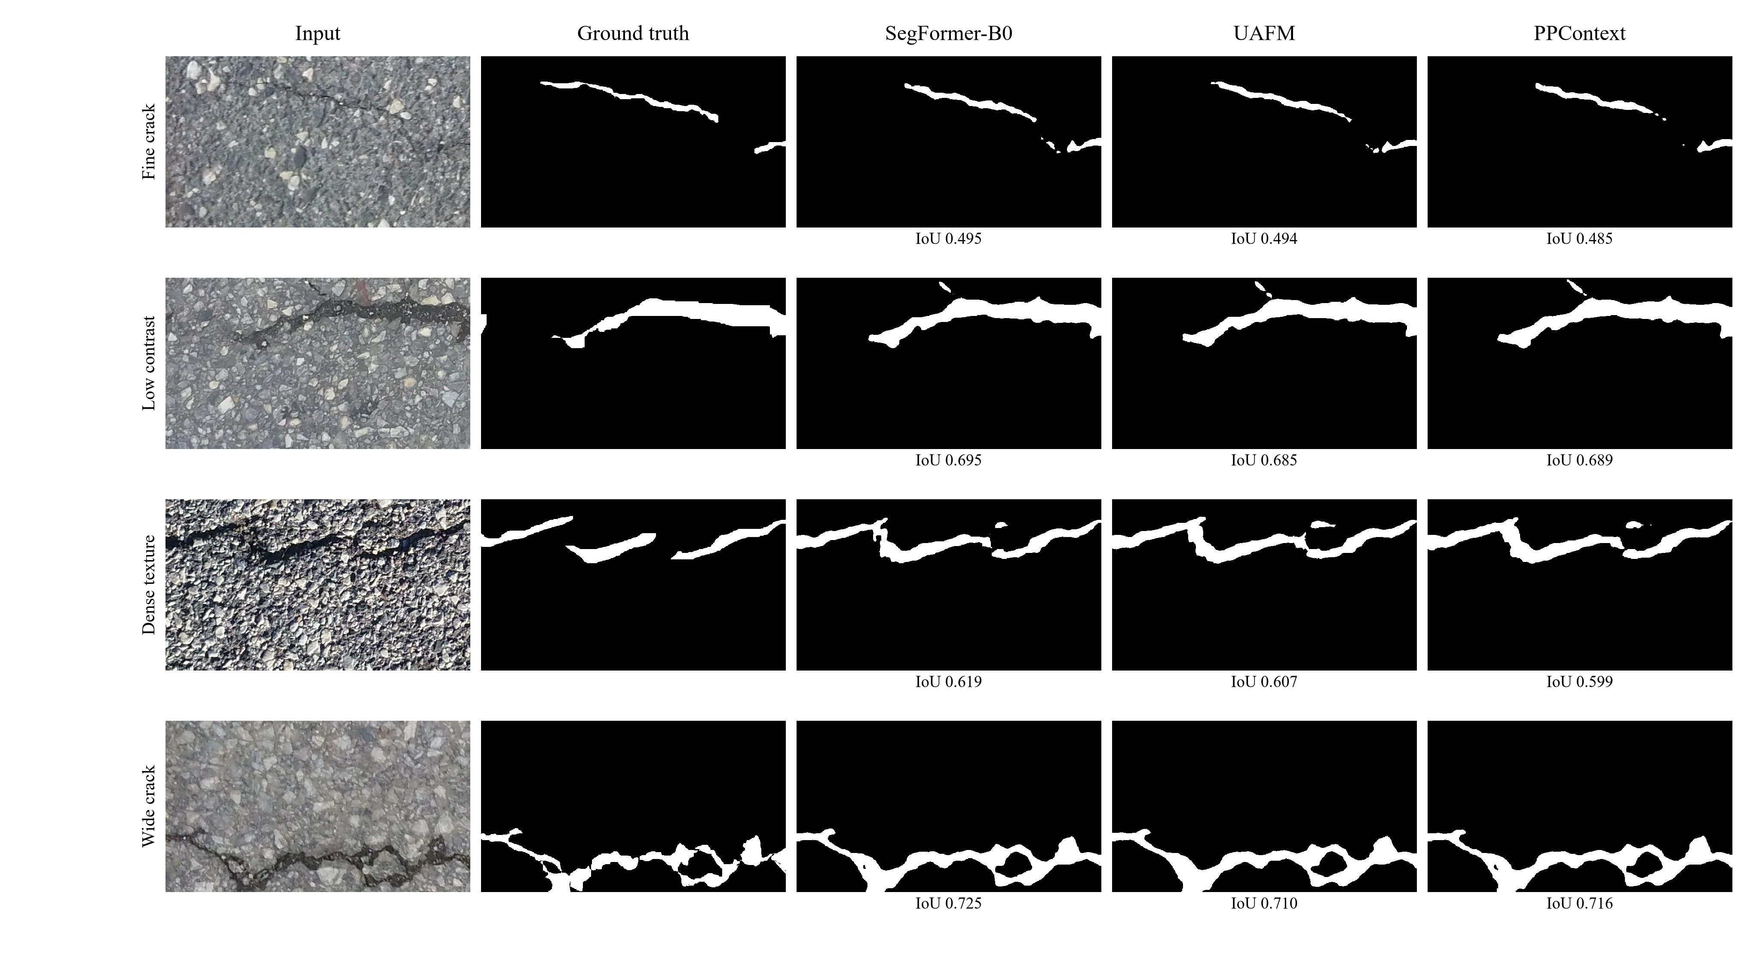
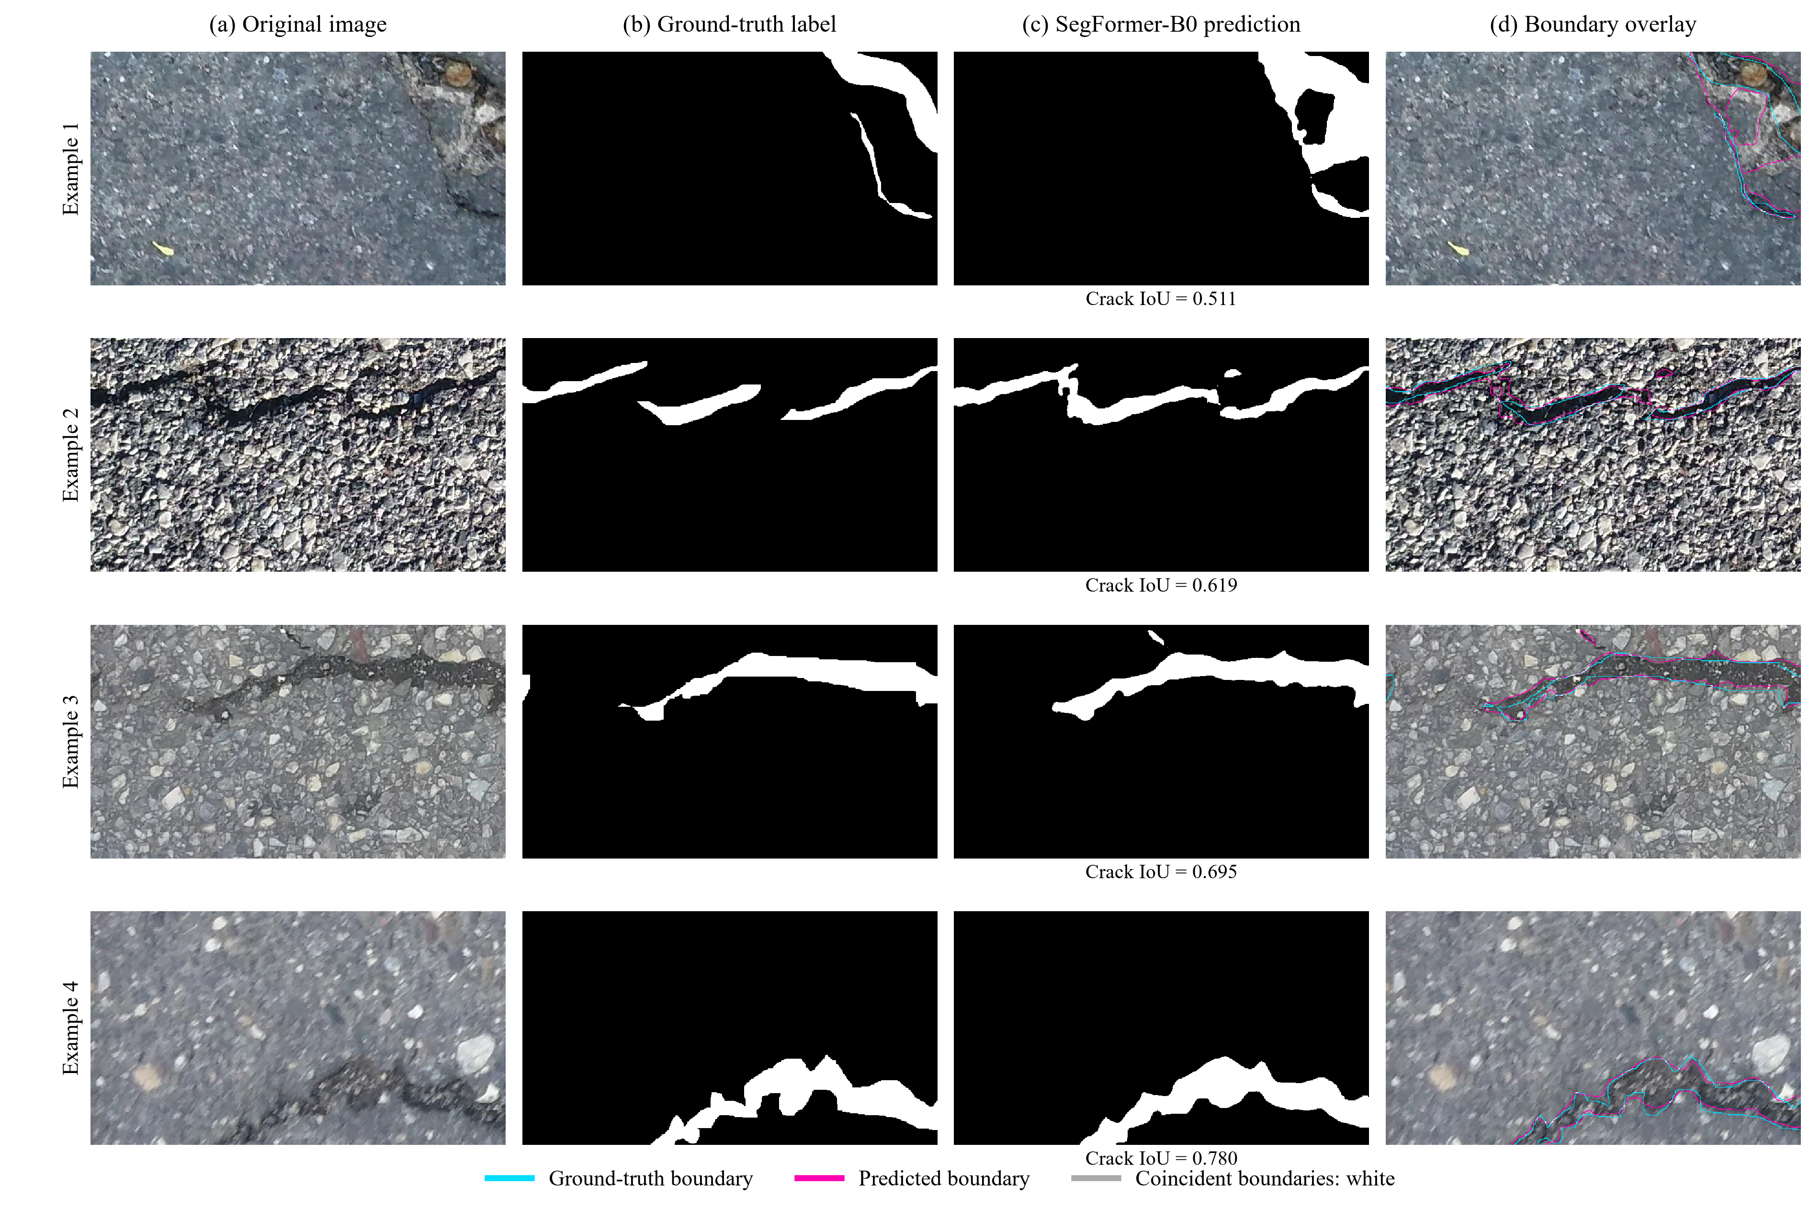

$×$逐图分析应围绕输入缩放、编码器特征提取和预测恢复三个阶段区分错误来源。第一类样本为细裂缝和端点，用于检查 400 × 400 裁剪、13 × 13 深层特征和最终双线性上采样是否造成裂缝消失、变细或断裂；第二类为阴影和低对比度区域，用于区分漏检与误检；第三类为纹理密集路面，用于观察模型是否将沥青纹理误认为裂缝；第四类为宽裂缝，用于检查主体区域和边界是否同时恢复。每张图应记录 IoU、Boundary F1、FP/FN 像素数、裂缝连通分量数、是否零重叠以及 source frame 信息，不能只根据总体均值判断模块有效性。

Experimental validation and discussion

Experimental platform and system setup
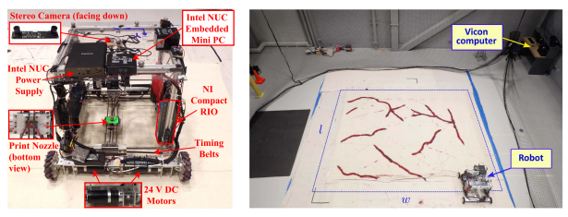
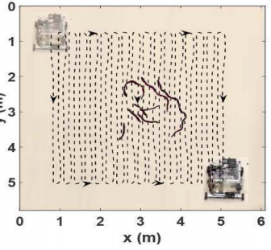

Performance of real-time crack inspection

Integrated repair test and effectiveness evaluation

Conclusion

