40. Derive the formula for a feed-forward three layers neural network
Textbook P227-229
Slides 09_Neural_Networks_1
We can add a new layer of hidden units based on the original two-layer feed-forward neural network to acquire a three-layer feed-forward neural network. Then, the three-layer feed-forward neural network will have two layers of hidden units. I will call the layer of hidden units closer to inputs as first-layer hidden units and the other layer of hidden units as second-layer hidden units respectively here.
Let input variables x₁, …, x_{D}. Now, in the three-layer neural network, we will have 3 layers of weights. Firstly, we construct M linear combinations of the input variables
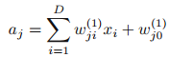
where j = 1, …, M.
Apply a differentiable, nonlinear activation function h(·) to get the output of the first-layer hidden units
h(·)is typically sigmoidal or tanh.
Then, the outputs of the first-layer hidden units are again linearly combined
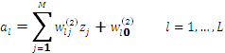
Apply a differentiable, nonlinear activation function f(·) to get the output of the second-layer hidden units
Also f(·)is typically sigmoidal or tanh.
Then, the outputs of the second-layer hidden units are again linearly combined
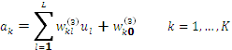
Apply again a differentiable, nonlinear activation function g(·) to get the network outputs y_{k}
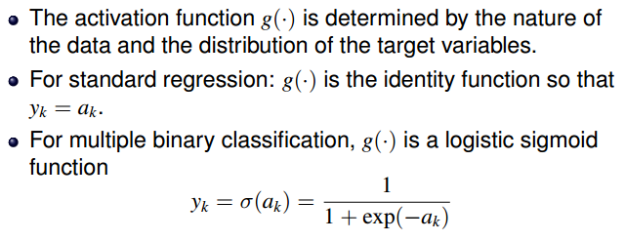
We can combine these various stages to give the overall network function

41. Why if all activation functions in a neural network are linear then there exists an equivalent network without hidden unit?
P229
If all the activation functions in a network are taken to be linear, then for any such network we can always find an equivalent network without hidden units. This follows from the fact that the composition of successive linear transformations is itself a linear transformation. That is, if all the activation functions in the neural network are linear, the overall network function will be the composition of successive linear transformations of hidden units and input variables, and then can also be expressed as a linear transformation of the input variables. That is, the overall network function can be expressed as a linear function of input variables, i.e. we can directly model this network function as parametric linear functions of input variables. Then, the corresponding network will have only one-layer adaptive weights and don’t have any hidden units. That is, we get an equivalent network without hidden units.

42. What are the advantages of neural network compared with linear regression (classification) model?
P225-226
Neural network fix the number of basis functions in advance but allow them to be adaptive, in other words to use parametric forms for the basis functions in which the parameter values of the basis functions are also adapted, along with the coefficients {} of the linear combinations of the basis functions, during training. Unlike the linear regression or classification models that use the fixed basis functions and then their practical applicability is limited by the curse of dimensionality, neural network can be applied to large scale problems.

43. Describe the weight-space symmetries in a neural network.
Textbook P231-232
Slides P341-342
Weight-space symmetries is that multiple distinct choices for the weight vector w can all give rise to the same mapping function from inputs to outputs.
There are 2 kinds of symmetries:
Assume that activation functions for the hidden units are a particular kind of odd functions, such as tanh. If we change the sign of all of the weights and the bias feeding into a particular hidden unit, then, for a given input, the sign of the activation of the hidden unit will be reversed, because ‘tanh’ is an odd function, so that tanh(−a)=−tanh(a). However, if we also change the sign of all of the weights leading out of that hidden unit, the resulting mapping function will remain the same. Thus, we have found two different weight vectors that give rise to the same mapping function. For M hidden units, there exists 2^{M} such kind of equivalent weight vectors.
Similarly, imagine that we interchange the values of all of the weights leading both into and out of a particular hidden unit with the corresponding values of the weights associated with another hidden unit. Again, this clearly leaves the network input–output mapping function unchanged, but it corresponds to a different choice of weight vector. For M hidden units, there exists M! equivalent weight vectors associated with this interchange symmetry, corresponding to the M! different orderings of the hidden units.
Therefore, the network will have an overall weight-space symmetry factor ofM!2^{M}.
For networks with more than two layers of weights, the total level of symmetry will be given by the product of such factors, one for each layer of hidden units.

44. What are the methods to optimize the parameters in neural network? Describe it (them) in as much detail as you can.
Textbook P240-245
1. Framework of methods: use different kinds of gradient descent optimization methods to optimize the parameters, such as gradient descent
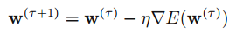
Or stochastic gradient descent
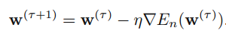
2. Then, use error backpropagation to evaluate the gradient of an error function:
1) Present an input vector x_{n} to the network and forward propagate through the network to get the activations of all the hidden and output units.
2) For all output units, evaluate
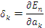
3)For each hidden unit in the network, backpropagate the δ’s using
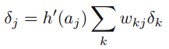
to obtain δ_{j}
4) Use
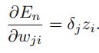
to evaluate the required derivatives to get 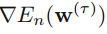 eventually

45. What are the methods that are used to avoid overfitting in training a neural network?
Method 1:
Textbook P256 the second last paragraph
One approach is to plot a graph illustrating the generalization error as a function of the number of hidden units M (for each M, choose multiple random initializations for the weight vector to get probable different values of generalization error) and then to choose the specific solution of optimal value M having the smallest validation set error.
Method 2:
Textbook P256-257
Choose a relatively large value of for M and then use the regularised error
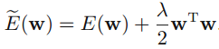
Method 3:
Textbook P259
Early stopping
Stop training at the point of smallest error with respect to the test set before a minimum of the training error has been reached
The training of nonlinear network models corresponds to an iterative reduction of the error function defined with respect to a set of training data. For many of the optimization algorithms used for network training, the error is a nonincreasing function of the iteration index. However, the error measured with respect to test set, often shows a decrease at first, followed by an increase as the network starts to over-fit. Training can therefore be stopped at the point of smallest error with respect to the test set in order to obtain a network having good generalization performance.

46. Describe Bayesian Neural Network in as much detail as you can.
Prior:
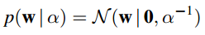
Likelihood:
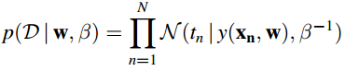
Posterior:
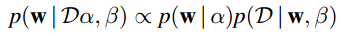
Use Laplace Approximation:
1) find a (local) maximum of the posterior, using iterative numerical optimization:
log-posterior
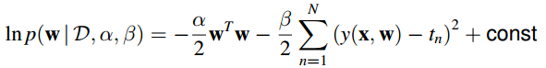
2) Evaluate the matrix of second derivatives of the negative log posterior distribution
where H is the Hessian matrix comprising the second derivatives of the sum-of-squares error function with respect to the components of w.
Then, the Gaussian approximation to the posterior
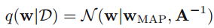

The predictive distribution:
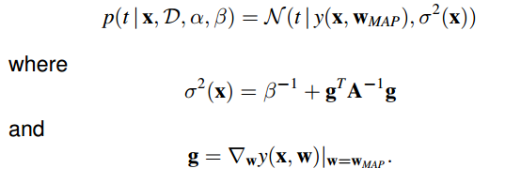

47. Derive the dual representation of a linear regression model with regularized sum-of-squared error.
Textbook P293-294
Slides 11_Kernel_Methods P389-391
A linear regression model with regularized sum-of-squares error
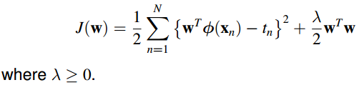
We could also write this in more compact form
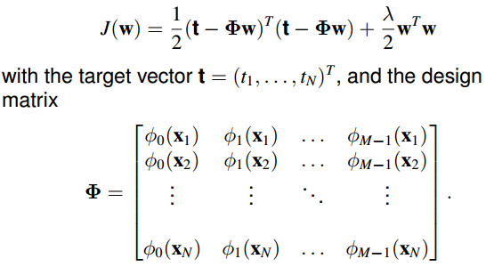
Set the gradient of J(w)with respect to w equal to zero, the solution for w
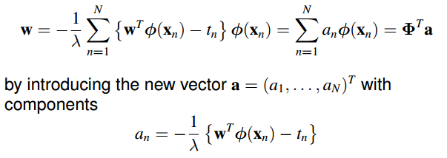
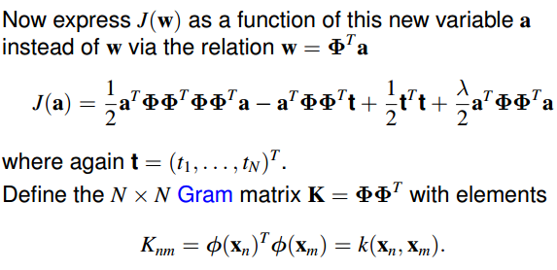
where we have introduced the kernel function k(x,x’)

Now, the sum-of-squares error function can be written as
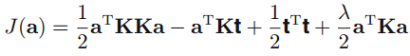
which is the dual representation of the original model.

48. What is the kernel function? What are the advantages of kernel method?
Textbook P292
Slides 11_Kernel_Methods P392
For models which are based on a fixed nonlinear feature space mapping φ(x), the kernel function is defined over two points, x and x’, of the input space by the relation
Textbook P294 second paragraph
Slides 11_Kernel_Methods P395
In kernel method (dual representation), the model can be expressed entirely in terms of the kernel function k(x,x’).
Then, the advantages:
The main advantage:
We can therefore work directly in terms of kernels and avoid the explicit introduction of the feature vector φ(x), which allows us implicitly to use feature spaces of high, even infinite, dimensionality.
(Minor advantages or maybe not appropriate answers:
We can construct new valid kernels directly from given ones (whatever the corresponding basis functions of the new kernel might be).
As a kernel defines a kind of ’distance’ between two points in the input space, we can define kernels over graphs, sets, strings, and text documents, thereby greatly expanding the range of problems that can be addressed.)

49. What are the operations that can preserve the validity of a kernel function (kernel functions)?
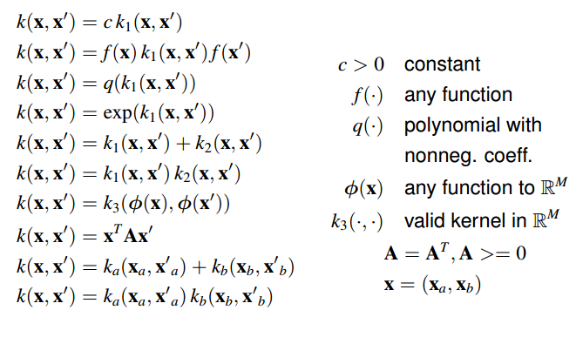
50. Describe Lagrange multipliers in detail. Especially consider that we have inequality constraints.
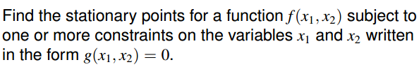
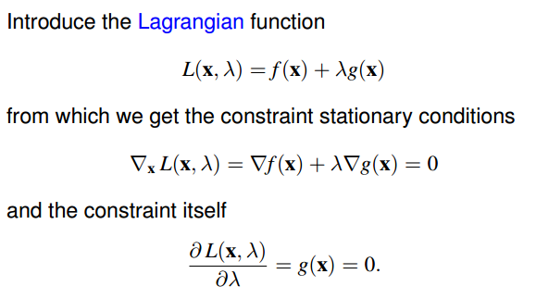
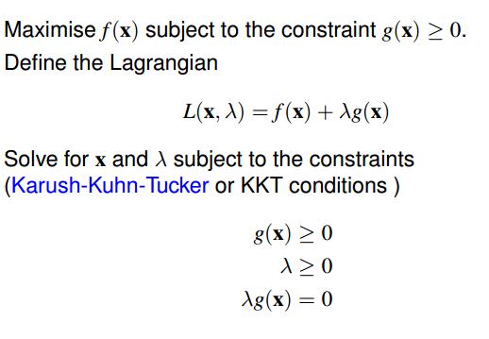
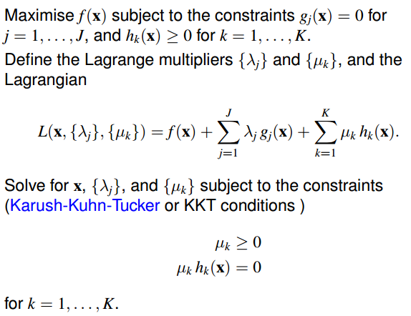

59.
The goal of K-means Clustering is, given a set of data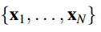, in D-dimensional space, to partition the data set into K clusters. A cluster is a group of data points whose distances to data points within the cluster are small compared to distances to data points outside the cluster. Every cluster has a center, let be the center of the k-th cluster representing that cluster.
Then, our goal can be restated as to find a set of cluster centers 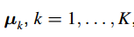, each representing a different cluster and find an assignment of each data point to one cluster.
Then, the algorithm can be briefly stated as following:
1. Initialize with arbitrary cluster centers
2. For each data point, find the closest cluster center, and then assign this data point to the corresponding clusters
3. After assigning all data points, for every cluster, update the center of this cluster with the mean of all data points assigned to this cluster
4. Repeat 2-3 until no data points are reassigned to another cluster
The formal description of this algorithm with formal mathematics notations will be added if I have time…

