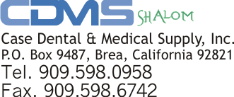**ORDER FORM**

# 1. Sold To: 2. Ship To:

Dentist / Office / Name: Street Address: City, State, Zip: Phone: Fax: Email:

**3. ORDER INFORMATION**

Name: _ Street Address: City, State, Zip: Phone: Fax: Email:

|  |  |  |  |  |  |
| --- | --- | --- | --- | --- | --- |
| QUANTITY | ITEM NUMBER | DESCRIPTION  (Include size / color if applicable) |  | UNIT PRICE | TOTAL |
|  |  |  |  |  |  |
|  |  |  |  |  |  |
|  |  |  |  |  |  |
|  |  |  |  |  |  |
|  |  |  |  |  |  |
|  |  |  |  |  |  |
|  |  |  |  |  |  |
|  | | |  | SUBTOTAL |  |
| **4. METHOD OF PAYMENT** | | | SALES TAX |
| VISA MASTER AMEX DISCOVER | | | FREIGHT |
| Credit Card #: | | | **TOTAL** |

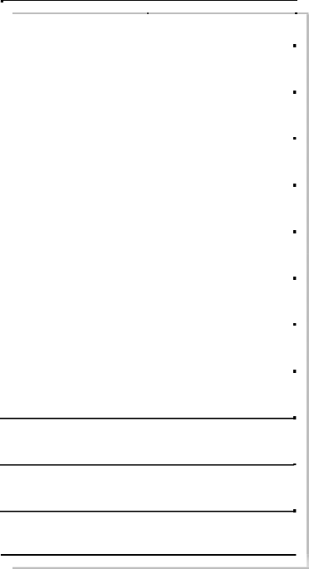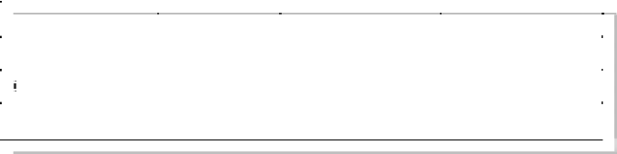**5. SHIPPING AND HANDLING RATE**

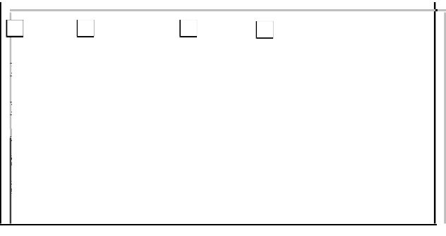

CVV Code: Exp. Date: Name on Card: Billing Address: Signature:

|  |  |  |  |
| --- | --- | --- | --- |
|  | Small | Medium | Large |
| Domestic | $8.00 | $12.00 | $20.00 |
| Canada / Mexico | $15.00 | $25.00 | $35.00 |
| International | $25.00 | $35.00 | $65.00 |

**RUSH SHIPMENTS/SPECIAL INSTRUCTIONS ** **Returns** All return must be notified and authorized prior to the return

Please request FedEx, UPS, Next Day, 2nd or 3rd Day, No refund after 30 days of receipt. All shipping costs are

or special instructions. We will promptly take care of your needs. non-refundable. 15% restocking fee may apply.

**SHIPPING POLICY Price**

Your order is shipped from our office in California. Prices subject to change without notice. Minimum order: 24 pcs/case. UPS is used whenever possible. However, should your order exceed For more information on wholesale price, please contact us

UPS size or weight limits, "Common Carrier" will be selected to speed directly. delivery to you. Actual shipping & handling change may apply.

CDMS Phone: 909-598-0958 Fax: 909-598-6742 Email: [info@cdmsupply.com](mailto:info@cdmsupply.com)

|  |  |  |  |  |  |  |  |
| --- | --- | --- | --- | --- | --- | --- | --- |
| ITEM | SIZE/COLOR | ITEM # | DESCRIPTION | PKG. QTY | SALE PRICE | QTY | TOTAL |
| Cotton Roll |  | D-CR-01 | 2000/bx | 1case(6bx) | $65.00 |  |  |
| Disposable A/W Syring Tip |  | D-ST-AWP | Plastic | 1case | $160.00 |  |  |
| Disposable A/W Syring Tip |  | D-ST-AWM | Metal | 1case | $225.00 |  |  |
| Disp Surg Tips |  | D-ST-S01 | 1/8" tip, 25/box | 1case(10bx) | $45.00 |  |  |
| D-ST-L01 | 1/4" tip, 25/box | 1case(10bx) | $45.00 |  |  |
| Disposable Plastic Mirror |  | D-PM | Disposable plastic mirror | 50 pc./box | $15.00 |  |  |
| Disposable Prophy Angel |  | D-PA | Medium soft cup, 100 pcs/box | 1case(4bx) | $80.00 |  |  |
| Evacuation Tips (Vented,  White) |  | D-ET-F01 | Full size (100/bg) | 1case(10bgs) | $22.00 |  |  |
| D-ET-H01 | Half size (100/bg) | 1case(10bgs) | $20.00 |  |  |
| Gauze, filled |  | D-GE-22-01 | 2"x2", 5000pcs/case | 1case | $24.00 |  |  |
| D-GE-44-01 | 4"x4", 2000pcs/case | 1case | $28.00 |  |  |
| Gauze, non-woven |  | D-GN-22-01 | 2"x2", 5000pcs/case | 1case | $22.00 |  |  |
| D-GN-44-01 | 4"x4", 2000pcs/case | 1case | $28.00 |  |  |
| Micro Applicators Tip | R, F, SF | D-MAT | assorted colors | 400 pc./box | $12.00 |  |  |
| Saliva Ejector | W | D-SE-01 | White, 100/bag | 1case(10bgs) | $24.00 |  |  |
| C | D-SE-02 | Clear, 100/bag | 1case(10bgs) | $24.00 |  |  |
| Shoe Cover |  | D-SC | shoe cover-150 pairs | 300 pc./box | $25.00 |  |  |
| Latex Glove-LP | XS,S,M,L,XL | G-LX-P01 | Xs,S,M,L 100/bx | 1case(10bx) | $42.95 |  |  |
| Latex Glove-PF | XS,S,M,L,XL | G-LX-PF01 | Xs,S,M,L 100/bx | 1case(10bx) | $49.95 |  |  |
| Vinyl Glove-LP | XS,S,M,L,XL | G-VI-P01 | Xs,S,M,L 100/bx | 1case(10bx) | $34.95 |  |  |
| Vinyl Glove-PF | XS,S,M,L,XL | G-VI-PF01 | Xs,S,M,L 100/bx | 1case(10bx) | $44.95 |  |  |
| Dental Floss Toothpick |  | H-TP-01 | 50pc./box | 1case(36 bx) | $72.00 |  |  |
| Dental Floss | G | H-FL-01 | 20yd./ea. | 1bag (24 packs) | $10.00 |  |  |
| Interdental Refill Brushtips | C,T | H-BT-01 | (Cylindrical, Tapered) 72 ea./bag | 1bag | $15.00 |  |  |
| 1/2 Chair cover-P |  | I-P1/2CC-01 | Plastic 28"x24",1mil (500/cs) | 1case | $50.00 |  |  |
| A/W Syringe Cov-P |  | I-PAW-01 | Plastic 2.5x10 (5000/cs) | 1case | $50.00 |  |  |
| Barrier Film | B | I-BF-4601 | Blue, 4"x6", 1200/rl | 1case(8 rolls) | $90.00 |  |  |
| C | I-BF-4602 | Clear, 4"x6", 1200/rl | 1case(8 rolls) | $90.00 |  |  |
| Cone Mask | P,B | I-CM-01 | Starryshine (50/bx) | 1case(12box) | $60.00 |  |  |
| I-CM-02 | 3M-2042 F Triple Layer(50/bx) | 1 case(6box) | $120.00 |  |  |
| Ear Loop Mask | P,B | I-EL-01 | Latex free (50/bx) | 1case(12box) | $40.00 |  |  |
| I-EL-02 | Premium (50/bx) | 1case(12box) | $38.00 |  |  |
| Headrest Cover-P-SM |  | I-PHR-01 | Plastic 9.5x11 (2000/cs) | 1case | $50.00 |  |  |
| Headrest Cover-P-LG |  | I-PHR-02 | Plastic 11x14 (2000/cs) | 1case | $50.00 |  |  |
| Isolation Gown | B,P,G,Y,W | I-IG-K | Knitt cuff (50/case) | 1case | $30.00 |  |  |
| I-IG-E | Elastic cuff (50/case) | 1case | $28.00 |  |  |
| Patient Bibs | B,G,Y,M | I-PB-01 | 2ply, 500/box | 1case(4 bx) | $60.00 |  |  |
| Safety Glasses | R,B,BLK | I-SG-01 | Blu, Blk, 12/box | 1box | $28.00 |  |  |

|  |  |  |  |  |  |  |  |
| --- | --- | --- | --- | --- | --- | --- | --- |
| Sterilization Pch  (Self sealing) |  | I-SP-2255 | 2 1/4"x5" (200/bx) | 1case(16bx) | $85.00 |  |  |
| I-SP-27510 | 2 3/4"x10" (200/bx) | 1case(16bx) | $85.00 |  |  |
| I-SP-3565 | 3 1/2"x6 1/2" (200/bx) | 1case(16bx) | $85.00 |  |  |
| I-SP-3510 | 3 1/2"x10" (200/bx) | 1case(16bx) | $85.00 |  |  |
| I-SP-32512 | 3 1/4"x12" (200/bx) | 1case(16bx) | $130.00 |  |  |
| I-SP-42512 | 4 1/4"x12 (200/bx) | 1case(12bx) | $110.00 |  |  |
| I-SP-52511 | 5 1/4"x11" (200/bx) | 1case(12bx) | $110.00 |  |  |
| I-SP-42512 | 4 1/4" x 12" (200/bx) | 1case(12bx) | $120.00 |  |  |
| I-SP-52511 | 5 1/4" x 11" (200/bx) | 1case(12bx) | $120.00 |  |  |
| Tray Cover-P |  | I-PTC-01 | Plastic 11x14 (2000/cs) | 1case | $50.00 |  |  |
| X-ray Cover-P |  | I-PXR-01 | Plastic 15x26 (1000/cs) | 1case | $50.00 |  |  |
| Alginate | Fs,Rs (C,M,U) | L-AL-01 | 1 lb pouch | 1case(12bgs) | $65.00 |  |  |
| L-AL-03 | 3 lb pail | 1case(4pails) | $65.00 |  |  |
| Alginate Tray Cleaner |  | L-AC-1501 | 2 lb Jar | 1case(4 btl) | $60.00 |  |  |
| Disposable Bite Tray  (POLYBITE) |  | L-DB-A | Anterior-1box(35) | 1case(10box) | $70.00 |  |  |
| L-DB-P | Posterior- 1box (50) | 1case(10box) | $70.00 |  |  |
| L-DB-Q | Quandrant-1box( 40) | 1case(10box) | $70.00 |  |  |
| L-DB-S | Sideless-1box (50) | 1case(10box) | $70.00 |  |  |
| Disposable Impression Tray  (Green) |  | L-DI-L01 | #1 Lrg Full U (12/bg) | 1case(12bgs) | $45.00 |  |  |
| L-DI-L02 | #2 Lrg Full L (12/bg) | 1case(12bgs) | $45.00 |  |  |
| L-DI-M03 | #3 Med Full U (12/bg) | 1case(12bgs) | $45.00 |  |  |
| L-DI-M04 | #4 Med Full L (12/bg) | 1case(12bgs) | $45.00 |  |  |
| L-DI-S05 | #5 Sml Full U (12/bg) | 1case(12bgs) | $45.00 |  |  |
| L-DI-S06 | #6 Sml Full L (12/bg) | 1case(12bgs) | $45.00 |  |  |
| L-DI-Q07 | #7 Quad-UL/LR Post (12/bg) | 1case(12bgs) | $45.00 |  |  |
| L-DI-Q08 | #8 Quad-UR/LL Post (12/bg) | 1case(12bgs) | $45.00 |  |  |
| L-DI-Q09 | #9 Quad - Ant (12/bg) | 1case(12bgs) | $45.00 |  |  |
| Evac Sys Cleaner |  | L-EC-1-01 | 2lbs. | 1case(4 btl) | $60.00 |  |  |
| Impression Syringe |  | L-IS-01 | Clear, 50sets/box | 1case(10bx) | $60.00 |  |  |
| Lab Plaster | Fs,Rs | L-LP-01 | Lab, 25lb | 1case(25lb) | $16.00 |  |  |
| Ortho plaster |  | L-OP-01 | Ortho, 25lb | 1case(25lb) | $18.00 |  |  |
| Pumice | C,M,F | L-PU-01 | C, M, F, 15lb/bg | 1bag(15lb) | $20.00 |  |  |
| FL, XC | L-PU-02 | Flour, XC, 15lb/bg | 1bag(15lb) | $20.00 |  |  |
| Yellow Stone |  | L-YS-01 | Yellow, 25lb | 1case(25lb) | $18.00 |  |  |
| Pencil Kit (kids) - Small | B,G,Y,P | P-PK-01 | 4 items/pack@ $0.625/ ea. | 48 packs/box | $30.00 |  |  |
| Pencil Kit (kids) - Large | B,G,Y,P | P-PK-02 | 6 items/pack@$0.85/ea. | 24 packs/box | $20.00 |  |  |
| Pencil Kit -RS |  | P-PK-01-RS | Pencil Kit - Rubber Stamps | 60 pc./box | $18.00 |  |  |
| Pencil Kit - RSS |  | P-PK-01-RSS | Pencil Kit - Stamps & Sharpener | 24 pc./box | $18.00 |  |  |
| X-ray Film Mount |  | X-XM-U-01 | Univ, 1000/roll | 1case(4rolls) | $100.00 |  |  |
| X-XM-18-01 | 18 Slot, 100/pkg | 1case(10pk) | $200.00 |  |  |
| Kraft Manila Envelopes |  | X-XE | for X-Ray films: 2 1/4" x 3 1/2" | 500/bx, 20bx/case | $9.50 |  |  |
| SquirtBrush BrushHead |  | SQB-RBH | R BrushHead-$0.40/ea. | 24 pc./box | $12.00 |  |  |
| P BrushHead-$0.40/ea. | 24 pc./box | $12.00 |  |  |
| SquirtBrush |  | SQB-RM | Refillable-$0.90/ea. | 144 pc./box | $180.00 |  |  |
| Professional-$0.90/ea. | 144 pc./box | $180.00 |  |  |