**Contact Keeper Project**

1. This project is all about MERN Login, CRUD App of 6 hours
2. This Project keep track of the users.
3. 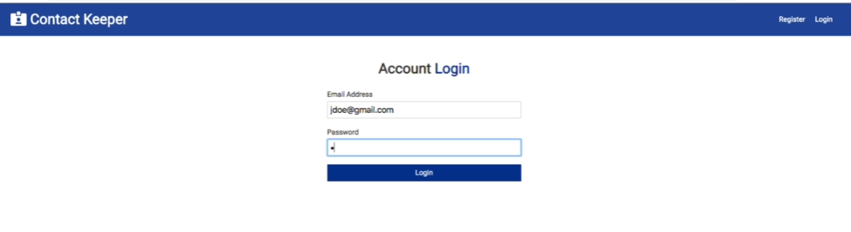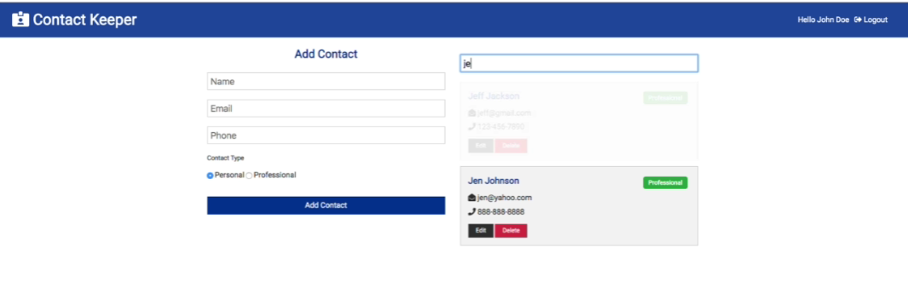
4. 