Table of Contents
Description of Game | 2
How to Play | 3
Evaluation of the Design Process
Storyboard

Hardware and Software Used & A Cost Analysis of the Development Process
References for the Game
Permission Letters

Description of Game

Storyline
It was the dawn of the 7th age of mankind, the year is 3072. Just after the great cataclysm left most developed species planet-bound, however mankind is beginning to rebuild and get back into space using the remains of the forerunners. You are a captain of a small salvage ship helping to rebuild The Great Terran Empire from the ashes of our predecessors.

How to Play

Evaluation of the Design Process
The design and development of the game went really smoothly, due to planning the game out in advance.

Storyboard
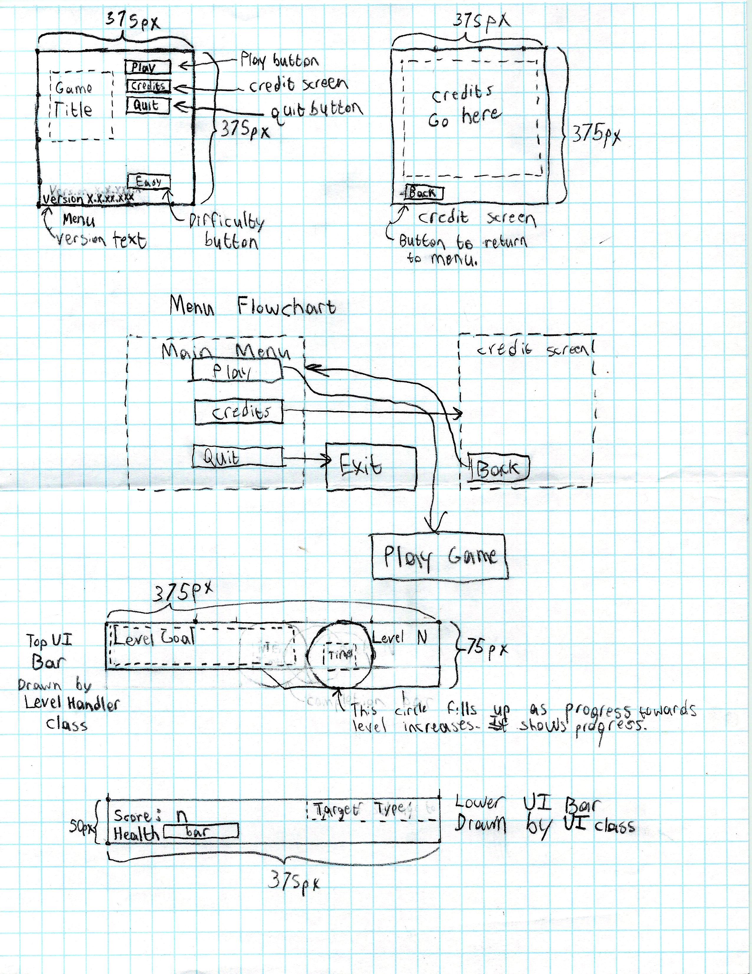
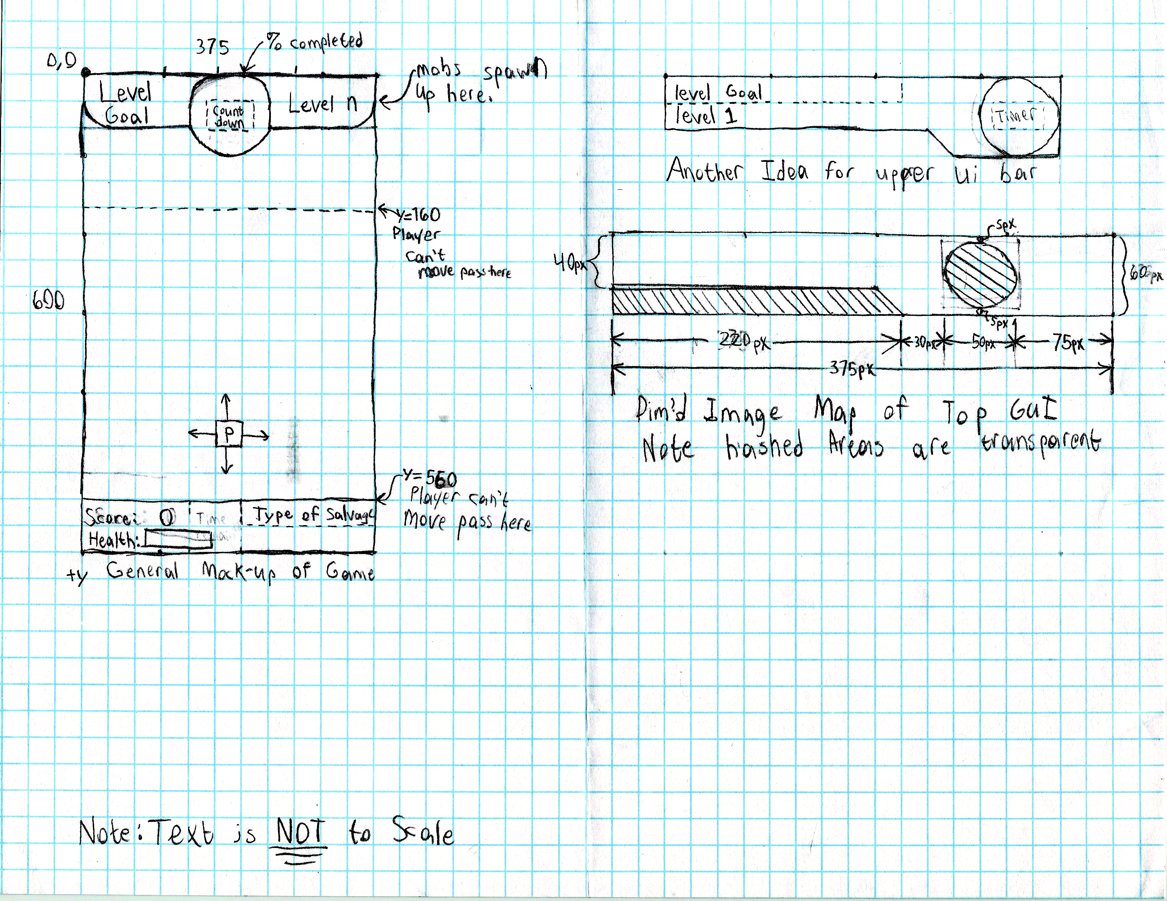

Hardware and Software Used & A Cost Analysis of the Development Process

Hardware
- Lenovo Ideapad Z580
  - Intel Core i5-3210m
  - 8Gb DDR3-1600 Ram
  - Intel HD4000 Graphics
  - 650GB Hard drive
- Custom-built Gaming PC (used as a file server)
  - Intel Pentium G3258 (Overclocked to 4.3GHz)
  - MSI PC Mate Z97 Motherboard
  - EVGA (Nvidia) GeForce Gt630 1GB GDDR5
  - 8GB DDR3-1600 Crucial Ballistix Sport Ram
  - Western Digital Blue 1TB Hard Drive
  - Antec VSK-4000e Case
  - Corsair CX500 power supply
  - Belkin N150 Wireless USB Dongle
  - Generic 19” Hp Monitor (bought at a yard sale for $5 personal equipment)
- Logitech MK270 Mouse and Keyboard Combo
- Cooler Master Dominator Keyboard and Mouse Combo
- IBM Model M Keyboard
- Netgear Wireless N-Router
- IT-Infastructure of the school – Who knows what's all in it?

Software
- Fedora 20 – Linux OS for my files server
- Fedora 21 – Update was released during development
- OpenSSH – for transferring files to the file server
- 7Zip – for making backups of game files
- Code::Blocks C++ IDE – for development of the game
  - GNU C/C++ Compiler – used for compiling the code of the game
- Microsoft Windows 8.1 – Operating System for Lenovo Z580. Most of the development was done on this OS.
- Cygwin 64 and the various packages therein – POSIX compatibility layer for Microsoft Windows. Provides a full Linux terminal with Bash scripting support and a Unix-like enviroment on Microsoft Windows.
- Simple Fast Multimedia Library(SFML) - Library used for the handling of all graphics in the game, because it provides a very straight forward interface for working with OpenGL windows, as well as networking and sound.
- INIH Library – A Library used for parsing config files for the game, and the level config files.
- LibreOffice Writer – used for typing the notebook for the competition.
- MySQL Server – for running the high scores server (used by the web host)
- Apache HTTP Server – for running website ( used by the web host)
- Cpanel – used by the web host

Cost Analysis of the Development Process
The computer hardware was already owned and had no cost to the TSA chapter as either the school district already owned it or it was owned by a team member. Additionally, all of the software used was already included with the hardware or free. The main cost of the game was the printing of the notebook and the cover for the notebook. The major cost is running the server for the database, as we had to register a domain, and pay for hosting, which is kind of expensive as it was roughly $12.00 to register a domain for a year. Then hosting costs about $3 to $4 per month depending on the host, it is a major cost. As we have no idea how much it costs to print per page on the school printers, we have to give this estimate this cost to be about $5. Another cost was the DVD to put the game on which is estimated to be $0.25 each. A couple of DVDs were used in the process of perfecting the autorun. The table below states the total cost.
Expense | Cost
Hardware | $0.00
Software | $0.00
Printing Cost – cost to print | $5.00
Binding Cost – cost of materials to bind notebook | $1.50
DVD cost | $3.00
Domain Name | $12.99
Web Host
Total | $9.50

References for the Game
"Space Fighter Loop"
Kevin MacLeod (incompetech.com)
Licensed under Creative Commons: By Attribution 3.0
http://creativecommons.org/licenses/by/3.0/

Permission Letters

Simple Fast Multimedia Library
SFML (Simple and Fast Multimedia Library) - Copyright (c) Laurent Gomila

This software is provided 'as-is', without any express or implied warranty.
In no event will the authors be held liable for any damages arising from
the use of this software.

Permission is granted to anyone to use this software for any purpose,
including commercial applications, and to alter it and redistribute it
freely, subject to the following restrictions:

1. The origin of this software must not be misrepresented; you must not claim
that you wrote the original software. If you use this software in a product,
an acknowledgment in the product documentation would be appreciated but is
not required.

2. Altered source versions must be plainly marked as such, and must not be
misrepresented as being the original software.

3. This notice may not be removed or altered from any source distribution.
SOURCE: http://sfml-dev.org/license.php
This licensee means that SFML is free for use by anyone.

INIH
The "inih" library is distributed under the New BSD license:
Copyright (c) 2009, Brush Technology
All rights reserved.
Redistribution and use in source and binary forms, with or without
modification, are permitted provided that the following conditions are met:
* Redistributions of source code must retain the above copyright
notice, this list of conditions and the following disclaimer.
* Redistributions in binary form must reproduce the above copyright
notice, this list of conditions and the following disclaimer in the
documentation and/or other materials provided with the distribution.
* Neither the name of Brush Technology nor the names of its contributors
may be used to endorse or promote products derived from this software
without specific prior written permission.

THIS SOFTWARE IS PROVIDED BY BRUSH TECHNOLOGY ''AS IS'' AND ANY
EXPRESS OR IMPLIED WARRANTIES, INCLUDING, BUT NOT LIMITED TO, THE IMPLIED
WARRANTIES OF MERCHANTABILITY AND FITNESS FOR A PARTICULAR PURPOSE ARE
DISCLAIMED. IN NO EVENT SHALL BRUSH TECHNOLOGY BE LIABLE FOR ANY
DIRECT, INDIRECT, INCIDENTAL, SPECIAL, EXEMPLARY, OR CONSEQUENTIAL DAMAGES
(INCLUDING, BUT NOT LIMITED TO, PROCUREMENT OF SUBSTITUTE GOODS OR SERVICES;
LOSS OF USE, DATA, OR PROFITS; OR BUSINESS INTERRUPTION) HOWEVER CAUSED AND
ON ANY THEORY OF LIABILITY, WHETHER IN CONTRACT, STRICT LIABILITY, OR TORT
(INCLUDING NEGLIGENCE OR OTHERWISE) ARISING IN ANY WAY OUT OF THE USE OF THIS
SOFTWARE, EVEN IF ADVISED OF THE POSSIBILITY OF SUCH DAMAGE.

Xolonium Font
Xolonium Font
Copyright (C) 2011-2012 Severin Meyer <sev.ch@web.de>

This font is free software. You can use, modify and/or redistribute it
under the terms of the GNU General Public License as published by the Free
Software Foundation, either version 2 of the license, or any later version.

As a special exception, if you create a document which uses this font,
and embed this font or unaltered portions of this font into the document,
this font does not by itself cause the resulting document to be covered by
the GNU General Public License. This exception does not however invalidate
any other reasons why the document might be covered by the GNU General
Public License. If you modify this font, you may extend this exception
to your version of the font, but you are not obligated to do so. If you
do not wish to do so, delete this exception statement from your version.

This font is distributed in the hope that it will be useful, but WITHOUT ANY
WARRANTY; without even the implied warranty of MERCHANTABILITY or FITNESS FOR
A PARTICULAR PURPOSE. See the GNU General Public License for more details.

You should have received a copy of the GNU General Public License
along with this font. If not, see <http://www.gnu.org/licenses/>.

