**CS691 - Computer Science, Spring 2021**

**Project Initiation Document**

Project: UniPath

Project Manager: Shazia Khan

Start Date: September 14, 2021

Completion Date:

Table of Contents

Document Purpose 4

Background to the Proposed Work 4

Vision 4

Project Objectives 5

Project Scope 5

Business Case 6

Assumptions 9

Constraints 10

Risk Management Strategy 11

Deliverables 12

Stakeholders 13

Project Team 14

Project Plan 15

Project Controls 16

Communication Plan ……………………………………………………………………………………………………………………………17

**Document Details - Shazia**

|  |  |  |  |
| --- | --- | --- | --- |
| Version | Modifications | Author | Date |
| 1.0 | Initial PID Document | PM | 09/21/2021 |
| 1.0 | Refined PID Document with Initial Project Plan | PM | 10/02/21 |
|  |  |  |  |
|  |  |  |  |

**Approvals - Shazia**

This document requires the following approvals:

|  |  |  |  |  |
| --- | --- | --- | --- | --- |
| Name | Role | Signature | Date | Version |
| Professor Yuri Chernak | Approver |  | 09/21/2021 | 1.0 |

**Distribution - Shazia**

This document has been distributed to:

|  |  |  |  |
| --- | --- | --- | --- |
| Name | Role | Date of Issue | Version |
| Shazia Khan | Project Manager | 09/21/2021 | 1.0 |
| Praneta Kasbe | Product Owner | 09/21/2021 | 1.0 |
| George Hidalgo | Lead Business Analyst | 09/21/2021 | 1.0 |
| Xinhao Huang | Lead Developer | 09/21/2021 | 1.0 |
| Sanket Bagul | DBA | 09/21/2021 | 1.0 |
| Saahiil Meswaanii | Lead QA Analyst | 09/21/2021 | 1.0 |
| Along Zhang | Tester | 09/21/2021 | 1.0 |

# Document Purpose - Shazia

This document has been created to record the basic information needed to manage the project. The document will describe the scope, objectives, tasks, roles and responsibilities, costs and deliverables related to Food for Thought Web Application.

The PID dictates the following critical aspects:

* Details of the approach to be adopted for the implementation of the UniPath Web Application Project.
* Details of the roles and responsibilities.
* Description of functions and activities.
* Explanation of the processes.
* Details of the communication plan between team members and with the stakeholders.
* Quality records, risks, project controls and exceptions.

The sections of this document are dynamic and could potentially change over the lifetime of the project. The changes will be recorded in the PID document. The PID will be referred to each time when a major decision is taken about the project. Also, the PID document will be used at the end of the project to measure whether the project was managed successfully or not and whether all deliverables were produced in a timely manner or not.

# Background to the Proposed Work - Xinhao

The purpose of the project is to help new students who do not have much experience living at Pace University. It is also designed for those people who would like to know more about Pace University. It will make their life more convenient. Those people who are planning to get to college, they are more likely to choose Pace University.

After the project completion, students can sell or buy their daily supplies including textbooks, new or used stuff, food, etc. Students who are in their first year can also get to know information about loan companies. When students are taking class, it will make sure that they do not get lost in the 1 Pace Plaza and they can get to their classroom quickly.

# Vision - Along

Our applications can bring many conveniences to students and make their lives more efficient. Students can quickly purchase and obtain daily supplies, buy and sell textbooks. And students can easily use map navigation to find canteens, libraries, and their classrooms, or anywhere else on campus.

# Project Objectives – Saahiil

* To create web application for university students with campus map, textbook store, daily supply store and provide useful guidance for student loan applications.
* To create user friendly interface.
* To create interactive campus maps.
* To create a secure portal for textbook buying and selling and for ordering daily supplies.
* To partner with local businesses for fulfilling supply orders.
* To mine data from different sources to provide a data-rich view of different student loan offering institutions.

# Project Scope – George

Our website offers a platform for users who are new to the university, it will guide them with their necessities to get around the university and also provide options to purchase supplies, books, and options to help apply for applications. The features include:

* User login function (Use student, staff Id login)
* Campus interactive Maps to guide users to buildings and classes
* Provide a textbook store that will help users get the books they need for class
* A supply store for any necessities a user may need
* Security payment process
* Scholarship Guidance

For the team, we will

* Analyse Pace Portal, Google indoor maps, mappedin, simple Tuition, Taobao
* Apply UX/UI practices
* Create a database for users that will provide reliable security
* Install all the required software
* Make sure all team members have the skills to make the application work
* Work together as a team on program development
* Hold meetings to discuss any issues we are having and find solutions

# 

# Business Case – Shazia

|  |  |
| --- | --- |
| **Application Name** | UniPath |
| **Type of business model** | Examples:  Direct sales, platform, etc. *See the document "Types of Business Models"*   * Subscription * Brokerage * Advertisement |
| **Target audience of external users**  **(Customer Segments)** | For whom are we creating value?   * University students   Who are our most important customers?   * University Management * Students. |
| **Groups of internal stakeholders, business users** | Indicate who will be using the system?   * Anyone in the university campus.   Do we need a product development group?   * Yes.   Do we need a sales group?   * No.   Do we need a finance group (accounts payable, receivable)?   * Yes.   Do we need a customer support team?   * Yes.   Do we need an advertising management group?   * Yes. |
| **Value propositions** | What value do we deliver to the customer?   * Guiding them in finding their particular destination. * Saving time by not getting lost. * Convenience in getting hold of textbooks, daily supplies. * Getting information on student loans.   Which one of our customers’ problems are we helping to solve?   * Improve university experience for new students. * Improve the overall branding of your university. * Save money on traditional signage and printed maps. * Time efficiency. * Hassle free shopping for textbooks and daily supplies. * Options to buy used books from students. * Directing the students to different loan plans and documents required for the process.   What bundles of products and services are we offering to each Customer Segment?   * Providing campus maps and exact directions to the user. * Providing textbooks, personal supplies. * Providing information about the student loans which are available.   Which customer needs are we satisfying?   * By helping them not to get lost. * Saving their time by telling them all the possible directions. * Hassle free shopping for textbooks, daily supplies. * Student loan guidance. |
| **Key resources** | What Key Resources do our Value Propositions require?   * Floor plan of the building, Wi-Fi access points, web browsers, textbook inventory, payment gateway, local businesses.   Our Distribution Channels?   * Web application.   Customer Relationships?   * Reliability and Loyalty.   Revenue Streams?   * Subscription and Brokerage fee. |
| **How the system is used** | What are the main business use scenarios?   * Web Application.   This application will serve as a portal for various services. Those services include buying and selling textbooks, getting daily supplies and having access to a campus map. From the map they can get exact directions to their respective classes they are enrolled in, to canteens, to libraries, to gymnasiums and various places.  The following features are available:   * User will have to utilize their student credentials to log into their accounts. * The students will be able to sell and buy old textbooks from the portal. * There will be a provision for the buying daily supplies. * The students have access to a list of loan providing institutions and a guide on necessary documents required for submitting a valid loan application for both domestic and international students. * A visitor visiting the campus with a valid guest pass will be provided with a link so that they can also use this application for navigation. * When a student logs in to the application, they will be able to see the list of courses they are enrolled in and from that as well they can navigate their particular classrooms. * The users also can search for offices, cafes, libraries, etc. * The application will utilize the user’s real time location and will suggest the route to the destination. * We will be charging different types of packages. Packages are based on number of features the university needs and the number of students the university wants to enroll for the service. |
| **Revenue generation, Revenue streams** | * Subscription and brokerage fee. * Advertisement. |
| **Key Partners/Suppliers**  **(Stake**  **holders)** | * University Management. * University students. * Local businesses. |
| **Expected Benefits** | * Money saving by buying used books. * Time saving. * Not getting lost. * Informed decision making. * Guidance on loan provisions. * Relaxed shopping experience from your room. |
| **Known Prototypes** | * Google indoor maps   <https://www.google.com/maps/about/partners/indoormaps/>   * N mappedin   <https://www.mappedin.com/industries/colleges-and-universities/>   * My Pace portal. * Simple Tuition * TaoBao   <https://2.taobao.com/> |

# Assumptions – Shazia

|  |  |  |  |
| --- | --- | --- | --- |
| Assumption | Validated by | Status | Comments |
| Meeting | Project Manager | In Process | Product manager will schedule three – four meetings every week. |
| Teamwork | Project Manager | In Process | Manager will keep details of all Modules and will assign ‘Single or Team’ work on specific modules. |
| Skill Requirement | All Members | In Process | All members should cooperate on the programming works. |
| Participation Time (10hr/week) | All Members | Completed | All members have agreed to provide the required number of hrs per week to this project. |
| Project Resources | QA Analyst | In Process | Analyst will check (Update) all the devices and resources every two week. |
| Updating Skill | Business Analyst | In Process | Business Analyst will provide specific ‘Required Skills for this Week’ in first meetings of every week. |
| Keep Same Technology for development | Business Analyst | In Process | Business Analyst will keep the track of latest technologies for the development. |
| Requirements will not change | Product Owner | In Process | Owner is responsible for the requirements of the project and will decide main features before the development. |
| Team Member will stay same | All members | Complete | All members have decided to take Project II in next semester. |

# Constraints - Praneta

The things that need to be taken into consideration during the delivery of this project are:

Time: As we have limited time, the project should be completed within the defined deadlines and as per the scheduled planned.

Cost: The product should be cost-effective for the purchasing party as we are making it for the University’s students.

Requirements: We should take care that students' requirements are fulfilled in this project, and it is user friendly so that maximum students get the benefit of it.

# Risk Management Strategy- George, Saahiil, Sanket

This section will include the risk mitigation and management techniques and strategies that will be applied to the project. This may be presented in the following format:

|  |  |  |  |
| --- | --- | --- | --- |
| Risk | Probability | Impact | Mitigation Method |
| Communication and Composure within the team | Medium | High | As we hold our meetings throughout each week each team member will have their say on the application. If there is any misunderstanding, then as a team we will do our best to explain and come together to have a solution. |
| Losing a teammate | Medium | High | In case a teammate chooses to leave the team or project. The team will come together to take over the work that missing teammate has done and continue to move forward. |
| Skill Sets | Medium | Medium | Some team members may struggle with a part that they do not have proper skill sets for. However, each team member would put effort to get more knowledge on what they will need to contribute to the application. |
| Completing the application on time | Medium | Medium | The time manager will create a schedule for the team to work off. Each teammate will know the work that they will need to provide within the team to complete the application on time. |
| Advancing Technology | Low | Low | It is a team of 7 so teammates can update and explain to each other on any new advancements in tech. |

Communication within the team is the most significant risk threatening the project as moving forward with the project there will come tough obstacles. The team will be moving forward and if someone doesn’t understand what is going on and doesn’t ask for clarification could cause problems in work being done or done incorrectly. This could affect the rest of the team as it causes a roadblock on the work getting done which can stall the process of the application being completed on time.

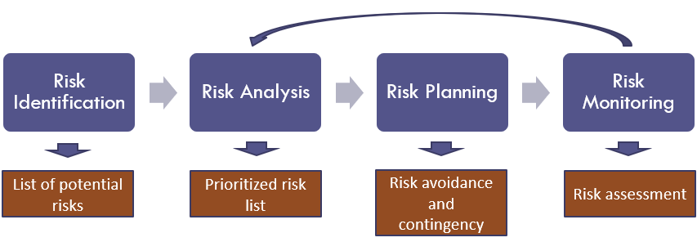

Risk Identification –Is used to list the potential risks that the team may go through while working on the application. As team each member would brainstorm and think about the roadblocks that they will face.

Risk Analysis – Look over the risk list and see which one will be the most crucial with the duration of the application.

Risk Planning – Plan ways in which the team can work through the risks that they will face.

Risk Assessment – As time goes by working on the application the team will need to Assess the factors that were brought up in the list of potential risks. They will need assure they the right measures to avoid any complications as they move forward.

# Deliverables – Shazia

|  |  |  |
| --- | --- | --- |
| No | Artifact Name | Responsible Party |
| 1 | Project Plan | PM |
| 2 | PID Document | PM |
| 3 | BRM Diagram; User Roles | Product Owner |
| 4 | Context Diagram; System Interface Table | Lead BA |
| 5 | Architecture Diagrams (Logical, Process views) | Lead Dev/DBA |
| 6 | Business Requirements | Product Owner |
| 7 | RCT (includes func. decomp., suppl. reqs) | Lead BA |
| 8 | Use-Case Diagrams (UML) | Lead BA |
| 9 | Activity Diagram (UML) | Lead BA |
| 10 | Data-flow Diagrams (logical, physical) | Lead BA |
| 11 | Functional Requirements (user stories) | Lead BA |
| 12 | Class Diagrams | Lead BA |
| 13 | Sequence Diagrams | Lead BA |
| 14 | ER Diagrams (conceptual, logical) | DBA |
| 15 | Table Specifications (Data Dictionary) | DBA |
| 16 | Source Code sample (part of Demo) + GitHub repository slides | Lead Dev |
| 17 | Test Plan document | Lead QA |
| 18 | Application Demo, Presentation PowerPoint | All |

# Stakeholders - Sanket

|  |  |
| --- | --- |
| Stakeholder | Interest |
| University Management | Providing university structural information, class schedules, floor maps and basic student information. |
| University students. | Will be providing their basic information, card details (Debit/Credit) and access to device location. |
| Local businesses | Brand Name, items available, location and exclusive offers if any for the users of UniPath. |

# Project Team – Shazia, Xinhao, Along, Praneta

The project team includes the following roles:

* Project Manager – Shazia Khan
* Product Owner – Praneta Kasbe
* Lead Developer – Xinhao Huang
* Business Analyst – George Hidalgo
* Tester – Along Zhang
* QA Analyst – Saahiil Meswaanii
* DBA – Sanket Bagul

RACI Table:

|  |  |  |  |  |  |  |  |  |
| --- | --- | --- | --- | --- | --- | --- | --- | --- |
|  |  | **Project Roles** | | | | | | |
| **Process Area** | **Project Tasks** | Project Manager | Product Owner | Dev Lead | Business Analyst | Tester | QA Analyst | DBA |
| Project Management | Develop a project plan | A,R | C | C | I | I | I | I |
| Provide cost estimate | A,R | C | I | I | I | I | I |
| Hire resources | A,R | C | R | I | I | C | C |
| Establish a project portal on SharePoint | A,R | I | C | I | I | I | I |
| Maintain a project risk and issue log | A,R | I | C | I | I | C | C |
| Provide project status reports | A | I | R | I | I | I | I |
| Requirements | Perform requirements analysts | A | C | C | R | C | I | I |
| Gather business requirements | A | R | I | C | I | I | I |
| Produce functional requirements | A | C | C | R | I | I | I |
| Design | Produce high-level design specs | A | I | R | C | I | C | C |
| Produce data model | A | I | R | C | I | C | R |
| Produce detailed design specs | A | I | R | C | I | C | C |
| Coding | Establish a code repository | A | I | R | I | I | C | C |
| Develop component code | A | I | R | I | I | I | I |
| Testing | Develop a test plan | A | C | C | I | R | C | C |
| Establish a test repository | A | I | C | I | R | C | C |
| Develop test specifications | A | I | I | I | R | I | I |
| Execute testing, report defects | A | C | I | I | R | I | I |
| Conduct defect review calls | A | C | C | I | R | I | I |
| Produce, deliver defect metrics | A | C | C | I | R | I | I |
| Support test environments | A | I | R | I | C | C | R |
| Deployment | Produce a deployment plan | A | I | R | I | I | C | R |
| Produce deployment procedures | A | I | R | I | I | C | R |
| Deploy software into production | A | I | R | I | I | C | R |

# Project Plan – Praneta, Along, Shazia, Xinhao

The project will follow an Agile project management methodology. The responsibility of the Product Owner is to analyze the quality of the product and improvements. The proposed project will be to design and develop a web-based application. The application will be a management resource to digitalize and promote an easier way to navigate maps, library management, books purchase process, and basic supply management. This will encourage mobility and reduce the efforts required to accomplish the tasks. This application will help guests, students, and faculty to save a lot of time.

Milestones:

MS1: Initial Project Plan (09/14/2021)

MS2: Requirements Completed (11/9/2021)

MS3: Design Completed (11/16/2021)

MS4: Coding Completed (11/30/2021)

MS5: Testing Completed (12/06/2021)

MS6: Project Presentation (12/21/2021)

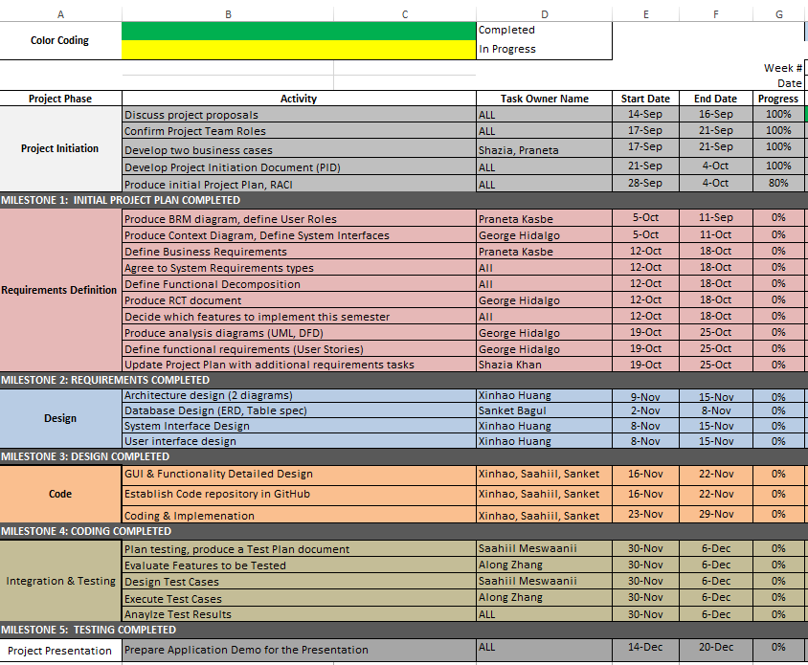

# Project Controls - Shazia

All project aspects will be maintained in English, including official meetings, communications, documents, and source code.

Official meetings will be held at least thrice or four times a week, either in person or through remote video conferencing, in order to discuss progress, delegate tasks, and actively collaborate on project assets. Methods of communication include Zoom for video conferencing, text by phone among team members, and Slack for team and professor communication.

All the team members are allotted work that must be completed before each week.

Important points and topics will be discussed in the weekly meetings. Final decisions will be made by the end of the meetings taking everyone’s opinion into consideration.

Weekly meeting minutes will be maintained by the project manager which will also include the progress of the project phases. The Project Manager will also keep track of the deadlines and ensure that everyone plays their role accurately.

Slack and WhatsApp will be used to update all the team members with the important information by the project manager.

Project documents will be kept and shared using Microsoft OneDrive for remote access and ease of editing.

# Communication Plan – Praneta

|  |  |  |  |
| --- | --- | --- | --- |
| Stakeholder | Frequency | Type | Purpose |
| Project Manager | Daily | Email/Slack | This meeting will be to discuss working progress, requirements, prioritization, roles and responsibilities within the team. And to discuss and issues related to the project. |
| Project Team | Daily | Email, Zoom, slack, calls | To discuss the progress of the project, new requirements, issues encountered while building it and solutions to solve it. |
| End Users | Potentially during the testing phase and after release. | Email, Online testing centre. | To obtain feedback. |
| Quality Management Team | Daily | Email, Zoom | To ensure that all key processes are implemented correctly. |
| University Management | In the initial stage of the project. | Email, Zoom, meeting room | To gather information related to campus building and locations. |
| Local businesses | At key stages | Email, meeting | To get information about store, books, and availability. |