**Main Page**

Welcome to our Arcade World! Here, we've crafted a user-friendly, casual, adaptive, and engaging space with a vibrant arcade theme. Easily create your account using the 'Register' and 'Login' buttons. Navigate effortlessly through our site with the navigation bar, accessing all games and returning to the home page at your convenience.

**Register Page**

Join us by filling out a simple registration form. It requires your first name, last name, username, password, password confirmation, and email. Note: username and password are mandatory fields. Password validation is performed upon clicking the submit button, ensuring the password and confirmation fields match.

**Login Page**

Access your account through our login form, requiring your username and password. The system securely fetches data from a JSON file to verify the authenticity of the account and the accuracy of the password.

**First Game: Tic Tac Toe**

Engage in the classic Tic Tac Toe, featuring a 3x3 grid with clickable cells for an interactive experience against a bot. Make your move by clicking a cell; the game checks its availability before placing your 'X'. The bot then makes a random counter-move. A reset button is available to start afresh.

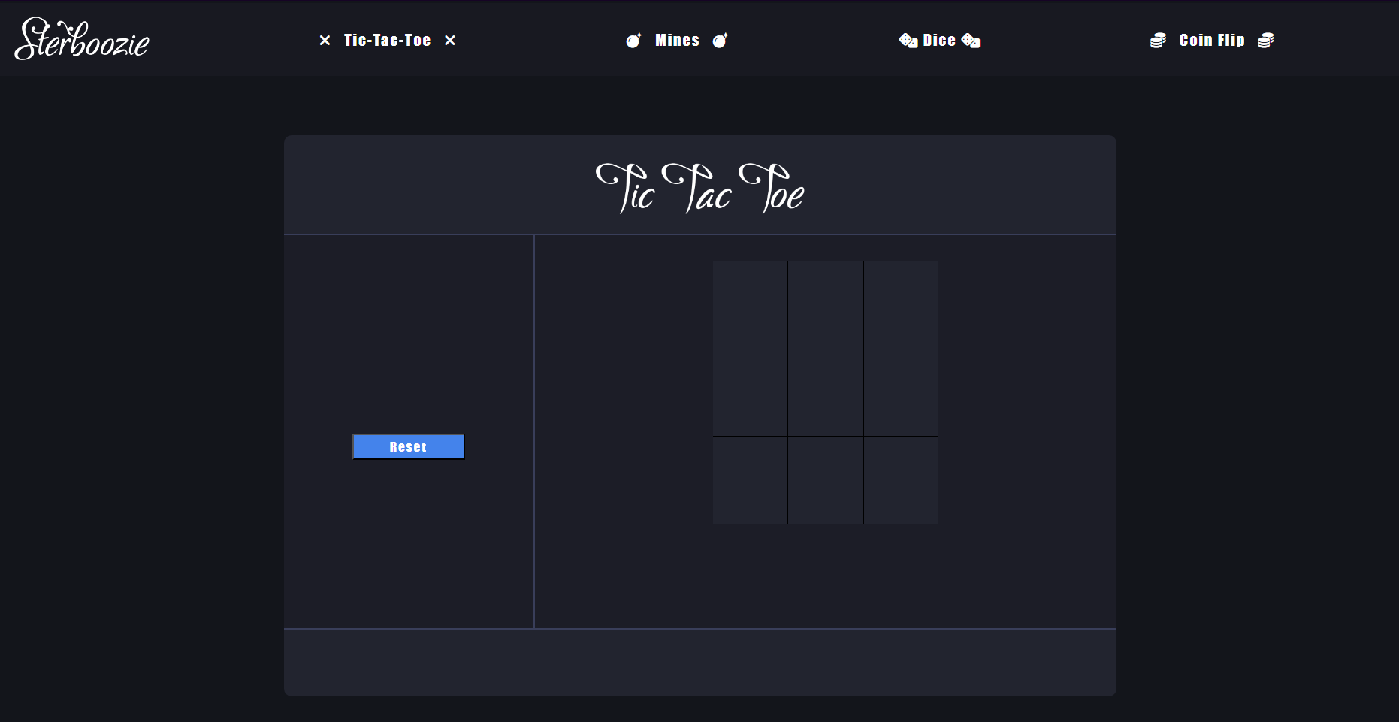  
  
**Second Game: Mines**

Test your luck with Mines. Begin by choosing the number of mines on a 4x4 grid. Each cell click checks if it's unused, and if so, whether it conceals a mine. Discovering a gem adds to your score, but hitting a mine ends the game. Start and reset options enhance gameplay.

**Third Game: Higher or Lower**

Challenge your intuition with 'Higher or Lower'. Select a number and guess whether the next dice roll will be higher or lower. Clicking 'Higher' or 'Lower' rolls two dice to generate a random number. Win by correctly predicting the outcome relative to your chosen number.

**Fourth Game: Coin Flip**

Enjoy the simplicity of a coin flip game. Choose 'heads' or 'tails' using the radio buttons, then click to flip. A visually appealing keyframe animation reveals the outcome. Correct guesses lead to wins, adding an element of chance and excitement to your gaming experience.

