Blazor Schools Readme

Stewart Hyde

# Introduction

This is my 2nd GitHub project and the planned was to use Blazor service as proxy to Json web API. The original was to use the official COVID19 Json API, but virus detection has made me change to a different API which in this case is related to schools – this API is publicly available on the internet as <https://code.org/schools.json>. My desired was use both SQL database and In-memory database and filter out only content need to be transfer to client.

Another interesting thing happen that help this project. Microsoft release Blazor Web Assembly.

I have the following goals for this project, and all have been implemented except for the last one which I will work on after updating this project on GitHub

* Provide an example of calling exiting json service with a Blazer web assembly webservice
* Provide in-memory or SQL storage of contents for faster retrieval of the information with reduce information
* SQL Storage uses both Dapper and Entity Framework along performance testing of all storage API’s
* School Json return 5000+ records so paging option is implemented for performance reasons
* Blazor website has options for Simulated and existing json with no SQL for portability
* Provide example of using WPF Core application to Blazer web-assembly webservice
* Blazor web-assembly progressive app supported but needs to be test on other devices

# Database services

The BlazorSchools.Server support the following database storage services which can be all loaded and configured

* Dapper SQL Service like what is in LegacyDelivery project using store procedures
* In-memory service like what is in LegacyDelivery project using in memory object storage
* Entity Framework that use the same Interface as above and can be interchange by configuration

The external Json service call is loaded into memory and can be store to any of the above. For normal transactions only one is configured. But there is option to included performance comparison between the APIs’. Basically, the test loads the API from external sites and updates configured storage and then reads from each storage twice.

The following is example screen shot from Blazor Application showing performance details with all storage service active

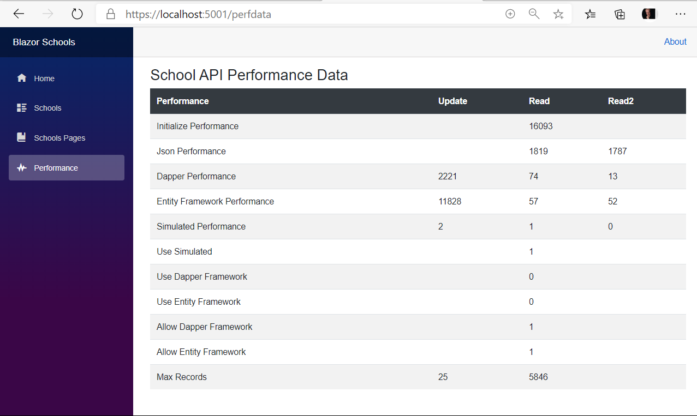

# WPF Client

There is also a WPF client provide which I designed to appear to be like Blazor application with some minor difference. This project is not like the one I note that use web output – but outputs screen using XAML controls. Table output is not as pretty, but I am sure with some work it could be. It uses fixed font for spacing. Implementation wise, it uses the same Http.GetFromJsonAsync calls that Blazor apps uses. The following is example of screen

