Bootstrap Importer Extension

Stewart Hyde

# Introduction

This extension is to aid in moving visual components of Bootstrap related to HTML over to Microsoft Blazor products and in Limited fashion to Razor Pages. This extension is an idea in connection with a 3rd party product called Bootstrap Studio but is not limited to just that product. In the extension has limited support for non-bootstrap pages. The extension will create Razor page, move some resources, include separate CSS files which are important. Embedded scripts in the body of html appears not be allowed in Razor pages and thus are removed.

Microsoft Blazor is a wonderful platform, and I found in the limited 2 or 3 months using it, that it was making a website is easy to do. In fact, I would say before April, I would say, except working with WordPress, that I personally could not do it. Initially, my plan was to use WPF because of Microsoft Blend, but with the current state of technology, I found that Blazor was a better fit. I really like option with Blazor Web assembly to provide ASP. Net Core Hosted option. This made creating and understand web services easier for me.

One of my things I like about WPF was the visual editing with Blend. But there is no option with Blend and since Blazor works with Bootstrap, I search the internet for a tool to help create Bootstrap HTML and found a product called Bootstrap Studio and I found it was much more graphical and also that I could export HTML and import the specific contents into Blend Razor source files. The custom scripts and CSS can be a challenge, and I desired a way to speed up the process. So, I desired to make an extension for Visual Studio to do the work and provide an extension for others. I research extensions for Visual Studio and found they were using WPF to create the ToolWindow. I figured out a way to make the WPF screen work in both the extension and standalone project for faster development. I found two issues with Visual Studio extensions that do not appear to happen with same code in WPF test application which are.

1. Initialize size of control cannot be shown, it appears to use a smaller size.
2. The icon does not appear on screen and not in the menu.

# Example Extension screen in Visual Studio

The following is example screen in Visual Studio with Blazor Project loaded. By default, the currently loaded project is loaded, and Extension will detect the type of project that is loaded the following types of projects are detected and acted on loaded.

1. Blazor Server
2. Blazor WebAssembly
3. Blazor WebAssembly PWA
4. Blazor Web assembly ASP.Net Core Hosted
5. Blazor Web assembly ASP.Net Core Hosted PWA
6. ASP.Net Razor pages

Blazor Server has best support, but for CSS Isolation to work, RenderMode must be set to “Static” and unfortunately menu option on small screen does not work with Static. But this is only required if different pages required different CSS and Scripts.

Blazor Web assembly does not seem to support CSS Isolation using the technique I am using with index.html which does not support C# code inside it? But for single CSS and script changes, it appears to work but background is same between all images.

Note: So far, not able detected ASP. Net core by client only, since this primary a Blazor product only Visual Studio 2019 is supported.

The following HTML Projects are supported

1. Bootstrap Studio projects with some limitation with custom scripts and CSS.
2. Bootstrap projects with limits on scripts
3. Blazor Web assembly projects have a message and reset configuration for better support.
4. Non-Bootstrap projects can be loaded with a warning message.

The idea of this extension is to give a start in migration of HTML to newer platforms like Blazor.

You can currently access the screen from Other windows while in Visual Studio as shown with the following screen

The following is an example of the Visual Studio screen in Visual Studio 2019 Community Edition showing Bootstrap Importer in options screen.

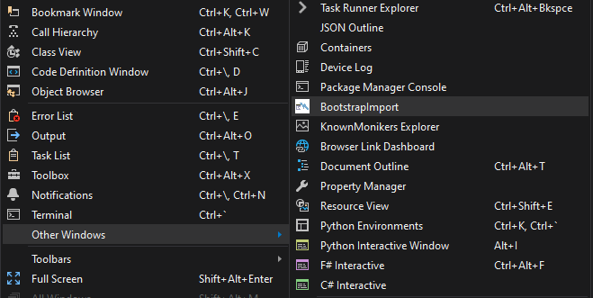

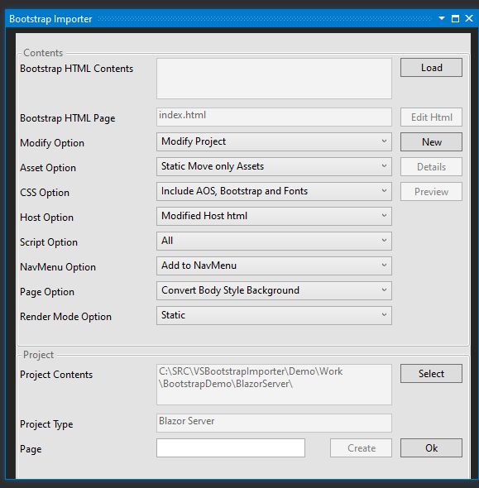

# Commands

The following is a list of commands available on the extension screen.

## *Load*

This command is used to load an HTML resource to be sparse on the system. When you pressed the command on screen, you will be prompted by the following screen to select the html project. This is the root directory and assume to be index.html. You can change which file with editorial command.

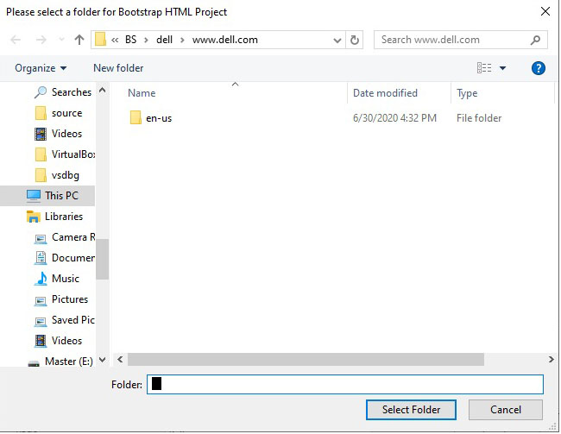

If you pick a non-bootstrap project such as download html–or html from another project, the extension will be prompted with the following screen and extension will attempt to add the specific information. But a lot of sites have embedded scripts in body and those scripts are not allowed on Blazor/razor page.

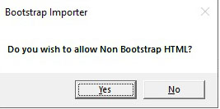

## *Preview*

This command is will show a preview of what is generated with changes applied to the project and preview will be written in the PageName_preview. text file in the project. The command is only available, is only available if both HTML and Visual Studio projects are valid.

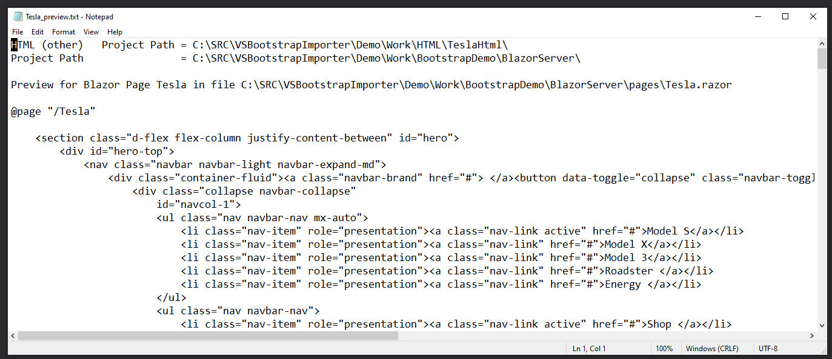

## *Edit HTML*

This is allowed you to change the name of HTML file from default of index.html. This is only available if both the HTML and Visual Studio projects are valid. This can be used in the following 2 situations.

1. If desired html to load is different than index.html
2. If using a shared assets access when multiple pages are used

## *New*

This command allows you to add new HTML project to system and only valid if both HTML and Visual Studio projects are valid

## *Details*

This command allows will display additional detail information about the configuration and will only be valid if both HTML and Visual Studio Projects are valid. This was originally intended for more advance options, but I found it was useful in normal actively. So, this become more of informational screen as below.

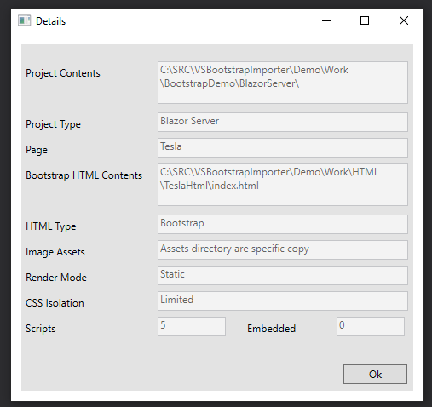

## *Select*

This command allows you to select a different Visual Studio project for generating changes on. This is normally not necessary and should use the default loaded project. But maybe used if your solution has multiple projects within it and will used current selected project. The following screen allows you to change product directory.

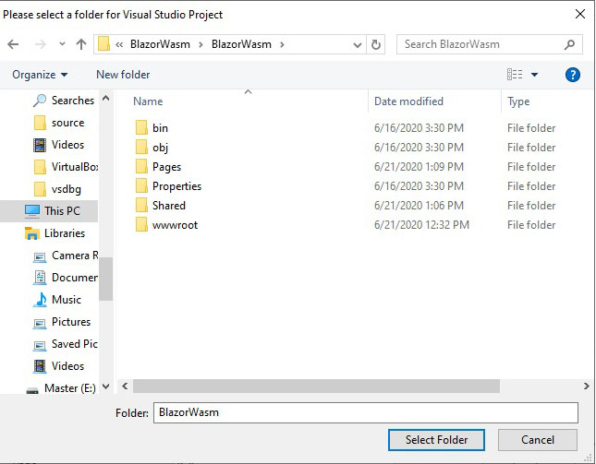

Note, Blazor Web-assembly, does not support CSS Isolation means the CSS must be shared between all pages. But as long as the CSS modification can function in Index.html, it can be functionally. I included two different web assembly examples for this reason.

## *Create*

This command will create changes to visual studio project with changes made by configuration. Once changes are made you should be able to re-compile your changes in the project. Note if HTML project comes back that it is warning, you could get errors especially if scripts are allowed. It is best practice to make sure that you have a backup of your projects before making changes.

## *Cancel*

This is basically same as X on windows and allows you exit the extension. Any changes done with Create command will be a change in project.

# Configurations

The following is a list of fields, and configurations used in the extension

## *Bootstrap HTML Contents*

This contain directory of where the extension gets information imported in for generating Razor pages and assets used by the system. This directory is loaded by used the Load command. This field is read only.

## *Bootstrap HTML Page*

This contains the html page which to parse for contents including assets, this will default to index.html but can be change using the Edit command.

## *Modify Option*

This combo allows you to select the modified option. This indicates what is allowed when modifying the project contents. The available options are.

1. Modify Project (default)
2. Modify No Preview
3. Modify Preview Only

## *Asset Option*

This combo allows you select assets options. This indicates how assets are handled in the generator. The following options are available.

1. Static
2. Static Same Index Page
3. Share between pages
4. Static Move only Assets
5. Static Move only Assets on Same Index Page
6. Move and Share between Pages
7. None

For different Bootstrap assets to work across multiple pages, RenderMode for Blazor Server needs to be marked as static. Also, Assets could be different if multiple pages are uses. This option allows this to be configured in two different ways

1. Static option where entire Asset is copy and used in project.
2. Specific assets are moving, and Extension will attempt to adjust Razor page to match. This allow potential for non-bootstrap layouts to work.

There is also the ability to shared asset directory across multiple pages. This is useful if website being imported has multiple html pages and use same resource. In this case the main index should be marked with Static or StaticMove and other pages mark with associated option to include option.

The following is the layout used by Bootstrap Studio tutorials and is best layout for import

Assets

Img

Image.jpg

Image.png

..

Css

Fonts

Bootstrap

The difference between move and copy is that move only copies the directory found in the html file during search, whereas copy will copy entire structure. Also, movement will attempt to place content in above structure. Once inside the structure it will also insert the page name (base one if pages are to share in front of directory structure. For example, in case Tesla page, the img directory will be wwwroot\telsa\assests\img.

## *CSS Option*

This combo allows you to specify how the Extension generates CSS Option. The following options are available.

1. Include Https Fonts
2. Include custom Bootstrap
3. Include Bootstrap and Fonts
4. Include AOS
5. Include AOS and Https Fonts
6. Include AOS and Bootstrap
7. Include AOS, Bootstrap and Fonts
8. None

For Blazor Server, the default Includes AOS, Bootstrap and Fonts

For Blazor Web assembly, the default Includes AOS and Https Fonts

## *Host Option*

This combo allows you to specify how extension handle host options. The available options are as follows:

1. Modified Host Html

This is following based type of Project

_Host.cshtml - Blazor

Index.html - Blazor Web assembly

_Layout.cshtml - Rasor ASP.Net

1. Preview Only
2. None

## *Script Option*

This combo allows you specific how scripts are handled by extension. The available options are as follows:

1. Ignore Scripts
2. Strip Multi-Line Scripts
3. Selected Script To Host
4. Default of Strip Multi-Line and Script to Host
5. None

## *NavMenu Option*

This combo is used to specify how NavMenu are handled by the extension. The available options are as follows:

1. Add to NavMenu
2. Preview Only
3. None

## *Page Option*

This combo allows you to specify how the page is handled by extension. This was notice with some of Bootstrap Studio templates where Body had style on it. The available options are:

1. Convert Body Style Background
2. None

## *Project Contents*

This option allows you to change the RenderMode options, which only Applies for Blazor Projects. By default, it “Static” so that CSS can be Isolated for multiple pages. Note, if “Static” is used, the small screen menu does not appear to work. The following options are available:

1. Server Pre-rendered
2. Server
3. Static
4. No Change

## *Project Contents*

This field contains a directory of Visual Studio project that is will be used for modifications. By default, it is the current project directory in the visual studio. But can be changed by Select command. This field is read only.

## *Project Type*

This field indicated the type of field that is loaded by in Project Contents, it is a read-only field and one of following values

1. Blazor Server
2. Blazor WebAssembly
3. Blazor WebAssembly PWA
4. ASP.Net Razor
5. Unknown please select

## *Page*

This field defaults to name of Razor page that is generated also when using static resource, this name is inserted in front of resource directory. The default value is “Test” and should be change. This value is also use in NavMenu that is generated.

# Steps for creating examples

## Initial Setup Steps

1. Create a Solution with BlazorServer, BlazorTeslaWasm, BlazorAppleWasmPWA, and Razor projects
2. Download Both the Tesla and Apple Bootstrap Studio and export the projects to HTML

You can download the projects and Bootstrap Studio from <https://bootstrapstudio.io/tutorials/>

I have also provided the exported HTML

1. Make sure the Bootstrap Importer extension is installed in Visual Studio 2019

Steps to reproduce example provided Testa and Apple on Blazor Server

The following are steps to reproduce the provided an example with both Tesla and Apple on Blazor Server

1. Make sure you select BlazorServer
2. Load the Tesla html into Bootstrap Importer solution
3. Change the Page from Text to Tesla but leave options for example as default.
4. Select Preview and/or Details if you desired
5. Hit Create and Create the solution and hit ok.
6. You can execute and verify the Tesla Page if so, desired now if you wish
7. Load the Apple html project into Bootstrap Importer Extension
8. Change the Page from Text to Apple but leave options for example as default.
9. Select Preview and/or Details if you desired
10. Hit Create and Create the solution and hit ok.
11. You can execute and verify the Tesla and Apple Page are visible
12. Save the Solution.

## Steps to reproduce example provided Testa on Blazor Web assembly

The following are steps to reproduce the provided an example with both Tesla on Blazor Web assembly

1. Make sure you select BlazorTeslaWasm project
2. Load the Tesla html into Bootstrap Importer solution
3. Change the Page from Text to Tesla but leave options for example as default.
4. Select Preview and/or Details if you desired
5. Hit Create and Create the solution and hit ok.
6. You can execute and verify the Tesla Page
7. Save the Solution

## Steps to reproduce example provided Apple on Blazor Web assembly PWA

The following are steps to reproduce the provided an example with both Apple on Blazor Web assembly PWA

1. Make sure you select BlazorAppleWasmPWA project
2. Load the Apple html into Bootstrap Importer solution
3. Change the Page from Text to Apple but leave options for example as default.
4. Select Preview and/or Details if you desired
5. Hit Create and Create the solution and hit ok.
6. You can execute and verify the Apple Page
7. Save the Solution

## Steps to reproduce example provided Testa and Apple on Blazor Server

The following are steps to reproduce the provided an example with both Tesla and Apple on ASP.Net Razor

1. Make sure you select Razor Project
2. Load the Tesla html into Bootstrap Importer solution
3. Change the Page from Text to Tesla but leave options for example as default.
4. Select Preview and/or Details if you desired
5. Hit Create and Create the solution and hit ok.
6. You can execute and verify the Tesla Page if so, desired now if you wish
7. Save the Solution
8. Load the Apple html project into Bootstrap Importer Extension
9. Change the Page from Text to Apple but leave options for example as default.
10. Select Preview and/or Details if you desired
11. Hit Create and Create the solution and hit ok.
12. You can execute and verify the Tesla and Apple Page are visible
13. Save the Solution.

# Example Screen Shot

Blazor Server with Tesla page

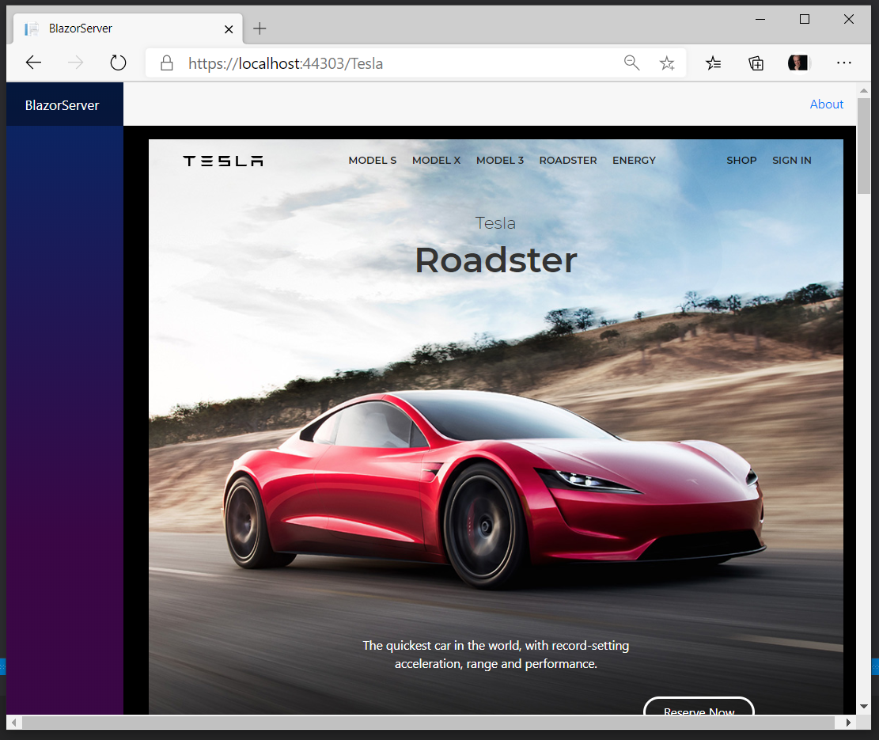

Blazer Server with Apple page

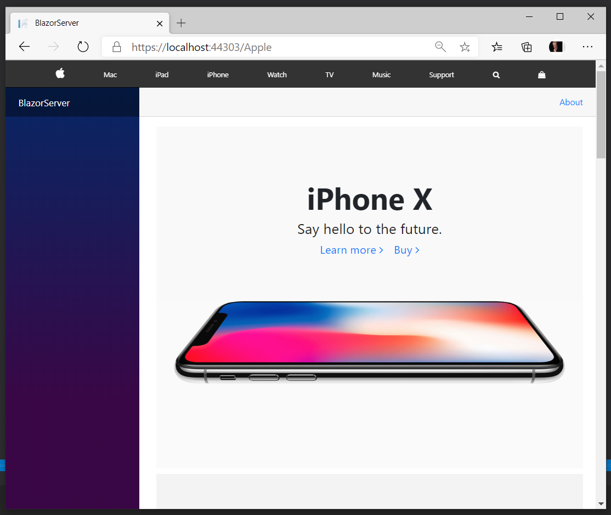

Blazer Web Assembly with Tesla website

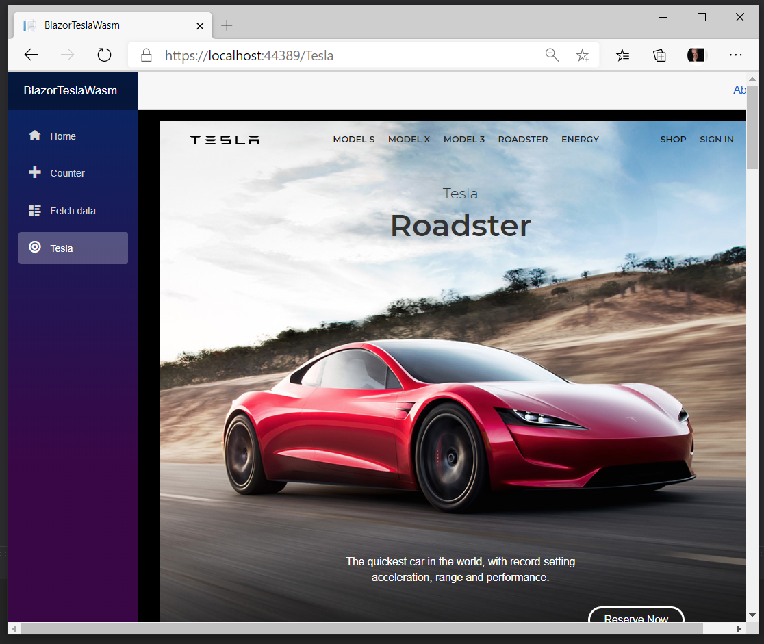

Main Blazor Page showing problem with CSS isolation issue

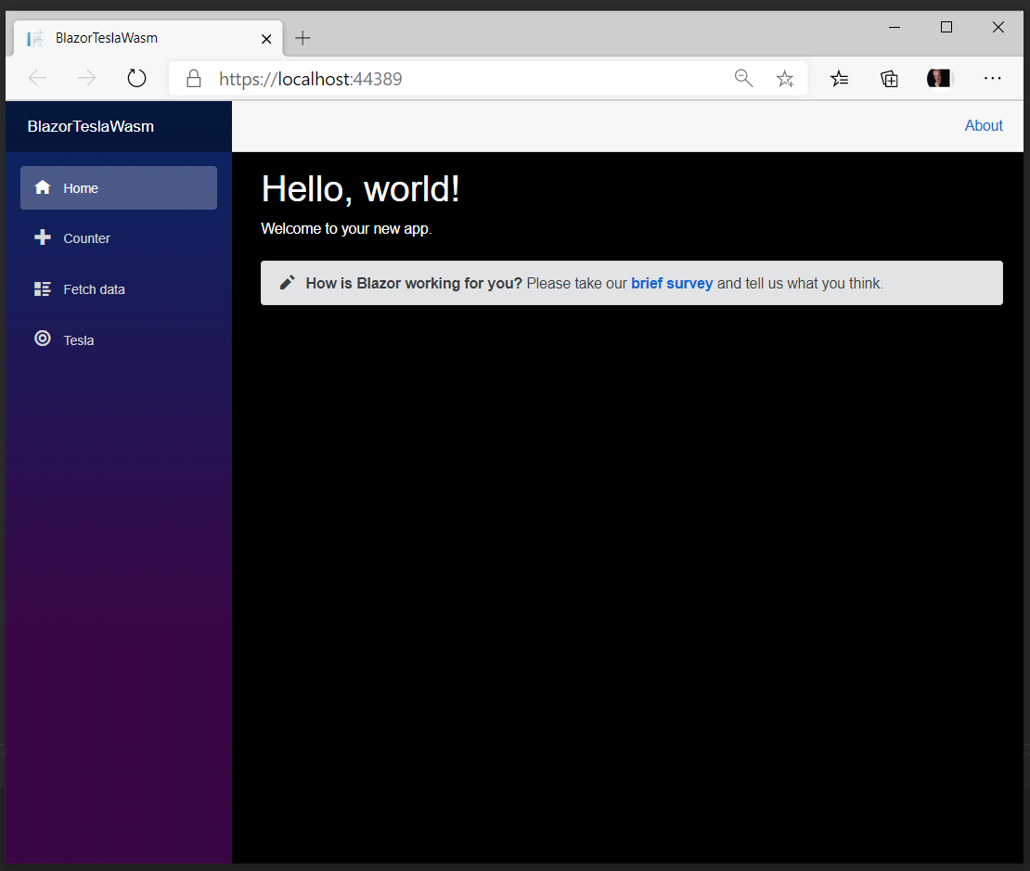

Blazor Web Assembly PWA as PWA

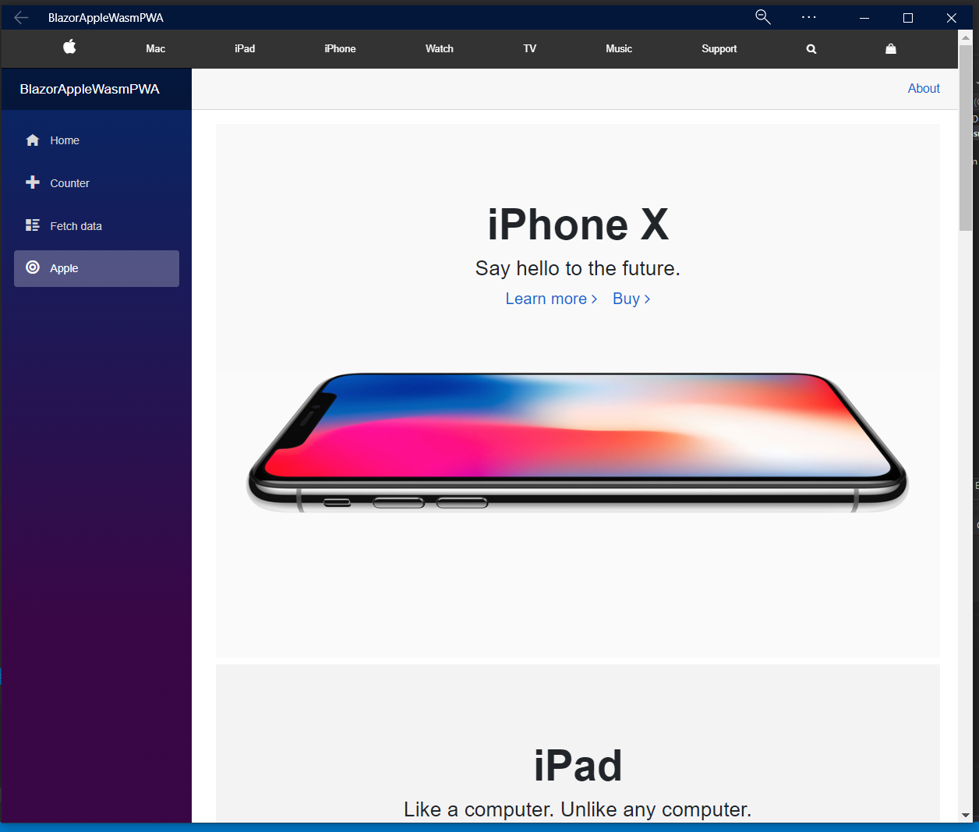

Blazor Web Assembly PWA reduce with Phone like menu

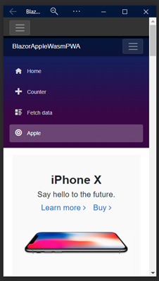

And without menu

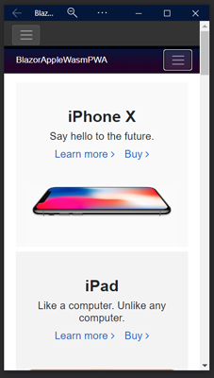

Razor Page showing Tesla

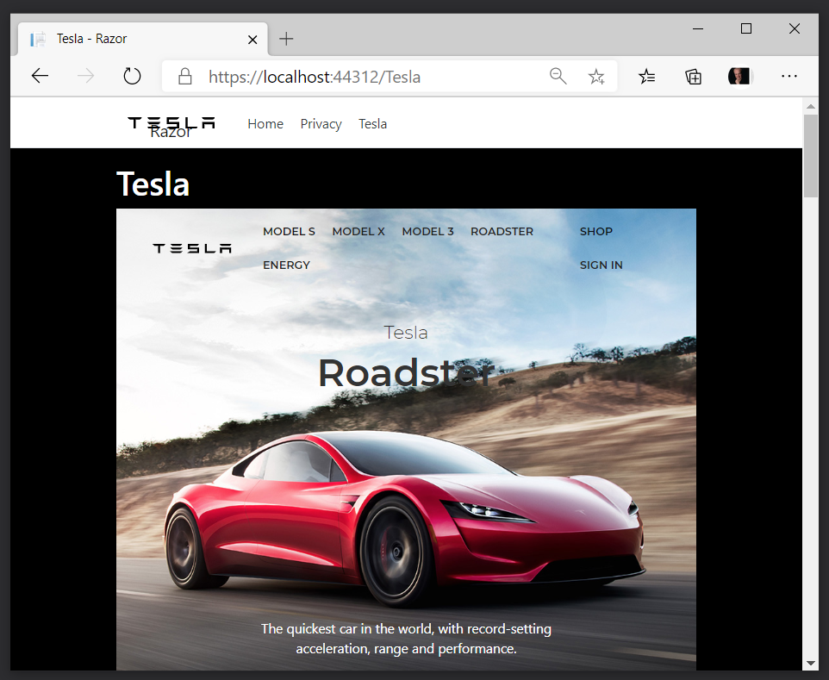

Razor Page showing Apple Page

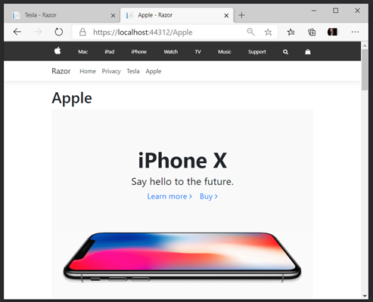

# Future Enhancements

1. Support for updating previous Razor NavMenu when more than one used
2. Improved File IO – currently uses external and would like generic it and allow Visual Studio IO.
3. Improved support for Non-Bootstrap HTML and addition Bootstrap abilities.
4. Options to handle back up existing files while processing.
5. Blazor server needs Render Mode to be static and small screen does not work

Mostly this will allow developer a starting point when import Bootstrap HTML