ANSWERS TO HOMEWORK SESSION 5 -ML ZOOMCAMP

Question 1
Install Pipenv
What's the version of pipenv you installed?
Use --version to find out

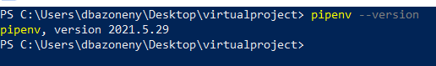

Question 2
- Use Pipenv to install Scikit-Learn version 1.0
- What's the first hash for scikit-learn you get in Pipfile.lock?

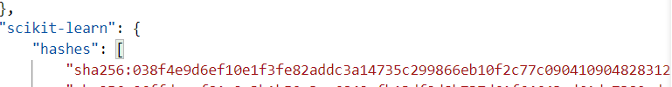

Ans ; "sha256:038f4e9d6ef10e1f3fe82addc3a14735c299866eb10f2c77c090410904828312",

Models
We've prepared a dictionary vectorizer and a model.
They were trained (roughly) using this code:
features = ['tenure', 'monthlycharges', 'contract']
dicts = df[features].to_dict(orient='records')

dv = DictVectorizer(sparse=False)
X = dv.fit_transform(dicts)

model = LogisticRegression().fit(X, y)
And then saved with Pickle. Load them:
- DictVectorizer
- LogisticRegression

Question 3
Let's use these models!
- Write a script for loading these models
- Score this customer:

{"contract": "two_year", "tenure": 12, "monthlycharges": 19.7}

What's the probability that this customer is churning?
Ans …Probability that the given Customer is churning is [0.11549581]

Question 4
Now let's serve this model as a web service
- Install Flask and Gunicorn (or waitress, if you're on Windows)
- Write Flask code for serving the model
- Now score this customer using requests:

url = "YOUR_URL"
customer = {"contract": "two_year", "tenure": 1, "monthlycharges": 10}
requests.post(url, json=customer).json()

What's the probability that this customer is churning?

Ans .. {'Churn': True, 'Churn Probability': 0.9988892771007961}

Docker
For this and the following quesition you'll need Docker. Install it. We will use it for the next two questions

For these questions, I prepared a base image: agrigorev/zoomcamp-model:3.8.12-slim. You'll need to use it (see Question 5 for an example).

This is what it already has:

FROM python:3.8.12-slim
WORKDIR /app
COPY ["model2.bin", "dv.bin", "./"]
I already built it and then pushed it to agrigorev/zoomcamp-model:3.8.12-slim

Question 5
Create your own Dockerfile based on this one

It should start like that:

FROM agrigorev/zoomcamp-model:3.8.12-slim
# add your stuff here
Now complete it:

Install all the dependencies form the Pipenv file
Copy your Flask script
Run it with gunicorn
When you build your image, what's the digest for agrigorev/zoomcamp-model:3.8.12-slim?

Look at the first step of your build log. It should look something like that:

Step 1/3 : FROM python:3.8.12-slim
---> 2e56f6b0af69

Ans
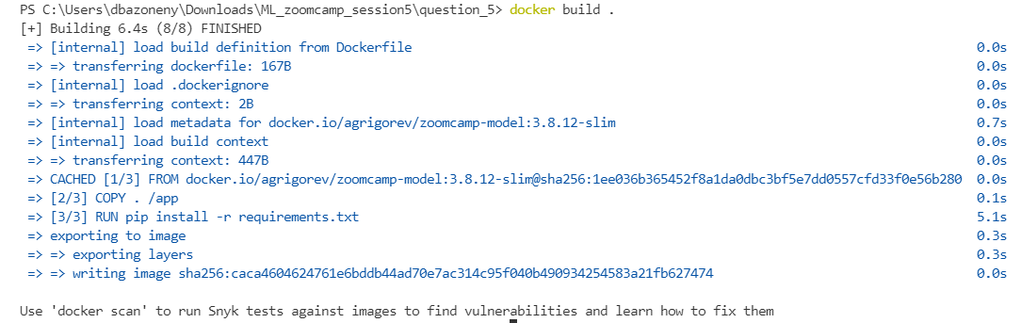

CACHED [1/3] FROM docker.io/agrigorev/zoomcamp-model:3.8.12-slim@sha256:1ee036b365452f8a1da0dbc3bf5e7dd0557cfd33f0e56b280
Question 6
Let's run your docker container!

After running it, score the same customer:

url = "YOUR_URL"
customer = {"contract": "two_year", "tenure": 12, "monthlycharges": 10}
requests.post(url, json=customer).json()

Ans {'Churn': False, 'Churn Probability': 0.32940789808151005}
