**SCREENSHOTS OF MODEL DEPLOYMENT -STREAMLIT APP**

1. Run streamlit_app.py from terminal (go into the project folder and activate conda virtual environment tensorflow-cpu where all dependencies have been installed)

The app is running on localhost

We can test the application in the local host

3. Building the Dockerfile

Docker run command

Now the application runs on localhost and can be tested

**DEPLOYMENT ON HEROKU**

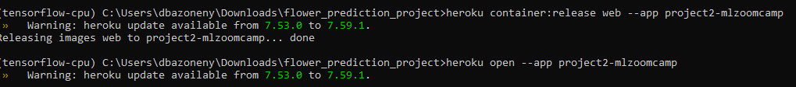

**Final deployment on cloud**

