How to Safely Make Changes to the Website Repository (For Beginners)
❗ Never make changes directly in the main branch. Always create your own branch and work in it. This ensures the live website isn’t accidentally broken.

🔧 Step-by-Step: Creating and Using Your Own Branch

🟢 Step 1: Make sure you’re on the latest main branch
Open your terminal or Git Bash, then type the following commands one by one:
git checkout main
git pull origin main
This will ensure you have the most up-to-date version of the live website.

🟡 Step 2: Create and switch to your own branch
Run this command:
git checkout -b yourname-dev
Replace yourname-dev with your own name. For example, Manisha used:
git checkout -b manisha-dev

🟠 Step 3: Push your new branch to GitHub
git push origin yourname-dev
You can now work safely in this branch.

💻 Making Code Changes in VS Code

Step 1: After you make changes to the code, you’ll see an icon like this (bottom left corner):
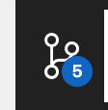
Click on this branch icon with a number.

Step 2: Enter a short message about what you did
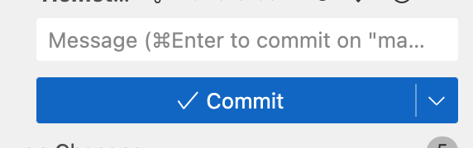
Examples:
- “Added images to gallery”
- “Fixed homepage scroll bug”
Then click the ✅ Commit button.
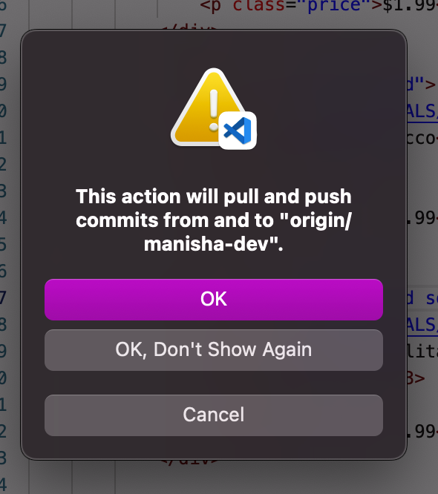

Step 3: Click on “Sync Changes”
This will push your local changes to GitHub.
If a pop-up appears asking to confirm, click OK.
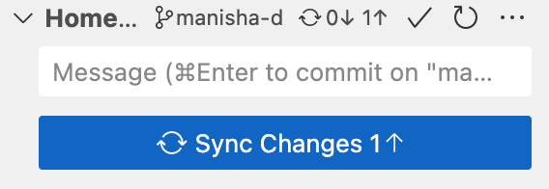

🔁 Creating a Pull Request (To Merge Your Code to Live Website)
1. Go to your GitHub repository (e.g., https://github.com/HT-wen/Hometown_website)
2. You’ll see a message saying: 'Compare & pull request' — click on it.
3. On the new page, click the 'Create pull request' button.
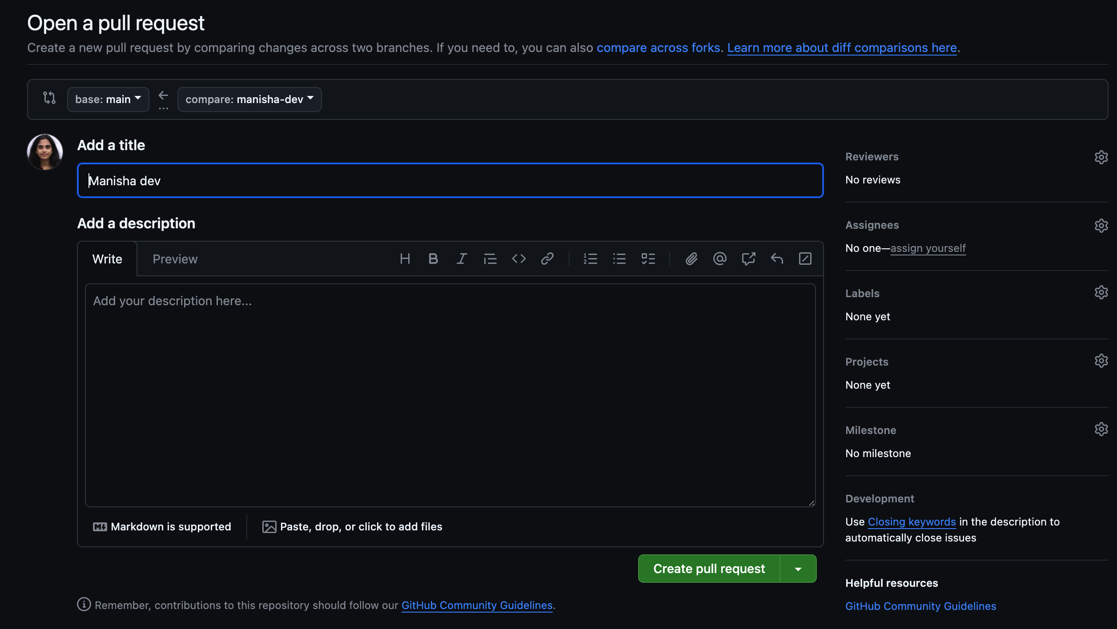
4. Wait for 2 automatic checks to pass ✅ ✅
5. Then click 'Merge pull request'
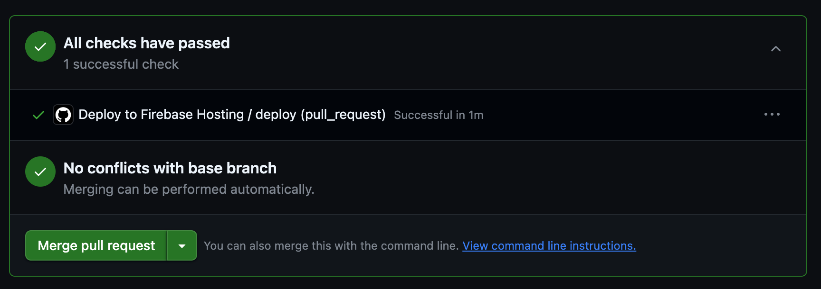
6. Confirm by clicking 'Confirm merge'
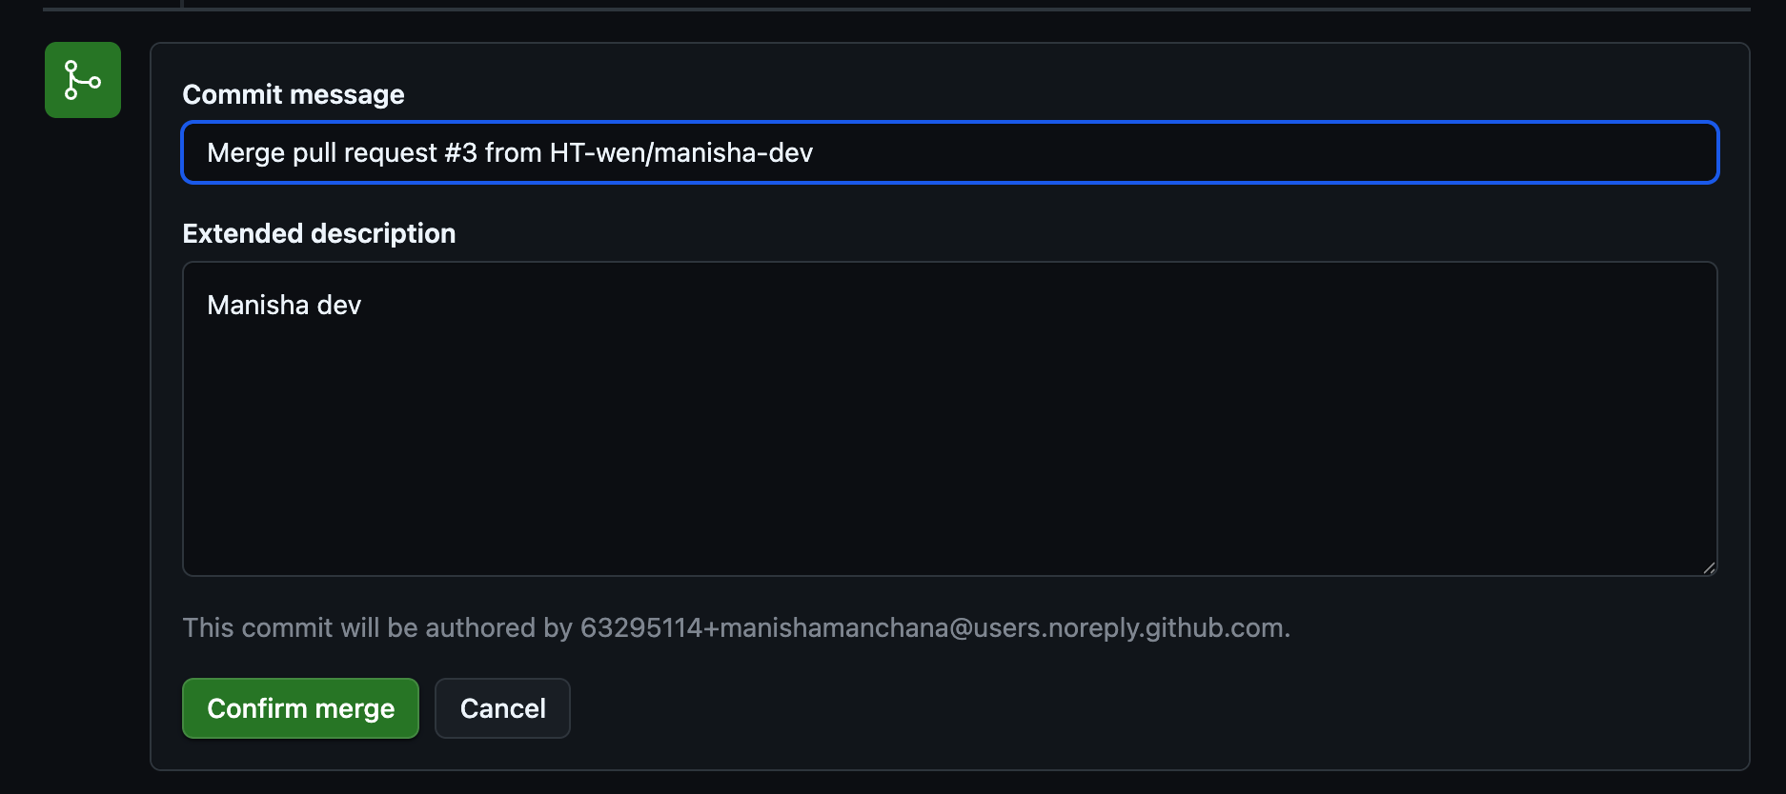
🎉 Done! Your changes will now go live — deployment is automatic.

🛒 Marking an Item as SOLD OUT (Homepage)
To mark an item as sold out on the Trending & Best Sellers section:
1. Find the product code in HTML like:
<div class="product-card">
2. Change it to:
<div class="product-card sold-out">
This will show the item as SOLD OUT on the website.

