**CP3407 Project Report “GlamUp” v2025**

Prepared for: CP3407 Project Assignment 2025

Team Members:

1. Nafisa Sadaf Toushi (ID: 14612865)
2. Prima Deb Borna (ID: 14623063)
3. Drashya Chadar (ID: 14506358)
4. Melvin Joy (ID: 14610152)
5. Htet Myet (ID: 14486886)

GitHub Repository Link:   
<https://github.com/HTEThub/CP3407project/tree/main>

Website Link:  
<https://glamup.infinityfreeapp.com/>

**1. Requirements**

**User Stories**

* **User Story 1: Sign up as a customer**
  + Description: As a customer, I want to create an account by providing my personal details and payment information, so I can use the services offered.
  + Priority: High
  + Estimation: 2 days
* **User Story 2: Sign up as an artist**
  + Description: As an artist, I want to create an account by providing my personal details, payment information, and submitting my resume, so I can offer my services to customers.
  + Priority: High
  + Estimation: 2.5 days
* **User Story 3: Log into my account**
  + Description: As a user, I want to log into my account so I can access personalized features.
  + Priority: High
  + Estimation: 1 day
* **User Story 4: View my profile information**
  + Description: As a user, I want to view all the information I've provided so I can confirm it's correct.
  + Priority: Medium
  + Estimation: 1 day
* **User Story 5: Update my profile information**
  + Description: As a user, I want to edit my personal details whenever necessary, so my information stays current.
  + Priority: Medium
  + Estimation: 2 days
* **User Story 6: See what services are offered**
  + Description: As a customer, I want to view the list of available services, including descriptions and prices, to decide which service suits my needs.
  + Priority: High
  + Estimation: 1 day
* **User Story 7: Book an appointment**
  + Description: As a customer, I want to select a service, pick a convenient date and time, and confirm my booking details so I can schedule an appointment.
  + Priority: High
  + Estimation: 2 days
* **User Story 8: Store booking details**
  + Description: As a customer, I want my booking details securely saved so I can review or manage them later.
  + Priority: High
  + Estimation: 1.5 days
* **User Story 9: View my appointments (for artists)**
  + Description: As an artist, I want to see all upcoming bookings from customers, including their requested service and contact information.
  + Priority: High
  + Estimation: 2 days
* **User Story 10: Manage appointment status (for artists)**
  + Description: As an artist, I want to be able to accept, complete, or cancel appointments so I can effectively manage my schedule.
  + Priority: High
  + Estimation: 1.5 days
* **User Story 11: Understand website purpose easily (Home page)**
  + Description: As a visitor, I want to quickly understand what this website offers and find the important sections easily.
  + Priority: Medium
  + Estimation: 1 day
* **User Story 12: Find business contact information**
  + Description: As a visitor, I want clear access to the business's contact details so I can easily get in touch if I have questions or concerns.
  + Priority: Medium
  + Estimation: 0.5 day

**Feature Planning**

* Planned user stories across two iterations.
* High priority features (signup, login, service view, booking) are completed first.
* Medium priority features (profile management, contact page) are completed in iteration two.
* All features are achievable within the project time and resource constraints.

**Budget Planning**

* Total estimated time: 18.5 days
* Iteration 1 (Week 2-5): 10 days workload
* Iteration 2 (Week 6-9): 8 days workload
* Schedule fits within trimester timeframe with buffer time for testing and feedback.

**2. Design**

**Architectural Design**

We implemented a lightweight MVC-style structure using PHP to maintain separation of concerns between presentation, logic, and data layers.

* Frontend: HTML and CSS (Bootstrap framework used for responsiveness and consistency)
* Backend: PHP handles routing, form processing, and business logic
* Database: MySQL is used to store users and bookings
* Hosting: All components are hosted on [InfinityFree](https://infinityfree.net/)

**UML Diagram**

Made using [draw.io](https://app.diagrams.net/):

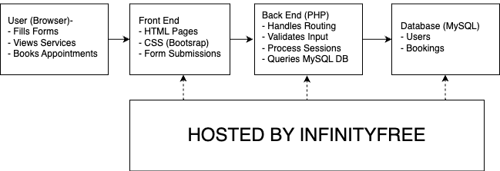

**Database Design**

Managed using MySQL:

|  |  |
| --- | --- |
| **Table Name** | **Description** |
| users | Stores user login, phone, location, payment info and roles |
| bookings | Stores customer bookings |

Relationships:

* Each user has one role (Customer or Artist)
* Customers can make multiple bookings
* Artists can view all bookings

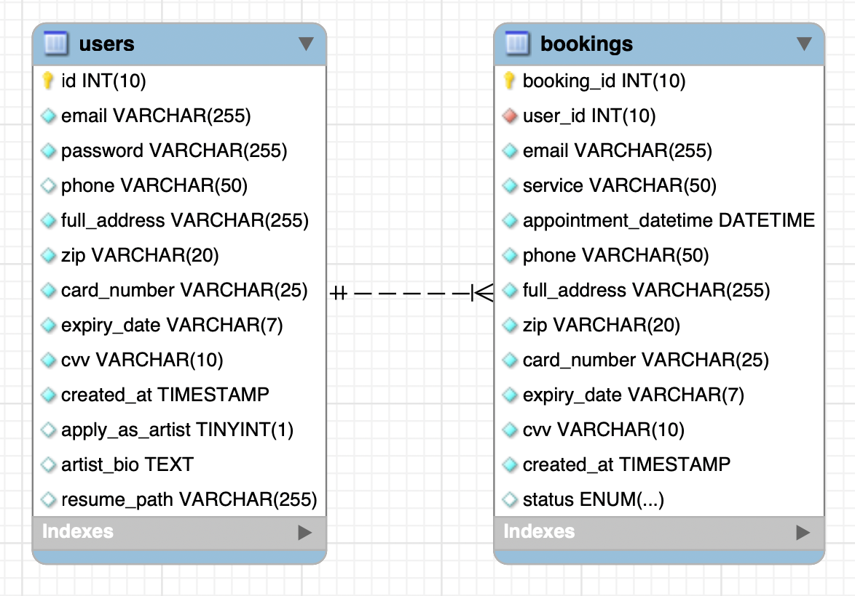

**User Interface Design**

Wireframes were created by hand and by html ([UI-Mockups](https://github.com/HTEThub/CP3407project/tree/main/UI-Mockups)):

|  |  |
| --- | --- |
| **Page Name** | **Description** |
| Home | Welcome page with promotions |
| Services | Service list with descriptions |
| Booking | Customer appointment creation |
| Booking List | Artist appointment management |
| Contact | Static contact information and form |
| Profile/Edit | Editable user information |
| Login/Register | Separate forms for login and registration |

UI Considerations:

* Different booking page depending on user type (customer vs artist)
* Clear navigation

Drawn designs:  
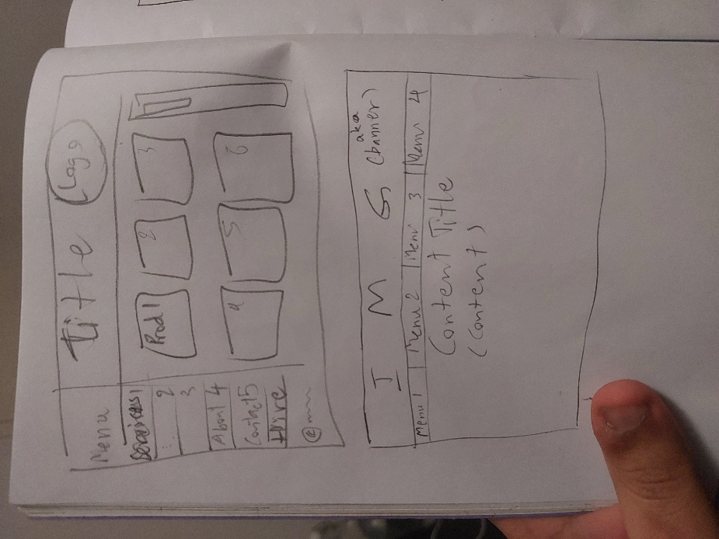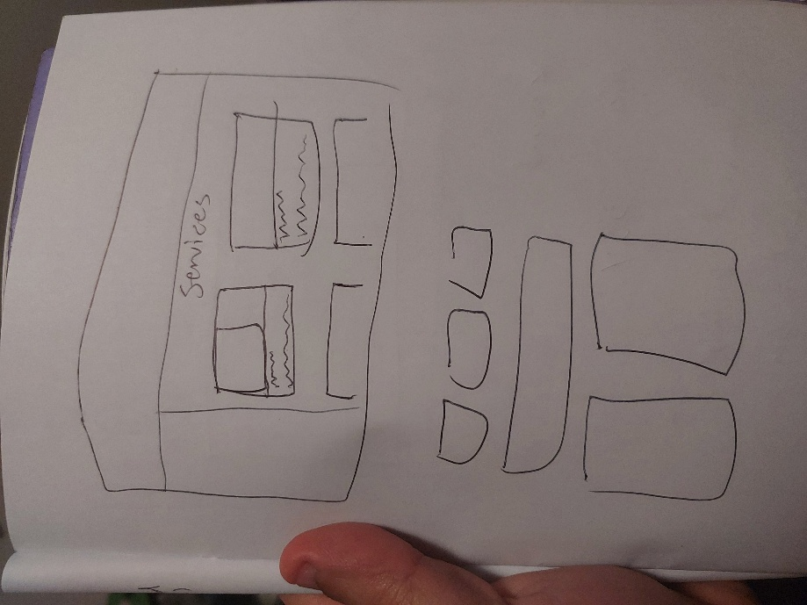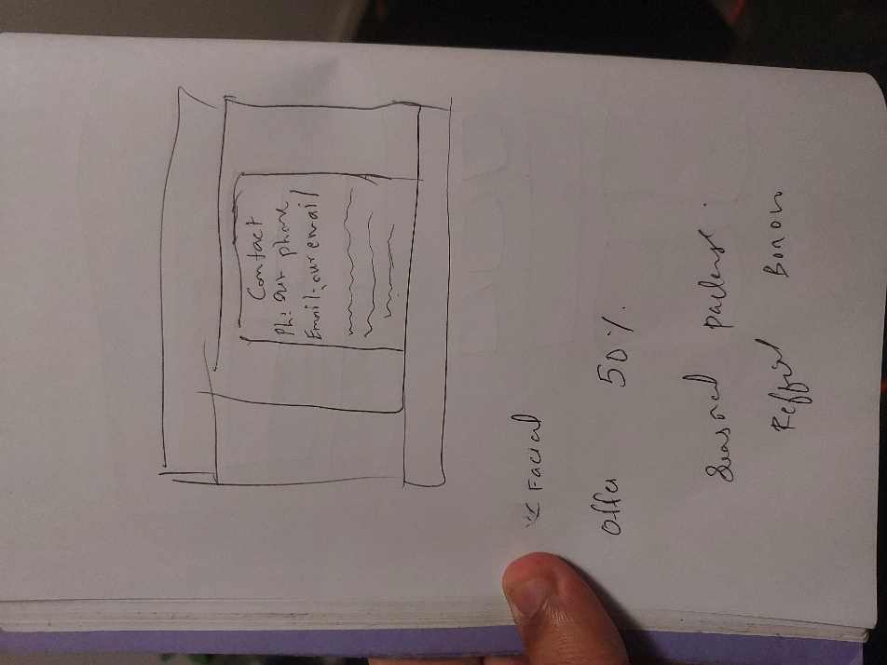

**Design Summary**

* Clear user-role separation
* Scalable database
* Responsive and intuitive UI

**3. Implementation/Code**

**Iteration 1 Implementation**

* **Features completed:**
  + Customer registration (including artist registration with resume upload)
  + User login and logout
  + View list of services
  + Book an appointment
  + Store booking details securely in the database
* **Challenges faced:**
  + Handling different user roles (customer vs artist) after login.  
    ➔ Solved by storing user role in the session and redirecting based on role.
  + File upload issues for artist resumes due to server permission limits.  
    ➔ Solved by adjusting file upload settings on InfinityFree and validating file types.
* **Deployment details:**
  + Deployed on **InfinityFree** free hosting service.
  + PHP backend, MySQL database setup using phpMyAdmin on the InfinityFree platform.
  + SSL enabled for HTTPS secure connection.

**Iteration 2 Implementation**

* **Features completed:**
  + View and update user profile (edit details with optional password update)
  + Artists can view all bookings
  + Artists can manage bookings (accept, complete, or cancel appointments)
  + Home page to explain website purpose
  + Contact page to display business information
* **Challenges faced:**
  + Keeping profile update flexible (only update password if filled).  
    ➔ Solved by adding conditional PHP checks on the server side.
  + Managing booking status updates properly without overwriting other fields.  
    ➔ Solved by using targeted SQL UPDATE queries.
* **Deployment updates:**
  + Updated the deployed site with new profile and booking management features.
  + Small improvements to navigation menu after adding Profile and Booking List pages.

**Client/User Feedback**

* **Feedback after Iteration 1:**
  + Users found registration and booking intuitive but wanted clearer navigation back to the home page after login.
  + Minor confusion between customer vs artist roles.
* **Feedback after Iteration 2:**
  + Artists appreciated having status updates (accept/complete/cancel) but suggested improving the table layout for easier viewing.
  + Profile edit page was considered user-friendly but some users suggested optional password update should be even clearer.
* **Changes made based on feedback:**
  + Added a clearer navigation bar linking Home, Profile, and Bookings after login.
  + Improved booking list table design for artists (more spacing, clearer status buttons).
  + Added helper text to profile edit form about password being optional.

**4. Testing**

**Testing Overview**

This section explains the testing strategy used in the GlamUp online beauty booking system.

**What We Tested**

|  |  |  |
| --- | --- | --- |
| **Component** | **Test File** | **Description** |
| Registration | tests/RegisterTest.php | Tests all inputs, password hashing, artist checkbox, resume upload |
| Login | tests/LoginTest.php | Tests email/password reading, password verification, redirect |
| Logout | tests/LogoutTest.php | Tests session clearing and redirect logic |
| Profile View/Update | tests/ProfileTest.php | Tests session presence, user info rendering, form field values |
| Booking Flow | tests/BookingTest.php | Tests booking datetime format, POST logic, session state |
| Artist Bookings | tests/BookingListTest.php | Tests artist access, booking status update POST logic |
| Edit Profile | tests/EditProfileTest.php | Tests optional password updates, email conflict, update logic |

**Test Strategy**

* Unit tested all PHP files containing core application logic.
* Simulated $_POST, $_GET, $_FILES, and $_SESSION variables.
* Validated security measures (password hashing, input escaping, session handling).
* Verified conditional logic paths, user roles, and form behaviors.
* Focused testing on business logic rather than view rendering.

**Tools Used**

* PHPUnit 12.1.2
* PHP 8.4.6
* macOS with XAMPP local server
* Manual browser testing for user interface behaviors

**Testing Outcome**

* 35 test cases written.
* 60 total assertions performed.
* All tests passed successfully.
* Minor warnings observed, no critical issues.
* No test failures or errors.

**Summary**

This test suite provides strong confidence in the logic and flow of the GlamUp project. Each major feature was tested in isolation using realistic data and edge cases. Logic was validated through assertions, and important security measures such as password hashing and session management were also covered.

**5. Version Control**

**GitHub Usage**

* **Repository link:**  
  <https://github.com/HTEThub/CP3407project/tree/main>

**Branching Strategy**

* A simple branching model was used.
* Most work was committed directly to the main branch.
* Due to time constraints and the small team size, separate feature branches were not created.

**Commit Practices**

* Commits were made after significant portions of work were completed (such as completing a page or a full feature).
* Some commits involved large code blocks rather than small incremental changes.
* In future projects, a more frequent and granular commit approach will be adopted for better traceability and collaboration.

**Pull Request (PR) Process**

* Pull requests were not used in this project.
* Changes were pushed directly to the main branch by individual developers.
* In future team projects, implementing a pull request and review system will be considered to enhance code quality and collaboration.

**6. Building and Development Tools**

**Development Tools**

|  |  |  |
| --- | --- | --- |
| **Tool** | **Purpose** | **Why We Chose It** |
| Visual Studio Code (VS Code) | Code editor | Lightweight, easy to use, supports HTML, PHP, and extensions |
| HTML & PHP | Frontend and backend development | HTML for layout/UI, PHP for server-side logic |
| MySQL | Database | Easy to integrate with PHP and manage user and service data |
| phpMyAdmin | Database management | Web-based interface for managing MySQL databases easily |

**Planning and Project Management**

|  |  |  |
| --- | --- | --- |
| **Tool** | **Purpose** | **Why We Chose It** |
| Trello | User story management and task tracking | Visual board, drag & drop cards, helps track progress using Agile methodology |

**Hosting and Deployment**

|  |  |  |
| --- | --- | --- |
| **Tool** | **Purpose** | **Why We Chose It** |
| InfinityFree | Free website hosting | Supports PHP and MySQL, no cost, suitable for student projects |
| Free SSL (via InfinityFree) | Secure HTTPS connection | Enables secure data transfer with automatic SSL installation and DNS verification |

**Summary**

We selected tools that were simple, beginner-friendly, and effective for our group project.  
This combination allowed us to collaborate efficiently, track progress, and deliver a working product hosted online with secure HTTPS encryption.

**7. Agile Software Engineering**

**Agile Approach**

* Agile iterative development method used.
* Two major iterations planned based on user story priorities.
* Weekly meetings to track progress, identify blockers, and adjust priorities.

**Project Planning Before Iteration-1**

* **Checklist/TODOs:**
  + GitHub entry timestamp is BEFORE iteration-1
  + User stories are correct (see p39)
  + More user stories planned than needed to practice prioritization.
* **User Stories and Priorities:**
  + Sign up as a customer – Priority 1 – 2 days
  + Sign up as an artist – Priority 2 – 2.5 days
  + Log into my account – Priority 3 – 1 day
  + View my profile information – Priority 4 – 1 day
  + Update my profile information – Priority 5 – 2 days
  + See what services are offered – Priority 6 – 1 day
  + Book an appointment – Priority 7 – 2 days
  + Store booking details – Priority 8 – 1.5 days
  + View my appointments (for artists) – Priority 9 – 2 days
  + Manage appointment status (for artists) – Priority 10 – 1.5 days
  + Understand website purpose easily (Home page) – Priority 11 – 1 day
  + Find business contact information – Priority 12 – 0.5 day
  + **Total:** 18.5 days
* **Iteration 1 Plan (Week 2 to Week 5):**
  + Total estimated work: 10 days
* **Iteration 2 Plan (Week 6 to Week 9):**
  + Total estimated work: 8 days
* **Resource Planning:**
  + 5 developers
  + No backlog overflow at planning stage.

**Iteration Planning**

* **Iteration 1 plan:**
  + Sign up as a customer
  + Sign up as an artist
  + Log into my account
  + See what services are offered
  + Book an appointment
  + Store booking details
* **Iteration 2 plan:**
  + View my profile information
  + Update my profile information
  + View my appointments (for artists)
  + Manage appointment status (for artists)
  + Understand website purpose easily (Home page)
  + Find business contact information

**Daily/Weekly Standups**

* **Frequency:**
  + Weekly during practical classes
* **Topics discussed:**
  + Progress updates
  + Blockers and technical challenges
  + Burndown chart tracking
  + Task redistribution if delays occurred
  + Preparation for sprint reviews

**Sprint Reviews and Retrospectives**

* **Sprint Review after Iteration 1:**
  + Completed customer and artist signup, login/logout, service browsing, booking creation, and booking storage.
  + Site successfully deployed on InfinityFree.
  + Minor UI feedback received for navigation improvements.
* **Sprint Review after Iteration 2:**
  + Completed profile view and update, artist booking management, home page, and contact page.
  + Booking management table improved after client feedback.
* **Retrospective Notes:**
  + **What went well:**
    - Good communication and teamwork.
    - Consistent use of GitHub and Trello.
    - Most tasks completed on schedule.
  + **What could improve:**
    - Start manual testing earlier.
    - Improve initial UI consistency between customer and artist pages.
    - Slightly better time estimation needed for complex features.

**Actual Iteration-1 Board**

* **Start Date:** Week 2
* **End Date:** Week 5

**Checklist:**

* GitHub entry timestamps
* User stories correct
* Assumed Velocity: 3 days per developer per week
* Number of Developers: 5
* Total estimated amount of work: 10 days

**User Stories or Tasks:**

* Sign up as a customer – Priority 1 – 2 days
* Sign up as an artist – Priority 2 – 2.5 days
* Log into my account – Priority 3 – 1 day
* See what services are offered – Priority 6 – 1 day
* Book an appointment – Priority 7 – 2 days
* Store booking details – Priority 8 – 1.5 days

**In Progress:**

* (No tasks left)

**Completed:**

* Task-4 (Melvin), completed Week 2
* Task-1 (Nafisa), completed Week 3
* Task-2 (Drashya), completed Week 3
* Task-3 (Melvin), completed Week 4
* Task-5 (Htet Myet), completed Week 5
* Task-6 (Prima), completed Week 5

**Burn Down Chart for Iteration-1:**

* 4 weeks left: 10 days of estimated work
* 3 weeks left: 9 days
* 2 weeks left: 4.5 days
* 1 week left: 3.5 days
* 0 weeks left: 0 days

**Actual Velocity:** ~2.5 days per developer per week

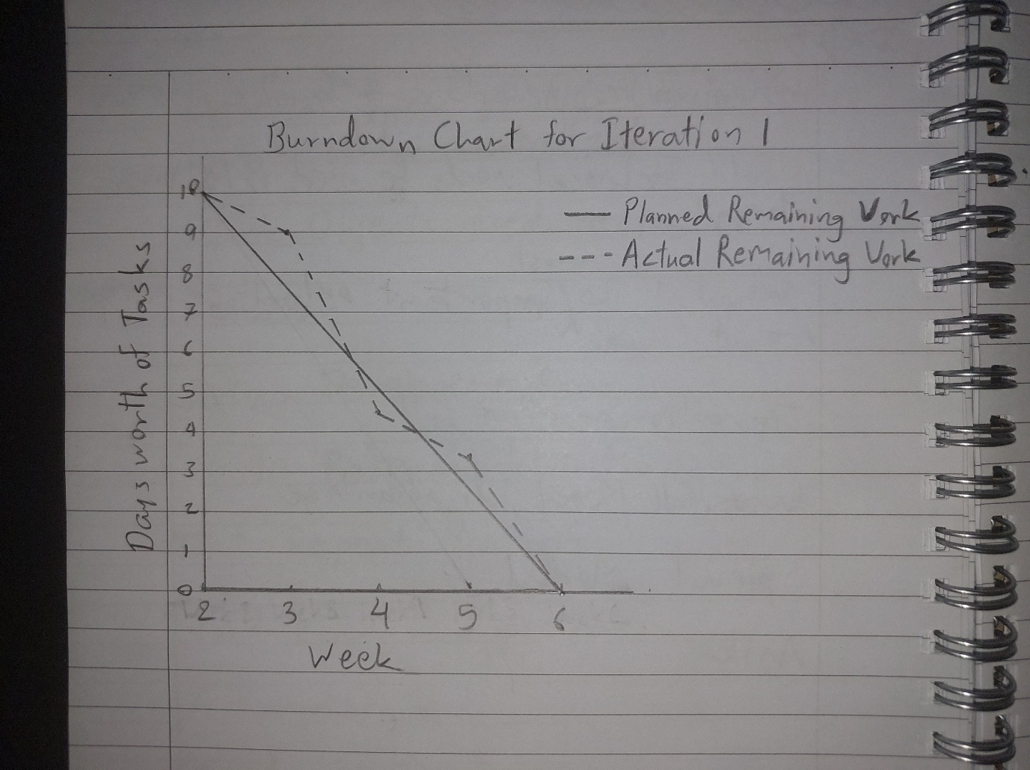

**Actual Iteration-2 Board**

* **Start Date:** Week 6
* **End Date:** Week 9

**Checklist:**

* GitHub entry timestamps
* User stories correct
* Assumed Velocity from Iteration-1: 2.5 days per developer per week
* Number of Developers: 5
* Total estimated amount of work: 8 days

**User Stories or Tasks:**

* View my profile information – Priority 4 – 1 day
* Update my profile information – Priority 5 – 2 days
* View my appointments (for artists) – Priority 9 – 2 days
* Manage appointment status (for artists) – Priority 10 – 1.5 days
* Understand website purpose easily (Home page) – Priority 11 – 1 day
* Find business contact information – Priority 12 – 0.5 day

**In Progress:**

* (No tasks left)

**Completed:**

* Task-6 (Nafisa), completed Week 6
* Task-5 (Nafisa), completed Week 6
* Task-4 (Htet Myet), completed Week 7
* Task-1 (Prima), completed Week 8
* Task-3 (Drashya), completed Week 8
* Task-2 (Melvin), completed Week 9

**Burn Down Chart for Iteration-2:**

* 4 weeks left: 8 days of estimated work
* 3 weeks left: 6.5 days
* 2 weeks left: 5 days
* 1 week left: 2 days
* 0 weeks left: 0 days

**Actual Velocity:** ~2 days per developer per week

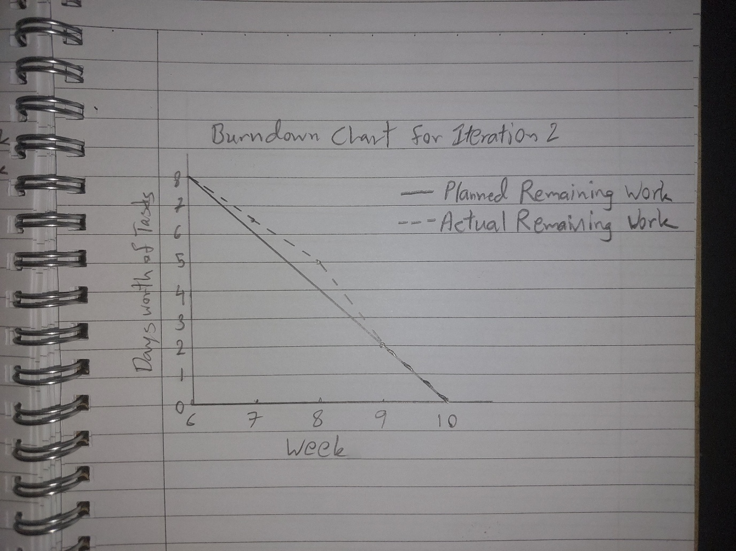

**8. Project Technical Writing**

**Documentation Files**

* [**Design.md**](https://github.com/HTEThub/CP3407project/blob/main/Design.md)**:**
  + Detailed documentation covering the system architecture (MVC structure), database schema (users, bookings, messages tables), and user interface designs (hand-drawn wireframes and layout planning).
  + UML diagrams and ER diagrams included with descriptions of component interactions and data flow.
* [**testing.md**](https://github.com/HTEThub/CP3407project/blob/main/testing.md)**:**
  + Explanation of the unit testing strategy using PHPUnit.
  + Full test coverage of user registration, login, logout, profile update, booking flow, and artist management functionality.
  + Testing dataset description, strategies for session and POST simulation, and summary of test results (35 tests, 60 assertions, 0 failures).
* [**README.md**](https://github.com/HTEThub/CP3407project/blob/main/cp3407-project-v2025a-main/cp3407-project-v2024-main/README.md)**:**
  + Description of project development through two Agile iterations. ([iteration_1.md](https://github.com/HTEThub/CP3407project/blob/main/cp3407-project-v2025a-main/cp3407-project-v2024-main/iteration_1.md), [iteration_2.md](https://github.com/HTEThub/CP3407project/blob/main/cp3407-project-v2025a-main/cp3407-project-v2024-main/iteration_2.md))
* [**User_stories.md**](https://github.com/HTEThub/CP3407project/blob/main/cp3407-project-v2025a-main/cp3407-project-v2024-main/User_stories.md)**:**
  + List of user stories
* [**UserStories.docx**](https://github.com/HTEThub/CP3407project/blob/main/cp3407-project-v2025a-main/cp3407-project-v2024-main/user_stories/UserStories.docx)**:**
  + Contains a detailed list of all user stories following the structure outlined in the template ([user_story_nth_title.md](https://github.com/HTEThub/CP3407project/blob/main/cp3407-project-v2025a-main/cp3407-project-v2024-main/user_stories/user_story_nth_title.md))
  + While the initial plan was to create separate .md files for each user story, we consolidated them into a single document for efficiency and better manageability.
* [**tools.md**](https://github.com/HTEThub/CP3407project/blob/main/tools.md)**:**
  + Detailed list of all development tools and technologies used in the project.
  + Includes Visual Studio Code (VS Code) as the main code editor for HTML, PHP, and CSS development.
  + MySQL database management through phpMyAdmin for easy setup and maintenance of user and booking data.
  + Trello used for Agile planning, user story tracking, and visual task management across the team.
  + Project deployed using InfinityFree hosting, with SSL enabled for secure HTTPS connections.
  + Tools selected for their simplicity, effectiveness, and suitability for beginner-level group collaboration.

**Appendix**

**Burndown Charts**

* **Iteration-1 Burndown Chart:**
  + Shows consistent progress toward estimated 10 days of work over 4 weeks.

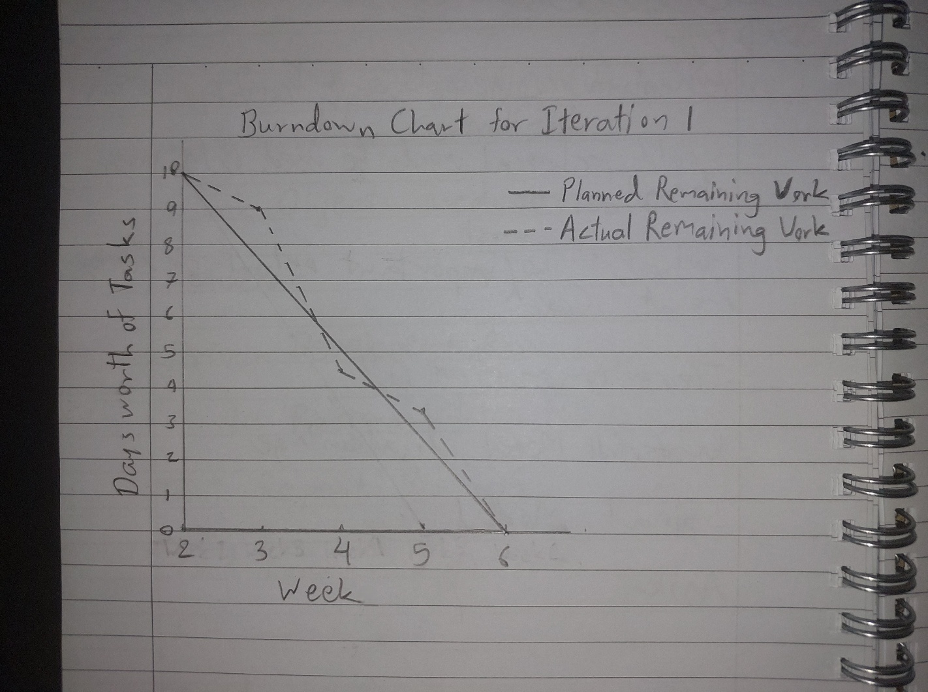

* **Iteration-2 Burndown Chart:**
  + Shows remaining 8 days of work reducing steadily over the 4-week period.

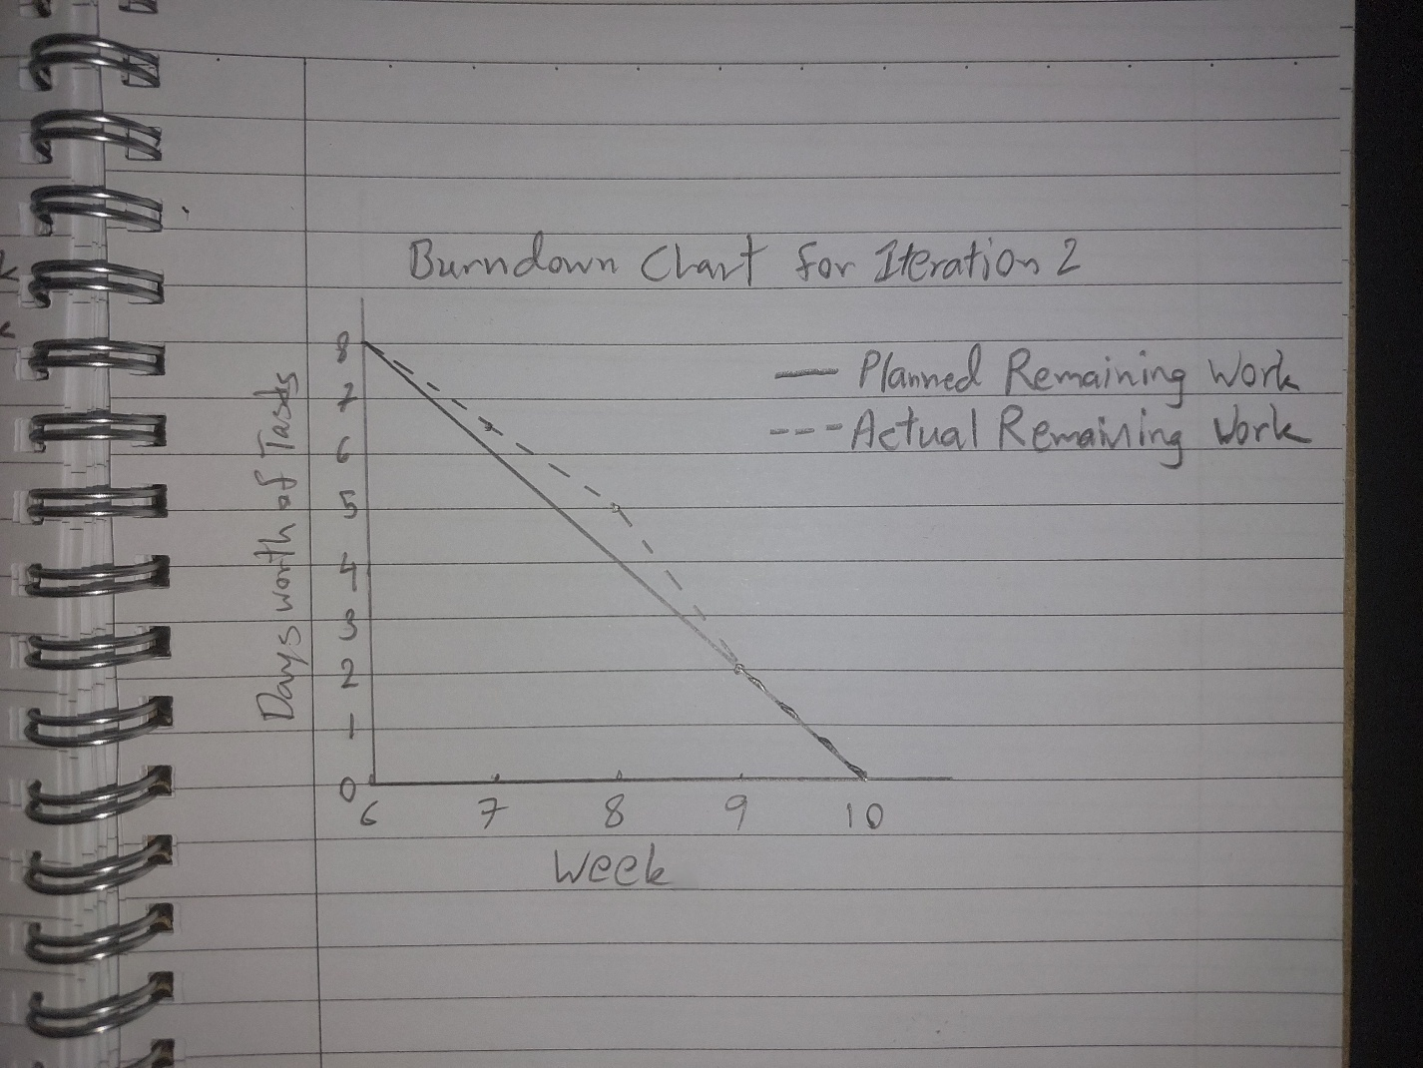

**Full User Story List**

* Already included in the Requirements section (Section 1).

**Testing Screenshots**

* Screenshots of successful test runs for each major feature (registration, login, booking creation, profile update): [Glamup_InnerWorkings.pptx](https://github.com/HTEThub/CP3407project/blob/main/cp3407-project-v2025a-main/cp3407-project-v2024-main/Glamup_InnerWorkings.pptx)
* Highlighted test pass results with PHPUnit showing 35 test cases and 60 assertions without failures.