**User story title: Sign up as a customer**

Keep any other version here as well, e.g. Create account for service booking.

**Priority: 1**

High priority for iteration-1. Needed to allow customer participation.

**Estimation:**

* Nafisa: 2 days
* Prima: 1.5 days
* Htet Myet: 2 days

**Assumptions:**

* Users will provide email, password, phone number, address, and payment info.
* Users are not applying as artists.

**Description:**

Description-v1: As a customer, I want to create an account by providing my personal details and payment information, so I can use the services offered.

**Tasks:**

1. Create a registration form for customers, Estimation: 0.5 days
2. Add input validation for form fields, Estimation: 0.5 days
3. Save customer info to database, Estimation: 1 day
4. Display success message and redirect, Estimation: 0.5 day

**UI Design:**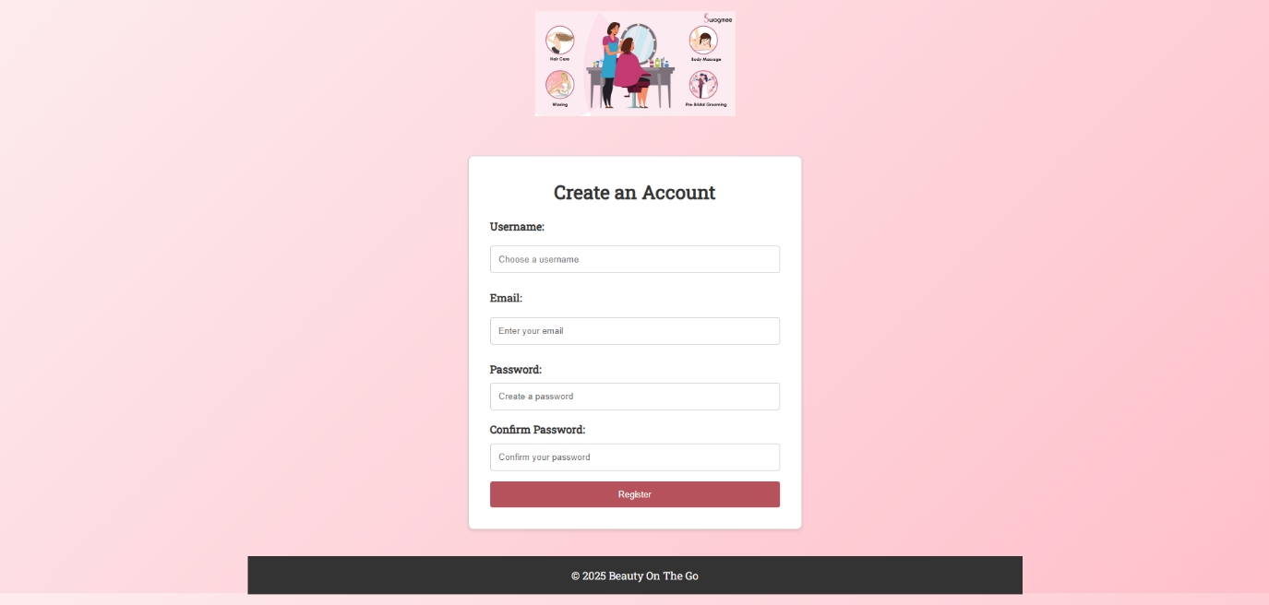

**Completed:**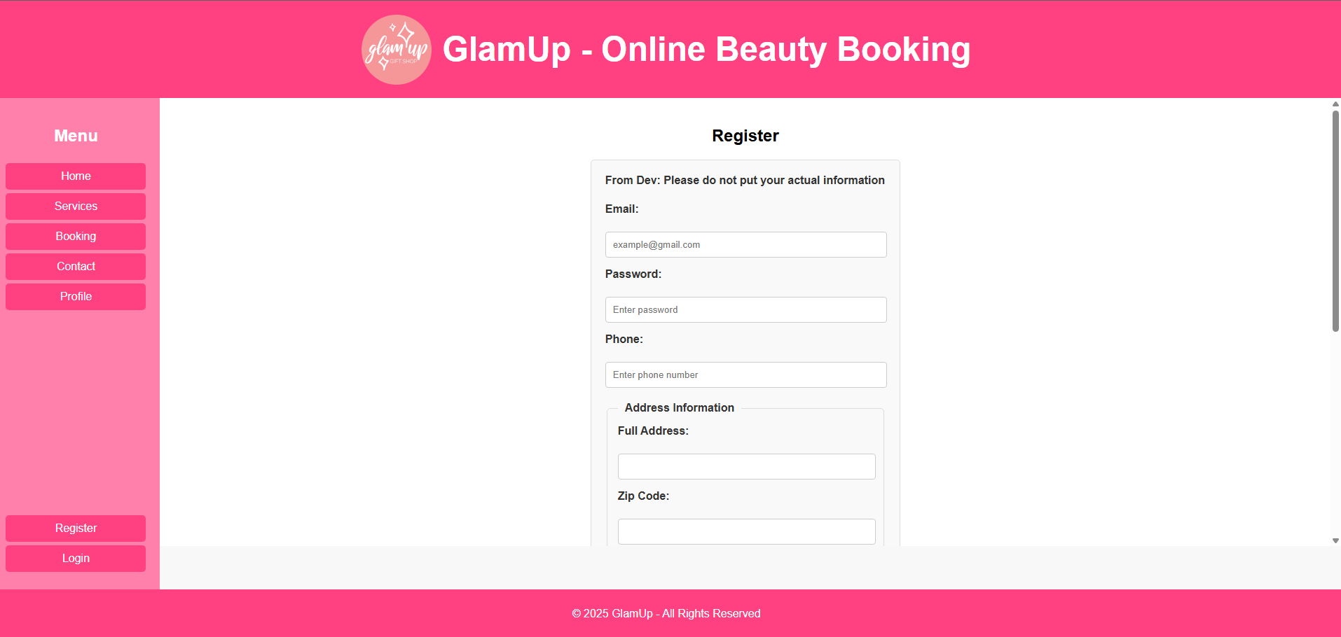

**User story title: Sign up as an artist**

Keep any other version here as well, e.g. Create artist account, Register to offer services.

**Priority: 2**

High priority for iteration-1. Required for enabling service providers.

**Estimation:**

* Drashya: 2 days
* Nafisa: 2.5 days
* Prima: 3 days

**Assumptions:**

* Artist will provide same personal info as customers.
* Artist must upload a resume file to complete registration.

**Description:**

Description-v1: As an artist, I want to create an account by providing my personal details, payment information, and submitting my resume, so I can offer my services to customers.

**Tasks:**

1. Add an artist toggle or checkbox on the registration form, Estimation: 0.5 day
2. Display file upload field when artist option is selected, Estimation: 0.5 day
3. Validate and store resume file along with other info, Estimation: 1 day
4. Save all details to the database, Estimation: 0.5 day

**Completed:**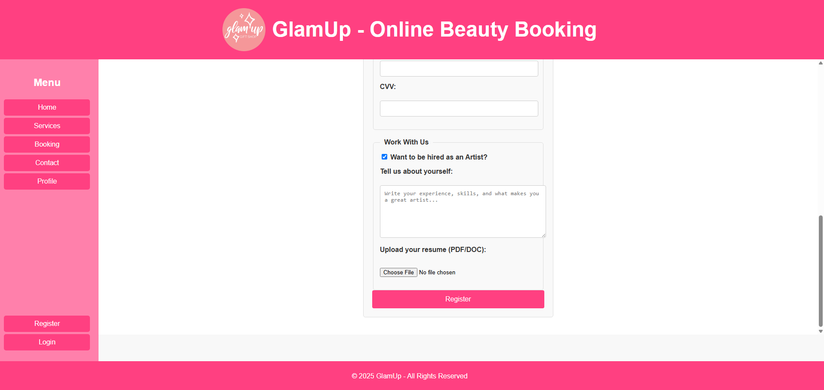

**User story title: Log into my account**

Keep any other version here as well, e.g. User login access, Sign in to use services.

**Priority: 3**

Needed for all further features. Iteration-1 must have.

**Estimation:**

* Htet Myet: 1 day
* Melvin: 1 day
* Drashya: 1.5 days

**Assumptions:**

* Users must be registered to log in.
* Login requires valid email and password.

**Description:**

Description-v1: As a user, I want to log into my account so I can access personalized features.

**Tasks:**

1. Create a login form with email and password fields, Estimation: 0.5 day
2. Check if user exists and password matches, Estimation: 0.5 day
3. Redirect to dashboard or home after login, Estimation: 0.5 day

**UI Design:**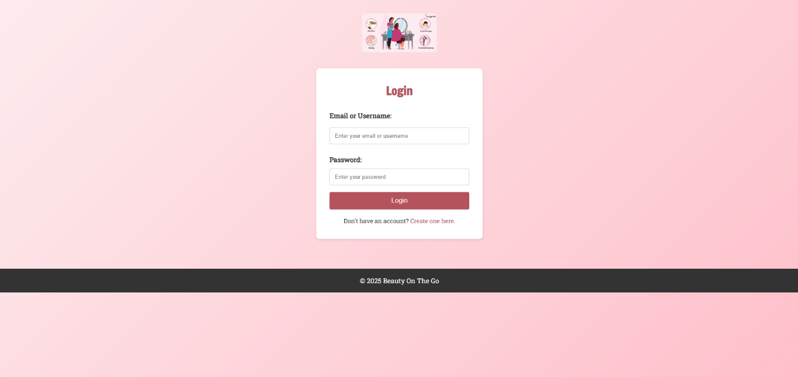

**Completed:**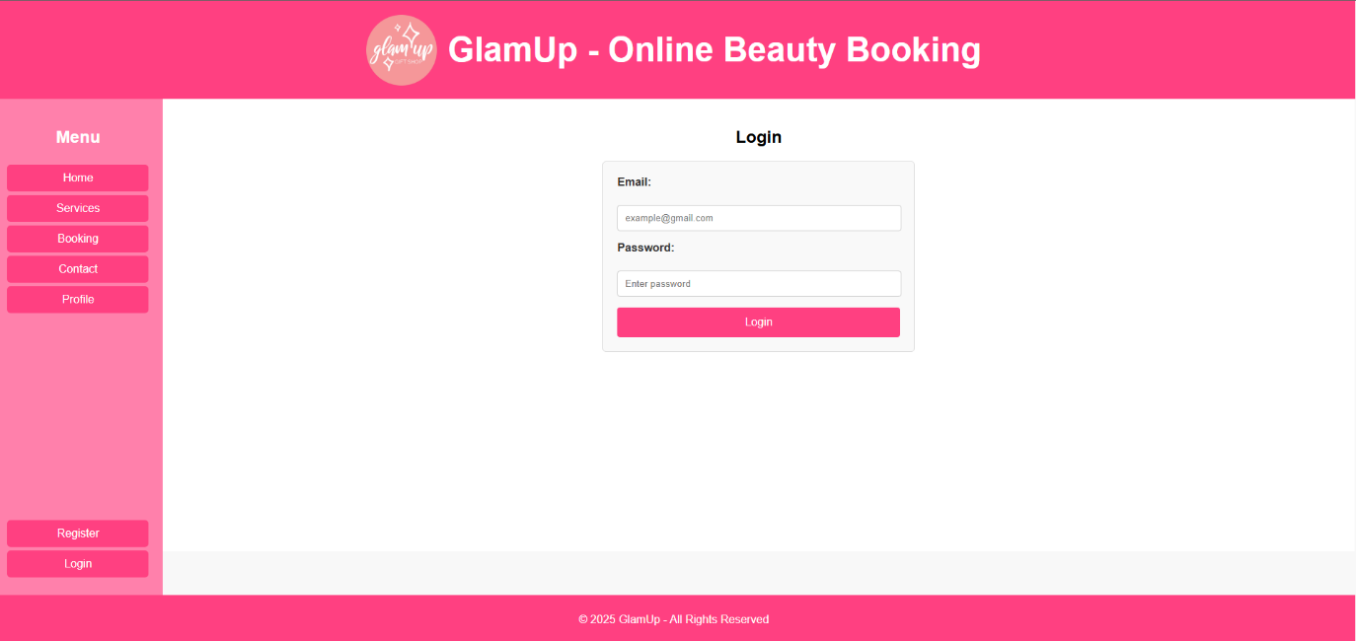

**User story title: View my profile information**

**Priority: 4**

Helps user verify their stored info. Iteration-2.

**Estimation:**

* Prima: 1 day
* Melvin: 1 day
* Htet Myet: 1 day

**Assumptions:**

* Only logged-in users can view their profile.

**Description:**

Description-v1: As a user, I want to view all the information I've provided so I can confirm it's correct.

**Tasks:**

1. Display all personal details of the logged-in user, Estimation: 0.5 day
2. Link profile page to navigation or dashboard, Estimation: 0.5 day

**Completed:**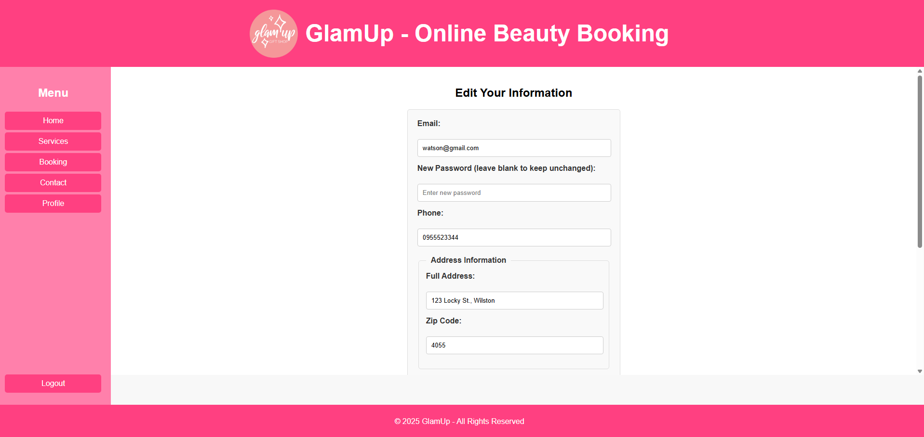

**User story title: Update my profile information**

**Priority: 5**

Ensures user info stays current.

**Estimation:**

* Nafisa: 2 days
* Drashya: 1.5 days
* Melvin: 2 days

**Assumptions:**

* Only logged-in users can edit their info.

**Description:**

Description-v1: As a user, I want to edit my personal details whenever necessary, so my information stays current.

**Tasks:**

1. Add edit fields to profile page, Estimation: 1 day
2. Validate inputs and save updates, Estimation: 1 day

**Completed:**

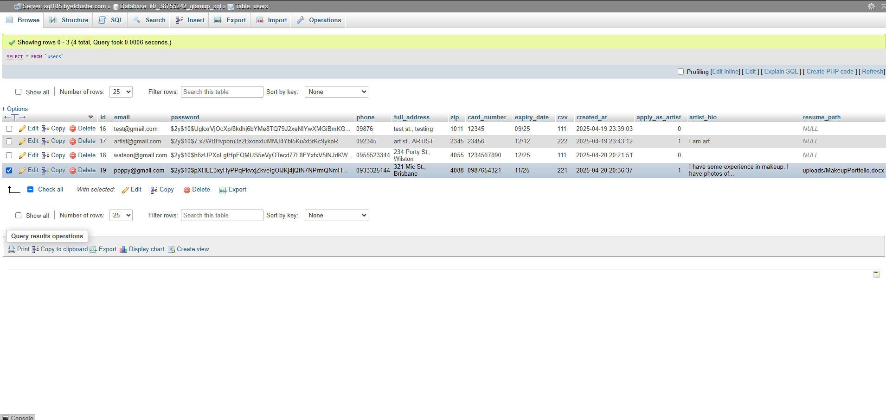

**User story title: See what services are offered**

**Priority: 6**

Essential for booking.

**Estimation:**

* Htet Myet: 1 day
* Prima: 1 day
* Melvin: 1 day

**Assumptions:**

* Service list is managed by admin or hard-coded.

**Description:**

Description-v1: As a customer, I want to view the list of available services, including descriptions and prices, to decide which service suits my needs.

**Tasks:**

1. Design and display a static or dynamic service list, Estimation: 0.5 day
2. Link each service to booking functionality, Estimation: 0.5 day

**UI Design:**

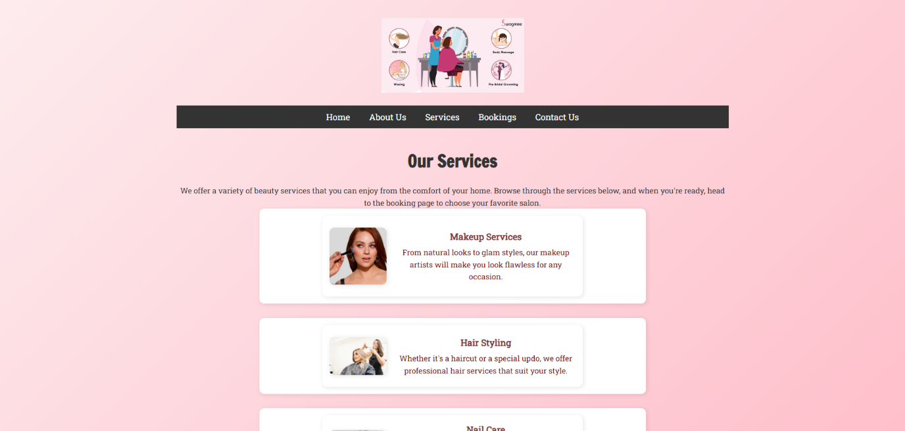**Completed:**

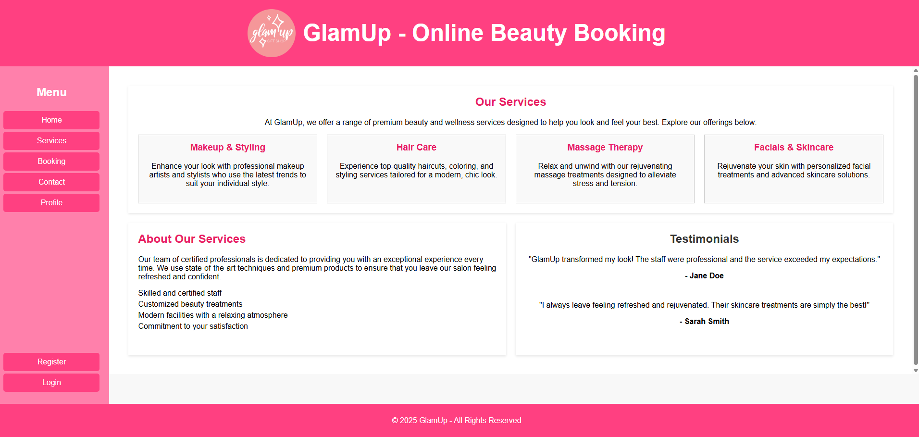

**User story title: Book an appointment**

**Priority: 7**

Core feature for customers.

**Estimation:**

* Nafisa: 2 days
* Prima: 2 days
* Melvin: 2 days

**Assumptions:**

* Users must be logged in to book.

**Description:**

Description-v1: As a customer, I want to select a service, pick a convenient date and time, and confirm my booking details so I can schedule an appointment.

**Tasks:**

1. Create booking form with date/time pickers, Estimation: 1 day
2. Validate and confirm booking inputs, Estimation: 1 day

**UI Design:**

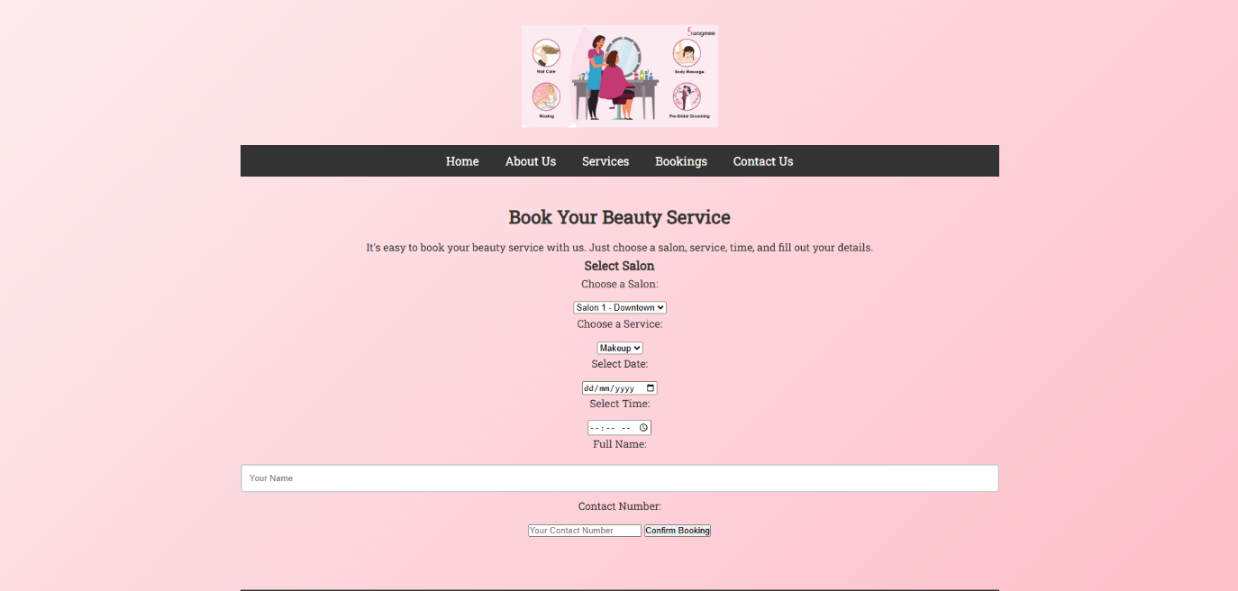**Completed:**

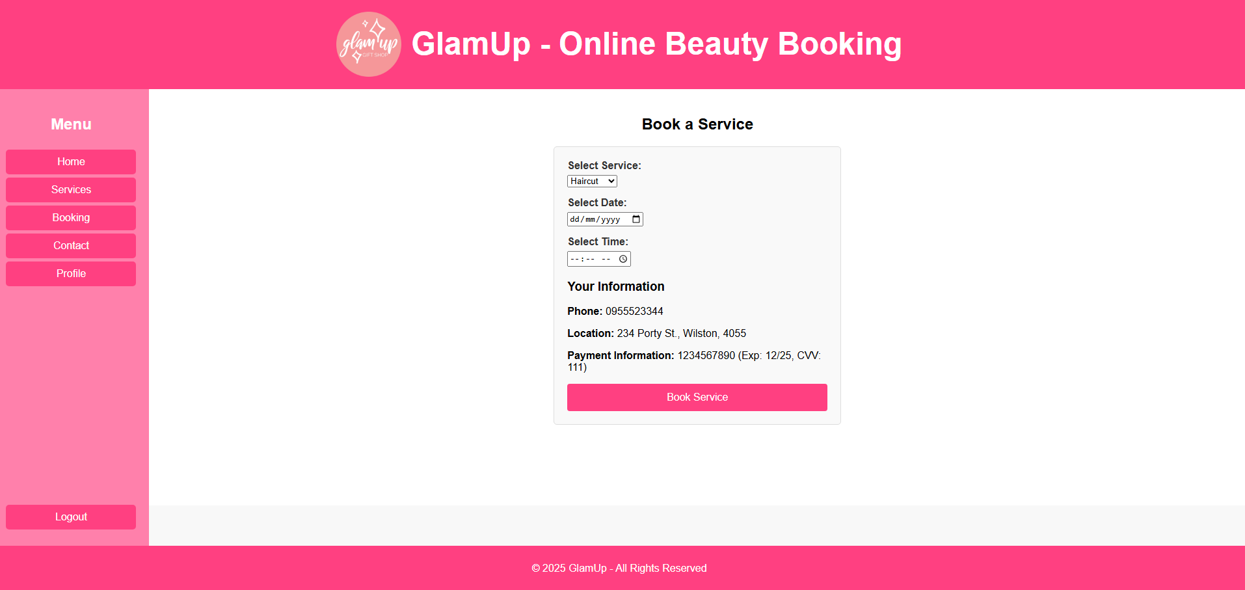

**User story title: Store booking details**

**Priority: 8**

Needed to track appointments.

**Estimation:**

* Drashya: 1 day
* Nafisa: 1.5 days
* Htet Myet: 2 days

**Assumptions:**

* Booking data is saved immediately after confirmation.

**Description:**

Description-v1: As a customer, I want my booking details securely saved so I can review or manage them later.

**Tasks:**

1. Store appointment data into system records, Estimation: 1 day
2. Redirect or notify user booking is complete, Estimation: 0.5 day

**Completed:**

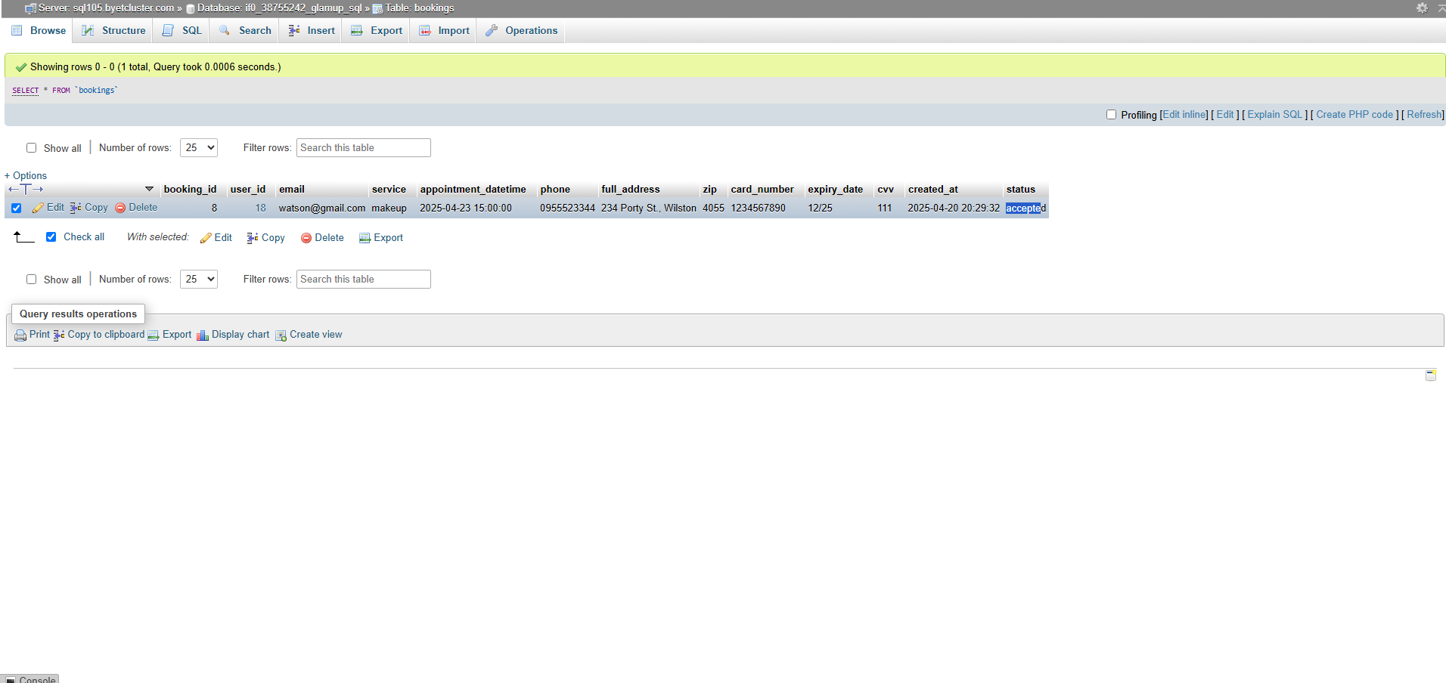

**User story title: View my appointments (for artists)**

**Priority: 9**

Helps artists plan their work.

**Estimation:**

* Melvin: 2 days
* Drashya: 2 days
* Nafisa: 2 days

**Assumptions:**

* Only artist users can see this view.

**Description:**

Description-v1: As an artist, I want to see all upcoming bookings from customers, including their requested service and contact information.

**Tasks:**

1. Display bookings relevant to the artist, Estimation: 1 day
2. Provide filtering or sorting (optional), Estimation: 1 day

**Completed:**

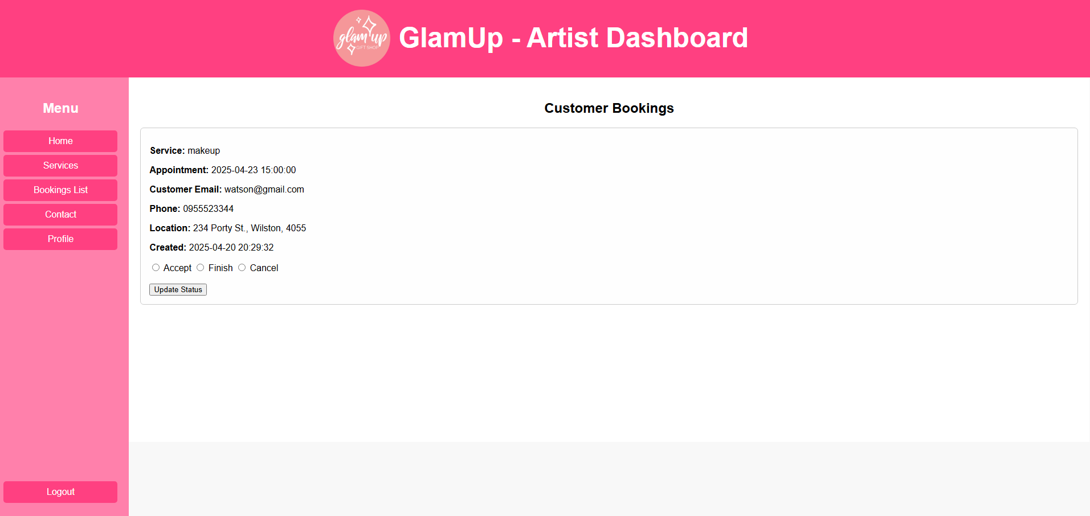

**User story title: Manage appointment status (for artists)**

**Priority: 10**

Needed for managing customer flow.

**Estimation:**

* Prima: 1.5 days
* Htet Myet: 1 day
* Drashya: 2 days

**Assumptions:**

* Status options include: Accept, Finish, Cancel.

**Description:**

Description-v1: As an artist, I want to be able to accept, complete, or cancel appointments so I can effectively manage my schedule.

**Tasks:**

1. Add status controls for each booking, Estimation: 0.5 day
2. Save status changes properly, Estimation: 1 day

**Completed:**

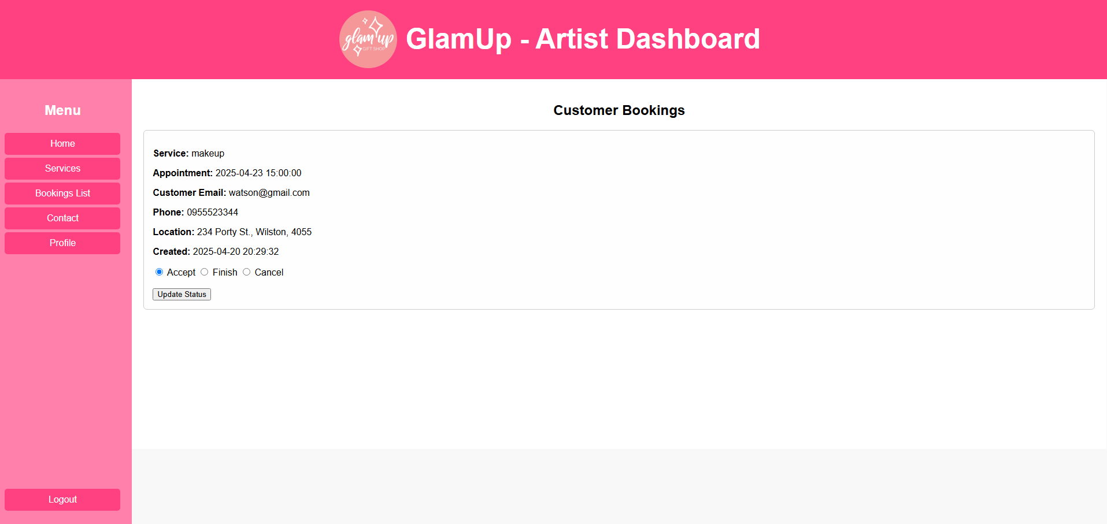

**User story title: Understand website purpose easily (Home page)**

**Priority: 11**

For good first impression.

**Estimation:**

* Nafisa: 1 day
* Melvin: 0.5 day
* Drashya: 1 day

**Assumptions:**

* Home page includes intro text, buttons, and images.

**Description:**

Description-v1: As a visitor, I want to quickly understand what this website offers and find the important sections easily.

**Tasks:**

1. Write intro content and basic layout, Estimation: 0.5 day
2. Add navigation to main areas, Estimation: 0.5 day

**UI Design:**

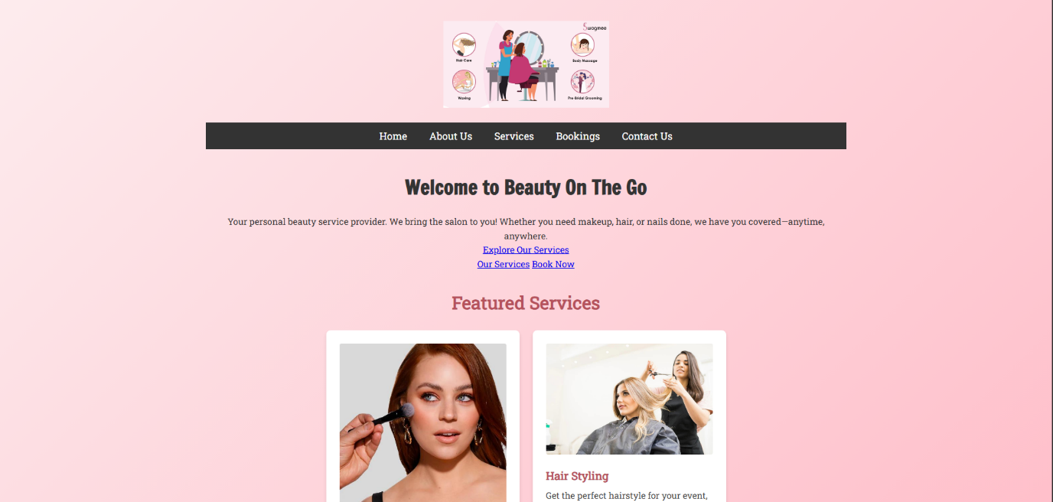**Completed:**

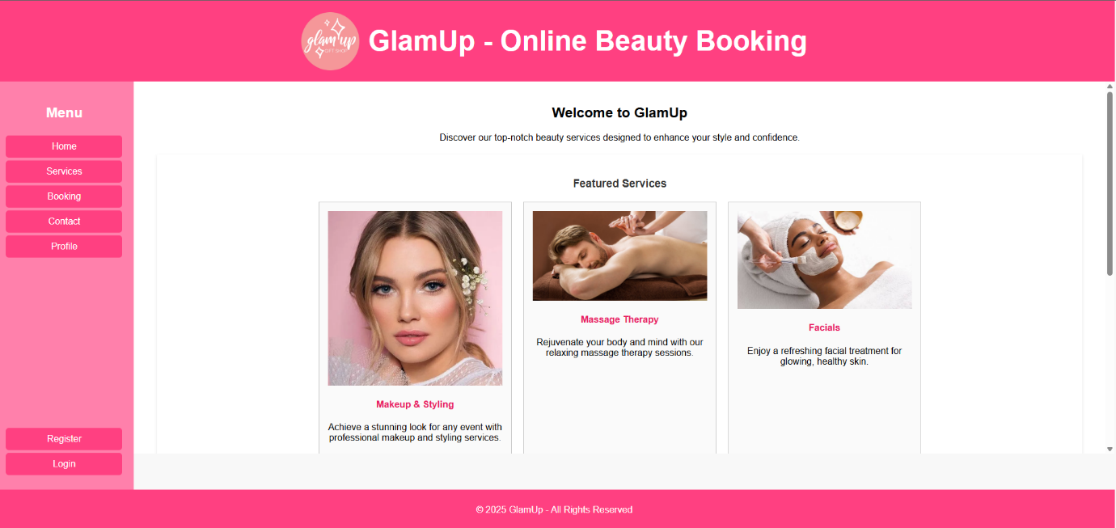

**User story title: Find business contact information**

**Priority: 12**

Important for communication.

**Estimation:**

* Prima: 0.5 day
* Htet Myet: 0.5 day
* Melvin: 0.5 day

**Assumptions:**

* Info includes phone, email, and address.

**Description:**

Description-v1: As a visitor, I want clear access to the business's contact details so I can easily get in touch if I have questions or concerns.

**Tasks:**

1. Add a contact section with details, Estimation: 0.5 day

**UI Design:**

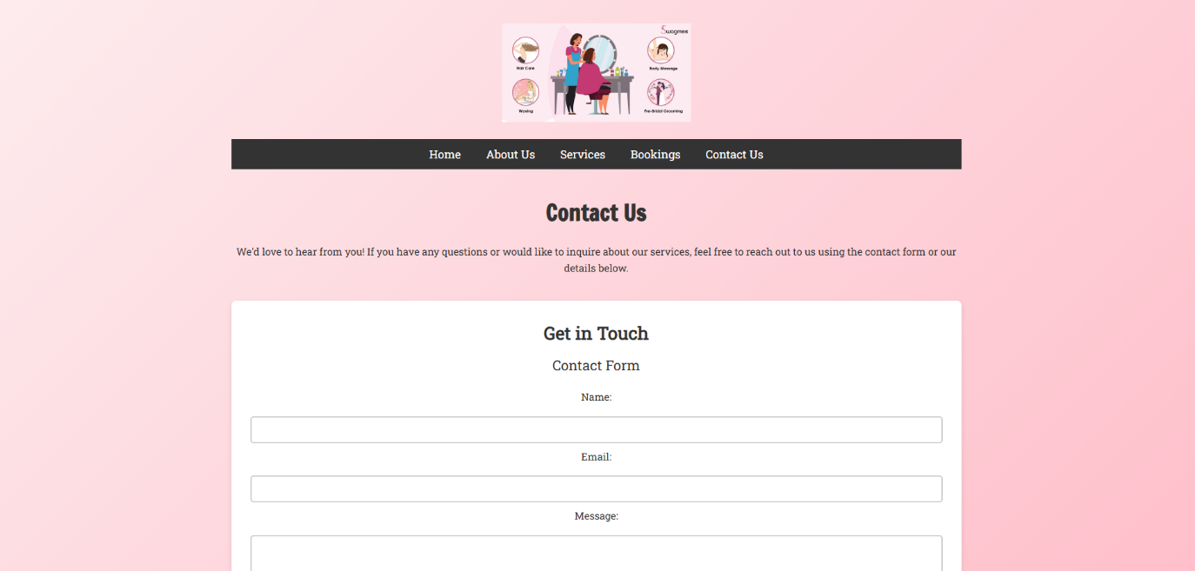**Completed:**

