Rover SLAM Module — Architecture Report
European Rover Challenge (ERC) — Autonomous Navigation Subsystem
Platform: NVIDIA Jetson Orin Nano | Intel RealSense D4xx | 4x wheel encoders | BNO IMU

1. Overview and hardware context
This report documents the design of the SLAM (Simultaneous Localization and Mapping) module for a Mars-analog rover competing in the European Rover Challenge (ERC). The SLAM module is responsible for producing a continuous, drift-corrected pose estimate of the rover, which downstream navigation and the existing perception module rely on.
Hardware available to the SLAM module:
- Wheel encoders: 4x wheel encoders on independently driven wheels, used for dead-reckoning odometry.
- BNO IMU: providing orientation (quaternion), angular velocity, and linear acceleration.
- RealSense camera: an Intel RealSense D4xx-series RGB-D camera, used both for visual odometry input and for detecting ArUco markers.
- Compute: NVIDIA Jetson Orin Nano — this constrains which SLAM/VO algorithms are practical to run in real time.
Upstream context: a perception module is already implemented and publishes a costmap with obstacle features and obstacle markers. The SLAM module does not duplicate this — its job is to provide the accurate, drift-corrected coordinate frame (map → odom → base_link) that the perception output and the navigation stack are expressed in.
Additional input: the competition environment includes ArUco markers at known, surveyed world coordinates. These are used as periodic absolute corrections to counteract the drift that is unavoidable in wheel- and vision-based odometry alone.

2. Final architecture
The diagram below is the final agreed architecture. It reflects two key simplifications made during design: (1) RTAB-Map is used as the single core fusion and mapping engine — it ingests wheel odometry, IMU, and RGB-D data directly, removing the need for a separate hand-built EKF fusion node; and (2) a fuzzy adaptive weighting stage sits between per-sensor filtering and RTAB-Map, dynamically adjusting how much each sensor is trusted based on real-time conditions (e.g. wheel slip, vibration) rather than using fixed, static noise assumptions.
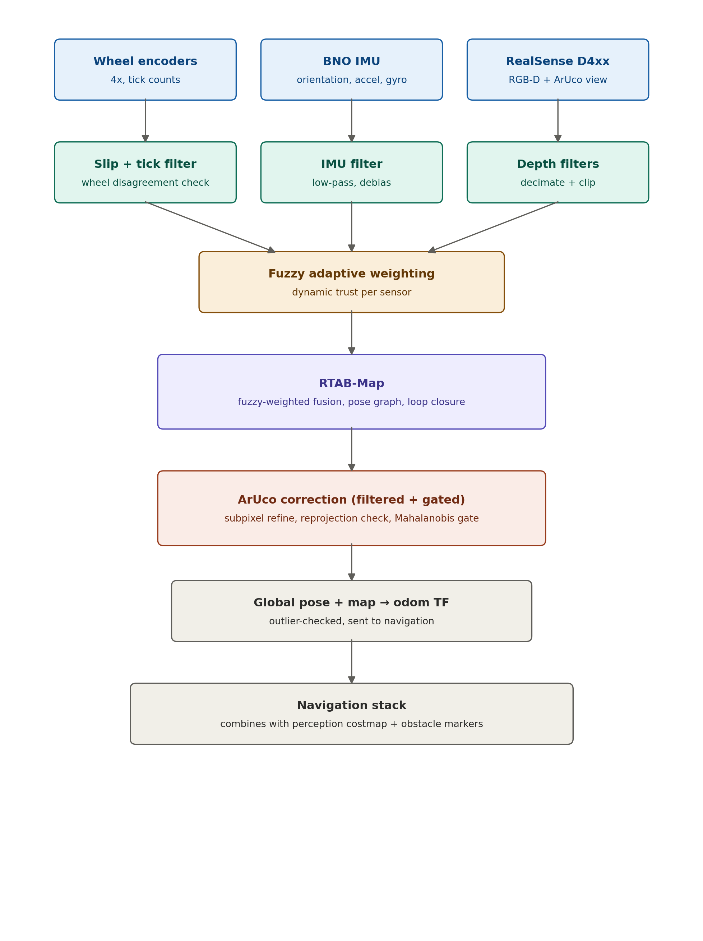

3. Submodule breakdown

3.1 Sensor / driver layer
Raw sensor nodes, each publishing at native rate with hardware timestamps rather than arrival timestamps. Two things must be correct before anything downstream is trustworthy:
- Time sync: Time synchronization between IMU and camera streams — even a 50 ms skew visibly corrupts visual odometry.
- Extrinsic calibration: camera-to-IMU, camera-to-base_link, and wheel radius/wheelbase must be calibrated once (e.g. with Kalibr) before use.

3.2 Per-sensor filtering
Each sensor is filtered before it reaches fusion:
- Wheel encoders: compare per-wheel speed against IMU-derived turn rate; disagreement indicates slip, and that sample is down-weighted or discarded. A low-pass filter also removes tick-count quantization noise at low speed.
- IMU: low-pass filter on linear acceleration to remove chassis vibration; periodic gyro bias re-zeroing during known-stationary moments; outlier/spike rejection for bumps on rocky terrain.
- RealSense depth: RealSense SDK post-processing chain — decimation, spatial, temporal, and hole-filling filters, plus hard min/max depth range clipping. Outdoor sunlight degrades IR-based depth accuracy, so this stage matters more outdoors than indoors.

3.3 Fuzzy adaptive weighting
Fixed-covariance fusion assumes constant sensor trust at all times, which does not match reality on loose or rocky terrain where wheel slip and vibration vary unpredictably. This stage computes real-time indicators — a wheel slip score (odometry vs. IMU turn-rate disagreement) and a vibration/innovation magnitude — and uses them to dynamically scale how much each sensor is trusted at that instant, before the data reaches RTAB-Map.
Recommended first implementation: a simple heuristic threshold-based weighting (e.g. reduce wheel odometry trust proportionally to a computed slip score), rather than a full fuzzy inference engine. This captures most of the practical benefit with far less implementation complexity, and can be formalized into true fuzzy membership rules later if needed.

3.4 RTAB-Map (odometry + fusion + mapping backend)
RTAB-Map is the core SLAM engine. It accepts wheel odometry, IMU, and RGB-D input directly, performs the sensor fusion internally, builds and maintains the pose graph, and performs loop closure via visual place recognition. This consolidates what would otherwise be three separate components (VO/VIO front-end, EKF fusion, and graph backend) into one well-tested, ROS2-native package — a significant simplification for a first SLAM implementation.
Alternative odometry front-ends considered and why RTAB-Map was preferred:
- ORB-SLAM3: more accurate on paper, but a harder research codebase to build, tune, and debug on ARM/Jetson for a first SLAM project.
- VINS-Fusion / Open-VINS: strong VIO but assumes tight stereo+IMU integration and preintegration knowledge; steeper setup for a first project.
- RTAB-Map (chosen): ROS2-native, accepts RGB-D + wheel odometry + IMU directly, includes pose graph and loop closure out of the box, and is far easier to debug when something goes wrong — the practical choice for a first SLAM implementation on this hardware.

3.5 ArUco correction (filtered and gated)
Since marker world-coordinates are known in advance, detecting a marker lets the rover compute an absolute correction to its estimated pose. This is essential because wheel- and vision-based odometry both drift over time with no global reference otherwise.
Pipeline: detect marker in the RealSense RGB stream → estimate marker pose relative to camera → look up the marker's known world coordinate → invert the transform chain to recover the rover's global pose. Before this correction is accepted:
- Subpixel corner refinement (cv2.aruco.CORNER_REFINE_SUBPIX or CORNER_REFINE_APRILTAG) improves pose accuracy over raw corner detection.
- Reprojection error check: reject detections above an error threshold (motion blur, glare, steep angle).
- Distance / angle gating: discard detections beyond a maximum usable distance or incidence angle.
- Temporal consistency check: only accept a correction seen consistently across consecutive frames.
- Mahalanobis distance gating: before accepting the correction into RTAB-Map's estimate, compare it against the current pose uncertainty (covariance). A correction that disagrees wildly with the current belief is more likely a bad detection than a real correction, and is rejected or down-weighted rather than applied outright. This is the single most important filter for preventing one bad marker read from teleporting the rover's global pose estimate.

3.6 Output
The module publishes:
- /odom: continuous, high-rate pose in the odom frame, for the local controller.
- map → odom transform: periodically corrected by RTAB-Map's graph and by accepted ArUco corrections.
- /slam/pose: best current global pose estimate, in the map frame, for the global planner.
- Full TF tree: map → odom → base_link → {camera, imu, wheels}.
- Final outlier check: implausible pose jumps (faster than the rover could physically move) are flagged and smoothed before being sent to navigation.

4. Integration with the perception module
The perception module already publishes a costmap with obstacle features and obstacle markers, in a local (base_link or odom) frame. Once the SLAM module publishes a stable, drift-corrected map → odom transform, the navigation stack can transform perception's costmap into the map frame for globally consistent path planning. The SLAM module is not responsible for rebuilding obstacle maps — only for providing perception's existing output with an accurate, drift-corrected coordinate frame to live in.

5. Future work: error-state / iterated Kalman filter
RTAB-Map's internal fusion is not a Kalman filter, so this is not part of the current architecture, but is worth planning for as a second iteration if ArUco corrections do not converge cleanly using RTAB-Map's built-in handling:
- Iterated EKF (IEKF): re-linearizes the measurement model around the updated estimate and repeats the correction step until convergence — more accurate for nonlinear measurements like ArUco pose-from-pixel-corners.
- Error-state formulation (ESKF): estimates the error between an IMU-propagated nominal state and the true state rather than the state directly, avoiding quaternion singularities. This is the formulation used by most modern high-performance VIO/LIO systems (e.g. FAST-LIO, MSCKF-based VINS, ROVIO).
If pursued, this would replace RTAB-Map's internal fusion with a custom filter node, giving tighter control over how large ArUco corrections are incorporated after periods of unmarked dead reckoning — a realistic scenario in the ERC autonomous navigation task.

6. Inputs / outputs summary
Direction | Topic / data | Frame | Rate
In | Wheel encoder ticks | wheel frames | native
In | IMU data (orientation, accel, gyro) | imu frame | native
In | RealSense RGB-D stream | camera frame | native
In | ArUco marker world-coordinate map (config) | map | static
Out | /odom | odom | ≈50–200 Hz
Out | map → odom transform | — | on correction event
Out | /slam/pose | map | ≈5–30 Hz

7. Open decisions
- Marker density: How many ArUco markers will realistically be visible during the autonomous task, and how far apart — this determines how much weight to place on ArUco correction versus dead reckoning between markers.
- Fuzzy weighting fidelity: whether to implement the fuzzy weighting as a heuristic (recommended for v1) or a formal fuzzy inference system (possible upgrade, or for competition documentation/report purposes).
- Outdoor validation: test RTAB-Map's RGB-D odometry and the RealSense depth filters on actual outdoor, Mars-analog terrain early — indoor performance does not reliably predict outdoor performance under sunlight and low-texture ground.

