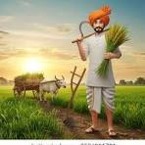
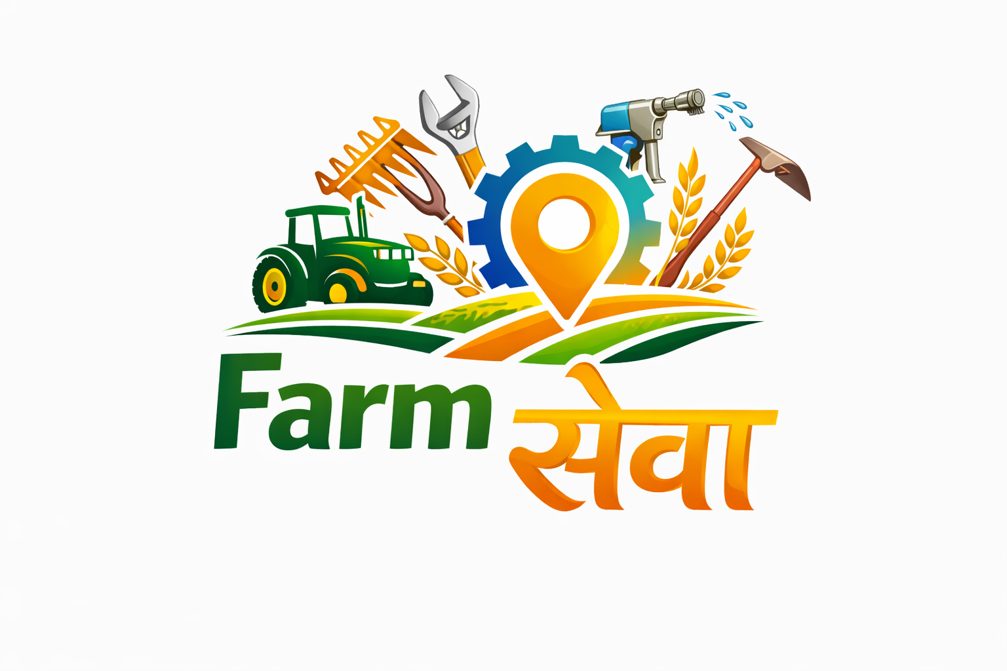
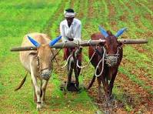
Let us present you what we bring !
FarmSeva-
Kisanon ki digital Seva
A digital platform for your needs
Presented by- Aarav, Kiaan and Shainil

Farm Seva

1. Introduction and working
FarmSeva is a digital marketplace for farmers, enabling seamless booking of agricultural services including equipment rental, skilled labor, expert consultation, and AI-based crop disease detection. It allows users to rent farm machinery, hire skilled labour, consult experts, and detect crop diseases using AI technology. FarmSeva provides an opportunity and a platform for those who want affordable options and want to make their farming more efficient and convenient . Here owners can register themselves, their machinery, vehicles to give them on rent on hour-to-hour or day-to-day basis. Farmers who need these services have to book them according to the prices and the availability.

2. Vision & Mission
Vision: To make farming easy, affordable, and technology-driven for every farmer in India.
Mission: To eliminate middlemen and provide fair pricing with direct access to services.
*We do not take profit in any of the bookings, the prices set are given by the owners. The website’s main purpose is to make farming and availability of technology easier in underdeveloped and rural areas. Only in some cases, if needed we might charge some amounts to either the owner or the customer for GST, other taxes or registration charges.

3. Problem Statement
Farmers face challenges such as high machinery costs, lack of skilled labour, delayed services, and limited access to expert guidance. If a farmer does not have enough money to afford a tractor, labour etc. he can rent tractors, machinery, labour etc through FarmSeva.

Complete Service Categories
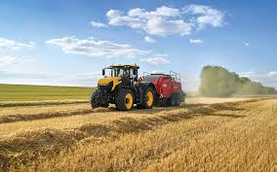
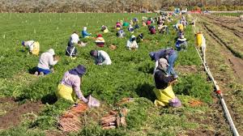
FarmSeva provides multiple service categories:
1. Equipment Rental:
- Tractors
- Harvesters
- Drones ( if available)
- Tiller/Rotavator
- Sprayers
- Seed Drills
2. Skilled Labour:
- Sowing workers
- Harvesting labor
- Irrigation setup workers
- Field maintenance workers
3. Expert Consultation:
- Crop advisory
- Soil health consultation
- Pest and disease control
- Yield improvement strategies
4. AI Disease Detection:
- Upload crop images
- Instant diagnosis
- Suggested treatments
5.Repair and maintenance
-Emergency repair for pumps, tractors, drip irrigation etc
6. Group booking
If more number of farmers make a group and rent together they can split costs making it cheaper for each of them

Equipment Rental Features
- Daily pricing model
- Transparent pricing with no hidden charges
- Availability indicators (Available Today)
- Ratings and reviews system
- Equipment specifications (HP, cutting width, features)
- Operator inclusion option
- Location-based matching

4. Solution - Farm Seva Platform
Farm Seva connects service providers (machine owners, labourers, experts) with farmers through a single platform.

5. Key Features
- Equipment Rental (tractors, harvesters, drones, etc.)
- Skilled Labour Booking
- AI Crop Disease Detection
- Expert Consultation
- User Registration for all roles
- Advanced Filters (location, price, category)
- Multi-language & Voice Support

6. Booking Workflow
Step 1: User selects service (Equipment / Labour / Consultation)
Step 2: Applies filters (location, category, price range)
Step 3: Views available options with ratings and pricing
Step 4: Selects preferred service
Step 5: Books instantly using 'Book Now'
Step 6: Confirms date, time, and location
Step 7: Service is delivered at farm location

. Competitive Advantage

- No middlemen
- Fair pricing
- All-in-one agri platform
- AI integration
- Localized services

Impact & Benefits
- Increased farmer productivity
- Reduced operational cost
- Access to modern technology
- Employment generation
- Digitization of rural economy
7. Innovation & USP
Farm Seva is a complete smart farming ecosystem combining rental, labour, AI, and expert consultation with no middlemen and fair pricing.

How we could expand & Future Scope

Target Market
- Small and medium farmers (primary users)
- Rural and semi-urban agricultural regions
- Farm machinery owners (tractors, harvesters, etc.)
- Agricultural labourers seeking work
- Agri-experts and consultants

Market Demand
- High demand for affordable machinery rental
- Shortage of skilled labour during peak seasons
- Increasing need for on-demand farming services
- Growing adoption of digital platforms in agriculture
- Demand for cost reduction and higher productivity

Target Audience
- Farmers who cannot afford expensive machinery
- Farmers needing quick and reliable labour services
- Young farmers open to using technology
- Rural users needing simple, mobile-based solutions
- Agri-service providers looking to earn income
Farmer Feedback
-We asked 8 farmers from Gujarat for their feedback
-6/8 farmers found it interesting and helpful
-Farmers said this platform would be helpful and it would make it much easier for them to get different services easily.
Thank You!
For letting us present
-FarmSeva

