DIPLOMA THESIS
Documentation

Author(s) | Nico Leitner, André Jerebitsch
Form, academic year | 5AHWIN, 2026/27
Topic | Construction of a Humanoid Robot
Co-operation partners | HTL Leoben

Assignment of tasks | Individual task Nico Leitner 5AHWIN: Project management, final mechanical assembly as well as ROS-based control and system integration of the pib robot.  Research objective: The aim of this individual task is the step-by-step mechanical assembly and software integration of the humanoid robot pib via the Robot Operating System (ROS) to replace the previous "Pepper" robot at HTL Leoben. It will be investigated how the 3D-printed components (head, torso, limbs) can be optimally assembled while ensuring dimensional accuracy and mechanical stability, and how the servo motors can be controlled via the ROS environment in near real-time. The concrete result is a fully assembled, functional humanoid robot and validated control of its motor functions via defined ROS interfaces.  Individual task Andre Jerebitsch 5AHWIN: Setup and integration of the electronic components, motor control, and development of the control system for gripping and transporting objects using the humanoid robot PIB.  Research objective: The aim of this individual task is the electronic integration and control of the motors of the humanoid robot PIB. It will investigate how the individual motors and electronic components can be reliably controlled and connected into a functioning overall control system. Another focus lies on the precise and controlled actuation of the motors to enable smooth and gentle movements of the robot. The gripping and transportation of objects without damaging them must also be taken into account. The result will be a functional electronic control system that allows the motors to be coordinated and defined movement sequences to be executed.

Realisation | Through the implementation of the humanoid robot PIB and the underlying individual tasks, a new foundation is systematically established for HTL Leoben to work in the field of robotics and humanoid robotics without relying on outdated hardware and unsupported software. As a sub-topic, our diploma thesis also deals with the planning and creation of teaching material based on "pib.Academy", the proprietary teaching and learning tool provided by the Franco-German company that develops and continuously improves PIB. Through the construction and commissioning, space and opportunities will also be created for students in future lessons or diploma theses to further develop this project and make their own contributions. With good documentation, this will facilitate a smooth entry into pib for future students.

Results | The completion of PIB – fully functional with a handout for subsequent diploma students, pupils, and teachers, including instructions, basic programs, and suggestions for improvement.

Illustrative graph, photo  (incl. explanation) | 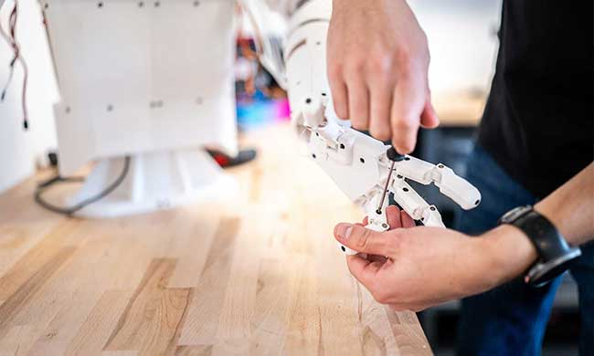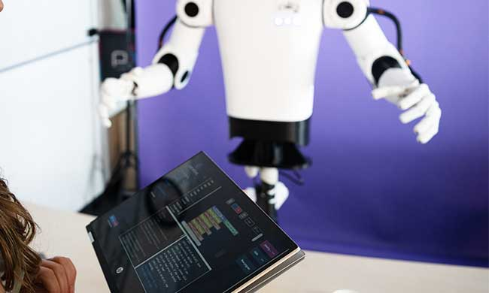  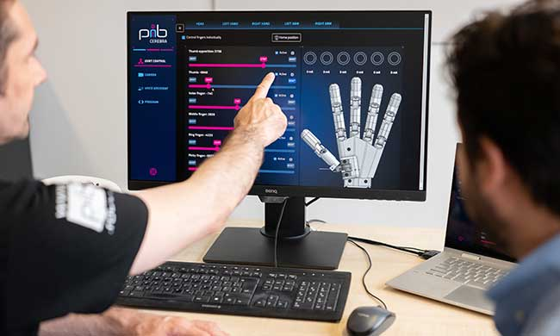  Here we can see both the Construction of PIB aswell as the controlling using the inbuilt Software Cerebra

Participation in competitions  Awards | ARGE Humanoid Robotics Seminar at HTL Leoben

Accessibility of the  Diploma Thesis | Yes, https://github.com/HTLLEHumanoidRobotics/Bau-eines-Humanoiden-Roboters - Nov 3, 2026

Approval  (Date / Signature) | Examiner | Head of College

