DIPLOMA THESIS
Documentation

Author(s) | Jerebitsch André, Nico Leitner
Form, academic year | 5AHWIN, 2026/27
Topic | Construction of a Humanoid Robot
Co-operation partners | HTL Leoben, Leoben

Assignment of tasks | Design and integration of the electronic components, motor control, and development of the control system for gripping and transporting objects with the humanoid robot PIB.

Realisation | As part of this individual project, the electronic implementation of the humanoid robot PIB will be carried out. This includes selecting, assembling, and integrating the required electronic components into the overall system. A major part of the work involves controlling the individual motors and coordinating them to ensure that the desired movements can be performed reliably. In addition, a control system for gripping and transporting objects will be developed. Particular emphasis will be placed on precise and controlled motor movements to enable secure gripping and ensure that transported objects are handled as carefully as possible. Through step-by-step testing and adjustments, the individual components will be coordinated and combined into a fully functioning system.

Results | Completion of a fully functional electronic integration and motor control system for the humanoid robot PIB. This includes the integrated electronic components, reliable motor control, and a developed control system for gripping and transporting objects. Furthermore, the implemented functions will be tested and documented so that the results can be used for the further development and improvement of the robot.

Illustrative graph, photo  (incl. explanation) | 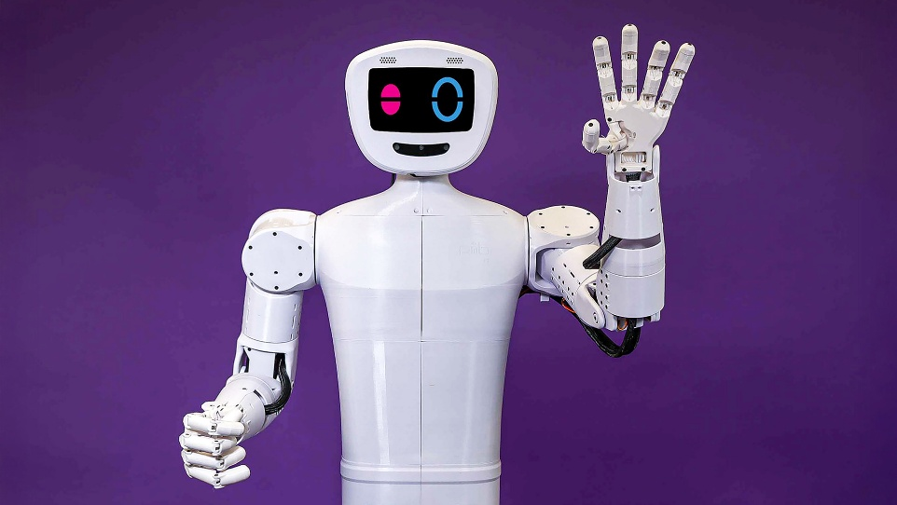  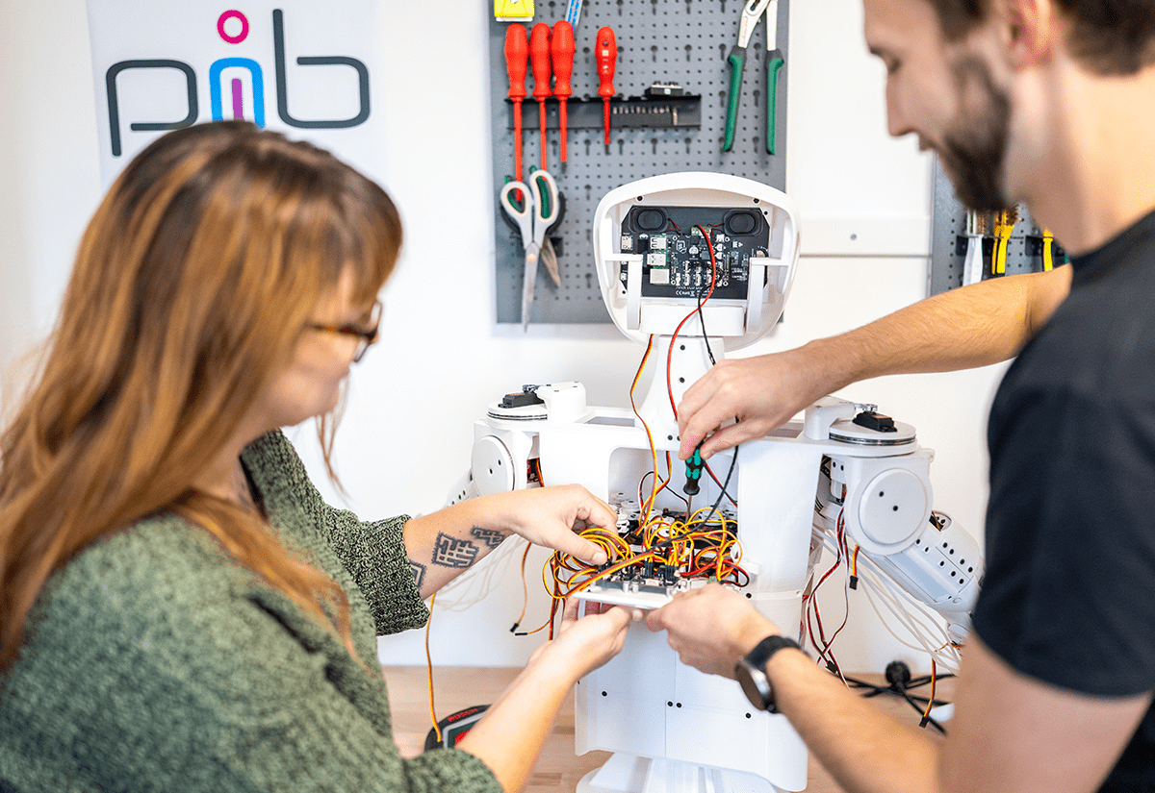  Here, we can see both the assembly of PIB and how it is controlled using the built-in Cerebra software.

Participation in competitions
Awards

Accessibility of the  Diploma Thesis | Yes, https://github.com/HTLLEHumanoidRobotics/Bau-eines-Humanoiden-Roboters - Nov 3, 2026

Approval  (Date / Signature) | Examiner | Head of College

