## Game Design Considerations: Chapter 9

The puzzle level in the examples to this point has focused entirely on creating an understandable and consistent logical challenge; we’ve avoided burdening the exercise with any kind of visual design, narrative, or fictional setting (design elements traditionally associated with enhancing player presence) to ensure we’re thinking only about the rules of play without introducing distractions. However, as you create core game mechanics it’s important to understand how certain elements of gameplay can contribute directly to presence; the logical rules and requirements of core game mechanics often have a limited effect on presence until they’re paired with an interaction model, sound and visual design, and a setting. As discussed in Chapter 8, lighting is an example of a presence-enhancing visual design element that can also be used directly as a core game mechanic, and introducing physics to game world objects is similarly a presence-enhancing technique that’s perhaps even more often directly connected to game play.

Our experience in the real world is governed by physics, so it stands to reason that introducing similar behaviors in a game might be expected to enhance presence. An example of object physics enhancing presence but not necessarily contributing to design could be destructible environments that have no direct impact on gameplay: in a first-person shooter, for example, if the player shoots at crates and other game objects that respond by realistically exploding on impact, or if they throw a ball in the game world that bounces in a reasonable approximation of how a ball would bounce in the physical world, these are examples of physics being used purely to enhance presence but not necessarily contributing to game play. If a player is engaging with a game like Angry Birds, however, and launches one of the birds from their slingshot into the game space and they need to time the shot based on the physics-modeled parabolic arc the bird follows upon launch (as shown in Figure 9-31), this is an example of physics being used as both a core element of gameplay while also enhancing presence. In fact, any game that involves jumping a character or other game object in an environment with simulated gravity is an example of physics contributing to both presence and the core mechanic, so many platformer games utilize physics as both a core mechanic and a presence-enhancing design element.

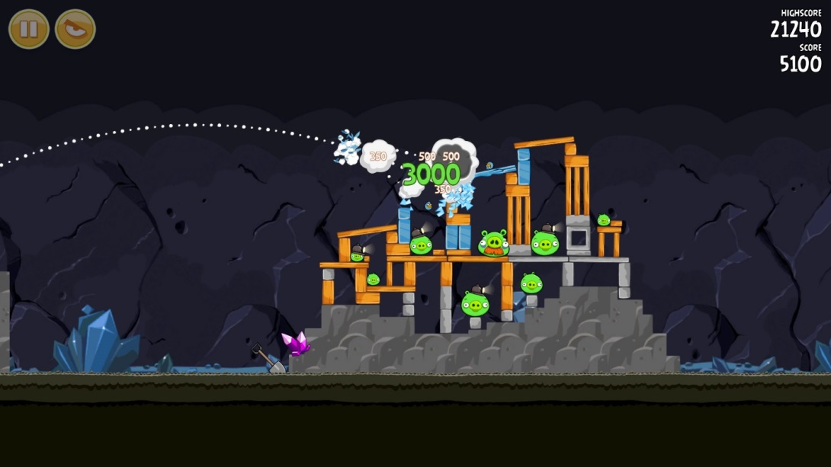

Figure 9-31. Rovio’s Angry Birds requires players to launch projectiles from a slingshot in a virtual world that models gravity, mass, momentum, and object collision detection. The game physics are a fundamental component of the game mechanic and enhance the sense of presence by assigning physical world traits to virtual objects.

The projects in Chapter 9 introduce you to the powerful ability of physics to bring players into the game world. Instead of simply moving the hero character like a screen cursor, the player can now experience simulated inertia, momentum, and gravity requiring the same kind of predictive assessments around aiming, timing, and forward trajectory that would exist when manipulating objects in the physical world, and game objects are now capable of colliding in a manner familiar to our physical world experience. Even though specific values might take a detour from the real world in a simulated game space (e.g., lower or higher gravity, more or less inertia, and the like), as long as the relationships are consistent and reasonably analogous to our physical experience presence will typically increase when these effects are added to game objects. Imagine, for example, a game level where the hero character was required to push all the robots into a specific area within a specified time limit while avoiding being hit by projectiles. Imagine the same level without physics and it would of course be a very different experience.

We left the level design in Chapter 8 with an interesting two-stage mechanic focused almost exclusively on abstract logical rules and hadn’t yet incorporated elements that would add presence to the experience and bring players into the game world. Recall the current state of the level in Figure 9-32:

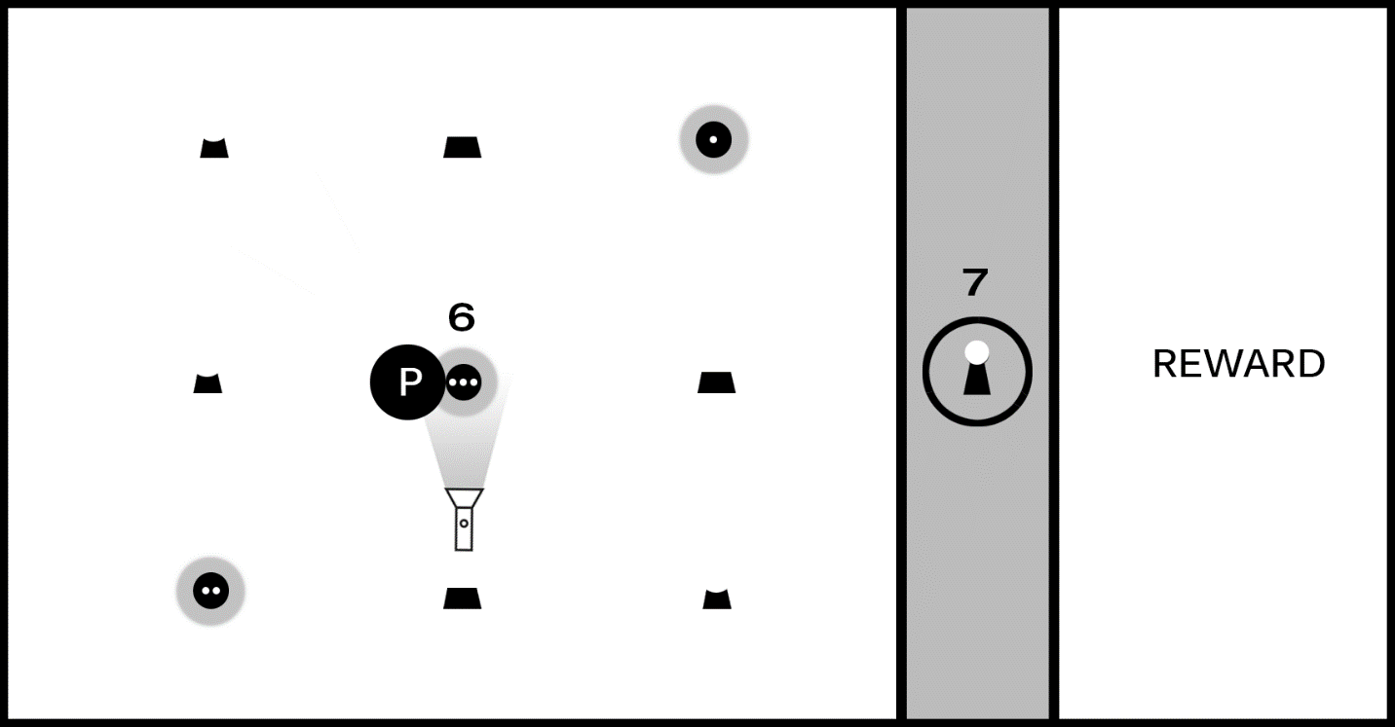

Figure 9-32. The level as it currently stands includes a two-step puzzle first requiring players to move a flashlight and reveal hidden symbols; the player must then activate the shapes in the correct sequence to unlock the barrier and claim the reward.

There is, of course, some sense of presence conveyed by the current level design: the barrier preventing players from accessing the reward is “impenetrable” and represented by a virtual wall, and the flashlight object is “shining” a virtual light beam that reveals hidden clues in the manner perhaps that a UV light in the real world might reveal special ink. Presence is frankly weak at this stage of development, however, as we have yet to place the game experience in a setting and the intentionally generic shapes don’t provide much to help a player build their own internal narrative. Our current prototype uses a flashlight-like game object to reveal hidden symbols, but it’s now possible to decouple the game mechanic’s logical rules from the current implementation and describe the core game mechanic as as “the player must explore the environment to find tools required to assemble a sequence in the correct order.”

For the next iteration of our game let’s revisit the interaction model and evolve it from purely a logic puzzle to something a bit more active that makes use of object physics. Figure 9-33 changes the game screen to include a jumping component:

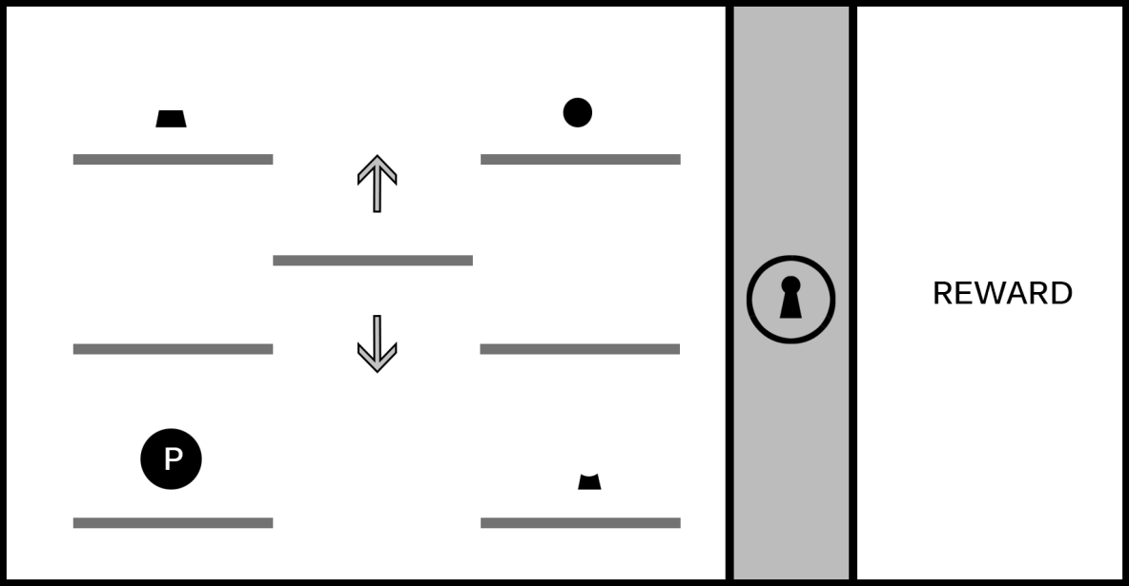

Figure 9-33. The game screen now shows just one instance of each part of the lock (top, middle, bottom), and the hero character moves in the manner of a traditional jumping 2D platformer. The six platforms on the left and right are stationary, and the middle platform moves up and down, allowing the player to ascend to higher levels. (This image assumes the player is able to “jump” the hero character between platforms on the same level but cannot reach higher levels without using the moving platform.)

We’re now evolving game play to include a dexterity challenge -- in this case, timing the jumps -- yet it retains the same logical rules from the earlier iteration: the shapes must be activated in the correct order to unlock the barrier blocking the reward. Imagine the player experiences this screen for the first time; they’ll begin exploring the screen to learn the rules of engagement for the level, including the interaction model (the keys and/or mouse buttons used to move and jump the hero character), whether missing a jump results in a penalty (for example, the loss of a “life” if the hero character misses a jump and falls off the game screen), and what it means to “activate” a shape and begin the sequence to unlock the barrier.

The game now has the beginning of an interesting (although still basic) platformer puzzle, but we’ve also now simplified the solution compared to our earlier iteration and the platformer jumping component isn’t especially challenging as shown in Figure 9-33. Recall how adding the flashlight in Chapter 8 increased the logical challenge of the original mechanic by adding a second kind of challenge requiring players to identify and use an object in the environment as a tool; we can add a similar second challenge to the platformer component, as shown in Figure 9-34:

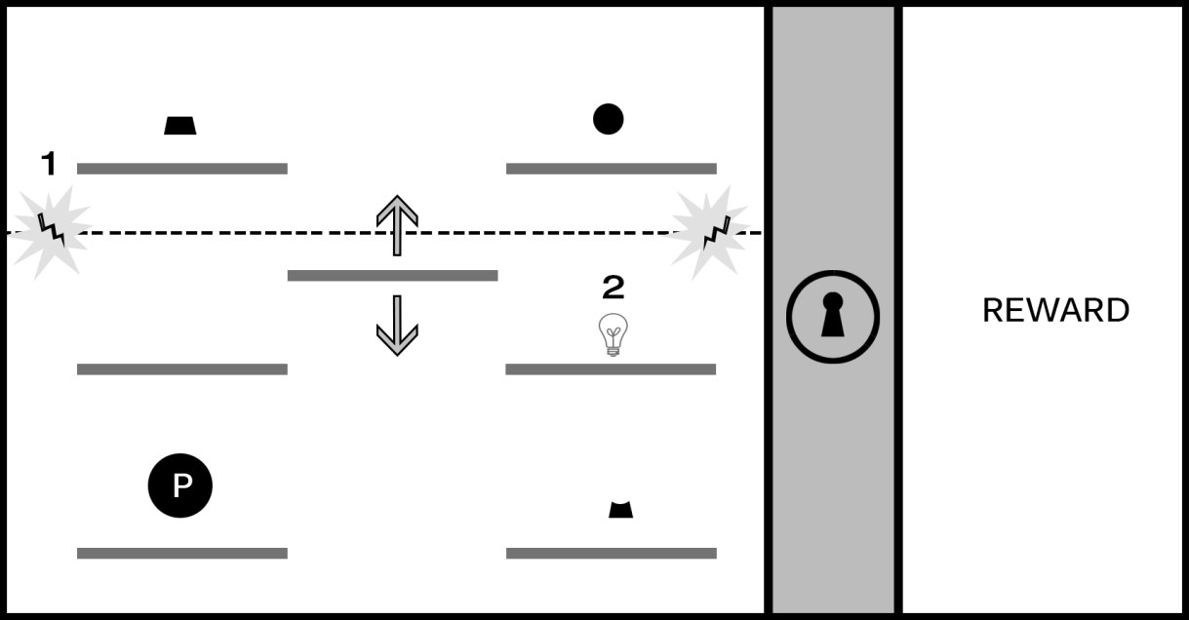

Figure 9-34. The introduction of a force field blocking access to the upper platforms (#1) can significantly increase the challenge of the platformer component. In this design, the player must activate the switch (represented with a lightbulb in #2) to disable the force field and reach the first and third shapes.

The introduction of a force field opens a variety of interesting possibilities to increase the challenge. The player must time the jump from the moving platform to the switch before hitting the force field, and the shapes must be activated in order (requiring the player to first activate top right, then the bottom right, and then the top left). Imagine a time limit is placed on the deactivation when the switch is flipped and that the puzzle will reset if all shapes aren’t activated before the force field is reengaged.

We’ve now taken an elemental mechanic based on a logical sequence and adapted it to support an action platformer experience. At this stage of development, the mechanic is becoming more interesting and beginning to feel more like a playable level, but it’s still lacking setting and context; this is a good opportunity to explore the kind of story we might want to tell with this game. Are we interested in a sci-fi adventure, perhaps a survival horror experience, or maybe a series of puzzle levels with no connected narrative? The setting will not only help inform the visual identity of the game but can also guide decisions on the kinds of challenges we create for players (for example, are “enemies” in the game working against the player, will the game play continue focusing on solving logic puzzles, or perhaps both?). A good exercise to practice connecting a game mechanic to a setting is to pick a place (for example, the interior of a space ship) and begin exploring game play in that fictional space and defining the elements of the challenge in a way that make sense for the setting. For a game on a spaceship perhaps something has gone wrong and the player must make their way from one end of the ship to the other while neutralizing security lasers through the clever use of environment objects. Experiment with applying the spaceship setting to the current game mechanic and adjusting the elements in the level to fit that theme: lasers are just one option, but can you think of other uses of our game mechanic that don’t involve an unlocking sequence? Try applying the game mechanic to a range of different environments to begin building your comfort for applying abstract game play to specific settings.

Remember also that including object physics in level designs isn’t always necessary to create a great game; sometimes you may want to subvert or completely ignore the laws of physics in the game worlds you create. The final quality of your game experience is the result of how effectively you harmonize and balance the nine elements of game design, it’s not about the mandatory implementation of any one design option. Your game might be completely abstract and involve shapes and forms shifting in space in a way that has no bearing on the physical world, but your use of color, audio, and narrative might still combine to create an experience with a strong presence for players. However, if you find yourself with a game environment that seeks to convey a sense of physicality by making use of objects that people will associate with things found in the physical world, it’s worth exploring how object physics might enhance the experience.