Simulating the Rigid World

## Collision Between Rectangles and Circles

The support point approach to computing collision detection does not work with circles because a circle does not have identifiable vertex positions. Instead, you will implement an algorithm that detects collisions between a rectangle and a circle according to the relative position of the circle’s center with respect to the rectangle.

Before discussing the actual algorithm, as illustrated in Figure 9-15, it is convenient to recognize that the area outside an edge of a rectangle can be categorized into three distinct regions by extending the connecting edges. In this case, the dotted lines separated the area outside the given edge into: R1, the region to the left/top; R2, the region to the right/bottom; and R3, the region immediately outside of the given Edge.

With this background, the collision between a rectangle and a circle can be detected as follows:

* **Step A**: Edge = Compute the edge on the rectangle that is closest to the circle center.
* **Step B**: If circle center is outside

**Step B1**: If in Region R1: distance between the circle center and left/top vertex from the Edge determines if collision has occurred.

**Step B2**: If in Region R2: distance between the circle center and right/bottom vertex from the Edge determines if collision has occurred.

**Step B3**: If in Region R3: perpendicular distance between the center and the Edge determines if collision has occurred.

* **Step C**: If the circle center is inside the rectangle: collision is detected.

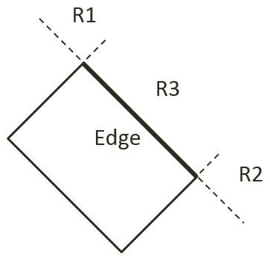

Figure 9-15. The Three Regions Outside a Given Edge of a Rectangle

## The Rectangle and Circle Collisions Project

This project guides you in implementing the described rectangle-circle collision detection algorithm with detailed discussions for each of the steps.. You can see an example of this project running in Figure 9-16. The source code to this project is defined in chapter9/9.4.rectangle_and_circle_collisions.

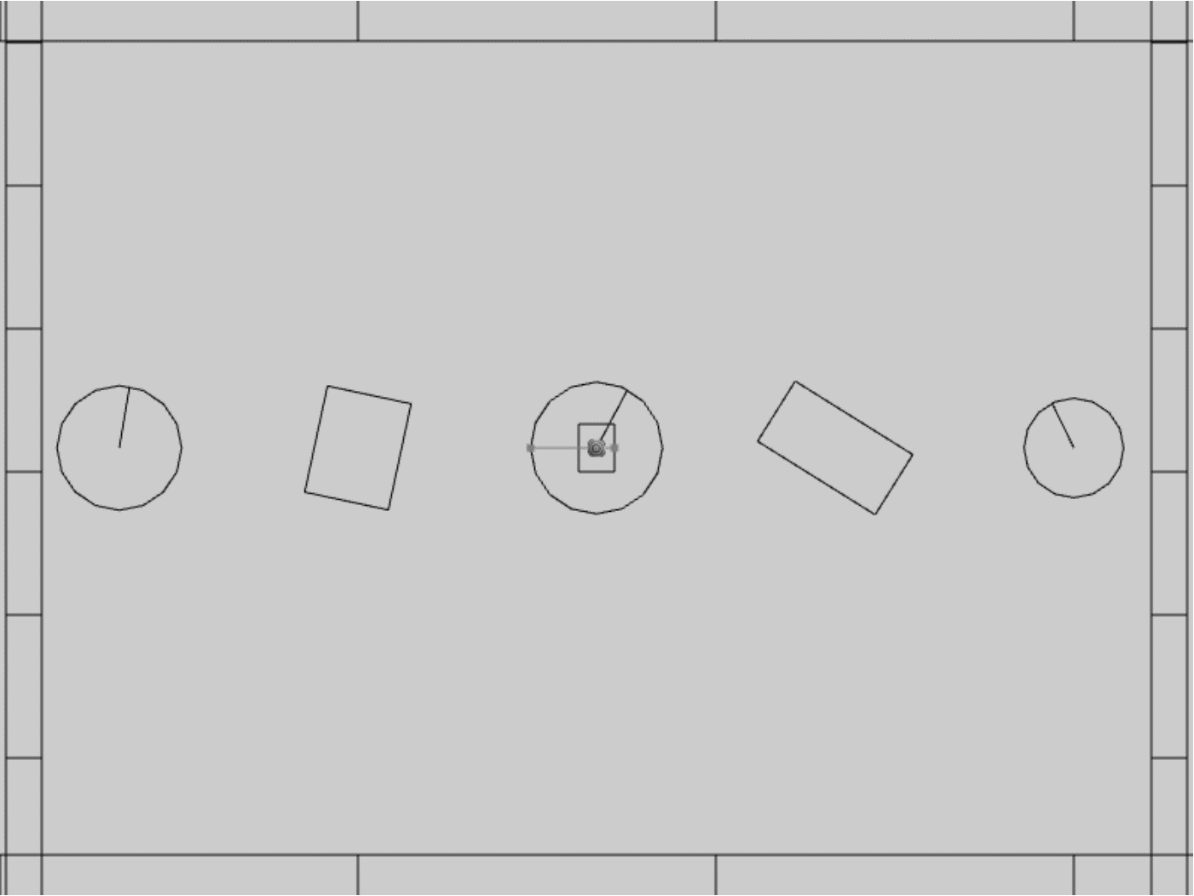

Figure 9-16. Running the Rectangle and Circle Collisions project

The controls of the project are as follows, for both scenes:

* **This and that**
* **This and that**.

The goals of the project are as follows:

* To To understand and implement the rectangle circle collision detection algorithm.

You can find the following external resource files in the assets folder: this file and tht file (no changes)

### Modify Rectangle Collision

You are going to implement the described algorithm in the Rectangle_collision.js file.

1. Edit the Rectangle_collision.js file in the RigidBody folder.
2. Create a new function, collidedRectCirc, to detect the collision between a rectangle and a circle. Accordingly, there will be five major steps in this function. The following listing collapsed all of the steps with detailed to be filled-in in the rest of this section.

Rectangle.prototype.collidedRectCirc = function (otherCir, collisionInfo) {

// **Step A**: Compute the nearest edge

if (!inside) {

// **Step B1**: If center is in Region R1

// **Step B2**: If center is in Region R2

// **Step B3**: If center is in Region R3

} else {

// **Step C**: If center is inside

}

return true;

};

1. **Step A**: Compute the nearest edge. The nearest edge can be computed by computing the perpendicular distances between the circle center to each of the edges of the rectangle. This distance is simply the projection of the vector between each vertex and the circle center onto the corresponding face normal. The following code shows marching through all of the vertices, computing the vector from the vertex to the circle center, and projecting the computed vector to the corresponding face normals.

// **Step A**: Compute the nearest edge

for (i = 0; i < 4; ++i) {

//find the nearest face for center of circle

circ2Pos = otherCir.mCenter;

v = circ2Pos.subtract(this.mVertex[i]);

projection = v.dot(this.mFaceNormal[i]);

if (projection > 0) {

//if the center of circle is outside of rectangle

bestDistance = projection;

nearestEdge = i;

inside = false;

break;

}

if (projection > bestDistance) {

bestDistance = projection;

nearestEdge = i;

}

}

As illustrated in Figure 9-17, one interesting observation is that when the circle center is inside the rectangle, all vertex to center vectors will be in the opposite directions of their corresponding face normal and thus will result in negative projected length. This is in contrast to, when the center is outside of the rectangle then, at least one of the projected length is positive. For this reason, the “nearest projected distance” is the one with the least negative value and thus is actually the largest number.

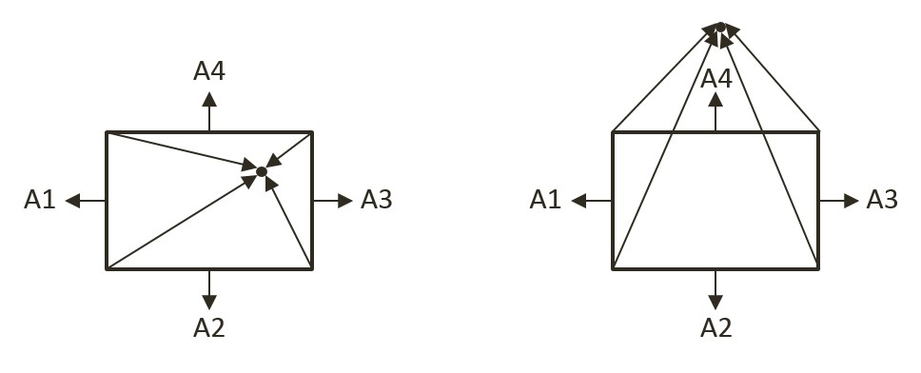

Figure 9-17. Left: Center inside the rectangle will result in all negative projected length. Right: Center outside the rectangle will result in at least one positive projected length

1. **Step B1**: if center is outside of the rectangle and in Region R1. As illustrated on the left of Figure 9-18, the Region R1 can be detected when v1, the vector between the center and the edge vertex is in the opposite direction of v2, the direction of the edge. This is to say, the center of the circle is in Region R1 when the dot product of those two vectors is negative. The right diagram of Figure 9-18 shows that collision occurs when the length of vector v1 is less than the circle radius, and in this case, the collision normal is simply along the vector v1, and collision depth is the difference between the radius and dist, the length of vector v1.

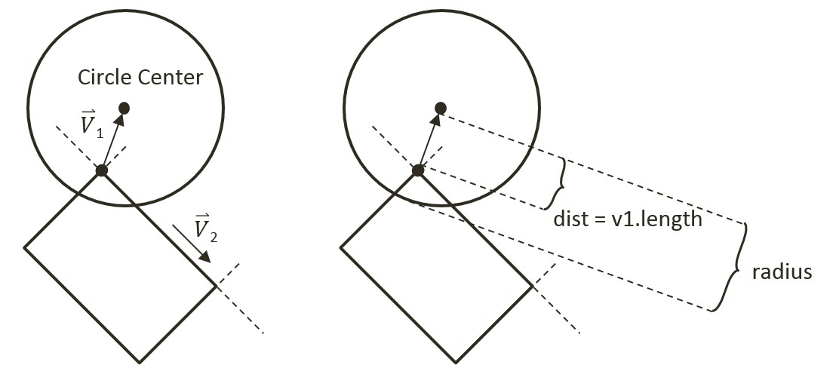

Figure 9-18. Left: Condition when Center is in Region R1. Right: The corresponding collision information

// **Step A**: Compute the nearest edge (*details discussed*)

if (!inside) { //the center of circle is outside of rectangle

// **Step B1**: if ceter is in Region R1

//v1 is from left vertex of face to center of circle

//v2 is from left vertex of face to right vertex of face

var v1 = circ2Pos.subtract(this.mVertex[nearestEdge]);

var v2 = this.mVertex[(nearestEdge + 1) % 4].subtract(this.mVertex[nearestEdge]);

var dot = v1.dot(v2);

if (dot < 0) { // Region R1

//the center of circle is in corner region of mVertex[nearestEdge]

var dis = v1.length();

//compare the distance with radium to decide collision

if (dis > otherCir.mRadius)

return false;

var normal = v1.normalize();

var radiusVec = normal.scale(-otherCir.mRadius);

collisionInfo.setInfo(otherCir.mRadius - dis, normal, circ2Pos.add(radiusVec));

} else { // Not in Region R1

// … *details to follow* …

// **Step B2**: If center is in Region B2

if (…) { // in Region R2

// … *details to follow* …

} else { // not in Region R2

// **Step B3**: If center is in Region B3

// … *details to follow* …

}

}

} else { // *else of (!inside)*

// **Step C**: If center is inside the rectangle

// … *details to follow* …

}

1. **Step B2**: if the center is outside of the rectangle and in Region R2. The following code complements that of Step B1, with the only difference being the direction of v2, the vector along the edge. In this case, the vector along the edge is in the opposite direction as compared for working with Region R1.

// **Step A**: Compute the nearest edge (*details discussed*)

if (!inside) {

// **Step B1**: If center is in Region R1 (*detailed discussed*)

} else {

// **Step B2**: If center is in Region R2

//the center of circle is in corner region of mVertex[nearestEdge+1]

//v1 is from right vertex of face to center of circle

//v2 is from right vertex of face to left vertex of face

var v1 = circ2Pos.subtract(this.mVertex[(nearestEdge + 1) % 4]);

var v2 = v2.scale(-1);

var dot = v1.dot(v2);

if (dot < 0) {

var dis = v1.length();

//compare the distance with radium to decide collision

if (dis > otherCir.mRadius)

return false;

var normal = v1.normalize();

var radiusVec = normal.scale(-otherCir.mRadius);

collisionInfo.setInfo(otherCir.mRadius - dis, normal, circ2Pos.add(radiusVec));

} else {

// **Step B3**: If center is in Region B3

// … *details to follow* …

}

1. **Step B3**: If the center is in Region R3. The last possible region for the circle center to be located in would be the area immediately outside the nearest edge. In this case, the bestDistance computed previously in **Step A** is the distance, if this distance is less than the circle radius then collision occurred.

// **Step B3**: If center is in Region B3

//the center of circle is in face region of face[nearestEdge]

if (bestDistance < otherCir.mRadius) {

var radiusVec = this.mFaceNormal[nearestEdge].scale(otherCir.mRadius);

collisionInfo.setInfo(otherCir.mRadius - bestDistance,

this.mFaceNormal[nearestEdge], circ2Pos.subtract(radiusVec));

} else {

return false;

}

1. **Step C**: If the circle center is inside the rectangle, then collision is detected and the corresponding collision information can be computed and returned.

if (!inside) {

//… *conditions for Region R1, R2, and R3 as discussed*

} else {

//the center of circle is inside of rectangle

var radiusVec = this.mFaceNormal[nearestEdge].scale(otherCir.mRadius);

collisionInfo.setInfo(otherCir.mRadius - bestDistance,

this.mFaceNormal[nearestEdge], circ2Pos.subtract(radiusVec));

}

return true;

};

1. The last step is to modify the collisionTest function to call the newly defined collision function accordingly.

Rectangle.prototype.collisionTest = function (otherShape, collisionInfo) {

var status = false;

if (otherShape.mType === "Circle") {

status = this.collidedRectCirc(otherShape, collisionInfo);

} else {

status = this.collidedRectRect(this, otherShape, collisionInfo);

}

return status;

};

### Observations

You You can now run the project to test your implementation. You can create rectangles and circles, move and rotate them to observe the corresponding collision information represented by orange lines. Rotate colliding rectangles to observe the collision information adapting to the shape’s rotation. That is because the calculated collision information is depend on the position of vertex and face normal of the rectangle. However, when you rotate a colliding circle, the collision information does not change. That is because the calculated collision information is only dependent on the circle's center position and its radius. For this reason, the rotation of a circle does not change its collision information..