Physics

# Movement

Movement is the description of how object positions change in the simulated world. Mathematically, movement can be formulated in many ways. In Chapter 6, you experienced working with movements where you continuously accumulated a velocity to an object’s position. As illustrated in the following equation and in Figure 9-19, you have been working with describing movement based on constant displacements.

$p_{new}= p_{current}+ displacement$

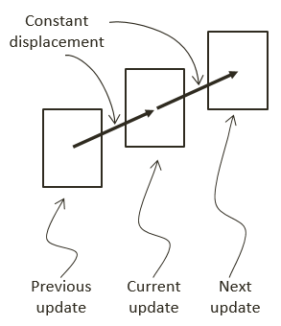

Figure 9-19. Movement Based on Constant Displacements

A movement that is governed by the constant displacement formulation becomes restrictive when it is necessary to change the amount to be displaced over time. Newtonian mechanics address this restriction by considering time in the movement formulations, as seen in the following equations.

$v_{new}=v_{current}+\int{a\left(t\right)dt}$

$p_{new}= p_{current}+\int{v\left(t\right)dt}$

These two equations represent Newtonian based movements where $v(t)$ is the velocity that describes the change in position over time and $a(t)$ is the acceleration that describes the change in velocity over time.

Notice that both velocity and acceleration are vector quantities encoding both the magnitude and direction. The magnitude of a velocity vector defines the speed, and the normalized velocity vector identifies the direction that the object is traveling. An acceleration vector lets you know whether an object is speeding up or slowing down and the change of travelling directions. Acceleration is changed by the forces acting upon an object. For example, if you were to throw a ball into the air, the gravitational force would affect the object’s acceleration over time, which in turn would change the object’s velocity.

## Explicit Euler Integration

The Euler method, or Explicit Euler Integration, approximates integrals based on initial values. This is one of the most straightforward approximation for integrals. As illustrated in the following two equations, in the case of the Newtonian movement formulation, the new velocity, $v_{new}$, of an object can be approximated as the current velocity, $v_{current}$, plus the current acceleration, $a_{current}$, multiplied by the elapsed time. Similarly, the object’s new position, $p_{new}$, can be approximated by the object’s current position, $p_{current}$, plus the current velocity, $v_{current}$, multiplied by the elapsed time.

$v_{new}=v_{current}+ a_{current}*dt$

$p_{new}= p_{current}+ v_{current}*dt$

The left diagram of Figure 9-20 illustrates a simple example of approximating movements with Explicit Euler Integration. Notice that the new position, $p_{new}$, is computed based on the current velocity, $v_{current}$. While the new velocity, $v_{new}$, is computed to move the position for the next update cycle.

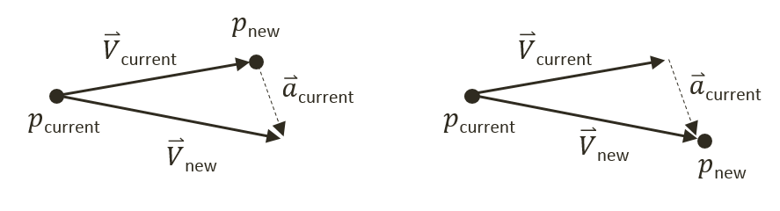

Figure 9-20. Explicit (Left) and Symplectic (Right) Euler Integration

## Symplectic Euler Integration

You will implement the Semi-Implicit Euler Integration or Symplectic Euler Integration, where intermediate results are used in subsequent approximations. The following equations show Symplectic Euler Integration. Notice that it is nearly identical to the Euler Method except that the new velocity, $v_{new}$, is being used when calculating the new position, $p_{new}$. This essentially means that the velocity for the next frame is being used to calculate the position of this frame.

$v_{new}=v_{current}+ a_{current}*dt$

$p_{new}= p_{current}+ v_{new}*dt$

The right diagram of Figure 9-20 illustrates that with the Symplectic Euler Integration, the new position $p_{new}$ is computed based on the newly computed velocity, $v_{new}$.

## The Rigid Shape Movements Project

You are now ready to implement Symplectic Euler Integration to approximate movements. The fixed time step, $dt$, formulation conveniently allows the integral to be evaluated once per update cycle. This project will guide you through working with the RigidShape class to support movement approximation with the Symplectic Euler Integration. You can see an example of this project running in Figure 9-21. The source code to this project is defined in chapter9/9.5.rigid_shape_movements.

In addition to implementing Symplectic Euler Integration, this project first guides you to define attributes required for collision simulation and response, such as mass, inertia, friction, etc. As will be explained, each of these attributes will play a part in the simulation of object movements and collision responses. This straightforward information is presented here to avoid distracting the discussions of the more complex concepts to be covered in the subsequent projects.

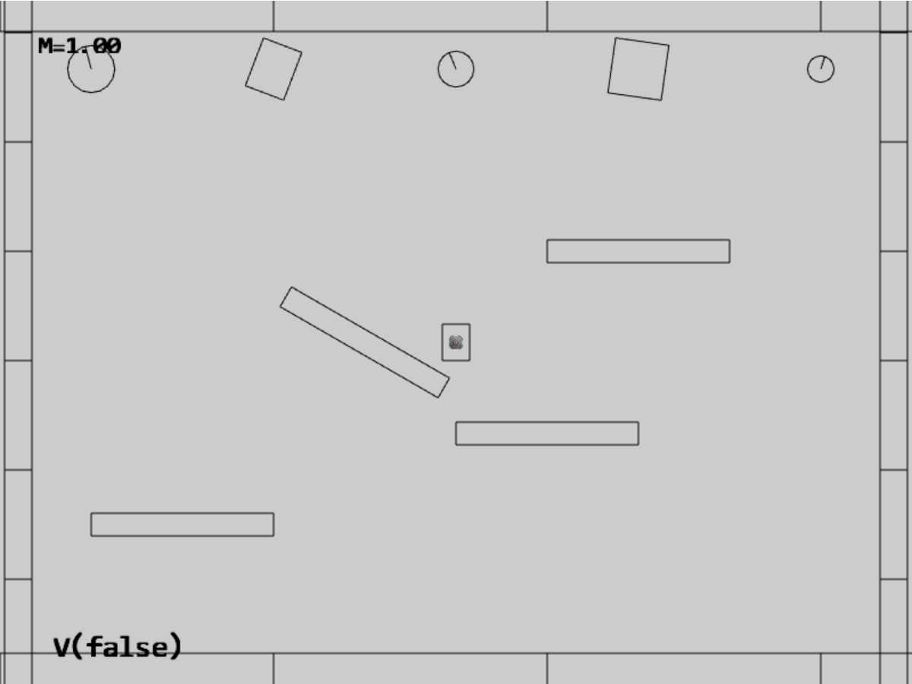

Figure 9-21. Running the Rigid Shape Movements project

The controls of the project are identical to the previous project with a single addition of the V and H key commands in behavior control:

* **Behavior control:**

**V key**: Toggle motion of all objects

**H key**: Inject random velocity to all objects

G key: Randomly create a new rigid circle or rectangle

* **Draw control**

C key: Toggle the drawing of all CollisionInfo

T key: Toggle textures on all objects

R key: Toggle the drawing of RigidShape

B key: Toggle the drawing of the bound on each RigidShape

* **Object control:**

Left/right-arrow key: Sequence through and select an object

WASD keys: Move the selected object

Z/X key: Rotate the selected object

Y/U key: Increase/decrease RigidShape size of the selected object, this does not change the size of corresponding Renderable object

The goals of the project are as follows:

* To complete the implementation of RigidShape classes to include relevant physical attributes
* To implement movement approximation based on Symplectic Euler Integration

In the following, you will first define relevant physical attributes to complete the RigidShape implementation. After which, you will focus on building Symplectic Euler Integration support for approximating movements.

### Completing the RigidShape Implementation

As mentioned, in order to allow focused discussions of the more complex concepts in the later sections, the attributes for supporting collisions and the corresponding supporting functions are introduced in this project. These attributes are defined in the rigid shape classes.

#### Modifying the RigidShape Class

Edit rigid_shape.js in the src/engine/rigid_shape folder.

1. In the constructor of the RigidShape class, define variables representing acceleration, velocity, angular velocity, mass, rotational inertia, restitution (bounciness), and friction. Notice that the inverse of the mass value is actually stored for computation efficiency (by avoiding an extra division during each update calculation). Additionally, notice that a mass of zero is used to represent a stationary object.

class RigidShape {

constructor(xf) {

this.mXform = xf;

this.mAcceleration = physics.getSystemAcceleration();

this.mVelocity = vec2.fromValues(0, 0);

this.mType = "";

this.mInvMass = 1;

this.mInertia = 0;

this.mFriction = 0.8;

this.mRestitution = 0.2;

this.mAngularVelocity = 0;

this.mBoundRadius = 0;

this.mDrawBounds = false;

}

1. Define the setMass() function to set the mass of the object. Once again, for computational efficiency the inversed of the mass is store. Setting the mass of an object to zero or negative is a signal that the object is stationary with zero acceleration and will not participate in any movement computation. Notice that when the mass of an object is changed you would need to call updateInertia() to update its rotational inertia, mInertial. Rotational inertia is geometric shape specific and that the implementation of updateIntertia() function is a subclass specific responsibility.

setMass(m) {

if (m > 0) {

this.mInvMass = 1 / m;

this.mAcceleration = physics.getSystemAcceleration();

} else {

this.mInvMass = 0;

this.mAcceleration = [0, 0]; // to ensure object does not move

}

this.updateInertia();

}

1. Define getter and setter functions for all of the other corresponding variables.

getInvMass() { return this.mInvMass; }

getInertia() { return this.mInertia; }

setInertia(i) { this.mInertia = i; }

getFriction() { return this.mFriction; }

setFriction(f) { this.mFriction = f; }

getRestitution() { return this.mRestitution; }

setRestitution(r) { this.mRestitution = r; }

getAngularVelocity() { return this.mAngularVelocity; }

setAngularVelocity(w) { this.mAngularVelocity = w; }

setAngularVelocityDelta(dw) { this.mAngularVelocity += dw; }

getVelocity() { return this.mVelocity; }

setVelocity(x, y) {

this.mVelocity[0] = x;

this.mVelocity[1] = y;

}

flipVelocity() {

this.mVelocity[0] = -this.mVelocity[0];

this.mVelocity[1] = -this.mVelocity[1];

}

getAcceleration() { return this.mAcceleration; }

setAcceleration(x, y) {

this.mAcceleration[0] = x;

this.mAcceleration[1] = y;

}

1. For the convenience of debugging, define a function, getCurrentState(), to retrieve variable values as text, and a function, userSetsState(), allow a user to set the variables.

getCurrentState() {

let m = this.mInvMass;

if (m !== 0)

m = 1 / m;

return "M=" + m.toFixed(kPrintPrecision) +

"(I=" + this.mInertia.toFixed(kPrintPrecision) + ")" +

" F=" + this.mFriction.toFixed(kPrintPrecision) +

" R=" + this.mRestitution.toFixed(kPrintPrecision);

}

userSetsState() {

// keyboard control

let delta = 0;

if (input.isKeyPressed(input.keys.Up)) {

delta = kRigidShapeUIDelta;

}

if (input.isKeyPressed(input.keys.Down)) {

delta = -kRigidShapeUIDelta;

}

if (delta !== 0) {

if (input.isKeyPressed(input.keys.M)) {

let m = 0;

if (this.mInvMass > 0)

m = 1 / this.mInvMass;

this.setMass(m + delta * 10);

}

if (input.isKeyPressed(input.keys.F)) {

this.mFriction += delta;

if (this.mFriction < 0)

this.mFriction = 0;

if (this.mFriction > 1)

this.mFriction = 1;

}

if (input.isKeyPressed(input.keys.R)) {

this.mRestitution += delta;

if (this.mRestitution < 0)

this.mRestitution = 0;

if (this.mRestitution > 1)

this.mRestitution = 1;

}

}

}

#### Modifying the RigidCircle Classes

As mentioned, the rotational inertia, mInertial, is a specific to geometric shape and must be modified by the corresponding classes.

1. Edit rigid_circle_main.js in the src/engine/rigid_shapes folder to modify the RigidCircle class to define the updateInertia() function. This function calculates the rotational inertia of a circle when its mass has changed.

updateInertia() {

if (this.mInvMass === 0) {

this.mInertia = 0;

} else {

// this.mInvMass is inverted!!

// Inertia=mass * radius^2

// 12 is a constant value that can be changed

this.mInertia = (1 / this.mInvMass) * (this.mRadius * this.mRadius) / 12;

}

};

1. Update the RigidCircle constructor and incShapeSize() function to call the updateInertia() function.

constructor(xf, radius) {

super(xf);

… identical to previous code …

this.updateInertia();

}

incShapeSizeBy(dt) {

… identical to previous code …

this.updateInertia();

}

#### Modifying the RigidRectangle Classes

Modifications similar to the RigidCircle class must be defined for the RigidRectangle class.

1. Edit rigid_rectangle_main.js in the src/engine/rigid_shapes folder to define the updateInertia() function.

updateInertia() {

// Expect this.mInvMass to be already inverted!

if (this.mInvMass === 0)

this.mInertia = 0;

else {

//inertia=mass*width^2+height^2

this.mInertia = (1 / this.mInvMass) * (this.mWidth * this.mWidth + this.mHeight * this.mHeight) / 12;

this.mInertia = 1 / this.mInertia;

}

};

1. Similar to the RigidCircle class, update the constructor and incShapeSize() function to call the updateInertia() function.

constructor(xf, width, height) {

super(xf);

… identical to previous code …

this.updateInertia();

}

incShapeSizeBy(dt) {

… identical to previous code …

this.updateInertia();

}

### Defining System Acceleration and Motion Control

With the RigidShape implementation completed, you are now ready to define support for movement approximation.

Define a system-wide acceleration and motion control by adding appropriate variables and access functions to physics.js in the src/engine/components folder. Remember to export the newly defined functionality.

let mSystemAcceleration = [0, -20]; // system-wide default acceleration

let mHasMotion = true;

// getters and setters

function getSystemAcceleration() { return vec2.clone(mSystemAcceleration); }

function setSystemAcceleration(x, y) {

mSystemAcceleration[0] = x;

mSystemAcceleration[1] = y;

}

function getHasMotion() { return mHasMotion; }

function toggleHasMotion() { mHasMotion = !mHasMotion; }

… identical to previous code …

export {

// Physics system attributes

getSystemAcceleration, setSystemAcceleration,

getHasMotion, toggleHasMotion,  
  
 … identical to previous code …

}

### Accessing the Fixed Time Interval

In your game engine the fixed time step, $dt$, is simply the time interval of the game loop updates. Now, edit loop.js in the src/engine/core folder to define and export the update time interval.

onst kUPS = 60; // Updates per second

const kMPF = 1000 / kUPS; // Milliseconds per update.

const kSPU = 1/kUPS; // seconds per update

… identical to previous code …

function getUpdateIntervalInSeconds() { return kSPU; }

… identical to previous code …

export {getUpdateIntervalInSeconds}

### Implementing Symplectic Euler Integration in the RigidShape class

You can now integrate Symplectic Euler Integration movement approximation into the rigid shape classes. Since this movement behavior is common to all types of rigid shapes, the implementation should be located in the base class, RigidShape.

1. In the src/engine/rigid_shapes folder, edit rigid_shape.js to define the travel() function to implement Symplectic Euler Integration for movement. Notice how the implementation closely follows the listed equations where the updated velocity is used for computing the new position. Additionally, notice the similarity between linear and angular motion where the location (either a position or an angle) is updated by a displacement that is derived from the velocity and time step. Rotation will be examined in detailed in the last section of this chapter.

travel() {

let dt = loop.getUpdateIntervalInSeconds();

// update velocity by acceleration

vec2.scaleAndAdd(this.mVelocity, this.mVelocity, this.mAcceleration, dt);

// p = p + v*dt with new velocity

let p = this.mXform.getPosition();

vec2.scaleAndAdd(p, p, this.mVelocity, dt);

this.mXform.incRotationByRad(this.mAngularVelocity * dt);

}

1. Modify the update() function to invoke travel() when the object is not stationary, mInvMass of 0, and when motion of the physics component is switched on.

update() {

if (this.mInvMass === 0)

return;

if (physics.getHasMotion())

this.travel();

}

### Modifying MyGame to Test Movements

The modification to the MyGame class involves supporting new user commands for toggling system-wide motion, injecting random velocity, and, setting the scene stationary boundary objects to rigid shape with zero mass. The injecting of random velocity is implemented by the randomizeVelocity() function defined in my_game_bounds.js file.

All updates to the MyGame class are straightforward. To avoid unnecessary distraction, the details are not shown. As always, you can refer to the source code files in the src/my_game folder for implementation details.

### Observations

You can now run the project to test your implementation. In order to properly observe and track movements of objects, initially motion is switched off. You can type the V key to enable motion when you are ready. When motion is toggled on, you can observe a natural-looking free-falling movement for all objects. You can type G to create more objects and observe similar free-fall movements of the created objects.

Notice that when the objects fall below the lower platform they are re-generated in the central region of the scene with a random initial upward velocity. Observe objects move upwards until the y-component velocity reaches zero, and then they begin to fall downwards as a result of gravitational acceleration. Typing the H key injects new random upward velocities to all objects resulting in objects decelerating while moving upwards.

Try typing the C key to observe the computed collision information when objects overlap, or, interpenetrate. Pay attention and note that as objects travel through the scene interpenetration occurs frequently. You are now ready to examine and implement how to resolve object interpenetration in the next section.

# Interpenetration of Colliding Objects

The fixed update time step introduced in the previous project means that the actual location of an object in a continuous motion is approximated by a discrete set of positions. As illustrated in Figure 9-22, the movement of the rectangular object is approximated by placing the object at the three distinct positions over three update cycles. The most notable ramification of this approximation is in the challenges when determining collisions between objects.

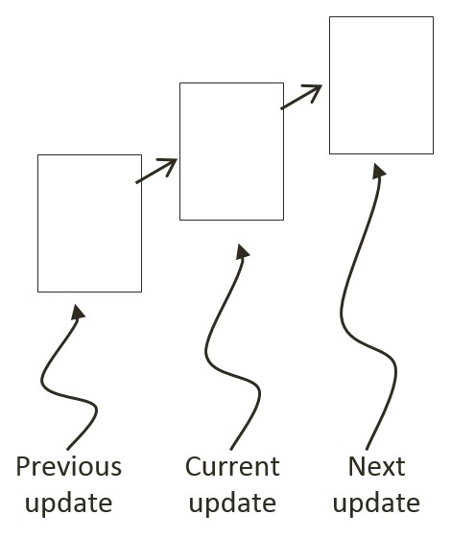

Figure 9-22: A Rigid Square in Continuous Motion

You can see one such challenge in Figure 9-22. Imagine a thin wall existed in the space between the current and the next update. You would expect the object to collide and stop by the wall in the next update. However, if the wall was sufficiently thin, the object would appear to pass right through the wall as it jumped from one position to the next. This is a common problem faced in many game engines. A general solution for these types of problems can be algorithmically complex and computationally intensive. It is typically the job of the game designer to mitigate and avoid this problem with well-designed (for example, appropriate size) and well-behaved (for example, appropriate traveling speed) game objects.

Figure 9-23 shows another, and more significant, collision related challenge resulting from fixed update time steps. In this case, before the time step the objects are not touching. After the time step, the results of the movement approximation place the two objects where they partly overlap. In the real world, if the two objects are rigid shapes or solids then the overlap, or interpenetration, would never occur. For this reason, this situation must be properly resolved in a rigid shape physics simulation. This is where details of a collision must be computed such that interpenetrating situations like these can be properly resolved.

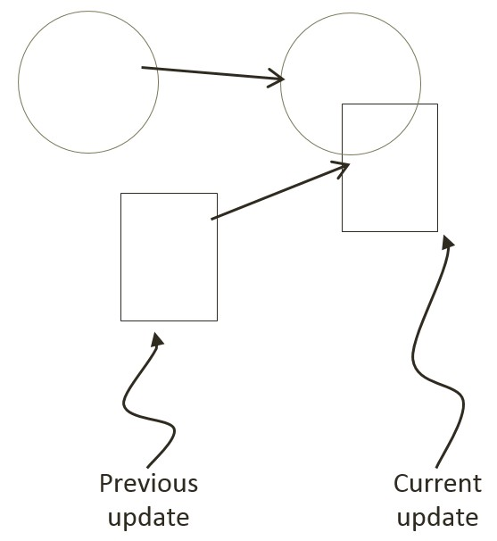

Figure 9-23: The Interpenetration of Colliding Objects

## Collision Position Correction

In the context of game engines, collision resolution refers to the process that determines object responses after a collision, including strategies to resolve the potential interpenetration situations that may have occurred. Notice that in the real-world, interpenetration of rigid objects can never occur since collisions are strictly governed by the law of physics. As such, resolutions of interpenetrations are relevant only in a simulated virtual world where movements are approximated and impossible situations may occur. These situations must be resolved algorithmically where both the computational cost and resulting visual appearance must be acceptable.

In general, there are three common methods for responding to interpenetrating collisions. The first is to simply displace the objects from one another by the depth of penetration. This is known as the Projection Method since you simply move positions of objects such that they no longer overlap. While this is simple to calculate and implement, it lacks stability when many objects are in proximity and overlap with each other. In this case, the simple resolving of one pair of interpenetrating objects can result in new penetrations with other nearby objects. However, the Projection Method is still often implemented in simple engines or games with simple object interaction rules. For example, in the Pong game, the ball never comes to rest on the paddles or walls and continuously remains in motion by bouncing off any object it collides with. The Projection Method is perfect for resolving collisions for these types of simple object interactions.

The second method, the Impulse Method, uses object velocities to compute and apply impulses to initiate the objects to move in the opposite directions at the point of collision. This method tends to slow down colliding objects rapidly and converges to relatively stable solutions. This is because impulses are computed based on the transfer of momentum, which in turn has a damping effect on the velocities of the colliding objects.

The third method, the Penalty Method, models the depth of object interpenetration as the degree of compression of a spring and approximates an acceleration to apply forces to separate the objects. This last method is the most complex and challenging to implement.

For your engine, you will be combining the strengths of the Projection and Impulse Methods. The Projection Method will be used to separate the interpenetrating objects, while the Impulse Method will be used to compute impulses to reduce the object velocities in the direction that caused the interpenetration. As described, the simple Projection Method can result in an unstable system, such as objects that sink into each other when stacked. You will overcome this instability by implementing a relaxation loop where, in a single update cycle, interpenetrated objects are separated incrementally via repeated applications of the Projection Method.

With a relaxation loop, each application of the Projection Method is referred to as a relaxation iteration. During each relaxation iteration, the Projection Method reduces the interpenetration incrementally by a fixed percentage of the total penetration depth. For example, by default the engine sets relaxation iterations to 15, and each relaxation iteration reduces the interpenetration by 80%. This means that within one update function call, after the movement integration approximation, the collision detection and resolution procedures will be executed 15 times. While costly, the repeated incremental separation ensures a stable system.

## The Collision Position Correction Project

This project will guide you through the implementation of the relaxation iterations to incrementally resolve inter-object interpenetrations. You are going to use the collision information computed from previous project to correct the position of the colliding objects. You can see an example of this project running in Figure 9-24. The source code to this project is defined in chapter9/9.6.collision_position_correction.

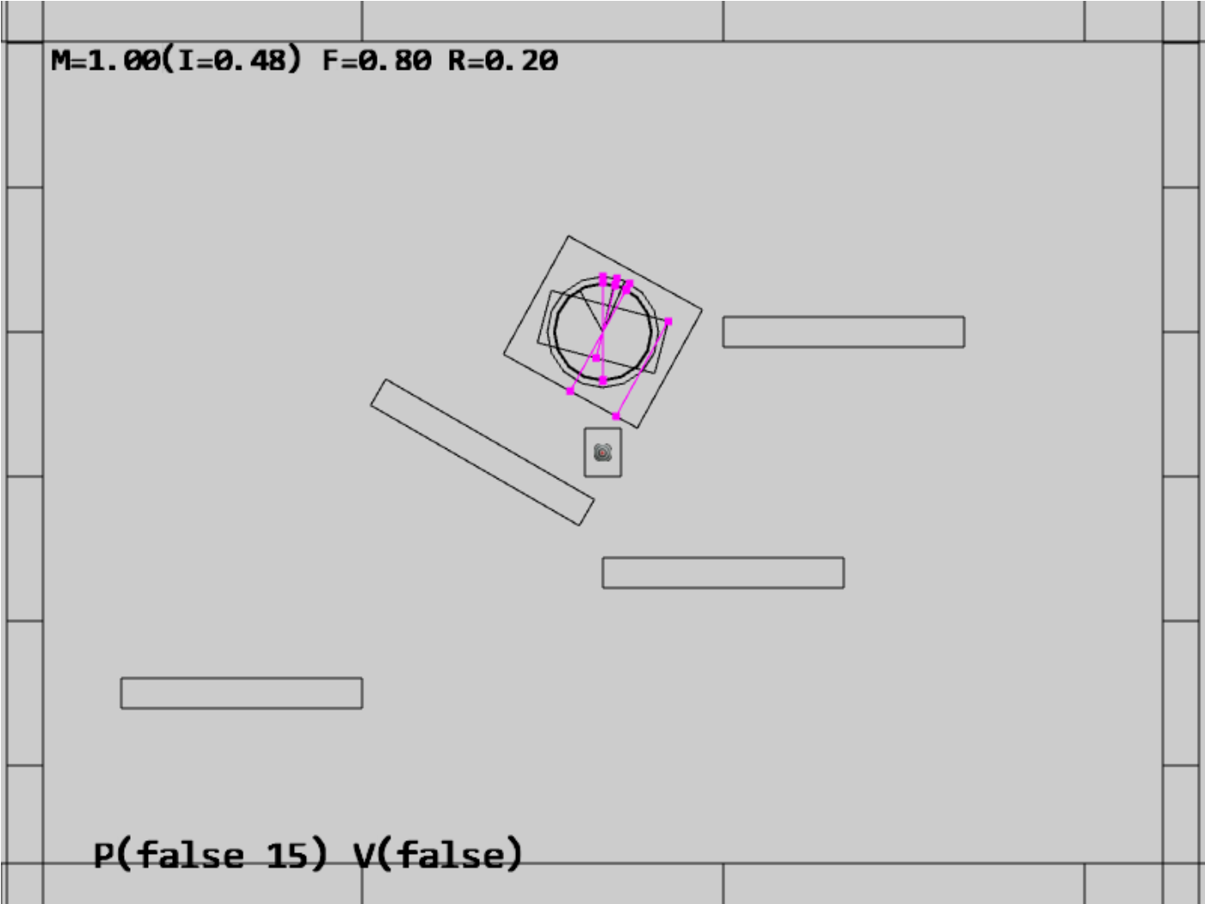

Figure 9-24. Running the Collision Position Correction project

The controls of the project are identical to the previous project with a single addition of the P key commands in behavior control:

* **Behavior control:**

**P key**: Toggle penetration resolution for all objects

**V key**: Toggle motion of all objects

**H key**: Inject random velocity to all objects

G key: Randomly create a new rigid circle or rectangle

* **Draw control**

C key: Toggle the drawing of all CollisionInfo

T key: Toggle textures on all objects

R key: Toggle the drawing of RigidShape

B key: Toggle the drawing of the bound on each RigidShape

* **Object control:**

Left/right-arrow key: Sequence through and select an object

WASD keys: Move the selected object

Z/X key: Rotate the selected object

Y/U key: Increase/decrease RigidShape size of the selected object, this does not change the size of corresponding Renderable object

The goals of the project are as follows:

* To implement positional correction with relaxation iteration
* To appreciate the importance of and work with the computed collision information
* To understand and experience implementing interpenetration resolution

### Updating the Physics Component

The previous projects have established the required simulation infrastructure including the completion of the RigidShape implementation in the previous project. You can now focus on the details of positional correction logic which is localized and hidden in the core of the physics component in the physics.js file in the src/engine/components folder.

1. Edit physics.js to define variables and the associated getters and setters for positional correction rate, relaxation loop count, and, toggling the positional correction computation. Make sure remember to export the newly defined functions.

let mPosCorrectionRate = 0.8; // percentage of separation to project objects

let mRelaxationCount = 15; // number of relaxation iteration

let mCorrectPosition = true;

function getPositionalCorrection() { return mCorrectPosition; }

function togglePositionalCorrection() { mCorrectPosition = !mCorrectPosition; }

function getRelaxationCount() { return mRelaxationCount; }

function incRelaxationCount(dc) { mRelaxationCount += dc; }

… identical to previous code …

export {

… identical to previous code …

togglePositionalCorrection,

getPositionalCorrection,

getRelaxationCount,

incRelaxationCount

}

1. Define positionalCorrection() function to move and reduce the overlaps between objects by the predefined rate, mPosCorrectionRate. To properly support object momentum in the simulation, the amount in which each object moves is inversely proportional to their masses. That is, upon collision, an object with a larger mass will be moved by an amount that is less than the object with a smaller mass. Notice that the direction of movement is along the collision normal as defined in by the collisionInfo object.

function positionalCorrection(s1, s2, collisionInfo) {

if (!mCorrectPosition)

return;

let s1InvMass = s1.getInvMass();

let s2InvMass = s2.getInvMass();

let num = collisionInfo.getDepth() / (s1InvMass + s2InvMass) * mPosCorrectionRate;

let correctionAmount = [0, 0];

vec2.scale(correctionAmount, collisionInfo.getNormal(), num);

s1.adjustPositionBy(correctionAmount, -s1InvMass);

s2.adjustPositionBy(correctionAmount, s2InvMass);

}

1. Modify the collideShape() function to perform positional correction when a collision is detected. Notice that objects of collisions are only performed between objects with non-zero masses.

function collideShape(s1, s2, infoSet = null) {

… identical to previous code …

if ((s1 !== s2) && ((s1.getInvMass() !== 0) || (s2.getInvMass() !== 0))) {

if (s1.boundTest(s2)) {

hasCollision = s1.collisionTest(s2, mCInfo);

if (hasCollision) {

vec2.subtract(mS1toS2, s2.getCenter(), s1.getCenter());

if (vec2.dot(mS1toS2, mCInfo.getNormal()) < 0)

mCInfo.changeDir();

positionalCorrection(s1, s2, mCInfo);

… identical to previous code …

}

return hasCollision;

}

1. Integrate a loop in all three utility functions, processObjToSet(), processSetToSet(), and processSet(), to execute relaxation iterations in performing the positional corrections.

function processObjToSet(obj, set, infoSet = null) {

let j = 0, r = 0;

let hasCollision = false;

let s1 = obj.getRigidBody();

for (r = 0; r < mRelaxationCount; r++) {

for (j = 0; j < set.size(); j++) {

let s2 = set.getObjectAt(j).getRigidBody();

hasCollision = collideShape(s1, s2, infoSet) || hasCollision;

}

}

return hasCollision;

}

function processSetToSet(set1, set2, infoSet = null) {

let i = 0, j = 0, r = 0;

let hasCollision = false;

for (r = 0; r < mRelaxationCount; r++) {

… identical to previous code …

}

return hasCollision;

}

// collide all objects in the GameObjectSet with themselves

function processSet(set, infoSet = null) {

let i = 0, j = 0, r = 0;

let hasCollision = false;

for (r = 0; r < mRelaxationCount; r++) {

… identical to previous code …

}

return hasCollision;

}

### Testing Positional Correction in MyGame

The MyGame class must be modified to support the new P key command, to toggle off initial motion and positional correct, and, to spawn initial objects in the central region of the game scene to guarantee initial collisions. These modifications are straightforward and details are not shown. As always, you can refer to the source code files in the src/my_game folder for implementation details.

### Observations

You can now run the project to test your implementation. Notice that by default, motion is off, showing of collision information is on, and, positional correction is off. For these reasons, you will observe the created rigid shapes clumping in the central region of the game scene with many associated magenta collision information.

Now, type the P key and observe all of the shapes being pushed apart with all overlaps resolved. You can type the G key to create additional shapes and observe the shapes continuously push each other aside to ensure no overlaps. A fun experiment to perform is to toggle off positional correction, followed by typing the G key to create a large number of overlapping shapes and then to type the P key to observe the shapes pushing each other apart.

If you switch on motion with the V key you will first observe all objects free falling as a result of the gravitational force. These objects will eventually come to a rest on one of the stationary platforms. Next, you will observe the magenta collision depth increasing continuously in the vertical direction. This increase in size is a result of the continuously increasing downward velocity as a result of the downward gravitational acceleration. Eventually, the downward velocity will grow so large that in an update the object will move pass the resting platform and appear to fall right through the platform. You are observing is precisely the situation discussed in Figure 9-22. The next subsection will discuss responses to collision and address this ever-increasing velocity.

Lastly, notice that the utility functions defined in the physics component, the processSet(), processObjToSet(), and processSetToSet() functions, these functions are designed to detect and resolve collisions. While useful, these functions are not designed to report on if a collision has occurred--a common operation supported by typical physics engines. To avoid distraction from the rigid shape simulation discussion, functions to support simple collision detection without responses are not presented. At this point, you have the necessary knowledge to define such functions and it is left as an exercise for you to complete.