Defining Behaviors and Detecting Collisions

After completing this chapter, you will be able to:

* Implement autonomous, controlled, gradual turning and target-locked chasing behaviors
* Collide textured objects accurately
* Understand the efficiency concerns of pixel-accurate collision
* Program with pixel-accurate collision effectively and efficiently

# Introduction

By this point, your game engine is capable of implementing games in convenient coordinate systems and presenting and animating objects that are visually appealing. However, there is a lack of abstraction support for the behaviors of objects. You can see the direct results of this shortcoming in the init() and update() functions of the MyGame objects in all the previous projects: the init() function is often crowded with mundane per-game object settings, while the update() function is often crowded with conditional statements for controlling objects, such as checking for key presses for moving the hero.

A well-designed system should hide the initialization and controls of individual objects with proper object-oriented abstractions, or classes. An abstract GameObject class should be introduced to encapsulate and hide the specifics of initialization and behaviors. There are two main advantages to this approach. First, the init() and update() functions of a game level can focus on managing individual game object and the interactions of these objects without being clustered with details specific to different types of objects. Second, as you have experienced with the Renderable and Shader object hierarchies, proper object-oriented abstraction creates a standardized interface and facilitates code sharing and reuse.

As you transition from working with the mere drawing of objects (in other words, Renderable) to programming with behavior of objects (in other words, GameObject), you will immediately notice that for the game to be entertaining or fun, the objects need to interact. Interesting behaviors of objects, such as facing or evading enemies, often require the knowledge of the relative positions of other objects in the game. In general, resolving relative positions of all objects in a two-dimensional world is nontrivial. Fortunately, typical video games require the knowledge of only those objects that are in close proximity to each other or are about to collide or have collided. An efficient but somewhat crude approximation to detect collision is to compute, bound, and approximate object collisions based on colliding bounding boxes. In the simplest cases, bounding boxes are rectangular boxes with edges that are aligned with the x/y-axes. These are referred to as Axis-Aligned Bounding Boxes, or AABB. Because of the axes alignments, it is computationally efficient to detect when two AABBs overlap or when collision is about to occur. Most 2D game engines detect the actual collision between two textured objects by comparing the location of pixels from both objects and detecting the situation when at least one of the non-transparent pixels overlap. This computationally intensive process is known as per-pixel-accurate collision detection, pixel-accurate collision, or per-pixel collision.

This chapter begins by introducing the GameObject class to provide a platform for abstracting game object behaviors. The GameObject class is then generalized to introduce common behavior attributes including speed, movement direction, and target-locked chasing. The rest of the chapter focuses on deriving an efficient per-pixel accurate collision implementation that supports both textured and animated sprite objects.

# Game Objects

As mentioned, an abstraction that encapsulates the intrinsic behavior of typical game objects should be introduced to minimize the clustering of code in the init() and update() functions of a game level and to facilitate reuse. This section introduces the simple GameObject class to illustrate how the cleaner and uncluttered init() and update() functions clearly reflect the in-game logic and to demonstrate how the basic platform for abstracting object behaviors facilitates design and code reuse.

## The Game Objects Project

This project defines the simple GameObject class as the first step in building an abstraction to represent actual objects with behaviors in a game. You can see an example of this project running in Figure 6-1. Notice the many minions charging from right to left and wrapping around when they reach the left boundary. This project leads you to create the infrastructure to support the many minions while keeping the logic in the MyGame level simple. The source code to this project is defined in the chapter6/6.1.game_objects folder.

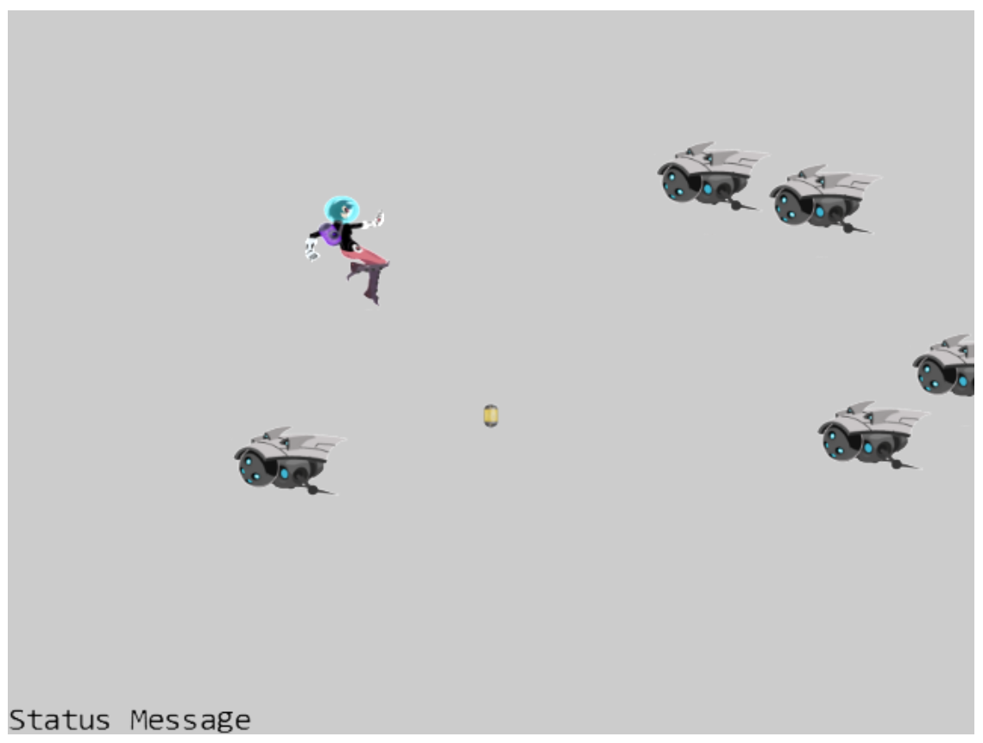

Figure 6-1. Running the Game Objects project

The controls of the project are as follows:

* **WASD keys:** Move the hero up, left, down, and right

The goals of the project are as follows:

* To begin defining the GameObject class to encapsulate object behaviors in games.
* To demonstrate the creation of subclasses to the GameObject class to maintain the simplicity of the MyGame level update() function.
* To introduce the GameObjectSet class demonstrating support for a set of homogenous objects with identical interface (methods).

You can find the following external resource file in the assets folder: minion_sprite.png; you’ll also find the fonts folder that contains the default system fonts. Note that, as shown in Figure 6-2, the minion_sprite.png image file has been updated from the previous project to include two extra sprite elements: the DyePack and the Brain minion.

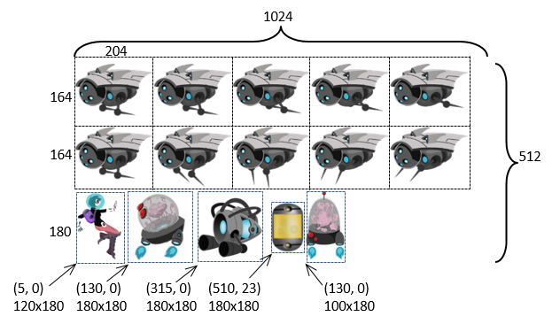

Figure 6-2. The new sprite elements of the minion_sprite.png image

### Define the GameObject Class

The goal is to define a logical abstraction to encapsulate all relevant behavioral characteristics of a typical object in a game including the ability to control positions, drawing, and so on. As in the case for the Scene objects in the earlier chapter, the main result is to provide a well-defined interface governing the functions that subclasses implement. The more sophisticated behaviors will be introduced in the next section. This example demonstrates the potential of only the GameObject class with minimal behaviors defined.

1. Add a new folder src/engine/game_objects for storing GameObject-related files.
2. Create a new file in this folder, name it game_object.js, and add the following code:

class GameObject {

constructor(renderable) {

this.mRenderComponent = renderable;

}

getXform() { return this.mRenderComponent.getXform(); }

getRenderable() { return this.mRenderComponent; }

update() { }

draw(aCamera) {

this.mRenderComponent.draw(aCamera);

}

}

export default GameObject;

With the assessors to the Renderable and Transform objects defined, all GameObject instances can be drawn and have defined locations and sizes. Note that the update() function is designed for subclasses to override with per-object specific behaviors, and thus it is left empty.

### Manage Game Objects in Sets

Because most games consist of many interacting objects, it is useful to define a utility class to support working with a set of GameObject instances.

1. Create a new file in the src/engine/game_objects folder and name it game_object_set.js. Define the constructor to create an array for holding GameObject instances.

class GameObjectSet {

constructor() {

this.mSet = [];

}

… implementation to follow …

export default GameObjectSet;

1. Define functions for managing the set membership.

size() { return this.mSet.length; }

getObjectAt(index) { return this.mSet[index]; }

addToSet(obj) { this.mSet.push(obj); }

removeFromSet(obj) {

let index = this.mSet.indexOf(obj);

if (index > -1)

this.mSet.splice(index, 1);

}

1. Define functions to update and draw each of the GameObject instances in the set.

update() {

let i;

for (i = 0; i < this.mSet.length; i++) {

this.mSet[i].update();

}

}

draw(aCamera) {

let i;

for (i = 0; i < this.mSet.length; i++) {

this.mSet[i].draw(aCamera);

}

}

### Export the classes to the Client

The last step in integrating any new functionality into the engine involves modifying the engine access file, index.js. Edit index.js and add the following import and export statements to grant the client access to GameObject and GameObjectSet classes.

… identical to previous code …

// game objects

import GameObject from "./game_objects/game_object.js";

import GameObjectSet from "./game_objects/game_object_set.js";

… identical to previous code …

export default {

… identical to previous code …

// Game Objects

GameObject, GameObjectSet,

… identical to previous code …

}

**Note** This process of import/export classes via the engine access file, index.js, must be repeated for every newly defined functionality. Henceforth, only a reminder will be provided and the straightforward code change will not be shown again.

### Test the GameObject and GameObjectSet

The goals of this project are to ensure proper functioning of the new GameObject class, to demonstrate customization of behaviors by individual object types, and to observe a cleaner MyGame implementation clearly reflecting the in-game logic. To accomplish these goals, three object types are defined: DyePack, Hero, and Minion. Before you begin to examine the detailed implementation of these objects, follow good source code organization practice and create a new folder src/my_game/objects for storing the new object types.

#### The DyePack GameObject

The DyePack object derives from the GameObject class to demonstrate the most basic example of a GameObject: an object that has no behavior and is simply drawn to the screen.

Create a new file in the src/my_game/objects folder and name it dye_pack.js. Import from the engine access file, index.js, to gain access to all game engine functionality. Define DyePack as a subclass of GameObject and implement the constructor as follows.

import engine from "../../engine/index.js";

class DyePack extends engine.GameObject {

constructor(spriteTexture) {

super(null);

this.kRefWidth = 80;

this.kRefHeight = 130;

this.mRenderComponent = new engine.SpriteRenderable(spriteTexture);

this.mRenderComponent.setColor([1, 1, 1, 0.1]);

this.mRenderComponent.getXform().setPosition(50, 33);

this.mRenderComponent.getXform().setSize(this.kRefWidth / 50, this.kRefHeight / 50);

this.mRenderComponent.setElementPixelPositions(510, 595, 23, 153);

}

}

export default DyePack;

Notice that even without specific behaviors, the DyePack is implementing code that used to be found in the init() function of the MyGame level. In this way, the DyePack object hides specific geometric information and simplifies the MyGame level.

**Note** The need to import from the engine access file, index.js, is true for almost all client source code file and will not be repeated.

#### The Hero GameObject

The Hero object supports direct user keyboard control. This object demonstrates hiding of game object control logic from the update() function of MyGame.

1. Create a new file in the src/my_game/objects folder and name it hero.js. Define Hero as a subclass of GameObject and implement the constructor to initialize the sprite UV values, size, and position. Make sure to export and share this class with the rest of the source code files.

class Hero extends engine.GameObject {

constructor(spriteTexture) {

super(null);

this.kDelta = 0.3;

this.mRenderComponent = new engine.SpriteRenderable(spriteTexture);

this.mRenderComponent.setColor([1, 1, 1, 0]);

this.mRenderComponent.getXform().setPosition(35, 50);

this.mRenderComponent.getXform().setSize(9, 12);

this.mRenderComponent.setElementPixelPositions(0, 120, 0, 180);

}

… implementation to follow …

export default Hero;

1. Add a function to support the update of this object by user keyboard control. The Hero object moves at a kDelta rate based on WASD input from the keyboard.

update() {

// control by WASD

let xform = this.getXform();

if (engine.input.isKeyPressed(engine.input.keys.W)) {

xform.incYPosBy(this.kDelta);

}

if (engine.input.isKeyPressed(engine.input.keys.S)) {

xform.incYPosBy(-this.kDelta);

}

if (engine.input.isKeyPressed(engine.input.keys.A)) {

xform.incXPosBy(-this.kDelta);

}

if (engine.input.isKeyPressed(engine.input.keys.D)) {

xform.incXPosBy(this.kDelta);

}

#### The Minion GameObject

The Minion object demonstrates that simple autonomous behavior can also be hidden.

1. Create a new file in the src/my_game/objects folder and name it minion.js. Define Minion as a subclass of GameObject and implement the constructor to initialize the sprite UV values, sprite animation parameters, size, and position as follows:

class Minion extends engine.GameObject {

constructor(spriteTexture, atY) {

super(null);

this.kDelta = 0.2;

this.mRenderComponent =

new engine.SpriteAnimateRenderable(spriteTexture);

this.mRenderComponent.setColor([1, 1, 1, 0]);

this.mRenderComponent.getXform().setPosition(Math.random() * 100, atY);

this.mRenderComponent.getXform().setSize(12, 9.6);

// first element pixel position: top-left 512 is top of image

// 0 is left of the image

this.mRenderComponent.setSpriteSequence(512, 0,

204, 164, // widthxheight in pixels

5, // number of elements in this sequence

0); // horizontal padding in between

this.mRenderComponent.setAnimationType(engine.eAnimationType.eSwing);

this.mRenderComponent.setAnimationSpeed(15);

// show each element for mAnimSpeed updates

}

… implementation to follow …

export default Minion;

1. Add a function to update the sprite animation, support the simple right-to-left movements, and provide the wrapping functionality.

update() {

// remember to update this.mRenderComponent's animation

this.mRenderComponent.updateAnimation();

// move towards the left and wraps

let xform = this.getXform();

xform.incXPosBy(-this.kDelta);

// if fly off to the left, re-appear at the right

if (xform.getXPos() < 0) {

xform.setXPos(100);

xform.setYPos(65 * Math.random());

}

}

#### MyGame Scene

As in all cases, the MyGame level is implemented in the my_game.js file. With the three specific GameObject subclasses defined, follow these steps:

1. In additional to the engine access file, index.js, in order to gain access to the newly defined objects the corresponding source code must be imported.

import engine from "../engine/index.js";

// user stuff

import DyePack from "./objects/dye_pack.js";

import Minion from "./objects/minion.js";

import Hero from "./objects/hero.js";

**Note** As is the case for other import/export statements, unless there are other specific reasons, this reminder will not be shown again.

1. The constructor and the load(), unload(), and draw() functions are similar as in previous projects, so the details are not shown here. Please refer to the my_game.js file for the actual implementations.
2. Edit the init() function and add the following code:

init() {

… identical to previous code …

// Step B: The dye pack: simply another GameObject

this.mDyePack = new DyePack(this.kMinionSprite);

// Step C: A set of Minions

this.mMinionset = new engine.GameObjectSet();

let i = 0, randomY, aMinion;

// create 5 minions at random Y values

for (i = 0; i < 5; i++) {

randomY = Math.random() * 65;

aMinion = new Minion(this.kMinionSprite, randomY);

this.mMinionset.addToSet(aMinion);

}

// Step D: Create the hero object

this.mHero = new Hero(this.kMinionSprite);

// Step E: Create and initialize message output

this.mMsg = new engine.FontRenderable("Status Message");

this.mMsg.setColor([0, 0, 0, 1]);

this.mMsg.getXform().setPosition(1, 2);

this.mMsg.setTextHeight(3);

}

The details of step A, the creation of the camera and initialization of the background color, are not shown because they are identical to previous projects. Steps B, C, and D show the instantiation of the three object types, with step C showing the creation and insertion of the right-to-left moving Minion objects into the mMinionset, an instance of the GameObjectSet class. Notice that the init() function is free from the clustering of setting each object’s textures, geometries, and so on.

1. Edit the update() function to update the game state.

update() {

this.mHero.update();

this.mMinionset.update();

this.mDyePack.update();

}

With the well-defined behaviors for each object type abstracted, the clean update() function clearly shows that the game consists of three noninteracting objects.

You can now run the project and notice that the slightly more complex movements of six minions are accomplished with much cleaner init() and update() functions. The init() function consists of only logic and controls for placing created objects in the game world and does not include any specific settings for different object types. With the Minion object defining its motion behaviors in its own update() function, the logic in the update() function of MyGame can focus on object-level controls. Note that the structure of this function clearly shows the three objects are updated independently and do not interact with each other.

**Note** Throughout this book, in almost all cases, MyGame classes are designed to showcase the engine functionality. As a result, the source code organization in most MyGame classes may not represent the best practices in implementing games.

# Creating a Chase Behavior

A closer examination of the previous project reveals that though there are quite a few minions moving on the screen, their motions are simple and boring. Even though there are variations in speed and direction, the motions are without purpose or awareness of other game objects in the scene. To support more sophisticated or interesting movements, a GameObject needs to be aware of the locations of other objects and determine motion based on that information.

Chasing behavior is one such example. The goal of a chasing object is usually to catch the game object that it is targeting. This requires programmatic manipulation of the front direction and speed of the chaser such that it can hone in on its target. However, it is generally important to avoid implementing a chaser that has perfect aim and always hits its target—because if the player is unable to avoid being hit, the game becomes impossibly difficult. Nonetheless, this does not mean you should not implement a perfect chaser if your game design requires it. You will implement a chaser in the next project.

Vectors and the associated operations are the foundation for implementing object movements and behaviors. Before programming with vectors, a quick review is provided. As in the case of matrices and transform operators, the following discussion is not meant to be a comprehensive coverage of vectors. Instead, the focus is on the application of a small collection of concepts that are relevant to the implementation of the game engine. This is not a study of the theories behind the mathematics. If you are interested in the specifics of vectors and how they relate to games, please refer to the discussion in Chapter 1 where you can learn more about these topics in depth by delving into relevant books on linear algebra and games.

## Vectors Review

Vectors are used across many fields of study, including mathematics, physics, computer science, and engineering. They are particularly important in games; nearly every game uses vectors in one way or another. Because they are used so extensively, this section is devoted to understanding and utilizing vectors in games.

**Note** Please refer to, “Basic Math for Game Development with Unity 3D: A Beginner’s Guide to Mathematical Foundations.” APress, 2019. for an introductory and comprehensive coverage of vectors and their applications in games.

One of the most common uses for vectors is to represent an object’s displacement and direction, or *velocity*. This can be done easily because a vector is defined by its size and direction. Using only this small amount of information, you can represent attributes such as the velocity or acceleration of an object. If you have the position of an object, its direction, and its velocity, then you have sufficient information to move it around the game world without user input.

Before going any further, it is important to review the concepts of a vector, starting with how you can define one. A vector can be specified using two points. For example, given the arbitrary positions and , you can define the vector from to or, , as . You can see this represented in the following equations and Figure 6-3:

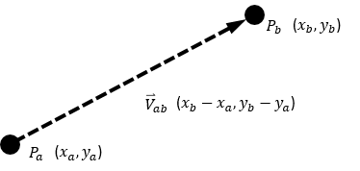

Figure 6-3. A vector defined by two points

Now that you have a vector , you can easily ascertain its length (or size) and its direction. A vector’s length is equal to the distance between the two points that created it. In this example, the length of is equal to the distance between and , while the direction of goes from toward .

■ **Note** The size of a vector is often referred to as its length, or magnitude.

In the gl-matrix library, the vec2 object implements the functionality of a two-dimensional (2D) vector. Conveniently, you can also use the vec2 object to represent 2D points, or positions in space. In the preceding example, , , and can all be implemented as instances of the vec2 object. However, is the only mathematically defined vector. and represent positions, or points used to create a vector.

Recall that a vector can also be normalized. A normalized vector (also known as a unit vector) always has a size of 1. You can see a normalized vector by the following function and Figure 6-4. Notice that the mathematic symbol for a regular vector is and for a normalized vector is :

* : Normalizes vector and stores the results to the vec2 object

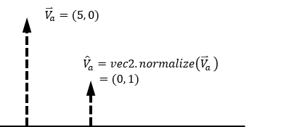

Figure 6-4. A vector being normalized

Vectors to a position can also be rotated. If, for example, the vector represents the direction from the origin to the position and you want to rotate it by , then you can use the following equations to derive and . Figure 6-5 shows the application of a rotation by to a vector that points from the origin to the position .

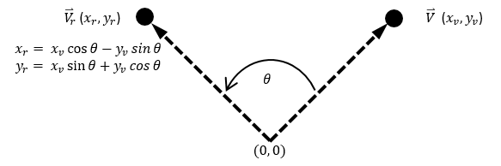

Figure 6-5. A vector from the origin to the position being rotated by the angle theta

■ **Note** JavaScript trigonometric functions, including the Math.sin() and Math.cos() functions, assume input to be in radians and not degrees. Recall that 1 degree is equal to radians.

It is always important to remember that vectors are defined by their direction and size. In other words, two vectors can be equal to each other independent of the locations of the vectors. Figure 6-6 shows two vectors and that are located at different positions but have the same direction and magnitude. Because their direction and magnitude are the same, these vectors are equal to each other. In contrast, the vector is not the same because its direction and magnitude are different from the others.

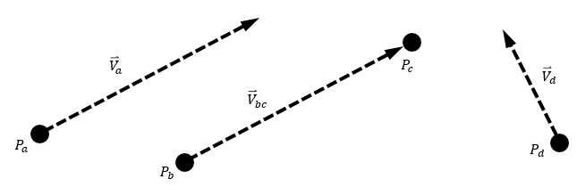

Figure 6-6. Three vectors represented in 2D space with two vectors equal to each other

### The Dot Product

The dot product of two normalized vectors provides you with the means to find the angle between those vectors. For example, given the following:



then the following is true:

* .

Additionally, if both vectors and are normalized, then:

* .

Figure 6-7 depicts an example of the and vectors with an angle in between them. It is also important to recognize that if , then the two vectors are perpendicular.

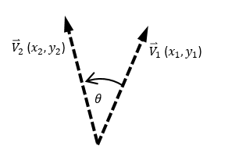

Figure 6-7. The angle between two vectors, which can be found through the dot product

■ **Note** If you need to review or refresh the concept of a dot product, please refer to www.mathsisfun.com/algebra/vectors-dot-product.html.

### The Cross Product

The cross product of two vectors produces a vector that is *orthogonal*, or perpendicular, to both of the original vectors. In 2D games, where the 2D dimensions lie flat on the screen, the results of the cross product is a vector that points either inward (toward the screen) or outward (away from the screen). This may seem odd because it is not intuitive that crossing two vectors in 2D or the XY plane results in a vector that lies in the third dimension, or along the z-axis. However, the resulting vector in the third dimension carries crucial information. For example, the direction of this vector in the third dimension can be used to determine whether the game object needs to rotate in the clockwise or counterclockwise direction. Take a closer look at the following:



Given the previous, the following is true:

* is a vector perpendicular to both and .

Additionally, you know that the cross product of two vectors on the XY plane results in a vector in the Z direction. When , you know that is in the clockwise direction from similarly, when , you know that is in the counterclockwise direction. Figure 6-8 should help clarify this concept.

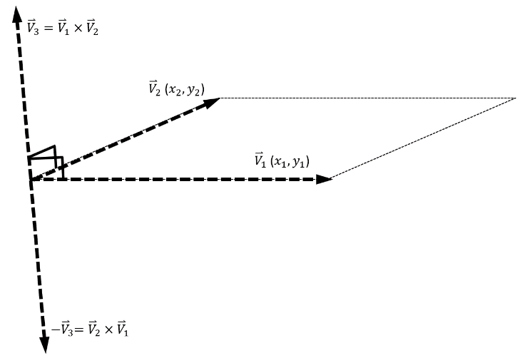

Figure 6-8. The cross product of two vectors

■ **Note** If you need to review or refresh the concept of a cross product, please refer to www.mathsisfun.com/algebra/vectors-cross-product.html.

## The Front and Chase Project

This project implements more interesting and sophisticated behaviors based on the vector concepts that have been reviewed. Instead of constant and aimless motions, you will experience the process of defining and varying the front direction of an object and guiding an object to chase after another object in the scene. You can see an example of this project running in Figure 6-9. The source code to this project is defined in the chapter6/6.2.front_and_chase folder.

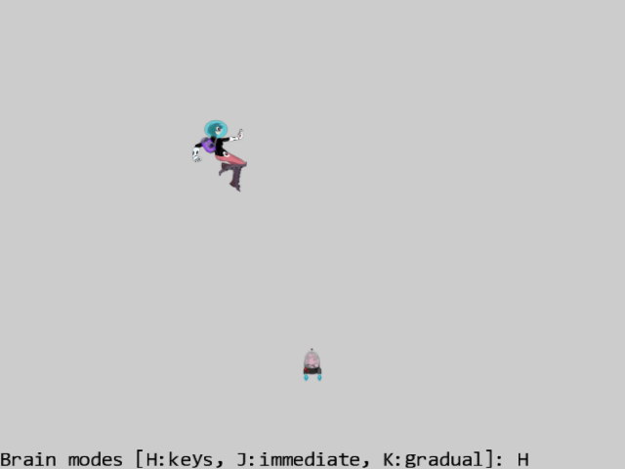

Figure 6-9. Running the Front and Chase project

The controls of the project are as follows:

* **WASD keys:** Moves the Hero object
* **Left/Right-Arrow keys:** Change the front direction of the Brain object when it is under user control
* **Up/Down Arrow keys**: Increase/decrease the speed of the Brain object
* **H key:** Switches the Brain object to be under user arrow keys control
* **J key:** Switches the Brain object to always point at and move toward the current Hero object position
* **K key:** Switches the Brain object to turn and move gradually toward the current Hero object position

The goals of the project are as follows:

* To experience working with speed and direction
* To practice traveling along a predefined direction
* To implement algorithms with vector dot and cross products
* To examine and implement chasing behavior

You can find the same external resource files as in the previous project in the assets folder.

### Add Vector Rotation to the gl-matrix Library

The gl-matrix library does not support rotating a position in 2D space. This can be rectified by adding the following code to the gl-matrix.js file in the lib folder:

vec2.rotate = function(out, a, c){

var r=[];

// perform rotation

r[0] = a[0]*Math.cos(c) - a[1]*Math.sin(c);

r[1] = a[0]*Math.sin(c) + a[1]*Math.cos(c);

out[0] = r[0];

out[1] = r[1];

return r;

};

**Note** This modification to the gl-matrix library must be present in all the projects from this point forward.

### Modify GameObject to Support Interesting Behaviors

The GameObject class abstracts and implements the desired new object behaviors:

1. Edit the game_object.js file and modify the GameObject constructor to define visibility, front direction, and speed.

constructor(renderable) {

this.mRenderComponent = renderable;

this.mVisible = true;

this.mCurrentFrontDir = vec2.fromValues(0, 1); //Current front direction

this.mSpeed = 0;

}

1. Add assessor and setter functions for the instance variables.

getXform() { return this.mRenderComponent.getXform(); }

setVisibility(f) { this.mVisible = f; }

isVisible() { return this.mVisible; }

setSpeed(s) { this.mSpeed = s; }

getSpeed() { return this.mSpeed; }

incSpeedBy(delta) { this.mSpeed += delta; }

setCurrentFrontDir(f) { vec2.normalize(this.mCurrentFrontDir, f); }

getCurrentFrontDir() { return this.mCurrentFrontDir; }

getRenderable() { return this.mRenderComponent; }

1. Implement a function to rotate the front direction toward a position, p.

rotateObjPointTo(p, rate) {

// Step A: determine if reach the destination position p

let dir = [];

vec2.sub(dir, p, this.getXform().getPosition());

let len = vec2.length(dir);

if (len < Number.MIN_VALUE) {

return; // we are there.

}

vec2.scale(dir, dir, 1 / len);

// Step B: compute the angle to rotate

let fdir = this.getCurrentFrontDir();

let cosTheta = vec2.dot(dir, fdir);

if (cosTheta > 0.999999) { // almost exactly the same direction

return;

}

// Step C: clamp the cosTheta to -1 to 1

// in a perfect world, this would never happen! BUT ...

if (cosTheta > 1) {

cosTheta = 1;

} else {

if (cosTheta < -1) {

cosTheta = -1;

}

}

// Step D: compute whether to rotate clockwise, or counterclockwise

let dir3d = vec3.fromValues(dir[0], dir[1], 0);

let f3d = vec3.fromValues(fdir[0], fdir[1], 0);

let r3d = [];

vec3.cross(r3d, f3d, dir3d);

let rad = Math.acos(cosTheta); // radian to roate

if (r3d[2] < 0) {

rad = -rad;

}

// Step E: rotate the facing direction with the angle and rate

rad *= rate; // actual angle need to rotate from Obj's front

vec2.rotate(this.getCurrentFrontDir(), this.getCurrentFrontDir(), rad);

this.getXform().incRotationByRad(rad);

}

The rotateObjPointTo() function rotates the mCurrentFrontDir to point to the destination position p at a rate specified by the parameter rate. Here are the details of each operation:

1. Step A computes the distance between the current object and the destination position p. If this value is small, it means current object and the target position are close. The function returns without further processing.
2. Step B computes the dot product to determine the angle θ between the current front direction of the object (fdir) and the direction towards the destination position p (dir). If these two vectors are pointing in the same direction ( is almost 1 or θ almost zero) the function returns. This computation is illustrated in Figure 6-10.

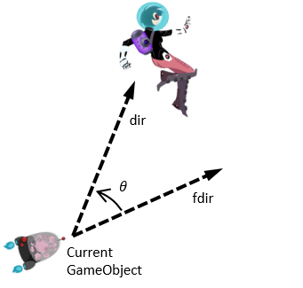

Figure 6-10. A GameObject (Brain) chasing a target (Hero)

1. Step C checks for the range of cosTheta. This is a step that must be performed because of the inaccuracy of floating-point operations in JavaScript.
2. Step D computes the results of the cross product to determine whether the current GameObject should be turning clockwise or counterclockwise to face toward the destination position p.
3. Step E rotates mCurrentFrontDir and sets the rotation in the Transform of the Renderable object. It is important to recognize the two separate object rotation controls. The Transform controls the rotation of the what is being drawn, and mCurrentFrontDir controls the direction of travel. In this case, the two are synchronized and thus must be updated with the new value simultaneously.
4. Add a function to update the object’s position with its direction and speed. Notice that if the mCurrentFrontDir is modified by the rotateObjPointTo() function, then this update() function will move the object toward the target position p, and the object will behave as though it is chasing the target.

update() {

// simple default behavior

let pos = this.getXform().getPosition();

vec2.scaleAndAdd(pos, pos, this.getCurrentFrontDir(), this.getSpeed());

}

1. Add a function to draw the object based on the visibility setting.

draw(aCamera) {

if (this.isVisible()) {

this.mRenderComponent.draw(aCamera);

}

}

### Test the Chasing Functionality

The strategy and goals of this test case are to create a steerable Brain object for testing traveling along a predefined front direction and direct the Brain object to chase after the Hero object to test the chasing functionality.

#### Define the Brain GameObject

The Brain object will travel along its front direction under the control of the user’s Left/Right Arrow keys for steering:

1. Create a new file in the src/my_game/objects folder and name it brain.js. Define this as a subclass of GameObject and implement the constructor to initialize the appearance and initial behavior of the object.

class Brain extends engine.GameObject {

constructor(spriteTexture) {

super(null);

this.kDeltaDegree = 1;

this.kDeltaRad = Math.PI * this.kDeltaDegree / 180;

this.kDeltaSpeed = 0.01;

this.mRenderComponent = new engine.SpriteRenderable(spriteTexture);

this.mRenderComponent.setColor([1, 1, 1, 0]);

this.mRenderComponent.getXform().setPosition(50, 10);

this.mRenderComponent.getXform().setSize(3, 5.4);

this.mRenderComponent.setElementPixelPositions(600, 700, 0, 180);

this.setSpeed(0.05);

}

… implementation to follow …

export default Brain;

1. Override the update() function to support user steering and controlling the speed. Notice that the default update() function in the GameObject must be called to support the basic traveling of the object along the front direction according to its speed.

update() {

super.update();

let xf = this.getXform();

let fdir = this.getCurrentFrontDir();

if (engine.input.isKeyPressed(engine.input.keys.Left)) {

xf.incRotationByDegree(this.kDeltaDegree);

vec2.rotate(fdir, fdir, this.kDeltaRad);

}

if (engine.input.isKeyPressed(engine.input.keys.Right)) {

xf.incRotationByRad(-this.kDeltaRad);

vec2.rotate(fdir, fdir, -this.kDeltaRad);

}

if (engine.input.isKeyClicked(engine.input.keys.Up)) {

this.incSpeedBy(this.kDeltaSpeed);

}

if (engine.input.isKeyClicked(engine.input.keys.Down)) {

this.incSpeedBy(-this.kDeltaSpeed);

}

}

#### The MyGame Scene

Modify the MyGame scene to test the Brain object movement. In this case, except for the update() function, the rest of the source code in my_game.js is similar to previous projects. For this reason, only the details of the update() function are shown. Please refer to the source code in the my_game.js file for the rest of the implementation details.

update() {

let msg = "Brain [H:keys J:imm K:gradual]: ";

let rate = 1;

this.mHero.update();

switch (this.mMode) {

case 'H':

this.mBrain.update(); // player steers with arrow keys

break;

case 'K':

rate = 0.02; // graduate rate

// When "K" is typed, the following should also be executed.

case 'J':

this.mBrain.rotateObjPointTo(

this.mHero.getXform().getPosition(), rate);

// the default GameObject: only move forward

engine.GameObject.prototype.update.call(this.mBrain);

break;

}

if (engine.input.isKeyClicked(engine.input.keys.H)) {

this.mMode = 'H';

}

if (engine.input.isKeyClicked(engine.input.keys.J)) {

this.mMode = 'J';

}

if (engine.input.isKeyClicked(engine.input.keys.K)) {

this.mMode = 'K';

}

this.mMsg.setText(msg + this.mMode);

}

In the update() function, the switch statement uses mMode to determine how to update the Brain object. In the cases of J and K modes, the Brain object turns toward the Hero object position with the rotateObjPointTo() function call. While in the H mode, the Brain object update() function is called for the user to steer the object with the arrow keys. The final three if statements simply set the mMode variable according to user input.

Note that in the cases of J and K, in order to bypass the user control logic after the rotateObjPointTo(), the update() function called is the one defined by the GameObject and not by the Brain.

**Note** The JavaScript syntax, ClassName.prototype.FunctionName.call(anObj), calls FunctionName defined by ClassName, where anObj is a subclass of ClassName.

You can now try running the project. Initially the Brain object is under the user’s control. You can use the left and right-arrow keys to change the front direction of the Brain object and experience steering the object. Pressing the J key causes the Brain object to immediately point and move toward the Hero object. This is a result of the default turn rate value of 1.0. The K key causes a more natural behavior, where the Brain object continues to move forward and gradually turns to move towards the Hero object. Feel free to change the values of the rate variable or modify the controls value of the Brain object. For example, change the kDeltaRad or kDeltaSpeed to experiment with different settings for the behavior.

# Collisions Between GameObjects

In the previous project, the Brain object would never stop traveling. Notice that under the J and K modes, the Brain object would orbit or rapidly flip directions when it reaches the target position. The Brain object is missing the critical ability to detect that it has collided with the Hero object, and it never stops moving as a result. This section describes the axes-aligned bounding boxes (AABB), one of the most straightforward tools for approximating object collisions, and demonstrates the implementation of collision detection based on AABB.

## Axis-Aligned Bounding Box (AABB)

An AABB is an x/y-axes aligned rectangular box that bounds a given object. The term *x/y-axes aligned* refers to the fact that the four sides of an AABB are parallel either to the horizontal x-axis or to the vertical y-axis. Figure 6-11 shows an example of representing the bounds to the Hero object by the lower-left corner (mLL), width, and height. This is a fairly common way to represent an AABB because it uses only one position and two floating-point numbers to represent the dimensions.

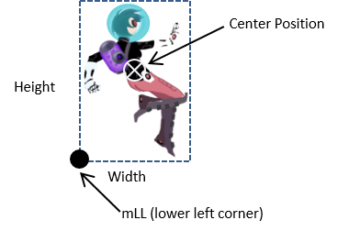

Figure 6-11. The lower-left corner and size of the bounds for an object

It is interesting to note that in addition to representing the bounds of an object, bounding boxes can be used to represent the bounds of any given rectangular area. For example, recall that the WC visible through the Camera is a rectangular area with the camera’s position located at the center and the WC width/height defined by the game developer. An AABB can be defined to represent the visible WC rectangular area, or the WC window, and used for detecting collision between the WC window and GameObject instances in the game world.

**Note** In this book, AABB and “bounding box” are used interchangeably.

## The Bounding Box and Collisions Project

This project demonstrates how to define a bounding box for a GameObject instance and detect collisions between two GameObject instances based on their bounding boxes. It is important to remember that bounding boxes are axes aligned, and thus the solution presented in this section does not support collision detections between rotated objects. You can see an example of this project running in Figure 6-12. The source code to this project is defined in the chapter6/6.3.bbox_and_collisions folder.

Figure 6-12. Running the Bounding Box and Collisions project

The controls of the project are identical to the previous project.

* **WASD keys:** Moves the Hero object
* **Left/Right-Arrow keys:** Change the front direction of the Brain object when it is under user control
* **Up/Down Arrow keys**: Increase/decrease the speed of the Brain object
* **H key:** Switches the Brain object to be under user arrow keys control
* **J key:** Switches the Brain object to always point at and move toward the current Hero object position
* **K key:** Switches the Brain object to turn and move gradually toward the current Hero object position

The goals of the project are as follows:

* To understand the implementation of the bounding box class
* To experience working with the bounding box of a GameObject instance
* To compute and work with the bounds of a Camera WC window
* To program with object collisions and object and camera WC window collisions

You can find the same external resource files as in the previous project in the assets folder.

### Define a Bounding Box Class

Define a BoundingBox class to represent the bounds of a rectangular area.

1. Create a new file in the src/engine folder, name it bounding_box.js. First, define an enumerated data type with values that identify the collision sides of a bounding box.

const eBoundCollideStatus = Object.freeze({

eCollideLeft: 1,

eCollideRight: 2,

eCollideTop: 4,

eCollideBottom: 8,

eInside: 16,

eOutside: 0

});

Notice that each enumerated value is different and has only one nonzero bit. This allows the enumerated values to be combined with the bitwise-or operator to represent a multisided collision. For example, if an object collides with both the top and left sides of a bounding box, the collision status will be eCollideLeft | eCollideTop = 4 | 1 = 5.

1. Now, define the class and the constructor with instance variables to represent a bound, as illustrated in Figure 6-11. Notice that the eBoundCollideStatus must also be exported such that the rest of the engine, including the client, can also have access.

class BoundingBox {

constructor(centerPos, w, h) {

this.mLL = vec2.fromValues(0, 0);

this.setBounds(centerPos, w, h); }

… implementation to follow …

export {eBoundCollideStatus}

export default BoundingBox;

1. The setBounds() function computes and sets the instance variables of the bounding box.

setBounds(centerPos, w, h) {

this.mWidth = w;

this.mHeight = h;

this.mLL[0] = centerPos[0] - (w / 2);

this.mLL[1] = centerPos[1] - (h / 2);

}

1. Define a function to determine whether a given position, (x, y), is within the bounds of the box.

containsPoint(x, y) {

return ((x > this.minX()) && (x < this.maxX()) &&

(y > this.minY()) && (y < this.maxY()));

}

1. Define a function to determine whether a given bound intersects with the current one.

intersectsBound(otherBound) {

return ((this.minX() < otherBound.maxX()) &&

(this.maxX() > otherBound.minX()) &&

(this.minY() < otherBound.maxY()) &&

(this.maxY() > otherBound.minY()));

}

1. Define a function to compute the intersection status between a given bound and the current one.

boundCollideStatus(otherBound) {

let status = eBoundCollideStatus.eOutside;

if (this.intersectsBound(otherBound)) {

if (otherBound.minX() < this.minX()) {

status |= eBoundCollideStatus.eCollideLeft;

}

if (otherBound.maxX() > this.maxX()) {

status |= eBoundCollideStatus.eCollideRight;

}

if (otherBound.minY() < this.minY()) {

status |= eBoundCollideStatus.eCollideBottom;

}

if (otherBound.maxY() > this.maxY()) {

status |= eBoundCollideStatus.eCollideTop;

}

// if the bounds intersects and yet none of the sides overlaps

// otherBound is completely inside thisBound

if (status === eBoundCollideStatus.eOutside) {

status = eBoundCollideStatus.eInside;

}

}

return status;

}

Notice the subtle yet important difference between the intersectsBound() and boundCollideStatus() functions where the former is capable of returning only a true or false condition while the latter function encodes the colliding sides in the returned status.

1. Implement the functions that returns the X/Y values to the min and max bounds of the bounding box.

minX() { return this.mLL[0]; }

maxX() { return this.mLL[0] + this.mWidth; }

minY() { return this.mLL[1]; }

maxY() { return this.mLL[1] + this.mHeight; }

Lastly, remember to update the engine access file, index.js, to forward the newly defined functionality to the client.

### Use the BoundingBox in the Engine

The newly defined functionality will be used to detect collisions between objects and between objects and the WC bounds. In order to accomplish this, the GameObject and Camera classes must be modified.

1. Edit game_object.js to import the newly defined functionality and modify the GameObject class implement the getBBox() function to return the bounding box of the unrotated Renderable object.

import BoundingBox from "../bounding_box.js";

class GameObject {

… identical to previous code …

getBBox() {

let xform = this.getXform();

let b = new BoundingBox(

xform.getPosition(),

xform.getWidth(),

xform.getHeight());

return b;

}

… identical to previous code …

1. Edit camera.js to import from bounding box and modify the Camera class to compute the collision status between the bounds of a Transform object (typically defined in a Renderable object) and that of the WC window.

import BoundingBox from "./bounding_box.js";

class Camera {

… identical to previous code …

collideWCBound(aXform, zone) {

let bbox = new BoundingBox(

aXform.getPosition(),

aXform.getWidth(),

aXform.getHeight());

let w = zone * this.getWCWidth();

let h = zone * this.getWCHeight();

let cameraBound = new BoundingBox(this.getWCCenter(), w, h);

return cameraBound.boundCollideStatus(bbox);

}

}

Notice that the zone parameter defines the relative size of WC that should be used in the collision computation. For example, a zone value of 0.8 would mean computing for intersection status based on 80 percent of the current WC window size. Figure 6-13 shows how the camera collides with an object.

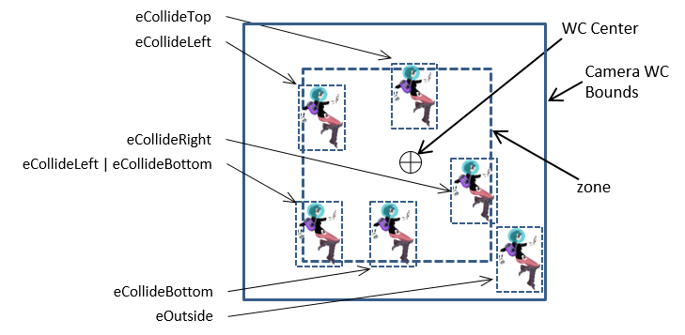

Figure 6-13. Camera WC Bounds colliding with the bounds defined a Transform object

### Test Bounding Boxes with MyGame

The goal of this test case is to verify the correctness of the bounding box implementation in detecting object-object and object-camera intersections. Once again, with the exception of the update() function, the majority of the code in the my_game.js file is similar to the previous projects and is not repeated here. The update() function is modified from the previous project to test for bounding box intersections.

update() {

… identical to previous code …

switch (this.mMode) {

case 'H':

this.mBrain.update(); // player steers with arrow keys

break;

case 'K':

rate = 0.02; // graduate rate

// no break here on purpose

case 'J':

// stop the brain when it touches hero bound

if (!hBbox.intersectsBound(bBbox)) {

this.mBrain.rotateObjPointTo(

this.mHero.getXform().getPosition(), rate);

// the default GameObject: only move forward

engine.GameObject.prototype.update.call(this.mBrain);

}

break;

}

// Check for hero going outside 80% of the WC Window bound

let status = this.mCamera.collideWCBound(this.mHero.getXform(), 0.8);

… identical to previous code …

this.mMsg.setText(msg + this.mMode + " [Hero bound=" + status + "]");

}

In the switch statement’s **J** and **K** cases, the modification tests for bounding box collision between the Brain and Hero objects before invoking Brain.rotateObjPointTo() and update() to cause the chasing behavior. In this way, the Brain object will stop moving as soon as it touches the bounds of the Hero object. In addition, the collision results between the Hero object and 80 percent of the camera WC window are computed and displayed.

You can now run the project and observe the Brain object stop moving as soon as it touches the Hero object. When you move the Hero object around, observe the Hero Bound output message begin to echo WC window collisions before the Hero object actually touches the WC window bounds. This is a result of the 0.8, or 80 percent, parameter passed to the mCamera.collideWCBound() function, configuring the collision computation to 80 percent of the current WC window size. When the Hero object is completely within 80 percent of the WC window bounds, the output Hero Bound value is 16, or the value of eboundcollideStatus.eInside. Try moving the Hero object to touch the top 20 percent of the window bound and observe the Hero Bound value of 4, or the value of eboundcollideStatus.eCollideTop. Now move the Hero object toward the top-left corner of the window and observe the Hero Bound value of 5, or eboundcollideStatus.eCollideTop | eboundcollideStatus.eCollideLeft. In this way, the collision status is a bitwise-or result of all the colliding bounds.

# Per-Pixel Collisions

In the previous example, you saw the results of bounding box collision approximation. Namely, the Brain object’s motion stops as soon as its bounds overlap that of the Hero object. This is much improved over the original situation where the Brain object never stops moving. However, as illustrated in Figure 6-14, there are two serious limitations to the bounding box–based collisions.

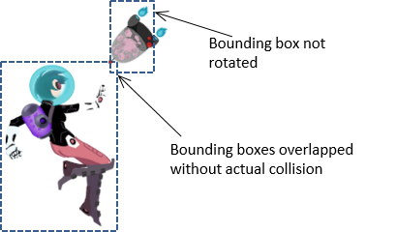

Figure 6-14. Limitation with bounding box–based collision

1. The BoundingBox object introduced in the previous example does not account for rotation. This is a well-known limitation for AABB: although the approach is computationally efficient, it does not support rotation.
2. The two objects do not actually collide. The fact that the bounds of two objects overlap does not automatically equate to the two objects colliding.

In this project, you will see how to achieve per-pixel-accurate collision detection, pixel-accurate collision, or per-pixel collision, which identifies overlapping of nontransparent pixels of two colliding objects. However, keep in mind that this is not an end-all solution. While the per-pixel collision detection is precise, the trade-off is potential performance costs. As an image becomes larger and more complex, it also has more pixels that need to be checked for collisions. This is in contrast to the constant computation cost required for bounding box collision detection from the previous example.

## The Per-Pixel Collisions Project

This project demonstrates how to detect collision between a large textured object, the Collector minion and a small textured object, the Portal minion. Both of the textures contain transparent and nontransparent areas. A collision occurs only when the nontransparent pixels overlap. In this project, when a collision occurs, a yellow DyePack appears at the collision point. You can see an example of this project in Figure 6-15. The source code to this project is defined in the chapter6/6.4.per_pixel_collisions folder.

Figure 6-15. Running the Per-Pixel Collisions project

The controls of the project are as follows:

* **Arrow keys:** Move the small textured object, the Portal minion
* **WASD keys:** Move the large textured object, the Collector minion

The goals of the project are as follows:

* To demonstrate how to detect nontransparent pixel overlap
* To understand the pros and cons of using per-pixel-accurate collision detection

**Note** A “transparent” pixel is one where you can see through completely, and in the case of this engine has an alpha value of 0. A “nontransparent” pixel has a greater than 0 alpha value, which may or may not occlude, or the pixel does not completely block what is behind it. An “opaque” pixel occludes, is “nontransparent”, and has an alpha value of 1. For example, notice that you can “see through” the top region of the Portal object. These pixels are nontransparent but not opaque and should cause a collision when an overlap occurs.

You can find the following external resources in the assets folder: the fonts folder that contains the default system fonts, minion_collector.png, minion_portal.png, and minion_sprite.png. Note that minion_collector.png is a large, 1024x1024 image, while minion_portal.png is a small, 64x64 image; minion_sprite.png defines the DyePack sprite element.

### Overview of Per-Pixel Collision Algorithm

Before moving forward, it is important to identify the requirements for detecting a collision between two textured objects. Foremost is that the texture itself needs to contain an area of transparency in order for this type of collision detection to provide any increase in accuracy. Without transparency in the texture, you can and should use a simple bounding box collision detection. If one or both of the textures contain transparent areas, then you’ll need to handle two cases of collision. The first case is to check whether the bounds of the two objects collide. You can see this reflected in Figure 6-16. Notice how the bounds of the objects overlap yet none of the nontransparent colored pixels are touching.

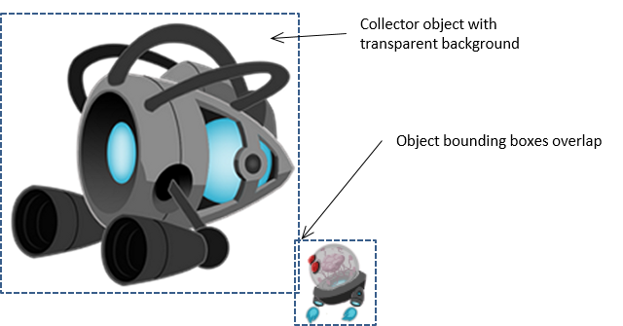

Figure 6-16. Overlapping bounding boxes without actual collision

The next case is to check whether the nontransparent pixels of the textures overlap. Take a look at Figure 6-17. Nontransparent pixels from the textures of the Collector and Portal objects are clearly in contact with one another.

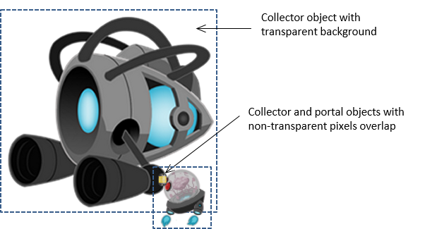

Figure 6-17. Pixel collision occurring between the large texture and the small texture

Now that the problem is clearly defined, here is the logic or pseudocode for per-pixel-accurate collision detection:

Given two images, Image-A and Image-B

If the bounds of the object of Image-A and Image-B collide then

For each Pixel-A in Image-A

pixelCameraSpace = Pixel-A position in camera space

Transform pixelCameraSpace to Image-B space

Read Pixel-B from Image-B

If Pixel-A and Pixel-B are not both completely transparent then

A collision has occurred

The per-pixel transformation to Image-B space from pixelCameraSpace is required because collision checking must be carried out within the same coordinate space. Additionally, pay attention to the runtime of this algorithm. Each pixel within Image-A must be checked, so the runtime is , where is equal to the number of pixels in Image-A, or Image-A’s resolution. To mitigate this performance hit, you should use the smaller of the two images (the Portal minion in this case) as Image-A. However, at this point, you can probably see why the performance of pixel-accurate collision detection is concerning. Checking for these collisions during every update with many high-resolution textures onscreen can quickly bog down performance. You are now ready to examine the implementation of per-pixel accurate collision.

### Modify Texture to Load a Texture as an Array of Colors

Recall that the Texture component reads image files from the server file system, loads the images to the WebGL context, and processes the images into WebGL textures. In this way, texture images are stored on the GPU and are not accessible by the game engine that is run on the CPU. To support per-pixel collision detection, the color information must be retrieved from the WebGL context on the GPU and stored in the CPU. The Texture component can be modified to support this requirement.

1. In the texture.js file, expand the TextureInfo object to include a new variable for storing the color array of a file texture.

class TextureInfo {

constructor(w, h, id) {

this.mWidth = w;

this.mHeight = h;

this.mGLTexID = id;

this.mColorArray = null;

}

}

1. Define a function to retrieve the color array from the WebGL context and remember to export it.

function getColorArray(textureName) {

let gl = glSys.get();

let texInfo = get(textureName);

if (texInfo.mColorArray === null) {

// create a framebuffer bind it to the texture, and read the color content

let fb = gl.createFramebuffer();

gl.bindFramebuffer(gl.FRAMEBUFFER, fb);

gl.framebufferTexture2D(gl.FRAMEBUFFER,

gl.COLOR_ATTACHMENT0,

gl.TEXTURE_2D, texInfo.mGLTexID, 0);

if (gl.checkFramebufferStatus(gl.FRAMEBUFFER) ===

gl.FRAMEBUFFER_COMPLETE) {

let pixels = new Uint8Array(texInfo.mWidth * texInfo.mHeight * 4);

gl.readPixels(0, 0, texInfo.mWidth, texInfo.mHeight,

gl.RGBA, gl.UNSIGNED_BYTE, pixels);

texInfo.mColorArray = pixels;

} else {

throw new Error("WARNING: Engine.Textures.getColorArray() failed!");

return null;

}

gl.bindFramebuffer(gl.FRAMEBUFFER, null);

gl.deleteFramebuffer(fb);

}

return texInfo.mColorArray;

}

export {has, get, load, unload,

TextureInfo,

activate, deactivate,

getColorArray

}

The getColorArray() function creates a WebGL FRAMEBUFFER, fills the buffer with the desired texture, and retrieves the buffer content into the associated texInfo.mColorArray.

### Modify TextureRenderable to Support Per-Pixel Collision

The TextureRenderable is the most appropriate class for implementing the per-pixel collision functionality. This is because TextureRenderable is the base class for all classes that render textures. Implementation in this base class means all subclasses can inherit the functionality with minimal additional changes.

As the functionality of the TextureRenderable class increases, so will the complexity and size of the implementation source code. For readability and expandability, it is important to maintain moderate size source code files. An effective approach is to separate the source code of a the class into multiple files according to their functionality.

#### Organize the Source Code

In the following steps, the TextureRenderable class will be separated into three source code files: texture_renderable_main.js for implementing the basic functionality from previous projects, texture_renderable_pixel_collision.js for implementing the newly introduced per-pixel accurate collision, and, texture_renderable.js for serving as the class access point.

1. Rename texture_renderable.js.to texture_renderable_main.js. This file defines the basic functionality of the TextureRenderable class.
2. Create a new file in src/engine/renderables and name it texture_renderable_pixel_collision.js. This file will be used to extend the TextureRenderable class functionality in supporting per-pixel accurate collision. Add in the following code to import from the Texture module and the basic TextureRenderable class and re-export the TextureRenderable class. For now, this file does not serve any purpose, you will add in the appropriate extending functions in the following subsection.

"use strict";

import TextureRenderable from "./texture_renderable_main.js";

import * as texture from “../resources/texture.js”;

… implementation to follow …

export default TextureRenderable;

1. Create a new texture_renderable.js file to serve as the TextureRenderable access point by adding the following code.

"use strict";

import TextureRenderable from "./ texture_renderable_pixel_collision.js";

export default TextureRenderable;

With this structure, the texture_renderable_main.js file implements all the basic functionality and exports to texture_renderable_pixel_collision.js, which appends additional functionality to the TextureRenderable class. Finally, texture_renderable.js imports the extended functions from texture_renderable_pixel_collision.js. The users of the TextureRenderable class can simply import from texture_renderable.js and will have access to all of the defined functionality.

In this way, from the perspective of the game developer, texture_renderable.js serves as the access point to the TextureRenderable class and hides the details of the implementation source code structure. At the same time, from the perspective of you as the engine developer, complex implementations are separated into source code files with names indicating the content achieving readability of each individual file.

#### Define Access to Texture Color Array

Recall that you began this project by first editing the Texture module to retrieve, from the GPU to the CPU, the color array that represent a texture. You must now edit TextureRenderable to gain access to this color array.

1. Edit the texture_renderable_main.js file and modify the constructor to add instance variables to hold texture information, including a reference to the retrieved color array, for supporting per-pixel collision detection and for later subclass overrides:

class TextureRenderable extends Renderable {

constructor(myTexture) {

super();

// Alpha of 0: switch off tinting of texture

super.setColor([1, 1, 1, 0]);

super._setShader(shaderResources.getTextureShader());

this.mTexture = null;

// these two instance variables are to cache texture information

// for supporting per-pixel accurate collision

this.mTextureInfo = null;

this.mColorArray = null;

// defined for subclass to override

this.mElmWidthPixels = 0;

this.mElmHeightPixels = 0;

this.mElmLeftIndex = 0;

this.mElmBottomIndex = 0;

// texture for this object, cannot be a "null"

this.setTexture(myTexture);

}

1. Modify the setTexture() function to initialize the instance variables accordingly.

setTexture(newTexture) {

this.mTexture = newTexture;

// these two instance variables are to cache texture information

// for supporting per-pixel accurate collision

this.mTextureInfo = texture.get(newTexture);

this.mColorArray = null;

// defined for one sprite element for subclass to override

// For texture_renderable, one sprite element is the entire texture

this.mElmWidthPixels = this.mTextureInfo.mWidth;

this.mElmHeightPixels = this.mTextureInfo.mHeight;

this.mElmLeftIndex = 0;

this.mElmBottomIndex = 0;

}

Note that the mElmWidthPixels and mElmHeightPixels variables are the width and height of the texture. These variables are defined for later subclass overrides such that the algorithm can support the collision of sprite elements.

#### Implement Per-Pixel Collision

You are now ready to implement the per-pixel collision algorithm in the newly created texture_renderable_pixel_collision.js file.

1. Edit the texture_renderable_pixel_collision.js file and define a new function for the TextureRenderable class to set the mColorArray.

TextureRenderable.prototype.setColorArray = function() {

if (this.mColorArray === null) {

this.mColorArray = texture.getColorArray(this.mTexture);

}

}

**Note** JavaScript classes are implemented based on prototype chains. After class construction, instance methods can be accessed and defined via the prototype of the class or aClass.prototype.method. For more information on JavaScript classes and prototypes, please refer to https://developer.mozilla.org/en-US/docs/Web/JavaScript/Inheritance_and_the_prototype_chain

1. Define a new function to return the alpha value, or the transparency, of any given pixel (x, y).

TextureRenderable.prototype._pixelAlphaValue = function(x, y) {

x = x * 4;

y = y * 4;

return this.mColorArray[(y * this.mTextureInfo.mWidth) + x + 3];

}

Notice that mColorArray is a one-dimensional array where colors of pixels are stored as four floats and organized by rows.

1. Define a function to compute the WC position (returnWCPos) of a given pixel (i, j).

TextureRenderable.prototype._indexToWCPosition = function(returnWCPos, i, j) {

let x = i * this.mXform.getWidth() / this.mElmWidthPixels;

let y = j * this.mXform.getHeight() / this.mElmHeightPixels;

returnWCPos[0] = this.mXform.getXPos() + (x - (this.mXform.getWidth() * 0.5));

returnWCPos[1] = this.mXform.getYPos() + (y - (this.mXform.getHeight() * 0.5));

}

1. Now, implement the inverse of the previous function and use a WC position (wcPos) to compute the texture pixel indices (returnIndex).

TextureRenderable.prototype._wcPositionToIndex = function(returnIndex, wcPos) {

// use wcPos to compute the corresponding returnIndex[0 and 1]

let delta = [];

vec2.sub(delta, wcPos, this.mXform.getPosition());

returnIndex[0] = this.mElmWidthPixels * (delta[0] / this.mXform.getWidth());

returnIndex[1] = this.mElmHeightPixels * (delta[1] / this.mXform.getHeight());

// recall that xForm.getPosition() returns center, yet

// Texture origin is at lower-left corner!

returnIndex[0] += this.mElmWidthPixels / 2;

returnIndex[1] += this.mElmHeightPixels / 2;

returnIndex[0] = Math.floor(returnIndex[0]);

returnIndex[1] = Math.floor(returnIndex[1]);

}

1. Now it is possible to implement the outlined per-pixel collision algorithm.

TextureRenderable.prototype.pixelTouches = function(other, wcTouchPos) {

let pixelTouch = false;

let xIndex = 0, yIndex;

let otherIndex = [0, 0];

while ((!pixelTouch) && (xIndex < this.mElmWidthPixels)) {

yIndex = 0;

while ((!pixelTouch) && (yIndex < this.mElmHeightPixels)) {

if (this._pixelAlphaValue(xIndex, yIndex) > 0) {

this._indexToWCPosition(wcTouchPos, xIndex, yIndex);

other._wcPositionToIndex(otherIndex, wcTouchPos);

if ((otherIndex[0] >= 0) && (otherIndex[0] < other.mElmWidthPixels) &&

(otherIndex[1] >= 0) && (otherIndex[1] < other.mElmHeightPixels)) {

pixelTouch = other._pixelAlphaValue(otherIndex[0], otherIndex[1]) > 0;

}

}

yIndex++;

}

xIndex++;

}

return pixelTouch;

}

The parameter other is a reference to the other TextureRenderable object that is being tested for collision. If pixels do overlap between the objects, the returned value of wcTouchPos is the first detected colliding position in the WC space. Notice that the nested loops terminate as soon as one pixel overlap is detected or when pixelTouch becomes true. This is an important feature for efficiency concerns. However, this also means that the returned wcTouchPos is simply one of many potentially colliding points.

### Support Per-Pixel Collision in GameObject

Edit the game_object.js file to add the pixelTouches() function to the GameObject class.

pixelTouches(otherObj, wcTouchPos) {

// only continue if both objects have getColorArray defined

// if defined, should have other texture intersection support!

let pixelTouch = false;

let myRen = this.getRenderable();

let otherRen = otherObj.getRenderable();

if ((typeof myRen.pixelTouches === "function") && (typeof otherRen.pixelTouches === "function")) {

let otherBbox = otherObj.getBBox();

if (otherBbox.intersectsBound(this.getBBox())) {

myRen.setColorArray();

otherRen.setColorArray();

pixelTouch = myRen.pixelTouches(otherRen, wcTouchPos);

}

return pixelTouch;

}

}

This function checks to ensure that the objects are colliding and delegates the actual per-pixel collision to the TextureRenderable objects. Notice the intersectsBound() function for a bounding box intersection check before invoking the potentially expensive TextureRenderable.pixelTouches() function.

### Test the Per-Pixel Collision in MyGame

As illustrated in Figure 6-15, the testing of per-pixel collision is rather straightforward, involving three instances of GameObject: the large Collector minion, the small Portal minion, and the DyePack. The Collector and Portal minions are controlled by the arrow and WASD keys respectively. The details of the implementation of MyGame is similar to previous projects and is not shown. The only noteworthy code fragment is the collision testing in the update() function, as shown here:

update() {

let msg = "No Collision";

this.mCollector.update(engine.input.keys.W, engine.input.keys.S,

engine.input.keys.A, engine.input.keys.D);

this.mPortal.update(engine.input.keys.Up, engine.input.keys.Down,

engine.input.keys.Left, engine.input.keys.Right);

let h = [];

// Portal's resolution is 1/16 x 1/16 that of Collector!

// VERY EXPENSIVE!!

// if (this.mCollector.pixelTouches(this.mPortal, h)) {

if (this.mPortal.pixelTouches(this.mCollector, h)) {

msg = "Collided!: (" + h[0].toPrecision(4) + " " + h[1].toPrecision(4) + ")";

this.mDyePack.setVisibility(true);

this.mDyePack.getXform().setXPos(h[0]);

this.mDyePack.getXform().setYPos(h[1]);

} else {

this.mDyePack.setVisibility(false);

}

this.mMsg.setText(msg);

}

You can now test the collision accuracy by moving the two minions and intersecting them at different locations (for example, top colliding with the bottom, left colliding with the right) or moving them such that there are large overlapping areas. Notice that it is rather difficult, if not impossible, to predict the actual reported intersection position (position of the DyePack). It is important to remember that the per-pixel collision function is mainly a function that returns true or false indicating whether there is a collision. You cannot rely on this function to compute the actual collision position. Lastly, try switching to calling the Collector.pixelTouches() function to detect collisions. Notice the less than real-time performance! In this case, the computation cost of the Collector.pixelTouches() function is 16×16=256 times that of the Portal.pixelTouches() function.

# Generalized Per-Pixel Collisions

In the previous section, you saw the basic operations required to achieve per-pixel-accurate collision detection. However, as you may have noticed, the previous project applies only when the textures are aligned along the x/y-axes. This means that your implementation does not support collisions between rotated objects.

This section explains how you can achieve per-pixel-accurate collision detection when objects are rotated. The fundamental concepts of this project are the same as in the previous project; however, this version involves working with vector decomposition, and a quick review can be helpful.

## Vector Review: Components and Decomposition

Recall that two perpendicular directions can be used to decompose a vector into corresponding components. For example, Figure 6-18 contains two normalized vectors, or the component vectors, that can be used to decompose the vector : the normalized component vectors and decompose the vector into the components and .

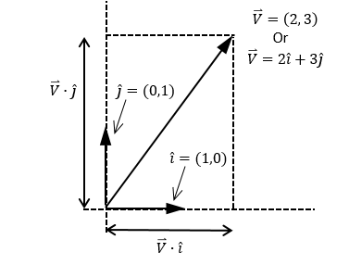

Figure 6-18. The decomposition of vector

In general, as illustrated in Figure 6-19, given the normalized perpendicular component vectors and and any vector , the following formulas are always true.

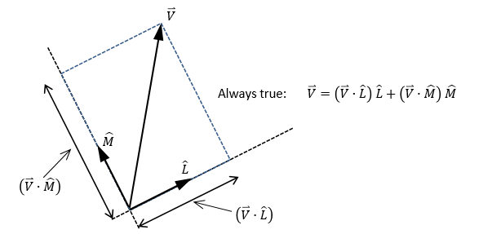

Figure 6-19. Decomposing a vector by two normalized component vectors

Vector decomposition is relevant to this project because of the rotated image axes. Without rotation, an image can be referenced by the familiar normalized perpendicular set of vectors along the default x-axis () and y-axis (). You handled this case in the previous project. You can see an example of this in Figure 6-20.

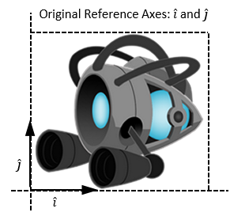

Figure 6-20. An axes-aligned texture

However, after the image has been rotated, the reference vector set no longer resides along the x/y-axes. Therefore, the collision computation must take into account the newly rotated axes and , as shown in Figure 6-21.

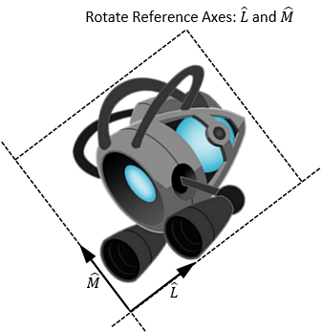

Figure 6-21. A rotated texture and its component vectors

## The General Pixel Collisions Project

This project demonstrates how to detect a collision between two rotated TextureRenderable objects with per-pixel accuracy. Similar to the previous project, a yellow DyePack object (as a test confirmation) will be displayed at the detected colliding position. You can see an example of this project running in Figure 6-22. The source code to this project is defined in the chapter6/6.5.general_pixel_collisions folder.

Figure 6-22. Running the General Pixel Collisions project

The controls of the project are as follows:

* **Arrow keys:** Move the small textured object, the Portal minion
* **P key**: Rotates the small textured object, the Portal minion
* **WASD keys:** Move the large textured object, the Collector minion
* **E key**: Rotates the large textured object, the Collector minion

The goals of the project are as follows:

* To access pixels of a rotated image via vector decomposition
* To support per-pixel accurate collision detection between two rotated textured objects

You can find the same external resource files as in the previous project in the assets folder.

### Modify Pixel Collision to Support Rotation

1. Edit the texture_renderable_pixel_collision.js file and modify the _indexToWCPosition() function.

TextureRenderable.prototype._indexToWCPosition = function (returnWCPos, i, j, xDir, yDir) {

let x = i * this.mXform.getWidth() / this.mElmWidthPixels;

let y = j * this.mXform.getHeight() / this.mElmHeightPixels;

let xDisp = x - (this.mXform.getWidth() * 0.5);

let yDisp = y - (this.mXform.getHeight() * 0.5);

let xDirDisp = [];

let yDirDisp = [];

vec2.scale(xDirDisp, xDir, xDisp);

vec2.scale(yDirDisp, yDir, yDisp);

vec2.add(returnWCPos, this.mXform.getPosition(), xDirDisp);

vec2.add(returnWCPos, returnWCPos, yDirDisp);

}

In the listed code, xDir and yDir are the and normalized component vectors. The variables xDisp and yDisp are the displacements to be offset along xDir and yDir respectively. The returned value of returnWCPos is a simple displacement from the object’s center position along the xDirDisp and yDirDisp vectors. Note that xDirDisp and yDirDisp are the scaled xDir and yDir vectors.

1. In a similar fashion, modify the _wcPositionToIndex() function to support the rotated normalized vector components.

TextureRenderable.prototype._wcPositionToIndex = function (returnIndex, wcPos, xDir, yDir) {

// use wcPos to compute the corresponding returnIndex[0 and 1]

let delta = [];

vec2.sub(delta, wcPos, this.mXform.getPosition());

let xDisp = vec2.dot(delta, xDir);

let yDisp = vec2.dot(delta, yDir);

returnIndex[0] = this.mElmWidthPixels * (xDisp / this.mXform.getWidth());

returnIndex[1] = this.mElmHeightPixels * (yDisp / this.mXform.getHeight());

// recall that xForm.getPosition() returns center, yet

// Texture origin is at lower-left corner!

returnIndex[0] += this.mElmWidthPixels / 2;

returnIndex[1] += this.mElmHeightPixels / 2;

returnIndex[0] = Math.floor(returnIndex[0]);

returnIndex[1] = Math.floor(returnIndex[1]);

}

1. The pixelTouches() function needs to be modified to compute the rotated normalized component vectors.

TextureRenderable.prototype.pixelTouches = function (other, wcTouchPos) {

let pixelTouch = false;

let xIndex = 0, yIndex;

let otherIndex = [0, 0];

let xDir = [1, 0];

let yDir = [0, 1];

let otherXDir = [1, 0];

let otherYDir = [0, 1];

vec2.rotate(xDir, xDir, this.mXform.getRotationInRad());

vec2.rotate(yDir, yDir, this.mXform.getRotationInRad());

vec2.rotate(otherXDir, otherXDir, other.mXform.getRotationInRad());

vec2.rotate(otherYDir, otherYDir, other.mXform.getRotationInRad());

while ((!pixelTouch) && (xIndex < this.mElmWidthPixels)) {

yIndex = 0;

while ((!pixelTouch) && (yIndex < this.mElmHeightPixels)) {

if (this._pixelAlphaValue(xIndex, yIndex) > 0) {

this._indexToWCPosition(wcTouchPos, xIndex, yIndex, xDir, yDir);

other._wcPositionToIndex(otherIndex, wcTouchPos, otherXDir, otherYDir);

if ((otherIndex[0] >= 0) && (otherIndex[0] < other.mElmWidthPixels) &&

(otherIndex[1] >= 0) && (otherIndex[1] < other.mElmHeightPixels)) {

pixelTouch = other._pixelAlphaValue(otherIndex[0], otherIndex[1]) > 0;

}

}

yIndex++;

}

xIndex++;

}

return pixelTouch;

}

The variables xDir and yDir are the rotated normalized component vectors and of this TextureRenderable object, while otherXDir and otherYDir are those of the colliding object. These vectors are used as references for computing transformations from texture index to WC and from WC to texture index.

### Modify GameObject to Support Rotation

Recall that the GameObject class first tests for the bounding-box collision between two objects before it actually invokes the much more expensive per-pixel collision computation. As illustrated in Figure 6-14, the BoundingBox object does not support object rotation correctly, and the following code remedies this shortcoming:

pixelTouches(otherObj, wcTouchPos) {

// only continue if both objects have getColorArray defined

// if defined, should have other texture intersection support!

let pixelTouch = false;

let myRen = this.getRenderable();

let otherRen = otherObj.getRenderable();

if ((typeof myRen.pixelTouches === "function") && (typeof otherRen.pixelTouches === "function")) {

if ((myRen.getXform().getRotationInRad() === 0) && (otherRen.getXform().getRotationInRad() === 0)) {

// no rotation, we can use bbox ...

let otherBbox = otherObj.getBBox();

if (otherBbox.intersectsBound(this.getBBox())) {

myRen.setColorArray();

otherRen.setColorArray();

pixelTouch = myRen.pixelTouches(otherRen, wcTouchPos);

}

} else {

// One or both are rotated, compute an encompassing circle

// by using the hypotenuse as radius

let mySize = myRen.getXform().getSize();

let otherSize = otherRen.getXform().getSize();

let myR = Math.sqrt(0.5*mySize[0]*0.5*mySize[0] + 0.5*mySize[1]*0.5*mySize[1]);

let otherR = Math.sqrt(0.5*otherSize[0]*0.5*otherSize[0] + 0.5*otherSize[1]*0.5*otherSize[1]);

let d = [];

vec2.sub(d, myRen.getXform().getPosition(), otherRen.getXform().getPosition());

if (vec2.length(d) < (myR + otherR)) {

myRen.setColorArray();

otherRen.setColorArray();

pixelTouch = myRen.pixelTouches(otherRen, wcTouchPos);

}

}

}

return pixelTouch;

}

The listed code shows that if either of the colliding objects is rotated, then two encompassing circles are used to determine whether the objects are sufficiently close for the expensive per-pixel collision computation. The two circles are defined with radii equal to the hypotenuse of the x/y size of the corresponding TextureRenderable objects. The per-pixel collision detection is invoked only if the distance between these two circles is less than the sum of the radii.

### Test Generalized Per-Pixel Collision

The code for testing the rotated TextureRenderable objects is essentially identical to that from the previous project, with the exception of the two added controls for rotations. The details of the implementation are not shown. You can now run the project, rotate the two objects, and observe the accurate collision results.

# Per-Pixel Collisions for Sprites

The previous project implicitly assumes that the Renderable object is covered by the entire texture map. This assumption means that the per-pixel collision implementation does not support sprite or animated sprite objects. In this section, you will see how to remedy this deficiency.

## The Sprite Pixel Collisions Project

This project demonstrates how to move an animated sprite object around the screen and perform per-pixel collision detection with other objects. The project tests for the correctness between collisions of TextureRenderable, SpriteRenderable, and SpriteAnimateRenderable objects. You can see an example of this project running in Figure 6-23. The source code to this project is defined in the chapter6/6.6.sprite_pixel_collisions folder.

Figure 6-23. Running the Sprite Pixel Collisions project

The controls of the project are as follows:

* **Arrow and P keys:** Move and rotate the Portal minion
* **WASD keys:** Move the Hero
* **L, R, H, B keys**: Select the target for colliding with the Portal minion

The goal of the project is as follows:

* To implement per-pixel collision detection for sprite and animated sprite objects

You can find the following external resource files in the assets folder: the fonts folder that contains the default system fonts, minion_sprite.png, and minion_portal.png.

### Implement Per-Pixel Collision for SpriteRenderable

Edit sprite_renderable.js to implement the per-pixel specific support for SpriteRenderable objects.

1. Modify the SpriteRenderable constructor to call the _setTexInfo() function to initialize per-pixel collision parameters, this function is defined in the next step.

constructor(myTexture) {

super(myTexture);

super._setShader(shaderResources.getSpriteShader());

// sprite coordinate

// bounds of texture coordinate (0 is left, 1 is right)

this.mElmLeft = 0.0;

this.mElmRight = 1.0;

this.mElmTop = 1.0; // 1 is top and 0 is bottom of image

this.mElmBottom = 0.0; //

// sets info to support per-pixel collision

this._setTexInfo();

}

1. Define the _setTexInfo() function to override instance variables defined in the TextureRenderable superclass. Instead of the entire texture image, the instance variables now identify the currently active sprite element.

_setTexInfo() {

let imageW = this.mTextureInfo.mWidth;

let imageH = this.mTextureInfo.mHeight;

this.mElmLeftIndex = this.mElmLeft * imageW;

this.mElmBottomIndex = this.mElmBottom * imageH;

this.mElmWidthPixels = ((this.mElmRight - this.mElmLeft) * imageW) + 1;

this.mElmHeightPixels = ((this.mElmTop - this.mElmBottom) * imageH) + 1;

}

Notice that instead of the dimension of the entire texture map, mElmWidthPixel and mElmHeightPixel now contain pixel values that correspond to the dimension of a single sprite element in the sprite sheet.

1. Remember to call the _setTexInfo() function when the current sprite element is updated in the setElementUVCoordinate() and setElementPixelPositions() functions.

setElementUVCoordinate(left, right, bottom, top) {

this.mElmLeft = left;

this.mElmRight = right;

this.mElmBottom = bottom;

this.mElmTop = top;

this._setTexInfo();

}

setElementPixelPositions(left, right, bottom, top) {

// entire image width, height

let imageW = this.mTextureInfo.mWidth;

let imageH = this.mTextureInfo.mHeight;

this.mElmLeft = left / imageW;

this.mElmRight = right / imageW;

this.mElmBottom = bottom / imageH;

this.mElmTop = top / imageH;

this._setTexInfo();

}

### Support Accesses to Sprite Pixels in TextureRenderable

Edit the texture_renderable_pixel_collision.js file and modify the _pixelAlphaValue() function to support pixel accesses with a sprite element index offset.

TextureRenderable.prototype._pixelAlphaValue = function (x, y) {

y += this.mElmBottomIndex;

x += this.mElmLeftIndex;

x = x * 4;

y = y * 4;

return this.mColorArray[(y * this.mTextureInfo.mWidth) + x + 3];

}

### Test Per-Pixel Collision for Sprites in MyGame

The code for testing this project is a simple modification from previous projects, and the details are not listed. It is important to note the different object types in the scene.

* Portal minion: A simple TextureRenderable object
* Hero and Brain: SpriteRenderable objects where the textures shown on the geometries are sprite elements defined in the minion_sprite.png sprite sheet
* Left and Right minions: SpriteAnimateRenderable objects with sprite elements defined in the top two rows of the minion_sprite.png animated sprite sheet

You can now run this project and observe the correct results from the collisions of the different object types.

1. Try moving the Hero object and observe how the Brain object constantly seeks out and collides with it. This is the case of collision between two SpriteRenderable objects.
2. Press the L/R keys and then move the Portal minion with the WASD keys to collide with the Left or Right minions. Remember that you can rotate the Portal minion with the P key. This is the case of collision between TextureRenderable and SpriteAnimatedRenderable objects.
3. Type the H key and then move the Portal minion to collide with the Hero object. This is the case of collision between TextureRenderable and SpriteRenderable objects.
4. Type the B key and then move the Portal minion to collide with the Brain object. This is the case of collision between rotated TextureRenderable and SpriteRenderable objects.

# Summary

This chapter showed you how to encapsulate common behaviors of objects in games and demonstrated the benefits of the encapsulation in the forms of simpler and better organized control logic in the client MyGame test levels. You reviewed vectors in 2D space. A vector is defined by its direction and magnitude. Vectors are convenient for describing displacements (velocities). You reviewed some foundational vector operations, including normalization of a vector and how to calculate dot and cross products. You worked with these operators to implement the front-facing direction capability and create simple autonomous behaviors such as pointing toward a specific object and chasing.

The need for detecting object collisions becomes prominent as the behaviors of objects increase in sophistication. The axes-aligned bounding boxes, or AABB, were introduced as a crude and yet computationally efficient solution for approximating object collisions. You learned the algorithm for per-pixel-accurate collision detection and that it is accurate but computationally expensive. You now understand how to mitigate the computational cost in two ways. First, you invoke the pixel-accurate procedure only when the objects are sufficiently close to each other, such as when their bounding boxes collide. Second, you execute the pixel iteration process based on the texture with a lower resolution. When implementing pixel-accurate collision, you began with tackling the basic case of working with axis-aligned textures. After that implementation, you went back and added support for collision detection between rotated textures. Finally, you generalized the implementation to support collisions between sprite elements. Solving the easiest case first lets you test and observe the results and helps define what you might need for the more advanced problems (rotation and subregions of a texture in this case).

At the beginning of this chapter, your game engine supported interesting sophistication in drawing ranging from the abilities to define WC space, to view the WC space with the Camera object, and to draw visually pleasing textures and animations on objects. However, there was no infrastructure for supporting the behaviors of the objects. This shortcoming resulted in clustering of initialization and control logic in the client-level implementations. With the object behavior abstraction, mathematics, and collision algorithms introduced and implemented in this chapter, your game engine functionality is now better balanced. The clients of your game engine now have tools for encapsulating specific behaviors and detecting collisions. The next chapter reexamines and enhances the functionality of the Camera object. You will learn to control and manipulate the Camera object and work with multiple Camera objects in the same game.

# Game Design Considerations

Chapters 1–5 introduced foundation techniques for drawing, moving, and animating objects on the screen. The Scene Objects project from Chapter 4 described a simple interaction behavior and showed you how to change the game screen based on the location of a rectangle. Recall that moving the rectangle to the left boundary caused the level to visually change, and the Audio Support project added contextual sound to reinforce the overall sense of presence. Although it’s possible to build an intriguing (albeit simple) puzzle game using only the elements from Chapters 1–5, things get much more interesting when you can integrate object detection and collision triggers; these behaviors form the basis for many common game mechanics and provide opportunities to design a wide range of interesting gameplay options.

Starting with the Game Objects project, you can see how the screen elements start working together to convey the game setting. Even with the interaction in this project limited to character movement, the setting is beginning to resolve into something that feels coherent. The hero character appears to be flying through a moving scene populated by a number of mechanized robots; there’s also a small object in the center of the screen that you might imagine could become some kind of special pickup.

Even at this basic stage of development, it’s possible to brainstorm game mechanics that could potentially form the foundation for a full game. If you were designing a simple game mechanic based on only the screen elements found in the Game Object Abstraction project, what kind of behaviors would you choose and what kind of interactions would you require? As one example, imagine that the hero character must avoid colliding with the flying robots and that perhaps some of the robots will detect and follow the hero; maybe the hero is also “zapped” if she comes into contact with a robot. Imagine also that the small object in the center of the screen allows the hero to be invincible for a certain duration. With these few basic interactions, you have opened opportunities to explore mechanics and levels typically associated with familiar game genres, all with just the inclusion of the object detection, chase, and collision behaviors covered in Chapter 6. Try this design exercise yourself using just the elements shown in the Game Object Abstraction project. What kinds of simple conditions and behaviors might you design to make your experience unique? How many ways can you think of to use the small object in the center of the screen? The final design project in Chapter 11 will explore these themes in greater detail.

This is also a good opportunity to brainstorm some of the other nine elements of game design discussed in Chapter 1. What if the game wasn’t set in space with robots? Perhaps the setting is in a forest, or under water, or even something completely abstract. How might you incorporate audio to enhance the sense of presence and reinforce the game setting? You’ll probably be surprised by the variety of settings and scenarios you come up with, and keeping yourself limited to just the elements and interactions covered through Chapter 6 is actually a beneficial exercise; design constraints often help the creative process by shaping and guiding your ideas.

The Vectors: Front and Chase project is interesting from both a game mechanic and presence perspective. Many games, of course, require objects in the game world to detect the hero character and will either chase or try to avoid the player (or both if the object has multiple states). The project also demonstrates two different approaches to chase behavior, instant and smooth pursuit, and the game setting will typically influence which behavior you choose to implement. The choice between instant and smooth pursuit is a great example of subtle behaviors that can significantly influence the sense of presence. If you were designing a game where ships were interacting on the ocean, for example, you would likely want their pursuit behavior to take real-world inertia and momentum into consideration because ships can’t instantly turn and respond to changes in movement; rather, they move smoothly and gradually, demonstrating a noticeable delay in how quickly they can respond to a moving target. Most objects in the physical world will display the same inertial and momentum constraint to some degree, but there are also situations where you may want game objects to respond directly to path changes (or, perhaps, you want to intentionally flout real-world physics and create a behavior that isn’t based on the limitations of physical objects). The key is to always be intentional about your design choices, and it’s good to remember that virtually no implementation details are too small to be noticed by players.

The Bounding Box and Collisions project introduces the key element of detection to your design arsenal. Detection allows you to begin including more robust cause-and-effect mechanics that form the basis for many game interactions. Chapter 6 discusses the trade-offs of choosing between the less precise but more performant bounding box collision detection method versus the precise but resource-intensive per-pixel detection method. There are situations where the bounding-box approach is sufficient, but if players perceive collisions to be arbitrary because the bounding boxes are too removed from the actual visual objects, it can negatively impact the sense of presence. Detection and collision are even more powerful design tools when coupled with the result from the Per Pixel Collisions project. Although the dye pack in this example was used to indicate the first point of collision, you can imagine building interesting casual chains around a new object being produced as the result of two objects colliding (for example, player pursues object, player collides with object, object “drops” a new object that enables the player to do something they couldn’t do before). Game objects that move around the game screen will typically be animated, of course, so the Sprite Pixel Collisions project reviewed how to implement collision detection when the object boundaries aren’t stationary.

With the addition of the techniques in Chapter 6, you now have a critical mass of behaviors that can be combined to create truly interesting game mechanics relevant to many genres from action games to puzzlers. Of course, game mechanic behaviors are only one of the nine elements of game design and typically aren’t sufficient on their own to create a magical gameplay experience: the setting, visual style, meta game elements, and the like all have something important to contribute. The good news is that creating a memorable game experience need not be as elaborate as you often believe. Great games continue being produced based on relatively basic combinations of the behaviors and techniques covered in Chapters 1–6. The games that often shine the brightest aren’t always the most complex, but rather they’re often the games where every aspect of each of the nine elements of design is intentional and working together in harmony. If you give the appropriate attention and focus to all aspects of the game design, you’re on a great track to produce something great whether you’re working on your own or you’re part of a large team.