EXPERIMENT 1: GIT AND GITHUB OPERATIONS
Aim:
To learn and perform basic Git and GitHub operations including repository creation, file tracking, committing changes, branching, merging, pushing to GitHub, and cloning repositories.
Concepts:
Git
Git is a distributed version control system used to track changes in files and source code over time. It allows developers to maintain different versions of a project, collaborate efficiently, and revert to previous versions when needed.
GitHub
GitHub is a cloud-based platform that hosts Git repositories. It enables developers to store projects online, collaborate with others, and manage source code from anywhere.
Repository (Repo)
A repository is a storage location for a project where Git tracks all files and their version history.
Commit
A commit is a snapshot of the project's current state. It records changes made to files along with a descriptive message.
Branch
A branch is an independent line of development. It allows users to work on new features or modifications without affecting the main project.
Merge
Merging combines changes from one branch into another branch.
Push
The push command uploads local repository changes to a remote repository such as GitHub.
Clone
Cloning creates a copy of a remote repository on a local computer.
File States in Git
- Modified – File has been changed but not staged.
- Staged – File is ready to be committed.
- Committed – Changes have been saved in the local repository.

Commands Used:
Commands Used
Check Git Installation
git --version
Configure Git
git config --global user.name "Your Name"
git config --global user.email "your_email@example.com"
Initialize Repository
git init
Check Repository Status
git status
Add Files to Staging Area
git add .
Commit Changes
git commit -m "first commit"
Connect Local Repository to GitHub
git remote add origin https://github.com/username/repository.git
Rename Branch to Main
git branch -M main
Push Repository to GitHub
git push -u origin main
Create and Switch to a New Branch
git checkout -b test
Switch to Existing Branch
git checkout main
Display Available Branches
git branch
Merge Branches
git merge test
Push Test Branch
git push -u origin test
Clone Repository
git clone https://github.com/username/repository.git

Screenshots:
Git initialisation
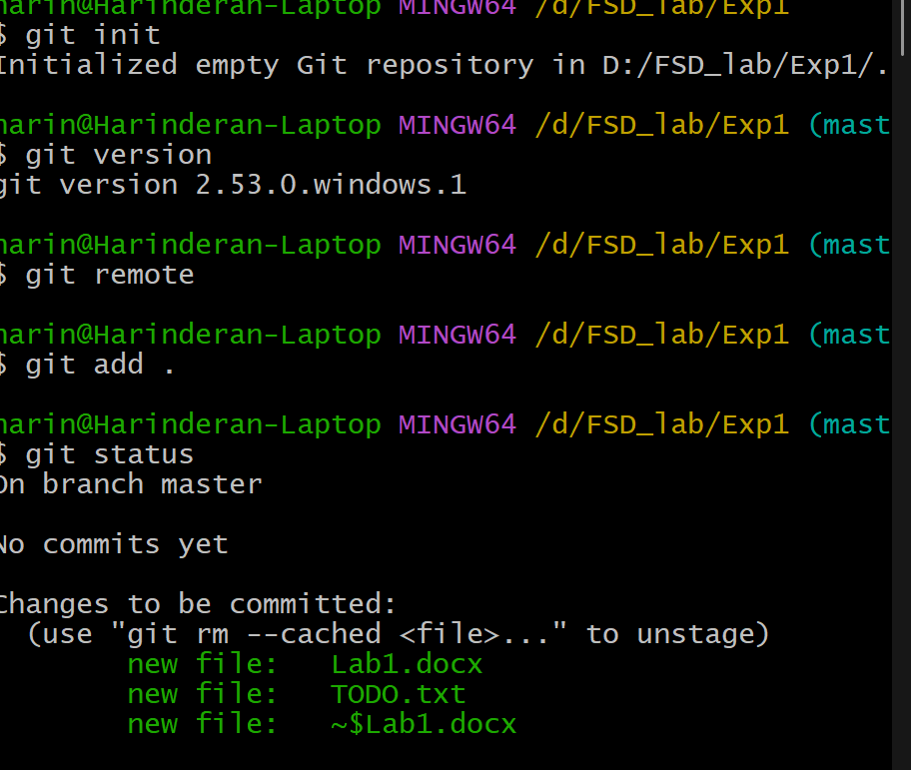

Git commit:
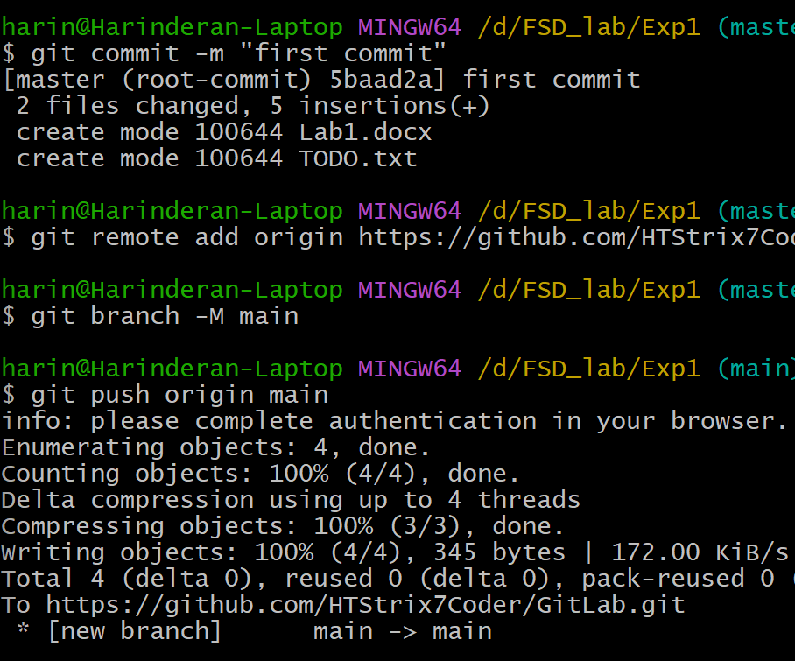
Git Modification:
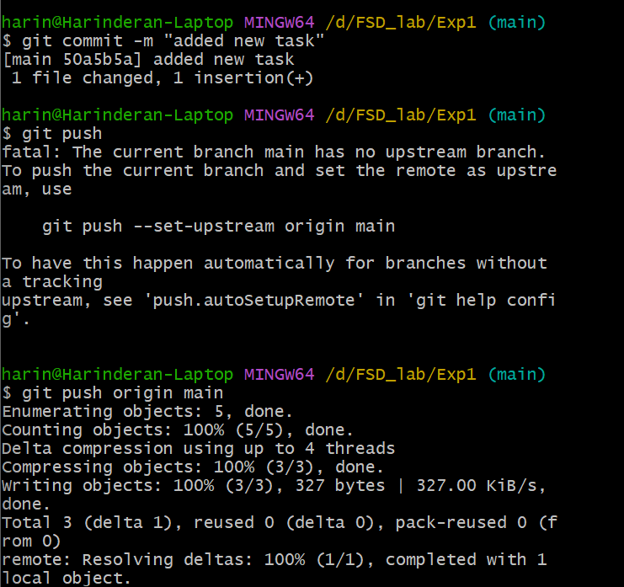

Git create new branch
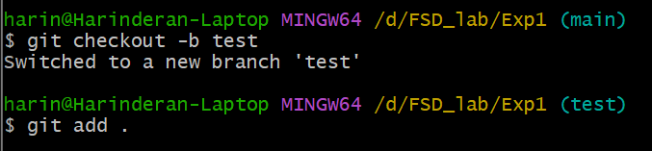

Git Merge new branch to main branch after changes
