

**FPT ACADEMY INTERNATIONAL**

**FPT – APTECH COMPUTER EDUCATION**

Project:

JADON EVENT MANAGEMNT WEBSITE



Class code:

Curriculum: 6715

Team: Group 2

Hoang Toan Thang (Team Leader) Student1236866

Quach Gia Lam Student1235029

Nguyen Ngoc Thach Student1225467

Instructor:

Le Mong Thuy

December – 2019

**This is to certify that**

**Mr./Ms.:**

Hoang toan Thang

Quach Gia Lam

Nguyen Ngoc Thach

**has successfully designed & developed**

eProject: JADON Website link: https://htt-01.github.io/jadon-191215/

**Submitted by:**

Hoang Toan Thang

**Date of issue:**

17-Dec-2019

**Authorised Signature:**

Contents

1. Acknowledgements 2

2. eProject Synopsis 2

3. eProject Analysis 3

4. eProject Design 3

4.1. DFD’s (Data Function Diagram) 3

4.2. FlowCharts 3

4.3. Process Diagrams 3

4.4. Database Design / Structure 3

5. Screen Shot’s 3

6. Source Code with Comments 3

7. User Guide 3

8. Developer’s Guide 3

8.1. Module Descriptions 3

# Acknowledgements

# eProject Synopsis

# eProject Analysis

## Problem definition

The Developer Team is presented with a task to build a website for an event management company. The website is defined as a front-end interaction of JADON with its costumers that will be devised with appropriate tools to link to back-end database in the later stage. The team will have to solve the following problems:

* What is JADON business and what JADON want to communicate to the users.
* Who are the user of the website and what are their priorities in terms of demand for information.
* How to categorize and group information into pages to tell an interesting story about JADON services, experience, capabilities. At the same time the user can immediately see what service they are looking for
* How to gather all information from JADON and acquire additional material to follow the defined narrative.
* As the front-end interaction, how to provide users with smoothest access in the fastest and most attractive manner. What is the fastest ways to contact or make reservation with JADON.
* The website have to have the richest of information without redundancy.

The website is to be developed for the Windows Platform using HTML5, JavaScript and Geolocation. The site should work well in all leading browsers including Chrome, IE, Firefox etc.

## Requirement Specification:

### Client:

JADON Event Management Services

### Business/Project Objective

JADON Event Management Services in the city is famous for catering their services by organizing the complete events like Marriage, Birthdays, Wedding Anniversaries, Promotion parties, Annual Shows at School, Offices and so on. For each type of events there varieties of formats or themes to execute and also charges also keeps on varying based on the type of theme selected. With a view that user has proper idea about the task to performed in event the JADON services wishes to design the website.

### Input provided by Client

#### Input to the system

List of business categories and detail description

Interview with managers and staff to capture the business spirit and its inspiration

Documents and graphic materials to depict the business and its categories

Additional copy writings and graphics procured by the client requested by Developer Team.

#### Output from the system

Website with categorize services, experience, resource, delivery, contact for the user to understand and to use services of JADON including:

* The Home page should be designed stating some information about the event services and proper template must be designed.
* Uniformity and Navigation must be made smooth throughout the website.
* Different themes for each category along with the list of the task which they perform must be stated.
* Some reviews and past events details.
* Press reviews.
* Gallery section must be included.
* Our team Members.
* About us
* The “Contact Us” page should have the Address of the Company and the mail address which when clicked will invoke the local mail client from where they can send an email. Address of the Company should be displayed using GeoLocation API (eg. GoogleMaps).
* Feedback must be allowed to enter by the viewer
* Site map, Gallery, about us, Queries link, Contact us link must be added.

#### Process involved in the system

Each page will represent a category of JADON’s business at different level. All the text, images, graphics must be programmed to load, position and present as intended by the Designer and following approved story line.

User can follow the links to other pages to continue the story line. These links are structured so that user can get to any information within couple of click.

Information or queries from user/customer to JADON can be implemented by a click from any page to a query form or email. Access to JADON’s social media account also be done by the same way.

#### Expected delivery date

All deliverable is to be submitted by 7/1/2020.

#### List of deliverables

Project documentation

User guide

Complete Source code and supporting Files and Folders.

### Hardware and software requirement

#### Hardware requirement

A minimum computer system that will help you access all the tools in the courses is a Pentium 166 or better

64 Megabytes of RAM or better

#### Software requirement

Notepad/HTML editor

Dreamweaver

IE 5.0/ Netscape 6.0

The website is to be developed for the Windows Platform using HTML5, JavaScript and Geolocation. The site should work well in all leading browsers including Chrome, IE, Firefox etc.

### Scope of work

JADON Event Management Services in the city is famous for catering their services by organizing the complete events like Marriage, Birthdays, Wedding Anniversaries, Promotion parties, Annual Shows at School, Offices and so on.

The scope of work for the Developer Team is to design a website which is defined as a front-end interaction of JADON with its costumers. The website provides everything customers need to know about JADON such as services, experience, resource, delivery, contact. It act as the gateway to promote JADON and attract new business through online reservation and exchange nformation.

## Architecture and Design of the Project

## Site Map

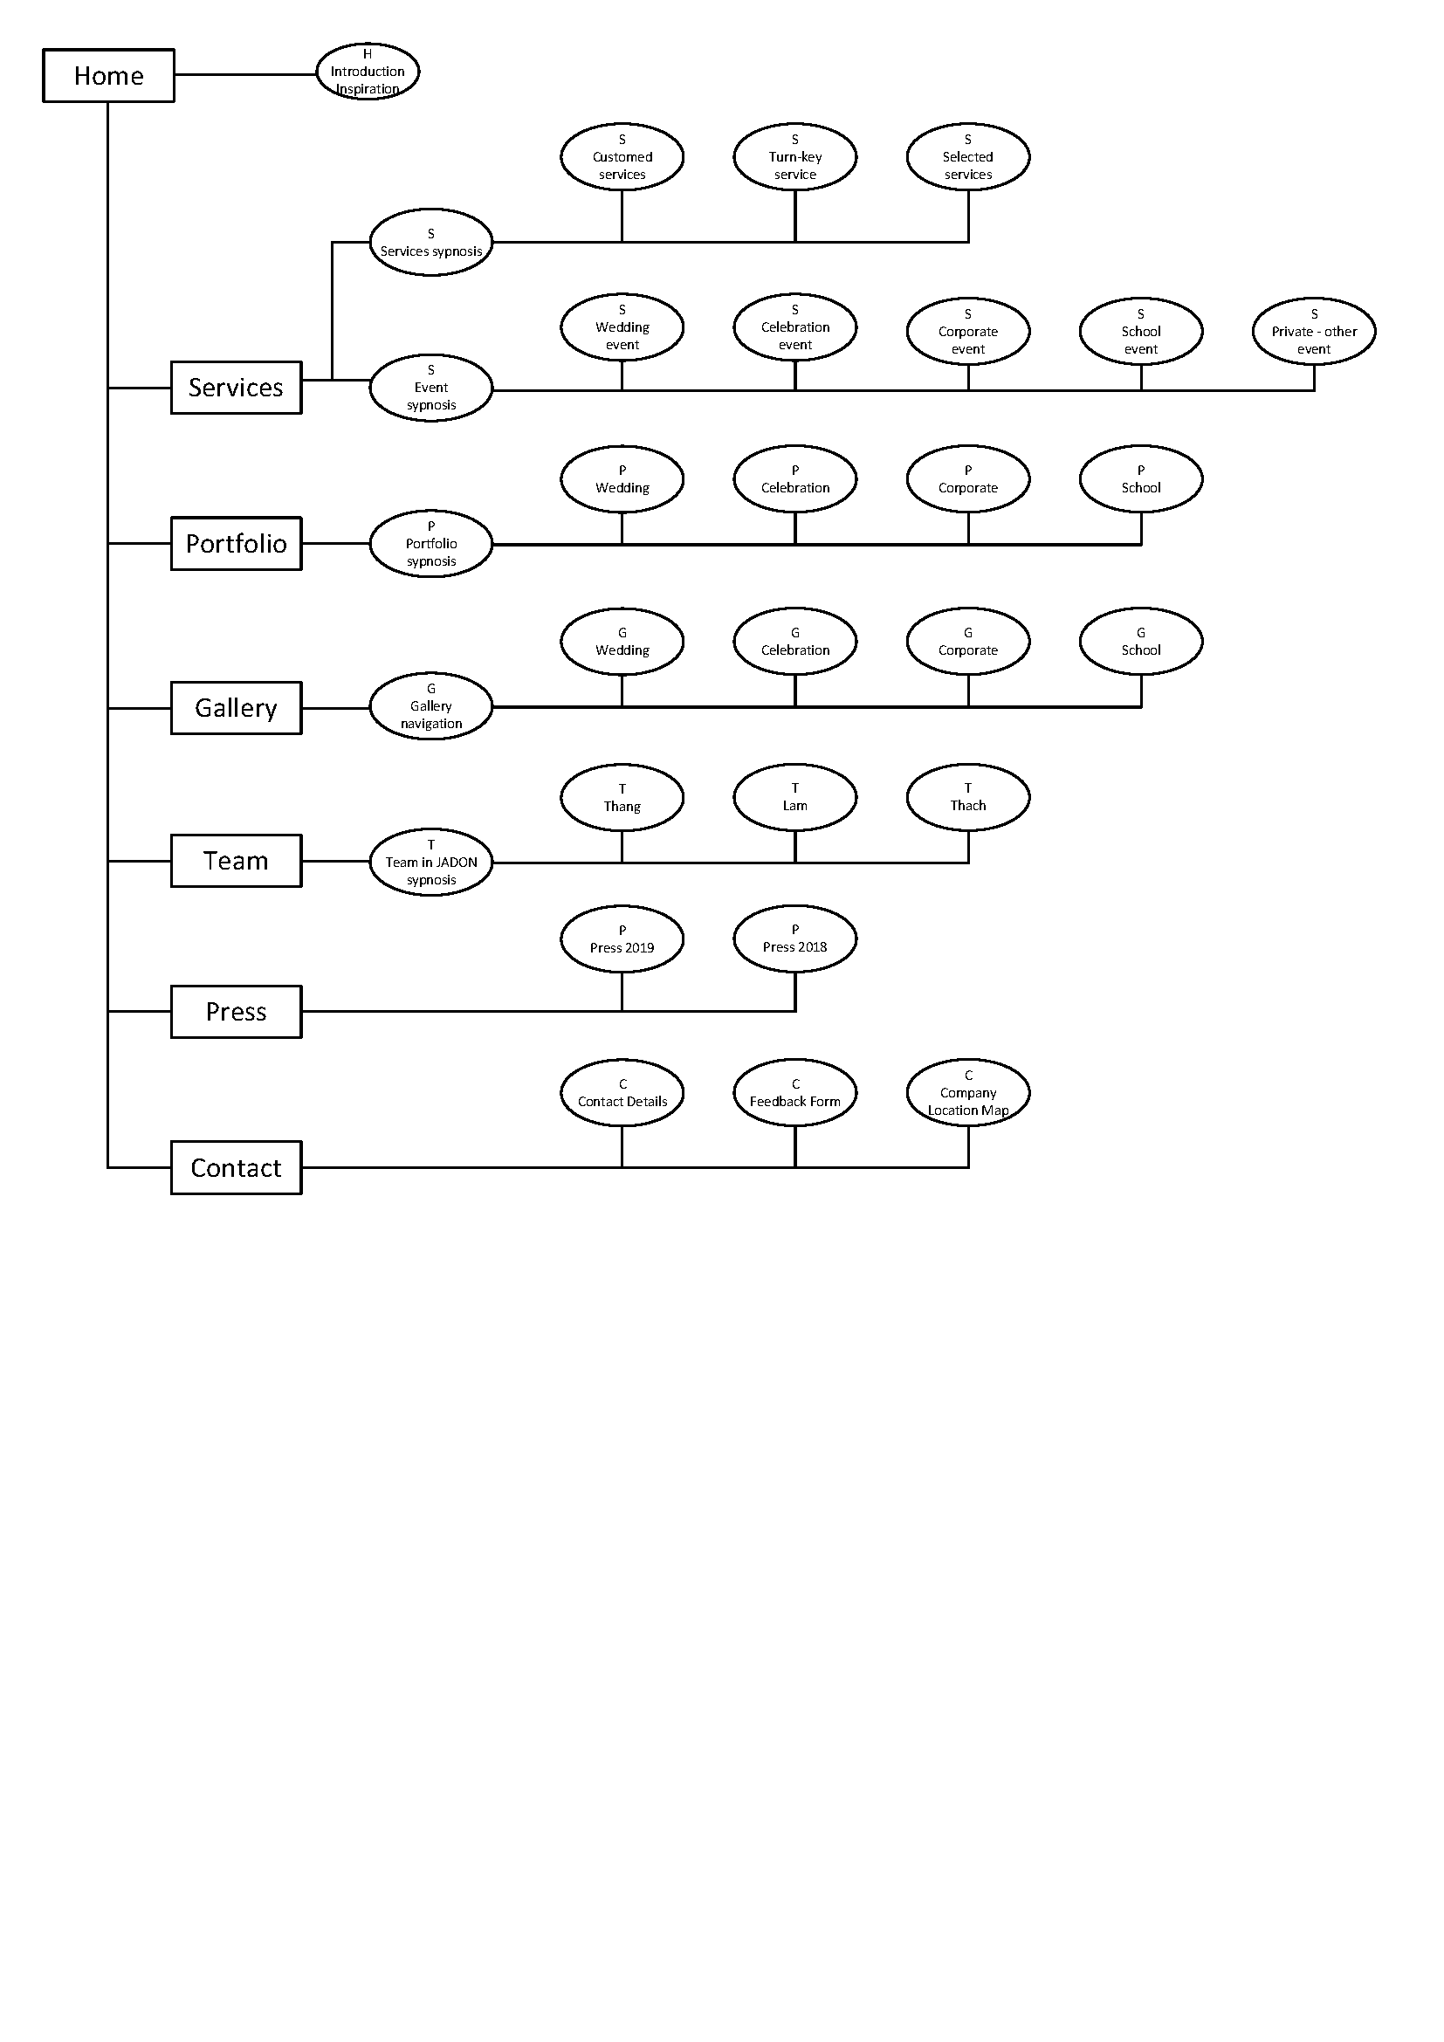

## Task Sheet

Refer to 9.1 Appendix 9-1: Task Sheet

## Check list of validations

|  |  |
| --- | --- |
| **Option** | **Validated** |
| Do all numeric variables have a default value of zero? |  |
| Does the administrator have all the rights to create and delete the records? |  |
| Are all the records properly fed into the appropriate database? |  |
| Have all the modules been properly integrated and are completely functional? |  |
| Have all the Design and Coding Standards been followed and impletemented? |  |
| Is the GUI design consistent all over? |  |
| Is the navigation sequence correct through all the forms/screens in the application? |  |
| Is exception handling mechanism implemented in all the screens? |  |
| Are all the program codes working? |  |

## Submission checklist

|  |  |  |  |  |  |
| --- | --- | --- | --- | --- | --- |
| Sr. No. | Particulars | Yes | No | NA | Comments |
| 1 | Are all the users able to search for a particular record? |  |  |  |  |
| 2 | Are all the old records properly saved and retrieved when required? |  |  |  |  |
| 3 | Have all the modules been properly integrated and are completely functional? |  |  |  |  |
| 4 | Are the GUI content devoid of spelling mistakes? |  |  |  |  |
| 5 | Is the application user-friendly? |  |  |  |  |
| 6 | Is the project published properly into a setup file? |  |  |  |  |

# eProject Design

## FlowCharts

## Process Diagrams

## Mock-up Design

Refer to 9.2 Appendix 9-2: Mock-up of Website layout

# Screen Shot’s

# Source Code with Comments

# User Guide

# Developer’s Guide

## Module Descriptions

# Appendices

## Appendix 9-1: Task Sheet

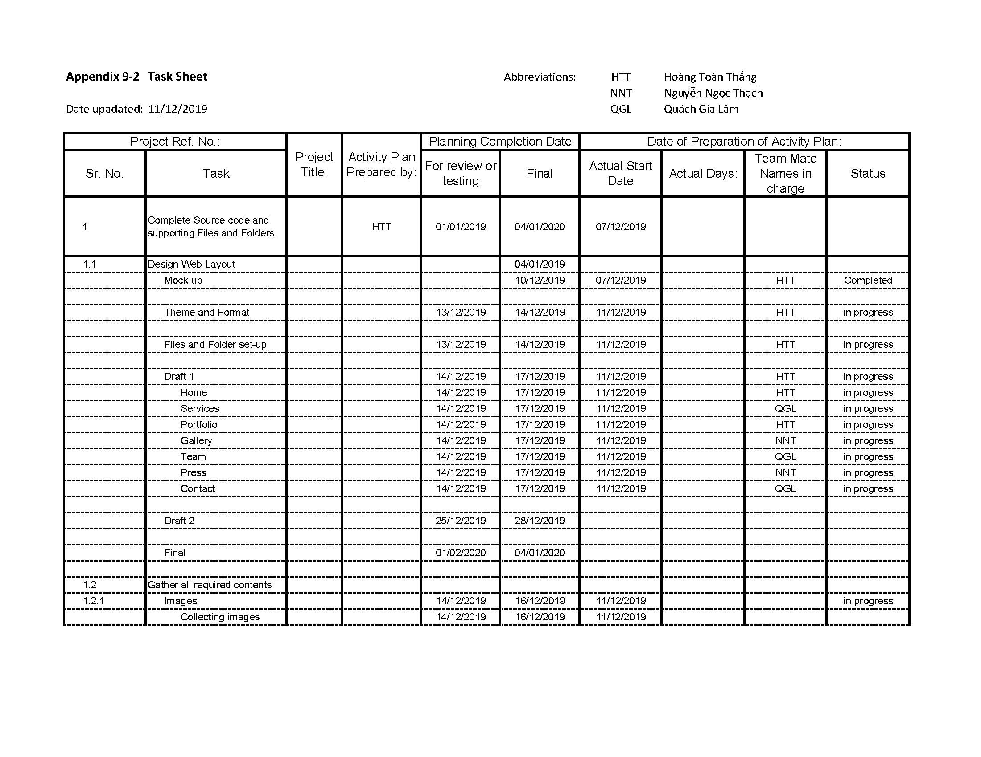

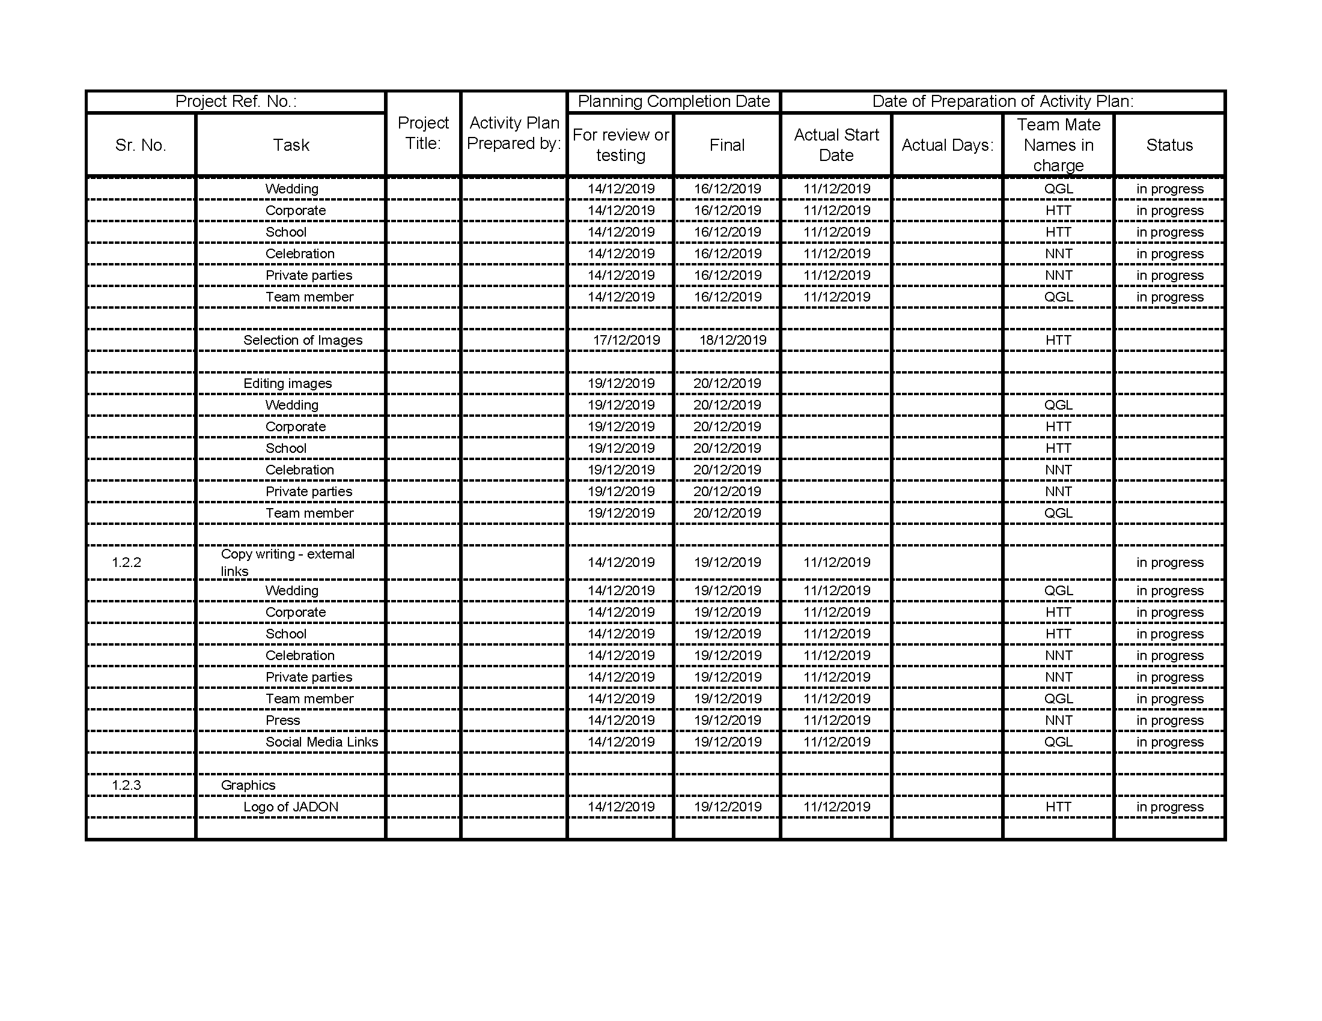

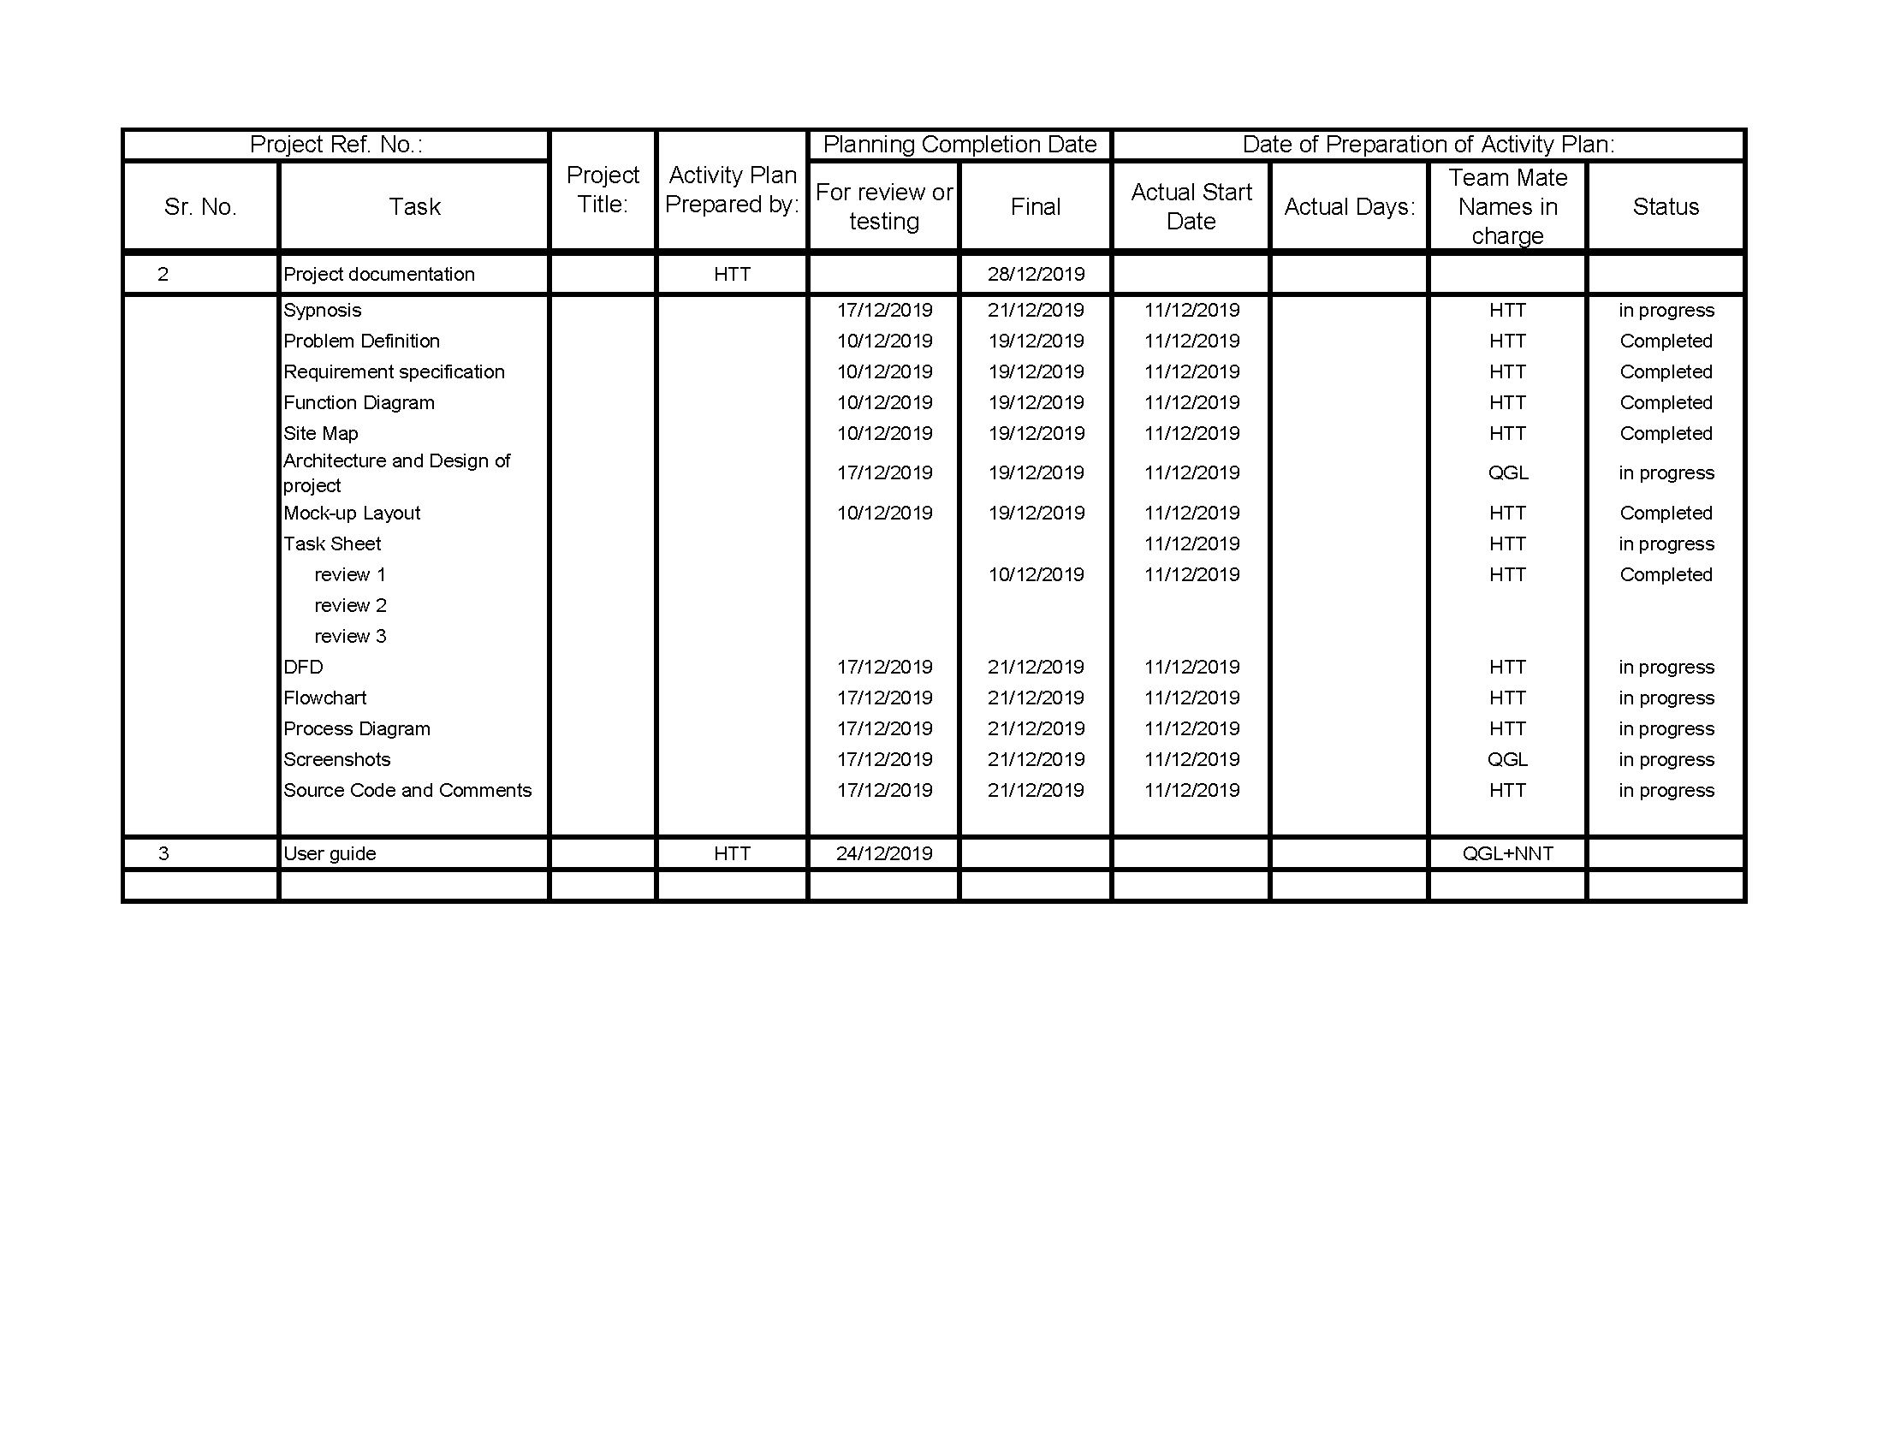

## Appendix 9-2: Mock-up of Website layout

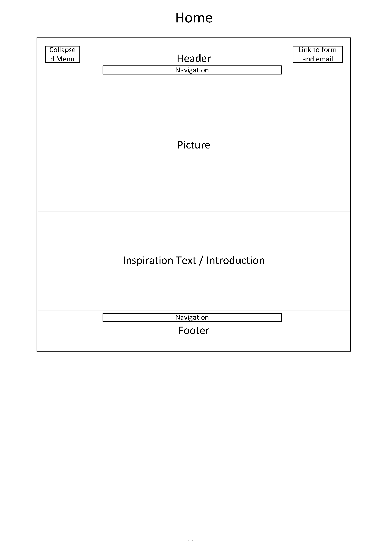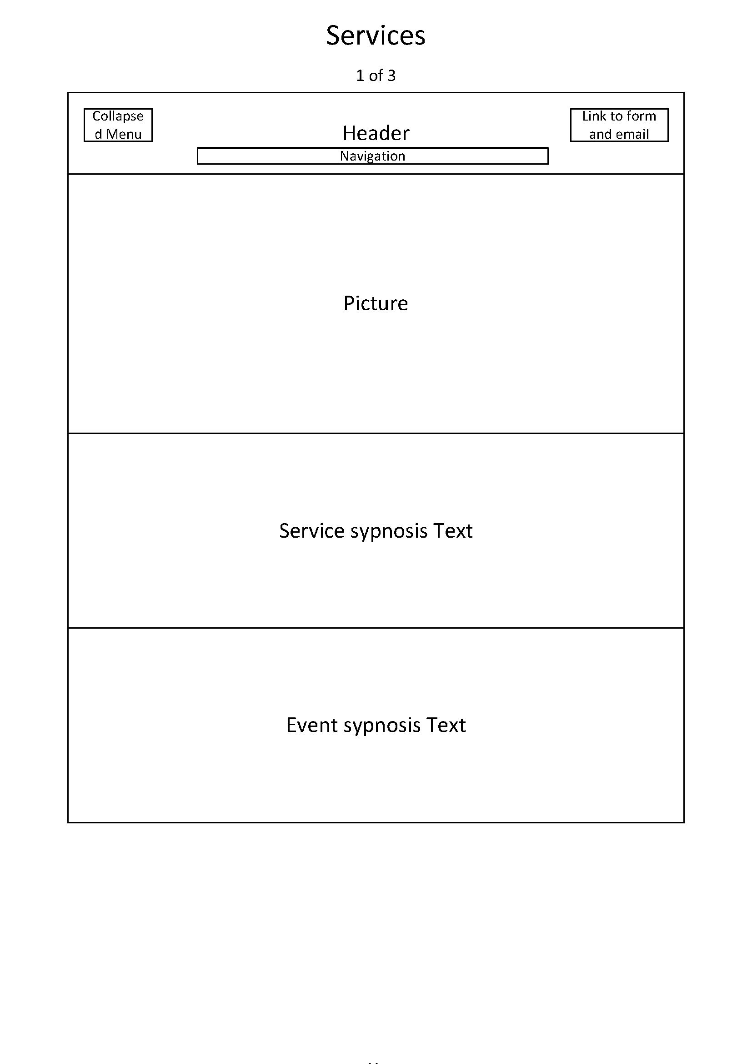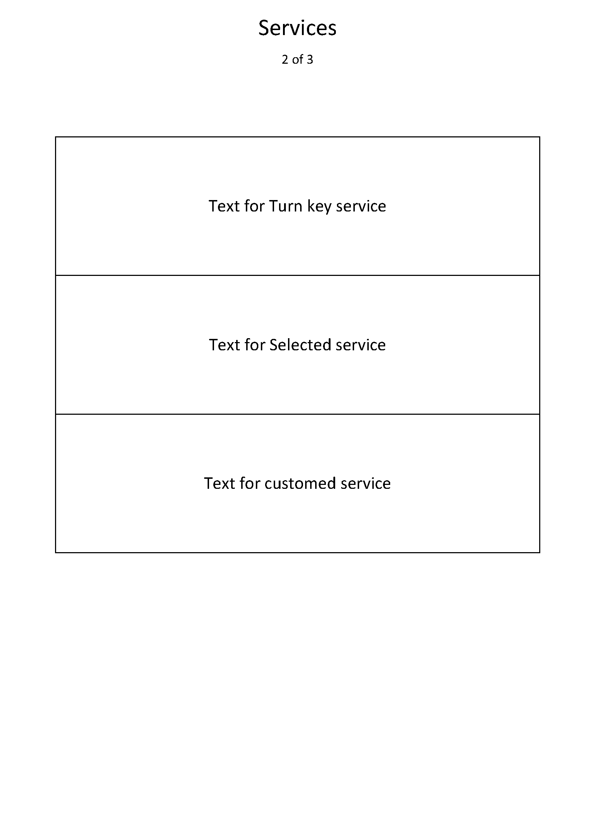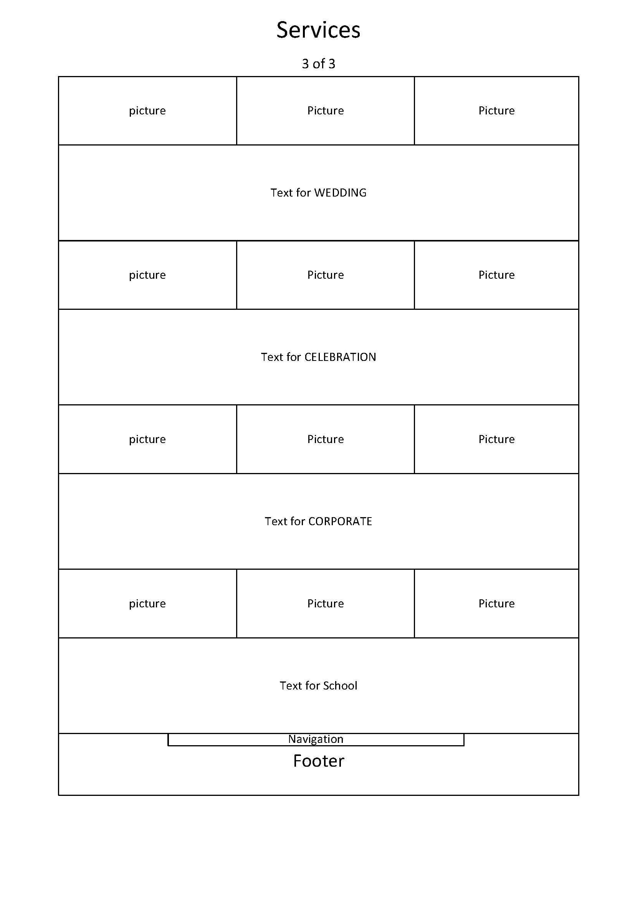

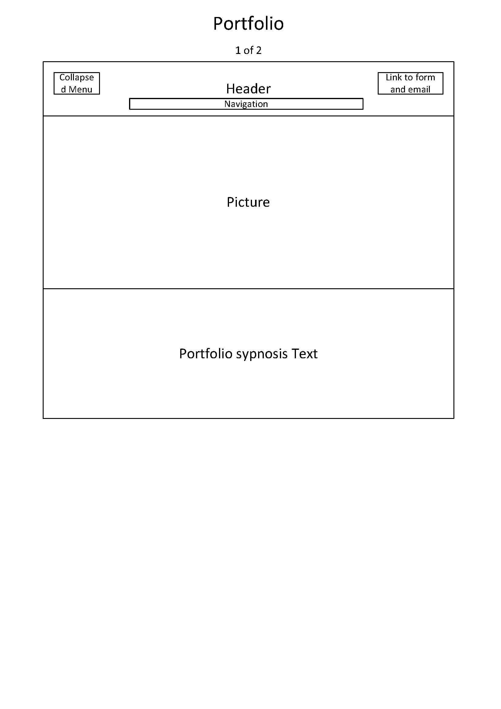

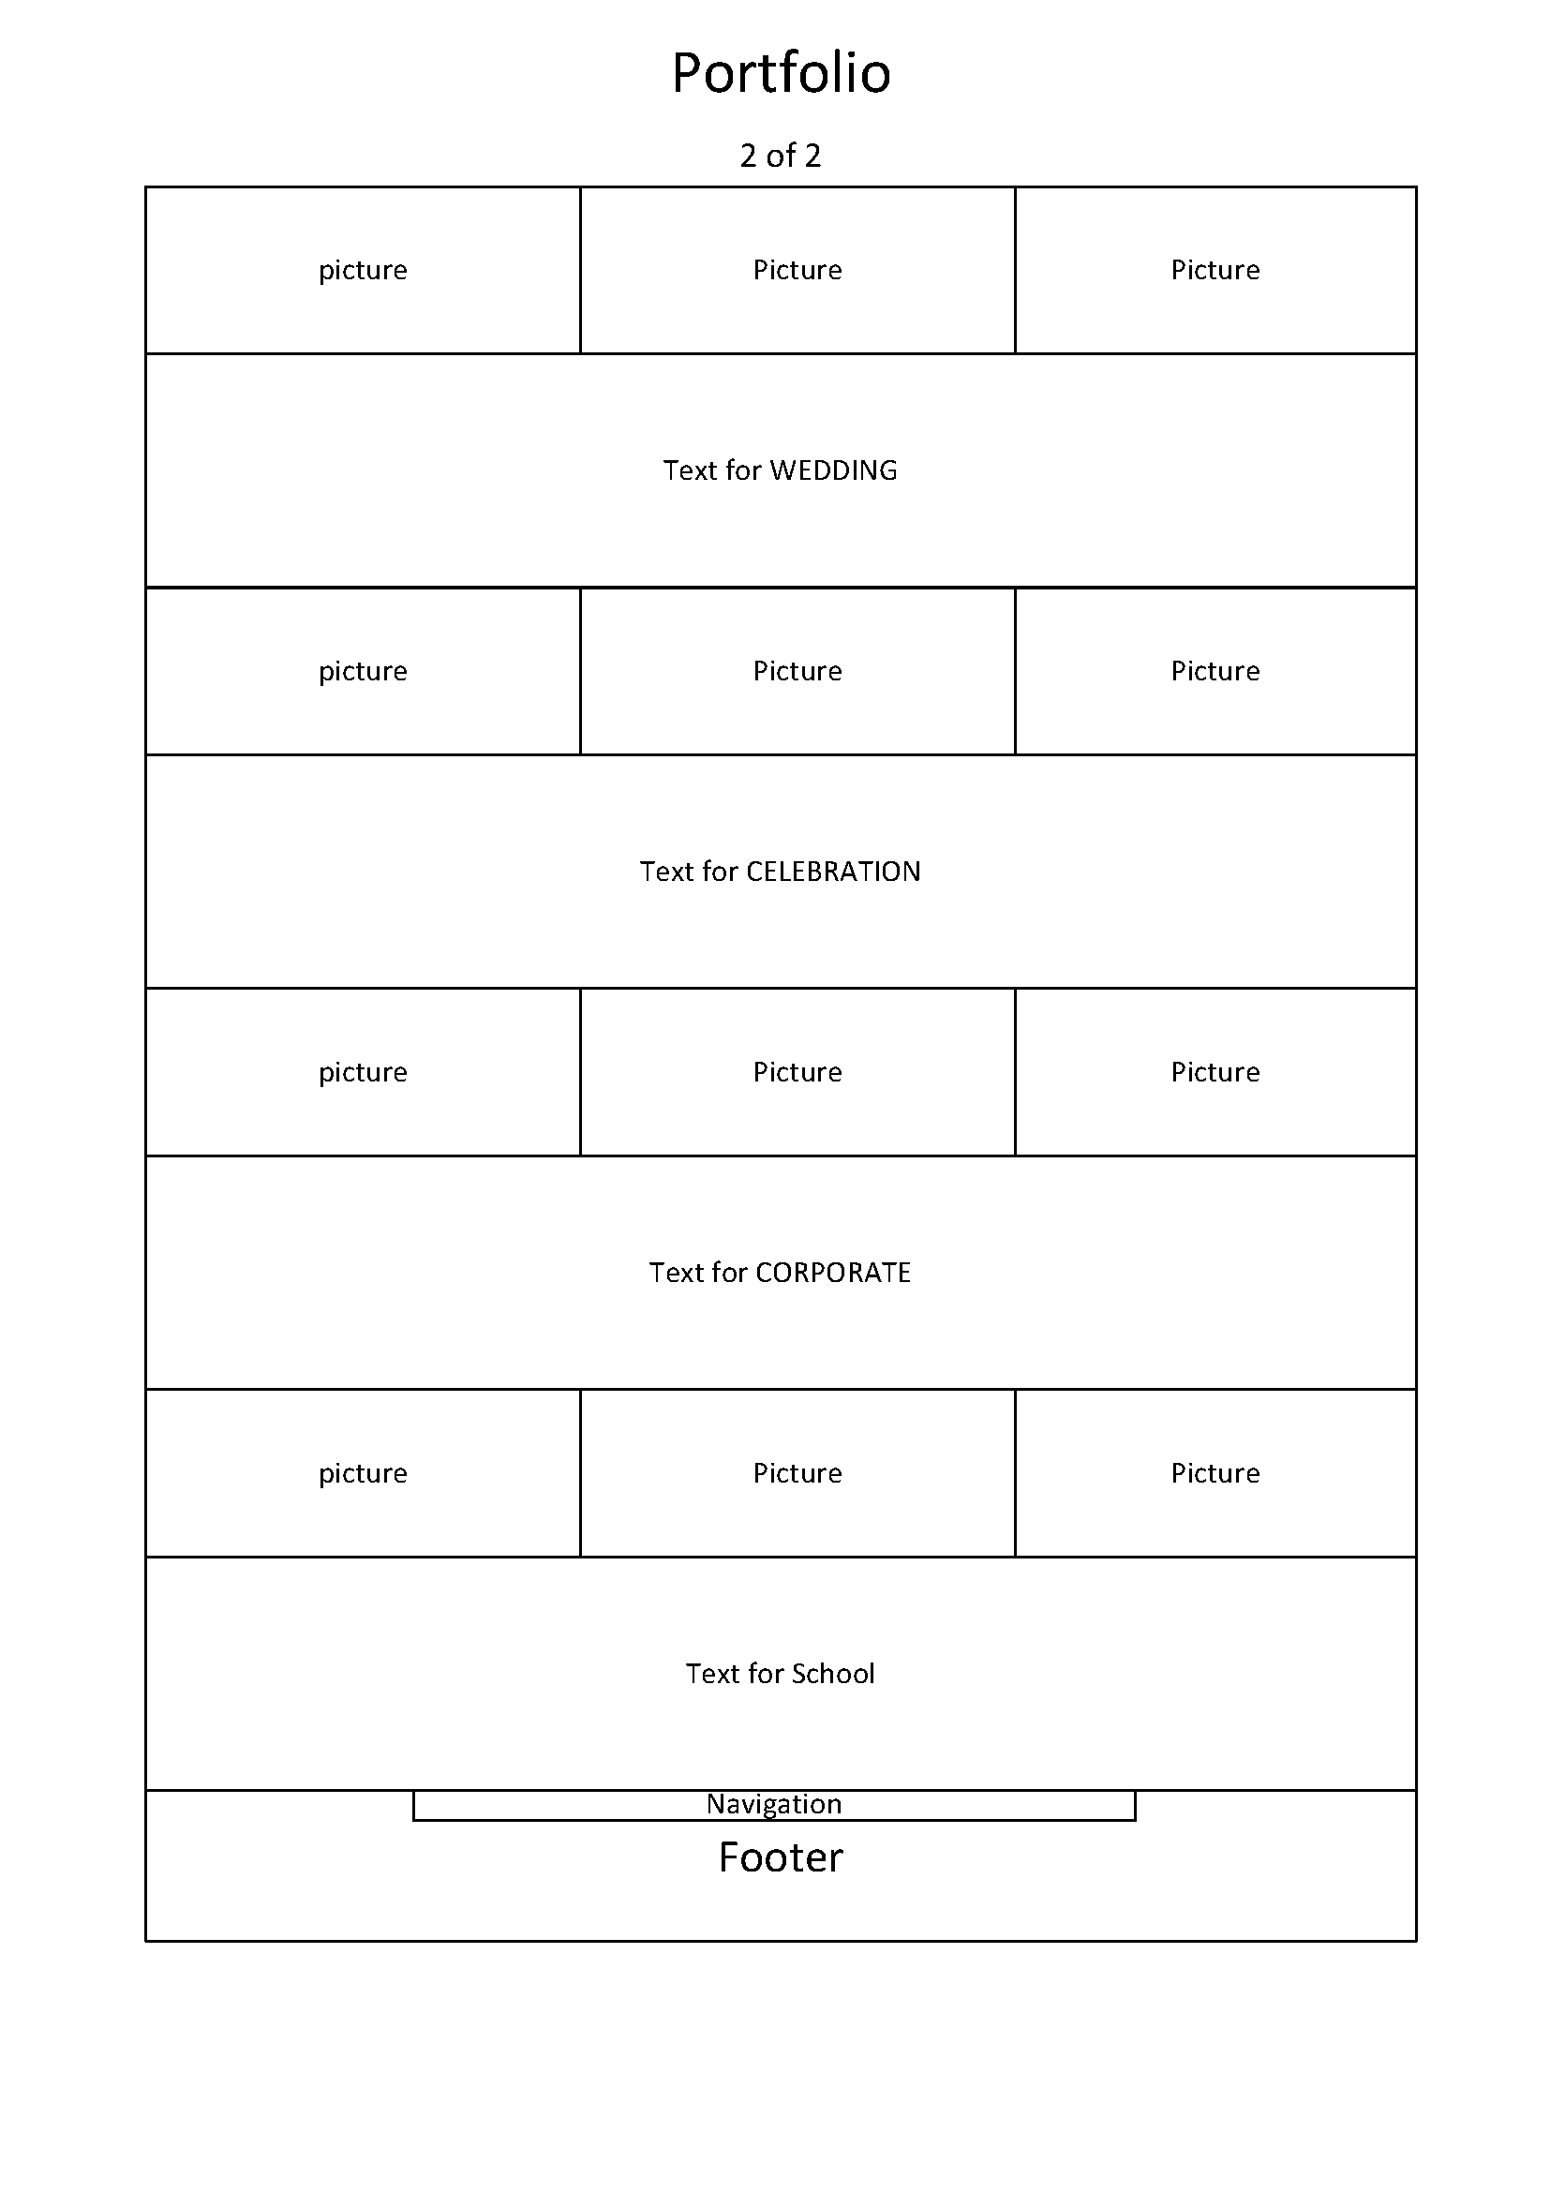

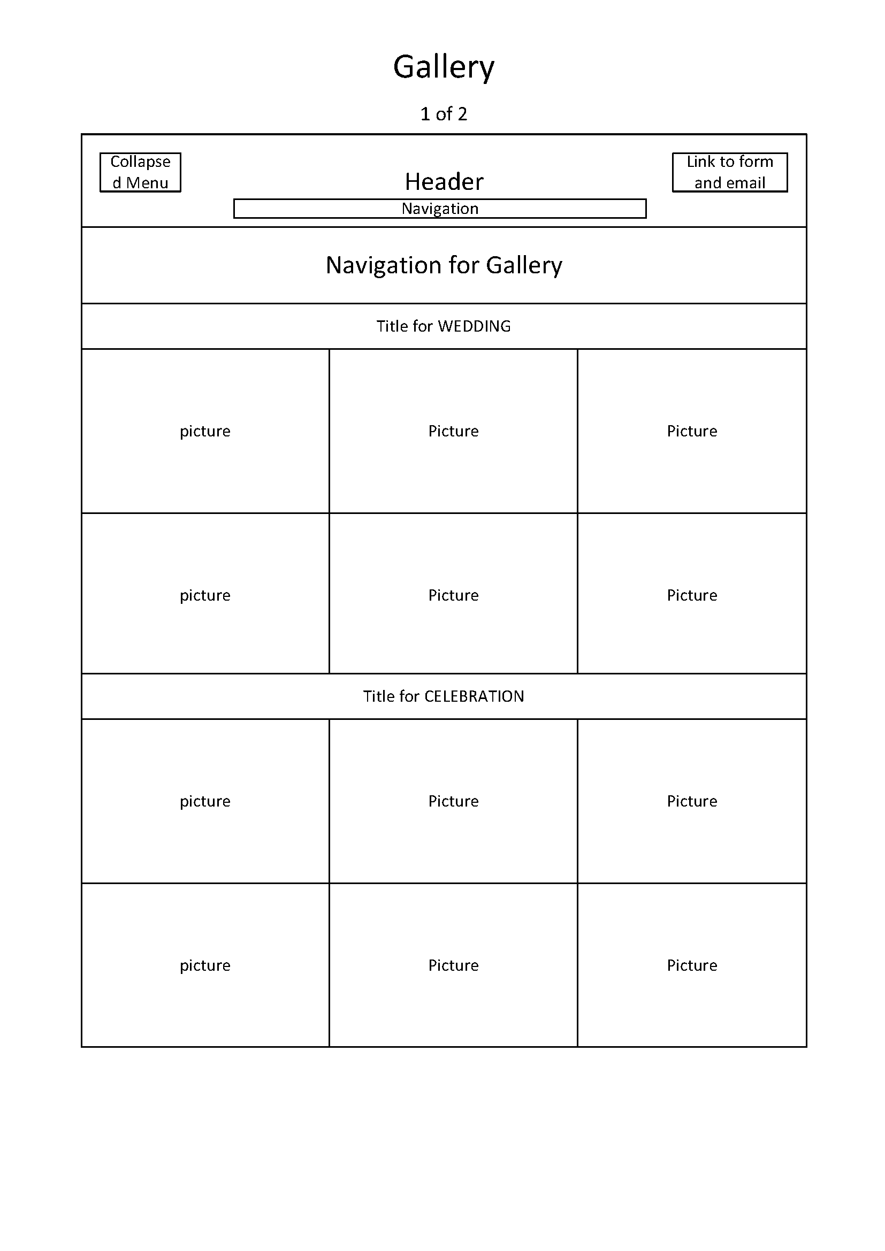

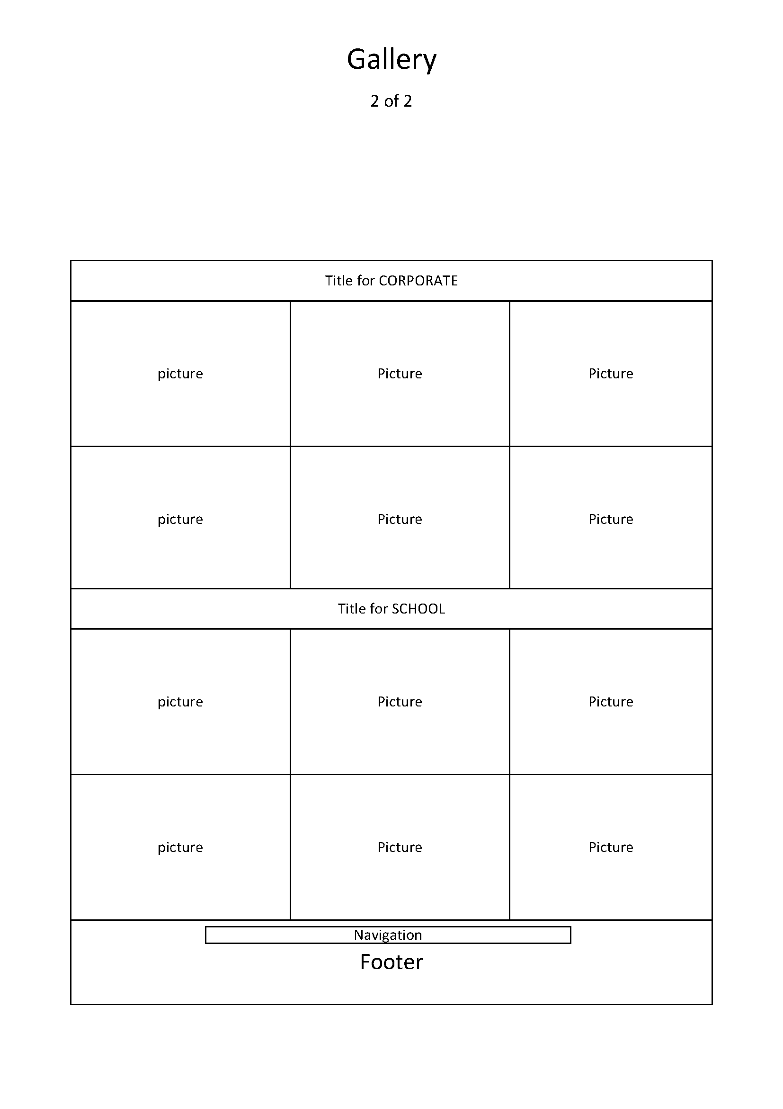

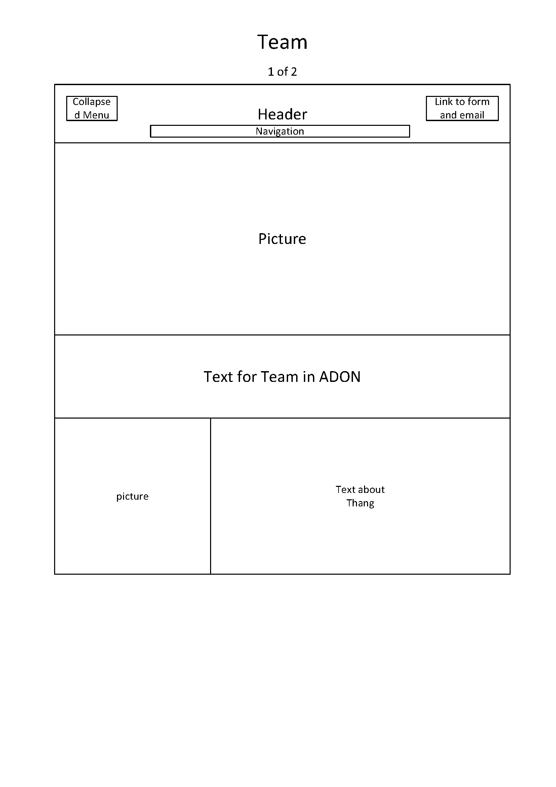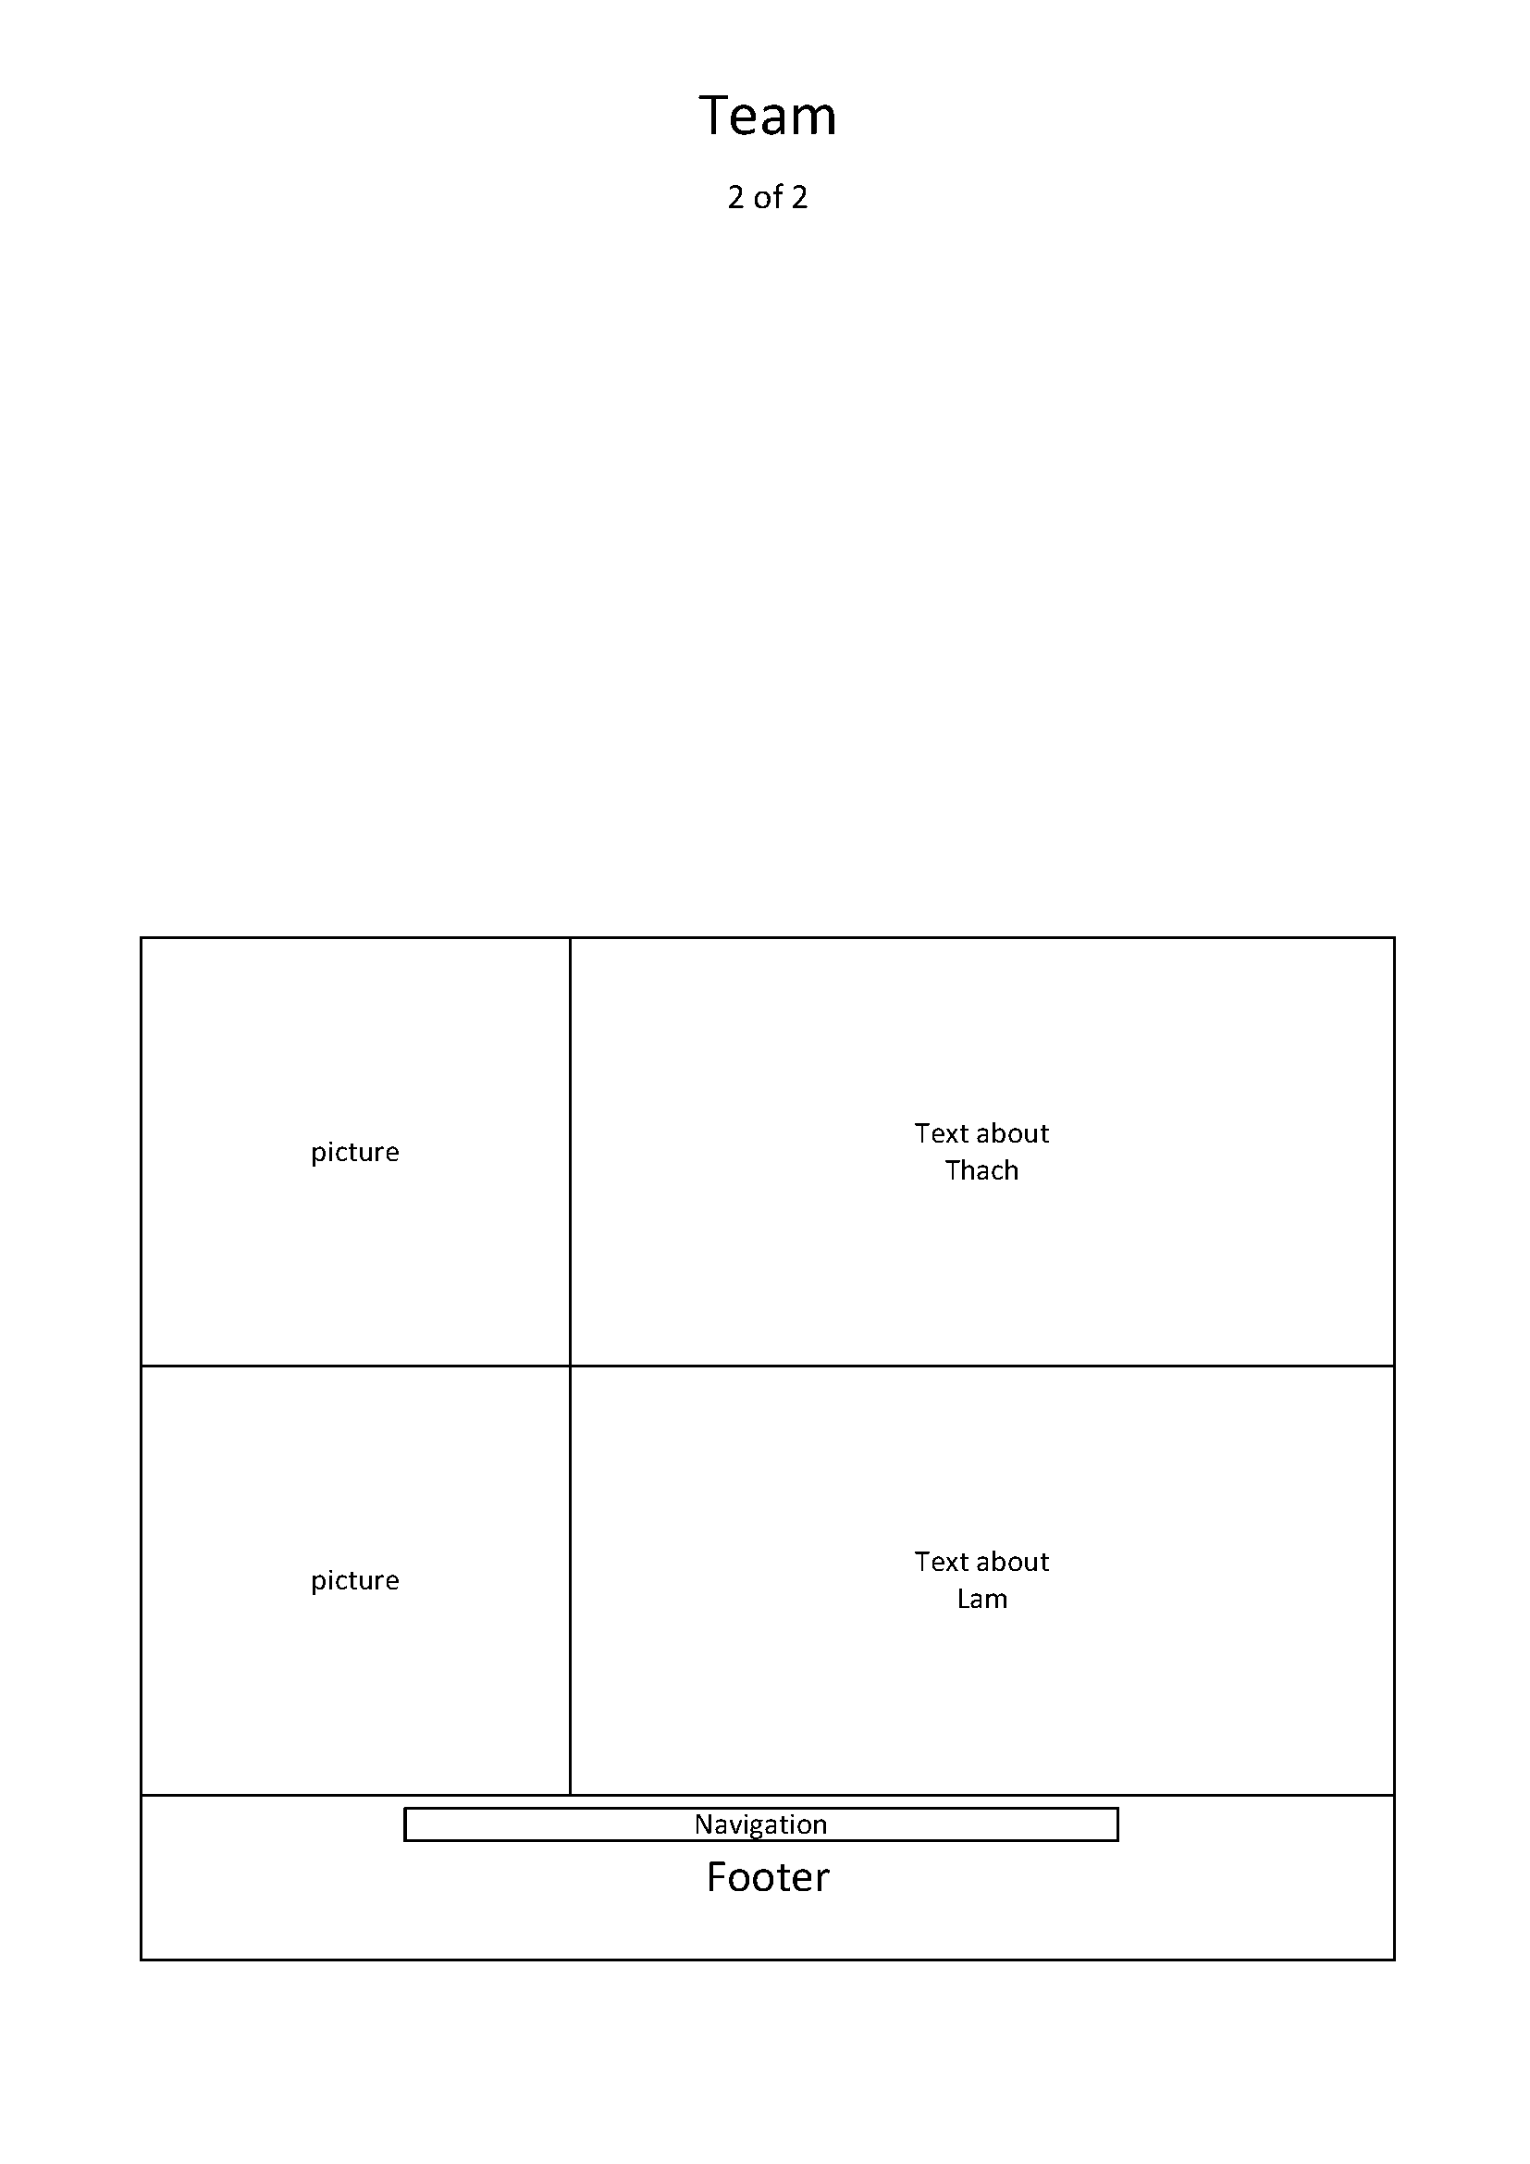

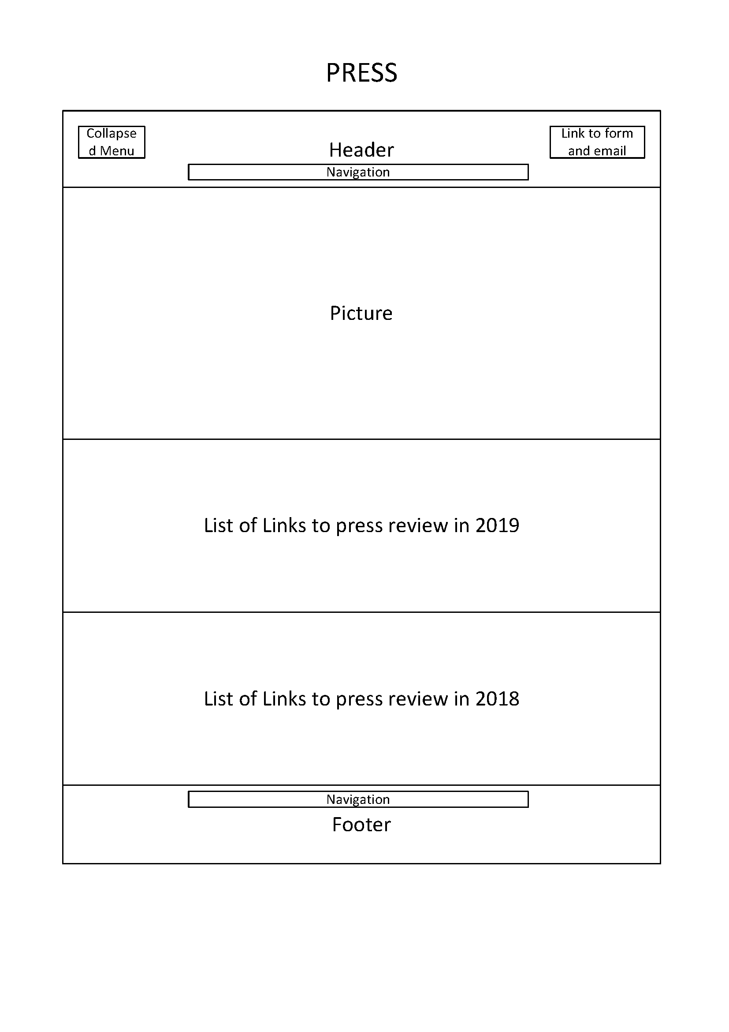

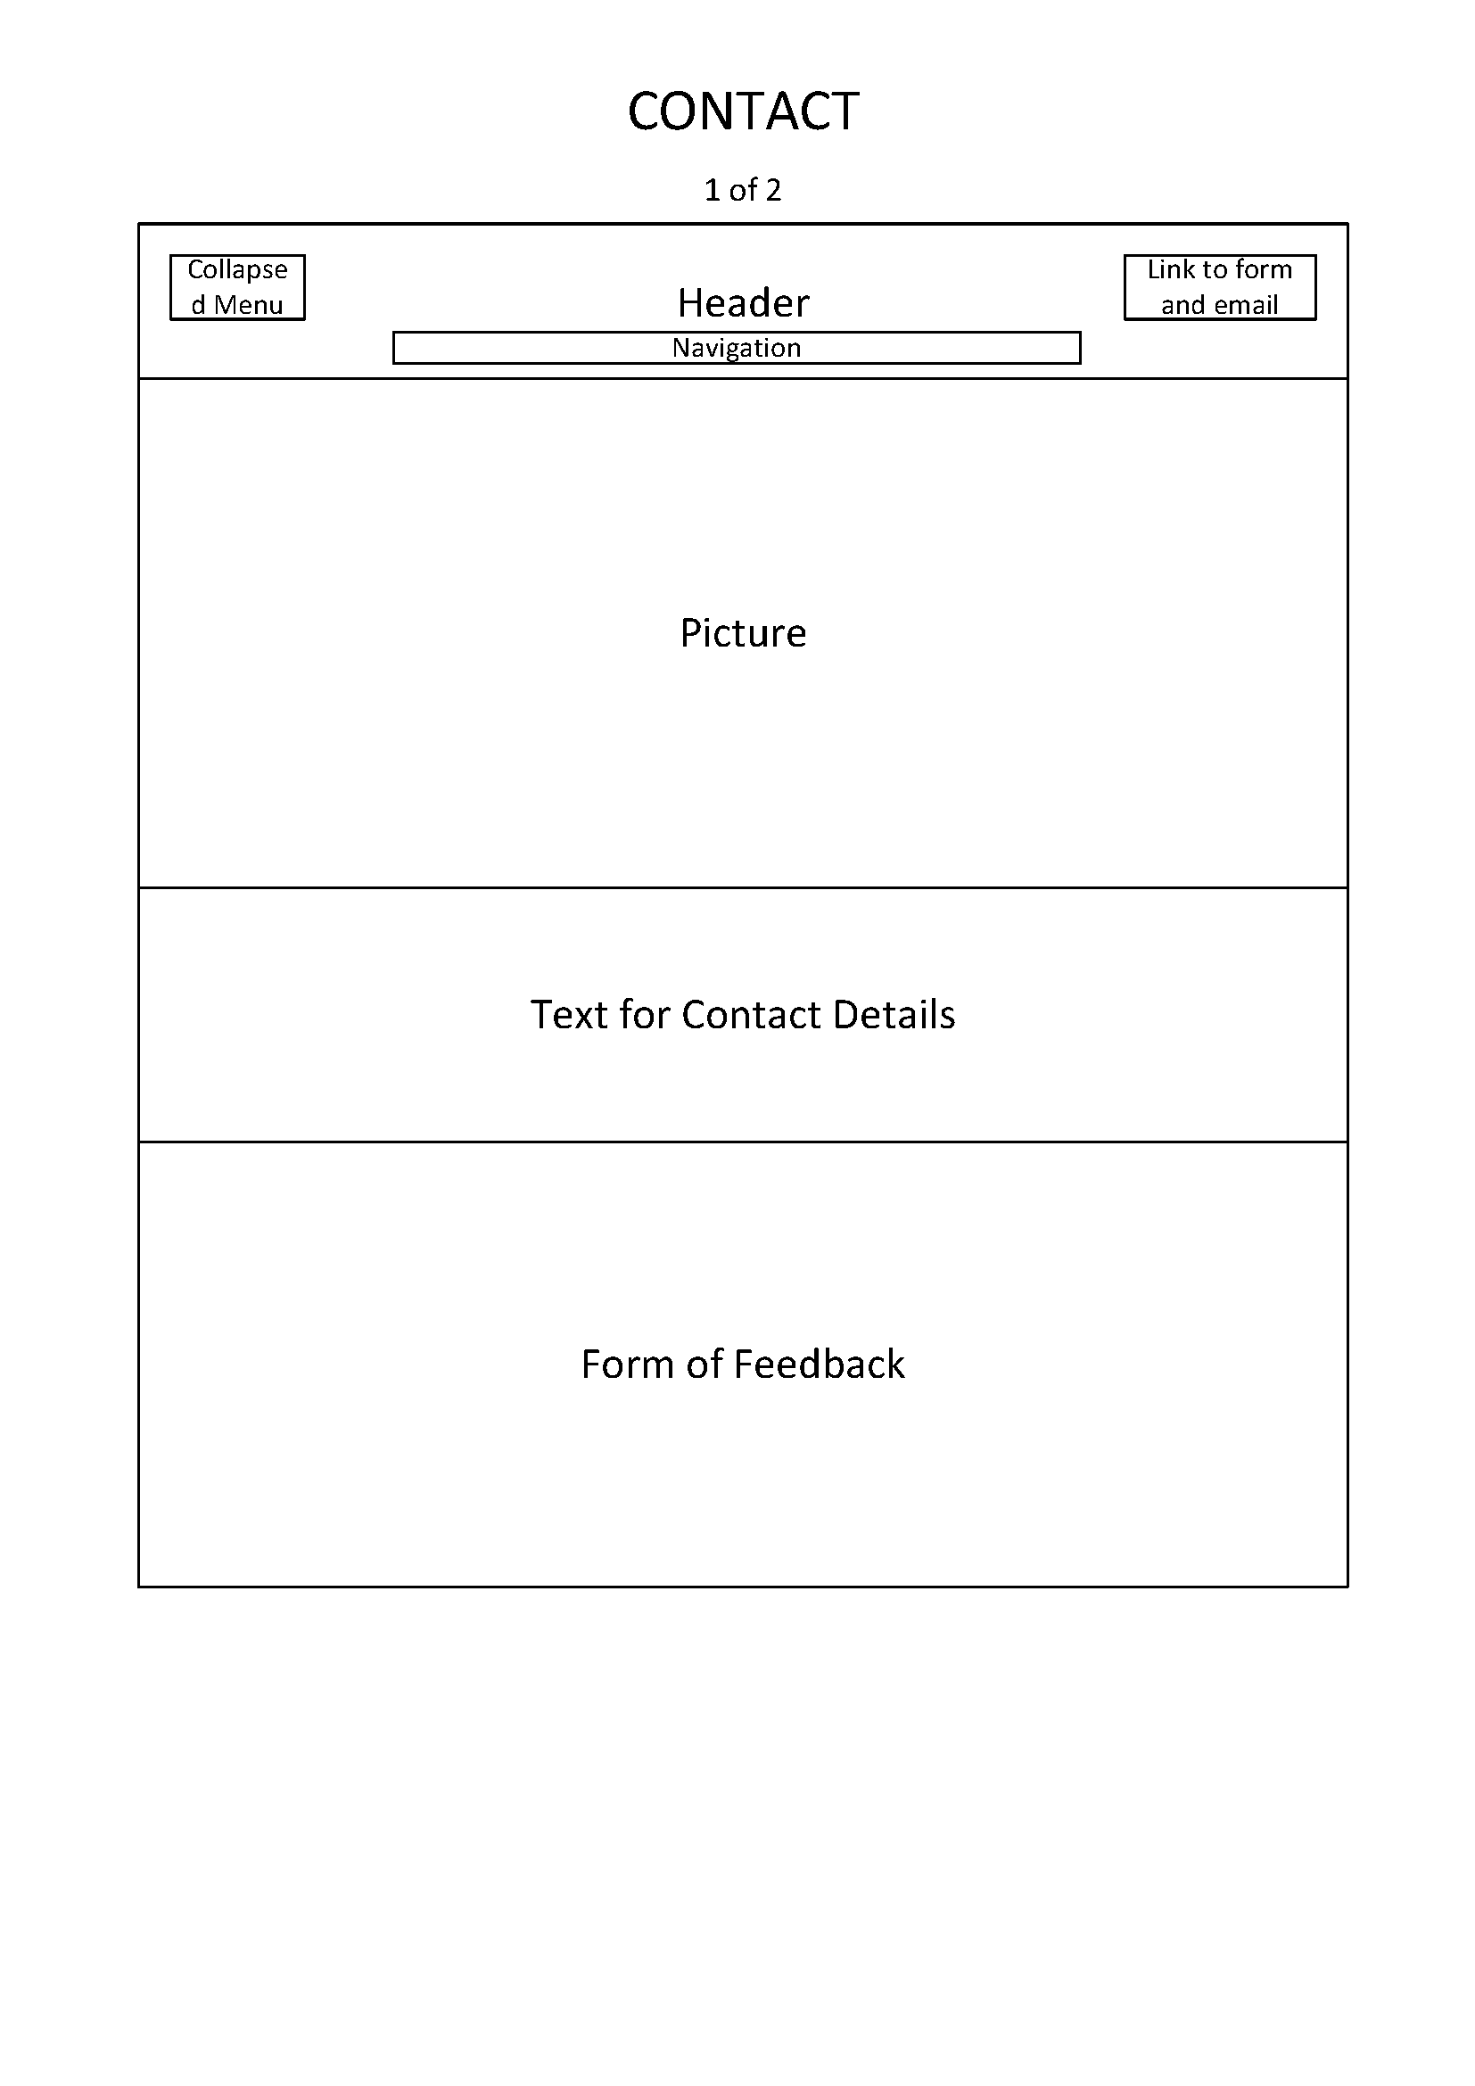

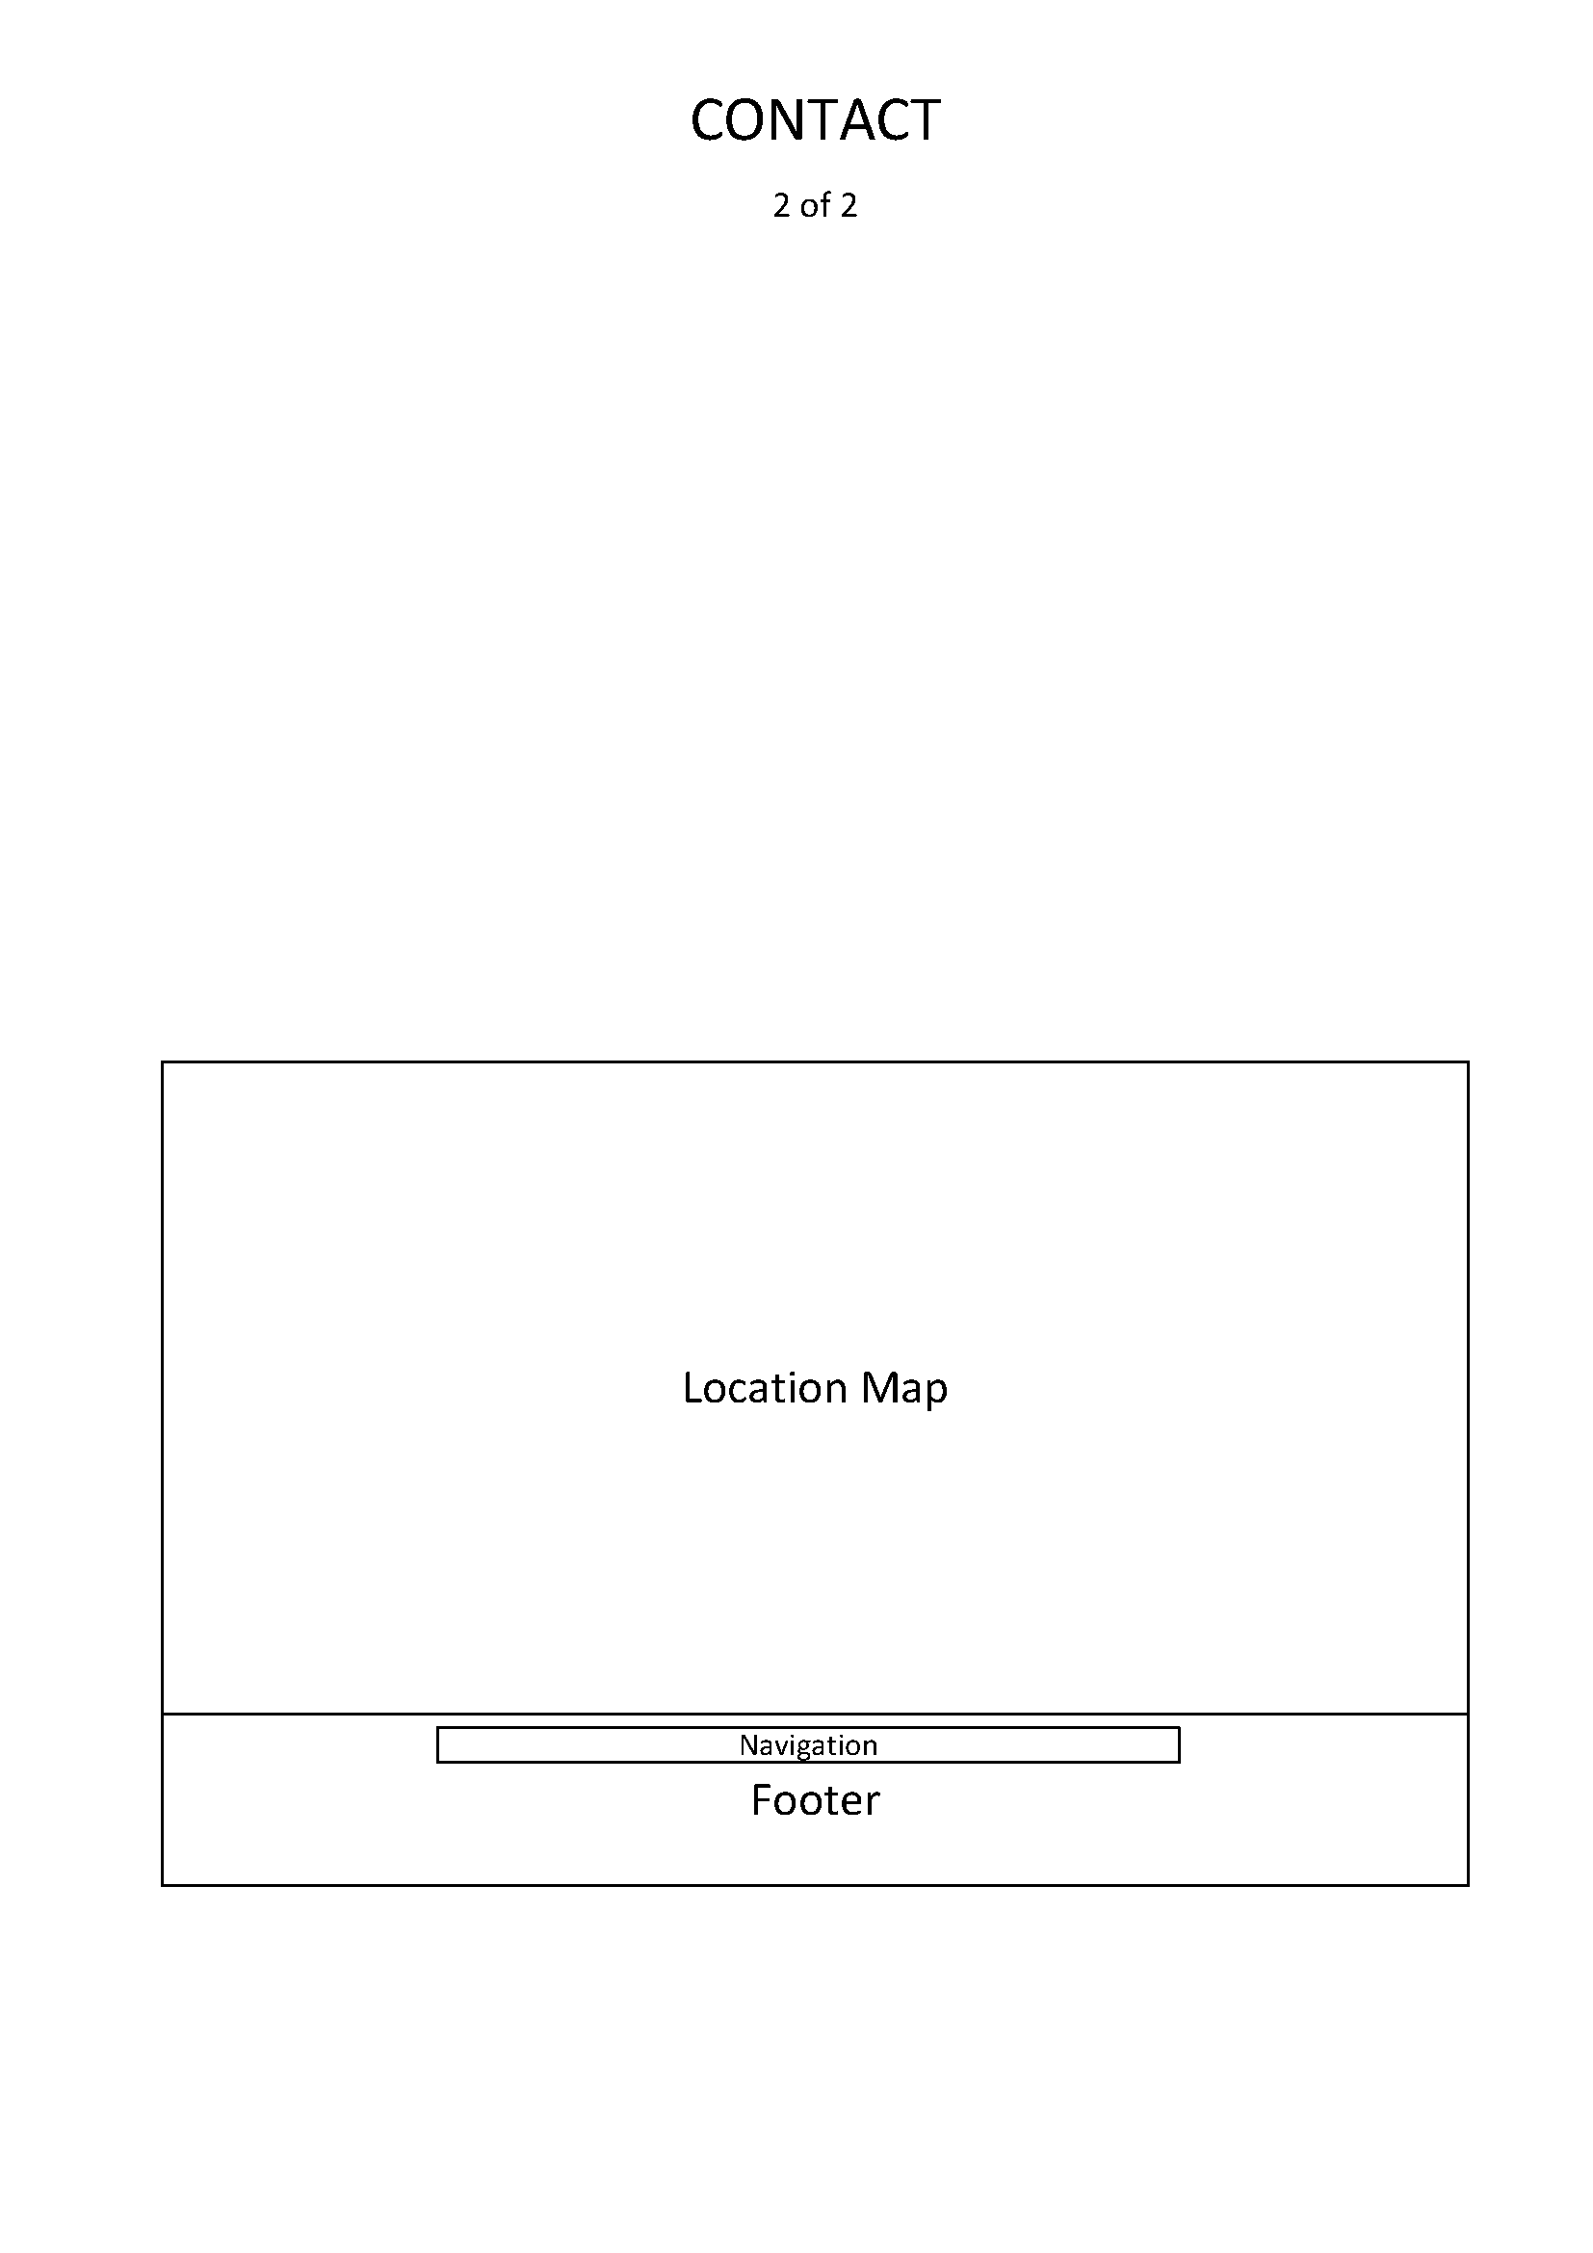

# The End