AIM: Artificial Intelligence for Multimediageneration
– Student Workshop Materials

First name 1 last name 1  , first name 2 last name 2 and other authors using the same notation
Abstract: Media literacy education is an important skill to make sense and think critically about media. The rise of (generative) Artificial Intelligence (AI) has made 1.) media generation accessible to anyone, media ubiquitous
Artifical Intelligence for Multimediageneration (AIM) bundles a set of Jupyter Notebooks and additional resources to explain concepts of generative Artificial Intelligence (AI) with practical examples. AIM addresses mainly students. The resources are modular, but form a coherent workshop if used in their entirety. The Modules can be adapted to address different target groups and subtopics.
Keywords: Artifical Intelligence, Generative Models, Prompt Engineering, AI Literacy, E-Learning

Background
Media Literacy education is an important skill to make sense and think critically about media, as well as learn how to use media to transport one’s own message (Abreu, 2021). As large parts of daily activities, such as education, work and media consumption are interacted with digitally, digital and media literacy have become intertwined. The sudden advancements and the fast adaption rate of AI, not only furthers the need to teach adequate digital and media literacy, but requires yet another skill called AI literacy.
(Long & Magerko, 2020) define AI literacy as 1.) “a set of competencies that enables individuals to critically evaluate AI technologies” and their outputs 2.), “communicate and collaborate effectively with AI” and 3.) “use as a tool online, at home, and in the workplace.”. The student workshop materials “Artificial Intelligence for Multimediageneration” (AIM) aim to address all three AI literacy competencies, as well as general media and digital literacy, by giving students access to a digital learning environment to interact with generative AI models to generate media.
It is deemed important to address media and digital literacy alongside AI literacy, as the rise of (generative) AI has made a) synthetic media ubiquitous (Garon, 2023), b) it harder to differentiate between genuine and fake media (Kalpokas, 2021) and c) the generation of media accessible to anyone (Wang et al., 2023).

AIM Workshop Structure
AIM builds upon Open-Source AI models and Jupyter Notebooks, and is available as an Open Educational Resource (OER) at https://github.com/plc-dev/AIM.
AIM is structured into the modules:
- text generation,
- image and video generation,
- music generation,
- voice-cloning and text-to-speech (TTS) generation.
The modules are separately useable and individually composable to form a coherent workshop. The given module order above is suggested, as the complexity of the modality increases and builds on each previous model.
Before each module is presented to the students, a high-level explanation of the functioning of each model and a set of examples on how to interact with it is presented, before the students interact with the model. To address competency 1.) the students results and their experiences are discussed after each module. To address competency 2.) students learn basic prompt engineering techniques by providing progressive prompt templates. To address competency 3.) students are shown how to utilize large language models (LLM) to explain concepts and can act as learning aids.
By providing prompt templates, the theme of the workshop can be adapted to the target audience, e.g., animals for young kids, or superheroes for adolescents.

Future additions
To increase the benefit and scope of application, AIM will implement model agents and enable plugins for utilized LLMs with e.g., LangChain or LlamaIndex. In order to give an adequate representation of the current capabilities of generative AI models, the utilized models will be updated, as new and more powerful open-source models are made available.
In the spirit of OER, all researchers and teachers are welcome to critique, remix, combine, adapt and distribute the materials and utilize them for their own teaching scenarios.

Figures
To prevent graphics from shifting the text, the wrap style ‘in line with text’ is used – a new paragraph must be begun for the graphic. The graphic should be centred.
Beneath the graphic should be written the signal word ‘Fig.’ (‘Abb.’ in German papers), the consecutive number and the description, all in font Times New Roman non-bold and in font size 9 pt. In conference and seminar proceedings the numbering is consecutive within a paper, in monographs and dissertations it is consecutive within a chapter with the chapter number as the prefix (e.g. Fig. 4.17: description).
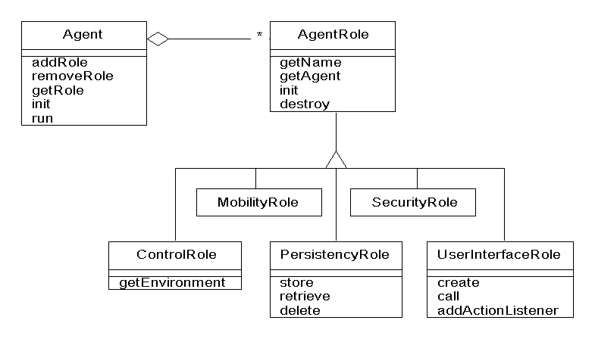
Fig. 1: Description of figure
If figures have been scanned in, then any figure numbers or descriptions should be ‘erased’ to ensure a uniform appearance and numbering scheme. If figures are cited then the figure description must include a complete source reference, and in addition printing permission must be obtained from the publisher and submitted to the editor.
Fig. 2: Description of figure [AB00]
If figures are reduced in size, it is important to ensure that letters and numbers are at least 1 mm in height. If scanned figures are used, it is vital to ensure that alphanumeric characters, lines and shading are identifiable when displayed in black and white.

Tables
Tables should be centred vertically and may be no wider than the standard text (table properties: preferred width 12.6 cm). The table grid must have a maximum pixel width of 1 pt.
Heading levels | Example | Font size and type
Title (left-justified) | Title... | 14 pt, bold
Heading 1 | 1 Introduction | 12 pt, bold
Heading 2 | 2.1 Title | 10 pt, bold
Tab. 1: Description of table
The text contained therein should be in the same format as the running text (Times New Roman, size 10 pt) but there should be no spacing (0 pt) between the individual lines. The text is left-justified and should be vertically centred within tables.
Under the table – centred and in the font Times New Roman, non-bold in font size 9 pt – appears the signal word ‘Tab.’, the description and the consecutive number: in conference and seminar proceedings the numbering is consecutive within a paper, in monographs and dissertations it is consecutive within a chapter with the chapter number as the prefix (e.g. Tab. 4.17: description).
Scanned tables should be treated in the same way as graphics.

Abreu, B. D. (2021). Skills for Life: Media Literacy and Critical Thinking. https://doi.org/10.18235/0003779
Garon, J. M. (2023). A Practical Introduction to Generative AI, Synthetic Media, and the Messages Found in the Latest Medium. SSRN Electronic Journal. https://doi.org/10.2139/ssrn.4388437
Kalpokas, I. (2021). Problematising reality: The promises and perils of synthetic media. SN Social Sciences, 1(1), 1. https://doi.org/10.1007/s43545-020-00010-8
Long, D., & Magerko, B. (2020). What is AI Literacy? Competencies and Design Considerations. Proceedings of the 2020 CHI Conference on Human Factors in Computing Systems, 1–16. https://doi.org/10.1145/3313831.3376727
Wang, S., Menon, S., Long, T., Henderson, K., Li, D., Crowston, K., Hansen, M., Nickerson, J. V., & Chilton, L. B. (2023). ReelFramer: Co-creating News Reels on Social Media with Generative AI. https://doi.org/10.48550/ARXIV.2304.09653

Institution/university, department, address, town/city, postcode, emailaddress@author1, , https://orcid.org/0000-0000-0000-0000
Institution/university, department, address, town/city, postcode, emailaddress@author2
https://github.com/hwchase17/langchain
https://github.com/jerryjliu/llama_index

