Lab Report 2 – Scenarios. Use Cases, Use Case Diagrams

**Actors**

At the beginning, we looked at the description and wrote down all kinds of roles found in the text. Afterwards we thought through the whole process of ordering food and noted down those actors. There is a customer that orders food, people that take care of the food and then someone who is responsible for the delivery.

Initial Actors:

1. Shipping Customer
2. Bill Customer
3. Delivery
4. Manager
5. System Manager
6. Cook
7. Online-Shop
8. Product Manager
9. Administrator
10. Banking
11. Supplier
12. Selfies
13. Local Shop

We wanted to give each actor a specification. Our result is written below. Afterwards we had to change many definitions because of changes in our cases.

1. A Shipping Customer receives the product. (member name)
2. A Billing Costumer receives the invoice and pays for it. (member name)
3. A Shop Assistant is a pick-up station where Hoagies get taken by each – the customer or the deliverer.
4. A Deliverer brings the Hoagies from the Shop to the Shipping Customer and (optionally) gets the money.
5. A Cook prepares and packs the food.
6. 6. A Product Manager creates a section of available products (With pricing & statistic overview).
7. A Supplier is the place where the Shop gets the ingredients for the Hoagies.
8. The Database is connected to Twitter & the website to easily spread information and pictures. User of the website can interact with it.
9. The Online Shop is the place where Customer see the products, order them and (optionally) pay them.
10. The Banking Center manages the money if the Customer chooses to pay online.
11. The Admin is responsible for maintaining the information about available products.
12. The customer service deals with all kinds of customer requests and problems.
13. The customer database saves information about the customer and orders.

However, some of them did not really had an important role or work (minor details). Therefore, we removed some and added others. Some actors also did similar things or were just named differently. We simplified the scenarios and use cases, which resulted in a much smaller list.

Final Actors:

1. Customer (1 + 2)
2. Deliverer (3)
3. System Admin (4 + 5 + 8 +9)
4. Cook
5. Supplier
6. Shop Assistant (13)

**Scenarios**

We thought about what scenarios we want to deal with in the lab. Therefor we used three scenarios for each member of our group. So, we had nine scenarios in total at the end. At this point we still had some actors left that we removed later on.

1. Customer places an order online. (Florian)
2. Customer cancels an order. (Sao Chi)
3. Customer takes selfies and places them online. (Sao Chi)
4. Product Manager deals with statistics and updates the ingredient list. (Johanna)
5. Customer orders his own created Hoagie. (Florian)
6. Deliverer delivers the Hoagie to the Shipping Customer. (Johanna)
7. Cook prepares order. (Sao Chi)
8. Customer gets his order at the Shop Assistant. (Florian)
9. Customer gets his invoice. (Florian)

Johanna:

Scenario 4:

While creating this scenario I saw that we only need one person who checks the statistics and orders the ingredients. I also defined what happens, if the ingredients are not available or had to be ordered more frequently.

Scenario 6:

I saw that the Deliverer has to get the information from somewhere. This somewhere I defined as the Shop Assistant. The Deliverer also has to deal with the payment if needed.

Scenario 8:

In this scenario the Customer needs to know the address of the Shop and has to deal with the different methods of payment. The Hoagie has to be prepared as soon as possible, when the Customer wants to get it at the Shop.

**Use Cases**

Tool for diagrams: <https://www.draw.io/>

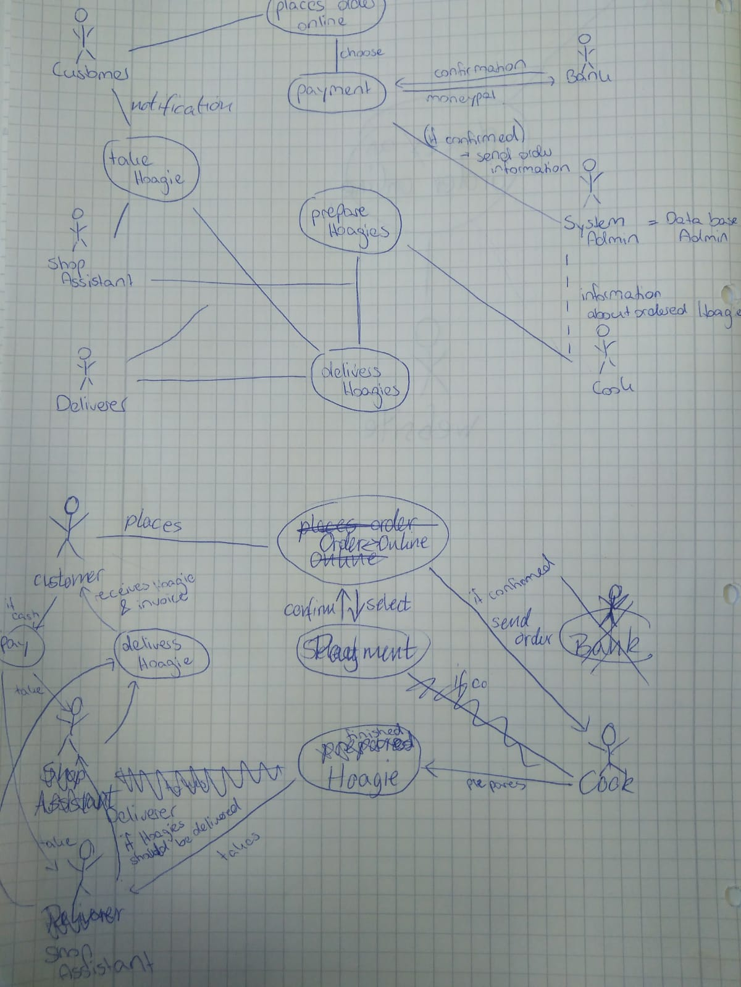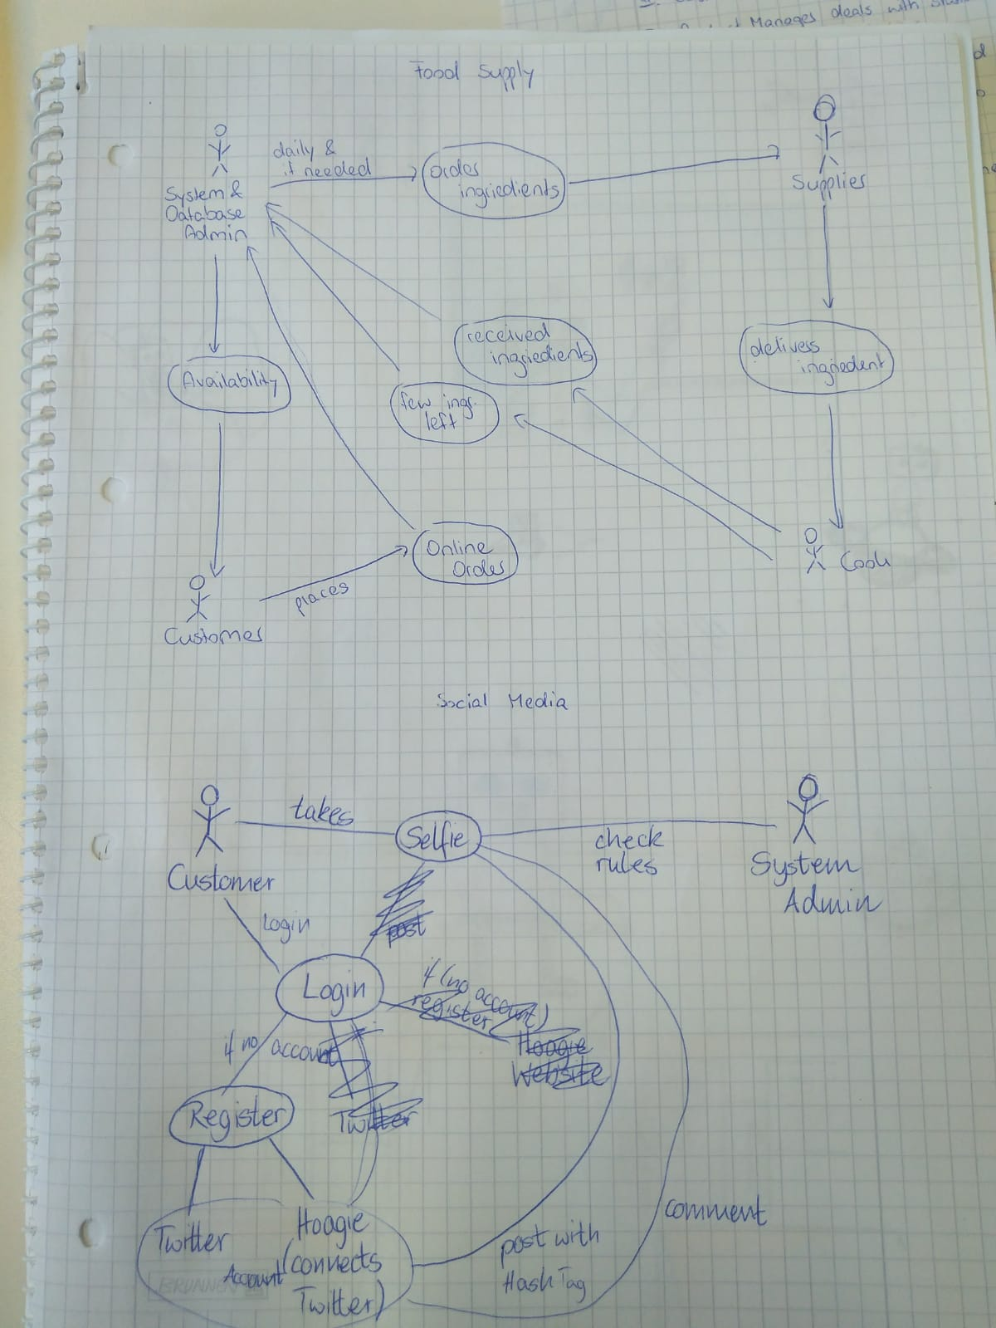

Modeling the Use Cases was a pretty hard job. We often had ideas and did not use them because of other ideas. We used pen and paper first to model our use cases. The first diagrams looked really chaotic. In the end we specified three use cases as you can see below.

The first use case is the process of ordering a Hoagie in our shop. The important actors are the Shop Assistant, the Customer, the Bank, the Deliverer and the Cook. We had to think about the simplest scenario first and then make our way to the whole use case. This was not easy for this use case, because we had different thoughts about our scenarios and we had to figure out in which way we can display our ideas best.

The second use case is about the supply chain for the Hoagie store. This use case was a little bit easier to model as we already had ideas and concepts from our first use case.

The last use case that was about the social media aspect of our Hoagie store was a little bit trickier again. We were not sure if we can use something like an account or a database as an actor, too. In the end we stayed with our old actors for a better overview and modeled the use case below.

**Reflection**

**Johanna**

Time: I used the time in the lab (90 minutes + 90 minutes) plus

- one hour at for writing down my scenarios

- two hours and 30 min for writing down the use cases and the report

This time I sometimes thought that we take a step forward to go two steps back afterwards. It was hard to come to one solution that fits everyone's expectation. And we were only three people. Sometimes there were little details that costed us much time. Nevertheless I am quiet happy with our result. I also think that I understood how important good scenarios are. We had some scenarios that could be included in some others. So we had to think about scenarios again together in the second lab. This costed us much time.

**Sao Chi**

Time: The time in the lab was used for developing the use cases (180 minutes) plus

- 20 minutes for rough draft of scenarios

- 2 and a half hour for writing down the use case description, making the use case diagram prettier, writing down the scenarios, use case description and the reflection.

I enjoyed this exercise as it was like a big puzzle that needed to be put together. Everyone had something to say or an idea. The most difficult part was throwing away some concepts because we noticed discrepancies that made the diagrams more confusing than helpful. The end results are way more simplified but we also made 3 diagrams in the end to better describe each process. However, I did not like writing scenarios because there always seemed to miss something. In the end many of our scenarios were only edge case but those scenarios will be useful as there are many details that would have polluted the diagrams.

**Florian**

Time:

**Appendix [Material]**

* Use Case Diagrams
* Scenarios

**Appendix**

**Scenarios**

**Detailed try of a main case**

|  |  |
| --- | --- |
| Scenario Name | I Customer places an order online |
| Precondition | Customer needs access to the internet via a computer, smartphone or tablet. |
| Sequence of steps | 1. Customer goes to our website with one of the devices of our precondition. 2. A button appears, where the customer can start placing an order. 3. The customer gets to a new site, where she/he chooses one of our suggested sandwiches or a menu (both options will display pictures and a short description) or wants to create its own sandwich/menu from the scratch (Step 4).   When one of the first two options was chosen, it goes directly into the cart and is indicated to the user. This step repeats until the customer chooses one of the following: On the same page are two other buttons leading to a new site, one for seeing all the things of the cart (step 5) and the other to finish the order by proceeding to the payment options (step 6).   1. This step only appears, if the customer decided to create its own sandwich/menu from the scratch. A new page will appear, where different breads, ingredients and toppings for making their own sandwiches or alternatively (or optionally) other products (e. g. drinks, French fries) can be added to the order. When the customer has finished her/his order, she/he can click on a button like “add to the cart”, it gets indicated to the user and she/he returns to step 3. If a bread, topping or ingredient is chosen it appears to a list on the same page. A short description can be found on the very page, what ingredients are necessary in order to fulfill the basic requirements of a sandwich (e. g. bread and probably something onto it). The order of choosing any product is not important. The customer cannot add a sandwich to the cart, until it fulfills the requirements. When the user tries to click on the button “add to the cart” when the order is nor finished, a message with the missing products will appear. 2. When the user clicked on their cart, a new page with all added products (including the amount of them), which are currently in the cart, will appear. The customer can delete or change the number of chosen products of that kind. From here, the user has the options to go back to step 3 (adding a new product to the cart) or to step 6 (payment options). 3. The payment options appear on a new page. The user will see all products added to her/his cart and can choose between four payment options: Money transfer, credit card, MoneyPal (when one of these three options are chosen, they will later go to step 7) or in cash (will later go to step 8). Furthermore, the customer can choose if she/he wants the order delivered or picking it up at our shop. The approximately time when the order is finished/delivered is shown (calculated from our statistics of the average time). The user can also decide to receive or pick it up later, if possible. Last, if the user is not logged in to her/his customer account, she/he must enter a billing address (including an email address) and optionally a different delivery address (in case it was chosen to be delivered before). Alternatively, the custom can login and choose from the saved addresses and edit them if wished. The user has still the option to go back to add another product (step 3) or to review her/his cart in the overview again (in case she/he wants to change the order amounts, step 5). If the user is happy with the order, she/he can find a button to checkout. 4. If the user did not choose to pay with cash, she/he gets forwarded to the payment organization to finish the payment. When the payment has been confirmed, the user gets an information and is redirected back to our website (step 8). When something went wrong, she/he gets back to step 6. 5. The successful order is saved to the costumers account (in case she/he has one) and it appears to our staff for preparing the order. The user will see a notification and receives an email about the successful order with all the information from step 6. Additionally, the user can download the invoice in the PDF format (when she/he paid through a payment organization already). In case the customer decided to pay with cash, she/he gets the receipt after the payment. When the customer decided to pay with cash and picking it up from our shop, necessary instructions will be displayed as well (e. g. going to the shop and showing the order confirmation to our staff). |
| Post-condition | Customer got a fresh pizza to the time she/he ordered it. We received the money from the customer. |

**Specific try of the same scenario**

|  |  |
| --- | --- |
| Scenario Name | I Customer places an order online. |
| Precondition | Betty has access to the internet via a computer (and a kind of up-to-date browser). She has a MoneyPal account and all necessary data to login. Betty got enough money on her account and she has a billing and a delivery address (which is the same one) in Berlin (Germany). |
| Sequence of steps | 1. Betty opens our website with her Computer and Firefox 65. 2. On the appearing website, she clicks on a button “Order”. 3. Betty gets asked, if she wants to choose one of the suggested sandwiches, a menu or if she wants to create her own sandwich. Betty wants to make her own sandwich. 4. In the new menu, she has buttons for choosing different kind of breads, one for toppings and one for additionally products. Betty clicks on the “Blue bread” with mozzarella, tomato and corn. Additionally, she takes an order of fries and a Sprite. She confirms her choices by adding them to the cart. She gets redirected to the former page (of step 3). 5. Betty clicks on “checkout”. 6. Betty now sees her order again. She chooses to get the order delivered. 7. Betty fills out her billing address, which is the same one as the delivery address. She also fills out a field for her email address and another one for her mobile phone number. 8. Betty selects to pay via MoneyPal. She enters her email-address 9. Betty clicks on “confirm order”. She gets forwarded to the website of MoneyPal. 10. Betty successfully finished the transaction and gets redirected to our website again. 11. Betty sees the message “Order successfully sent” with all information of her order with the information of her order arriving at 6:35 pm, which is in 25 minutes from now. She sees also a button to print the invoice. 12. Betty clicks on the invoice button. 13. A download with the invoice in the PDF format starts immediately. 14. After 25 minutes, her bell is ringing, and she receives her sandwich, fresh and just as she ordered it before. |
| Post-condition | Customer got a fresh pizza to the time she/he ordered it. We received the money from the customer. |

|  |  |
| --- | --- |
| Name | IV Product Manager deals with statistics & updates the ingredients lists |
| Precondition | Product Manager has access to data about ingredients and prices  & can order ingredients  & can update availability website  &knows how to calculate the best products |
| Sequence of steps | 1. Product Manager accesses statistics from database 2. He sees the number of ordered Hoagies with details about the ingredients and the costumers 3. He orders new ingredients each working day at 4pm fort he next working day 4. If a Hoagie gets ordered more frequently at a specific day, the Product Manager orders more ingredients for this Hoagie 5. He gets a feedback from the supplier if the order can be processed 6. The successful order gets recorded in a table 7. No success with the order means that the Product Manager informs the store and cook about the lack of ingredients the next day. 8. He records this in the table 9. Updates the availability of Hoagies in the intern checking system and on the web page with a simple button for this function |
| Post-condition | The order has been processed and the Hoagies available for the next day are updated on the web page |

|  |  |
| --- | --- |
| Name | VI Deliverer delivers the Hoagies to the Shipping Costumer |
| Precondition | Deliverer has a transporting bag  & deliverer has a means of transport and can use it  & deliverer is able to use a map  & deliverer is able to take cash and payment by credit card |
| Sequence of steps | 1. Deliverer gets information that Hoagies have been ordered 2. Deliverer gets prepared Hoagies in a packaging from the Store Assistant and put them into his transporting bag 3. Deliverer gets the information of the destination of the order from the Store Assistant 4. Deliverer uses his map to search for the address 5. Deliverer uses his means of transportation to drive to this address 6. Deliverer rings the right bell or knocks the door  * If there is no one opening the door, the deliverer drives back to the store and informs the Store Assistant about the not delivered order  1. Deliverer gives the order to the Shipping Costumer 2. Deliverer gets payment (by cash or credit card)  * For cash he has a bag and knows how to calculate * For credit card he has a device and knows how to use it * If payment has been online Deliverer get this information from Store Assistant in advance  1. Deliverer drives back to the store |
| Post-condition | Order has been delivered to the Shipping Costumer and payment was successful |

|  |  |
| --- | --- |
| Name | VIII Costumer gets his order at the Shop Assistant |
| Precondition | Store Assistant is in the store and the store is open  & Costumer has ordered Hoagies  & Hoagies have been prepared  & Costumer knows the address of the store |
| Sequence of steps | 1. Costumer comes to the store and the Store Assistant 2. Costumer tells his order number for the Hoagies 3. Store Assistant looks into the system for the right order 4. Store Assistant takes the right prepared order and put it into a transporting bag 5. Store Assistant gives the order to the Costumer 6. Costumer takes the order and pays  * Cash * With credit card * Or the payment was already done online. The Store Assistant sees this in the system |
| Post-condition | Costumer got his ordered Hoagies and payment has been successful |

|  |  |
| --- | --- |
| Scenario Name | II Customer cancels order. |
| Precondition | The customer has already successfully ordered.   * made (custom) order on website * filled out bank information * got notification that order is posted |
| Sequence of steps | * If (already sent) then an error message is send that this is not possible. * Customer gets message that order was canceled. * Cooks are notified by the system that the order was canceled. * The order is marked as canceled in the system. |
| Post-condition | * If (successful) then the customer gets the money back and the order is “removed” from the system. Else The customer still gets the Hoagie and has to pay. |

|  |  |
| --- | --- |
| Scenario Name | III Customer takes selfie. |
| Precondition | The customer has an account and a device with a camera. |
| Sequence of steps | * Login on platform with either Twitter or Hoagie account (connected to Twitter). * If (not registered yet) send to register website. * Make a new post with a selfie. * Post it with Hashtag. * If (canceled) return to homepage. * If (content is fine) Selfie is posted to the website and world. * Comment on selfies. |
| Post-condition | * Posted selfie. * User account * Ability to comment on other selfies. |

|  |  |
| --- | --- |
| Scenario Name | VII Cook prepares order. |
| Precondition | * Order was given to the system. * A cook is available. |
| Sequence of steps | * Cook prepare food in proper order as stated in the order. * If (no ingredients left) order new food. * Cook packages food * Cook notifies the system that food was used. * Cook gives Hoagie to deliverer or shop assistant. * Notify the order as done and update ingredient list/database. |
| Post-condition | * Food statistics have changed. * Order was marked as done. |

**Food Order**

Summary: The customer places an online order for a Hoagie.

Actors involved: Customer, Cook, Deliverer, Shop Assistant

Sequence of steps: Customer Online Order → Payment Check → Food Preparation → Delivery

Alternate sequence: Payment is not accepted or the order is canceled.

Exceptions that can occur: There are not enough ingredients.

Extension points: -

Trigger: Online Order

Assumptions: The customer has an Internet connection.

Preconditions: The customer has a banking account or similar.

Post-conditions: The customer has a Hoagie. The order is cleared from the system, the ingredient list is updated and the Hoagie is payed.

Author and Date: -

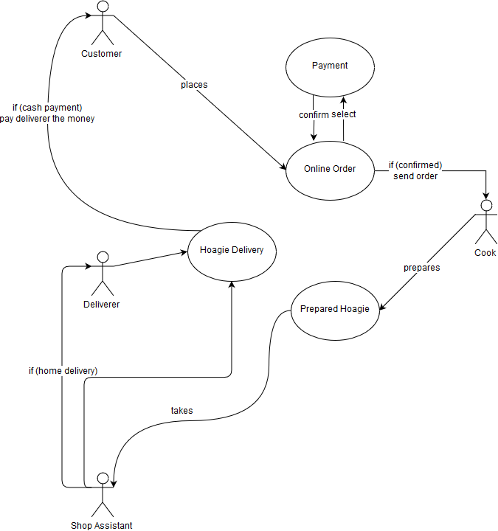

**Social Media**

Summary: The customer makes a selfie and posts it on the website.

Actors involved: Customer, System & Database Admin

Sequence of steps: Customer logins or registers into an account connected to the Website → Takes Selfie → Posts Selfie with Hashtag (→ Comments on Selfie) → Admin checks content of Selfie → Selfie on Website

Alternate sequence: The selfie is not posted on the website due to it violating the rules.

Exceptions that can occur: -

Extension points: -

Trigger: Selfie

Assumptions: The customer has an Internet connection and a device to take a selfie.

Preconditions: The customer can login into an account and can take a selfie.

Post-conditions: The selfie of the customer can bee seen on the website.

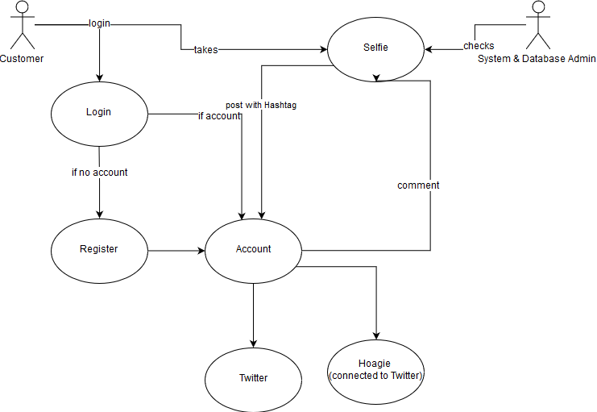Author and Date: -

**Food Supply**

Summary: The admin orders food depending on the daily needs.

Actors involved: Customer, System & Database Admin, Supplier, Cook

Sequence of steps: Customer sees available ingredients → Customer places online order → Admin orders food if needed → Supplier delivers ingredients to cook → Cook receives ingredients and notifies if there are a few left → Admin updates database which updates website

Alternate sequence: The selfie is not posted on the website due to it violating the rules.

Exceptions that can occur: The supplier is unable to deliver, so some ingredients are not available.

Extension points: -

Trigger: Online Order

Assumptions: There are orders and statistics which confirm the need for more ingredients.

Preconditions: The statistics are updated daily.

Post-conditions: The database and website is updated.

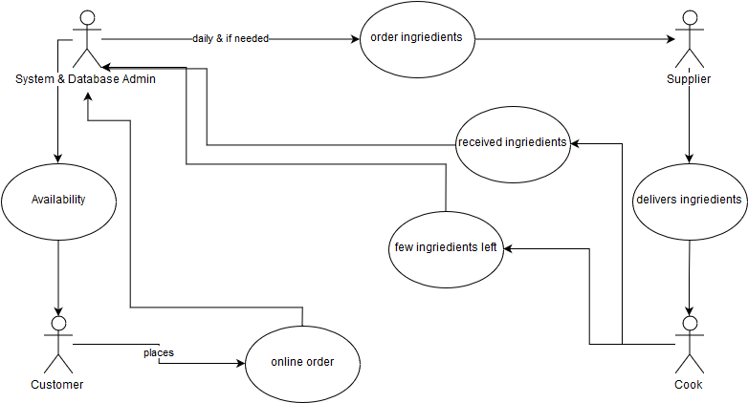Author and Date: -