|  |  |  |  |
| --- | --- | --- | --- |
|  | B1 | B2 | B3 |
| Red Balls | 2 | 4 | 3 |
| White Balls | 3 | 2 | 4 |
| Blue Balls | 6 | 3 | 3 |

1. Suppose that colored balls are distributed in three indistinguishable boxes, B1, B2 and B3 as follows:

For example, there are 2 red balls,3 white balls and 6 blue balls in B1. A box was selected at random and then a ball was selected from the box at random. The ball is red. What are the probability of the box selected being B1, B2 or B3?

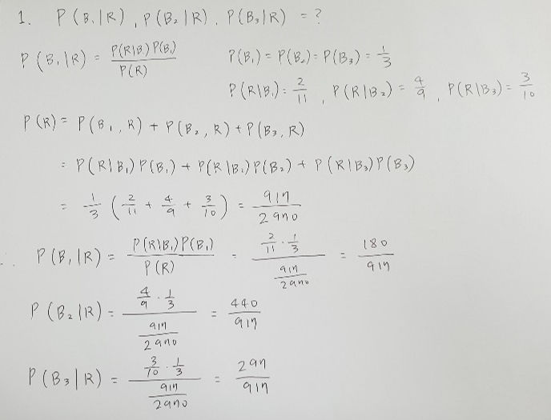

2. A doctor is checking a patient’s symptoms. Of a list of four symptoms for the dreaded lurgy, the patient has three. Suppose that the symptoms are independent for people who have the dreaded lurgy and are also independent for people free of the disease. Suppose that a patient with dreaded lurgy has a 3/4 chance of exhibiting each of the symptoms and that s random person who does not have dreaded lurgy has 1 chance in 50 of exhibiting each of the symptoms. If 1 person in 1,000 has dreaded lurgy, what is the probability that the patient has dreaded lurgy?

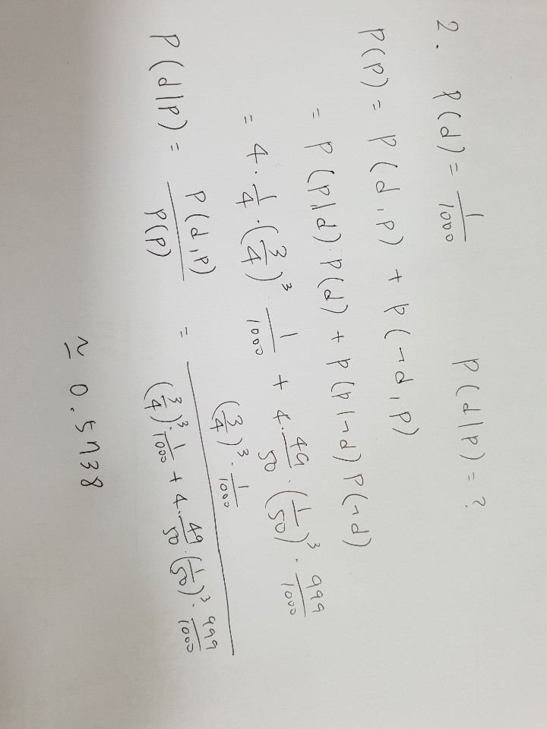

3. Answer whether two nodes are dependent or independent in the following Bayesian network



1. Nodes 13 and 35 : dependent
2. Nodes 22 and 11 : dependent
3. Nodes 22 and 11 given 31 : dependent
4. Nodes 5 and 32 : independent
5. Nodes 5 and 32 given 9 : dependent

4. Count the number of parameters of each network. Each node has only two values: true or false. The number of parameters is the number of probabilities which are necessary for a Bayesian network. When counting, regard that p(A) and p(➢A) are the same parameter because the one can be evaluated from the other.

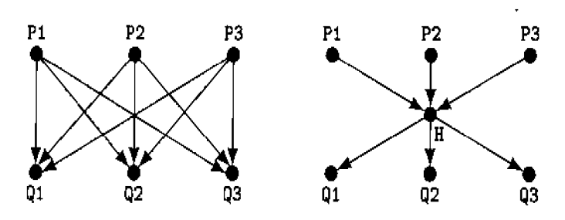

1. 27
2. 17

5. Evaluate p(P), p(Q|U), p(P|Q,U) with the following figure:

