1. What are the outputs if x = 1 and y = 1, and x = 1 and y = 0, respectively? A step function is used in each neuron. w1 = w2 = w4 = w6 = 1, w3 = -1.5, w5 = -2 and w7 = -0.5.

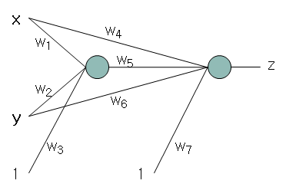

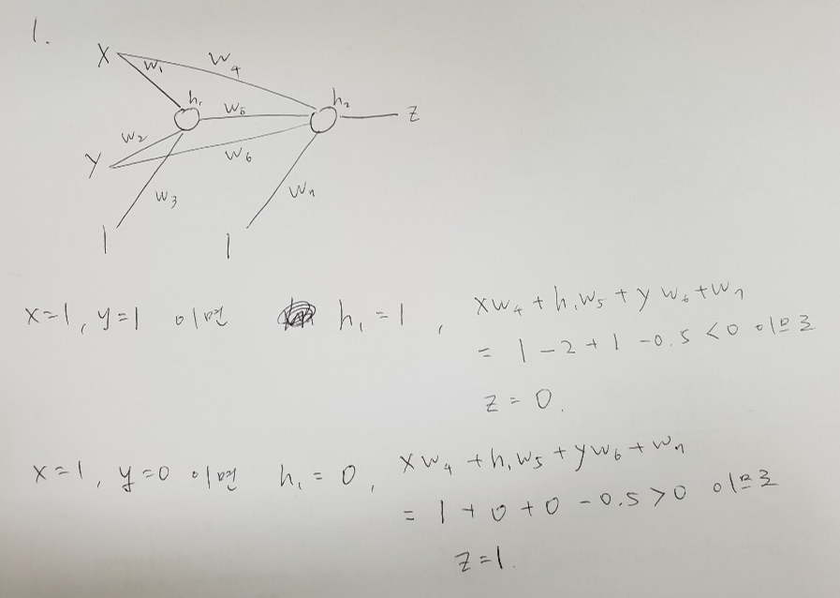

2. Set *w1, w2, w3, w4* so that the output is 1 only if at least one of inputs is 1s, where *f* is a step function.

 f

*x2*

*o*

*w1*

*w2*

*x1*

*x3*

*w3*

1

*w4*

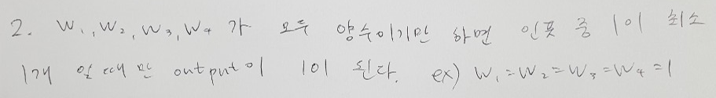

3. Fill out the tables on the slides 4 ~ 7 in “9-3. Neural Networks-EBP-3.pptx” for the second iteration of the XOR neural network training.

|  |  |  |  |
| --- | --- | --- | --- |
| N | X_n1 | X_n2 | X_n3 |
| 1 | 1 | 1 | 0 |
| 2 | 1 | 0 | 1 |
| 3 | 0 | 1 | 1 |
| 4 | 0 | 0 | 0 |

|  |  |  |
| --- | --- | --- |
| weight1 | weight2 | weight3 |
| -0.08907 | 0.097916 | 0.050961 |
| 0.027929 | -0.07008 | 0.062101 |
| 0.091862 | -0.01017 | 0.006224 |

|  |  |  |  |
| --- | --- | --- | --- |
| net_n1 | net_n2 | h_n1 | hn_2 |
| 0.030721 | 0.017666 | 0.50768 | 0.504416 |
| 0.002792 | 0.087746 | 0.500698 | 0.521922 |
| 0.119791 | -0.08025 | 0.529912 | 0.479948 |
| 0.091862 | -0.01017 | 0.522949 | 0.497458 |

|  |  |
| --- | --- |
| net_n1 | o_n1 |
| 0.06319 | 0.515792 |
| 0.064152 | 0.516032 |
| 0.063034 | 0.515753 |
| 0.063767 | 0.515936 |

|  |  |  |
| --- | --- | --- |
| ∂E_n/∂w_13 | ∂E_n/∂w_12 | ∂E_n/∂w_11 |
| 0.128819 | 0.064979 | 0.065399 |
| -0.12087 | -0.06308 | -0.06052 |
| -0.12094 | -0.05805 | -0.06409 |
| 0.128853 | 0.064099 | 0.067384 |

|  |  |  |  |  |  |
| --- | --- | --- | --- | --- | --- |
| ∂E_n/∂w_23 | ∂E_n/∂w_22 | ∂E_n/∂w_21 | ∂E_n/∂w_13 | ∂E_n/∂w_12 | ∂E_n/∂w_11 |
| 0.002 | 0.002 | 0.002 | 0.001641 | 0.001641 | 0.001641 |
| -0.00187 | 0 | -0.00187 | -0.00154 | 0 | -0.00154 |
| -0.00187 | -0.00187 | 0 | -0.00154 | -0.00154 | 0 |
| 0.002 | 0 | 0 | 0.001638 | 0 | 0 |

|  |  |  |
| --- | --- | --- |
| 0.015863 | 0.007948 | 0.008176 |

|  |  |  |  |  |  |
| --- | --- | --- | --- | --- | --- |
| 0.000253 | 0.000125 | 0.000127 | 0.000204 | 0.000105 | 0.000101 |

4. Implement the error back propagation algorithm for the $y=x\left(1-x\right)$ neural network on slide 12 in “9-3. Neural Networks-EBP-3.pptx”. You may change the number of hidden nodes, iterations, learning rate. Submit the followings:

- the code

- the final values of weights

- draw a graph for the output of neural network for $x=0.00, 0.01, 0.02, 0.03, 0.04, …, 1$