Report

2014313303, Taeha Hong

**1. Describe the input and functional structure of the machine learning model for the credit approval data set. (10 points)**

Input data is credit approval data set from UCI data repository. Number of instances is 690. 307 positive data(+), 383 negative data(-). Number of attributes is 15.

I used kears open source to make CNN, RNN, MLP models.

CNN

1 dimensional convolution layer -> max pooling -> batch normalization -> 1-d convolution layer -> max pooling -> batch normalization -> fully connected layer -> batch normalization -> fully connected layer -> batch normalization -> classify(sigmoid)

MLP

I stacked fully connected layer and batch normalization 3 times.

RNN(bidirectional)

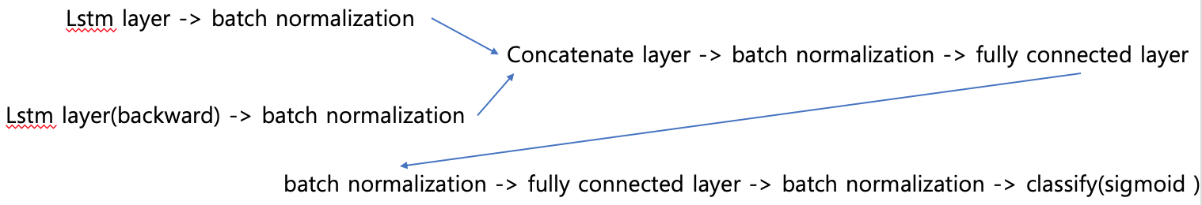

**2. Describe how and why learning parameters were determined for the selected learning model. (10 points)**

Decision Tree :

Max depth : 5 (I test None, 2, 3, 7, 10…. Then max depth 5 has best result.)

MLP:

Activation function : ReLu

Optimizer : Adam (lr=0.001, beta_1=0.9, beta_2=0.999, epsilon=1e-08)

Epoch : 30

Random Forest :

Max depth : 10

N_estimator : 100

AdaBoost (Decision Tree) :

Max depth : 5

Algorithm : SAMME

N_estimator : 100

CNN :

Activation function : ReLu

Optimizer : Adam (lr=0.001, beta_1=0.9, beta_2=0.999, epsilon=1e-08)

Epoch : 30

RNN :

Activation function : ReLu

Optimizer : Adam (lr=0.001, beta_1=0.9, beta_2=0.999, epsilon=1e-08)

Epoch : 50

**3. Using the methods of evaluation of the learning models described above, the measures of evaluation for each learning model are summarized. (20 points)**

10-fold evaluation (8 models)







Summary



**4. Compare and analyze the evaluation results of the summarized learning models and explain the reasons for experiment results. (30 points)**

RandomForest > AdaBoost(Decision Tree) > SVM > Decision Tree > RNN > CNN > MLP

AdaBoost boost decision tree 3% accuracy.

Deep Learning model have bad results. I think learning parameter or model structure is not suitable. If I make proper model structure, deep learning models have better results.

**5. Summarize references to the learning models and sources used in this assignment. (10 points)**

I used scikit learn and keras open source.

Data preprocessing

* Encode categorical attribute data to number.
* Split attribute and label.

Canonical models

* Decision Tree
* SVM
* MLP

Committee Machines

Deep Learning models

I made RBM models, but it predict all negative labels.

Evaluation methods

