**Based on Multisim Circuit Simulation and Analysis**

2022.12

Course Title：Fundamentals of Circuit Analysis

Name：Tian Bosong

Class and Grade：Electronic Science and Technology Class 21-2

Student number：202111040246

**Table of contents**

1 Software Introduction  1

2 Hardware design and principle  1

**2.1 Port characteristic test with source-port network**  1

**2.1.1 Thevenin equivalent circuit**  1

**2.1.2 Maximum Power Transfer Theorem**  2

**2.2 Full response of first-order dynamic circuits**  2

**2.3 Power of a sinusoidal steady-state circuit**  2

**2.4 Current-voltage relationship in three-phase circuits**  3

3 Simulation results and description  3

**3.1 Explanation of the simulation results of a source-port network**  3

**3.2 Explanation of the simulation results of the maximum power transfer theorem**  4

**3.3 Full response simulation results and explanations of the first-order circuit**  4

**3.4 Simulation results and explanations of sinusoidal steady state circuit power**  5

**3.5 Simulation results and explanation of three-phase circuit**  6

4 Circuit Design  7

**4.1 Design of network circuits with source-port**  7

**4.2 Design of Maximum Transmission Power Circuit**  7

**4.3 First-order circuit design of full response**  7

**4.4 Design of power circuit for sinusoidal steady-state**  8

**4.5 Design of current-voltage relationship circuit in three-phase circuit**  8

Simulation and Analysis of Circuit

Based on Multisim

Tian Bosong

(School of Information Science and Engineering, Yanshan University)

# Software introduction

A simulation system is a valuable tool for simulating the functional behavior of a circuit without building the actual circuit (which can be tedious and expensive). As the simulation system simulates the real situation more and more realistically, many universities and research institutions will use this kind of tools to assist the [teaching of electronic engineering .](https://zh.m.wikipedia.org/wiki/%E7%94%B5%E5%AD%90%E5%B7%A5%E7%A8%8B) Because electronic circuit simulation systems generally have a better graphical interface, they can often make users feel as if they were on the scene.

NI Multisim (formerly known as Electronics Workbench) is a well-known [electronic design automation](https://zh.m.wikipedia.org/wiki/%E9%9B%BB%E5%AD%90%E8%A8%AD%E8%A8%88%E8%87%AA%E5%8B%95%E5%8C%96) software, which belongs to the circuit design software suite of National Instruments together with HYPERLINK "[NI Ultiboard](https://zh.m.wikipedia.org/w/index.php?title=NI_Ultiboard&action=edit&redlink=1) . It is one of the few software selected in the [UC Berkeley](https://zh.m.wikipedia.org/wiki/%E4%BC%AF%E5%85%8B%E5%88%A9%E5%8A%A0%E5%A4%A7) [SPICE project.](https://zh.m.wikipedia.org/wiki/%E9%9B%86%E6%88%90%E7%94%B5%E8%B7%AF%E9%80%9A%E7%94%A8%E6%A8%A1%E6%8B%9F%E7%A8%8B%E5%BA%8F) Multisim is widely used in circuit teaching, circuit diagram design and SPICE simulation in academia and industry.

# Hardware Design and Principle

**2.1 Port characteristic test with source-port network**

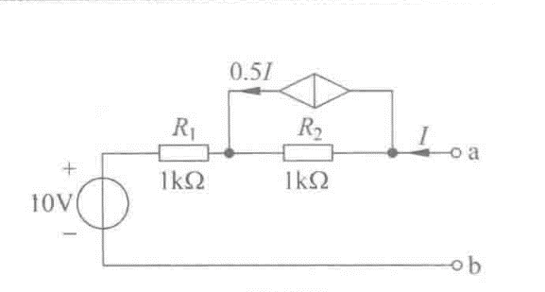

**Figure 2-1 source-port network**

**2.1.1 Thevenin equivalent circuit**

Principle: The two ends of a linear network containing an independent voltage source, an independent current source and a resistor, in terms of its external type, can be electrically combined with a series resistance combination of an independent voltage source V and a resistor two-terminal network effect.

**2.1.2 Maximum power transfer theorem**

Principle: In order to obtain the maximum external power from the power supply with limited internal resistance, the load resistance must be equal to the output equivalent resistance of the power supply network. The maximum power transfer theorem states, given the source resistance, how to choose the load resistance to achieve maximum power transfer.

**2.2 Full response of first-order dynamic circuits**

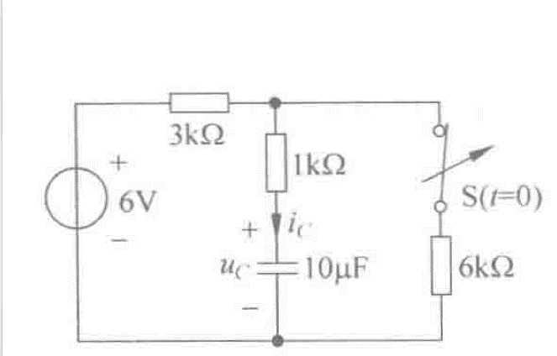

**Figure 2-2 Full response of a first-order circuit**

Principle: The response of the first-order circuit when the external excitation and the initial state of the dynamic element act together.

**2.3 Power of a sinusoidal steady-state circuit**

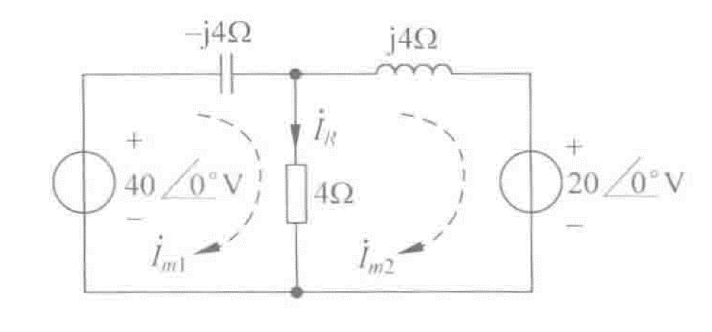

**Figure 2-3 Power of a sinusoidal steady-state circuit**

Principle: In a sinusoidal steady-state circuit, the total active power is the sum of the active power of each part of the circuit, and the total reactive power is the sum of the reactive power of each part of the circuit, that is, active power and reactive power are conserved respectively.

**2.4 Current-voltage relationship in a three-phase circuit**

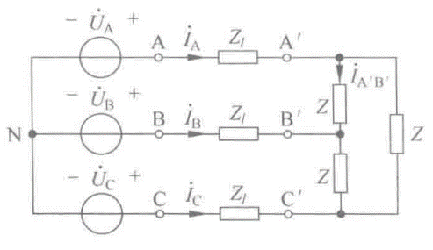

**Figure 2-4 The relationship between**

**current and voltage in a three-phase circuit**

Principle: A three-phase circuit is usually composed of a delta or star three-phase voltage and a three-phase load. There is a certain quantitative relationship between the phase voltage and the line voltage, and both the voltage source and the load can be transformed into a star-delta.

# Simulation Results and Description

**3.1 Explanation of simulation results with source-port network**

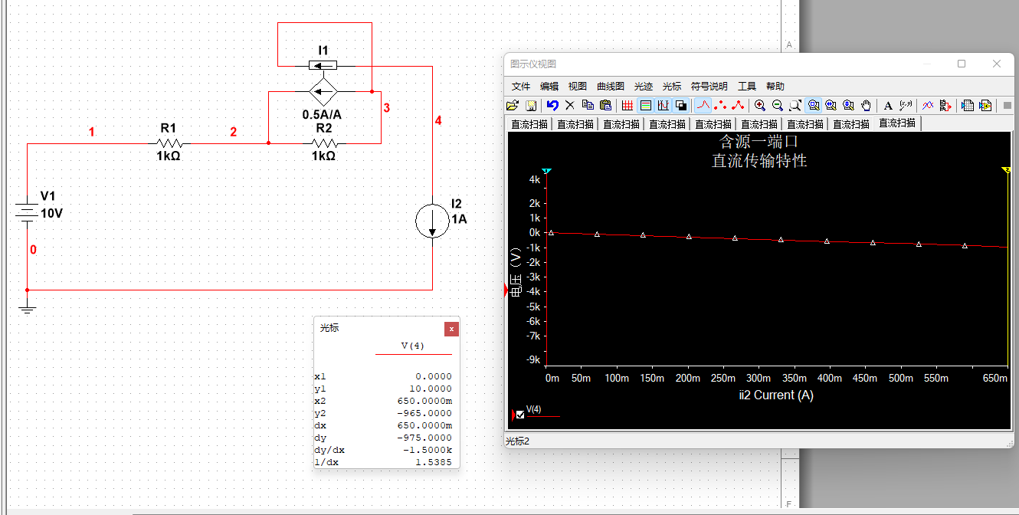

**Figure 3-1 Simulation results of a source-port network**

**Figure 3-2 Thevenin equivalent circuit with source-port network**

Scan the port of the circuit to obtain its port characteristic curve. Its intercept on the Y axis is 1 0 , and the slope is 1 500 , and the Thevenin equivalent circuit in Figure 3-2 is obtained .

**3.2 Explanation of the simulation results of the maximum power transfer theorem**

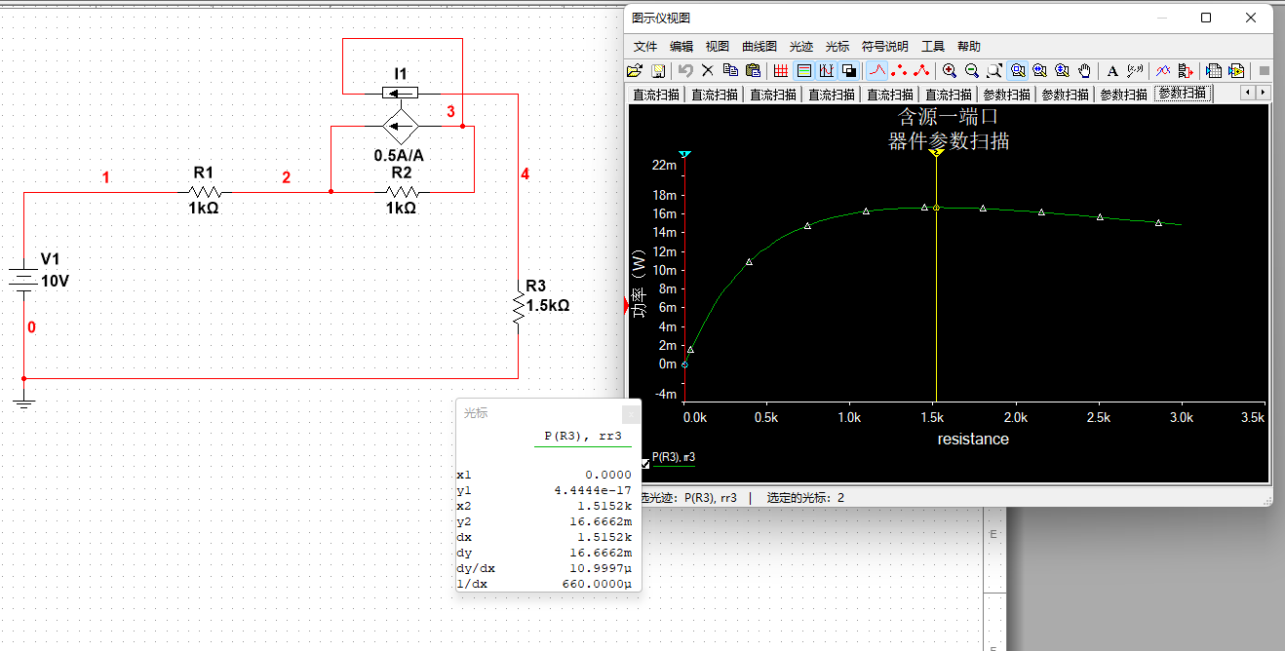

**Figure 3-3 Simulation results of the maximum power transfer theorem**

Since the source-port network can be equivalent to the Thevenin equivalent circuit, that is, Figure 3-2 . Therefore, according to the maximum power transmission theorem, when the external resistance is equal to the internal resistance of 1500Ω , the external circuit can obtain the maximum power at this time.

**3.3 Full response simulation results and explanations of the first-order circuit**

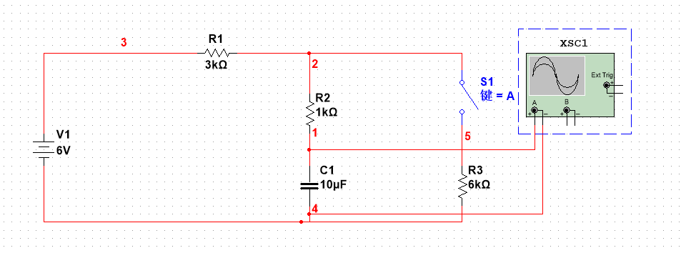

**Figure 3-4 Full response simulation results of the first-order circuit**

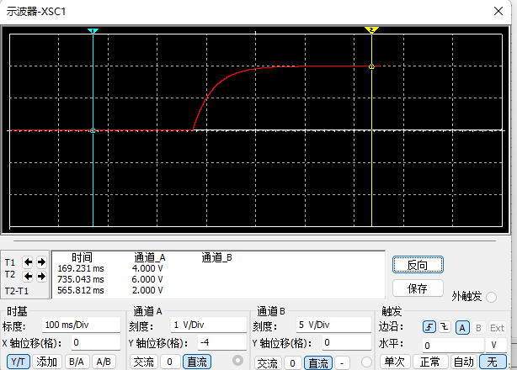

**Figure 3-5 uc change simulation curve Figure 3-6 uc change curve**

The response of the first-order circuit when the external excitation and the initial state of the dynamic element act together, the voltage across the capacitor is stable at 4V before time t = 0, and the capacitor voltage is stable at 6V after the circuit is disconnected and stabilized.

**3.4 Simulation results and descriptions of sinusoidal steady state circuit power**

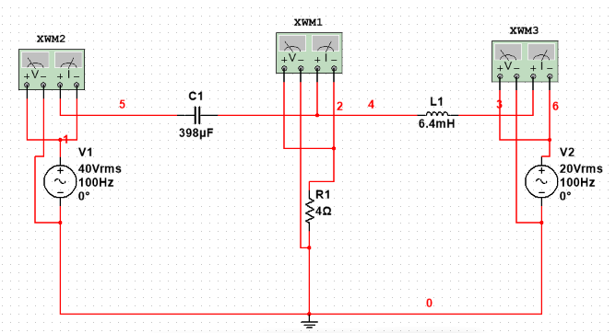

**Figure 3-7 Power simulation circuit diagram of sinusoidal steady state circuit**

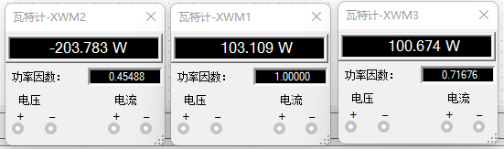

**Figure 3-8 Power simulation results of sinusoidal steady-state circuit**

In the sinusoidal steady-state circuit, in addition to the reactive power generated by the inductance and capacitance, the total power generated by the power source 1 is 200 W , and the power absorbed by the 4Ω resistor and the 20 V power supply is 100 W each.

**3.5 Simulation results and description of three - phase circuit**

**Figure 3-9 Three -phase circuit simulation circuit diagram** 图形用户界面

描述已自动生成

**Figure 3-10 Three -phase circuit simulation results**

In the three-phase circuit shown in the figure, the phase voltage is 220 V , the terminal line impedance Zl = ( 0.1+ j 0.17 )Ω, and the load impedance Z = ( 9+ j 6) Ω. Find the load current and line current.

Since the complex impedance cannot be drawn in Multisim, the formula

$Z=R+jωL-jωC$ (1)

It can be concluded that the equivalent inductance in the terminal line impedance is 541 uH , and the equivalent inductance in the load impedance is 19 mH .

# Circuit design

**4.1 Design of a source-port network circuit**

According to the data in Figure 2, it is easy to get the equation of its simulation curve, which is

$y=10-1500x$ (2)

So the Thevenin equivalent circuit has an equivalent voltage of 10 V and an equivalent resistance of 1500 Ω .

**4.2 Design of maximum transmission power circuit**

According to the equivalent internal resistance of Thevenin equivalent circuit with source-port network is 1500 Ω , it can be known from the parameter scanning diagram that when the resistance of the external circuit is equal to the equivalent resistance of 1500 Ω , the power of the external circuit reaches the highest point, namely reach the maximum power.

**4.3 Design of first-order full response circuit**

Before the switch is turned off, the capacitor is equivalent to an open circuit after the circuit is stable, and the voltage across it is equal to the voltage across R3 ,

$U_{c}=\frac{R_{1}U_{1}}{R_{1}+R_{3}}$ (3)

Solve it $U_{c}=4V$.

After the switch is turned off, the voltage across the capacitor gradually tends to the power supply voltage, which is the solution $U_{c}=6V$.

The time constant of this circuit

$τ=RC$ (4)

In this formula $R=4kΩ$, $C=10uf$, can be solved $τ=0.04$.

**4.4 Design of power circuit for sinusoidal steady-state circuit**

Since the equivalent resistance of capacitance and inductance is given in the original circuit diagram, it is necessary to pass

$R_{c}=\frac{1}{jωc}$*and $R_{l}=jωl$*  (5)

The two formulas calculate its equivalent capacitance 3 98 uF and equivalent inductance 0 .4 mH and substitute them into the simulation circuit.

1 and Im 2 can be calculated by the mesh current method , and because the current IR flowing through the resistor = Im 1 -Im 2 , the power of each load in the circuit can be calculated.

**4.5 Design of current-voltage relationship circuit in three-phase circuit**

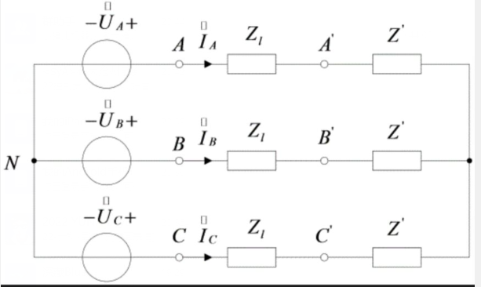

**Figure 4-1 Equivalent circuit of a three-wire circuit**

In the figure Z ' is

$Z^{'}=\frac{Z}{3}=(3+j2)Ω$ (6)

Assume $\dot{U_{A}}=220∠0°V$ that the line current $\dot{I_{A}}$ is

$\dot{I_{A}}=\frac{\dot{U_{A}}}{Z+Z'}=\frac{220∠0°}{3.1+j2.17}=58.14∠-35°A$ (7)

So the phase current $\dot{I_{A^{'}B^{'}}}$ is

$I_{A^{'}B^{'}}=\frac{\dot{I_{A}}}{\sqrt{3}}∠30°=33.57∠-5°A$ (8)

Within the allowable range of error, it is numerically equal to the simulation result.