**Based on ××× Circuit Simulation and Analysis**

Course Title：Fundamentals of Circuit Analysis

Name：

Class and Grade:

Student number:

2022.9

1 Software introduction

Multisim is a Windows based simulation tool launched by National Instruments (NI) Co., Ltd., which is applicable to the design of board level analog/digital circuit boards. It includes the graphic input of circuit schematic diagram and the input mode of circuit hardware description language, and has rich simulation and analysis capabilities.

People can use Multisim to interactively build circuit schematics and simulate circuits……

2 Hardware design and principle

**For example: Find the equivalent resistance of one-port network in figure (a)**.

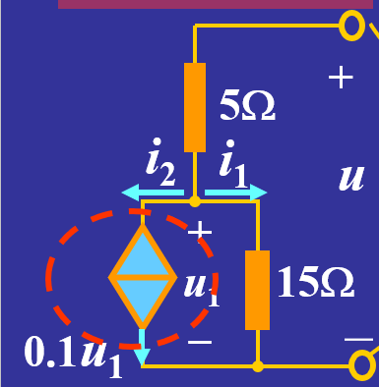

(a)

Principle: Equivalent transformation of resistance.

3 Description of simulation results (including circuit principle and analysis description, etc.)

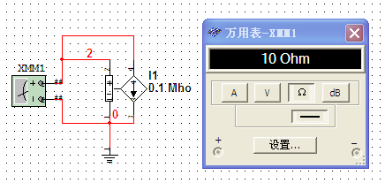 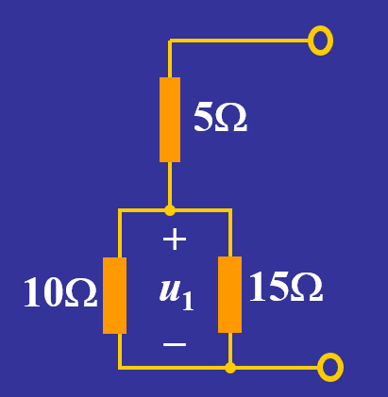

(b) (c)

Simulate the controlled source in figure (a) and obtain its equivalent resistance of 10 ohms, as shown in figure (b). The equivalent resistance is brought back to the original circuit to obtain figure (c), thus simplifying the circuit.

4 The design of ××× circuit (including parameter calculation and test results)

According to figure (c), it is easy to obtain the equivalent resistance of this port as 11 ohms.

Reference format

**1.Title 1**

Can be connected to the next level title or text.

The thesis requires clear themes, reliable data, rigorous logic, and concise text.

**1.1Title 1.1**

The title should properly and concisely reflect the specific content of the article, and should facilitate the compilation of the bibliography, index and key words. It is not advisable to use non-known acronyms, acronyms, code names, etc., nor to list the original form and abbreviation at the same time.

**1.1.1Title 1.1.1**

Following the text. The page numbers are arranged longitudinally in a B5 paper type, with a margin of 3 cm on the top, 2cm on the bottom, and 2.5cm on both sides. The size of the text is specified as follows: the abstract, figure name, table name and content, and references are all small five-size characters, and the main text except for the title is all five-size characters. The title is shown in the sample. All adopt Song Ti.

The titles of all levels in the text are arranged in three levels using Arabic numerals, and they are all typeset in the top left grid. The first-level headings are in the form of 1, 2, 3, ... sort; the second-level headings are in the form of 1.1, 1.2, ... sort; the third-level headings are in the form of 1.1.1, 1.1.2, ... sort.

**Table 1 Chinese table title is centered (the table appears with the text) aligned here when line breaks**

|  |  |
| --- | --- |
| basic requirements | The Chinese characters in the table are in Small No. 5 Song. |
|  |  |
|  |  |

**Note:** The notes on the table are in Small No. 5 Song

The body of the formula is centered and the numbers are aligned to the right.