University of Glasgow
School of Social and Political Sciences
Urban Studies

Evaluating the Accessibility and Equity Impacts of the Bee Network Overnight Bus Pilot: A Case Study of Hospitality Employment in Greater Manchester

HUA HUANG
3075639

Presented in partial fulfilment of the requirements for the degree of M.Sc. in Urban Transport

Word Count: 13515

August 2026

Abstract
This study evaluates the accessibility and equity implications of the Bee Network overnight bus pilot in Greater Manchester, focusing on access to hospitality employment. The timetable-based public transport accessibility model was used to compare two network scenarios, one including the four pilot services and one excluding the overnight pilot trips. Accessibility was measured as the number of hospitality employment opportunities reachable within 45 minutes from each of the 1,702 LSOAs. Spatial analysis, deprivation-group comparisons, regression modelling and spatial diagnostics were then used to examine the distribution of accessibility changes and their relationship with neighbourhood income deprivation. The results show that night-time accessibility remained spatially uneven under both scenarios, with higher accessibility concentrated in central and inner Greater Manchester. No significant differences in percentage accessibility change were found across income deprivation quintiles, and regression results provided limited evidence of an independent association with income deprivation. The findings show that targeted overnight service extensions can generate meaningful local accessibility gains without producing systematic improvements according to socioeconomic disadvantage, highlighting the importance of considering accessibility change and its spatial distribution when evaluating transport equity.

Key words：transport equity, public transport accessibility, night-time transport, employment accessibility, regression model, income deprivation

Contents
List of Figures v
List of Tables vi
1 Introduction 1
2 Literature Review 5
2.1 Transport Equity 5
2.2 Measuring Accessibility to Employment 7
2.3 Network and Time-Based Accessibility Measurement 9
2.4 Night-time Public Transport and Employment 11
2.5 Statistical Analysis of Accessibility Inequality 12
3 Methodology 14
3.1 Research design 14
3.2 Study Area and Pilot Case 15
3.3 Accessibility Modeling 16
3.3.1 Accessibility Measure and Routing 16
3.3.2 Pilot Scenario Design 17
3.4 Data 19
3.4.1 GTFS Data 19
3.4.2 Road Network 20
3.4.3 Hospitality Employment Data 21
3.4.4 Income Deprivation Data 22
3.4.5 Population Density 23
3.4.6 Household Car Availability 23
3.4.7 Descriptive Statistics of Study Data 24
3.5 GIS Spatial Analysis 25
3.6 Statistical Analysis 26
4 Results 29
4.1 Night-time Accessibility and Accessibility Change 29
4.1.1 Accessibility without the Pilot 29
4.1.2 Accessibility with the Pilot 31
4.1.3 Accessibility Change 32
4.2 Distributional Equity Analysis 37
4.2.1 Accessibility Change by Income Deprivation 37
4.2.2 Statistical Comparison 38
4.3 Regression Analysis 39
4.3.1 Probability of Accessibility Increase 39
4.3.2 Magnitude of Percentage Accessibility Change 43
4.3.3 Spatial Diagnostics 45
5 Discussion 49
5.1 Interpretation of Key Findings 49
5.2 Equity Implications of the Overnight Bus Pilot 50
5.3 Policy Implications 51
5.4 Limitations 52
6 Conclusions 55
Reference 58

List of Figures
Figure 1: Greater Manchester Study Area and Metropolitan Boroughs 15
Figure 2: Greater Manchester 24-Hour Bus Pilot Routes 16
Figure 3: Bus and Tram Stops in Greater Manchester 20
Figure 4: OSM Road Network in Greater Manchester 21
Figure 5: Spatial Distribution of Accommodation and Food Service Employment and Accessibility Destinations in Greater Manchester 22
Figure 6: IMD Income Score (rate) across Greater Manchester 23
Figure 7: Night-time public transport accessibility to hospitality employment within 45 minutes without the overnight bus pilot 30
Figure 8: Night-time public transport accessibility to hospitality employment within 45 minutes with the overnight bus pilot 32
Figure 9: Changes in night-time public transport accessibility associated with the pilot 35
Figure 10: LISA cluster maps of regression residuals for the probability and magnitude models 46

List of Tables
Table 1: Timetable of the Pilot Bus Routes 18
Table 2: Descriptive Statistics 24
Table 3: Regression Variables 26
Table 4: Comparison of night-time public transport accessibility with and without the overnight bus pilot 33
Table 5: Accessibility change by income deprivation quintile 37
Table 6: Kruskal–Wallis test results by income deprivation quintile 38
Table 7: Logistic regression results for the probability of positive accessibility change 40
Table 8: OLS regression results for the magnitude of positive percentage accessibility change 43
Table 9: Global and local spatial autocorrelation diagnostics for regression residuals 45

1 Introduction
Public transport accessibility plays a fundamental role in connecting people with employment opportunities (Bastiaanssen et al., 2022). This is important for night-time workers and others travelling during overnight hours, when public transport journeys can involve longer travel times and greater organisational effort (Kapitza, 2024). Limited night-time public transport can constrain access to employment, with greater effects on lower-income and public transport-dependent populations, which may reinforce existing transport inequalities (Lucas, 2012; Palm et al., 2023; Bastiaanssen et al., 2022; McArthur et al., 2019). Improving employment accessibility is an important consideration in transport planning, especially in urban areas where population and employment opportunities are unevenly distributed (Bastiaanssen et al., 2022; Geurs and van Wee, 2004).
Greater Manchester Combined Authority (2023) reported a population of approximately 2.87 million across the ten metropolitan boroughs of Bolton, Bury, Manchester, Oldham, Rochdale, Salford, Stockport, Tameside, Trafford and Wigan at the 2021 Census. Transport for Greater Manchester (2024) found that cars accounted for almost 60% of trips made by Greater Manchester residents, while public transport accounted for around 7%. The survey also found that around one quarter of households had no access to a car or van, with lower car availability among less affluent households and greater reliance on bus travel among residents without a car.
Greater Manchester has a diverse but spatially uneven economy, with access to employment and economic opportunities varying across the metropolitan area (HM Government, 2019; Mealy and Coyle, 2022). Greater Manchester also has a large night-time economic activity, with approximately one-third of its workforce working in sectors or businesses operating during night-time hours (Greater Manchester Combined Authority, 2022). Accommodation and food service activities are especially relevant because the sector has a high concentration of evening and night-time work (Office for National Statistics, 2023). Manchester city centre has a strong night-time and visitor economy (Manchester City Council, 2024). Access to these employment opportunities can be more difficult at night, as limited night-time transport provision can constrain workers’ access to employment (McArthur et al., 2019; Smeds et al., 2017). In Greater Manchester, transport provision has been identified as an important factor in supporting access to night-time employment and economic activity (Bee Network Committee, 2024; Transport for Greater Manchester, 2021). Transport for Greater Manchester (TfGM) introduced the Bee Network overnight bus pilot, extending the operating hours of four existing routes to improve overnight connectivity and support access to employment (Transport for Greater Manchester, n.d.; Greater Manchester Combined Authority, 2024, 2025). These conditions make Greater Manchester a useful case study for examining the relationship between night-time transport provision and employment accessibility. The pilot provides a basis for examining the spatial distribution of accessibility gains and the socioeconomic characteristics of the neighbourhoods that benefit (Bee Network Committee, 2024; Transport for Greater Manchester, n.d.).
Changes in operating hours may influence employment accessibility differently across Greater Manchester, reflecting variation in service availability and the location of employment opportunities (Geurs and van Wee, 2004; Greater Manchester Combined Authority, 2024). The study examines the location of these changes and their distribution across neighbourhoods with different levels of income deprivation.
The previous research shows that public transport accessibility can change across the day because network performance and service availability vary over time (Raza et al., 2023). McArthur et al. (2019) identified severe accessibility barriers for night-time workers in London, including dependence on low-frequency bus services and limited spatial coverage. Pan et al. (2025) argue that the transport needs of night commuters remain underrepresented in conventional planning and show that public transport job accessibility is associated with night-time public transport use. However, existing studies have mainly examined general night-time accessibility, travel behaviour or broader network conditions. Limited research has examined neighbourhood-level employment accessibility changes associated with targeted extensions of overnight operating hours and the socioeconomic distribution of these changes. The Bee Network pilot provides a case through which this more specific question can be examined.
The aim of this study is to evaluate the accessibility changes associated with the Bee Network overnight bus pilot and assess how these changes are distributed across neighbourhoods with different levels of income deprivation in Greater Manchester.
The study answers three research questions:
- How is night-time public transport accessibility to hospitality employment distributed across Greater Manchester with and without the overnight bus pilot?
- To what extent are accessibility improvements associated with the pilot, and where are these improvements concentrated?
- How do accessibility changes associated with the pilot differ according to neighbourhood income deprivation after accounting for relevant neighbourhood characteristics?
The study adopts a quantitative neighbourhood-level design using Lower Layer Super Output Area (LSOA) as the spatial unit. Public transport accessibility is measured using timetable-based routing and a cumulative opportunity measure of hospitality jobs reachable within a specified travel-time threshold. Two network scenarios are compared, one with the overnight pilot services and the other one without the pilot services. All other modelling conditions are held constant to estimate the accessibility change associated with the pilot. Spatial analysis is used to examine the distribution of accessibility and accessibility change across Greater Manchester. These results are combined with the Income Deprivation domain of the English Indices of Deprivation 2025 (IMD 2025) to assess differences in accessibility change across neighbourhoods with different levels of income deprivation. Regression analysis examines the association between income deprivation and accessibility change after controlling for relevant neighbourhood characteristics, while spatial autocorrelation analysis assesses residual spatial dependence. By combining timetable-based accessibility modelling with spatial and statistical analysis, the study examines both the extent and distribution of accessibility change. The scenario comparison identifies changes associated with the additional overnight services, while the equity analysis examines differences across neighbourhoods with different levels of income deprivation. This approach distinguishes local accessibility gains from their broader socioeconomic distribution. Evaluation needs to consider both where improvements occur and how large they are. The increase in accessibility does not necessarily mean that benefits are concentrated in neighbourhoods experiencing greater socioeconomic disadvantage (Pereira et al., 2017).
The findings show that accessibility improvements associated with the pilot are geographically concentrated, while 96.3% of LSOAs record no measurable change. No significant differences are found between income deprivation groups, and income deprivation shows limited explanatory power in the regression analysis. The dissertation is organised into six chapters. The study contributes to night-time transport equity research by distinguishing between local accessibility improvement and the wider distribution of accessibility benefits across neighbourhoods.
Following this introduction, Chapter 2 reviews the literature on transport equity, employment accessibility, time-based accessibility and night-time public transport. Chapter 3 sets out the study area, data, accessibility modelling and analytical methods. Chapter 4 reports the results of the night-time accessibility, pilot comparison, distributional equity, regression and spatial analyses. Chapter 5 discusses these findings in relation to transport equity and policy, together with the main limitations of the study. Chapter 6 summarises the main conclusions, research contribution and areas for future research.

2 Literature Review

2.1 Transport Equity
Transport equity concerns how the advantages and disadvantages associated with transport systems are distributed across populations and places (Delbosc and Currie, 2011; Di Ciommo and Shiftan, 2017). Transport equity is discussed in terms of horizontal and vertical equity. Horizontal equity refers to the distribution of transport resources and outcomes across individuals or groups with similar transport needs, whereas vertical equity recognises differences in socioeconomic circumstances and transport needs and gives greater consideration to disadvantaged groups(Camporeale et al., 2019; Lin et al., 2026; van Wee and Mouter, 2021). This distinction means that an equitable system does not require identical levels of transport provision across all population groups or areas, as differences in social and transport needs may justify different distributions of transport resources and benefits (Camporeale et al., 2019; van Wee and Mouter, 2021). Vertical equity is relevant to the distribution of transport benefits across groups with different levels of socioeconomic disadvantage. Pereira et al. (2017) place these distributional concerns within a distributive justice framework, arguing that transport policy evaluation should consider how its impacts are distributed, the position of disadvantaged groups and inequalities in access to opportunities. This study adopts a vertical and distributional equity perspective, focusing on how accessibility changes are distributed across neighbourhoods with different levels of income deprivation. Based on this framework, transport equity is assessed through the distribution of employment accessibility and accessibility improvements, with attention to neighbourhoods experiencing greater socioeconomic disadvantage.
Within public transport research, the core equity concern is the relationship between transport provision and social need (Foth et al., 2013). Currie (2004) points out areas where public transport provision does not adequately match social need. Shafiq et al. (2026) conceptualise public transport inequity as a mismatch between transport needs and access to public transport services. Socioeconomic disadvantage is relevant to this relationship because low income combined with limited transport options can restrict access to employment and other essential activities (Lucas et al., 2016). Low-income and no-car households have been identified as important transport-disadvantaged groups in public transport equity (Ricciardi et al., 2015). These findings provide a basis for examining public transport equity in relation to income deprivation, with greater attention given to areas experiencing higher levels of socioeconomic disadvantage.
Assessing equity through the distribution of transport services is insufficient, because service provision does not itself indicate the opportunities that people can reach. Pereira et al. (2017) argue that transport justice should place accessibility at its centre because transport enables people to reach important destinations and take part in everyday activities. Accessibility-based evaluation shifts attention from the distribution of transport resources to the opportunities that individuals can reach through the interaction between the transport and land-use systems (Geurs and van Wee, 2004). For employment, accessibility measures estimate how many jobs can be reached by public transport within a given travel-time threshold and how access differs across socioeconomic groups (El-Geneidy et al., 2016). Isambourg et al. (2026) also identify the distribution of accessibility as a key measure of transport equity and examine the relationship between poverty and public transport job accessibility.
Public transport equity also has an important spatial dimension. Accessibility may vary considerably between neighbourhoods, and these differences can be associated with socioeconomic characteristics (Pira and Hansson, 2025). Improvements in accessibility do not necessarily result in more equitable outcomes because accessibility gains may be distributed unevenly across socioeconomic groups. Pereira et al. (2019) found that public transport infrastructure investments in Rio de Janeiro would have increased accessibility, but the resulting gains would have been larger in higher-income areas. Equity assessment needs to consider accessibility change and the distribution of accessibility gains across different population groups (Martens, 2012; Cui et al., 2020).
Public transport equity also has a temporal dimension, as the distribution of accessibility can vary across different times of the day. Ryan et al. (2023) show that public transport accessibility to workplaces varies across departure periods and that these differences are associated with socioeconomic and demographic characteristics. Time-dependent public transport equity research demonstrates that access to employment opportunities can vary according to the time at which journeys are made (Raza et al., 2023). This issue is important at night, when job accessibility by public transport is relevant to the travel opportunities and public transport use of night commuters (Pan et al., 2025). This provides a basis for examining accessibility changes associated with additional night-time services and their distribution across neighbourhoods with different levels of income deprivation.

2.2 Measuring Accessibility to Employment
Accessibility has been used to describe the potential for individuals to reach activities and opportunities within an urban system (Handy and Niemeier, 1997; Hansen, 1959). It reflects the interaction between the spatial distribution of opportunities and the effort required to reach them (Geurs and van Wee, 2004). Accessibility has also been used as a planning principle for integrating land-use and transport strategies (Curtis, 2008). Geurs and van Wee (2004) distinguish four interacting components of accessibility: land use, transport, temporal and individual. The land-use component concerns the quantity and spatial distribution of opportunities, while the transport component reflects the time, cost and effort involved in travelling between origins and destinations. Accessibility can improve through closer opportunities or better transport conditions, and higher travel speed alone does not necessarily produce greater accessibility (Levine et al., 2012; Shen, 1998).
Transport accessibility can be applied to different types of activities and opportunities, including employment and other social activities (Saif et al., 2019; Santana Palacios and El-Geneidy, 2022). Employment accessibility is important because limited access to jobs can reduce the employment opportunities available within an individual’s reach (Shen, 1998; Bastiaanssen et al., 2020). In Great Britain, better public transport job accessibility is associated with a higher likelihood of employment, particularly in areas with lower car ownership and higher levels of income deprivation (Lucas et al., 2019; Bastiaanssen et al., 2020). Employment accessibility reflects the extent to which the spatial distribution of jobs and available transport conditions enable individuals to reach labour-market opportunities (Hernandez et al., 2020; Wang, 2003).
Employment accessibility is measured using gravity-based or cumulative opportunity approaches, which differ in how they account for travel impedance and reachable opportunities (Kapatsila et al., 2023). Gravity-based measures reduce the weight of opportunities as travel impedance increases, while cumulative measures are easier to interpret because they show how many opportunities can be reached within a specified travel time (Santana Palacios and El-Geneidy, 2022). Kapatsila et al. (2023) found that the two measures produced similar patterns of public transport job accessibility when the cumulative threshold was close to the average commuting time. Cumulative opportunity measures have consequently become widely used in accessibility research and planning because of their relative simplicity and communicability (Tomasiello et al., 2023). The results depend on the selected travel-time threshold, since opportunities immediately within the threshold are counted while those beyond it are excluded (Geurs and van Wee, 2004). The selection of this threshold can materially affect accessibility estimates and the conclusions drawn from accessibility and equity analyses (Rezende et al., 2026; Tomasiello et al., 2023). This limitation is relevant when accessibility change is used to evaluate transport interventions. Klar et al. (2023) found that cumulative, gravity-based and hybrid measures could produce different estimates of accessibility change following public transport interventions, showing that measure choice can influence project evaluation.
There is no universal travel-time threshold for measuring employment accessibility, and the choice depends on the purpose and context of the analysis (Tomasiello et al., 2023). Grisé et al. (2019) discuss the 45-minute threshold for public transport job accessibility in Montréal and Toronto. Mann and Levinson (2024) examine accessibility across 30-, 45- and 60-minute travel-time limits, illustrating how measured accessibility changes as the threshold increases. These studies illustrate that the amount of employment classified as accessible depends partly on the travel-time limit selected and that threshold choice should be justified in relation to the study background (Tomasiello et al., 2023).
Threshold selection can be informed by both observed commuting behaviour and commuting tolerance. Grisé et al. (2019) adopted a 45-minute threshold because average public transport commuting times in their study regions were 43 and 47 minutes. In Great Britain, the average commute by bus or coach was 40 minutes in 2024 (Department for Transport, 2025b). Commuting tolerance reflects how long people are willing to spend travelling to work. Milakis and van Wee (2018) show that acceptable travel time varies between individuals and contexts, while He et al. (2016) found that commuting time was most frequently concentrated between 30 and 40 minutes and that tolerance varied according to characteristics including income, travel mode and residential location. De Vos (2025) distinguishes between actual, ideal and maximum tolerable commute durations and shows that tolerable commuting time varies across travel modes, with longer maximum tolerable durations among public transport users. These findings suggest that travel-time thresholds are context-specific analytical choices and do not represent universal behavioural boundaries. A 45-minute threshold is adopted in this study to measure accessibility to hospitality employment. It is slightly above the observed average bus and coach commuting time of 40 minutes in Great Britain and is consistent with the threshold used in comparable metropolitan public transport employment-accessibility research (Department for Transport, 2025b; Grisé et al., 2019).

2.3 Network and Time-Based Accessibility Measurement
Public transport accessibility depends on the transport network connecting origins and destinations and the service conditions available at the time of travel (Kujala et al., 2018). Network-based approaches use routable connections to calculate travel times between locations (Salonen and Toivonen, 2013). Conway et al. (2017) show that public transport accessibility can vary according to departure time and transfer waiting times. Fayyaz S et al. (2017) show that changes in public transport schedules produce temporal variation in travel times and accessibility. Accessibility measured at a single departure time may provide an incomplete representation of public transport access across different periods of the day (Farber et al., 2014; Fransen et al., 2015).
General Transit Feed Specification (GTFS) data provide route, stop and timetable information that allows public transport travel times and accessibility to be estimated for specific departure times (Fayyaz S et al., 2017). This enables accessibility to reflect changes in service conditions throughout the day. Farber et al. (2014) examined temporal variation in public transport accessibility to supermarkets, while Fransen et al. (2015) used a time dependent, schedule-based approach to examine accessibility to key destinations at different times. Farber and Fu (2017) demonstrated that time-dependent public transport travel times can be used to assess changes in job accessibility following service reductions and network expansions. These studies show that timetable-based analysis is useful when accessibility is affected by changes in service frequency, departure time or operating hours.
Timetable data can be combined with routable transport networks to estimate public transport journeys between origins and destinations. Fayyaz S et al. (2017) calculate origin–destination travel times at different times of day using GTFS data, while Conway et al. (2017) apply accessibility analysis to multimodal networks containing both streets and public transport. Pereira et al. (2021) show that R5 can integrate GTFS and OpenStreetMap data to construct multimodal networks and generate travel-time matrices. This type of network-based routing allows accessibility estimates to reflect the spatial structure of the network and scheduled public transport services.
The limitation of timetable-based accessibility is that scheduled services may differ from actual operating conditions. Wessel et al. (2017) show that vehicle-location data can be used to reconstruct retrospective timetables that reflect observed public transport services. Wessel and Farber (2019) compare accessibility calculated from scheduled GTFS with accessibility reconstructed from actual vehicle movements and find differences across space and time. Nichols et al. (2024) found that recurring delays reduce job accessibility under observed public transport conditions compared with scheduled services. Schedule-based accessibility represents the opportunities available under planned service conditions and may differ from accessibility experienced during actual operations.
The findings are relevant to the analysis of night-time public transport because changes in operating hours alter the services available at specific times. Timetable-based network analysis provides a suitable basis for examining accessibility changes associated with extensions of overnight public transport services.

2.4 Night-time Public Transport and Employment
Night-time employment creates transport demand outside conventional daytime commuting periods (Kapitza, 2024). In 2022, 26.7% of the UK workforce usually worked during evening or night-time hours, with accommodation and food service activities recording the highest share of night-time workers (Office for National Statistics, 2023). This makes transport availability outside conventional daytime hours especially relevant to hospitality employment. Smeds et al. (2017) identify gaps between night-time transport provision and the transport needs of night-time workers in London. Their spatial analysis found that night-time services were limited or absent in many outer areas and that routes were predominantly radial, with limited lateral connectivity. They also argue that access to employment should be included explicitly in night-time transport planning. McArthur et al. (2019) found that night-time workers faced substantial accessibility barriers, with many depending on infrequent bus services and limited network coverage. Plyushteva and Boussauw (2020) examined the introduction of a night bus network in Sofia and found that a new night-time service did not automatically produce more inclusive mobility outcomes. These studies show that night-time transport disadvantage can result from both the spatial coverage and temporal availability of public transport services.
Night-time commuting also differs from daytime commuting in the travel conditions experienced by workers. Palm et al. (2023) found distinct travel patterns among evening and night shift workers, who relied more on buses, walking and travelling as car passengers. They also identified differences in shift work by income level, ethnic background, migration status and household circumstances linking evening and night commuting to wider questions of transport justice. Kapitza (2024) also found that public transport commuters faced greater journey-planning demands and longer travel times at night, while car and bicycle commuters tended to have shorter journeys. Chandra et al. (2017) found that walking and cycling conditions around transit stops can create additional barriers for low-income night-shift workers, including those employed in accommodation and food services.
Public transport accessibility is also associated with the travel behaviour of night commuters. Pan et al. (2025) found that night commuters with better access to jobs by public transport were more likely to use public transport. However, existing studies have mainly examined night-time transport provision, commuting experiences, mobility inclusion or travel behaviour. Limited research has examined changes in employment accessibility associated with targeted extensions of overnight public transport services and the socioeconomic distribution of these changes.

2.5 Statistical Analysis of Accessibility Inequality
Statistical analysis can be used to examine differences in accessibility across socioeconomic groups and neighbourhood characteristics. Foth et al. (2013) found that the most socially disadvantaged areas in Toronto had better job accessibility and shorter public transport travel times than other areas. El-Geneidy et al. (2016) found that including fare costs changed measured job accessibility across socioeconomic groups in Montréal. These studies show that statistical comparisons can reveal distributional differences in accessibility.
Regression analysis can examine these differences alongside other neighbourhood characteristics. Nie et al. (2024) found lower public transport accessibility in lower-income London neighbourhoods after controlling for car ownership and population density. Lunke (2022) linked socioeconomic disadvantage with lower accessibility and weaker public transport competitiveness in the Oslo region using spatial regression. Pira and Hansson (2025) found relationships between neighbourhood socioeconomic characteristics and accessibility patterns in Oslo using regression analysis. Isambourg et al. (2026) found that higher poverty concentration was generally not associated with better public transport job accessibility across French urban areas. These studies show that accessibility inequalities can remain after other neighbourhood characteristics are considered.
Statistical analysis can also examine how accessibility changes are distributed following transport interventions. Pereira et al. (2019) found that public transport investment and service reductions in Rio de Janeiro produced unequal changes in access to jobs and education across income groups. Ermagun and Koury (2024) found that weekday-to-weekend service reductions in Washington disproportionately reduced access for low-income and carless populations. Freiberg et al. (2024) found that some proposed mass-transit projects in São Paulo increased accessibility while widening inequalities between population groups. These studies show that improvements in accessibility can still be distributed unevenly.
Spatial dependence is also relevant because accessibility and socioeconomic disadvantage can be geographically clustered. Maharjan et al. (2024) used spatial lag regression and bivariate local spatial analysis to examine spatial inequalities in the gap between public transport and car access to jobs across 45 US metropolitan areas. Spatial diagnostics can complement regression analysis by identifying geographical clustering in accessibility inequalities.
Existing studies have examined socioeconomic differences in accessibility, the distribution of accessibility changes and spatial patterns of inequality. However, limited research has examined targeted extensions of overnight public transport services and how their accessibility benefits vary with neighbourhood socioeconomic disadvantage. This study addresses this gap by examining where accessibility improvements occur, their magnitude and their relationship with income deprivation.

3 Methodology

3.1 Research design
This study adopts a quantitative case-study design to evaluate the accessibility changes and equity implications associated with the Bee Network overnight bus pilot in Greater Manchester. The analysis is conducted at the LSOA level and compares two modelled public transport scenarios under the same night-time conditions, one retaining the four pilot services and one excluding them. This comparison estimates the accessibility difference associated with the additional overnight services while keeping the remaining network and modelling conditions unchanged. The analytical framework links the overnight service intervention to changes in employment accessibility and assesses how these changes are distributed according to neighbourhood socioeconomic disadvantage.
The analysis follows three stages corresponding to the research questions. First, night-time accessibility to hospitality employment is estimated under both scenarios to examine its spatial distribution across Greater Manchester. Second, the two scenarios are compared to identify the magnitude and spatial distribution of accessibility changes associated with the pilot. Third, the equity of these changes is assessed across neighbourhoods with different levels of income deprivation. Regression analysis is used to examine the relationship between income deprivation and the occurrence and magnitude of accessibility improvements, while controlling for relevant neighbourhood characteristics. Spatial diagnostics are used to examine whether unexplained geographical patterns remain in the regression results.

3.2 Study Area and Pilot Case
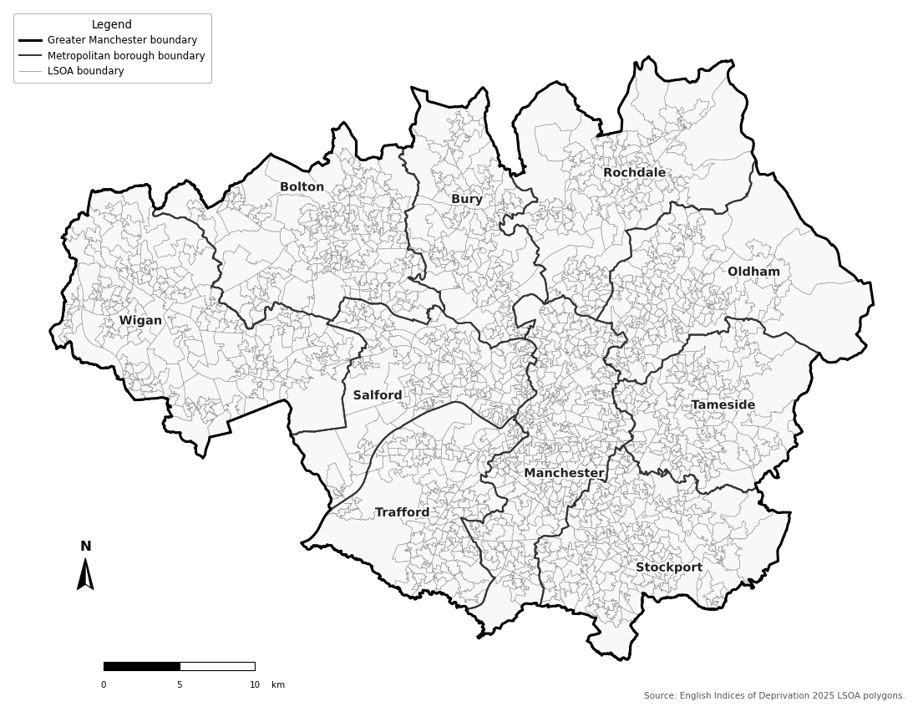
Figure 1: Greater Manchester Study Area and Metropolitan Boroughs
Greater Manchester was used as the study area and comprises ten metropolitan boroughs and 1,702 LSOAs. The LSOA was adopted as the neighbourhood-level spatial unit for the accessibility and equity analyses. The LSOA boundaries and deprivation attributes were obtained from the IMD 2025 spatial dataset and used to define and map the study area (Ministry of Housing, 2025). Figure 1 shows the study area, metropolitan borough boundaries and LSOAs. Representative points were generated for each LSOA and used as the spatial origins in the accessibility analysis.
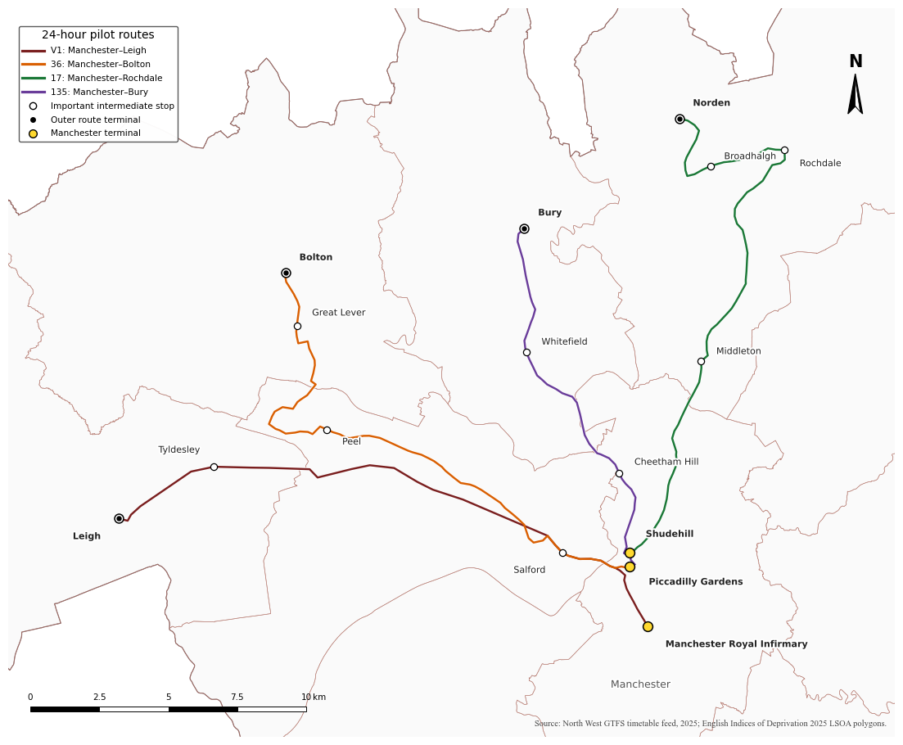
Figure 2: Greater Manchester 24-Hour Bus Pilot Routes
This study also examines the Bee Network 24-hour bus pilot. The first phase began in September 2024 with 24-hour operation on routes V1 and 36, linking Manchester with Leigh and Bolton. The pilot was later extended to routes 17 and 135, serving Rochdale and Bury. These four routes form the pilot network examined in this study (Greater Manchester Combined Authority, 2024, 2025; Transport for Greater Manchester, n.d.). Figure 2 shows the geographical distribution of the four pilot routes, reconstructed from the corresponding GTFS timetable data, together with their principal intermediate stops.

3.3 Accessibility Modeling

3.3.1 Accessibility Measure and Routing
Public transport accessibility was modelled using the r5py package, which constructs an R5 transport network from the GTFS timetable and OpenStreetMap (OSM) road network (Fink et al., 2022). LSOA representative points were used as origins, while LSOAs containing hospitality employment were used as destinations. R5 estimated public transport travel times, including walking access and egress, waiting, transfers and in-vehicle travel, and generated an origin–destination travel-time matrix between the two sets of locations (Conway et al., 2017).
Accessibility was measured using the cumulative opportunity approach (Geurs and van Wee, 2004). For each origin LSOA, hospitality employment in destination LSOAs reachable within the selected travel-time threshold was summed. The accessibility measure can be expressed as:
$$A_{i}=\sum_{j}{W_{j}f(c_{ij})}$$
where Ai represents accessibility at origin i, $W_{j}$ represents the number of accommodation and food service activities employment opportunities at destination j, and $c_{ij}$ represents the public transport travel time between the origin and destination. The impedance function $f(c_{ij})$is defined as:
$$f\left(c_{ij}\right)=\left\{\begin{aligned}1, &c_{ij}≤T \\ 0, &c_{ij}＞T\end{aligned}\right.$$
where T is the selected travel-time threshold. Employment opportunities that can be reached within the threshold contribute to the accessibility score, whereas destinations beyond the threshold are excluded.

3.3.2 Pilot Scenario Design
The North West England GTFS timetable obtained from the Bus Open Data Service (BODS) Archive was used to construct two night-time public transport scenarios (Department for Transport, 2025a). The scenarios were modelled to estimate the accessibility change associated with the Bee Network 24-hour bus pilot. The with-pilot scenario retained the overnight services on routes V1, 36, 17 and 135, while the without-pilot scenario used the same GTFS timetable but excluded only the overnight pilot trips on these four routes (Bee Network Committee, 2024). The without-pilot scenario was derived from the with-pilot timetable by removing only these overnight pilot trips, while all other scheduled services were retained unchanged. The separate pre-pilot timetable was not used because differences in service date, wider network configuration and unrelated timetable changes could reduce comparability between the two scenarios. This approach ensured that the scenarios differed only in the inclusion of the overnight pilot services. 20 December 2025 was selected because it was a Saturday within the normal pre-Christmas service period, when all four pilot routes were scheduled to operate overnight.
Table 1: Timetable of the Pilot Bus Routes
Route | Direction | Overnight departures (00:00–06:00) | Number of departures
V1 | Leigh Bus Station → Manchester Royal Infirmary | 00:00, 01:00, 02:00, 03:00, 04:00, 05:00 | 6
 | Manchester Royal Infirmary → Leigh Bus Station | 00:00, 00:30, 01:30, 02:30, 03:30, 04:30, 05:30 | 7
36 | Bolton Interchange → Piccadilly Gardens | 00:45, 01:45, 02:45, 03:45, 04:51, 05:21, 05:51 | 7
 | Piccadilly Gardens → Bolton Interchange | 00:55, 01:55, 02:55, 03:55, 04:55 | 5
17 | Rochdale Interchange → Shudehill Interchange | 00:04, 00:34, 01:34, 02:34, 03:34, 04:30, 04:34, 05:05, 05:09, 05:39 | 10
 | Shudehill Interchange → Rochdale Interchange | 00:42, 01:42, 02:42, 03:42, 04:42, 05:15, 05:45 | 7
135 | Bury Interchange → Piccadilly Gardens | 00:25, 01:25, 02:25, 03:25, 04:25, 05:11, 05:41 | 7
 | Piccadilly Gardens → Bury Interchange | 00:15, 01:15, 02:15, 03:15, 04:15, 05:15, 05:55 | 7
Table 1 summarises the timetable of the four pilot routes. Based on the schedules, the 02:00–03:00 period was selected because it falls within the core overnight operating period, avoiding the transition around midnight and the increase in early-morning services towards the end of the night. All four pilot routes operate in both directions during this hour, providing a consistent period for evaluating the accessibility change associated with the pilot. A one-hour departure window was used to account for the low frequency and different timings of overnight services. The same origins, destinations, travel modes and travel-time threshold were applied in both scenarios. The 45-minute threshold was selected as a reasonable public transport commuting time and was used to calculate the number of hospitality employment opportunities accessible from each LSOA. Keeping these parameters unchanged allowed the two scenarios to be compared directly.
Accessibility change for each LSOA was calculated as:
$${∆A}_{i}= A_{i}^{P}-A_{i}^{C}$$
Where $A_{i}^{P}$represents accessibility under the pilot scenario and $A_{i}^{C}$ represents accessibility under the without-pilot scenario. Positive values of ${∆A}_{i}$ indicate higher accessibility under the pilot scenario, zero indicates no change, and negative values indicate lower accessibility.

3.4 Data

3.4.1 GTFS Data
The North West England GTFS timetable dated 20 December 2025 was obtained from the Department for Transport Bus Open Data Service Archive (Department for Transport, 2025a). Only bus and tram (Metrolink) services within Greater Manchester were retained. The corresponding stops were converted to spatial point features, projected to the British National Grid and clipped to the study area, resulting in 12,510 stops within Greater Manchester. As GTFS represents scheduled services, it does not capture real-time operating conditions.
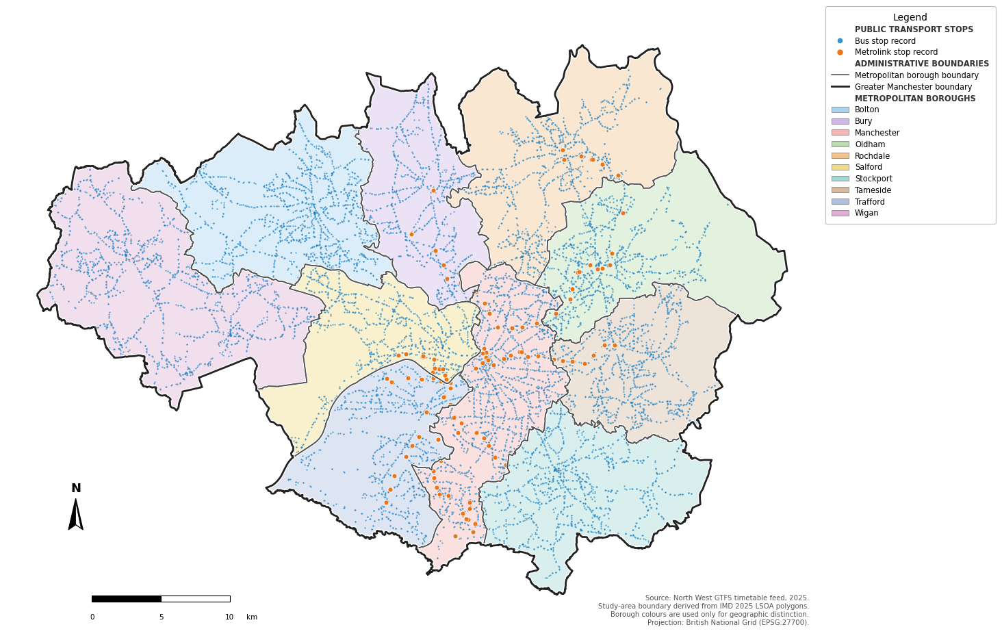
Figure 3: Bus and Tram Stops in Greater Manchester
Figure 3 presents the processed GTFS stops retained for this study. Bus stops provide near-continuous coverage across Greater Manchester, whereas tram stops are concentrated along fixed tram routes, particularly around Manchester city centre. This distribution reflects the complementary roles of the bus and tram networks within the regional public transport system.

3.4.2 Road Network
Street network data for the R5 accessibility model were obtained from OpenStreetMap. The separate road-network layer was obtained from OpenStreetMap using the OSMnx package for spatial visualisation (Boeing, 2017). To minimise edge effects, a 3 km buffer was applied to the Greater Manchester boundary before downloading the OSMnx network. The downloaded network was reprojected to the British National Grid. The OSM PBF network was used for R5 routing, while the OSMnx-derived layer was used for mapping.
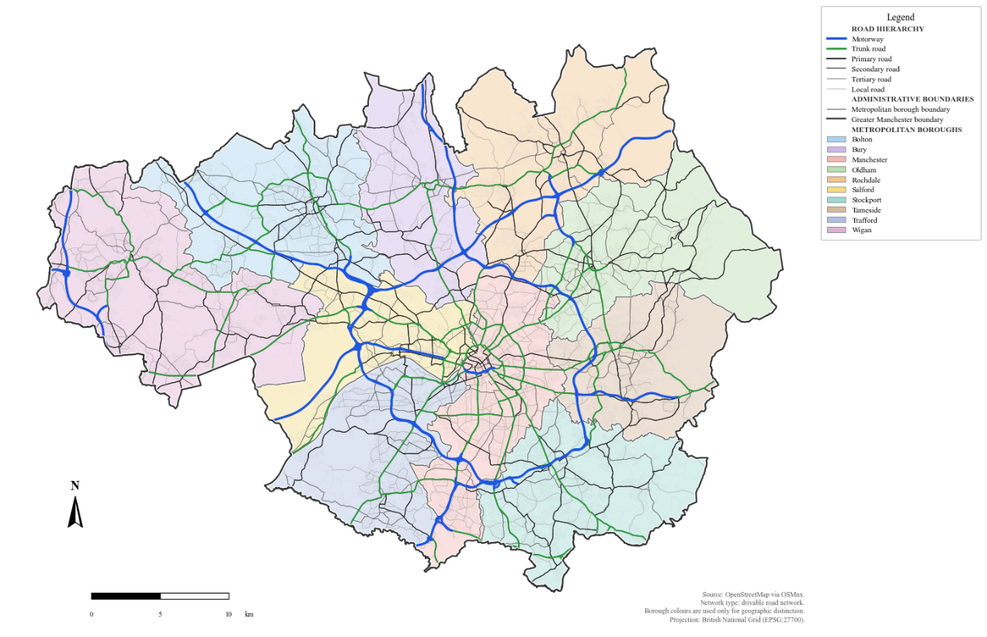
Figure 4: OSM Road Network in Greater Manchester
Figure 4 illustrates the processed OSM road network after spatial clipping and road reclassification. Motorways and trunk roads form the primary transport corridors radiating from Manchester city centre, while primary and secondary roads connect the metropolitan boroughs. Tertiary and local roads provide dense coverage within individual neighbourhoods.

3.4.3 Hospitality Employment Data
Employment data were obtained from the 2024 Business Register and Employment Survey (BRES) through the Nomis official data portal (Office for National Statistics, 2025). The 2024 dataset was extracted for the ten Greater Manchester metropolitan boroughs at the 2021 LSOA geography. Employee counts for SIC 2007 Section I, Accommodation and Food Service Activities, were used to represent hospitality employment opportunities. After data cleaning and spatial matching, employment data were linked to all 1,702 LSOAs with no missing or duplicated records. 1,205 LSOAs contained accommodation and food service employment and were used as destination points in the accessibility model. BRES reports workplace-based employment and does not represent the residential locations of employees.
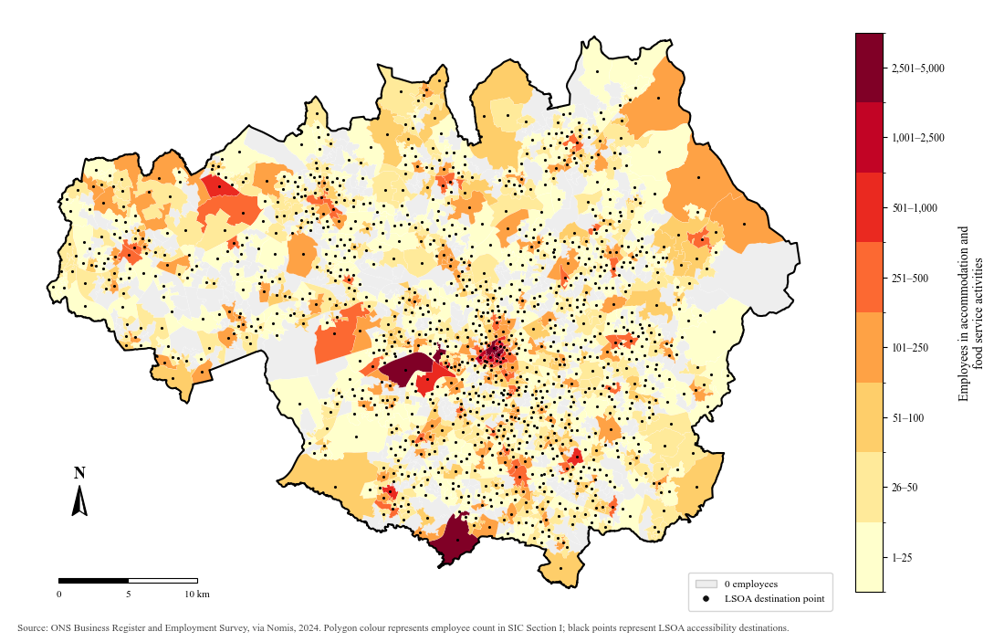
Figure 5: Spatial Distribution of Accommodation and Food Service Employment and Accessibility Destinations in Greater Manchester
Figure 5 presents the employment data used in the accessibility analysis. Polygon colours show the number of accommodation and food service employees in each LSOA, while the overlaid points represent the employment locations used in the accessibility model. Employment is concentrated in Manchester city centre and several major town centres, with lower levels across many suburban and peripheral areas.

3.4.4 Income Deprivation Data
Income deprivation data were obtained from the IMD 2025 published by the Ministry of Housing, Communities and Local Government (Ministry of Housing, 2025). The Income Deprivation domain was selected because it provides a measure of neighbourhood economic disadvantage and is closely aligned with the equity focus of this study. The Income Score Rate represents the estimated proportion of residents experiencing income deprivation within each LSOA. The dataset was projected to the British National Grid and clipped to the Greater Manchester boundary. The measure represents neighbourhood-level conditions and does not reflect differences between individuals within an LSOA.
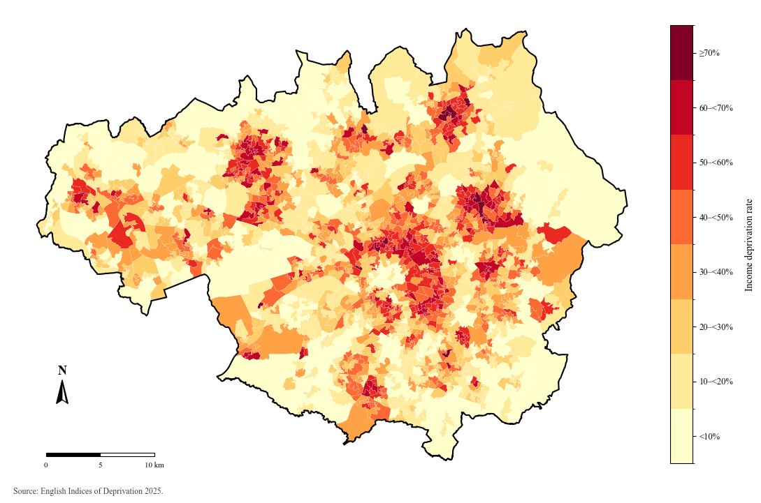
Figure 6: IMD Income Score (rate) across Greater Manchester
Figure 6 illustrates the spatial distribution of the Income Score Rate across Greater Manchester LSOAs. Higher levels of income deprivation are concentrated in several inner urban areas and town centres, while lower deprivation rates are more common in suburban and peripheral neighbourhoods.

3.4.5 Population Density
Population density data were obtained from the 2021 Census through the Nomis official data portal (Office for National Statistics, n.d.a). The TS006 Population Density dataset was used to measure the number of usual residents per square kilometre at the LSOA level. The resulting dataset was projected to the British National Grid and used as an LSOA-level measure of population concentration in the subsequent analysis.

3.4.6 Household Car Availability
Household car availability data were obtained from the 2021 Census through the Nomis official data portal (Office for National Statistics, n.d.b). The TS045 Car or Van Availability dataset was used to calculate the percentage of households with no car or van in each LSOA. This variable was used as a measure of household car availability in the subsequent analysis.

3.4.7 Descriptive Statistics of Study Data
Table 2: Descriptive Statistics
Variable | Mean | SD | Minimum | Maximum
Deprivation characteristics
Index of Multiple Deprivation score | 28.45 | 18.89 | 0.60 | 82.63
Income deprivation score (rate) | 0.28 | 0.19 | 0.01 | 0.81
Employment deprivation score (rate) | 0.17 | 0.10 | 0.01 | 0.56
Education, Skills and Training deprivation score | 24.58 | 18.99 | 0.09 | 84.58
Health Deprivation and Disability score | 0.56 | 0.80 | -1.97 | 2.96
Crime score | 0.49 | 0.78 | -1.95 | 2.58
Barriers to Housing and Services score | 19.58 | 9.73 | 3.04 | 60.95
Living Environment score | 25.29 | 14.94 | 0.46 | 80.33
Income Deprivation Affecting Children Index score (rate) | 0.39 | 0.23 | 0.01 | 1.00
Income Deprivation Affecting Older People Index score (rate) | 0.26 | 0.20 | 0.02 | 0.97
Children and Young People sub-domain score | -0.01 | 0.92 | -2.61 | 2.75
Adult Skills sub-domain score | 0.26 | 0.11 | 0.02 | 0.60
Geographical Barriers sub-domain score | 27.88 | 8.01 | 11.05 | 69.35
Wider Barriers sub-domain score | 1.02 | 2.80 | -6.20 | 8.97
Indoors sub-domain score | 0.17 | 0.54 | -1.34 | 1.64
Outdoors sub-domain score | 0.16 | 0.60 | -1.54 | 2.18
Spatial characteristics
Population density (persons/km²) | 4,715.51 | 3,291.13 | 61.10 | 37,681.20
Household car availability
Total households (number) | 692.24 | 133.12 | 406.00 | 1,201.00
No cars or vans in household (number) | 187.20 | 119.94 | 14.00 | 865.00
No cars or vans in household (%) | 26.16 | 14.05 | 2.80 | 78.00
1 car or van in household (number) | 297.09 | 66.82 | 117.00 | 598.00
1 car or van in household (%) | 42.89 | 4.87 | 19.90 | 56.50
2 cars or vans in household (number) | 163.73 | 69.10 | 12.00 | 479.00
2 cars or vans in household (%) | 24.27 | 10.35 | 1.70 | 50.80
3 or more cars or vans in household (number) | 44.22 | 24.94 | 0.00 | 165.00
3 or more cars or vans in household (%) | 6.68 | 4.04 | 0.00 | 27.90
Table 2 summarises the main variables used in the accessibility and statistical analyses. These variables describe hospitality employment, neighbourhood socioeconomic disadvantage, population density and household car availability across Greater Manchester LSOAs. Population density varies across the study area, reflecting differences between the urban core and more peripheral areas. Household car availability also varies across LSOAs. The mean proportion of households with no car or van is 26.16%, while one-car households are the largest category.

3.5 GIS Spatial Analysis
Spatial analysis was used to examine the geographical distribution of night-time accessibility and the changes associated with the overnight bus pilot. Accessibility results from the with-pilot and without-pilot scenarios were joined to LSOA boundaries and mapped across Greater Manchester. Absolute accessibility change was calculated as the difference between the two scenarios, while percentage change was used to compare the relative scale of improvement between LSOAs with different baseline accessibility levels. Percentage accessibility change was calculated as:
$$\%{∆A}_{i}= \frac{A_{i}^{P}-A_{i}^{C}}{A_{i}^{C}}×100$$
Where $A_{i}^{P}$represents accessibility with the pilot and $A_{i}^{C}$ accessibility without the pilot. Percentage change was calculated for LSOAs with positive without-pilot accessibility. The two LSOAs with zero without-pilot accessibility also recorded no accessibility change, so their percentage change remained zero. The spatial distribution of accessibility change was compared with neighbourhood income deprivation. This allowed the analysis to identify where accessibility improvements occurred and whether these improvements were concentrated in more or less deprived areas.

3.6 Statistical Analysis
Table 3: Regression Variables
Variable | Role | Source | Rationale
Income deprivation | Main explanatory variable (independent variable) | IMD 2025 | Measures economic disadvantage and allows accessibility change to be compared between more and less deprived areas
Accessibility change | Dependent variable | Derived from R5 accessibility results | Indicates whether accessibility increased and the percentage magnitude of improvement associated with the pilot
Baseline accessibility | Control variable | Derived from R5 without-pilot results | Accounts for differences in accessibility under the without-pilot
Population density | Control variable | ONS Census 2021 | Accounts for differences in urban form and population concentration
Households with no car or van (%) | Control variable | ONS Census 2021 | Provides a comparable measure of potential public transport dependence
Education, Skills and Training deprivation | Sensitivity variable | IMD 2025 | Captures a socioeconomic dimension that may influence employment accessibility
Table 3 summarises the variables used in the regression analysis. Income deprivation was the main explanatory variable. Accessibility change was represented differently in the two regression models: the logistic model examined whether an LSOA experienced a positive change, while the magnitude model examined percentage accessibility change among affected LSOAs. Population density and the proportion of households with no car or van were included as control variables. Baseline accessibility was additionally included in the logistic model. Education, Skills and Training deprivation was included separately as a sensitivity variable because of its strong correlation with income deprivation.
Statistical analysis was used to examine whether accessibility changes differed according to neighbourhood income deprivation. LSOAs were grouped into five income deprivation quintiles, and descriptive statistics were used to compare percentage accessibility change across the groups. The equity analysis was conducted at the LSOA level, with each LSOA treated as an equal analytical unit. Population-weighted estimates were not calculated because consistent LSOA-level population counts were not available, while population density was included as a neighbourhood-level control in the regression analysis. As the distribution of accessibility change was highly skewed and dominated by zero values, the Kruskal–Wallis test was used to test for differences across deprivation quintiles (Kruskal and Wallis, 1952). Epsilon-squared was also calculated as a measure of effect size (Tomczak Ewa and Tomczak, 2014).
Regression analysis was conducted in two stages. Binary logistic regression was used because the dependent variable distinguished LSOAs with a positive accessibility change from those with no change. Income deprivation was the main explanatory variable. Model 0 included income deprivation only, Model 1 added population density, Model 2 added the proportion of households with no car or van, and Model 3 added baseline accessibility under the without-pilot scenario. The sensitivity model additionally included Education, Skills and Training deprivation to assess the stability of the association with income deprivation after including an additional socioeconomic measure. Potential multicollinearity was assessed using correlations and variance inflation factors (O’Brien, 2007). Income deprivation and no-car households were scaled to represent a 10-percentage-point increase, population density was expressed per 1,000 persons per square kilometre, baseline accessibility was transformed using ln(1+A), and education deprivation was standardised. HC3 robust covariance estimates were used to reduce sensitivity to heteroskedasticity (Long and Ervin, 2000; MacKinnon and White, 1985).
OLS regression examined the magnitude of percentage accessibility change among LSOAs that experienced a positive change. Because positive percentage accessibility change was strongly right-skewed, its natural logarithm was used as the dependent variable. Model 0 included income deprivation, Model 1 added population density and Model 2 added no-car households. Education deprivation was added to Model 2 in the sensitivity specification. Baseline accessibility was not included in the magnitude model because the dependent variable was already expressed relative to accessibility under the without-pilot scenario. Residual spatial dependence in the main adjusted regression models was examined using Global Moran’s I and Local Indicators of Spatial Association (LISA) with Queen-contiguity spatial weights (Moran, 1950; Anselin, 1995). The diagnostics were applied to Model 3 of the logistic regression and Model 2 of the magnitude regression. Permutation tests used 999 permutations, with a significance threshold of 0.05 for the local analysis.

4 Results
This chapter presents the results of the accessibility, distributional equity and regression analyses. It compares night-time public transport accessibility to hospitality employment under the without-pilot and with-pilot scenarios and identifies the spatial distribution of accessibility changes. It also examines how these changes vary by income deprivation before presenting the regression results and spatial diagnostics.

4.1 Night-time Accessibility and Accessibility Change
The first stage compares night-time accessibility under the two public transport network scenarios. Accessibility represents the number of hospitality employment opportunities that can be reached from each LSOA within 45 minutes by public transport during the selected overnight departure period. The without-pilot scenario excludes the four overnight pilot services, while the with-pilot scenario retains these services. All other modelling conditions are held constant, allowing differences between the two scenarios to be identified as accessibility changes associated with the inclusion of the pilot services.

4.1.1 Accessibility without the Pilot
Night-time public transport accessibility was first calculated for the scenario without the overnight pilot services. The accessibility scores derived from the without-pilot routing results were linked to the corresponding LSOAs and mapped to show the number of hospitality employment opportunities reachable within 45 minutes.
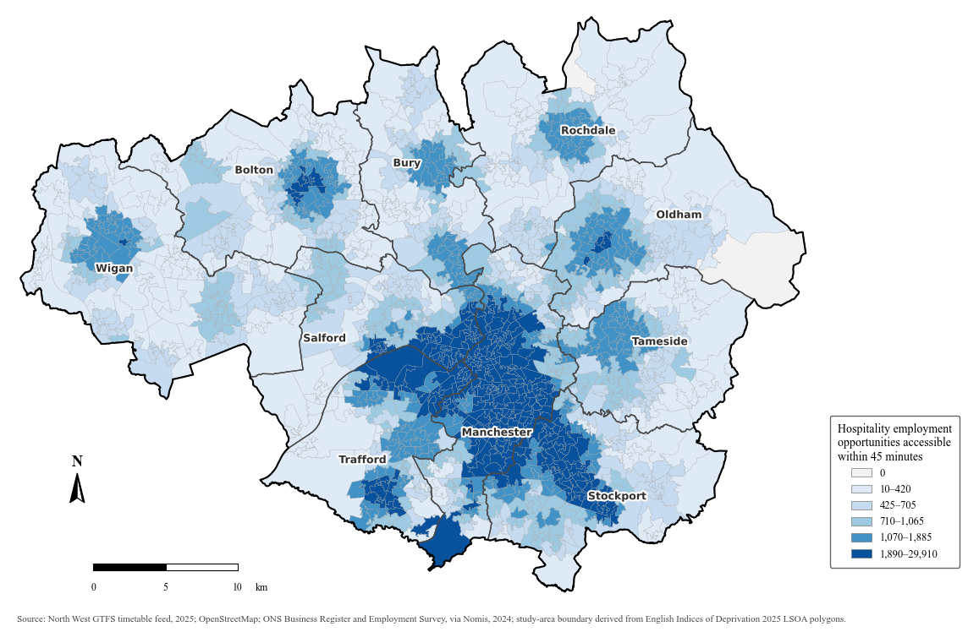
Figure 7: Night-time public transport accessibility to hospitality employment within 45 minutes without the overnight bus pilot
Figure 7 shows the number of hospitality employment opportunities reachable from each LSOA within 45 minutes. The highest levels are concentrated in Manchester and the surrounding inner urban area, where several contiguous LSOAs fall within the upper accessibility classes. Accessibility decreases from the central area, with much of the metropolitan periphery characterised by lower numbers of hospitality employment opportunities reachable within the 45-minute threshold. This pattern indicates spatial variation in the number of hospitality employment opportunities reachable within 45 minutes during the selected overnight period. The highest-accessibility area forms a relatively continuous concentration around central Manchester and extends into neighbouring inner areas, creating a clear contrast with the lower-accessibility LSOAs from the centre. The central concentration is larger and more spatially continuous than the other areas of relatively high accessibility visible across Greater Manchester.
Smaller local concentrations of higher accessibility are also visible around several metropolitan centres, although their extent and intensity are lower than those observed around Manchester. Between these local centres, many LSOAs fall within lower accessibility classes, producing a more fragmented pattern outside the central part of the city-region. The outer parts of several boroughs contain extensive areas of lower accessibility, indicating that access to hospitality employment during the selected overnight period varies substantially within as well as between metropolitan boroughs.
The figure also shows that distance from central Manchester does not correspond to a uniform decline in accessibility. Some LSOAs outside the inner urban area retain comparatively high accessibility around local centres, while neighbouring areas may fall within substantially lower accessibility classes. This produces a combination of a dominant central high-accessibility zone and smaller secondary concentrations elsewhere in the metropolitan area.
The spatial pattern also shows considerable variation within individual parts of Greater Manchester. LSOAs located at a similar distance from central Manchester do not necessarily fall within the same accessibility class, and the transition from higher to lower accessibility is spatially uneven. In some areas, relatively accessible LSOAs extend beyond the main central concentration, while nearby LSOAs fall into substantially lower classes. This creates a patchwork of accessibility levels outside the central area rather than a simple concentric pattern.

4.1.2 Accessibility with the Pilot
Night-time public transport accessibility was calculated for the with-pilot scenario, while the modelling date and the remaining network conditions were kept consistent with the without-pilot scenario. Accessibility was also measured as the number of hospitality employment opportunities reachable from each LSOA within 45 minutes.
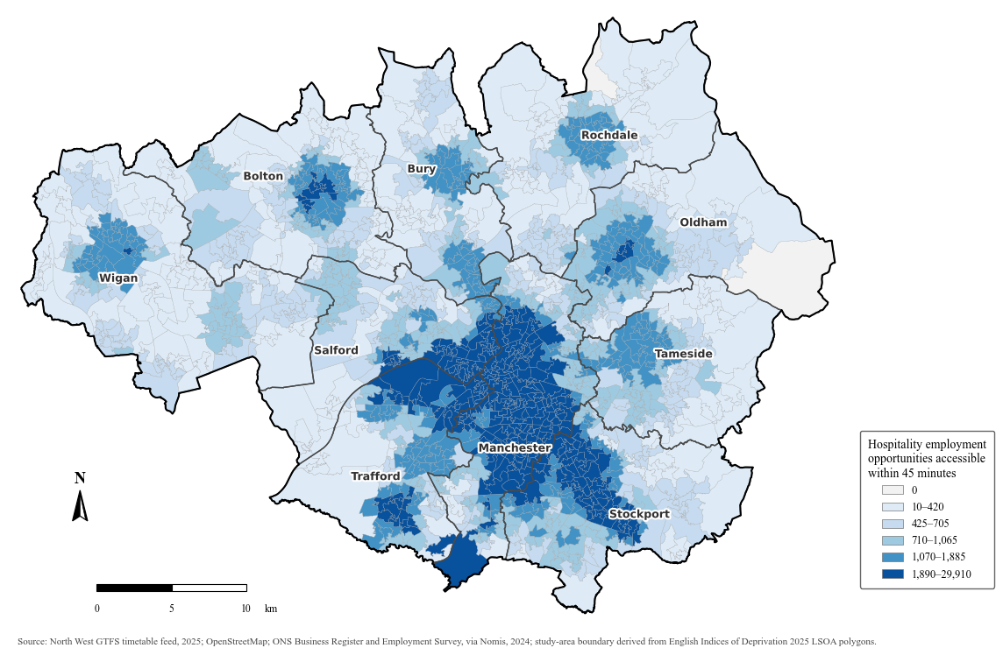
Figure 8: Night-time public transport accessibility to hospitality employment within 45 minutes with the overnight bus pilot
Figure 8 shows that the spatial pattern of accessibility with the pilot remains similar to that observed without the pilot. Higher accessibility continues to be concentrated in Manchester and the surrounding inner urban area, while lower accessibility remains more common across the outer parts of Greater Manchester. The broad metropolitan pattern is largely unchanged by the four overnight pilot services. The central high-accessibility zone remains the most extensive concentration in the city-region, while smaller concentrations around other metropolitan centres are also still visible.
Some LSOAs move to higher accessibility classes when the pilot services are included. These differences are difficult to distinguish from the two accessibility figures. Most LSOAs remain in the same class under both scenarios. The limited visual difference between Figure 7 and Figure 8 reflects the spatially concentrated nature of the accessibility changes rather than an absence of improvement.

4.1.3 Accessibility Change
The accessibility change associated with the overnight bus pilot was assessed by comparing the accessibility score for each LSOA under the with-pilot and without-pilot scenarios. Since the same analysis date, departure period, origins, destinations and 45-minute travel-time threshold were applied to both scenarios, the difference between the two accessibility scores represents the change associated with the inclusion of the four pilot services.
Table 4: Comparison of night-time public transport accessibility with and without the overnight bus pilot
Statistic | Without pilot | With pilot | Accessibility change (%)
Mean | 2,613.5 | 2,629.8 | 0.7
Median | 865.0 | 867.5 | 0.0
Standard deviation | 5,295.7 | 5,326.7 | 7.4
Minimum | 0.0 | 0.0 | 0.0
Maximum | 29,560.0 | 29,910.0 | 179.1
Zero-access LSOAs | 2 | 2 | —
LSOAs with positive change | — | — | 63 (3.7%)
LSOAs with no change | — | — | 1,639 (96.3%)
Mean percentage change among affected LSOAs | — | — | 19.4
Table 4 shows that the difference between the two scenarios was limited when considered across Greater Manchester as a whole. Mean accessibility increased from 2,613.5 accessible hospitality employment opportunities under the without-pilot scenario to 2,629.8 with the pilot. The mean LSOA-level percentage change was 0.7%, while the median was 0.0%. The standard deviation of percentage change was 7.4 percentage points and the maximum reached 179.1%, indicating variation between the relatively small number of LSOAs that recorded a change.
Positive change occurred in 63 LSOAs, while 1,639 LSOAs recorded no change. Among the 63 affected LSOAs, the mean percentage increase was 19.4%. The number of zero-access LSOAs remained unchanged at two in both scenarios. These results show that accessibility changes associated with the pilot services were concentrated in specific areas of Greater Manchester in specific areas of Greater Manchester. The contrast between the city-region-wide mean change of 0.7% and the mean increase of 19.4% among affected LSOAs shows that the overall average is strongly influenced by the large number of areas with no change. Positive changes affected 3.7% of all Greater Manchester LSOAs, while 96.3% retained the same accessibility score under the two scenarios. The pilot produced a limited geographical reach within the selected overnight period, although the size of the change varied considerably among the LSOAs that were affected. The unchanged number of zero-access LSOAs also shows that the additional services did not alter the accessibility status of the two areas with no reachable hospitality employment within the 45-minute threshold.
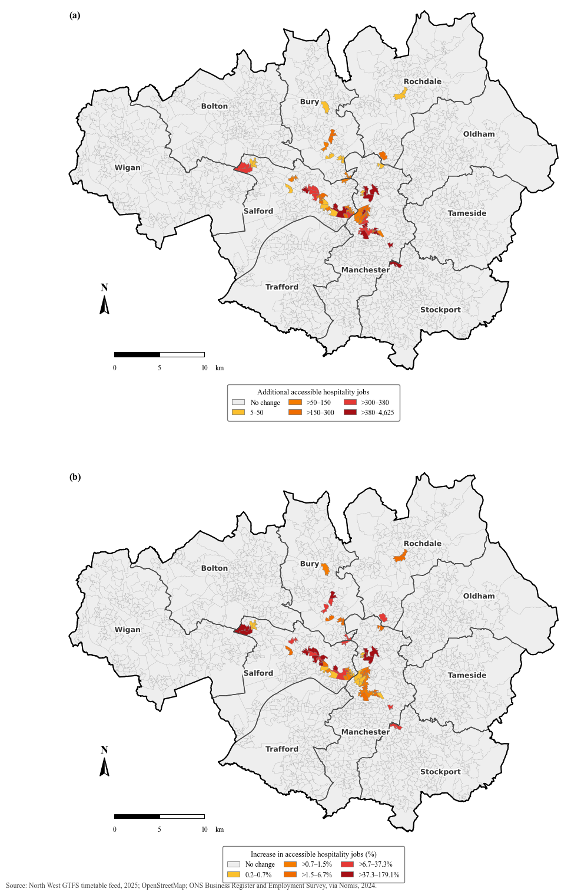
Figure 9: Changes in night-time public transport accessibility associated with the pilot
Figure 9 shows the spatial distribution of absolute and percentage accessibility change. Figure 9(a) shows the additional number of hospitality employment opportunities accessible within 45 minutes, while Figure 9(b) expresses the same scenario difference relative to accessibility under the without-pilot scenario. Positive change was restricted to the same 63 LSOAs in both figures, with the largest absolute increase reaching 4,625 additional accessible employment opportunities and the largest percentage increase reaching 179.1%. The affected LSOAs were concentrated around central Manchester and along several corridors extending from the centre, while most of Greater Manchester recorded no change. The affected areas form a spatially concentrated pattern rather than being dispersed evenly across the city-region. The largest group of affected LSOAs is located around central Manchester and the adjoining inner areas. From this central concentration, smaller groups of affected LSOAs extend westwards and northwards, with additional isolated areas of change visible north around Bury and towards Rochdale.
Both measures are reported because they capture different aspects of the accessibility change. Absolute change shows the number of additional employment opportunities made accessible, but this can be larger in areas with higher baseline accessibility. Figure 9 shows that the areas with the largest absolute gains are not distributed in the same way as those with the largest relative gains. Several LSOAs close to the central concentration record increases in the number of reachable jobs, while high percentage changes also appear in some locations from the main central cluster. This distinction is important because an LSOA can experience a relatively large percentage increase from a lower initial accessibility level without recording one of the largest absolute increases in reachable employment. The LSOA with higher initial accessibility can gain a comparatively large number of additional opportunities while recording a more moderate proportional increase. Both measures avoid representing the spatial pattern of improvement through a single measure. The percentage change standardises the increase relative to the without-pilot level and allows the scale of improvement to be compared more directly across LSOAs with different initial levels of accessibility. The two measures produce somewhat different patterns within the affected areas. Absolute change emphasises locations gaining the largest number of accessible employment opportunities, whereas percentage change highlights locations where the increase is large relative to existing accessibility. The percentage change is used in the distributional equity analysis and in the regression analysis of the magnitude of accessibility change.

4.2 Distributional Equity Analysis
This section examines the distributional dimension of equity by comparing percentage accessibility change across neighbourhoods with different levels of income deprivation. The 1,702 LSOAs were divided into five income deprivation quintiles, from the least deprived (Q1) to the most deprived (Q5). Descriptive statistics and the Kruskal–Wallis test were used to assess whether the distribution of percentage change differed across these groups.

4.2.1 Accessibility Change by Income Deprivation
Table 5: Accessibility change by income deprivation quintile
Income deprivation quintile | LSOAs | Mean change (%) | Median change (%) | LSOAs with positive change | Mean change among affected LSOAs (%)
Q1 | 343 | 0.3 | 0.0 | 14 (4.1%) | 7.5
Q2 | 339 | 0.8 | 0.0 | 14 (4.1%) | 18.6
Q3 | 342 | 0.3 | 0.0 | 10 (2.9%) | 11.2
Q4 | 337 | 0.5 | 0.0 | 8 (2.4%) | 21.9
Q5 | 341 | 1.7 | 0.0 | 17 (5.0%) | 33.5
Table 5 compares percentage accessibility change across the five income deprivation quintiles. Median change was 0.0% in every quintile, reflecting the fact that most LSOAs in each group recorded no change. Mean percentage change was highest in Q5, the most deprived group, at 1.7%. This was followed by Q2 at 0.8%, Q4 at 0.5%, and Q1 and Q3 at 0.3%.
The zero median across all five quintiles shows that the dominant outcome in every deprivation group was no measurable accessibility change. Differences between the groups appear mainly among the small number of LSOAs that experienced a positive change rather than across the overall distribution of LSOAs within each quintile.
The proportion of LSOAs recording a positive change also varied between groups. Q5 had the highest proportion at 5.0%, with 17 of 341 LSOAs recording an increase. Q1 and Q2 each recorded positive change in 4.1% of LSOAs, compared with 2.9% in Q3 and 2.4% in Q4. Among LSOAs that recorded a positive change, the mean percentage increase ranged from 7.5% in Q1 to 33.5% in Q5. The corresponding values were 18.6% in Q2, 11.2% in Q3 and 21.9% in Q4. Neither the proportion of affected LSOAs nor the mean change among affected LSOAs followed a consistent progression from the least deprived to the most deprived group. Q1 and Q2 recorded the same proportion of affected LSOAs, while Q3 and Q4 recorded lower proportions before the value increased again in Q5. The number of affected LSOAs varied across deprivation groups without increasing steadily with deprivation.
The similar non-linear pattern is visible in the scale of improvement among affected LSOAs. The mean increase rises from Q1 to Q2, falls in Q3, rises again in Q4 and reaches its highest value in Q5. Although Q5 recorded the highest mean percentage change and the largest mean change among affected LSOAs, the pattern was not monotonic across the five deprivation groups.

4.2.2 Statistical Comparison
Table 6: Kruskal–Wallis test results by income deprivation quintile
Statistic | Value
Kruskal–Wallis H | 4.178
Degrees of freedom | 4
p-value | 0.3824
Epsilon-squared | 0.0001
As shown in Table 6, the Kruskal–Wallis test was used to examine whether accessibility change differed across the five income deprivation quintiles. The test found no significant difference between the groups, H(4) = 4.178, p = 0.3824. The estimated effect size was also negligible, with an epsilon-squared value of 0.0001.
These results are consistent with the descriptive pattern shown in Table 5. Although mean percentage change and the proportion of LSOAs recording a positive change varied across the five quintiles, the differences were small in relation to the distribution of accessibility change. The small epsilon-squared value also indicates that income deprivation quintile explained very little of the variation in percentage accessibility change.
Although the descriptive results showed some variation in mean accessibility change and in the proportion of LSOAs experiencing a positive change, these differences did not form a consistent pattern across deprivation groups. The higher values observed in Q5 were not part of a clear gradient across the five quintiles. The results provide no statistical evidence that percentage accessibility change differed by income deprivation. The group comparison does not support a consistent relationship between higher income deprivation and greater or smaller percentage accessibility change. The following regression analysis examines whether income deprivation is associated with accessibility change after including other neighbourhood characteristics in the analysis.

4.3 Regression Analysis
The descriptive analysis identified where accessibility changed and how percentage change was distributed across income deprivation groups. Regression analysis was used to examine two dimensions of accessibility change in relation to neighbourhood characteristics. The first model examined whether an LSOA recorded any positive accessibility change, while the second examined the magnitude of percentage change among the 63 LSOAs that recorded a positive change. This distinction reflects the highly concentrated distribution of accessibility change, since most LSOAs recorded no change while the affected LSOAs varied substantially in the scale of improvement.

4.3.1 Probability of Accessibility Increase
Table 7: Logistic regression results for the probability of positive accessibility change
Predictor | Correlation with income (r) | VIF | Model 0 | Model 1 | Model 2 | Model 3 | Sensitivity
Income deprivation | — | 2.32–6.70 | 1.02 (0.88–1.19); p=0.768 | 0.96 (0.82–1.13); p=0.646 | 0.77 (0.67–0.89); p<0.001 | 0.87 (0.73–1.02); p=0.086 | 0.97 (0.73–1.28); p=0.805
Population density | 0.287 | 1.51 | — | 1.13 (1.07–1.19); p<0.001 | 1.00 (0.95–1.06); p=0.925 | 0.97 (0.91–1.03); p=0.307 | 0.97 (0.91–1.03); p=0.332
No-car households | 0.709 | 2.96–3.08 | — | — | 2.20 (1.81–2.69); p<0.001 | 1.72 (1.36–2.19); p<0.001 | 1.80 (1.40–2.31); p<0.001
Baseline accessibility | 0.122 | 1.79–1.90 | — | — | — | 1.52 (1.17–1.98); p=0.002 | 1.45 (1.11–1.89); p=0.006
Education deprivation | 0.912 | 6.39 | — | — | — | — | 0.75 (0.41–1.38); p=0.355
McFadden pseudo-R² | — | — | 0.000 | 0.031 | 0.159 | 0.176 | 0.178
Binary logistic regression was used to examine whether neighbourhood characteristics were associated with the probability that an LSOA recorded a positive accessibility change. Income deprivation was the main explanatory variable. Model 0 included income deprivation, followed by population density in Model 1, no-car households in Model 2 and baseline accessibility in Model 3. The sensitivity specification added Education, Skills and Training deprivation to Model 3. The models show how the estimated association with income deprivation changed as additional neighbourhood characteristics were included.
Table 7 reports the regression estimates as odds ratios with 95% confidence intervals and p-values. Income deprivation was moderately correlated with no-car households at r = 0.709, while its correlations with population density and baseline accessibility were weaker at 0.287 and 0.122. Education deprivation was strongly correlated with income deprivation at r = 0.912. The maximum VIF in Model 3 was 2.96, while the VIF values for income and education deprivation increased to 6.70 and 6.39 in the sensitivity specification, showing greater collinearity between the two deprivation measures.
Model 0 showed no evidence of an unadjusted association between income deprivation and the probability of accessibility improvement. The odds ratio was 1.02, with a 95% confidence interval of 0.88 to 1.19. The McFadden pseudo-R² was 0, indicating that income deprivation provided very little improvement in model fit.
Model 1 added population density to account for differences in population concentration and urban form. Population density was positively associated with the probability of accessibility improvement. The estimate for income deprivation changed from 1.02 to 0.96 and remained non-significant. The McFadden pseudo-R² increased to 0.031. The estimated association between income deprivation and accessibility change changed little after population density was included.
Model 2 added the proportion of households without access to a car or van. The odds ratio for income deprivation decreased to 0.77, indicating that a 10-percentage-point increase in income deprivation was associated with approximately 23% lower odds of a positive accessibility change after including population density and car availability in the model. No-car households showed a strong positive association, with a 10-percentage-point increase corresponding to an odds ratio of 2.20, or approximately 120% higher odds of an accessibility increase. The association for population density weakened from an odds ratio of 1.13 in Model 1 to 1.00 in Model 2. McFadden’s pseudo-R² also increased from 0.031 to 0.159, showing that the inclusion of car availability improved model fit and altered the estimated association between income deprivation and accessibility change.
Model 3 additionally included baseline accessibility. After this variable was included, the odds ratio for income deprivation increased from 0.77 to 0.87 and was no longer significant at the 5% level. The change in the estimate after baseline accessibility was included indicates that the association was sensitive to model specification. No-car households remained positively associated with accessibility improvement, although the odds ratio decreased from 2.20 to 1.72, meaning that a 10-percentage-point increase in no-car households was associated with approximately 72% higher odds of a positive accessibility change after the three controls were included. Baseline accessibility was also positively associated with improvement, while population density remained non-significant. McFadden’s pseudo-R² increased to 0.176. Across the model sequence, the association between income deprivation and accessibility improvement was not stable, while the association with no-car households remained positive in the adjusted model.
The sensitivity model retained all variables from Model 3 and additionally included Education, Skills and Training deprivation. The odds ratio for income deprivation increased from 0.87 to 0.97 and remained non-significant, while education deprivation was also not significant. The higher VIF values and wider confidence intervals for the two deprivation measures reflect their strong correlation and suggest that their independent associations are difficult to distinguish when included together. The other results were largely unchanged, with no-car households remaining positively associated with accessibility improvement, baseline accessibility remaining significant, and population density remaining non-significant. McFadden’s pseudo-R² increased from 0.176 in Model 3 to 0.178 in the sensitivity model, indicating little improvement in model fit after education deprivation was added.
The regression results provide limited evidence of an independent association between income deprivation and the probability of positive accessibility change. The estimated association changed across the model specifications and was not significant in Model 3 or the sensitivity specification. Model fit improved most when no-car households were introduced, with McFadden’s pseudo-R² increasing from 0.031 in Model 1 to 0.159 in Model 2. Further increases were smaller, reaching 0.176 after baseline accessibility was added and 0.178 in the sensitivity specification. No-car households remained positively and significantly associated with the probability of positive change across all models in which they were included, while baseline accessibility was also significant in Model 3 and the sensitivity model. The sensitivity specification produced little additional improvement in model fit and introduced greater collinearity between income and education deprivation. The results show a less stable association for income deprivation than for no-car households and baseline accessibility.

4.3.2 Magnitude of Percentage Accessibility Change
Table 8: OLS regression results for the magnitude of positive percentage accessibility change
Predictor | VIF | Model 0 | Model 1 | Model 2 | Sensitivity
Income deprivation | 1.02–4.28 | 21.0% (-4.8–53.7); p=0.118 | 15.4% (-7.8–44.4); p=0.211 | 14.9% (-8.5–44.3); p=0.233 | -15.4% (-52.3–50.0); p=0.567
Population density | 1.18 | — | -18.1% (-25.8–-9.7); p<0.001 | -11.9% (-23.2–1.2); p=0.073 | -11.9% (-23.8–1.7); p=0.085
No-car households | 1.16–1.18 | — | — | -31.0% (-44.6–-14.0); p<0.001 | -32.7% (-46.4–-15.4); p<0.001
Education deprivation | 4.24 | — | — | — | 107.3% (-43.2–657.3); p=0.270
Adjusted R² | — | 0.032 | 0.170 | 0.292 | 0.320
Table 8 presents the OLS regression results for the magnitude of percentage accessibility change among the 63 LSOAs that recorded a positive change. The coefficients from the log-transformed dependent variable were transformed back into percentage differences in the magnitude of accessibility change for interpretation. Model 0 included income deprivation, Model 1 added population density, Model 2 added no-car households, and Education, Skills and Training deprivation was included in the sensitivity specification.
In Model 0, a 10-percentage-point increase in income deprivation was associated with an estimated 21.0% larger accessibility improvement, but the association was not significant, with a 95% confidence interval of −4.8% to 53.7% and p = 0.118. The adjusted R² was 0.032, indicating limited explanatory power from income deprivation alone.
In Model 1, the estimated association with income deprivation decreased to 15.4% and remained non-significant, p = 0.211. Population density showed a negative association, with an additional 1,000 persons per square kilometre associated with an estimated 18.1% smaller accessibility improvement, with a 95% confidence interval of −25.8% to −9.7% and p < 0.001. The adjusted R² increased to 0.170.
In Model 2, income deprivation remained non-significant at 14.9%, p = 0.233. The association with population density weakened to −11.9% and was no longer significant, p = 0.073. No-car households showed a significant negative association, with a 10-percentage-point increase associated with an estimated 31.0% smaller accessibility improvement, with a 95% confidence interval of −44.6% to −14.0% and p < 0.001. The adjusted R² increased to 0.292. This result reflects differences in the size of accessibility gains among the 63 affected LSOAs and does not indicate a decline in accessibility.
In the sensitivity specification, income deprivation remained non-significant at −15.4%, p = 0.567, while population density was also non-significant at −11.9%, p = 0.085. No-car households remained negatively associated with the magnitude of accessibility improvement at −32.7%, with a 95% confidence interval of −46.4% to −15.4% and p < 0.001. Education deprivation had a positive estimate of 107.3%, but the confidence interval was wide, ranging from −43.2% to 657.3%, and the association was not significant, p = 0.270. The adjusted R² increased to 0.320.
Across the magnitude models, the estimated association with income deprivation remained non-significant despite changes in its direction and size. The estimate decreased from 21.0% in Model 0 to 15.4% in Model 1 and 14.9% in Model 2, before changing to −15.4% in the sensitivity specification. Population density was negatively associated with the magnitude of improvement in Model 1, but this association weakened after no-car households were added and was no longer significant in Model 2 or the sensitivity model. The association with no-car households remained negative and significant in both specifications in which it was included. Model fit also improved as additional neighbourhood characteristics were introduced, with adjusted R² increasing from 0.032 in Model 0 to 0.170 in Model 1 and 0.292 in Model 2, before reaching 0.320 in the sensitivity specification. The models provide little evidence of an association between income deprivation and the magnitude of accessibility improvement, while no-car households show the most consistent association across the adjusted specifications.

4.3.3 Spatial Diagnostics
Table 9: Global and local spatial autocorrelation diagnostics for regression residuals
Model | Moran's I | Permutation p-value | Significant LISA clusters | Not significant | Connectivity
Probability of positive change | 0.239 | 0.001 | HH 24 (1.4%); LH 60 (3.5%) | 1618 (95.1%) | 0 / 1 / 100.0%
Magnitude of positive percentage change | 0.418 | 0.002 | HH 3 (4.8%); LL 1 (1.6%); HL 1 (1.6%) | 49 (77.8%) | 9 / 16 / 60.3%
Spatial diagnostics were used to assess whether spatial dependence remained in the residuals of the main adjusted regression models. The probability diagnostics were based on Model 3, while the magnitude diagnostics were based on Model 2. Table 9 shows positive spatial autocorrelation in the residuals of both models. For the probability of positive change, Moran’s I was 0.239 with a permutation p-value of 0.001. The spatial weights formed a single connected component with no islands. Local analysis identified 24 High–High clusters and 60 Low–High spatial outliers, while 1,618 LSOAs showed no significant local spatial association.
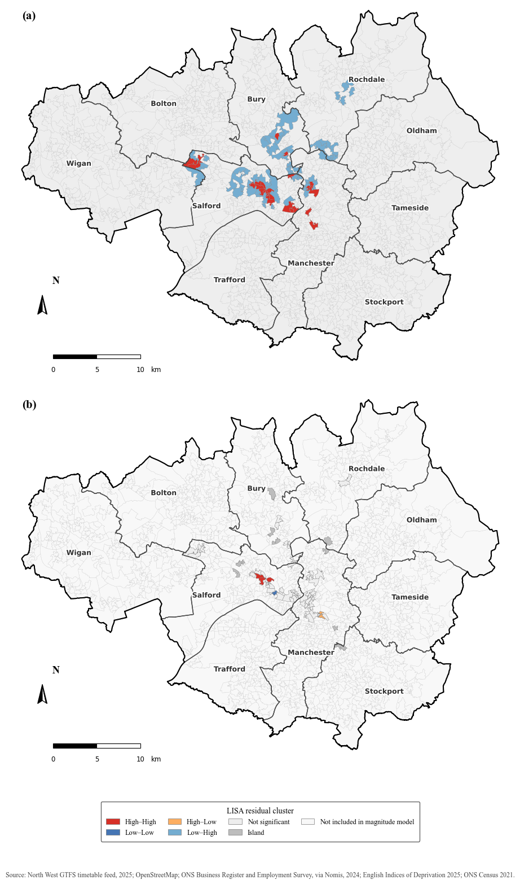
Figure 10: LISA cluster maps of regression residuals for the probability and magnitude models
The positive Moran’s I indicates that residuals with similar values were clustered rather than distributed randomly across Greater Manchester. However, the local results also show that significant local spatial association was limited to a relatively small proportion of LSOAs. High–High clusters represented 1.4% of all LSOAs and Low–High spatial outliers represented 3.5%, while 95.1% showed no significant local association. The global and local results indicate that residual spatial dependence was concentrated in particular parts of the study area rather than occurring uniformly across the whole city-region.
Figure 10(a) shows that the significant residual clusters were concentrated mainly within central and inner Greater Manchester, with additional clusters extending towards northern parts of the city-region. The High–High clusters form several local concentrations within this broader area, indicating locations where relatively high residual values occur close to other high residual values. The Low–High observations are more widely distributed around these concentrations and identify LSOAs with comparatively low residual values surrounded by higher values. The magnitude model had a higher Moran’s I of 0.418, with a permutation p-value of 0.002. Three LSOAs were classified as High–High clusters, one as Low–Low and one as a High–Low spatial outlier. 49 LSOAs showed no significant local spatial association, while nine were spatial islands. The sample was divided into 16 connected components, and 60.3% of observations were contained within the largest component.
The local results for the magnitude model were much more spatially fragmented. Only five of the 63 affected LSOAs were assigned to significant LISA categories, while nine could not be connected to neighbouring observations under the Queen-contiguity weights. The remaining observations were distributed across multiple connected components rather than forming a single continuous spatial network.
Figure 10(b) distinguishes the 63 LSOAs included in the magnitude analysis from the remaining LSOAs that were not included in this model. The significant local residual clusters were limited to a small number of locations. The magnitude sample was small and spatially fragmented; its Moran’s I and LISA results should be interpreted with greater caution.
The spatial diagnostics indicate that spatial structure remained in the residuals after the neighbourhood characteristics were included in the regression models. For the probability model, this remaining structure is visible across a connected city-region-wide sample, while the magnitude model is based on the dispersed subset of LSOAs that experienced positive accessibility change. The Moran’s I values describe residual dependence under substantially different spatial configurations and should not be compared directly between the two models.

5 Discussion

5.1 Interpretation of Key Findings
This study examined the accessibility changes associated with the Bee Network overnight bus pilot and their distribution across neighbourhoods with different levels of income deprivation in Greater Manchester. The findings show that night-time accessibility to hospitality employment is spatially uneven and that the inclusion of the four pilot services does not substantially alter the broader metropolitan pattern. Higher accessibility remains concentrated in Manchester and the surrounding inner urban area, while many peripheral neighbourhoods have lower access to hospitality employment within 45 minutes. This reflects the interaction between transport network structure and the spatial distribution of employment opportunities, consistent with the understanding of accessibility as a product of both transport and land-use conditions (Geurs and van Wee, 2004).
The accessibility changes associated with the pilot are geographically concentrated. Only 63 of the 1,702 LSOAs recorded a positive change, while 96.3% recorded no measurable change. However, the mean percentage increase among the affected LSOAs was 19.4%, indicating relative improvements in some locations despite the limited geographical reach of the pilot. This pattern is consistent with the route-specific nature of the pilot. Extending overnight operation on four existing routes can improve accessibility where those routes create useful connections to employment, but it is unlikely to reshape accessibility across the whole metropolitan network.
The distributional analysis found no income deprivation gradient in these changes. Although the most deprived quintile recorded the highest mean percentage increase, median change was zero in every quintile and differences between deprivation groups were not significant. The regression analysis provided limited evidence of an independent relationship between income deprivation and either the probability or magnitude of positive accessibility change. LSOAs with higher proportions of no-car households were more likely to record a positive accessibility change, but among affected LSOAs, higher no-car prevalence was associated with smaller proportional improvements.
The residual spatial autocorrelation remained in both regression models, suggesting that the explanatory variables did not explain the spatial pattern of accessibility change. Route alignment, network connectivity, interchange opportunities and the location of hospitality employment are likely to remain important in explaining where improvements occur.

5.2 Equity Implications of the Overnight Bus Pilot
The findings highlight an important distinction between accessibility improvement and distributional equity. Increasing the number of opportunities reachable from neighbourhoods does not produce a more equitable distribution of accessibility across the population. Workers travelling outside conventional daytime hours may have fewer alternative travel options, making the distribution of public transport provision relevant to questions of transport disadvantage and social exclusion (Lucas, 2012; McArthur et al., 2019).
The income deprivation analysis provides no statistical evidence that the accessibility changes associated with the pilot benefited either more or less deprived neighbourhoods. The high mean percentage increase in Q5 should not be interpreted as evidence of a progressive distributional outcome. The absence of a monotonic deprivation gradient also reflects the fact that socioeconomic disadvantage and transport accessibility do not necessarily share the same spatial pattern. Deprived inner-city neighbourhoods may have high accessibility because they are closer to dense transport networks and employment concentrations, while some less deprived peripheral neighbourhoods may have lower accessibility because of their geographical location (Cuthill et al., 2019; Nie et al., 2024).
The regression results highlight the importance of considering dimensions of disadvantage beyond income deprivation. The association between no-car households and accessibility change suggests that car availability may represent an important dimension of public transport dependence. LSOAs with higher proportions of no-car households were more likely to experience some positive change, but the relative magnitude of improvement was smaller among affected areas with higher no-car prevalence. This does not indicate a deterioration in accessibility, since all LSOAs included in the magnitude model recorded positive change. It shows that the occurrence and scale of accessibility improvement can have different distributional patterns. The analysis also illustrates a limitation of evaluating equity through average differences between deprivation groups. The non-significant difference between quintiles does not establish that accessibility is adequate or equitable. Transport equity assessment can also consider minimum levels of accessibility and the extent to which disadvantaged groups are prioritized (Pereira et al., 2017). Most LSOAs recorded no change, while spatial differences in absolute accessibility remained under both network scenarios.
The study contributes to research on night-time transport equity in two main ways. It shows that a route-specific extension of overnight public transport can produce accessibility improvements in a small number of neighbourhoods without generating an income deprivation gradient across the wider metropolitan area. This demonstrates that local accessibility improvement and broader distributional equity should not be treated as equivalent outcomes. By separating the probability of experiencing an accessibility increase from the magnitude of improvement among affected neighbourhoods, the analysis shows that the distribution of transport benefits can differ depending on which dimension of accessibility change is examined.

5.3 Policy Implications
The findings suggest that accessibility-based analysis can complement conventional approaches to planning night-time public transport. Passenger demand, operational feasibility and cost remain important considerations, but they do not by themselves indicate how proposed service changes affect access to employment across different neighbourhoods. Timetable-based accessibility modelling can provide an additional basis for identifying where proposed services expand access to opportunities and where accessibility gaps remain (Lucas, 2012; McArthur et al., 2019).
The results also show that extending the operating hours of existing routes can generate meaningful local improvements without changing accessibility across the wider metropolitan area. The limited spatial coverage reflects the scope of the pilot, which extends overnight services on four specific routes. However, if improving the distribution of employment accessibility becomes an explicit policy objective, accessibility could be considered existing demand and operational criteria when selecting future overnight routes.
The accessibility-based planning approach could identify neighbourhoods that combine low night-time employment accessibility with greater dependence on public transport. The association between the proportion of no-car households and accessibility change suggests that car availability may provide an additional indicator of public transport dependence when assessing the distribution of service improvements. However, service coverage does not guarantee a large improvement.
Comparing alternative overnight routes, service frequencies and interchange arrangements could help identify network configurations that improve connections between residential areas and major employment destinations. The findings suggest that temporal service expansion and spatial network coverage need to be considered together when planning future night-time public transport.

5.4 Limitations
The study has several limitations that should be considered when interpreting the findings. First, the analysis represents a specific date and overnight departure period. The accessibility may differ at other times of night, on different days or during other periods of the year. The results apply to the specific scenario modelled here and represent only part of the wider pattern of night-time accessibility.
Second, the study compares two modelled network configurations, while observed travel conditions with and without the pilot are not directly measured. The findings should not be interpreted as a causal estimate of changes in actual passenger behaviour following implementation.
Third, accessibility was estimated using scheduled GTFS services. R5 incorporates walking, waiting, transfers and scheduled in-vehicle travel but does not capture delays, cancellations, traffic conditions or other operational disruptions. These factors may be important overnight when service frequencies are low. The accessibility estimates represent potential accessibility under scheduled network conditions, while individual travel experiences may differ in practice.
Fourth, the cumulative opportunity measure depends on the selected 45-minute threshold. Opportunities inside and outside the threshold are treated differently even when their travel times are similar. Percentage change is also sensitive to baseline accessibility because a small absolute increase can produce a large percentage increase where initial accessibility is low. Absolute and percentage changes were reported together, but the percentage-based equity and magnitude results should be interpreted with this sensitivity in mind.
Fifth, the employment data represent all Accommodation and Food Service Activities jobs and do not distinguish jobs that require travel during the analysis period. BRES identifies workplace employment locations but does not provide employee residential locations, shift times or information on whether individual jobs involve overnight working. The analysis measures potential access to hospitality employment and does not capture the actual travel patterns of night-time workers.
Sixth, the equity analysis is limited to neighbourhood-level income deprivation. The analysis represents the distribution of accessibility change across neighbourhoods rather than a population-weighted distribution of benefits across residents.Transport equity relates to other dimensions of disadvantage, including disability, age, household circumstances, car availability and individual mobility needs. LSOA-level analysis also cannot identify variation between individuals within the same neighbourhood.
Finally, the regression analysis is subject to spatial and sample-size limitations. The magnitude model included 63 LSOAs that recorded a positive change, and its spatial weights contained nine islands and 16 connected components. Residual spatial autocorrelation also remained in both regression models, indicating that the included variables did not capture all spatial processes associated with accessibility change.

6 Conclusions
This study evaluated the accessibility and equity implications of the Bee Network overnight bus pilot by comparing night-time public transport accessibility to hospitality employment with and without the four pilot services across Greater Manchester. Accessibility remained spatially uneven under both scenarios, with higher levels concentrated in Manchester and the surrounding inner urban area and lower levels across much of the metropolitan periphery. Positive accessibility change occurred in 63 of the 1,702 LSOAs, while most areas recorded no measurable change. The improvements were concentrated, and the inclusion of the pilot services did not alter the broader spatial pattern of night-time accessibility. However, the larger mean increase among affected LSOAs indicates that the pilot produced meaningful local improvements within a limited geographical area.
The equity analysis found no clear evidence that accessibility improvements were distributed according to income deprivation. Although the most deprived quintile recorded the highest mean percentage increase, median change was zero across all deprivation groups and the differences between quintiles were not significant. Regression analysis also provided limited evidence that income deprivation was independently associated with either the probability or magnitude of positive accessibility change. No-car households showed a different relationship with the two dimensions of change: areas with higher levels of car non-ownership were more likely to experience an improvement, but among affected LSOAs they tended to record smaller proportional gains. Residual spatial autocorrelation also remained in both regression models, indicating that the included neighbourhood characteristics did not explain the spatial distribution of accessibility change.
The main academic contribution is to show that accessibility improvement and distributional equity should not be treated as equivalent outcomes. The pilot was associated with accessibility gains in some neighbourhoods without producing a an income deprivation gradient across Greater Manchester. The two-stage analysis also demonstrates the importance of distinguishing between the occurrence and magnitude of accessibility improvement, as the characteristics associated with receiving an improvement may differ from those associated with the size of that improvement. The study contributes to transport accessibility research by focusing on overnight public transport, when employment opportunities may remain available but the services required to reach them are more restricted. This temporal perspective shows the value of considering when employment accessibility is available as well as where opportunities are located.
The findings suggest that extending operating hours can improve access to employment, but the limited geographical reach of the pilot shows that a small number of route extensions is unlikely to produce widespread changes across a metropolitan area. The equitable improvements depend on both temporal service availability and spatial network coverage. If equity is an explicit planning objective, evaluation should consider which neighbourhoods receive accessibility gains, the scale of those gains and the characteristics of the populations affected. The results for car non-ownership also indicate that measures of public transport dependence can provide useful information alongside income deprivation when assessing the distribution of service benefits.
Several limitations should be considered. The analysis represents modelled accessibility for one timetable date, one overnight departure period and a 45-minute travel-time threshold, so results may vary under different temporal or network conditions. Timetable-based routing measures scheduled accessibility and does not include service reliability, fares, perceived safety or actual travel behaviour. BRES identifies hospitality employment locations but does not provide shift-time information, while the magnitude regression was based on only 63 affected LSOAs. Future research could test alternative dates, departure periods, thresholds and overnight network configurations, incorporate shift-level employment and observed passenger data, and examine additional dimensions of transport disadvantage. Overall, the Bee Network overnight bus pilot was associated with clear but geographically limited improvements in night-time employment accessibility, while the distribution of these gains did not follow a clear income deprivation gradient. The findings indicate that extending service hours can improve access to employment, but equitable outcomes also depend on where services operate and how their benefits are distributed across neighbourhoods.

Reference
Anselin, L. (1995) Local Indicators of Spatial Association—LISA. Geographical Analysis, 27 (2): 93–115. doi: 10.1111/j.1538-4632.1995.tb00338.x.
Bastiaanssen, J., Johnson, D. and Lucas, K. (2020) Does transport help people to gain employment? A systematic review and meta-analysis of the empirical evidence. Transport Reviews, 40 (5): 607–628. doi:10.1080/01441647.2020.1747569.
Bastiaanssen, J., Johnson, D. and Lucas, K. (2022) Does better job accessibility help people gain employment? The role of public transport in Great Britain. Urban Studies, 59 (2): 301–322. doi:10.1177/00420980211012635.
Bee Network Committee (2024) 24-hour Transport Pilot. Available at: https://democracy.greatermanchester-ca.gov.uk/documents/s31586/BNC%2020240321%2024-hour%20Transport%20Pilot.pdf.
Boeing, G. (2017) OSMnx: New methods for acquiring, constructing, analyzing, and visualizing complex street networks. Computers, Environment and Urban Systems, 65: 126–139. doi:10.1016/J.COMPENVURBSYS.2017.05.004.
Camporeale, R., Caggiani, L. and Ottomanelli, M. (2019) Modeling horizontal and vertical equity in the public transport design problem: A case study. Transportation Research Part A: Policy and Practice, 125: 184–206. doi:10.1016/J.TRA.2018.04.006.
Chandra, S., Jimenez, J. and Radhakrishnan, R. (2017) Accessibility evaluations for nighttime walking and bicycling for low-income shift workers. Journal of Transport Geography, 64: 97–108. doi:10.1016/J.JTRANGEO.2017.08.010.
Conway, M.W., Byrd, A. and van der Linden, M. (2017) Evidence-Based Transit and Land Use Sketch Planning Using Interactive Accessibility Methods on Combined Schedule and Headway-Based Networks. Transportation Research Record, 2653 (1): 45–53. doi:10.3141/2653-06.
Cui, B., Boisjoly, G., Miranda-Moreno, L., et al. (2020) Accessibility matters: Exploring the determinants of public transport mode share across income groups in Canadian cities. Transportation Research Part D: Transport and Environment, 80: 102276. doi:10.1016/J.TRD.2020.102276.
Currie, G. (2004) Gap Analysis of Public Transport Needs: Measuring Spatial Distribution of Public Transport Needs and Identifying Gaps in the Quality of Public Transport Provision. Transportation Research Record, 1895 (1): 137–146. doi:10.3141/1895-18.
Curtis, C. (2008) Planning for sustainable accessibility: The implementation challenge. Transport Policy, 15 (2): 104–112. doi:10.1016/J.TRANPOL.2007.10.003.
Delbosc, A. and Currie, G. (2011) Using Lorenz curves to assess public transport equity. Journal of Transport Geography, 19 (6): 1252–1259. doi:10.1016/J.JTRANGEO.2011.02.008.
Department for Transport (2025a) Bus Open Data - download all timetable data. Available at: https://data.datalibrary.uk/transport/BODS-ARCHIVE/timetables/.
Department for Transport (2025b) Transport Statistics Great Britain: 2024 Domestic Travel. Available at: https://www.gov.uk/government/statistics/transport-statistics-great-britain-2024/transport-statistics-great-britain-2023-domestic-travel.
De Vos, J. (2025) What makes a commute enjoyable: A duration close to the ideal, or far below the maximum tolerable? Travel Behaviour and Society, 41: 101095. doi:10.1016/J.TBS.2025.101095.
Di Ciommo, F. and Shiftan, Y. (2017) Transport equity analysis. Transport Reviews. 37 (2) pp. 139–151. doi:10.1080/01441647.2017.1278647.
El-Geneidy, A., Levinson, D., Diab, E., et al. (2016) The cost of equity: Assessing transit accessibility and social disparity using total travel cost. Transportation Research Part A: Policy and Practice, 91: 302–316. doi:10.1016/J.TRA.2016.07.003.
Ermagun, A. and Koury, E. (2024) Disproportionate impact of weekday-to-weekend transit service cuts on access for disadvantaged populations. Transportation Research Part D: Transport and Environment, 130: 104169. doi:10.1016/J.TRD.2024.104169.
Farber, S. and Fu, L. (2017) Dynamic public transit accessibility using travel time cubes: Comparing the effects of infrastructure (dis)investments over time. Computers, Environment and Urban Systems, 62: 30–40. doi:10.1016/J.COMPENVURBSYS.2016.10.005.
Farber, S., Morang, M.Z. and Widener, M.J. (2014) Temporal variability in transit-based accessibility to supermarkets. Applied Geography, 53: 149–159. doi:10.1016/J.APGEOG.2014.06.012.
Fayyaz S, S.K., Xiaoyue Cathy Liu and Guohui Zhang (2017) An efficient General Transit Feed Specification (GTFS) enabled algorithm for dynamic transit accessibility analysis. PLOS ONE, 12 (10): 1–22. doi:10.1371/journal.pone.0185333.
Fink, C., Klumpenhouwer, W., Saraiva, M., et al. (2022) r5py: Rapid Realistic Routing with R5 in Python. doi:10.5281/zenodo.7060438.
Foth, N., Manaugh, K. and El-Geneidy, A.M. (2013) Towards equitable transit: examining transit accessibility and social need in Toronto, Canada, 1996–2006. Journal of Transport Geography, 29: 1–10. doi:10.1016/J.JTRANGEO.2012.12.008.
Fransen, K., Neutens, T., Farber, S., et al. (2015) Identifying public transport gaps using time-dependent accessibility levels. Journal of Transport Geography, 48: 176–187. doi:10.1016/J.JTRANGEO.2015.09.008.
Freiberg, G., Giannotti, M. and Bittencourt, T.A. (2024) Are mass transit projects and public transport planning overlooking uneven distributional effects? Empirical evidence from Sao Paulo, Brazil. Journal of Transport Geography, 116: 103825. doi:10.1016/J.JTRANGEO.2024.103825.
Geurs, K.T. and van Wee, B. (2004) Accessibility evaluation of land-use and transport strategies: review and research directions. Journal of Transport Geography, 12 (2): 127–140. doi:10.1016/J.JTRANGEO.2003.10.005.
Greater Manchester Combined Authority (2022) GM Night Time Economy Strategy. Greater Manchester. Available at: https://www.greatermanchester-ca.gov.uk/media/6220/greater-manchester-night-time-economy-strategy-23.pdf.
Greater Manchester Combined Authority (2023) Greater Manchester Briefing: Total Population in Greater Manchester (2021 Census). Available at: https://www.greatermanchester-ca.gov.uk/media/7869/230514_population_final.pdf.
Greater Manchester Combined Authority (2024) Delivering the Bee Network – Network Performance. Manchester. Available at: https://democracy.greatermanchester-ca.gov.uk/documents/s35094/GMCA%2020241212%20Delivering%20the%20Bee%20Network.pdf.
Greater Manchester Combined Authority (2025) Supporting the Night Time Economy: Night Bus Pilot and Future Options. Manchester. Available at: https://democracy.greatermanchester-ca.gov.uk/mgConvert2PDF.aspx?ID=38872.
Grisé, E., Boisjoly, G., Maguire, M., et al. (2019) Elevating access: Comparing accessibility to jobs by public transport for individuals with and without a physical disability. Transportation Research Part A: Policy and Practice, 125: 280–293. doi:10.1016/J.TRA.2018.02.017.
Handy, S.L. and Niemeier, D.A. (1997) Measuring Accessibility: An Exploration of Issues and Alternatives. Environment and Planning A: Economy and Space, 29 (7): 1175–1194. doi:10.1068/a291175.
Hansen, W.G. (1959) How Accessibility Shapes Land Use. Journal of the American Planning Association, 25 (2): 73–76. doi:10.1080/01944365908978307.
He, M., Zhao, S. and He, M. (2016) Tolerance threshold of commuting time: Evidence from Kunming, China. Journal of Transport Geography, 57: 1–7. doi:10.1016/J.JTRANGEO.2016.09.007.
Hernandez, D., Hansz, M. and Massobrio, R. (2020) Job accessibility through public transport and unemployment in Latin America: The case of Montevideo (Uruguay). Journal of Transport Geography, 85: 102742. doi:10.1016/J.JTRANGEO.2020.102742.
HM Government (2019) Greater Manchester Local Industrial Strategy. Manchester. Available at: https://www.greatermanchester-ca.gov.uk/media/2132/gm-local-industrial-strategy-web.pdf.
Isambourg, T., Bouzouina, L. and Mignot, D. (2026) Public transport accessibility equity: A comprehensive distributive assessment in France. Transportation Research Part D: Transport and Environment, 155: 105305. doi:10.1016/J.TRD.2026.105305.
Kapatsila, B., Palacios, M.S., Grisé, E., et al. (2023) Resolving the accessibility dilemma: Comparing cumulative and gravity-based measures of accessibility in eight Canadian cities. Journal of Transport Geography, 107: 103530. doi:10.1016/J.JTRANGEO.2023.103530.
Kapitza, J. (2024) Commuting at night: How time of day affects commuter perceptions. Travel Behaviour and Society, 35: 100750. doi:10.1016/J.TBS.2024.100750.
Klar, B., Lee, J., Long, J.A., et al. (2023) The impacts of accessibility measure choice on public transit project evaluation: A comparative study of cumulative, gravity-based, and hybrid approaches. Journal of Transport Geography, 106: 103508. doi:10.1016/J.JTRANGEO.2022.103508.
Kruskal, W.H. and Wallis, W.A. (1952) Use of Ranks in One-Criterion Variance Analysis. Journal of the American Statistical Association, 47 (260): 583–621. doi:10.2307/2280779.
Kujala, R., Weckström, C., Mladenović, M.N., et al. (2018) Travel times and transfers in public transport: Comprehensive accessibility analysis based on Pareto-optimal journeys. Computers, Environment and Urban Systems, 67: 41–54. doi:10.1016/J.COMPENVURBSYS.2017.08.012.
Levine, J., Grengs, J., Shen, Q., et al. (2012) Does accessibility require density or speed? Journal of the American Planning Association, 78 (2): 157–172. doi:10.1080/01944363.2012.677119.
Lin, D., Peng, Y. and Feng, T. (2026) Assessing the impacts of metro loop lines on transit accessibility and equity. Applied Geography, 192: 104030. doi:10.1016/J.APGEOG.2026.104030.
Long, J.S. and Ervin, L.H. (2000) Using Heteroscedasticity Consistent Standard Errors in the Linear Regression Model. The American Statistician, 54 (3): 217–224. doi:10.1080/00031305.2000.10474549.
Lucas, K. (2012) Transport and social exclusion: Where are we now? Transport Policy, 20: 105–113. doi:10.1016/J.TRANPOL.2012.01.013.
Lucas, K., Mattioli, G., Verlinghieri, E., et al. (2016) Transport poverty and its adverse social consequences. Proceedings of the Institution of Civil Engineers - Transport, 169 (6): 353–365. doi:10.1680/JTRAN.15.00073.
Lucas, K., Stokes, G., Bastiaanssen, J., et al. (2019) Future of mobility: Inequalities in Mobility and Access in the UK Transport System. Government Office for Science. Available at: https://assets.publishing.service.gov.uk/government/uploads/system/uploads/attachment_data/file/784685/future_of_mobility_access.pdf/.
Lunke, E.B. (2022) Modal accessibility disparities and transport poverty in the Oslo region. Transportation Research Part D: Transport and Environment, 103: 103171. doi:10.1016/J.TRD.2022.103171.
MacKinnon, J.G. and White, H. (1985) Some heteroskedasticity-consistent covariance matrix estimators with improved finite sample properties. Journal of Econometrics, 29 (3): 305–325. doi:10.1016/0304-4076(85)90158-7.
Maharjan, S., Janatabadi, F. and Ermagun, A. (2024) Spatial Inequity of Transit and Automobile Access Gap across America for Underserved Population. Transportation Research Record, 2678 (1): 674–690. doi:10.1177/03611981231171914.
Manchester City Council (2024) Evening and Night-time and Visitor Economy. Manchester. Available at: https://democracy.manchester.gov.uk/documents/s50503/Evening%20and%20Night-time%20and%20Visitor%20Economy.pdf.
Mann, I. and Levinson, D.M. (2024) Access-based cost-benefit analysis. Journal of Transport Geography, 119: 103952. doi:10.1016/J.JTRANGEO.2024.103952.
Martens, K. (2012) Justice in transport as justice in accessibility: applying Walzer’s ‘Spheres of Justice’ to the transport sector. Transportation, 39 (6): 1035–1053. doi:10.1007/s11116-012-9388-7.
McArthur, J., Robin, E. and Smeds, E. (2019) Socio-spatial and temporal dimensions of transport equity for London’s night time economy. Transportation Research Part A: Policy and Practice, 121: 433–443. doi:10.1016/J.TRA.2019.01.024.
Mealy, P. and Coyle, D. (2022) To them that hath: economic complexity and local industrial strategy in the UK. International Tax and Public Finance, 29 (2): 358–377. doi:10.1007/s10797-021-09667-0.
Milakis, D. and van Wee, B. (2018) “For me it is always like half an hour”: Exploring the acceptable travel time concept in the US and European contexts. Transport Policy, 64: 113–122. doi:10.1016/J.TRANPOL.2018.02.001.
Ministry of Housing, C. and L.G. (2025) English indices of deprivation 2025. Available at: https://www.gov.uk/government/statistics/english-indices-of-deprivation-2025.
Moran, P.A.P. (1950) NOTES ON CONTINUOUS STOCHASTIC PHENOMENA. Biometrika, 37 (1–2): 17–23. doi:10.1093/biomet/37.1-2.17.
Nichols, A., Ryan, J. and Palmqvist, C.W. (2024) The importance of recurring public transport delays for accessibility and mode choice. Journal of Transport Geography, 115: 103796. doi:10.1016/J.JTRANGEO.2024.103796.
Nie, Y., Bhatnagar, S., Smith, D., et al. (2024) Disparities in public transport accessibility in London from 2011 to 2021. Computers, Environment and Urban Systems, 113: 102169. doi:10.1016/J.COMPENVURBSYS.2024.102169.
O’Brien, R.M. (2007) A Caution Regarding Rules of Thumb for Variance Inflation Factors. Quality & Quantity, 41 (5): 673–690. doi:10.1007/s11135-006-9018-6.
Office for National Statistics (2023) The night-time economy, UK: 2022. Available at: https://www.ons.gov.uk/businessindustryandtrade/business/activitysizeandlocation/articles/thenighttimeeconomyuk/2022/previous/v2.
Office for National Statistics (2025) Business Register and Employment Survey: open access. Available at: https://www.nomisweb.co.uk/datasets/newbres6pub.
Office for National Statistics (n.d.a) TS006 Population Density. Available at: https://www.nomisweb.co.uk/datasets/c2021ts006.
Office for National Statistics (n.d.b) TS045 - Car or van availability. Available at: https://www.nomisweb.co.uk/datasets/c2021ts045.
Palm, M., Allen, J. and Farber, S. (2023) Shifted out: The well-being and justice implications of evening and night commuting. Transportation Research Part D: Transport and Environment, 122: 103875. doi:10.1016/J.TRD.2023.103875.
Pan, M. (Melrose), Patwary, A.L. and Uddin, M. (2025) Unlocking nighttime mobility: Land use and accessibility in public transit for night commuters. Journal of Transport Geography, 127: 104290. doi:10.1016/J.JTRANGEO.2025.104290.
Pereira, R., Banister, D., Schwanen, T., et al. (2019) Distributional effects of transport policies on inequalities in access to opportunities in Rio de Janeiro. Journal of Transport and Land Use, 12. doi:10.5198/jtlu.2019.1523.
Pereira, R.H.M., Saraiva, M., Herszenhut, D., et al. (2021) r5r: Rapid Realistic Routing on Multimodal Transport Networks with R5 in R. Transport Findings, 2021. doi:10.32866/001c.21262.
Pereira, R.H.M., Schwanen, T. and Banister, D. (2017) Distributive justice and equity in transportation. Transport Reviews, 37 (2): 170–191. doi:10.1080/01441647.2016.1257660.
Pira, S. and Hansson, L. (2025) Analyzing equity in transport planning using the 15-minute city approach. A case study of Oslo city, Norway. Transportation Research Part A: Policy and Practice, 200: 104633. doi:10.1016/J.TRA.2025.104633.
Plyushteva, A. and Boussauw, K. (2020) Does night-time public transport contribute to inclusive night mobility? Exploring Sofia’s night bus network from a gender perspective. Transport Policy, 87: 41–50. doi:10.1016/J.TRANPOL.2020.01.002.
Raza, A., Akuh, R., Safdar, M., et al. (2023) Public transport equity with the concept of time-dependent accessibility using Geostatistics methods, Lorenz curves, and Gini coefficients. Case Studies on Transport Policy, 11: 100956. doi:10.1016/J.CSTP.2023.100956.
Rezende, G.H.C., Martínez-Díaz, M., Soriguera, F., et al. (2026) Beyond time: A multidimensional framework for assessing accessibility via active transportation. Journal of Urban Mobility, 9: 100217. doi:10.1016/J.URBMOB.2026.100217.
Ricciardi, A.M., Xia, J.C. and Currie, G. (2015) Exploring public transport equity between separate disadvantaged cohorts: a case study in Perth, Australia. Journal of Transport Geography, 43: 111–122. doi:10.1016/J.JTRANGEO.2015.01.011.
Ryan, J., Pereira, R.H.M. and Andersson, M. (2023) Accessibility and space-time differences in when and how different groups (choose to) travel. Journal of Transport Geography, 111: 103665. doi:10.1016/J.JTRANGEO.2023.103665.
Saif, M.A., Zefreh, M.M. and Torok, A. (2019) Public transport accessibility: A literature review. Periodica Polytechnica Transportation Engineering. 47 (1) pp. 36–43. doi:10.3311/PPtr.12072.
Salonen, M. and Toivonen, T. (2013) Modelling travel time in urban networks: comparable measures for private car and public transport. Journal of Transport Geography, 31: 143–153. doi:10.1016/J.JTRANGEO.2013.06.011.
Santana Palacios, M. and El-Geneidy, A. (2022) Cumulative versus Gravity-based Accessibility Measures: Which One to Use? Transport Findings, 2022. doi:10.32866/001c.32444.
Shafiq, M., Teixeira, J.F. and Couto, A. (2026) Transport disadvantage and accessibility gaps: Addressing equity in Porto’s metropolitan public transport system. Journal of Urban Mobility, 10: 100252. doi:10.1016/J.URBMOB.2026.100252.
Shen, Q. (1998) Location Characteristics of Inner-City Neighborhoods and Employment Accessibility of Low-Wage Workers. Environment and Planning B: Planning and Design, 25 (3): 345–365. doi:10.1068/b250345.
Smeds, E., McArthur, J. and Robin, E. (2017) Equitable transport provision for night-time workers in 24-hour London. Available at: https://discovery.ucl.ac.uk/id/eprint/10044424.
Tomasiello, D.B., Herszenhut, D., Oliveira, J.L.A., et al. (2023) A time interval metric for cumulative opportunity accessibility. Applied Geography, 157: 103007. doi:10.1016/J.APGEOG.2023.103007.
Tomczak Ewa and Tomczak, M. (2014) The need to report effect size estimates revisited. An overview of some recommended measures of effect size. TRENDS in Sport Sciences, 21 (1). Available at: https://tss.awf.poznan.pl/The-need-to-report-effect-size-estimates-revisited-An-overview-of-some-recommended,188960,0,2.html.
Transport for Greater Manchester (2021) GREATER MANCHESTER TRANSPORT STRATEGY 2040. Available at: https://assets.ctfassets.net/nv7y93idf4jq/01xbKQQNW0ZYLzYvcj1z7c/4b6804acd572f00d8d728194ef62bb89/Greater_Manchester_Transport_Strategy_2040_final.pdf.
Transport for Greater Manchester (2024) Travel Diary Survey 2024 – Main Report. Available at: https://assets.ctfassets.net/nv7y93idf4jq/5dMjk40s4A16mva8Hkanjv/7a04763ded3268fc3012d1afe010de8a/TRADS_2024_Main_Report_-_final_version.pdf.
Transport for Greater Manchester (n.d.) 24-hour transport pilot. Available at: https://tfgm.com/ways-to-travel/bus/night-buses.
van Wee, B. and Mouter, N. (2021) Evaluating transport equity. Advances in Transport Policy and Planning, 7: 103–126. doi:10.1016/BS.ATPP.2020.08.002.
Wang, F. (2003) Job Proximity and Accessibility for Workers of Various Wage Groups. Urban Geography, 24 (3): 253–271. doi:10.2747/0272-3638.24.3.253.
Wessel, N., Allen, J. and Farber, S. (2017) Constructing a routable retrospective transit timetable from a real-time vehicle location feed and GTFS. Journal of Transport Geography, 62: 92–97. doi:10.1016/J.JTRANGEO.2017.04.012.
Wessel, N. and Farber, S. (2019) On the accuracy of schedule-based GTFS for measuring accessibility. Journal of Transport and Land Use, 12 (1): 475–500. doi:10.5198/jtlu.2019.1502.

AI Statement
AI tools were used for language checking, including grammar, spelling and clarity. The research design, data analysis, interpretation of results and final academic judgement remain the author’s own work.

